**Paragon Affiliate Connect 2020**

**Paragon Affiliate Connect Enhancements for releases 5.75 to 5.80**

Affiliate Connect: Notifications for Sold Listings 2

Affiliate Connect: Additional Contact Information Available in Branding Block 2

Allow Agent to Add Comments When Sharing Contacts & Affiliates 2

Collaboration Center: School and Neighborhood Reports 2

Affiliate Dashboard available to all Affiliate Connect users 2

Updated PAC Agent Dashboard 3

Listing Search link added to Affiliate Dashboard 4

Add Agent comments when sharing Contacts with Affiliates 5

New! Affiliate Market Page and Sign up Form 5

Agent Dashboard Updates 6

Login Agreement Type – Terms of Use 7

Accepting Terms of Use 8

Terms of Use added to Quick Action Bar in Paragon 8

Paragon Affiliate Connect NEW Paywall Sign up Form 9

Added MLS logo to the Affiliate Dashboard 10

Added Disclaimer to Collaboration Center Detail Report 11

Added license number to Agent Details in Affiliate Dashboard 12

Allow Agent to suppress Affiliate from Displaying in Collaboration Center 13

Paragon Affiliate Connect – Disclaimer for Collaboration Center 14

Paragon for Brokers (P4B) Dashboard change 15

Preferences - Ability to Suppress a Connected Affiliate’s Branding Block 15

Preferences – Notification Options 16

Search Screen – Office City/State 17

## Affiliate Connect: Notifications for Sold Listings

Added the ability for Agents to opt to send notifications to affiliates when the status of their listing(s) change to Sold. They can turn this option on in the preference settings.

## Affiliate Connect: Additional Contact Information Available in Branding Block

Affiliates can now add additional contact information to the Call to Action part of their Branding Block. This includes phone number, email, and street address.

## Allow Agent to Add Comments When Sharing Contacts & Affiliates

Added ability for Agents to add comments when sharing contact/affiliate information with contacts/affiliates.

## Collaboration Center: School and Neighborhood Reports

### Action Item: Currently Only Available for US Customers

Collaboration Center is getting even better with the introduction of School and Neighborhood charts and reports powered by Onboard. These new charts and reports provide users with detailed information that allows them to understand the area around their potential new home.

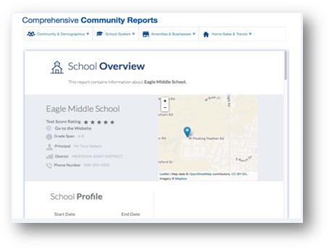

## Affiliate Dashboard available to all Affiliate Connect users

To help simplify Affiliate Connect setup for our users, we’ve eliminated the Basic and Premium tiers in favor of one level of service. Now all Affiliate Users have access to their own Affiliate Dashboard, and will not have access to your Paragon MLS site.

When Affiliates receive their setup email, the included URL directs them to the Dashboard.

## Updated PAC Agent Dashboard

The PAC Agent Dashboard has been updated to support a streamlined workflow. Agent and Office Affiliates have been combined onto one tab. Agents can share their Affiliates with their contacts, view Affiliate Disclosures, and add comments to Affiliates all from the same screen.

For Office and Firm managers, new enhancements accommodate adding Affiliates to one or more offices within a firm, or adding Disclosures to any Office Affiliate.

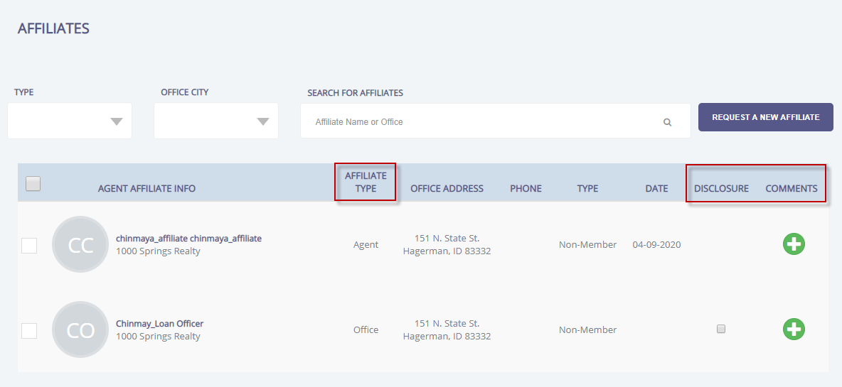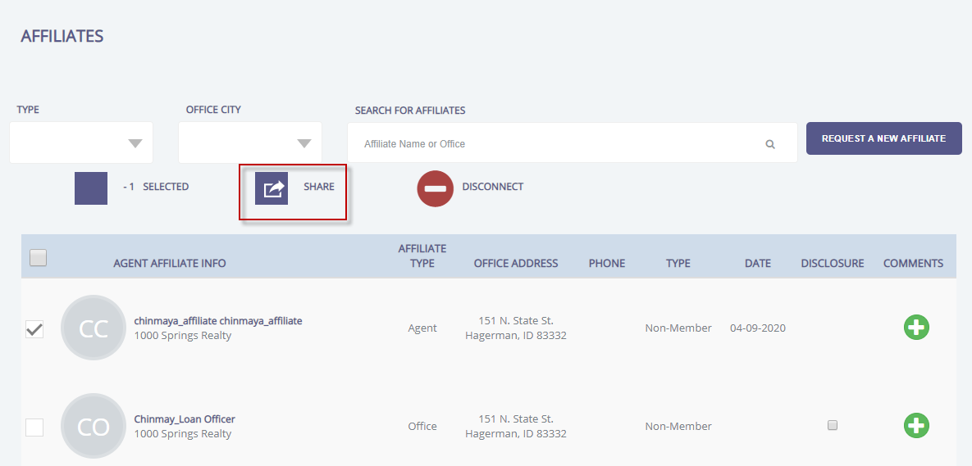

## Listing Search link added to Affiliate Dashboard

### AFFILIATE_CONNECT_PROPERTY_SEARCH_URL

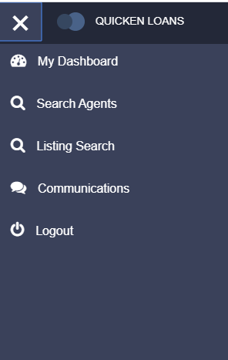

A Listing Search link can be added to the Affiliate Dashboard menu. The MLS can select the search site, either the MLS’s consumer facing site, or Black Knight’s IDX solution if a consumer site is not available. The search site is framed in the Affiliate Dashboard.

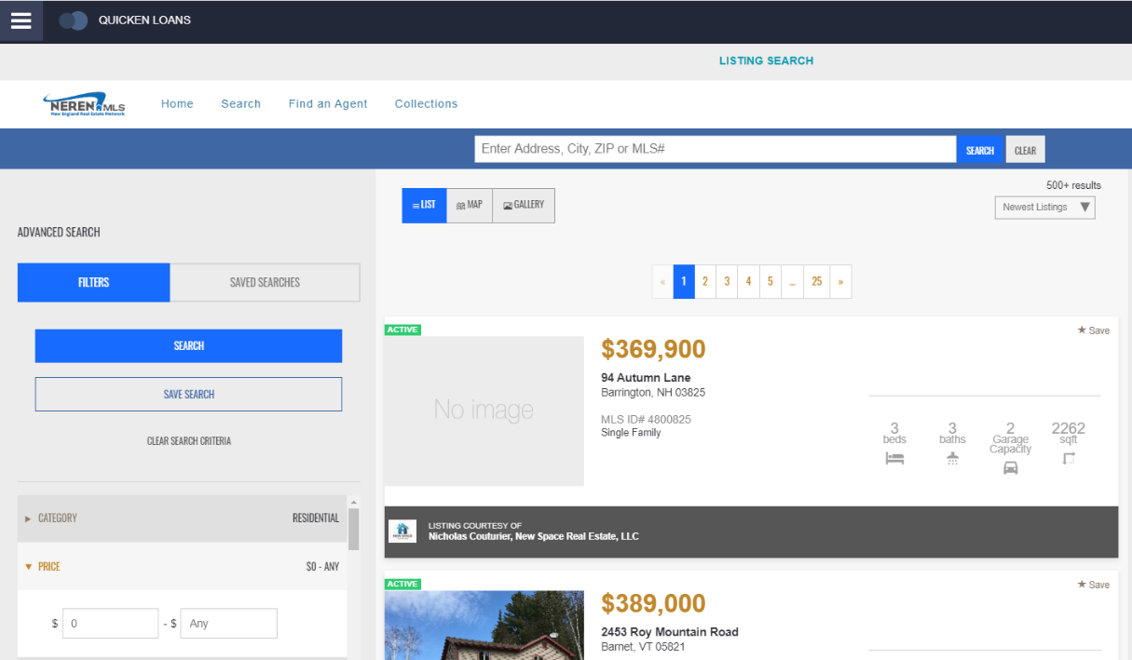

## Add Agent comments when sharing Contacts with Affiliates

Agents have the option of including comments or notes when sharing affiliate information with clients, or when sharing clients with affiliates.

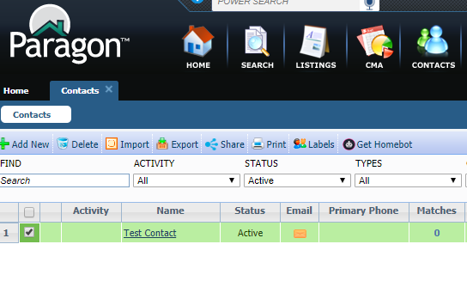

## New! Affiliate Market Page and Sign up Form

Paragon Affiliate Connect is now an easy, turn-key solution for the MLS to implement. We now have a full marketing page, sign up form and paywall for affiliates.

Black Knight will hold webinars for affiliates to learn about PAC, handle the onboarding of affiliates for your particular MLS and we will train and support the affiliates.

The pricing for PAC is $25 per month, per affiliate. There is no long-term contract and affiliates can cancel with a 30 day notice.

## Agent Dashboard Updates

The PAC agent dashboard has been further improved to support agent, office and firm level users.

The agent can connect with affiliates on an agent level, and benefit from being connected to affiliates on an office level by their office manager. Agents can interact with both agent and office level affiliates through comments. Any comment added will be available to the affiliate in their dashboard, and they can also send an email to the affiliate. The agent can view any disclosure added by an office or firm level manager.

An office or firm manager will be able to add affiliates to a specific office they oversee, or multiple offices within their firm. They are also able to add or edit disclosures as appropriate for the specific affiliate. When an affiliate is connected at an office or firm level, all the agents within the office(s) are visible in their dashboard.

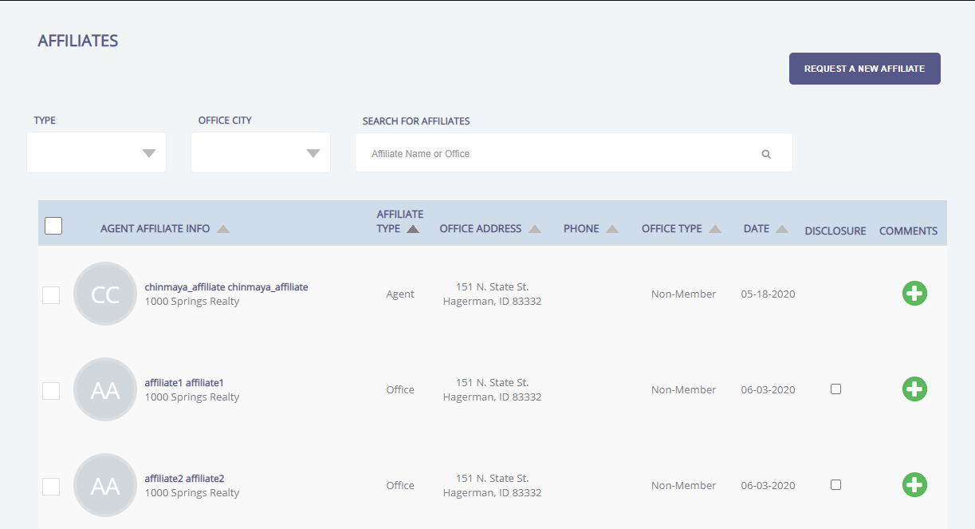

## Login Agreement Type – Terms of Use

Agents will be required to accept a Terms of Use Agreement in order to expose their buyers contacts to any Affiliate. Once Paragon Affiliate Connect is enabled, the MLS will enable the login agreement module. The next time the agents log in they will be prompted to accept the terms of use for Paragon Affiliate Connect.

The Admin in Paragon will go to Paragon, select Admin>Messaging>Login Agreement and then click on the + to add a new Login Agreement.

Once the agreement is saved you will see the following when you click on Login Agreement in Admin>Messaging>Login Agreement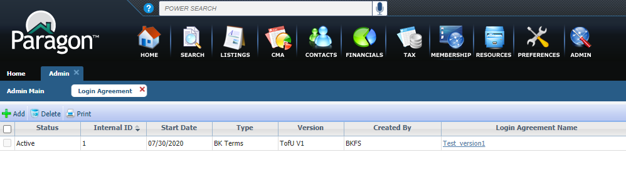

## Accepting Terms of Use

Agents will be required to accept a Terms of Use Agreement in order to expose their buyers contacts to any Affiliate. Once Paragon Affiliate Connect is enabled, the MLS will enable the login agreement module. The next time the agents log in they will be prompted to accept the terms of use for Paragon Affiliate Connect. Click here to read the full [BK Terms of Use.](http://paragonconnect.paragonrels.com/images/documents/release_notes/579/BK%20Paragon%20Terms%20of%20Use%2020180913%20Paragon%20Affiliate%20Connect.docx)

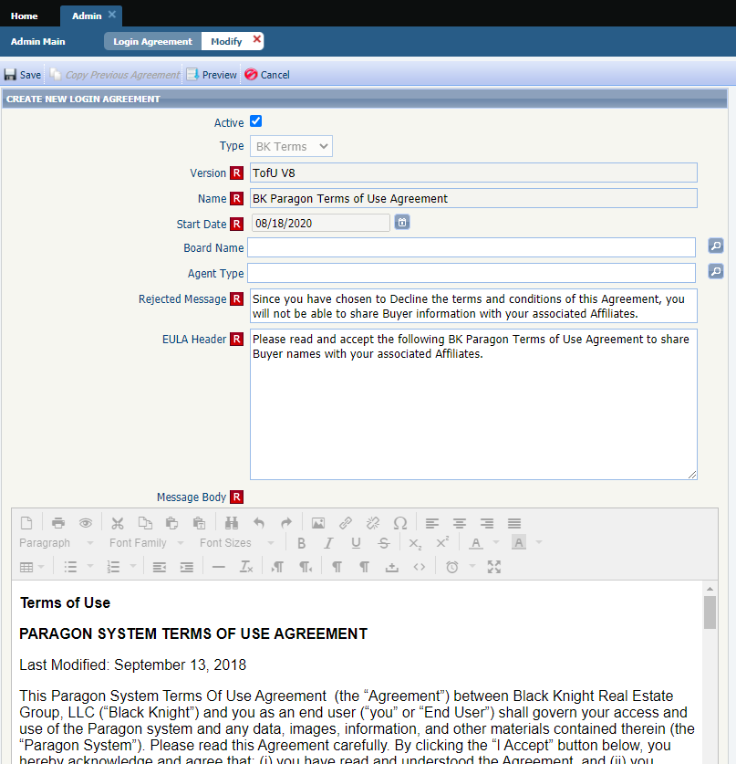

## Terms of Use added to Quick Action Bar in Paragon

To accommodate the addition of the Terms of Use for Paragon Affiliate Connect, we have added a link in the Quick Action Bar so that Agents can view the terms at any time.

Click here to read the full [BK Terms of Use.](http://paragonconnect.paragonrels.com/images/documents/release_notes/579/BK%20Paragon%20Terms%20of%20Use%2020180913%20Paragon%20Affiliate%20Connect.docx)

## Paragon Affiliate Connect NEW Paywall Sign up Form

Paragon Affiliate Connect now allows Affiliates to directly sign up from the Paragon Affiliate Connect marketing portal.

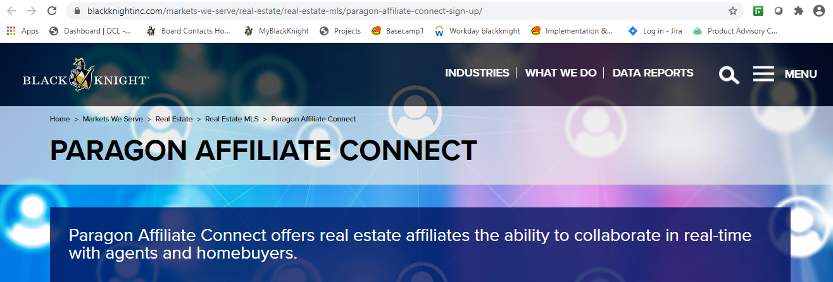

At the bottom of the screen the Affiliate will have the opportunity to click on the Sign up Today button which will allow them to pay via their credit card and sign up for monthly billing.

Once they click on the Sign Up Today button it will take them to a form to fill out and then they will click on Start me up!

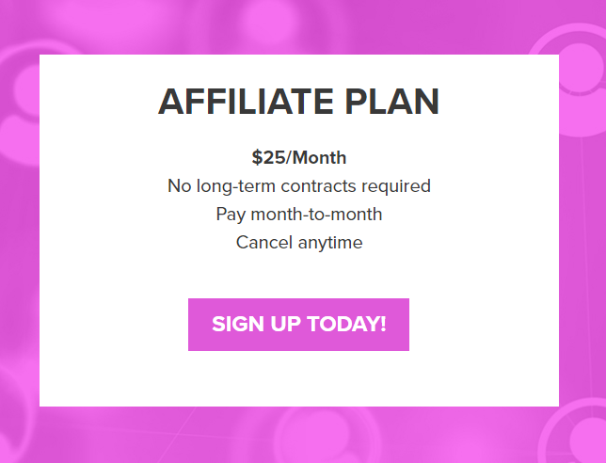

Once they click on Start Me up! they will be redirected to the Paywall where they will enter in their credit card information to pay for the service.

## Added MLS logo to the Affiliate Dashboard

### Action Item: MLS Admin must load logo in Paragon Admin/System Setup Options/MLS Information/MLS Login Page Logo Path (600 x 250)

If the MLS logo is uploaded in Paragon by the MLS administration, the logo will now appear on the Affiliate Dashboard login page. This helps identify what MLS they are affiliated with. If the MLS did NOT load a logo into Paragon, no logo will be displayed.

## Added Disclaimer to Collaboration Center Detail Report

MLSs can add a specific disclaimer to appear in Collaboration Center. It is found in Admin/MLS Information/Disclaimers. It allows for up to 2,000 characters. It is NOT dependent upon PAC being enabled.

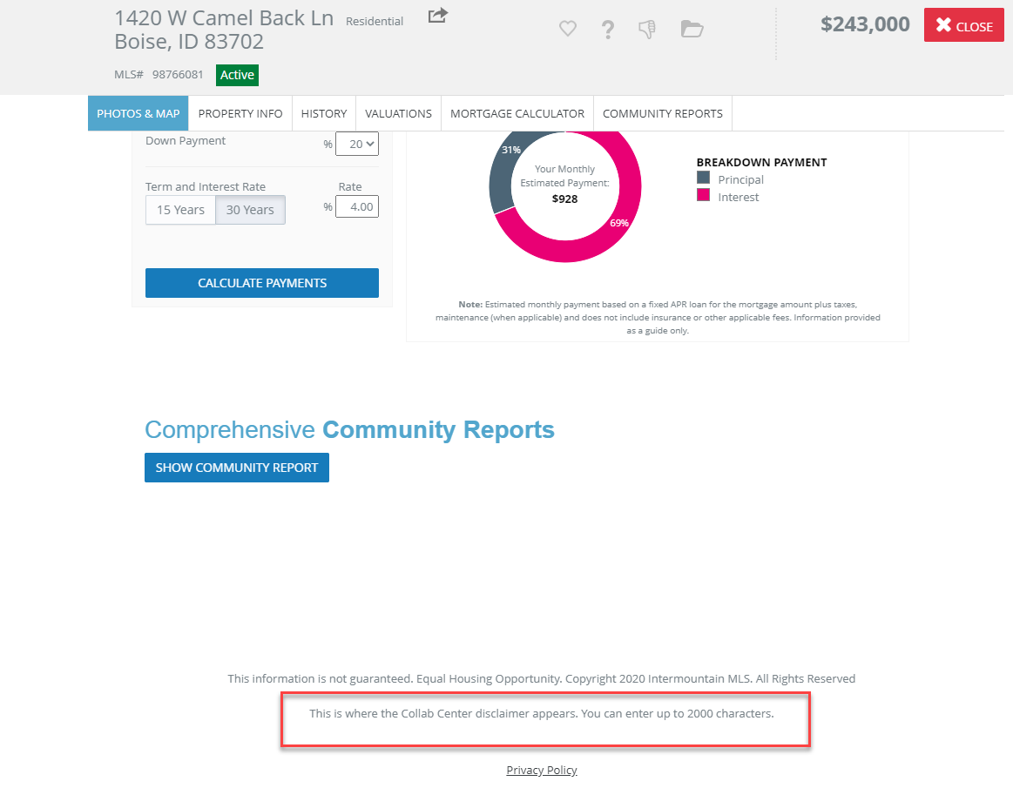 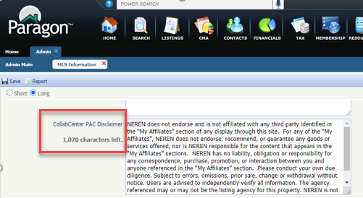

## Added license number to Agent Details in Affiliate Dashboard

Previously, the License number was not on the agent details on the Affiliate Dashboard. This has now been added.

## Allow Agent to suppress Affiliate from Displaying in Collaboration Center

From their list of affiliates, agent can select an affiliate and hide that affiliate from displaying in their collaboration center.

## Paragon Affiliate Connect – Disclaimer for Collaboration Center

The MLS can add a disclaimer to appear in the footer of the Collaboration Center. The specific disclaimer will appear in the footer of the email sent from the Collaboration Center and appear in the footer of the Collaboration Center site.

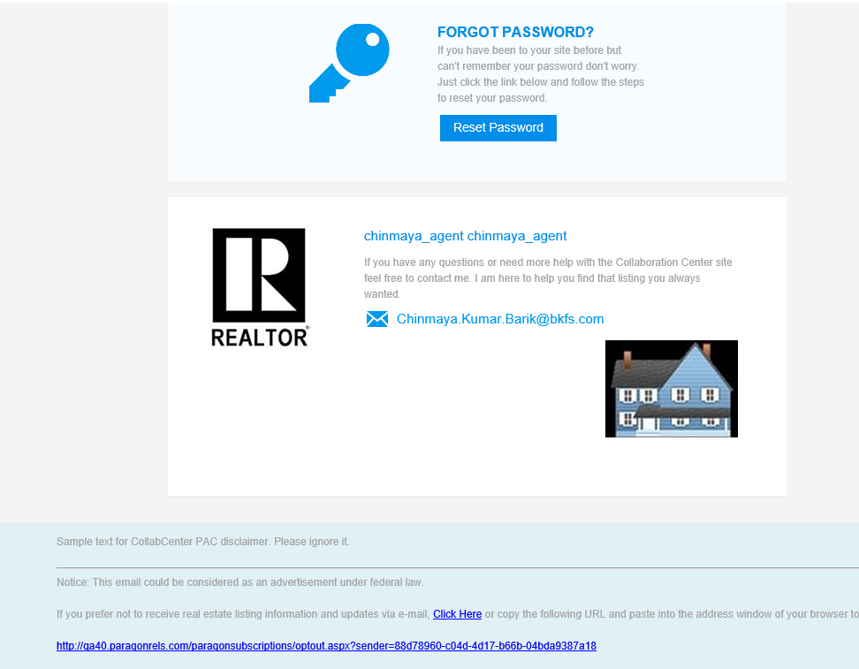

## Paragon for Brokers (P4B) Dashboard change

The My Affiliates link has been added to the Paragon for Brokers (P4B) dashboard. This link has the same functionality of Preferences/My Affiliates. It has been added to the P4B dashboard to highlight the broker added affiliates.

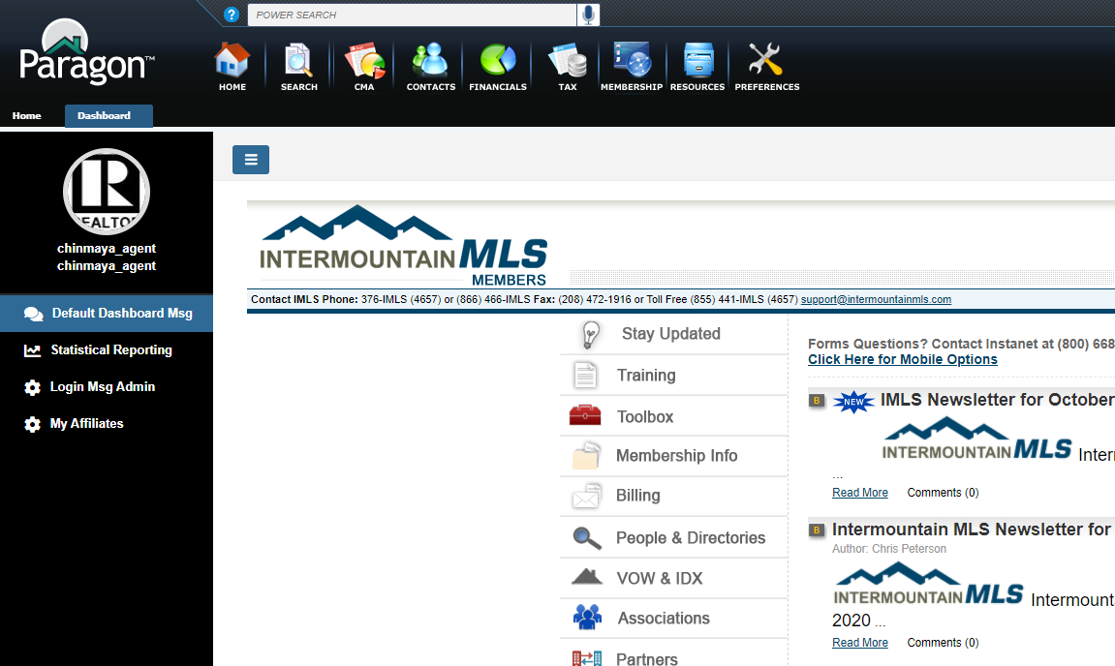

## Preferences - Ability to Suppress a Connected Affiliate’s Branding Block

### Action Item: N/A

Agents will have the ability to suppress a connected affiliate’s branding block from appearing in Collaboration Center. Now, when an agent suppresses an affiliate from appearing in Collab Center, the affiliate will also NOT display in the Collab Center emails that are sent.

## Preferences – Notification Options

Under Preference/Affiliate Connect, the label for “Seller Activity” has been changed to “Listing Activity” to better reflect the notifications that are sent. Affiliate Connect sends notifications to the affiliate based on listing activity, not sellers.

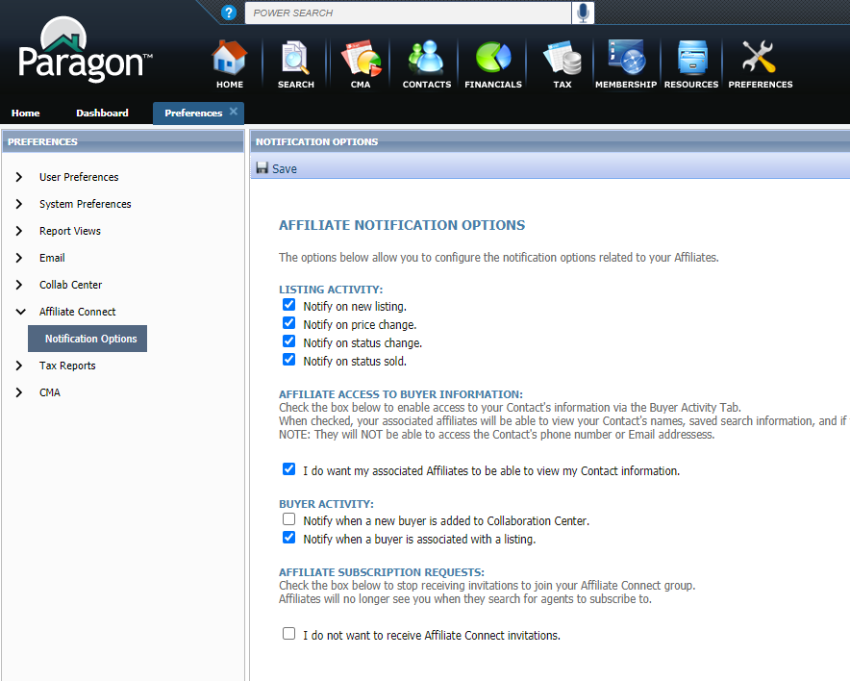

## Search Screen – Office City/State

To accommodate MLSs that may have affiliate offices in multiple states, the state abbreviation has been added to the city name under the Office City filter in Affiliate Search.

