**Paragon Affiliate Connect 2021**

**Paragon Affiliate Connect Enhancements for releases 5.81 to 5.86**

Association Autonomy – Apply Board/Association Participation logic 2

Affiliate Dashboard – Marketing Text removed 2

Search for Affiliates automatically displays results 3

Limit Affiliate invitations to Agents 3

Notification emails for Affiliates 4

Agent – Affiliate Connect Preferences 4

Agent My Affiliate Dashboard – Searching “All” Affiliate Types or Office City 4

Affiliate Dashboard – Buyer Activity Tab text 5

Affiliate Dashboard – Make My New Home 6

Agent Affiliate Dashboard hidden on smaller devices 6

Notifications Tab hidden 8

Admin – New link to send Affiliate Welcome email 10

Admin – Display Affiliate Broker Options in Preferences based on security level 11

Admin – Association Autonomy options for Affiliate Connect 11

Updated text for Broker Options in Preferences 11

Add office-level Disclaimer for Office Affiliates 12

Updates to the Agent My Affiliates page 13

Service Partners Tab in Collaboration Center 15

Reply button on dashboard notifications 16

Updates to the Buyer Activity tab 17

Additional updates to the Comments workflow 18

## Association Autonomy – Apply Board/Association Participation logic

Paragon Affiliate Connect now follows the same membership Participation sharing rules within associations. Both agents and affiliates will be searchable and able to connect based on the Board/Association participation rules applied.

The checkbox for Affiliate Connect participation indicates if a board or association participates in Paragon Affiliate Connect. If they participate the membership participation settings apply. If the association does not participate, none of their members will have access to Paragon Affiliate Connect, nor will they be searchable by an affiliate in another association.

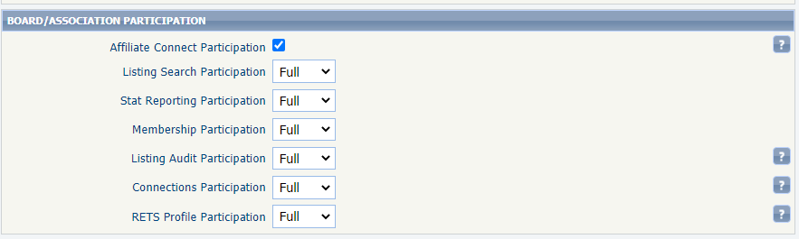

## Affiliate Dashboard – Marketing Text removed

To allow and encourage the affiliate to enter their own marketing text, we have removed the default marketing text in their dashboard. Affiliates can now add their own biography or information about their services.

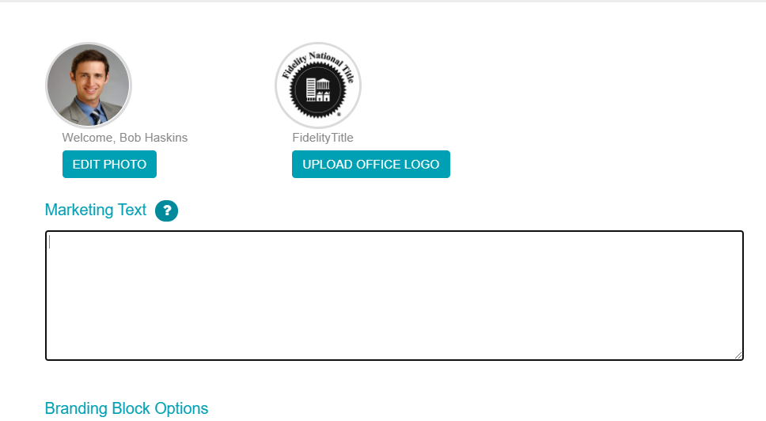

## Search for Affiliates automatically displays results

When agents are searching for affiliates, the screen will automatically refresh and display results as they choose criteria from the drop-down menus. This includes affiliate types, cities, and the name of the affiliate. 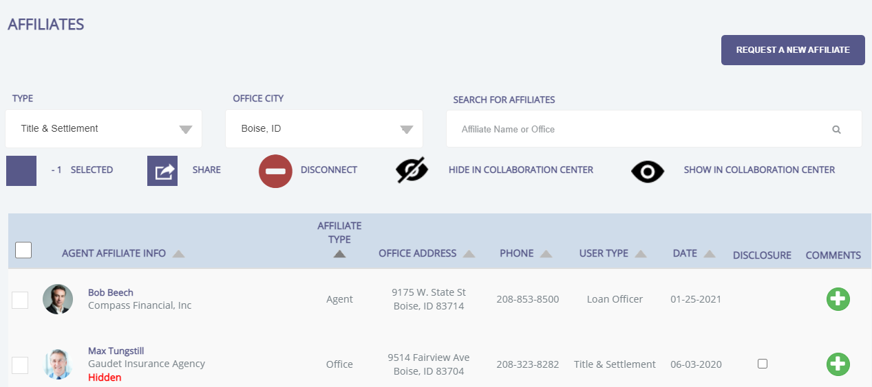

## Limit Affiliate invitations to Agents

Affiliates can send invitations to an agent to connect with them. We have limited that invitation to a total of two times to a specific Agent. This prohibits the affiliate from continually sending an invitation to an agent that may not want to connect. An agent can still reach out and connect with the affiliate through My Affiliates.

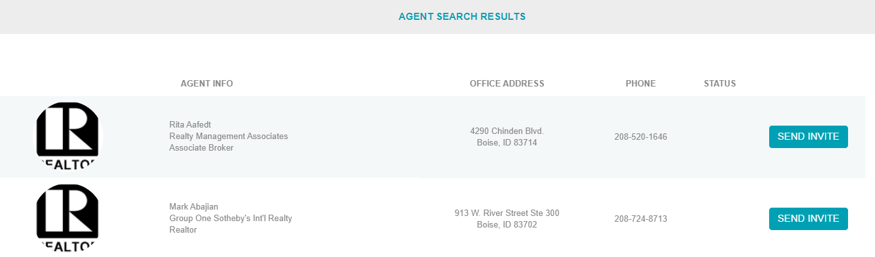

## Notification emails for Affiliates

Affiliates can be connected to agents at both an agent level and at an office level (the office manager or broker owner connected the affiliate to their agents). Affiliates now receive notification emails from all agents they are connected to, whether connected at the agent or office level. The notifications they receive are still at the agent’s discretion, based on the agent’s selected options in Preferences > Affiliate Connect.

The main purpose of this new feature was to ensure that Affiliates in System of Choice markets will still receive key notification emails on listings (new listings, prices/status changes), when connected to the brokerage in a Paragon for Brokers set up.

## Agent – Affiliate Connect Preferences

In Preferences > Affiliate Connect > Notification Options, the verbiage on the Affiliate Subscriptions Request has been clarified.

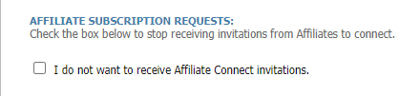

## Agent My Affiliate Dashboard – Searching “All” Affiliate Types or Office City

For Paragon and Paragon Connect users searching on the My Affiliates page, selecting the default “All” option for Type or Office City sometimes returned the error, “At least one search criteria must be entered.” This has been corrected, and searching on All will return matches.

## Affiliate Dashboard – Buyer Activity Tab text

The Affiliate Dashboard uses the View Details button in several locations, but different data was returned depending on where the button was located. To be consistent with Paragon Connect and Collaboration Center, when a listing detail view is returned, the button will still read View Detail. To eliminate confusion, the button on the Buyer Activity tab has been renamed to Buyer Detail and will continue to open the Buyer Details page.

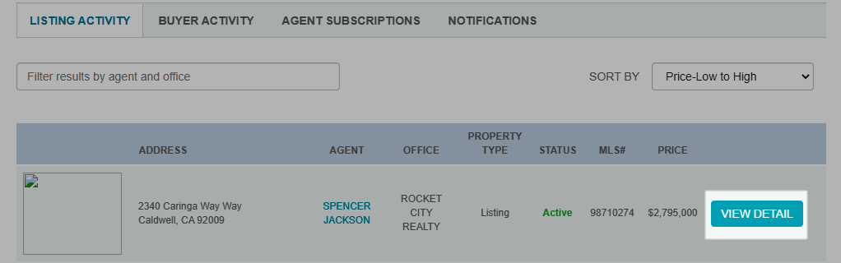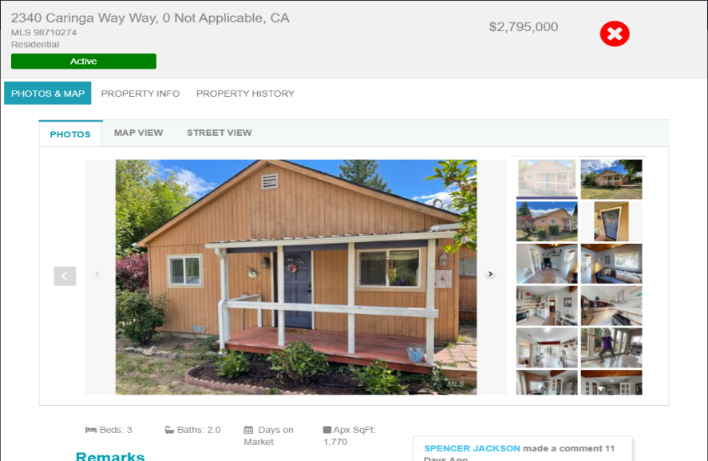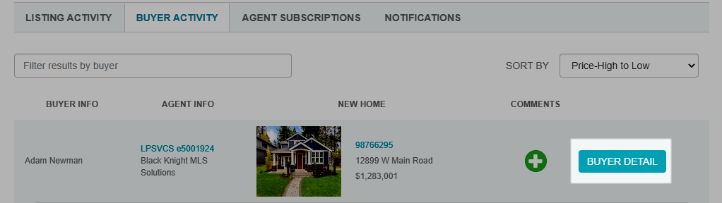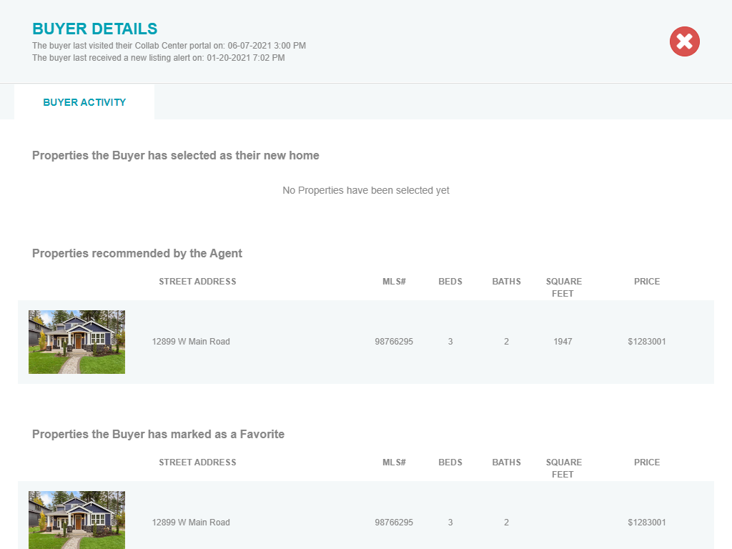

## Affiliate Dashboard – Make My New Home

The Collaboration Center feature, Make My New Home, is configurable by MLS, and may not be turned on for your clients. However, the related New Home feature was displaying on the Affiliate Dashboard even when not enabled on Collaboration Center. This enhancement hides all My New Home references on the Affiliate Dashboard when it is turned off in Collaboration Center.

## Agent Affiliate Dashboard hidden on smaller devices

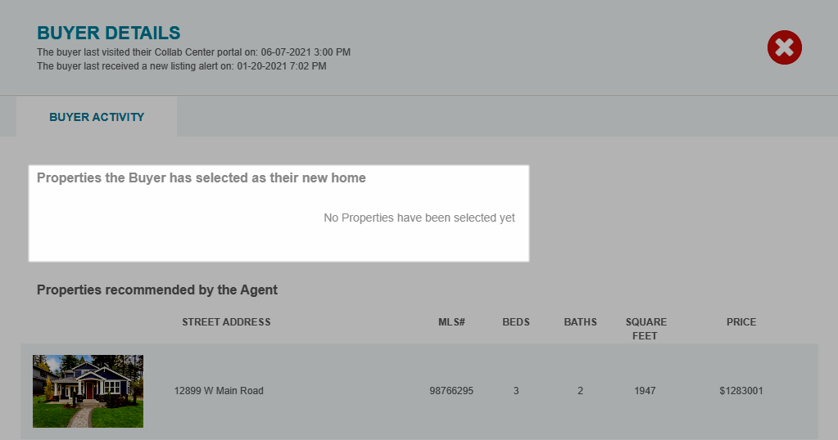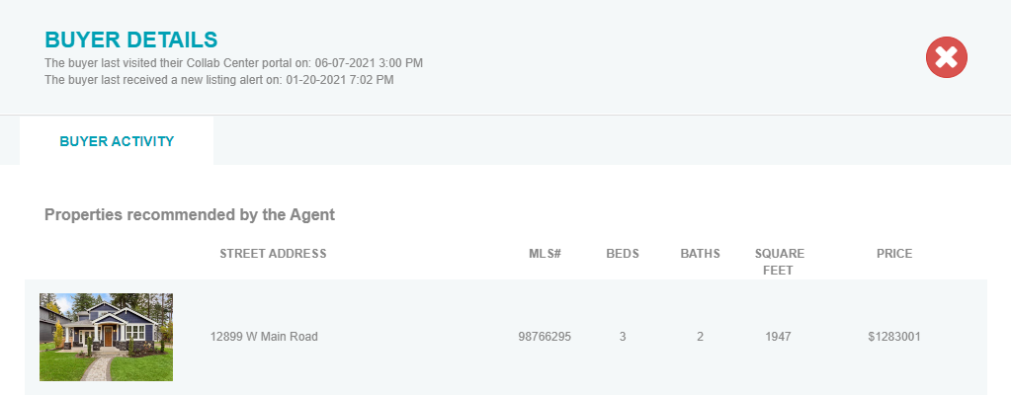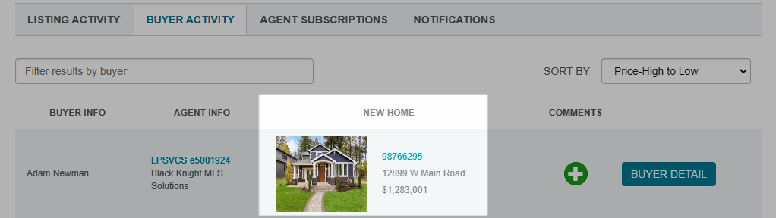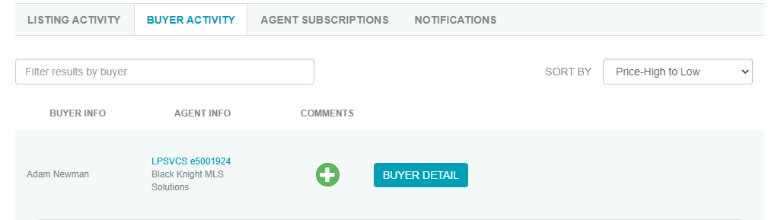

The agent’s Affiliate dashboard does not properly scale for mobile and small tablet devices, and parts of the page become inaccessible, resulting in a poor user experience. Because the page will need a complete rework to correct this issue, the Affiliate menu will be hidden on devices with resolution less than 992 x 800 pixels until that work can be completed.

1My Affiliates page in Paragon Connect Affiliate Connect menu removed

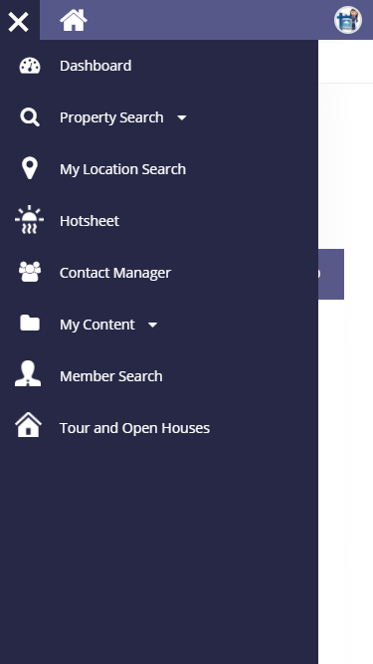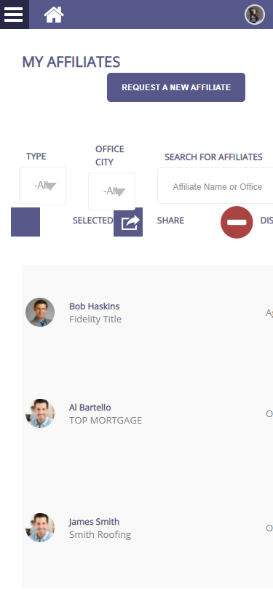

## Notifications Tab hidden

The Notifications workflow is being reviewed to ensure correct information is being logged on the Notifications page. In the meantime, the page will be hidden to eliminate confusion.

Affiliate Notifications Tabs

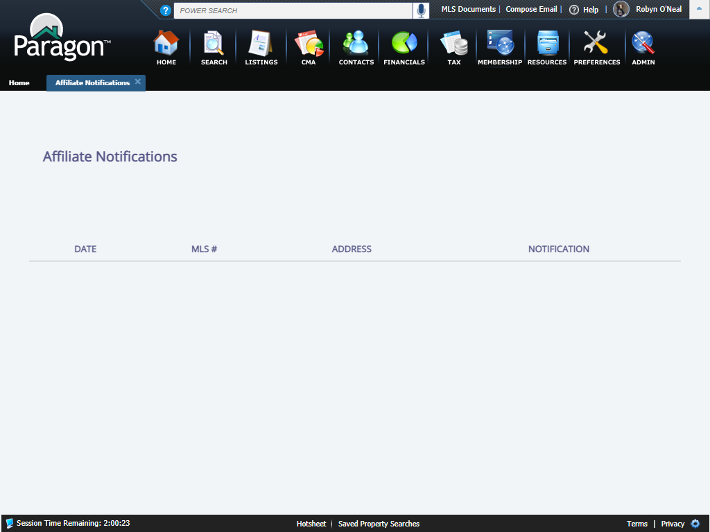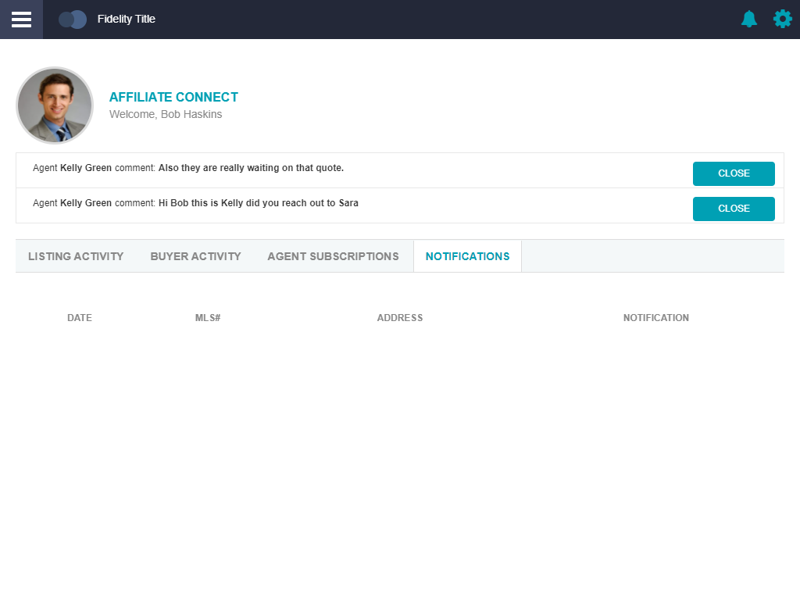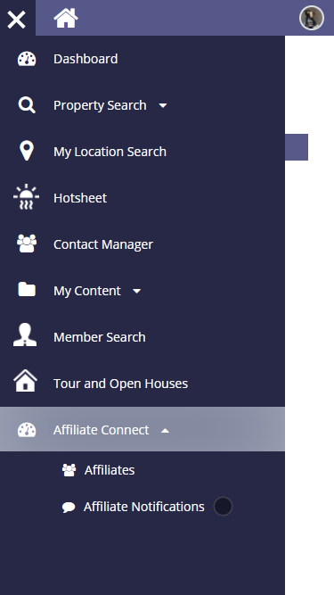

Notifications removed from menu

## Admin – New link to send Affiliate Welcome email

A link to Send Affiliate Welcome Email will display on the agent record, when Affiliate Connect is enabled, and the Agent Type is an Affiliate User. Previously, the welcome email was generated automatically when a new Affiliate user was added to Paragon, but there was no way to send the email for an existing user, or to resend a copy.

## Admin – Display Affiliate Broker Options in Preferences based on security level

The Affiliate > Broker Options in Preferences previously displayed only when the user was listed as the Office Broker in an office record. This has been updated to go by security level instead of the Office Broker field. Users with security level 5 and up will now see the Broker Options in Preferences.

## Admin – Association Autonomy options for Affiliate Connect

The Affiliate Connect checkbox for each Association has been moved to a new Affiliate Connect Participation section. The board restrictions will work the same as the existing Membership restrictions, with options for Full participation to all boards; Partial participation to specified boards; and None, participation in just the Affiliate’s board.

## Updated text for Broker Options in Preferences

The text in Preferences > Broker Options for Allow Agent Affiliates was restated for clarity.

## Add office-level Disclaimer for Office Affiliates

A new feature was added to Preferences > Affiliate Connect > Broker Options, to allow the broker to enter a disclaimer for their office-level affiliates. The disclaimer will apply to all office affiliates, and will be visible to agents in the office from the My Affiliates tab. This eliminates the need for the broker to add a disclaimer to each office affiliate separately.

## Updates to the Agent My Affiliates page

Several items on the Paragon > My Affiliates page have been updated to a newer User Interface.

* The Request an Affiliate dialog box was updated.

* A confirmation message was added when the user disconnects from an affiliate.

* To improve communication between the agent and affiliate, when an agent shares an affiliate with a contact/client, the affiliate will get a notification on their dashboard, a new comment in the comments thread with that agent, and an email notification. The client’s contact information is not shared with the affiliate.

## Service Partners Tab in Collaboration Center

Collaboration Center users will see a new tab for Service Partners to the right of the existing tabs. When Affiliate Connect is enabled, the tab will display with all the branding blocks for the agent’s connected affiliates. This provides the client with a full list of potential providers selected by their agent.

## Reply button on dashboard notifications

The Close button on the dashboard notifications for agents and affiliates has been changed to Reply. The Reply button will open the comment thread between the affiliate and agent, allowing the user to view the comment thread and reply from there. Clicking the Reply button will also remove the notification from the dashboard.

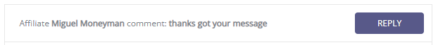

## Updates to the Buyer Activity tab

On the Affiliate Dashboard, the Buyer Activity tab has been streamlined to present each buyer one time, instead of multiple times.

If Make My New Home is enabled in Collaboration Center, the Buyer Activity tab will include a column to display the latest ‘my new home’ selected by the buyer.

## Additional updates to the Comments workflow

On the Affiliate Dashboard, several items were updated to improve the comments workflow between affiliate and agent.

* The Comments link was removed from the Buyer Activity tab and will be moved to the Buyer Detail tab in a future release.
* A Comments column was added to each agent on the Agent Subscriptions tab.

* Text on the Communications page was updated for clarity and the button text updated to Start a Conversation. Clicking the button will open the Agent Subscriptions tab, where the affiliate can begin a conversation with one of their connected agents.

