Paragon Affiliate Connect 2022
Paragon Affiliate Connect Enhancements for releases 5.87 to 5.92

UI Redesign 2
Affiliate Branding Blocks 5
Affiliate/Agent Profile Photo 6
Connecting to Affiliates 6
New Login Page for Affiliates 7
Login Name Displayed in Welcome Email to Affiliate 7
Email Communications 7
Affiliate/Agent Profile Photo 8
Connecting to Affiliates 8
New Login Page for Affiliates 9
Login Name Displayed in Welcome Email to Affiliate 9
Email Communications 9

UI Redesign
Black Knight is excited to announce the redesign of Paragon Affiliate Connect. The agent section within the resources tab called My Affiliate has gotten a major upgrade. We have updated the UI to a more modern look and feel making it easier for the agents to search, add, request, share and view comments with affiliates they are connected to.
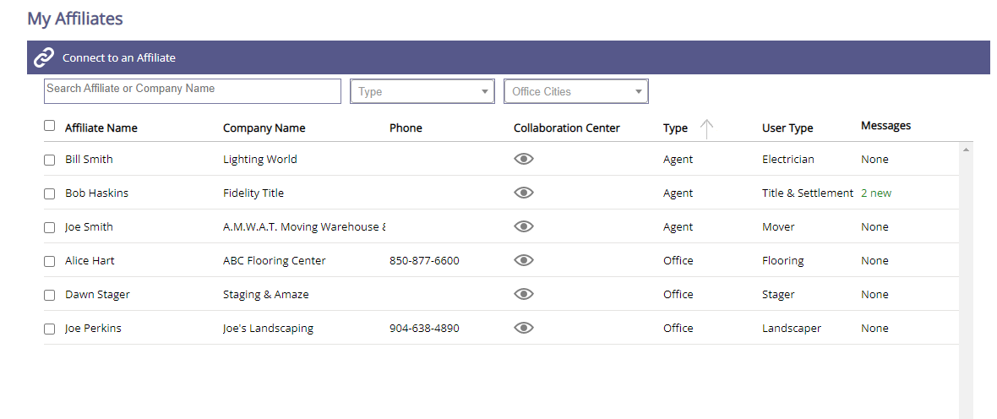Sorting has been added to all columns in the My Affiliates menu. By Clicking on the header an arrow will appear showing the sort for that column.
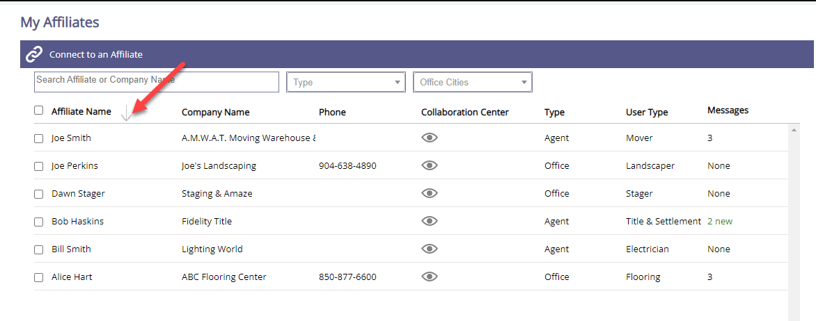
Connecting to Affiliates will open a new modal window. In that window the agent will be able to search by name or company name, type, or city.
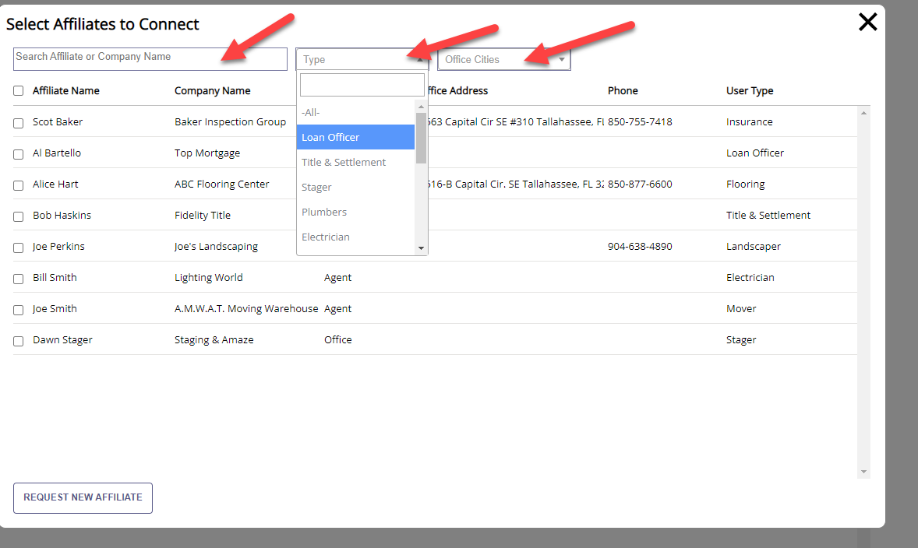
After selecting the Affiliate(s) that you would like to connect to there will be an option to “Connect to My Affiliates” if you are a Broker or a Broker Manager you will be able to connect to your Office, giving the affiliate access to everyone in your office and/or branch office.
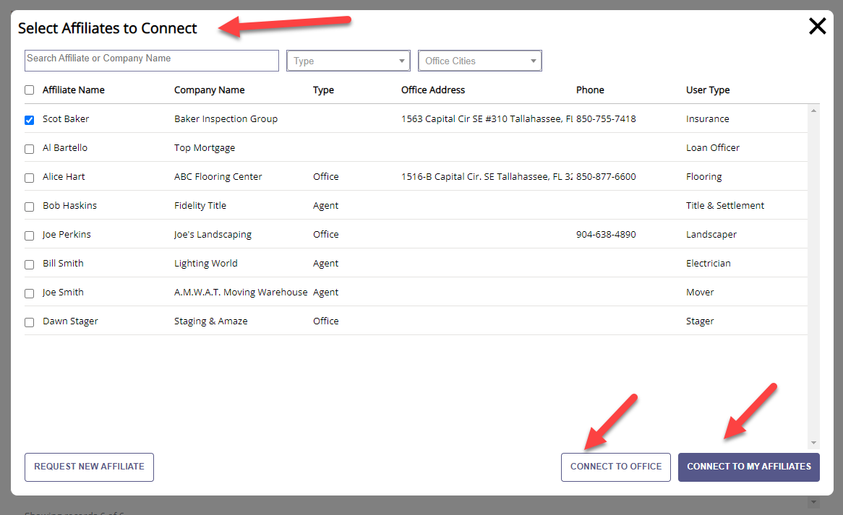
If you cannot find the Affiliate you want, you can still request a new Affiliate to join the board.
We have updated the Select Contacts to Share to Affiliate to also have a modal window that will pop up and show all your contacts in Paragon that you can select from. You can search, select and comment then share. The Affiliate(s) will get an email and a notification in their portal stating that you shared their contact information with your client(s).
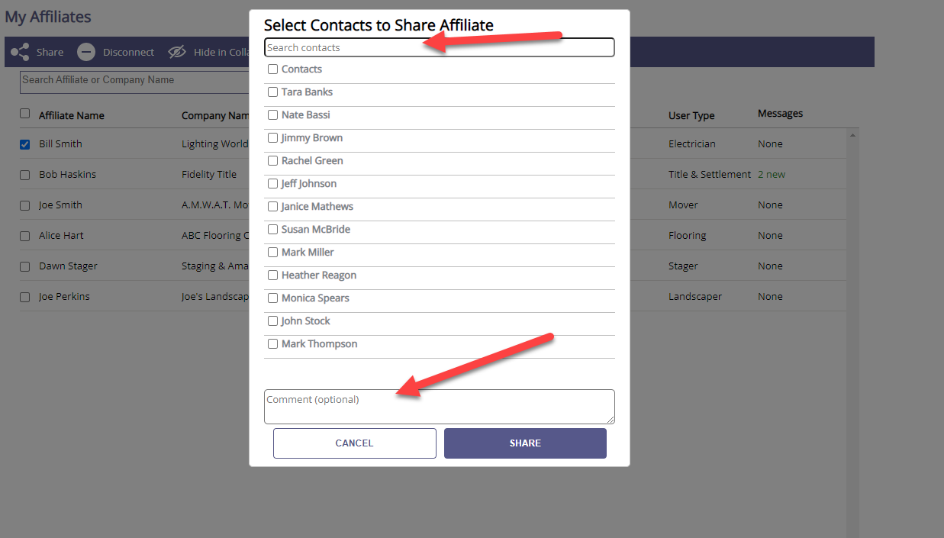
When Clicking on a connected Affiliate you can chat with them directly from the application. You can also see a history of the conversation.
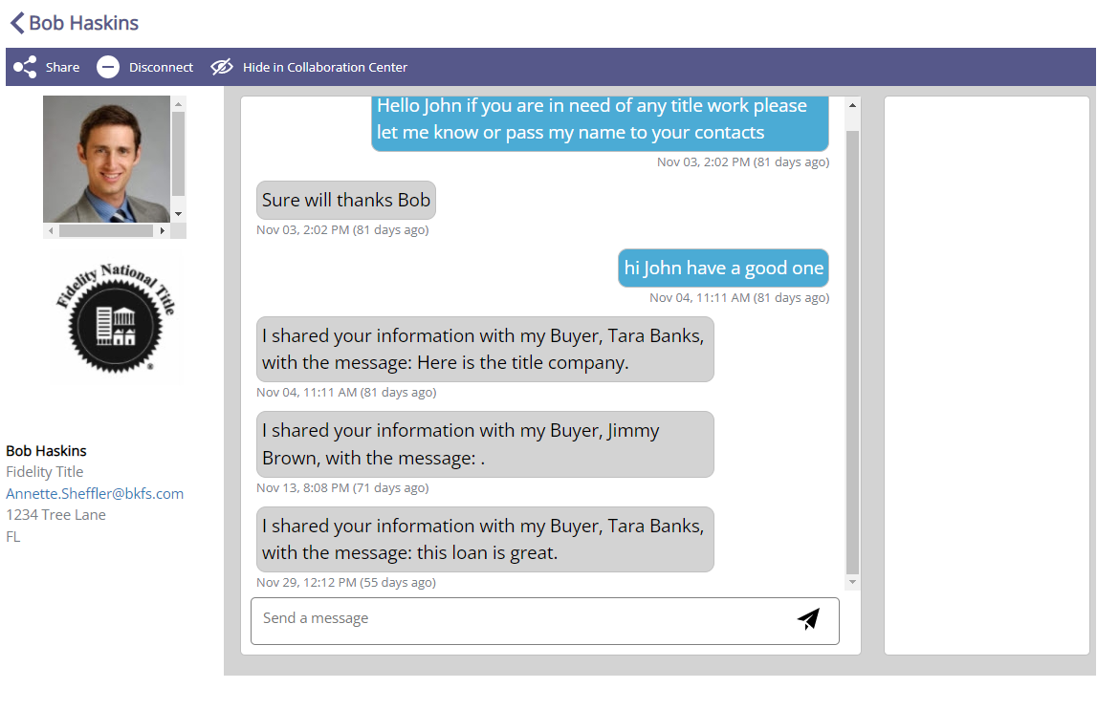

Affiliate Branding Blocks
If connected to an Agent, the Affiliate branding blocks will appear on the connected agents’ client’s collab center detail view. The system has been limited to display a maximum of three affiliate blocks at a time. The order of appearance and the order of affiliates that appear will be randomized.
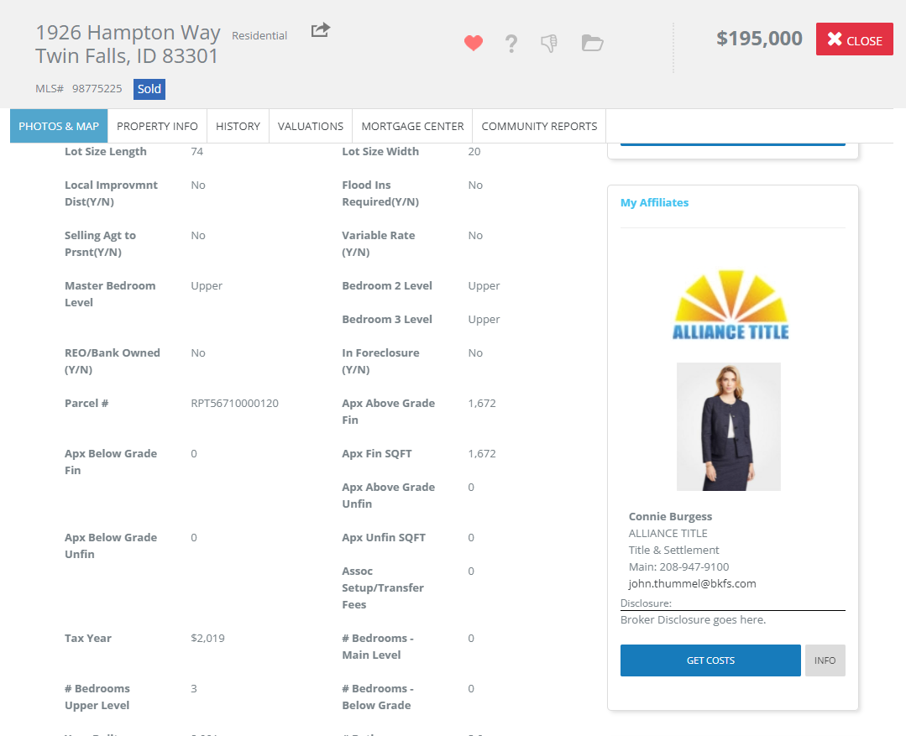

Affiliate/Agent Profile Photo
If the Agent and/or the Affiliate does not have a photo selected to display in their profile. The image circle will use their initials instead of the “R” (for REALTOR® logo) that used to display.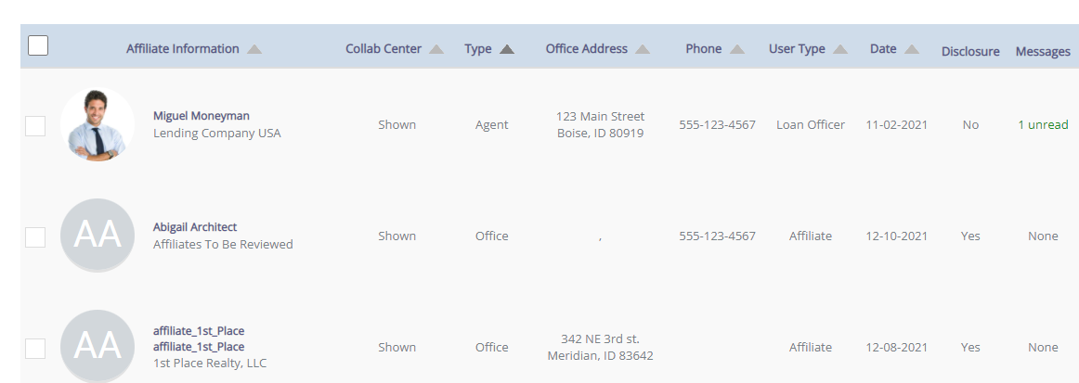

Connecting to Affiliates
When an agent searches for an affiliate to connect with, the only available affiliates that will appear are the ones with an email address attached to their profile.

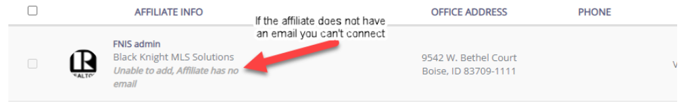

New Login Page for Affiliates
We have updated the login page for Affiliates, to keep more in line with Paragon. Previously we would take the Affiliate to a purple page where they would log into the system. Now when going to log into the system the Affiliate will see a similar page as Paragon users, however it will be labeled as Paragon Affiliate Connect! 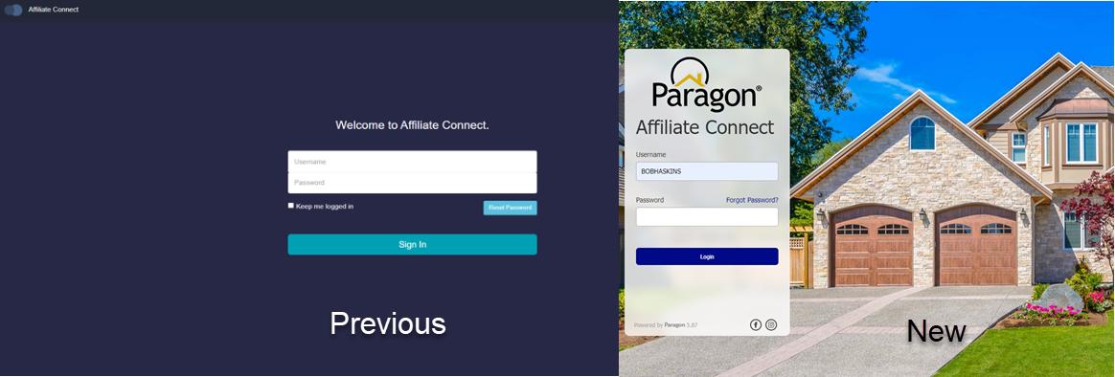

Login Name Displayed in Welcome Email to Affiliate
When joining Paragon Affiliate Connect (PAC) the Affiliate welcome email will now show the login name and a link to set their password.

Email Communications
All the various email communications delivered via Affiliate Connect have been updated to reflect the new standard styling and consistent information.

Affiliate/Agent Profile Photo
If the Agent and/or the Affiliate does not have a photo selected to display in their profile. The image circle will use their initials instead of the “R” (for Realtor logo) that used to display.

Connecting to Affiliates
When an agent searches for an affiliate to connect with, the only available affiliates that will appear are the ones with an email address attached to their profile.

New Login Page for Affiliates
We have updated the login page for Affiliates, to keep more in line with Paragon. Previously we would take the Affiliate to a purple page where they would log into the system. Now when going to log into the system the Affiliate will see a similar page as Paragon users, however it will be labeled as Paragon Affiliate Connect!

Login Name Displayed in Welcome Email to Affiliate
When joining Paragon Affiliate Connect (PAC) the Affiliate welcome email will now show the login name and a link to set their password.

Email Communications
All the various email communications delivered via Affiliate Connect have been updated to reflect the new standard styling and consistent information.

