**Enhanced Data 2020**

**Enhanced Data for releases 5.75 to 5.80**

Autofill Listing from Interactive Map Layers 2

Property Watch 3

My Property Watch & Alerts Grids 4

Property Watch Enhancements 5

New CRS Data Integration Points – Tax Autofill Search Results 7

New CRS Data Integration Points – Parcel Property Panel 8

New CRS Data Integration Points - Property Watch and Alerts 9

Enhanced Data to Parcel Panel for Subscribers of Intelligent Analytics 10

Display Public Records with Listings on Map 11

Map Drawings for Integrated Public Record Map Search 13

Display Average Value of all AVMs 14

Zestimate Direct Link 15

REALTORS® Valuation Model Direct Link 16

Parcel Property Panel Now Supports Multi-Unit Parcels 17

Retain 1.0 Geocode when converting Partial Listings 19

Homebot UI Update 19

## Autofill Listing from Interactive Map Layers

This enhancement uses the MLS-Level Interactive Map Layers and uses the geocode when using Listing Input and Change Geocode to autofill lookup location fields. When a listing is saved, Paragon determines the geocode, compares it to the interactive map layers with lookups, and autofills data where needed.

* If map layer data matches already provided listing data: no changes are made
* If blank or data doesn’t match: field is autofilled with the map layer lookup value and a warning notification is generated.

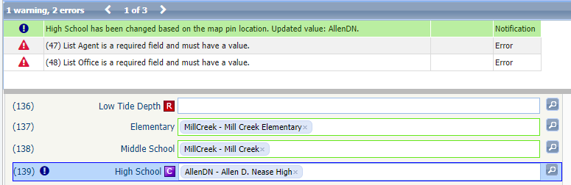

Note: Map Layers are created in Admin > System Setup > Interactive Map Layers

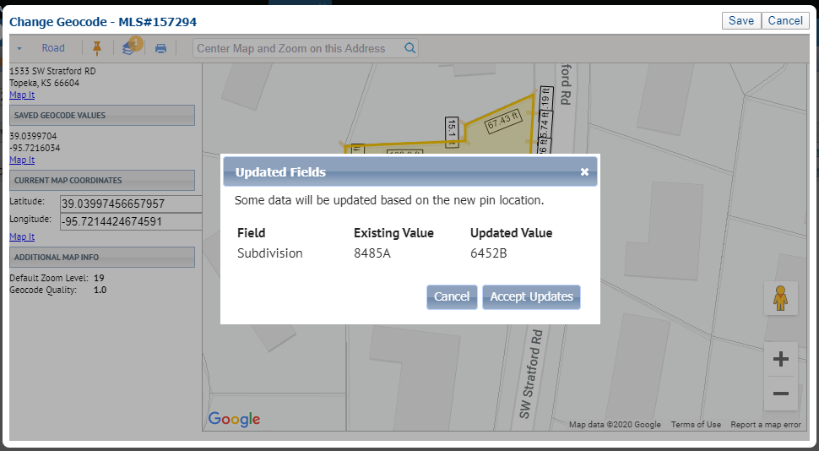

## Property Watch

We are excited to announce the release of Property Watch, a new Premium Tax offering.

Property Watch gives agents the ability to select a parcel from the map and add it to a watchlist and to be notified when any of the following occurs on the public record: Foreclosures, ARM Reset, Ownership Change, Tax Delinquency, Valuation Change, New Loan or even when it’s Listed on MLS by another agent.

After a Property Watch has been added, the agent is automatically set up to receive simple, textual email alerts when something has changed on the public record. After receiving the email alert, the agent can log into Paragon to view the Alerts from a new option under the Tax Menu

Property Watch can also be used like a “favorites” for public records, giving agents a way to quickly access a public record within Paragon.

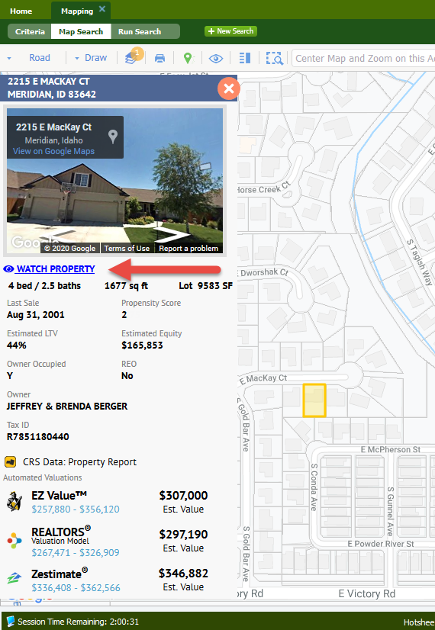Property watches can be added from the Parcel Property Panel in the Map Search or Google Map View.

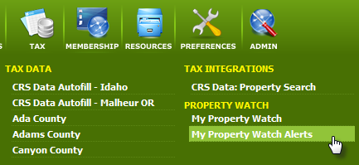

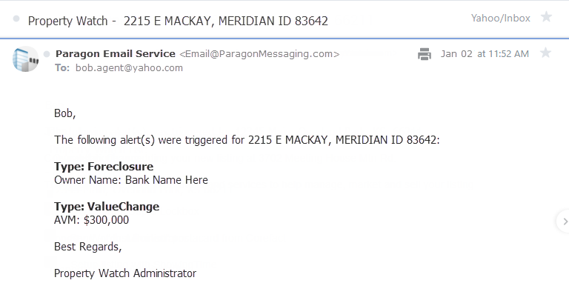

## My Property Watch & Alerts Grids

We’ve added a new grid view that displays information about a property that also includes the property panel from the Map View. Highlighting any of the rows updates the property panel for quick access to the enhanced data.

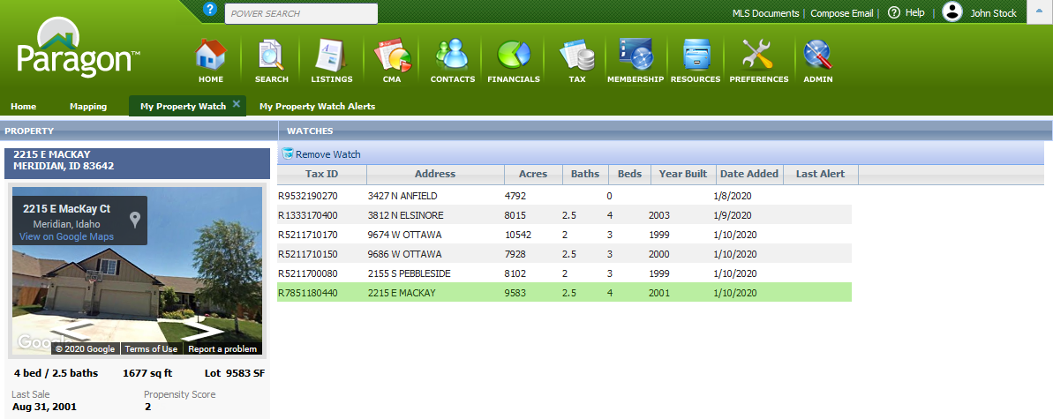

Alerts use a similar display to the property watch grid view.

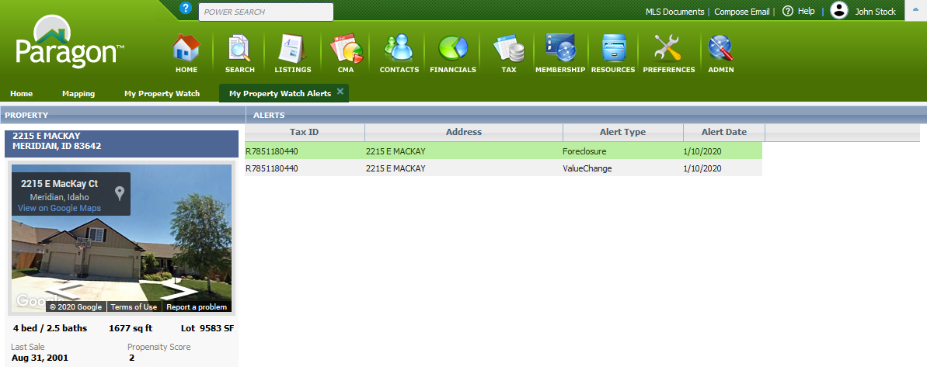

## Property Watch Enhancements

While we’re still in the process of enabling Property Watch for Premium Tax customers, we have made a few enhancements to improve the awesome feature.

* First, we changed the sort so the most recent addition appears at the top of the list.
* Next, we added all of the enhanced data from the property panel to the grid to include Propensity to List, Estimated Loan to Value (LTV) and Estimated Equity to name a few.
* Finally, since the grid is static, we added a “Refresh Record” button to the menu – if the Refresh Date is last month, just highlight the row and click the Refresh Record button to ensure you have the latest data.

Property Watch is a premium feature made available to customers using CRS Data or BK Paragon Tax. It is also available to other customers as an upgrade. If you’d like more information, contact your Black Knight Sales Representative.

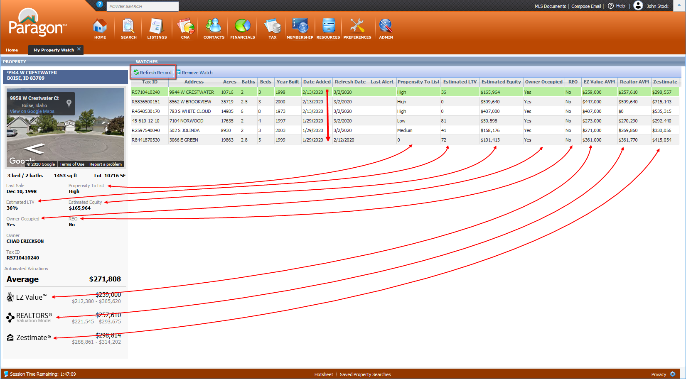

## New CRS Data Integration Points – Tax Autofill Search Results

You asked, we delivered. Now CRS subscribers can get more information about a public record property from CRS Tax Autofill search results via the new Tax Specialty View under the REPORTS menu.

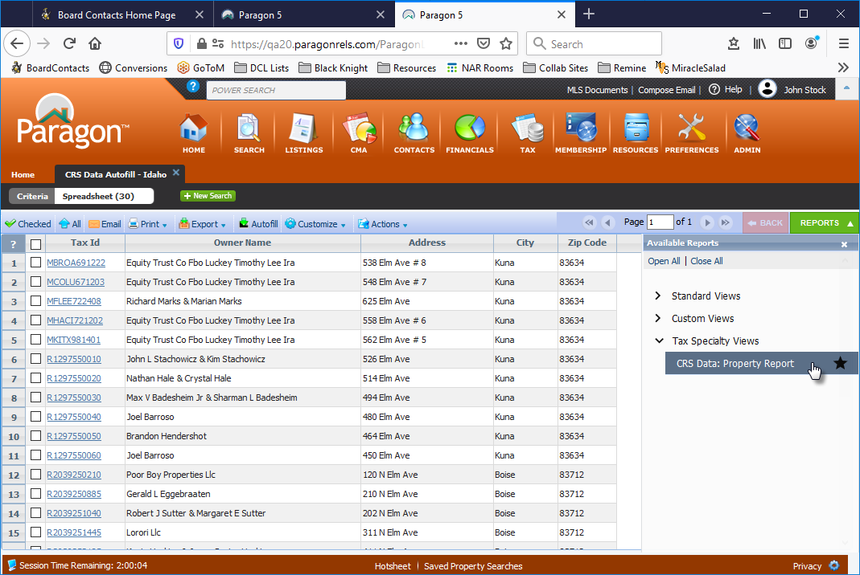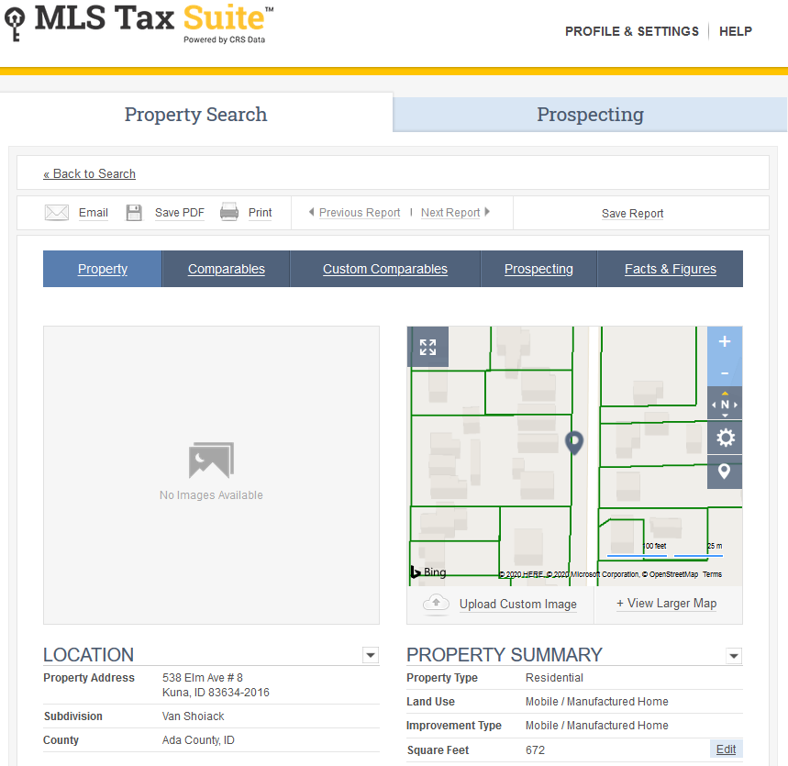

## New CRS Data Integration Points – Parcel Property Panel

Previously, users could only link from the Listing panel. Now, subscribers can link to CRS Data from the parcel property panel.

## New CRS Data Integration Points - Property Watch and Alerts

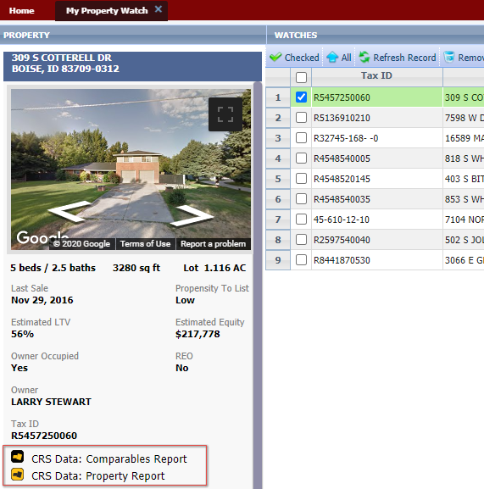Subscribers can now access the CRS Data Property Report and Comparables Report directly from the panel that displays for Property Watches and Alerts.

## Enhanced Data to Parcel Panel for Subscribers of Intelligent Analytics

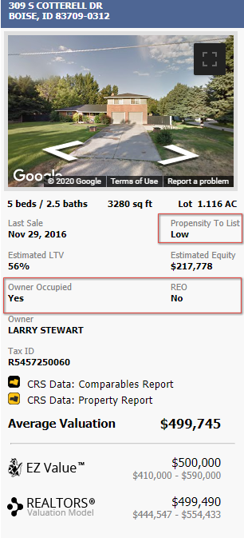

We’ve added three new data sets to the parcel panel: Propensity to List Score, Owner Occupied, and REO Data.

**Propensity to List:** Propensity to List has been added to the parcel property panel for Premium Tax users. The feature uses a proprietary algorithm that considers a variety of data to include Sales History, Loan to Value Ratio, Estimated Equity, Owner Occupied, Foreclosure Activity and Neighborhood Trends and assigns one of the following scores that reflects the probability that a property will be listed for sale: Low, Medium, High, Very High and Listed.

**Owner Occupied and REO Data:** These two fields provide additional information for agents.

## Display Public Records with Listings on Map

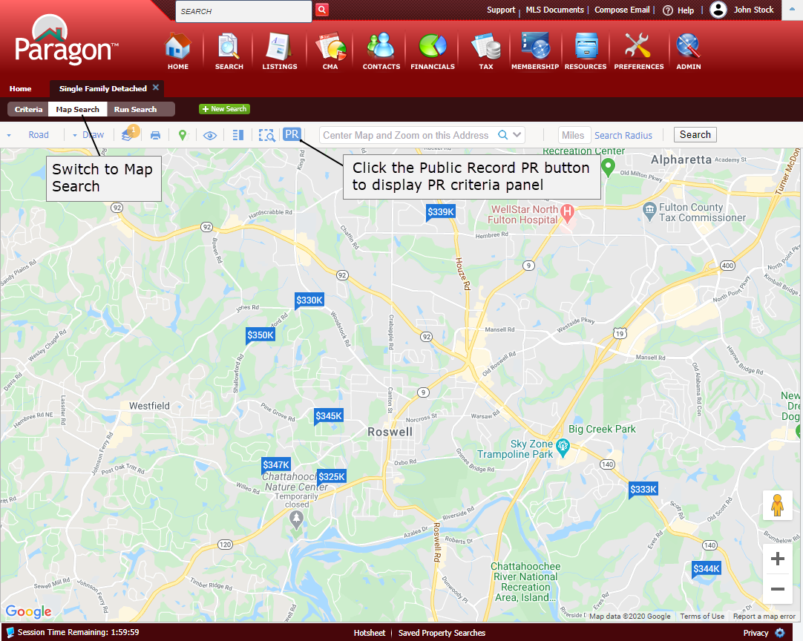Black Knight MLS is very excited to announce the release of a new Intelligent Analytics feature called Integrated Search that gives agents the ability to display both Listings and Public Records that meet the same criteria on a single Map View. Agents can also include Owner Occupied as criteria. This feature will automatically be enabled for CRS Data and Paragon Tax users.

Here’s how it works.

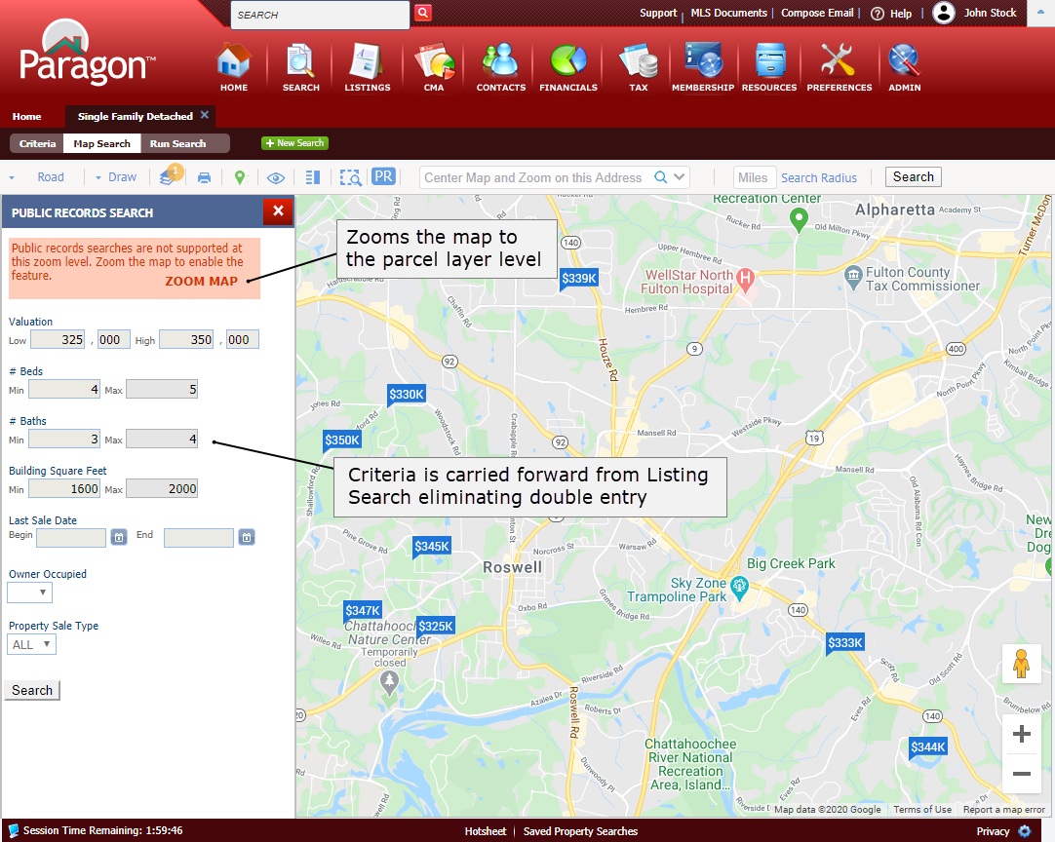After getting search results, switch to Map Search to access the new feature and click on the PR button.

Any Price, Beds, Baths, and Square Foot criteria entered for the Listing Search will automatically carry forward, eliminating the need to enter criteria twice. Users can also search by Last Sale Date, Owner Occupied and Property Sale Type = REO.

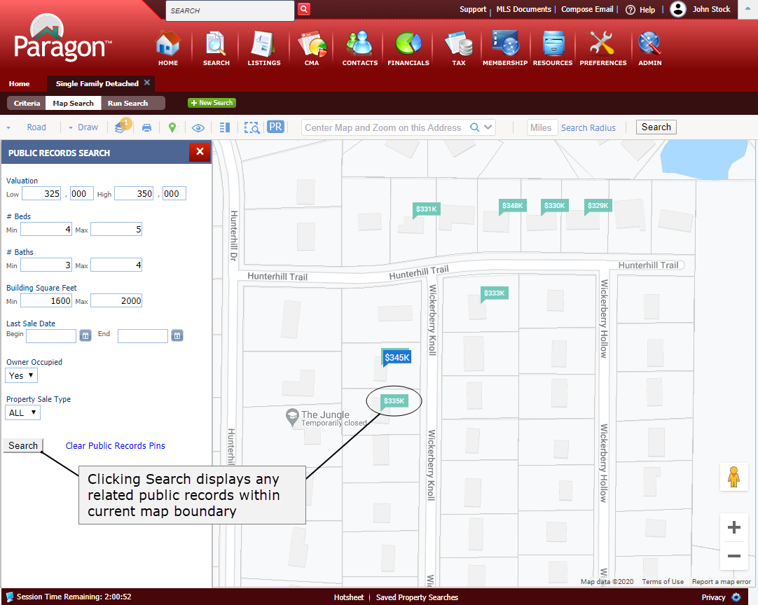Click the Search button to display any criteria-related public records (in the aqua colored pins) within the current map boundaries. If necessary, the public record pins can be removed by clicking the “Clear Public Record Pins” link.

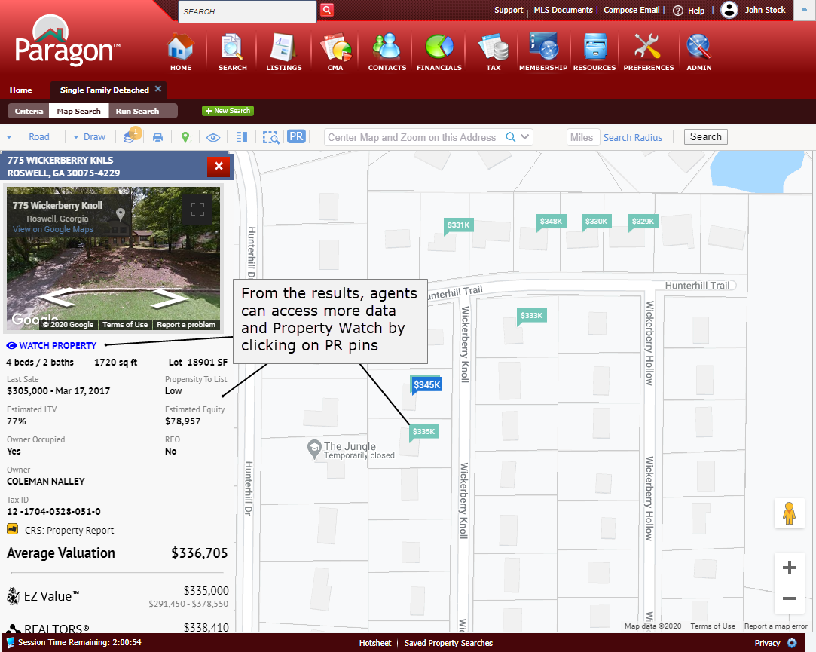

From the results, agents can view more data about the related public records by clicking on the pins.

From the panel, agents can also add a property watch by clicking the WATCH PROPERTY option.

## Map Drawings for Integrated Public Record Map Search

Subscribers of Intelligent Analytics can now use Map Drawings as criteria for the Integrated Public Record and Listing Search

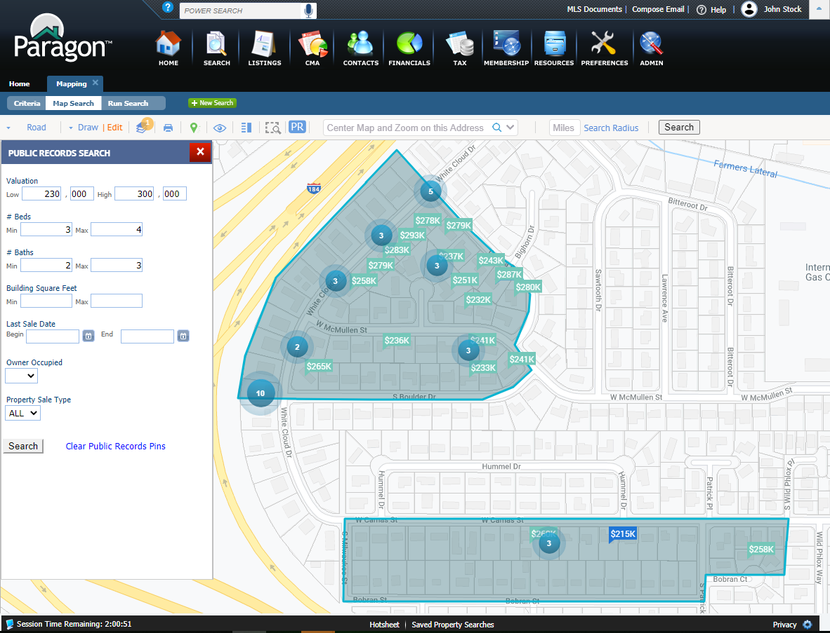

## Display Average Value of all AVMs

While it’s nice to know the individual values, what’s the average of the AVMs? Good question. With 5.76, you will have the answer. We’ve added the average value to everywhere the AVMs display; the CMA Comparable Price Analysis report, the parcel-click map panel in Paragon, the Detail View in Collab Center and Paragon Connect. The feature includes logic that if there are fewer than two AVM values returned, the Average will be hidden. In addition, we’ve also gone to monochromatic logos for a cleaner, consistent look.

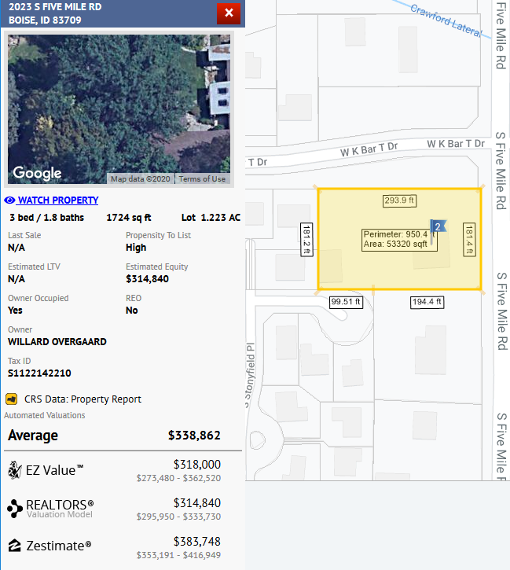

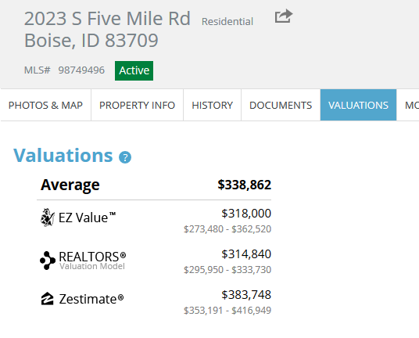

## Zestimate Direct Link

A link has been added from the Zestimate to the specific property in focus. Previously, the feature just linked to Zillow.com. Now it lands on the specific property in Zillow.

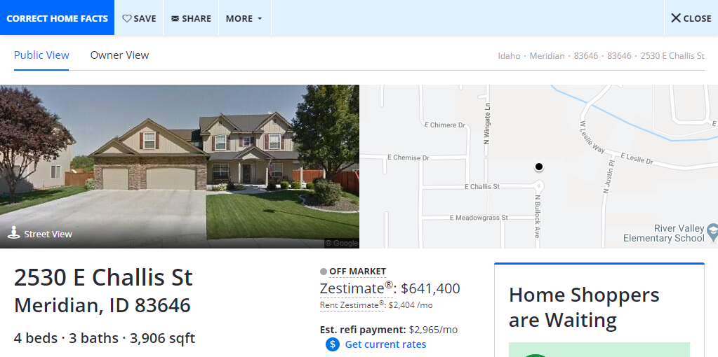



## REALTORS® Valuation Model Direct Link

Similar to the Zestimate link, a link has been added to the Realtors Valuation Model (RVM) that takes the user directly into the Refined Valuation Model in RPR, where the user can use the interactive RVM to create a report. **Note:** This link will only appear to agents.

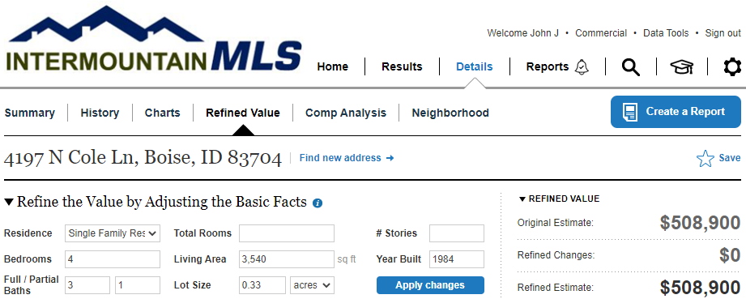

## Parcel Property Panel Now Supports Multi-Unit Parcels

You asked and we delivered! If you have a single parcel with multiple units, such as a condo, the property panel will display the parcel address followed by multiple Unit numbers for that parcel. Click the unit number to view the individual property record for that unit.

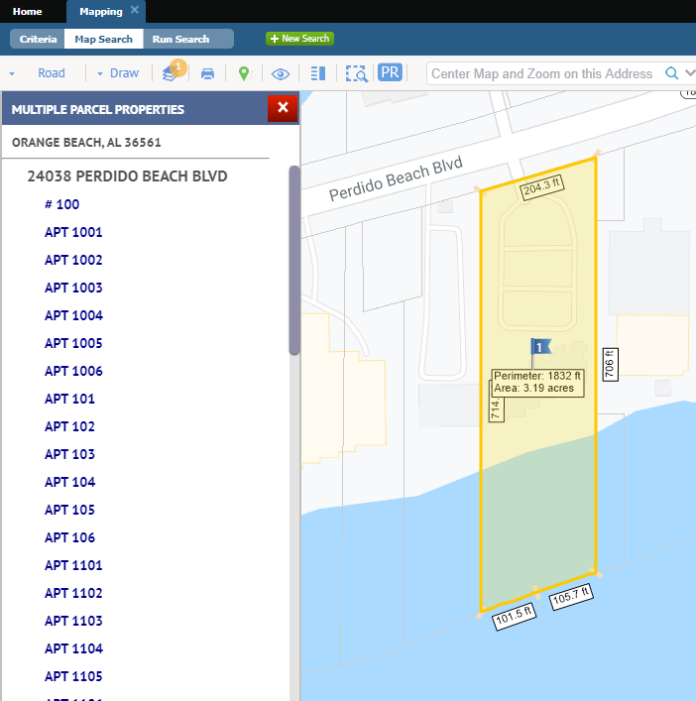

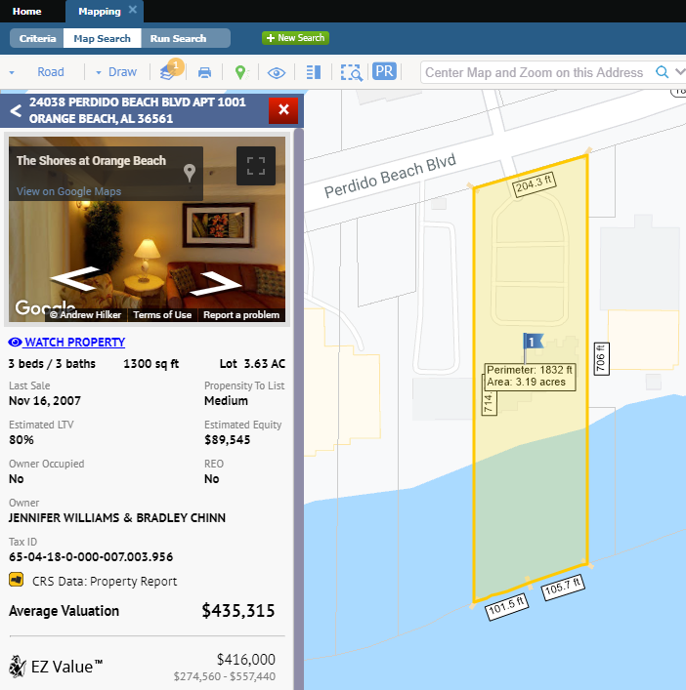

## Retain 1.0 Geocode when converting Partial Listings

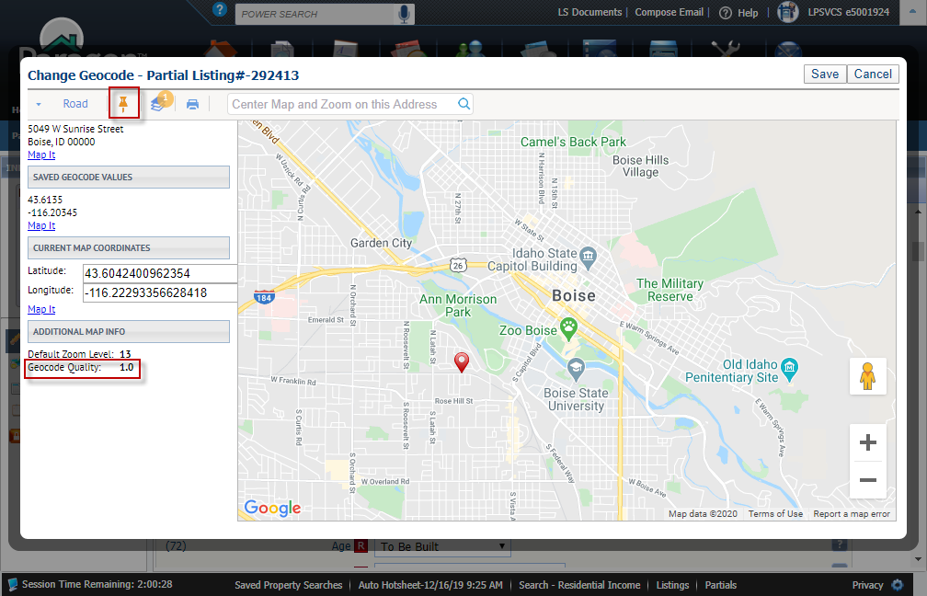If you have manually placed the map pin on a partial listing, resulting in a 1.0 geocode quality, Paragon will retain that pin placement when you convert the listing to a live listing, eliminating the extra step of placing the pin a second time.

## Homebot UI Update

A new, more appealing graphic, has replaced the graphic previously shown to agents who are not currently Homebot subscribers.

