**OpenMLS RESO API 2023**

**OpenMLS RESO API for releases 5.93 to 5.98**

**WEB API - L_LastDocUpdate is Added to OpenMLS Web API Mapping Tool** 2

**WEB API - Export Web API Mapping Button** 2

**WEB API - Removing Paragon Short Values in Lookups** 5

**WEB API - Enforcing Explicit Enumeration Mapping in Metadata** 6

**WEB API - Create a Sum from Multiple Feature Values** 6

**WEB API - System Generated Lookups vs Manual Mapped Enumerations** 7

**WEB API - Added PropertyGreenVerification for Data Dictionary 1.7** 8

**WEB API - Added Concatenated L_Address for Data Dictionary 1.7 Mapping** 10

**RETS - Added Manual Geocode Field to Listing Table** 11

**Admin – Web API - Mapping Tool – Added DOM, and CDOM fields** 12

**Action Item:** Contact your SSM to Enabled this field 12

**WEB API - L_LastDocUpdate is Added to OpenMLS Web API Mapping Tool**

Data Dictionary standards list the ***DocumentsChangeTimestamp*** field in the Property resource to be used for system generated timestamp of when the last update or change to the documents for this listing was made. The Paragon field is called ***Listings Last Doc Update***.

As a timestamp field, this can be used as a $filter to pull listings where documents have been updated for a certain timeframe.

/Property?$filter=DocumentsChangeTimestamp ne 2023-04-24

**WEB API - Export Web API Mapping Button**

Data Dictionary (DD) mapping requires spreadsheets to be used at various junctures to discuss the implementation. Copying the spreadsheets from the tool itself was a simple option. Detailed spreadsheets could only be created through backend access. No longer!

A new button labeled ***Export Mapping*** has been added to the ***Data System Resource Mapping*** page in the ***OpenMLS*** ***Web API Mapping Tool***.

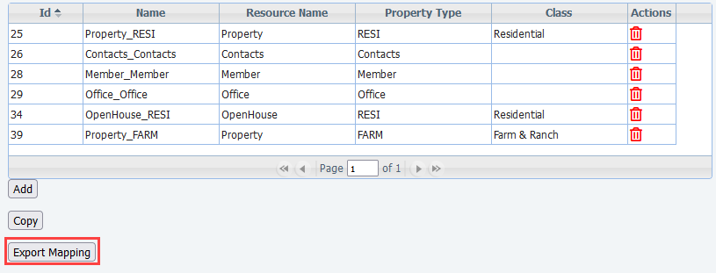

*Figure 1 - Data System Resource Mapping Screen*

When clicked, a modal/colorbox will appear requesting you to name your file. Please notice the file format is shown, currently Microsoft Excel. Simply click the ***Export Report*** button in the top right, and open, or download, the file.

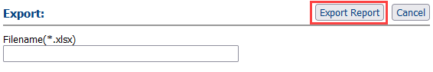

*Figure 2 - Name and Export File Colorbox*

Within the spreadsheet, you’ll find the Resources and Classes separated in their own tabs. This helps with organization and reduces confusion. The ***SourceSystemName*** column holds the ***RETS System Name***. This will assist in matching the DD Fields with RETS. *Very* helpful with vendors.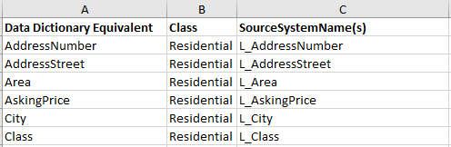

*Figure 3 - Example Export of Residential Class*

**WEB API - Server-Driven Paging with OData.nextLink**

As a technology leader we strive to bring quality of life improvements when requested. To this extent, ahead of RESO’s ratification of [Web API Core 2.1.0 specifications](https://github.com/RESOStandards/transport/blob/22-web-api-core-210-specification/web-api-core.md), we’ve added the **@Odata.nextLink annotation** to the message body per [OData’s 4.0 Control Information specifications](http://docs.oasis-open.org/odata/odata-json-format/v4.0/cs01/odata-json-format-v4.0-cs01.html#_Toc365464684). This will allow client-side API users to link directly to the next page of results.

*Figure 1 - Message Body When $top Is Not Used*

Pagination results (**$top**) default to 25 records per page. When a **$skip** is sent in the initial request without **$top**, the nextLink will add 25 to the original **$skip** value. If **$top** is less than 25 records, a nextLink will not be included, because one is not needed.

*Figure 2 - Message Body When Initial Query Used $skip=30 – 30+25=55*

The links follow the configurable **RETS Profiles** **Max Records** setting, which defaults to 2,500 records.

*Figure 3 - Message Body When Initial Query Used $top=150000&$skip=160000*

*Figure 4 - Second Message Body When Initial Query Used $top=150000&$skip=160000*

**WEB API - Removing Paragon Short Values in Lookups**

When direct field mapping is used in OpenMLS and no enumeration mapping is created, OpenMLS will automatically generate the lookups. To ensure all lookups were unique, we included the short value in parentheses.

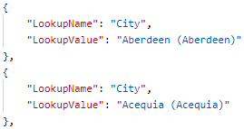

*Figure 1 - Paragon Short Value in Parentheses*

The [LookupValue](https://ddwiki.reso.org/display/DDW17/LookupValue+Field) needs to be a human-friendly display name. Even though Short Value in parentheses is friendly and understandable, most vendors won’t have need of this value. To make data easily readable, we will no longer display the Short Value unless there are lookups that share the same Long Description. **This only affects systems where Lookups are generated automatically. eg: /Paragon endpoints** If your Feature and Lookup enumerations are manually mapped, this change will **not** affect you.

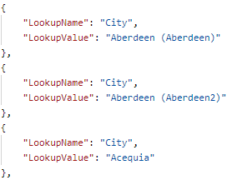

*Figure 2 - Paragon Short Values in Parentheses only for Duplicate Descriptions*

**WEB API - Enforcing Explicit Enumeration Mapping in Metadata**

RESO Data Dictionary (DD) 2.0 will focus on compliance. Prior to this release, if Paragon Feature or Lookup enumerations were partially mapped, the unmapped values were being sent out as well. This will no longer happen.

In the example below, if the agent chose Storage and Tennis on this Feature. Tennis will not be sent out because it is not mapped.

*Figure 1 - Paragon Value Mapping Example*

**WEB API - Create a Sum from Multiple Feature Values**

It’s not uncommon to group count options in a Feature Category. eg: Garage Spaces This gives users flexibility but does not match DD standards. We’ve added a new summation method to the Formula Editor (). The features sum() sum the selected Feature values which are mapped to this field. The External Value must be a number. This leverages the current feature () formula. This means you can include comma delimited features in the parenthesis.

|  |  |
| --- | --- |
| Before | After |

*Figure 1 - Before and After Sumation Functionality*

*Figure 2 - Various Features Mapped to a Number Field*

**WEB API - System Generated Lookups vs Manual Mapped Enumerations**

This release allows for data mappers to ability to truly “map it and forget it”. With the changes above, when a Feature or Lookup is mapped to a List Type field where RESO has not defined enumerations, the system now cleanly generates Lookups for you. There is no need to define those using the Value Mapping () tool. This eliminates the need to manually map new enumerations when added to your system.

To take full advantage of this functionality, your system must have the RETS_DYNAMIC_METADATA_OPTION set to fully dynamic. This can be completed by your SSM. When a new enumeration is added to an **existing lookup or feature,** a Lookup refresh can be run in the background without disruption to RETS or RESO API. Once completed, your vendors can repull metadata from either system to see the new value.

*Figure 1 - Blue Flag Indicates No Enumeration Mapping*



*Figure 2 - Green Flag Indicates Enumeration Mapping*

*Figure 3 - New City is Now Skipped Because Other Cities are Mapped*

For customers wishing to make scripted removal of enumeration mappings on fields, please contact your SSM. This would most likely be location fields, like City. **Please Remember: Any mapping changes will affect your API Metadata. If you are an OpenMLS customer, please instruct your Web API vendors to repull metadata and lookups once this process is complete.**

**WEB API - Added PropertyGreenVerification for Data Dictionary 1.7**

For customers who are mapping their own data, the new resource can be mapped from the **Resource Mapping** tab inside **Data Mapping: Data Dictionary** from **Admin**. Simply click the Add button, choose which RETS class to link it to, and you’re off.

*Figure 1 - PropertyGreenVerification in DD Resource Mapping Tab*

The fields can be mapped using click-and-drag or formulas. The Paragon Green fields were built to be DD compliant. This should be a one-to-one mapping. Please reference and information about each field, please use RESO’s [PropertyGreenVerification](https://ddwiki.reso.org/display/DDW17/PropertyGreenVerification+Resource) section of their wiki.

*Figure 2 - PropertyGreenVerification Field Mapping Tab*

Please remember that OpenMLS API translator uses similar pieces that RETS does. If these resources are not enabled in a **RETS Profile**, the API user will receive a **401 Unauthorized** HTTP error.

*Figure 3 - RETS Profile Resource List*

**WEB API - Added Concatenated L_Address for Data Dictionary 1.7 Mapping**

For customers who are mapping their own data, the L_Address RETS field can be used in the **Field Mapping** tab inside **Data Mapping: Data Dictionary** from **Admin**. Open an existing Data Set, then a property resource, and find List**ings Address** in the “Phys Num 6” grouping. Use click-and-drag mapping to match it with RESO’s **UnparsedAddress**, or use the white-green map icon to create a custom External Field.

*Figure 1 – Listings Address Seen in Available RETS Fields*

*Figure 2 – Listings Address Mapped to UnparsedAddress*

L_Address is a special calculated RETS field, like DOM, and will automatically send out the same string you see in RETS.

*Figure 3 – Resulting Data from L_Address to UnparsedAddress*

**RETS - Added Manual Geocode Field to Listing Table**

To allow flexibility in geocoding, we’ve added a new flag to the Property Resources in RETS. This is a flag called “Is Manual Geocode”. This flag was not enabled by default for this release. To enable, please contact your SSM. This new field will, of course, require a RETS Refresh.

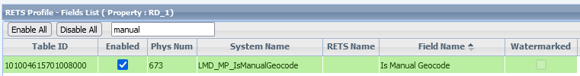

*Figure 1 - LMD_MPIsManualGeocode*

Like all other fields, this field can be managed in the RETS Profiles editor within Paragon Pro’s Admin section. The System Name for the field is LMD_MPIsManualGeocode. It will send out a value of ‘1’ when the listing in question is manually geocoded.

**Additional Enhancements**

**Admin – Web API - Mapping Tool – Added DOM, and CDOM fields**

**Action Item:** Contact your SSM to Enabled this field

RESO Data Dictionary specifications include DaysOnMarket and CumulativeDaysOnMarket field. These two Paragon fields are now available for manual mapping by MLS Admins or SSM.

