Paragon Connect 2023
Paragon Connect Enhancements for Releases 5.93 to 5.98
Listing - Agent Recommended 3
Listings - Print Single Listing 6
Listing Maintenance - Value Range Pricing 6
Listing Maintenance - View Detail 7
Listing Maintenance - Listing Maintenance Updates 7
Listing Maintenance - Tax Autofill for Paragon Tax 7
Listing Maintenance - Not Available Rules 8
Listing Maintenance - Room/Unit/Green fields in LIM 8
LIM and Search - Full Lookup and Feature Options 9
Searching - Property Search 10
Agent Auto-Notification Emails link to Listing Details 11
Settings 12
Dashboard 13
Dashboard - Sellers 14
UI - Branding 15
UI - New Display for Contact Email Opt-Out 16
Reports - Spreadsheet 17
Reports - Export Listings from Spreadsheets 19
Reports - Report Listing Issue 20
Mapping - Map View 22
Tour and Open House Search 23
Photo Maintenance 25
Bulk Photo Labels 28
New Display Options for Listing Photos 28
Integrations - Resources Third Party Links 29
Integrations - Supra Integration Added to Paragon Connect 30
Assume Identity – Phase 1 31
Assume Identity – Phase 2 32
Corrections and Improvements 33

Listing - Agent Recommended
You can now recommend listing(s) in Paragon Connect for your contacts.
- Included features:
  - Recommend listing(s) for a single existing contact or multiple contacts.
  - Recommend listing(s) and create a new contact all in one step.
  - Access and manage recommended listings: Remove, manually add a listing using the Listing ID, Add a Note
- Note: The Recommended functionality is only available when viewing listing results in Hotsheet, Tour/Open House Search, and Contacts.
Recommending listing to exiting contacts
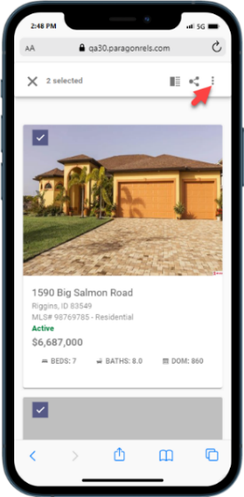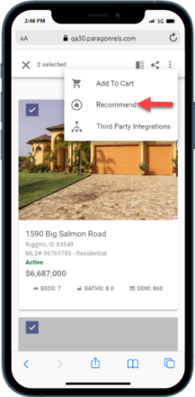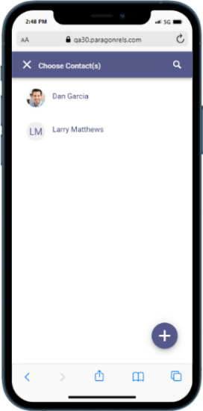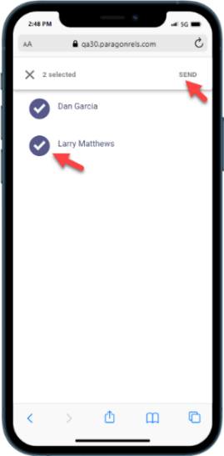
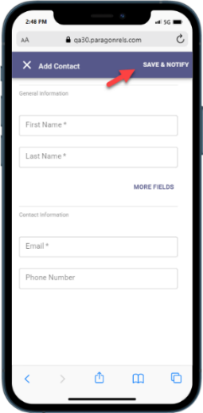
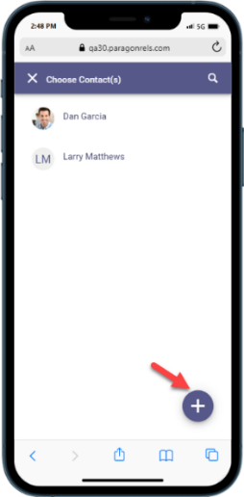
Create a new contact as you recommend listings

Access and Manage Recommended Listings
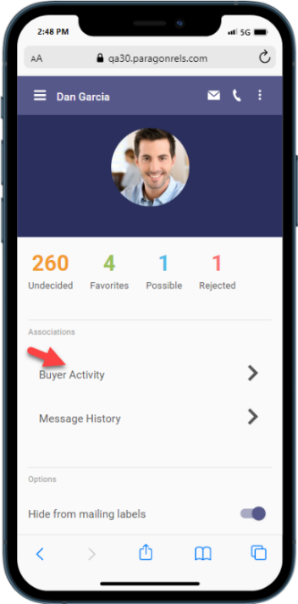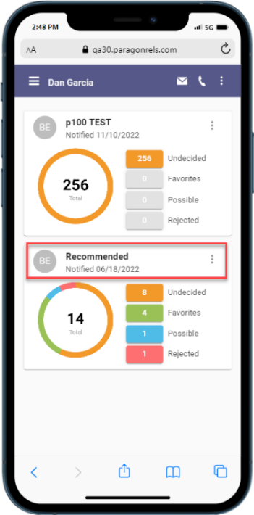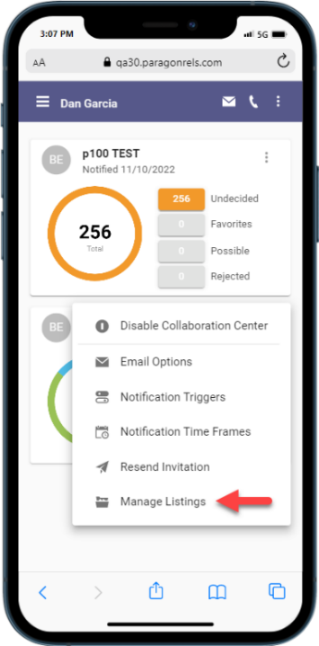
Remove Recommended Listing(s)
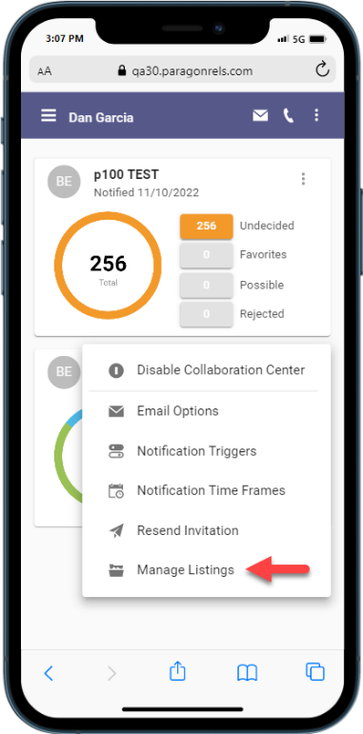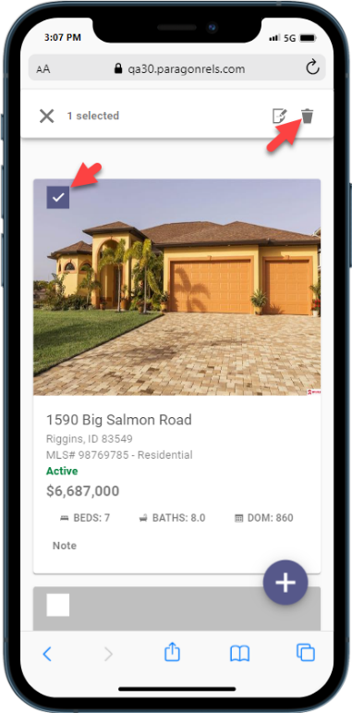
Recommend a listing using the Listing ID
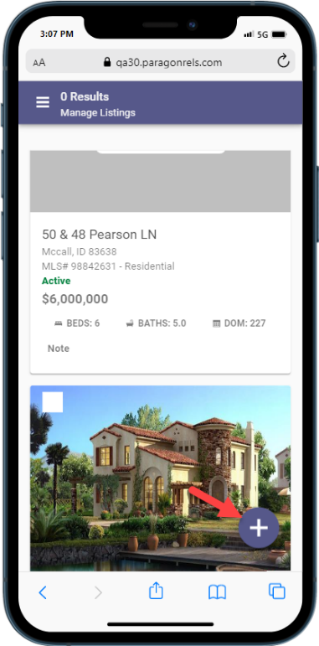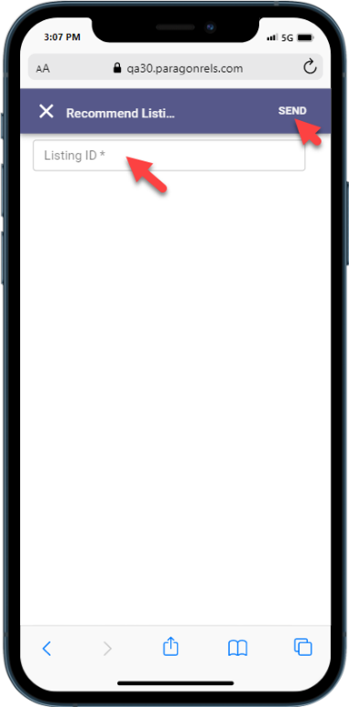
Adding notes to a recommended listing
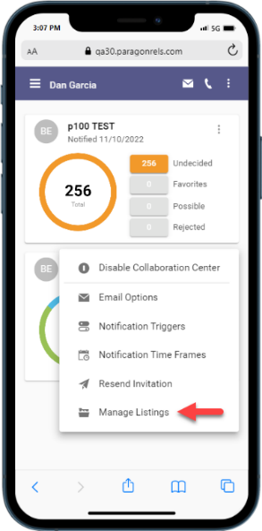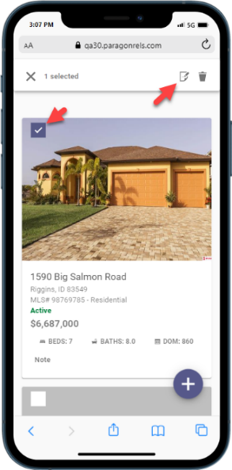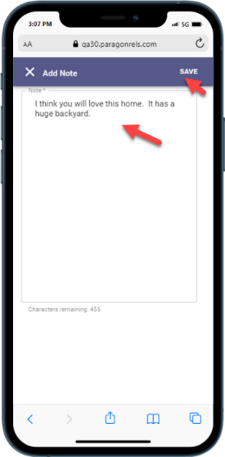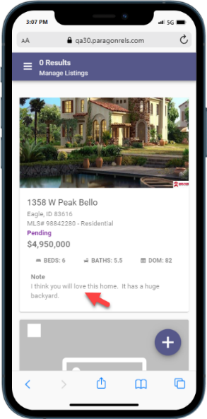

Listings - Print Single Listing
The ability to print a single listing has been added to Paragon Connect. The default Paragon Professional Agent and Consumer Detail reports will be available to print under the overflow menu.
Note: These printable reports must be enabled by your administrator.
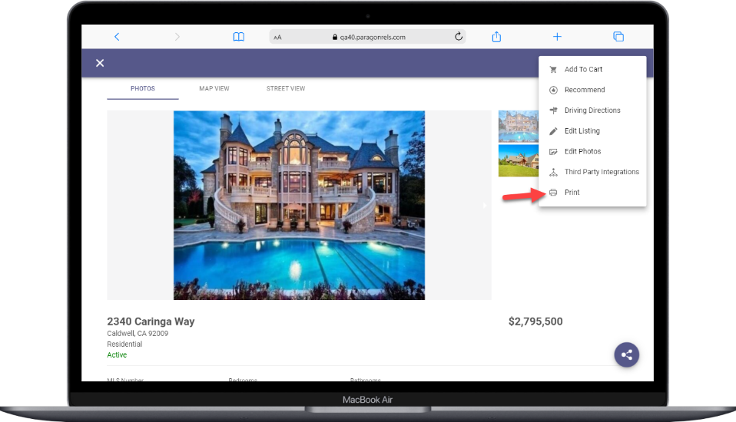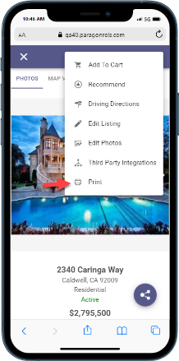

Listing Maintenance - Value Range Pricing
This feature Value Range Pricing is now supported within Paragon Connects listing edit module. This is existing configurable functionality used in Paragon Professional today. For those organizations that allow Value Price Range pricing, the feature allows listings to be populated with an exact list price or a price range.

Listing Maintenance - View Detail
While viewing your published listings with the listing maintenance module, you can now use the overflow menu on each listing to pull up the full listing detail report. This allows you to quickly examine the listing information.
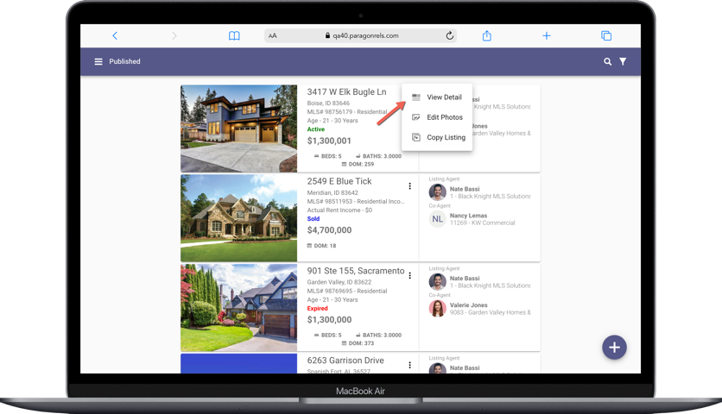

Listing Maintenance - Listing Maintenance Updates
- Office fields on the listing maintenance form will now automatically populate when any corresponding agent field is entered.
- Listing Input Maintenance (LIM) now supports Interactive Map Layers. If Interactive Map Layers are enabled for your system, then data in configured fields will be validated against the corresponding map layers.

Listing Maintenance - Tax Autofill for Paragon Tax

The add Listing process now supports Tax Autofill for Paragon Tax. Setup by Black Knight will be required before this feature is available for all Paragon Tax Customers. Teams are working to complete this setup and you will be notified when this feature is ready for use in your market.

Listing Maintenance - Not Available Rules

Listing Maintenance pages for adding and editing listings has been updated to support “Not Available” field rules. These conditional logic rules allow fields to remain hidden from view until specific conditions are met and the fields become visible.

Listing Maintenance - Room/Unit/Green fields in LIM

The listing maintenance feature in Paragon Connect now supports adding and editing Room, Unit, and Green, aka RUG, fields. If the RUG options are enabled for your system, these will appear as new sections on your listing maintenance form.
Data for rooms, units, and green info display as cards in their own designated RUG section. Users may add new entries or modify existing entries to complete their listings.

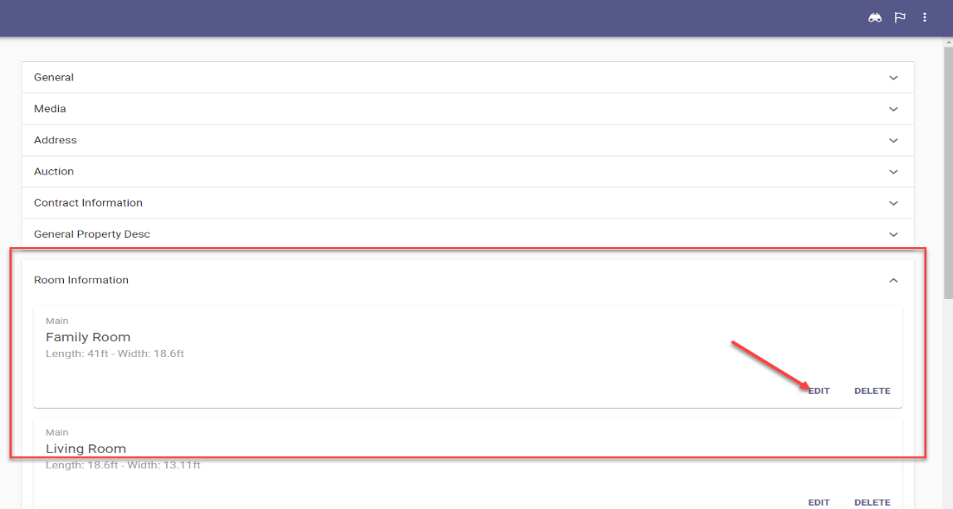

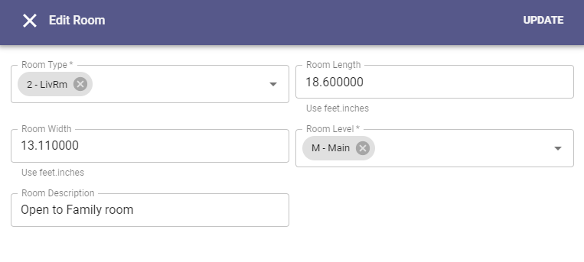

LIM and Search - Full Lookup and Feature Options

Lookup and Feature fields on search forms and listing maintenance now include the ability to see all available options in a new popup window view. This new option works alongside the existing auto-complete type-ahead feature.
Users can quickly type into a field to auto-complete a lookup value or open the new window to scroll through all available options. You can also search for options within the new modal view.

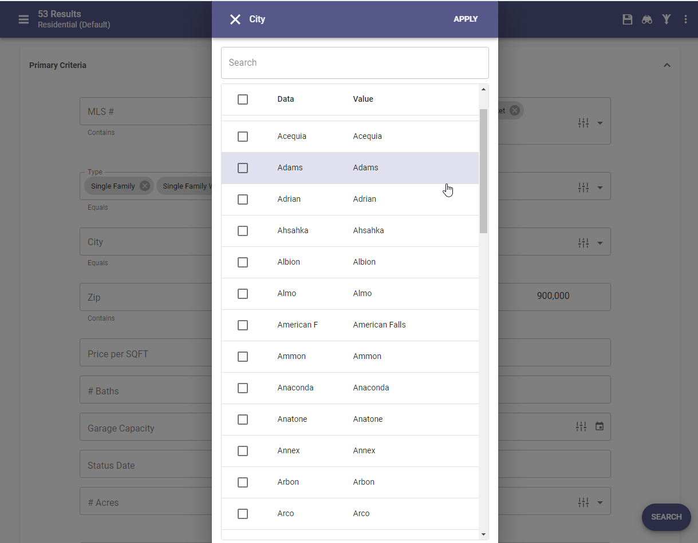

Searching - Property Search

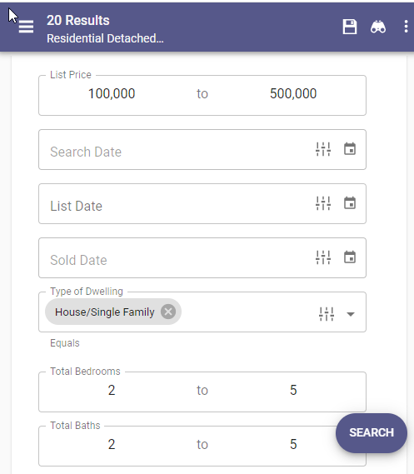
Property Class search pages have been updated to use the upgraded look and feel already applied to Hotsheet and Open House searches.

This new search interface is faster, utilizes more visible text/fonts, and remains in sync with your default search in Paragon Professional.

Users may save searches, view recent searches, apply filters to see search criteria, and update the criteria used in their default search.

Agent Auto-Notification Emails link to Listing Details

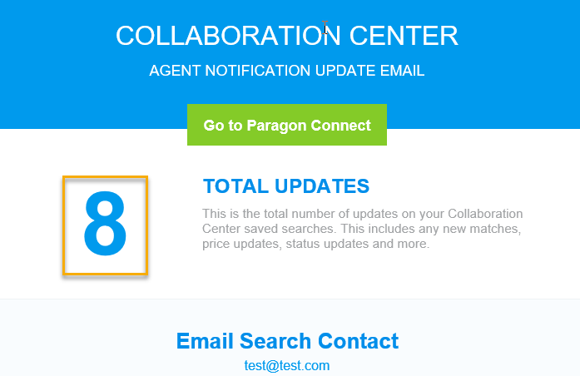
When setting up prospecting auto-notification emails you can choose to have an “agent version” sent to yourself along with the “consumer version” that goes to your contact. Starting with this release your agent version of these emails will include links to view the included, matched listings within Paragon Connect.

There are two places where new links are included in the agent auto-notification emails:

The first link location is the Total Updates count at the top of the email. This count will now link you to the Thumbnail View in Paragon Connect for these matched listings.
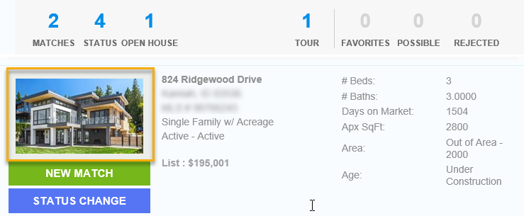
The second link location is behind the Primary Photo for each matched listing displayed in the email.
The photo will now link you to the Listing Detail View in Paragon Connect for the individual matched listing.

Settings

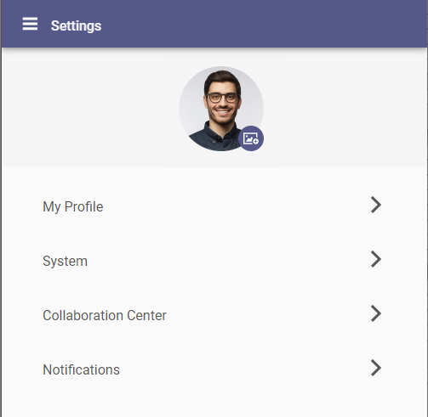
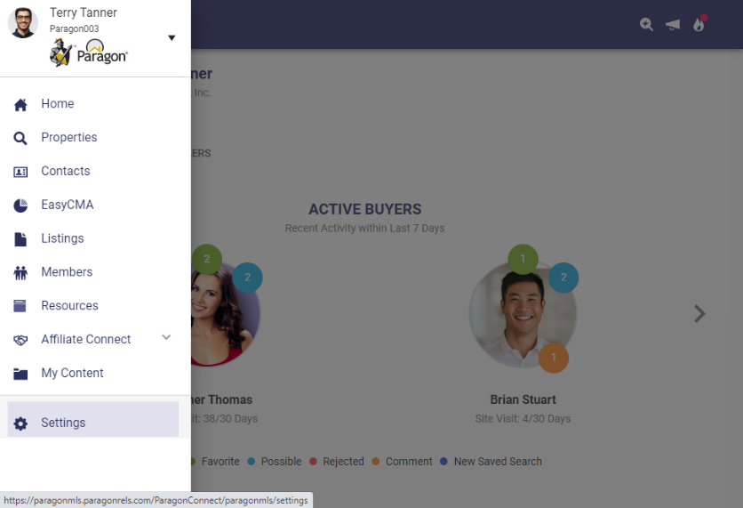
Paragon Connect main menu has a new option for Settings. This option will be used to edit and define your agent photo, password (if applicable), Collaboration Center and Notification settings, and other options.

The Settings area will expand over time as new preferences and options become available.

Dashboard

A brand-new version of the Dashboard is now available within Paragon Connect. The new dashboard contains a fresh face for all the data and features previously available and includes a few new options.

The dashboard still promotes the most recent Contact activity and Comments. This version also provides:

- Display of your Office Logo

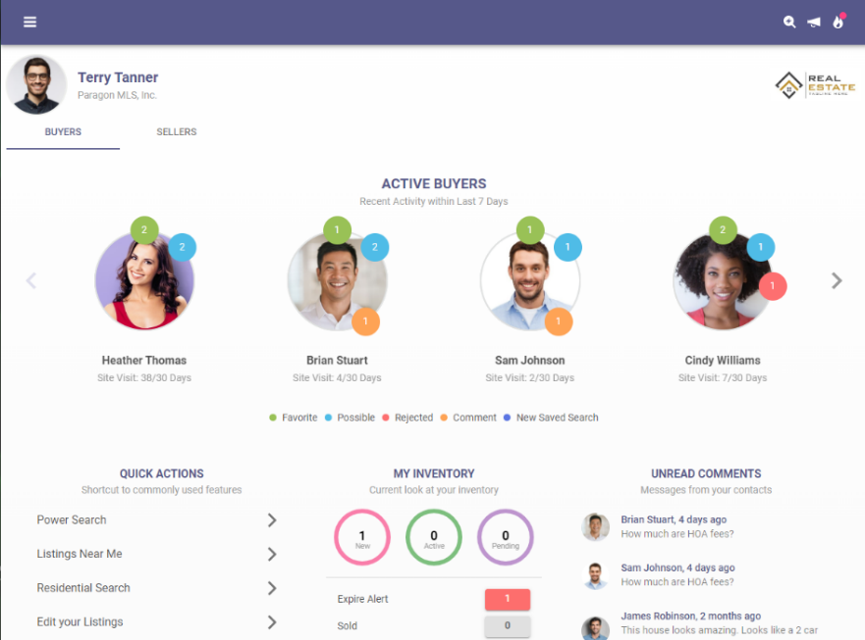
- New streamlined view for reading and responding to recent contact comments.

- New Quick Action links to give fast access to frequent features.

- Upgraded Power Search that provides auto-display of matching results.

Dashboard - Sellers

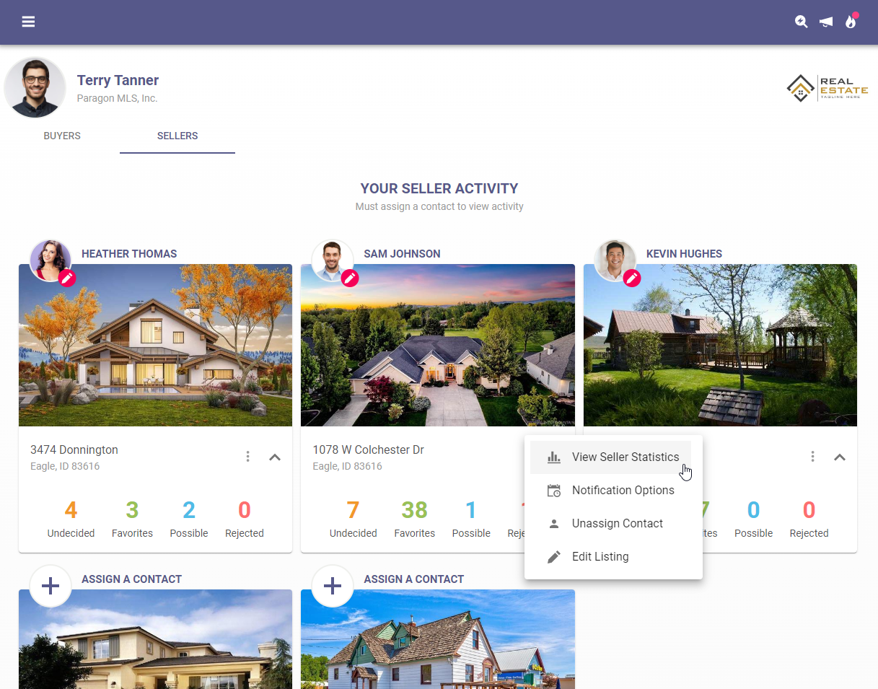
Updated versions of the Seller Dashboard and Activity pagers are now available. These updates move the same feature and functions for monitoring your Contacts’ properties for sale into the latest, fastest interface.

UI - Branding
The login page has been modified to incorporate branding opportunities for your MLS. When you go to the Paragon Connect login screen, you will find your organization’s logo. In addition, if you are on a larger device, you will notice we have included the same custom image used on the Paragon Professional login screen.
Note: If you are currently using an SSO dashboard you will not experience these updates
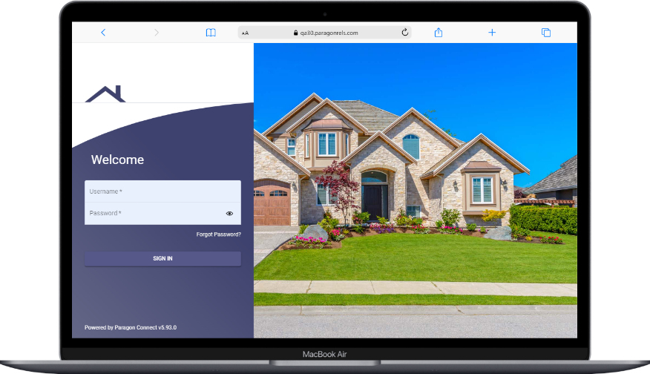
Branding has also been added to the hamburger menu in Paragon Connect.

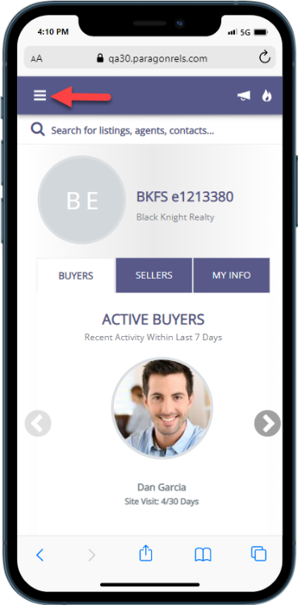
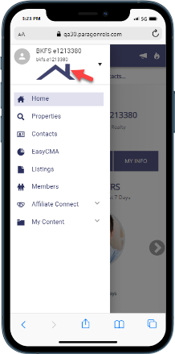

UI - New Display for Contact Email Opt-Out
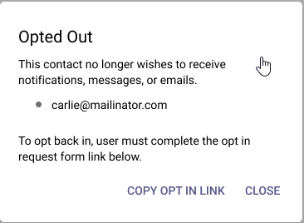
Every Contact has the option to opt-out of receiving automated emails from the Paragon system.
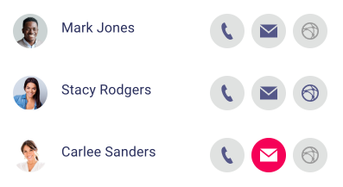
If any individual Contact has opted out of receiving emails, Paragon Connect now highlights the email icon to quickly let agents identify these contacts.
Quick access to the Opt-In process is also available and may be sent to any contact who
would like to opt back into receiving emails.

Notifications - Agent Auto-Notification Emails link to Listing Details

When setting up prospecting auto-notification emails you can choose to have an “agent version” sent to yourself along with the “consumer version” that goes to your contact. Starting with this release your agent version of these emails will include links to view the included, matched listings within Paragon Connect.

There are two places where new links are included in the agent auto-notification emails:

The first link location is the Total Updates count at the top of the email. This count will now link you to the Thumbnail View in Paragon Connect for these matched listings.
The second link location is behind the Primary Photo for each matched listing displayed in the email.
The photo will now link you to the Listing Detail View in Paragon Connect for the individual matched listing.

Reports - Spreadsheet
One of the more important features of any real estate application is the ability to quickly access a grid of results. Now in Paragon Connect, you will find a new spreadsheet view. This will allow you to sort, check one or more listings, check all, and customize fields on the grid.
This spreadsheet view is 100% responsive which means not only will you be able to use this on a large desktop resolution but on just about any device. This includes your phone, tablet, phablet, etc. The key is the design. We hard coded the checkbox and photo to be the first two columns. Those two columns are frozen allowing you to scroll horizontally on any device without losing those two important elements. Note: The spreadsheet is only available when viewing listing results in Hotsheet, Tour/Open House Search, and Contacts.
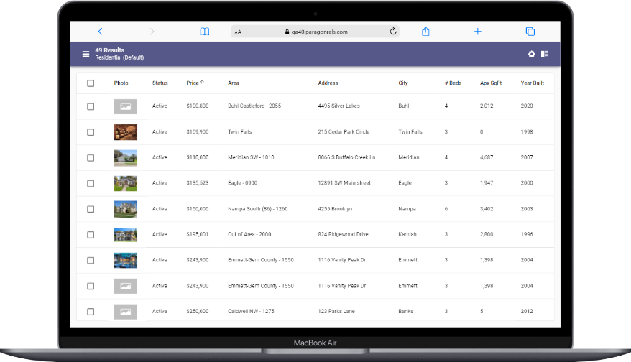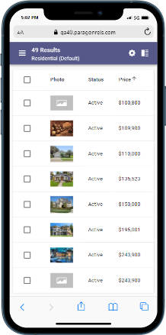
Check/Check All
The spreadsheet view allows you to check one or more listings. The top bar opens and presents the available options based on the number of listings checked. You can also check all visible listings. By default, the first twenty listings are displayed. When you click on the check all box, it will check the visible twenty listings. If you have more than twenty results, as you scroll down, the next twenty will load and display (total forty now). Those twenty listings just loaded will not be checked. You would just need to click the check all box again for all forty to be checked.
Sort
The spreadsheet will by default be sorted by price. However, you can simply click or tap on any column header to sort by that field.
Customize
The spreadsheet customization screen can be accessed by clicking the cog icon in the spreadsheet app bar. Here you will have the ability to set a default sort, change the order of the columns, remove columns, and add new columns.
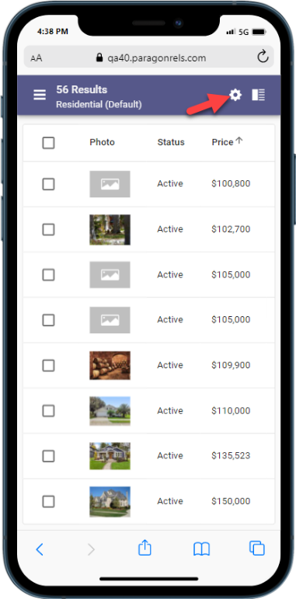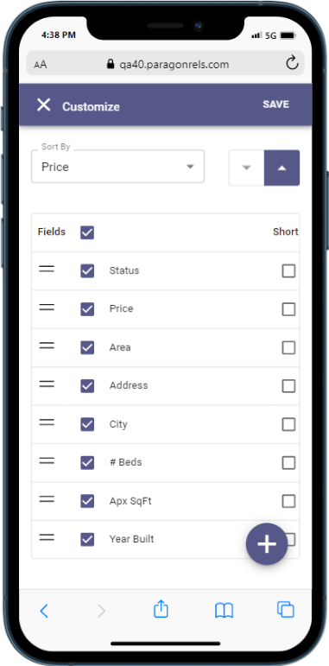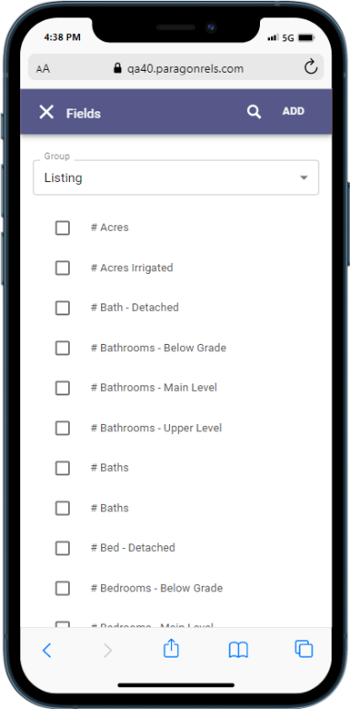

Reports - Export Listings from Spreadsheets
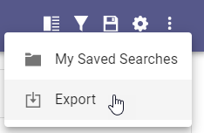
Paragon Connect spreadsheet views now support an option to export listing data. While viewing any results in a spreadsheet view, users may use the overflow menu to export all, or just selected, listings.
Listing data will be exported to a CSV file using the columns of data included in the current spreadsheet. The CSV download may be opened in applications like Excel.

Reports - Report Listing Issue
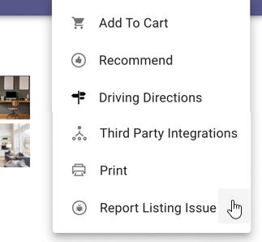
Paragon Connect Listing Detail View now supports the option to report an issue with listing data.
Users may select this option when viewing any single listing. A new email form allows users to provide details regarding the potential listing problem. The email is sent to the system administrator.
This feature follows the same email distribution choice defined within Paragon Professional.
Reports - New Display Options for Listing Photos

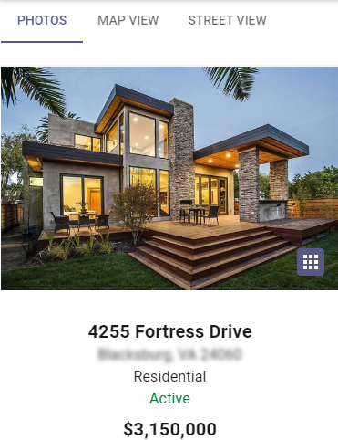
We enhanced the viewing options for Listing Photos. While on the Listing Detail View, you will see a new “grid icon”. This icon opens a new full screen page to view all photos for the listing.

From the new all-photo screen, users can scroll through all the listing’s photos and easily toggle on/off the display of photo labels and descriptions.
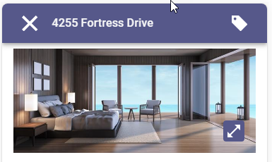
A new “expand icon” appears for each individual photo. Selecting this expand-option displays the photo in full screen and allows a zoom-view feature so you can see all the details in the picture.

Mapping - Map View

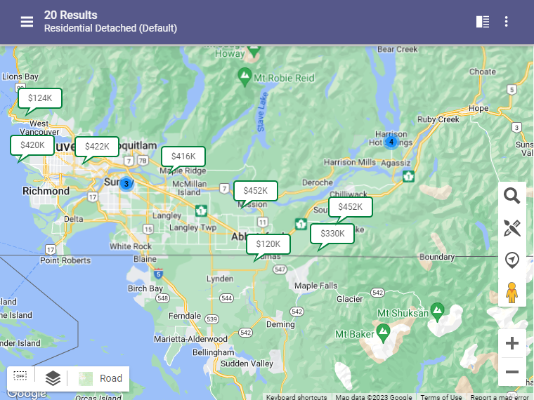
The Map View has also been updated to use the latest look and feel. This option is available for viewing listing results from a property search, along with the Thumbnail and Spreadsheet views.

Standard map layers and free-hand drawing options are available. If enabled, users may also select parcels from the Parcel Layer to view public record data or enable a Property Watch.

Tour and Open House Search
The tour and open house search have undergone a complete makeover. Prior to this release, the search features were very limited. You only had a few fields, and you could only run a search. Now, you will find all the same search fields, save, edit, and delete features found in Paragon Professional.
Fields:
You will find three containers on the tour and open house search form. The first allows you to search for days in the future or a specific date range. The next container consists of tour and open house unique fields. The last container contains up to sixteen additional fields determined by your organization.
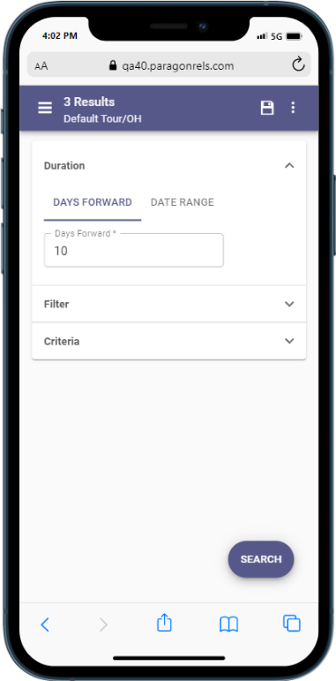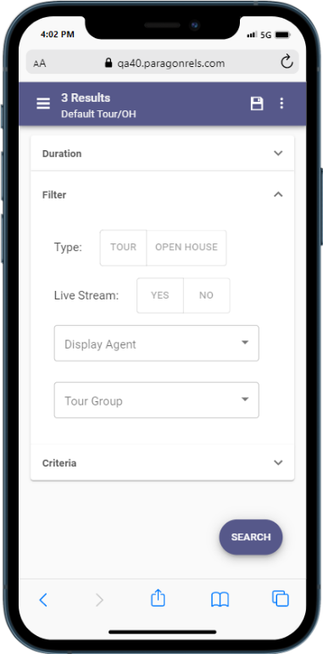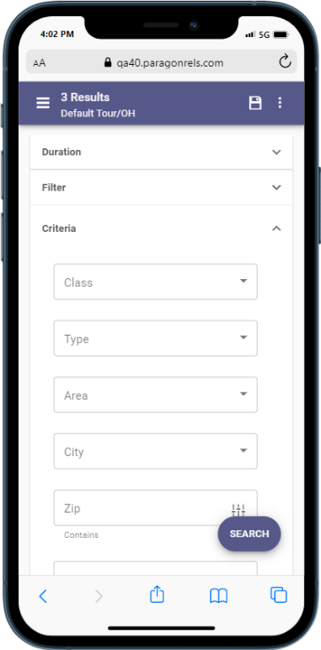 Search Options:
You can now save, load, rename, edit, and delete any tour and open house search. These searches are in sync with Paragon Professional so you can use either application to update your tour and open house searches. In addition, you can also update and modify your tour and open house search template.

Results:
When you perform a search, you will also see the thumbnail view contains a section for the date and time for each tour and open house. If too many are found on one listing, the system will allow you to click to expand to a dialog box to see all available tour and open houses. You can tap or click on any single event to see the date, time, and any other relevant data.
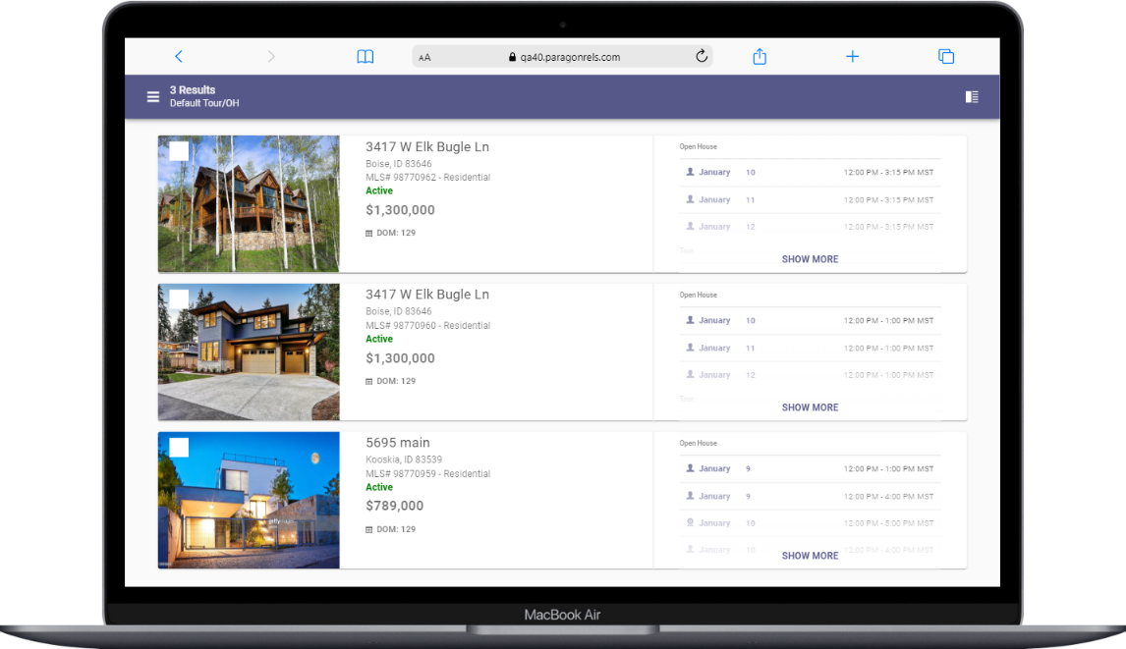
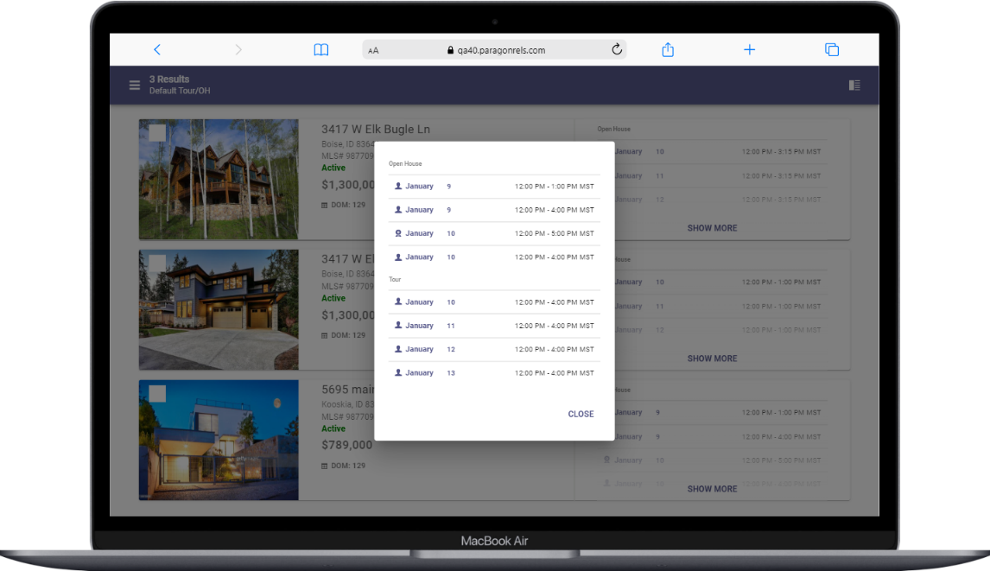

Photo Maintenance
The Photo Maintenance module has also been migrated into our design framework. You will find all the same options as before and then some. Below are some updates you will find.
- Preview uploaded listing photos
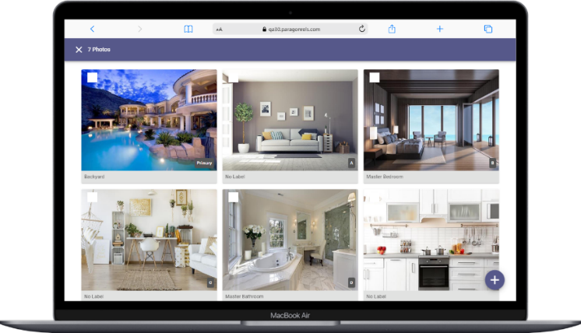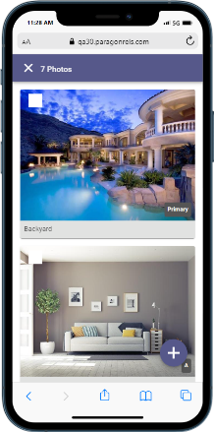

- If you have access to add photos the + button appears in the lower right corner.
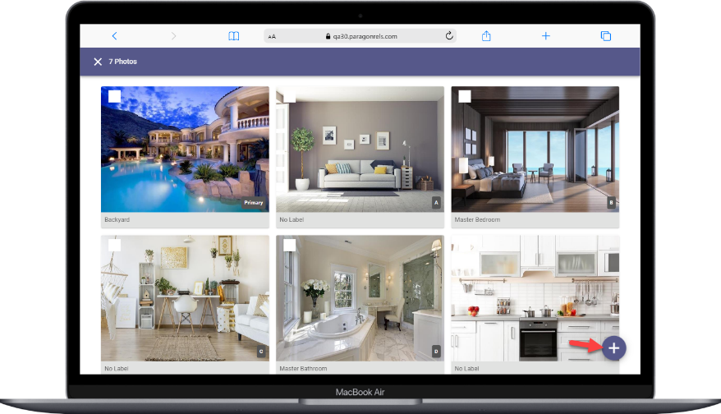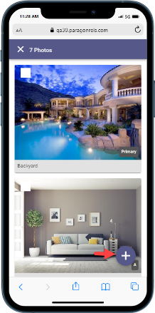

- Add photo label and description. This option will only display if enabled by your administrator.
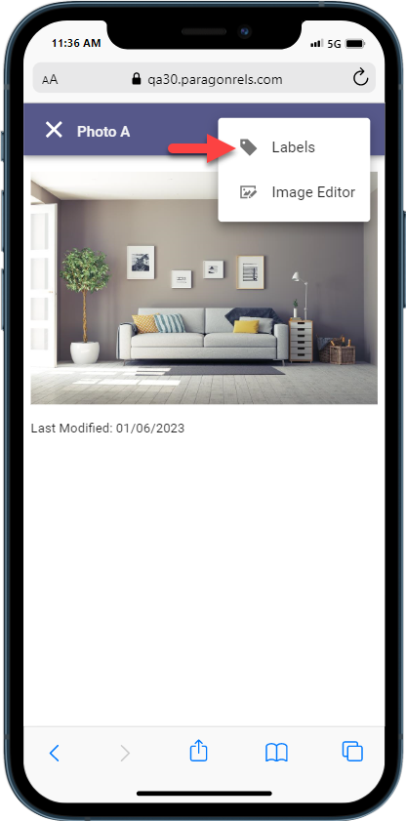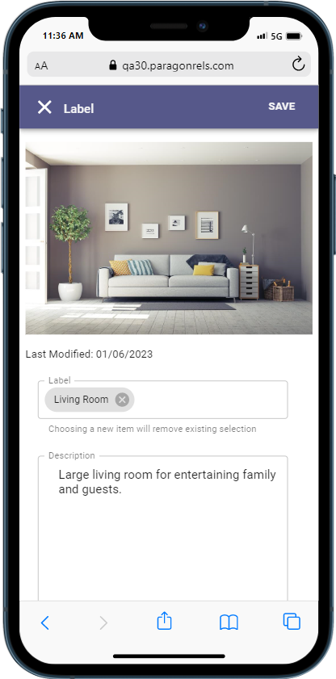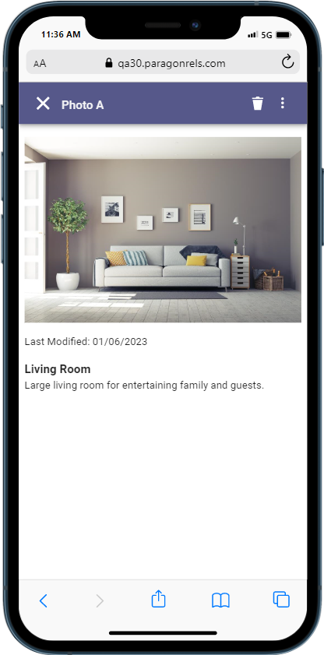

- Image Editor: Crop, Flip, Rotate, Photo Filters
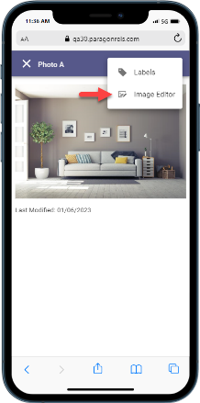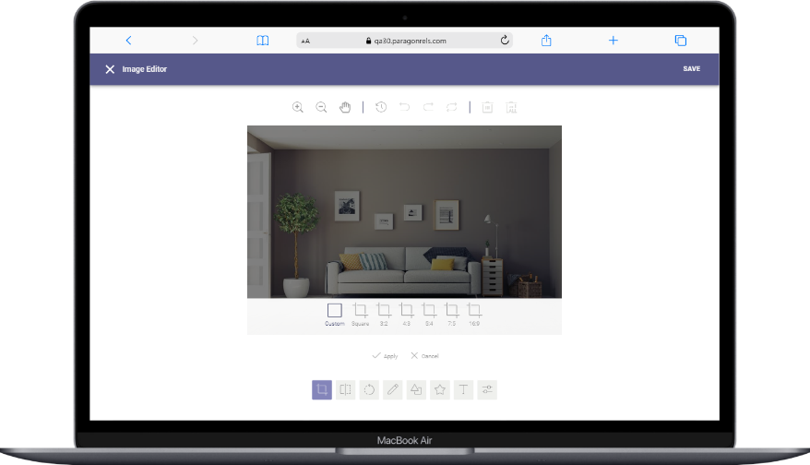

- Delete single photo or select multiple photos to delete.
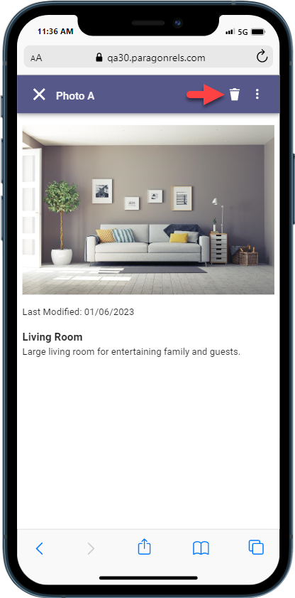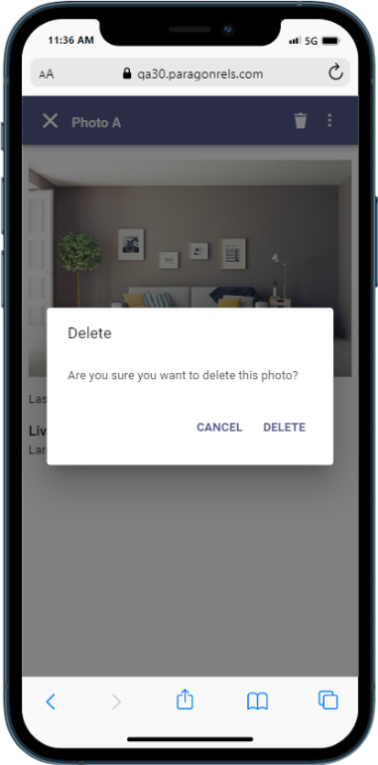

- Access the Edit Photos link directly from the LIM results overflow menu.
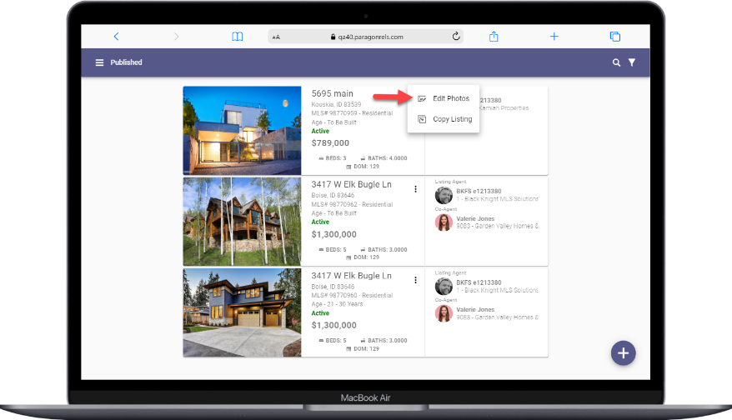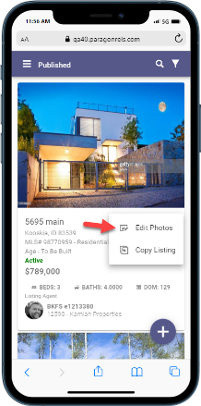

Bulk Photo Labels

Photo labels and descriptions are a great way to provide details for marketing listings. The photo maintenance section of Paragon Connect was just upgraded to offer a convenient option for setting or modifying labels and descriptions for all the photos for a listing in a single view.
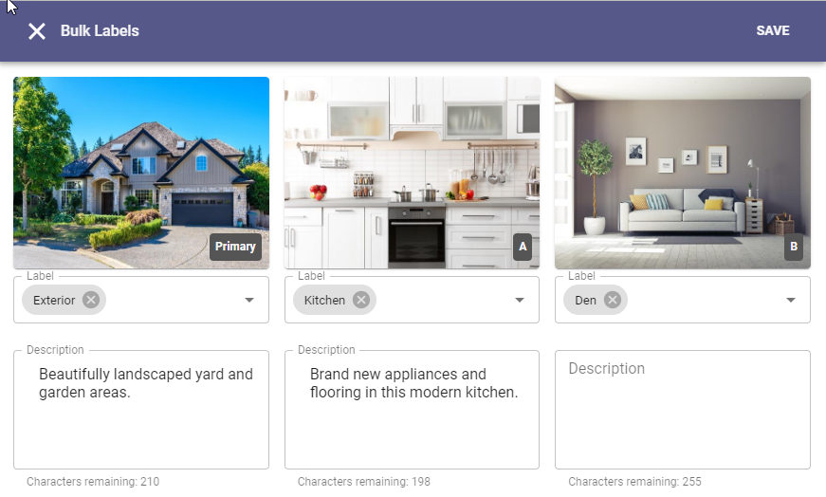
After selecting to edit listing photos, the overflow menu includes a new option called “Bulk Labels”. From this Bulk Labels page users will see any label and description options enabled for their system and will be able to easily set values for one or all photos at one time.

New Display Options for Listing Photos

We enhanced the viewing options for Listing Photos. While on the Listing Detail View, you will see a new “grid icon”. This icon opens a new full screen page to view all photos for the listing.

From the new all-photo screen, users can scroll through all the listing’s photos and easily toggle on/off the display of photo labels and descriptions.

A new “expand icon” appears for each individual photo. Selecting this expand-option displays the photo in full screen and allows a zoom-view feature so you can see all the details in the picture.

Integrations - Resources Third Party Links
Access your third-party links in Paragon Connect via the new Resources link. This menu option displays all the supported options currently available within your Paragon Professional Resource menu.
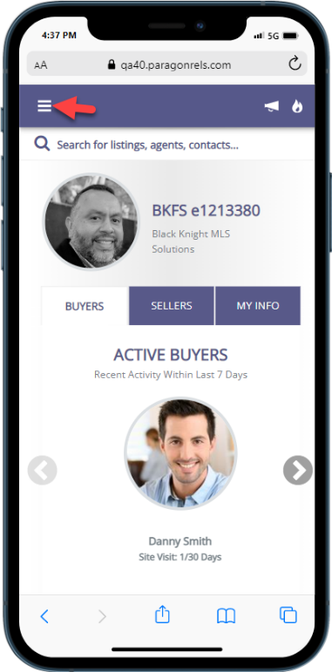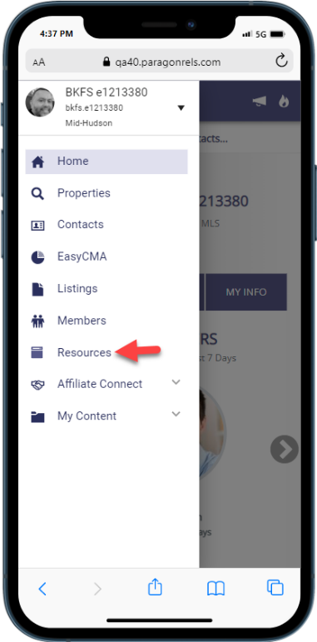

Integrations - Supra Integration Added to Paragon Connect
The following Supra integration points have been added to Paragon Connect.
- From Search Results – the Keybox Settings Report
- From Listing Maintenance – Assign Lockbox, Settings Report, Unassign Lockbox and Activity Report
Action item: – a script will be created and run to enable these integration points for all current Supra customers
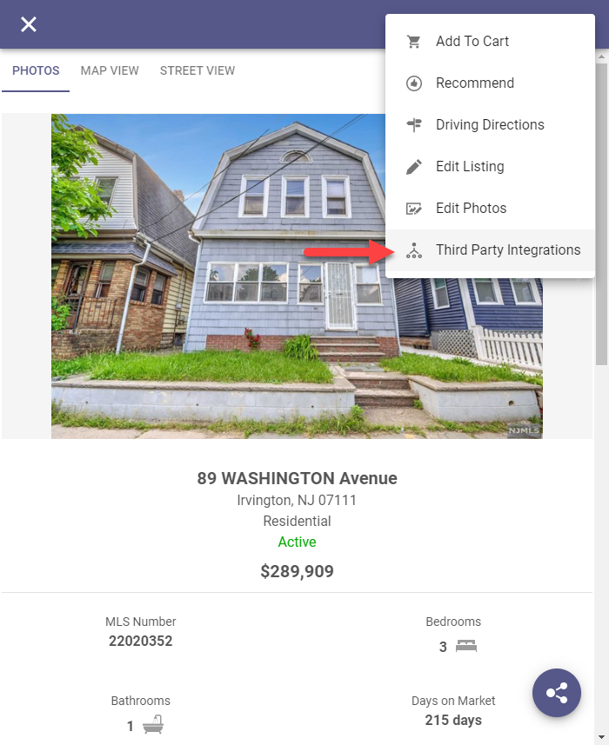
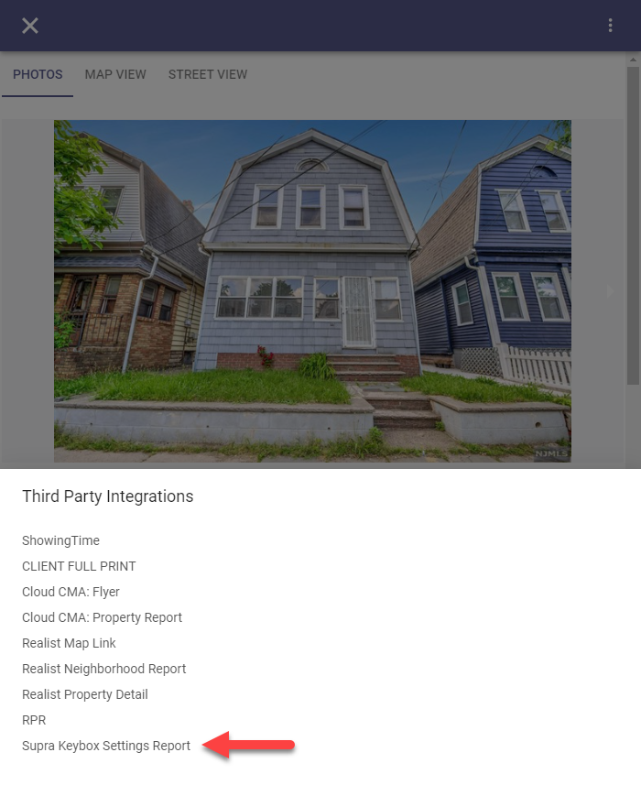
From Search Results, select a property from the grid or from a detail as shown below, click the overflow menu and select Third Party Integrations and then select Supra Keybox Settings Report from the menu and a new browser will launch displaying the Supra report.

From Listing Maintenance, select a published property and click the overflow menu from the input form and select Third Party Integrations and the four Supra options will appear in the menu. Selecting any of the options will launch a new browser displaying the Supra content.
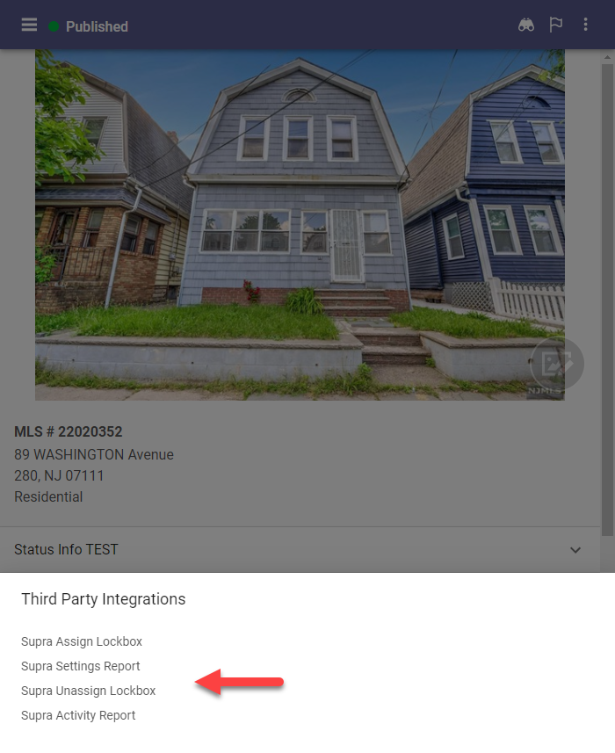
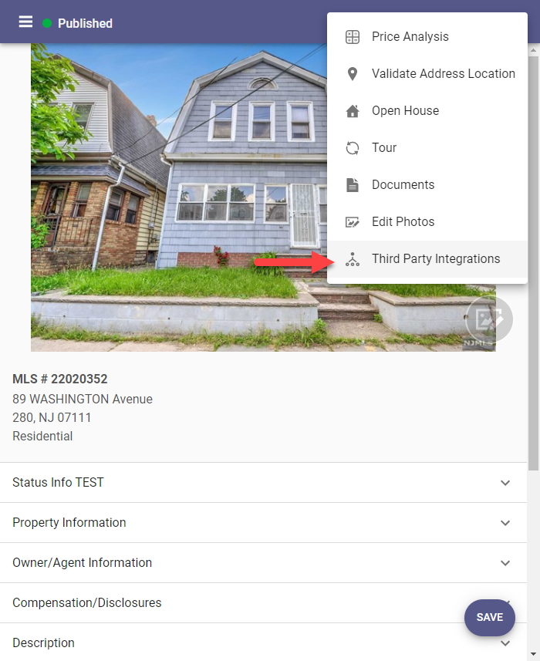

Assume Identity – Phase 1
The groundwork for supporting Assume Identity has started. With this release, if you assume a user’s identity in Paragon, then use the Resource Menu link to launch Paragon Connect, you will now see a pink circle around the user profile. This pink circle indicates that the assume identity feature is active. You may choose to return to your own identity directly within Paragon Connect using the pink back arrow.
In a future release, you will be able to initiate the Assume Identity process directly within Paragon Connect.

Assume Identity – Phase 2
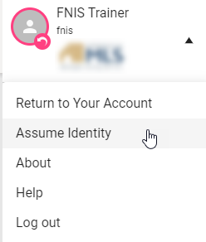
Paragon Connect now provides users a way to assume the identity of other users based upon the setup defined in Paragon Professional.

Within the hamburger menu, users who are authorized to use the Assume Identity will see a new option in the account drop-down area.
Users will see a list of people they are authorized to assume.

Also depending on your security level, you may Assume Identity while doing a member search for people you are allowed to Assume Identity for. If you are allowed, you will see the following in the upper right-hand corner to assume their identity after clicking on Details.
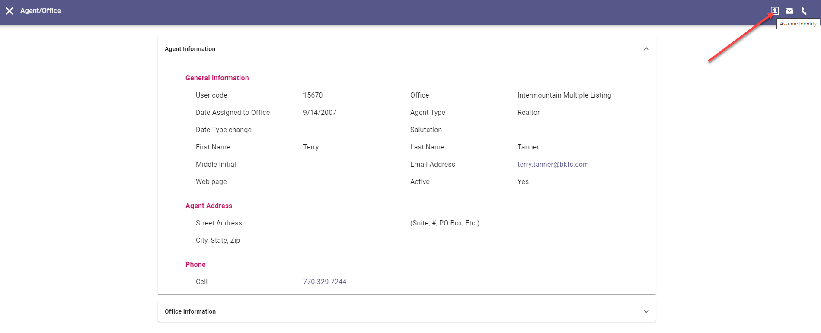

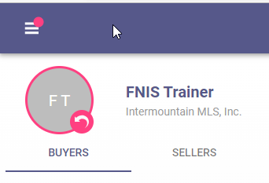
When an identity is assumed, Paragon Connect will display pink highlighting around the current user profile and a pink badge over the menu. This pink badge provides a visual indicated letting users know another identity is being used no matter where you are within the application.

Corrections and Improvements
- Resending Welcome Email now includes the office address.
- Validate Map link now showing current listing map location.
- Third Party Integrations previously blocked without warning by Safari browser pop-up blocker.
- Improvements to the loading time of the Dashboard.
- Update of the Property Watch feature to the React interface.
- Correction for the “add field” button scrolling on the Customize Spreadsheet.
- Correction for tax autofill results.
- Corrections for the resend Welcome email to use custom subject.
- Corrections for Tour and Open House search criteria using Area and Status.
- Correction for standard map layer alignment.
- Update to the appearance of the My Content menu.
- Layout adjustment for Spreadsheet view on mobile devices.
- Display proper decimal values on the listing detail view.
- Update Resend Welcome Email to use proper subject an agent photo.
- Modify default filters applied to Published Listings.
- Display alternate City value.
- Error fix for modifying Tour for a Partial listing.
- Listing Detail View now includes display for Team name and contact details.
- Additional options for Settings are available including Collab Center Links and Social Media Accounts.
- Correction for alternate City values displaying on the Detail View.
- Correction for lookup relationship filters not applying properly for Open House and Hotsheet searches.
- Updated interface for Listing Carts.
- Access to add/edit Associated Documents is now available from the Published Listings overflow menu.
- Improvements to loading of the Contact Summary page.
- Additional options are available under Settings for Collaboration Center setup and Notifications.
- Corrections for display of Sqft or Acreage on Detail View.
- Correction for lookup relationships on Tour, Open House, and Hotsheet search forms.
- Correction for searching Members by Full Name.
- Corrections for searching Offices by City and State/Province.
- Correction for driving directions using the incorrect destination location.
- Update to show map pin labels as “listings” instead of “units” when multiple listings appear at the same location.
- Update to include new filter options for viewing My Saved Searches.
- Option for uploading Contact photo under the Contacts module.
- Correction for CloudCMA integration to pass proper listing ID value.
- Correction to show the proper Yes/No Office Status value on the roster card.
- Improvement to support the Geocode Boundary Configuration added previously in Paragon. Professional is now available for Paragon Connect. This optional configuration prevents listings from being mapped outside of the defined market area.
- Improvement to the Contacts module to support adding and editing multiple email addresses per contact.
- Improvement to display Room, Unit, and Green (RUG) data on the Listing Detail View, when these RUG fields are enabled per system.
- Improvement for displaying photos on the Listing Detail View by increasing the size of the main photo and expanding the area for additional photos.
- Correction for Driving Directions map report which loads blank intermittently.
- Improvement to add and modify additional information for Contacts including phone numbers, emails, and spouse information.
- Correction to allow the agent search feature on Assume Identity to accept both first and last names.
- Correction to display the proper Office Website on Office Roster report.
- Correction to display field short values on spreadsheets when selected.
- Improvement to PowerSearch Member results cards to match the new results cards available from a standard Members search.
- Correction to show listing photos shared via Association setup option on the spreadsheet view.
- Correction to EasyCMA to fix the Comp Search Filter behavior when entering min or max values.
- Improvement to link to the Public Records Detail View from the Tax Autofill Results cards when the tax providers are Paragon Tax or CRS.
- Improvement to the Dashboard quick link for Create a Listing to offer tax autofill option when enabled.
- Correction to retain any customized fields added to the search form after viewing results then returning to the search form.
- Correction for the Mortgage Center text fields on the Listing Detail View to remain editable from Power Search results.
- Correction to display Assume Identity option when explicit permissions have been granted.
- Improvement to link to Public Record Detail View from Tax-Autofill results cards
- Correction to hide Feature Categories from search form when configured to be disabled for searching.
- Correction to remove the broken Phone Label image appearing in some prospect notification emails.
- Correction to display the complete list of Assume Identity users for Staff Level Admins
- Correction when the “Too Many Listings Found” message covers the secondary search containers.
- Correction for searching by Listing ID field on the Tour/Open House search form.

