**Paragon Simplification 2020**

**Paragon Enhancements for releases 5.75 to 5.80**

Paragon Simplifications 2020 3

New Tour/Open House option for Live Streams 3

LIM – Recurring Open Houses and Tours 6

LIM – Add Tour/Open House to Partial Listings 6

Paragon – New Login Page 7

Select All Associated Documents for Export 8

Contacts – Saved Searches simplification 9

System call-outs of new Features and Enhancements 10

LIM – Removed System Field Requirements when Saving a Partial Listing 11

LIM – Maintenance Rules Interface Redesign 12

New View – ConnectView 13

Search – Save and Notify for Listing Carts 14

Email CollabLink 14

Search – Power Search Refinements 15

Search - Power Search – Numeric String Changes 15

Search – Power Search – Three Additional Refinements 16

Tree Enhancements 17

Contacts – Tree Updates 18

Contacts Saved Searches – Notification Indicator in Contacts Tree 18

Search – Listing Slide Show 19

Contacts – Importing Google Contacts 20

Contacts – Importing Yahoo Contacts 21

Contacts – New Contact View Shows Listing Detail and Comments 22

Contacts – Agent Preview 23

Collab Center – Display Sold and List Price on Agent email notifications 24

Collab Center – Display Previous and Current list price on Agent email notifications 24

Contact Summary – Add Collaboration Center Notifications to Search Activity Section 25

Additional Enhancements 26

Link to BK Privacy Policy 26

New Date Picker Control 26

Contacts – Search the ‘To’ field in Sent Messages 26

Contacts – Agent email not configured 26

Contacts – Improved handling of email address 27

Contacts – Default Phone Type for Share Via Text and Adding Contact 27

Contacts – Contacts grid columns reordered 27

Search – Simplified Save Search and Listing Cart 28

Search – Advanced Date Range Operators and Prospecting 29

Search – Share via Text email requirement removed 30

Tooltip for Public Associated Documents 30

Email Reports – UI cleanup 31

CMA – Unique Cover Letters Per Presentation 32

CMA – Listing Office Check when Converting a Subject Property 32

LIM – Listing Expiration Notices in Sent Messages Log 33

Membership Roster – Office Broker and Main Office Added 34

# Paragon Simplifications 2020

## New Tour/Open House option for Live Streams

This new feature gives the MLS options to help agents, consumers, and home-owners practice social distancing while still providing services.

A new configuration setting provides three options for creating Tour and Open House events:

* **Allow In-Person and Live Stream.** This new default configuration allows users to optionally enter a live stream event URL into the current Tour and Open House management module, as well as schedule in-person events.
* **Allow Live Stream only.** This option requires users to enter a live stream URL when scheduling T/OH events.
* **Allow In-Person only.** This option makes no changes to the existing T/OH module.

When Live Stream is enabled, two new fields will be added to the T/OH module:

* Live Stream
* Live Stream URL

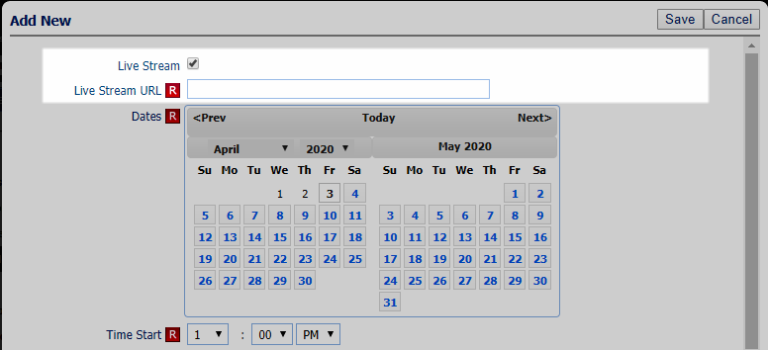

**Searching Live Stream Events**: A new yes/no field, Tour/Open House – Live Stream, will be added to the Tour and Open House search screen.

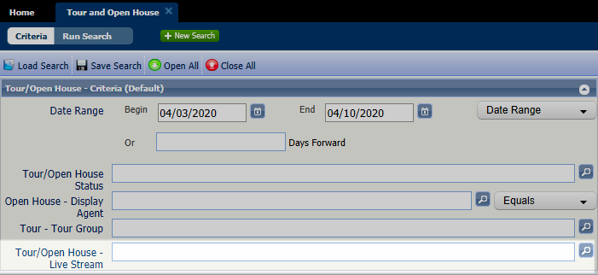

The new fields (Tour/Open House – Live Stream and Tour/Open House – Live Stream URL) will be added to the Tour/Open House Spreadsheet view by default, and available to be added to T/OH custom reports. *Note:* The new fields cannot be added to the Tour/Open House Thumbnail view at this time.

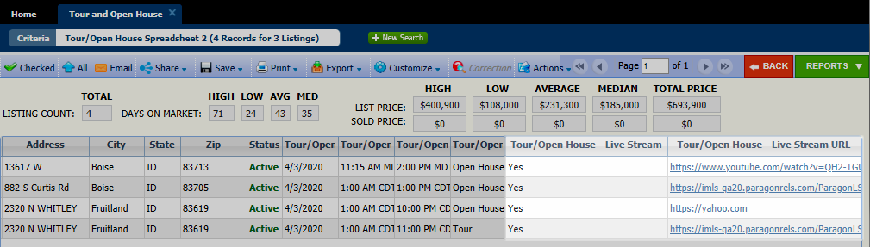

**Collaboration Center and CollabLink Detail Views**

The Open House Information section of the Collab Center and CollabLink detail view will automatically change to Live Stream Open House Information, when viewing a Live Stream event. The usual Start Date, Start Time, End Time, and Comments fields display, along with the Live Stream URL as entered in the T/OH module.

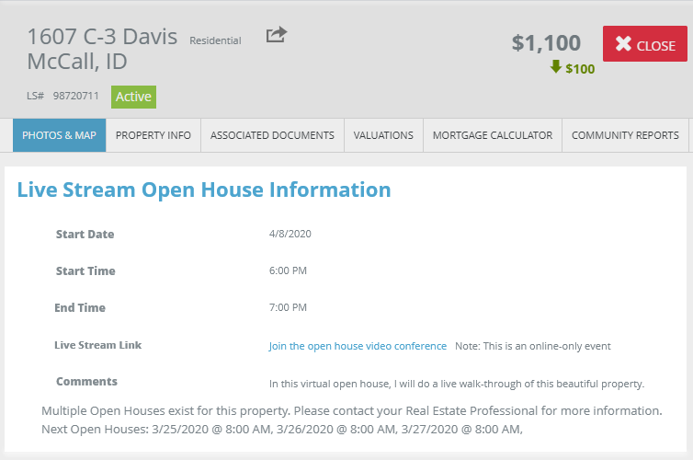

**RETS**

To accommodate the new Live Stream T/OH, two new resources have been added to RETS, Live Stream Open House and Live Stream Tour, with two new RETS fields, Live Stream (Y/N) and Live Stream URL.

The existing Open House and Tour resources will only include traditional in-person events. The new Live Stream resources will only include the live stream events. Users can enable in-person only, live stream only, or both. By default, both are enabled.

If the config setting TOUR_OH_MODE = O, then no Tour or Open House data will export from any resource.

**Configuration Settings:** A new configuration setting, **TOUR_OH_MODE**, determines what type of T/OH is available to users.

**Options:** V=Live stream only; P=in-person only; B=Both; O=no T/OH records are sent via RETS.

**Default:** B=Both live stream and in-person.

## LIM – Recurring Open Houses and Tours

With various enhancements along with new calendar controls for Open Houses and Tours, users can now select multiple dates to efficiently create recurring instances.

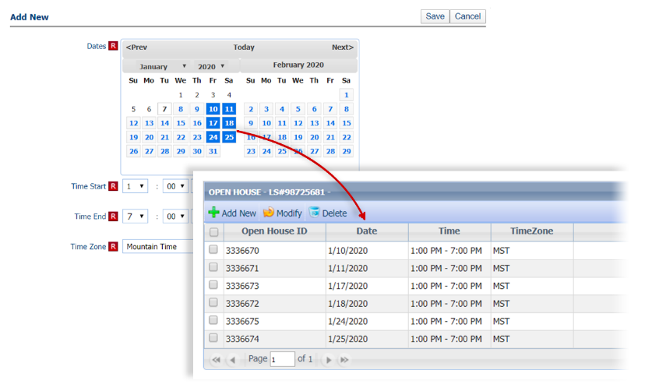

## LIM – Add Tour/Open House to Partial Listings

Now you can add Tour and Open House events to your Partial listings! The Add/Edit Tour and Add/Edit Open House options for Partial listings have been added to the left navigation pane in Listing Input/Maintenance, and in the Quick Actions modal.

**Note**: Tour and Open House events on Partial Listings will not go out in RETS or IDX feeds, and will not display in Tour and Open House searches, until the listing is saved as a full listing. A screenshot of a cell phone

## Paragon – New Login Page

As part of our continued effort to enhance the usability of Paragon, we have refreshed the Paragon login page. New features on the refreshed login page include:

* Multiple Elegant regional background photo options
* Version information
* Links to Black Knight’s social media pages
* All previous functionality
* Access to Paragon Connect Link

Your MLS may choose to replace the background image and Paragon logo with their own image and logo.

We are excited to present to you the newly redesigned Paragon Login Page!



## Select All Associated Documents for Export

We’ve added a checkbox for associated documents allowing you to select all that are Public.

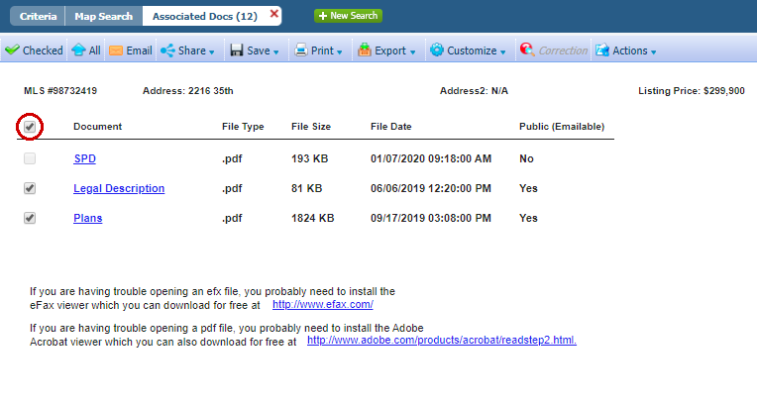

## Contacts – Saved Searches simplification

Current functionality was retained while a much more intuitive experience was achieved through careful analyzation and thoughtful design.

* Settings are grouped together

• Tools are in the toolbar

• Statistics are displayed together

• Comments are in context

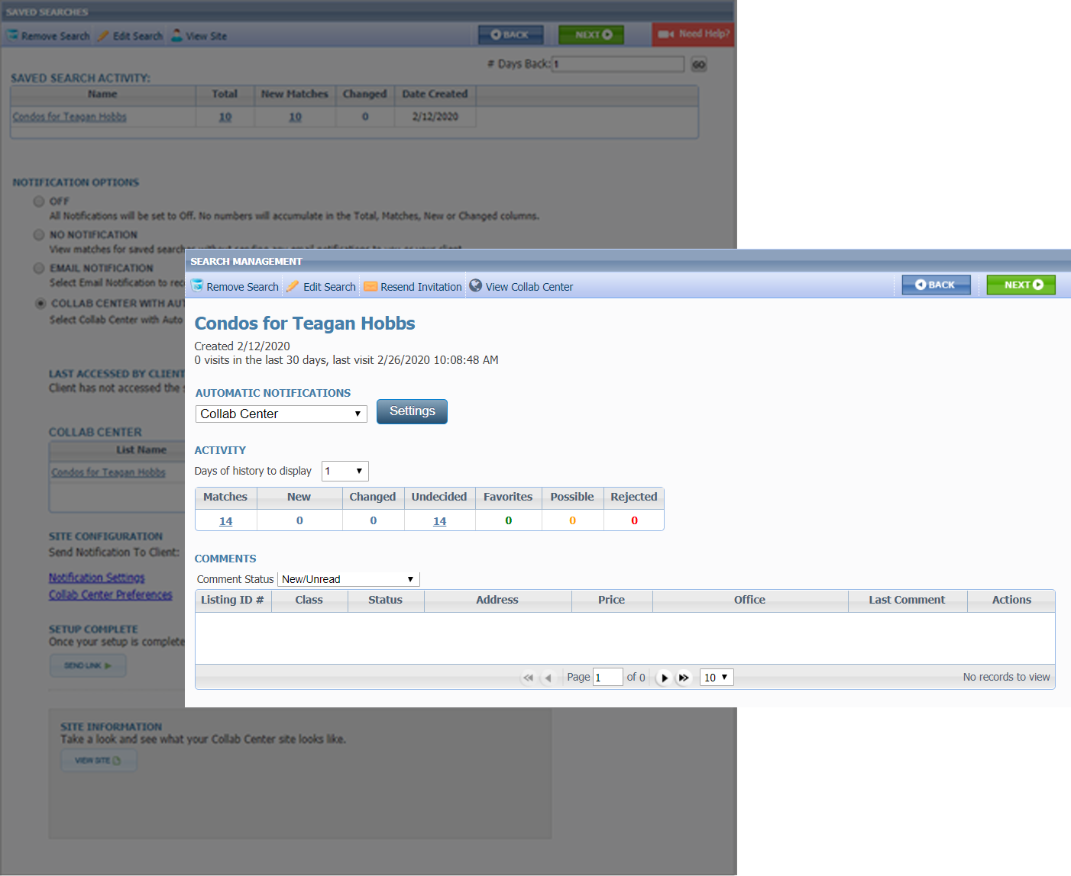

## System call-outs of new Features and Enhancements

Take a mini-walk-thru of new Paragon features and enhancements. The tour pops up in Paragon automatically at selected features. Page through the tour or select Remind Me Later to view on your next visit to the page.

In Preferences, users can choose to stop showing tours, or show them all again. [Preferences > System Preferences > User Interface > UI Tours.]

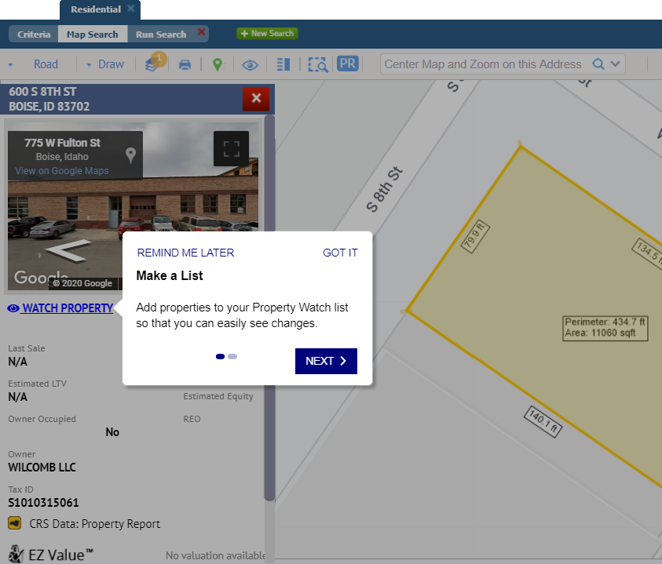

## LIM – Removed System Field Requirements when Saving a Partial Listing

Saving a Partial Listing just got easier!

When saving a Partial Listing you will no longer be required to save List Date, Expiration Date, Type, or Area. This will allow you to get the partial started, even if you don’t have all the details.

When the Partial listing is converted to a listing, the field requirements are enforced again.

## LIM – Maintenance Rules Interface Redesign

We’ve made a number of usability and workflow improvements to help you move through and correct errors in the Input Maintenance Table.

* Resizable pane above the form
* New icons indicate condition type
* Persistent highlighting on the form
* Errors and warnings totals
* Added navigation buttons for moving through the errors (F8 still works too)
* Simplified column data by combining condition type and acceptance columns

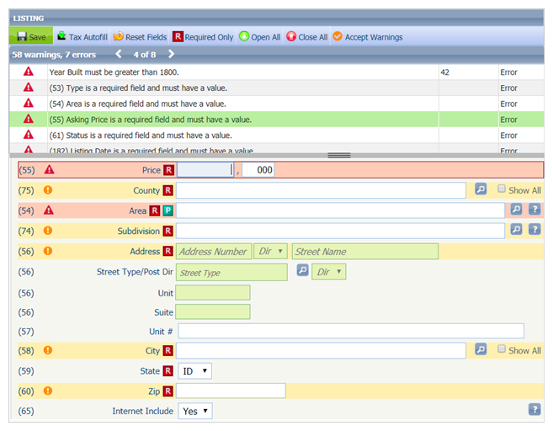

## New View – ConnectView

Everyone loves the Paragon Connect Detail View – So now we have embedded that view in Paragon Classic. This powerful report is located at the top of your Favorites folder (because we are sure you are going to want it as a favorite) and is called the **ConnectView.** If you decide to remove ConnectView from your favorites, it will appear under Specialty Views.

User Preferences are available for setting the ConnectView as the default search result report, default double-click report, etc.

The power of this view is that it combines all the details of the Listing, with any Documents, Property History, Automated Valuations, and Community Reports, and where applicable, Public Record Data as well. Simply click the tabs at the top to be taken to each section or scroll the View. Check out this short 1 minute 25 sec video that will walk you through it [Click here](https://vimeo.com/427754219/23850c104b).

Note: Due to its interactive nature, when shared via email the ConnectView will be sent as a CollabLink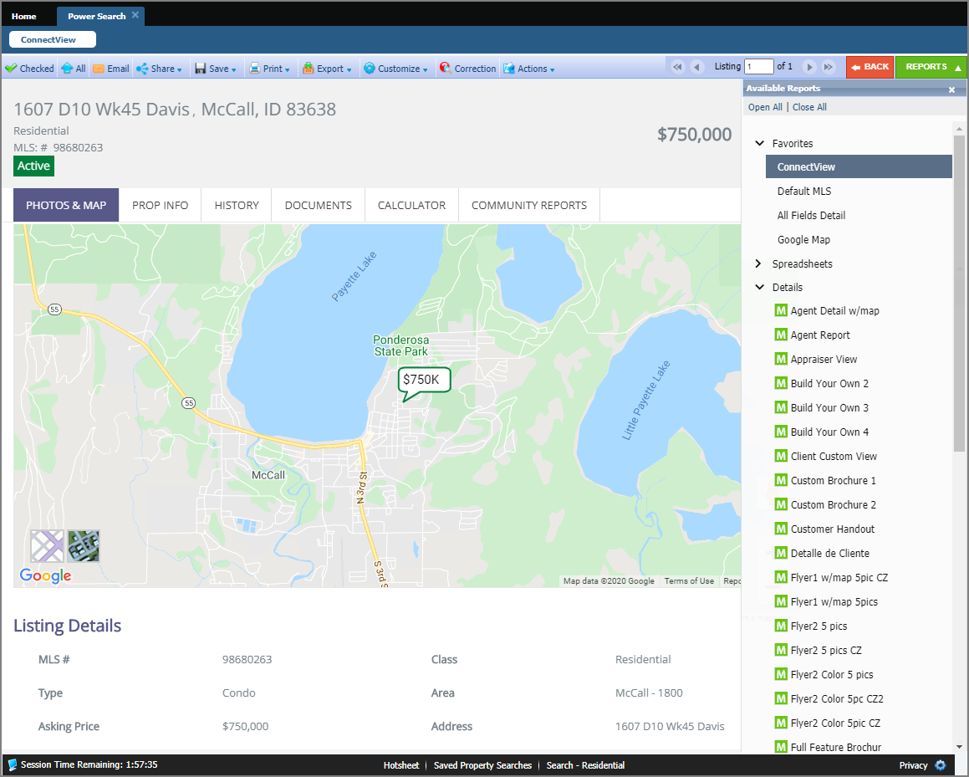

## Search – Save and Notify for Listing Carts

The Save & Notify button has been added to the Listing Cart, to improve the client communication workflow. Clicking Save & Notify routes you to the selected Contact’s Agent Recommended page, just as it does for Saved Searches.

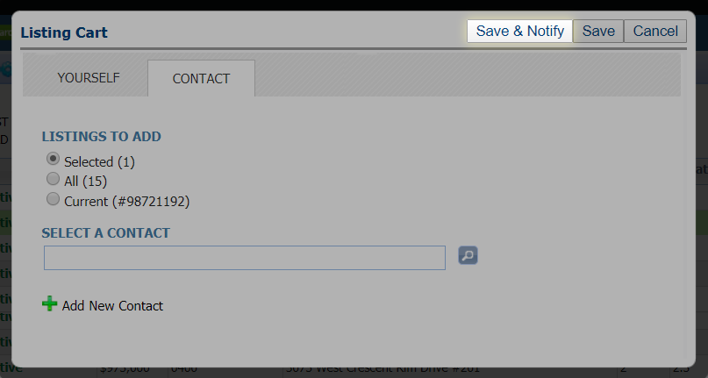

## Email CollabLink

The new CollabLink email type allows users to send the CollabLink report. This report is designed to be responsive and accessible across all device sizes.

## Search – Power Search Refinements

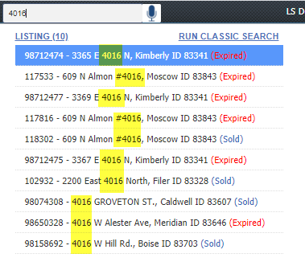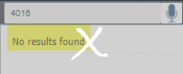We’ve tweaked Power Search to return better results when searching a numeric string. Power Search will return general search results based on matches to address fields, in addition to matching listing IDs.

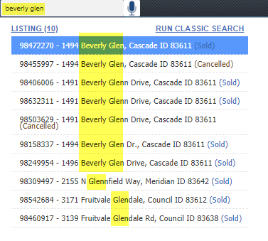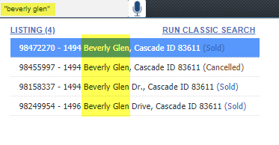Did you know that using quotes around your “search criteria” can return better results? We’ve updated the Power Search tooltip to include this helpful tip.

## Search - Power Search – Numeric String Changes

In this release, we’ve enhanced how Power Search views a short numeric string. Assuming a short numeric string is looking for an address, Power Search will return exact matches first, before returning ‘starts with’ matches insuring better accuracy.

For example, “123” will return listings with street number 123 before listings with street number 1234 or 1235.

## Search – Power Search – Three Additional Refinements

**Viewing Inactive Members and Include in Roster Flag:** We’ve refined how the Power Search results for members are displayed in the agent roster.

Previously the agent roster was only returning active members, even when the user had permission to view inactive members. Now the roster will return inactive members where applicable.

In addition to this the system will now respect the Include in Roster Flag in the agent record when returning Power Search results, based on user security.

**User Interface Enhancements to Power Search Bar:** To help improve the readability of the Power Search input and results, some minor UI changes were made. The size of the input box was increased; the Help icon and Voice Search icons were aligned with the box.

**Refinement to update status color:** To improve the readability of the listing results, in Power Search, the status text changes to white when the row is highlighted and returns to the specified status color when the row is not highlighted.

## Tree Enhancements

We’ve made a number of usability enhancements to the menu (tree view) while also maintaining legacy functionality.

* 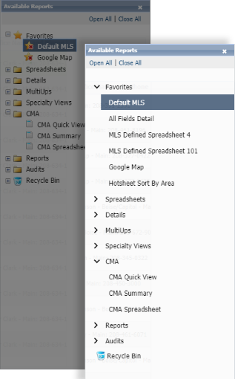Made it easier to click
* Removed unnecessary UI elements
* Promoted single items to be top level and no longer requiring a dropdown
* More intuitive method for managing favorites in Views/Reviews

## Contacts – Tree Updates

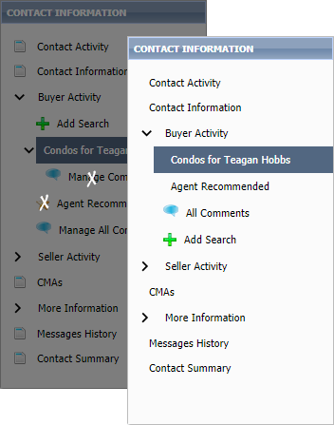We simplified the tree by removing unnecessary icons and we removed search-specific comments because they are now on the page with the search settings.

## Contacts Saved Searches – Notification Indicator in Contacts Tree

### If a saved search has been linked to a Contact, it appears under the Contact details. Each linked saved search may be enabled or disabled for prospecting. New icons now appear next to search to indicate the type of notification setting. These three icons indicate:

* Off 
* Collaboration Center with Notification 
* Email Only Notification 

## Search – Listing Slide Show

The Paragon Listing Slideshow can now be emailed directly to your contacts! Previously, the only option was to email the link to yourself, or copy and paste the URL from the preview and then email it. We have also updated the user interface so that it is easier to use. After selecting the listings that you want to use in a slide show, click on the Action menu and select Listing Slideshow. Below is the old interface vs the new.

**

## Contacts – Importing Google Contacts

You asked and we delivered! You now have a new import option for Contacts, this will allow you to browse and multi-select Google contacts to import into Paragon!

The fields that are imported are: First Name, Last Name, Email, and Phone Number.

**Note:** Browsers must allow pop-ups from Paragon for this function.

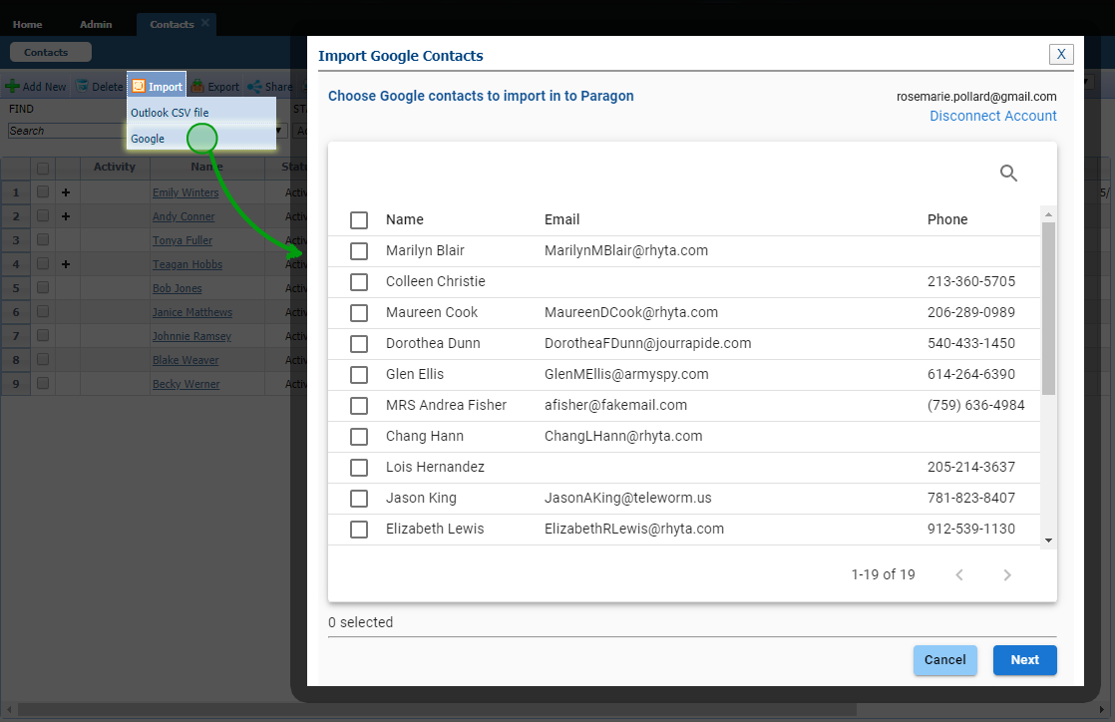

## Contacts – Importing Yahoo Contacts

Importing contacts just got easier. You can now import Contacts from your Yahoo account. This new option will allow you to browse, search, and multi-select Yahoo contacts to import into Paragon. The fields that will be imported are First and Last Name, Email Address and Phone number. Please note that Yahoo requires approval before you can access your Yahoo contacts, so you will need to get a code to view and import the contacts.A screenshot of a social media post

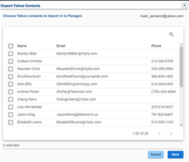Once you select Get Code the Yahoo authorization screen will open and give you the code to be able to grant access to log into your Yahoo account. You can now select your contacts to import.

## Contacts – New Contact View Shows Listing Detail and Comments

To help save you time, we have created a new view in contacts where you can see your listing default report with any comments made for a particular property your client is collaborating on with you. This view will allow you to read the comment and know exactly what property they are commenting on, so you can comment right back to them.

Accessing this view can be through the contact widget on the front page or through the contact tab by clicking on the bubble.

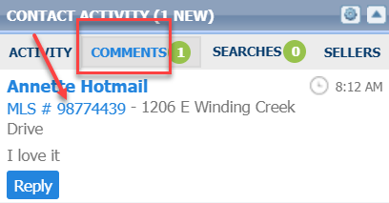

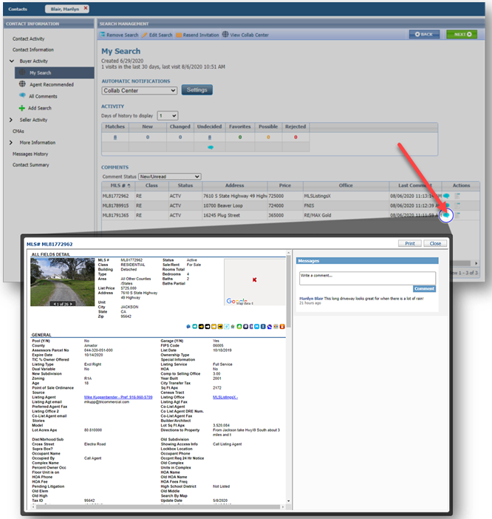

## Contacts – Agent Preview

The interface for approving and disapproving listings for Agent Preview searches has been modernized and clarified.

Multiple listings can still be approved or disapproved as a group from the grid view.

On the detail view, each listing can be approved or disapproved individually. We also fixed the detail view advancing to the next listing in the set, rather than returning to the first listing.

## Collab Center – Display Sold and List Price on Agent email notifications

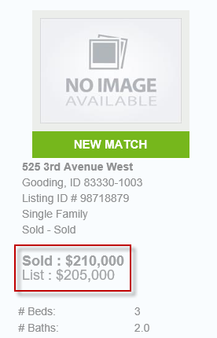If your MLS allows notifications on Sold or Leased listings, both the List Price and Sold Price will display on the Agent Collab Center email notifications, for status categories 2 and 6. All other statuses will continue to display the List Price.

## Collab Center – Display Previous and Current list price on Agent email notifications

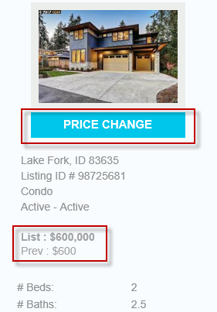On Agent Collab Center email notifications for price changes, both the previous price and current price will display.

## Contact Summary – Add Collaboration Center Notifications to Search Activity Section

The Contact Summary in the Paragon Contact Manager has been enhanced to now show Collaboration Center Notifications! Previously it only showed email searches, however now when you go to your Contact you will be able to see all information for notifications you sent out of Paragon to that client and how they were sent.

Go to Contacts> View Manage Contacts> Click on the Contact Name you wish to view. Next click on Contact Summary > Search Activity section. The grid has been enhanced to show all notification settings: Off, Email, or Collab Center.

# Additional Enhancements

## Link to BK Privacy Policy

A link for the BK Privacy policy has been added to the Quick Action bar at the bottom of Paragon. This link cannot be removed when customizing the bar.

## New Date Picker Control

The Paragon date picker has been upgraded, which will make navigating calendars and selecting dates easier.

## Contacts – Search the ‘To’ field in Sent Messages

In Contacts > Sent Messages and Message History, the Search field will now search on both the Subject Line and the “To” field, enabling users to search for messages to a specific contact.

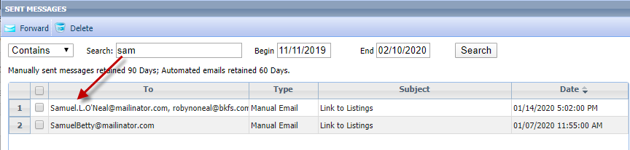

## Contacts – Agent email not configured

We’ve clarified the message that displays if the user doesn’t have an email address configured when attempting to set up notifications for a contact.

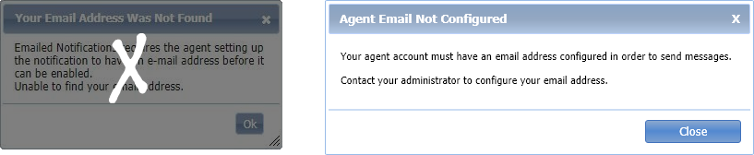

## Contacts – Improved handling of email address

Paragon has improved the handling of invalid characters in email addresses, based on industry standards, to help improve data quality and avoid bounced messages.

* When an email address is entered with invalid characters, an updated error message displays the incorrect address and provides a list of invalid characters.
* If an email address has a plus sign in the “local part” of the email address, Paragon will retain the plus sign, rather than replacing it with a space, as it did previously. The receiving email system will handle those addresses according to their protocols.

## Contacts – Default Phone Type for Share Via Text and Adding Contact

When adding a new contact from the Share via Text modal, the phone type will now default to Personal Cellular.

## Contacts – Contacts grid columns reordered

We’ve rearranged the columns in the View/Manage Contacts grid to match the nested Search grid.

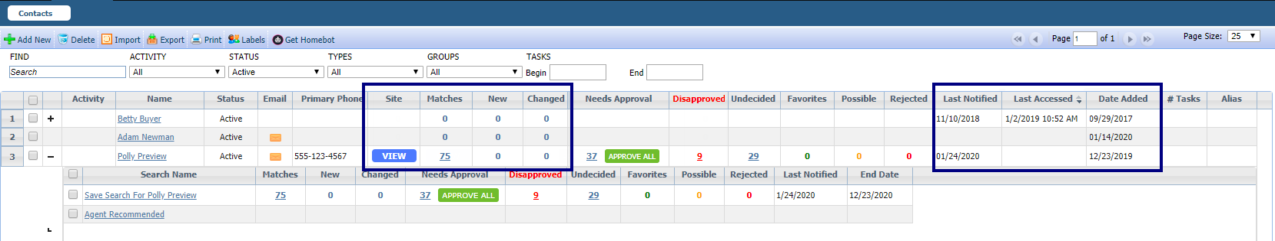

## Search – Simplified Save Search and Listing Cart

The designs for Save Search and Listing Carts dialog boxes have been upgraded with better controls, straightforward wording, and consistent design. This will help usability by making workflows and instructions similar across Paragon.

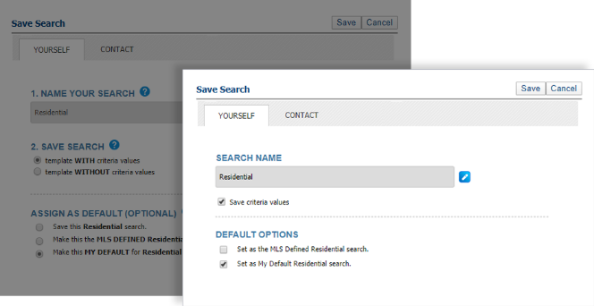

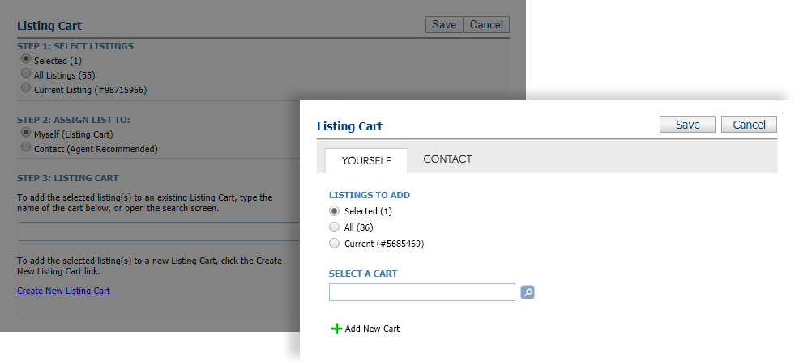

## Search – Advanced Date Range Operators and Prospecting

To improve performance, we’ve added Advanced Date Range Operators (7 days back, 6 months back, etc.) to the list of invalid search criteria for prospecting. Including advanced date operators in a search saved to a contact causes degraded performance issues over time. The advanced date operators are now included in the check for invalid criteria, and a warning message will alert the user as to which fields are invalid

Advanced date range operators can still be used in a saved search if it is not saved to a contact for prospecting.

## Search – Share via Text email requirement removed

We’ve removed the email address requirement when adding a new contact from Share via Text. The email address is needed to opt a contact back into receiving text messages from Paragon. The Opt-In process in Contacts has an existing check for an email address, making it unnecessary to require it when a new contact is being added.

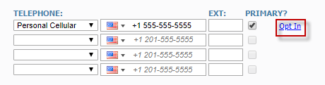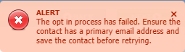

## Tooltip for Public Associated Documents

A new tooltip has been added to the Add New Documents screen that explains “Public” must be checked so that the document can be emailed from Paragon.

## Email Reports – UI cleanup

We used more concise labels, removed some irrelevant information, and clarified some terminology to simplify the manual email reports dialog box.

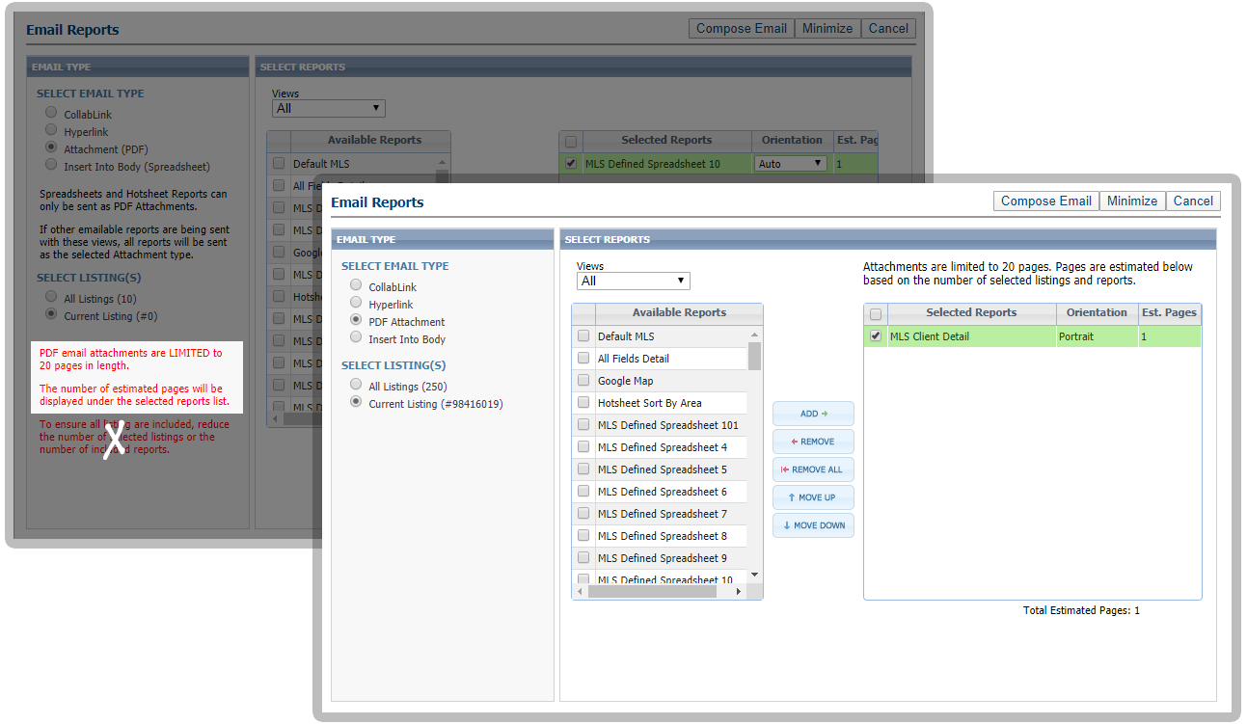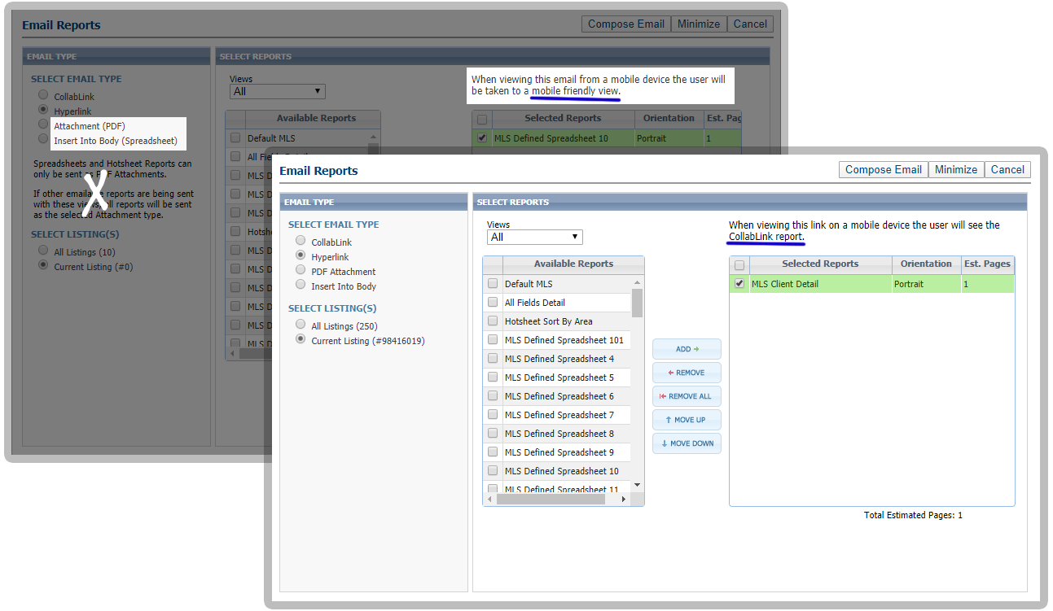

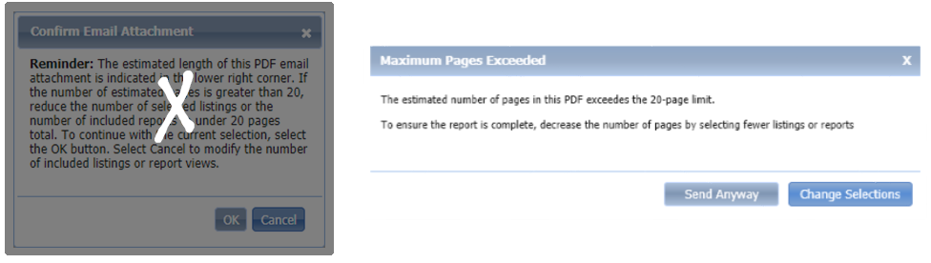

## CMA – Unique Cover Letters Per Presentation

With this enhancement, adding a cover letter to a presentation creates and saves a unique copy of the cover letter to that presentation. Users can edit and modify the cover letter, and it will only affect that presentation, rather than all instances of the cover letter throughout the CMA module.

To get the unique cover letter on an existing CMA, open the Cover Page in Presentation Setup for that CMA, then Save the new cover page.

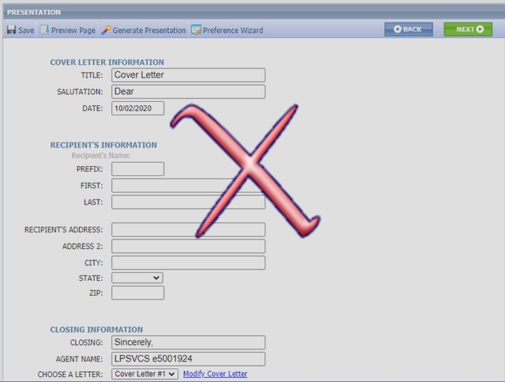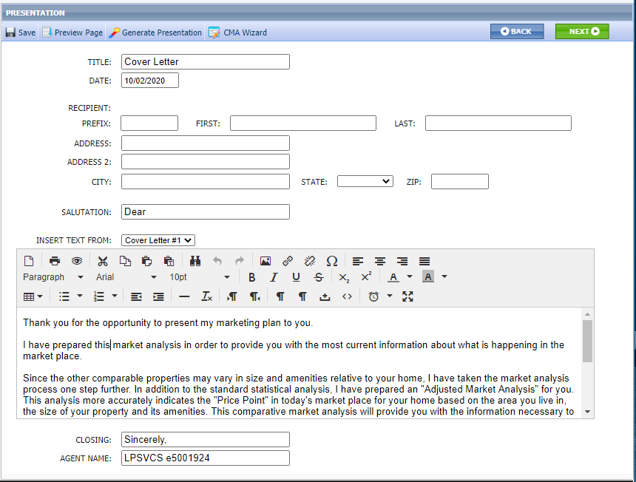

## CMA – Listing Office Check when Converting a Subject Property

When converting a Subject Property to a listing using CMA> Maintain Subject Property, the system will check that the Listing Agent is in the Listing Office for the selected property. If not, an error is returned and the user must select the correct office to clear the error and save. This ensures that if an agent changes offices after creating a Subject Property, the newly saved listing will be assigned to the correct office.

## LIM – Listing Expiration Notices in Sent Messages Log

Listing expiration notices have been added to the Sent Messages log to help users track them. We’ve also updated the subject line by adding the listing address where available. Listing expiration notices use the current customer automated email retention settings.

## Membership Roster – Office Broker and Main Office Added

On the Membership Roster, a link to the Office Broker’s information card and the Main Office information card has been added below the existing office information. When the links are clicked the detail cards are displayed.

