Paragon Simplification 2021
Paragon Enhancements for releases 5.81 to 5.86
Listings – Embedded Videos 3
Listings – New “Add” button in Listing Toolbar 5
Listings – New Listing navigation simplification 5
Listings - Improved Handling of Street Address fields 6
Listings - Price Analysis Widget 7
Partial Listing – Removed the Log Off toolbar button 9
Photos –Easier to Read Instructions for Uploading Your Photos 9
Prospecting – Reminder to approve listings for Agent Preview 11
Prospecting – Updates to Expiring Notifications 11
Search - Enhanced Access to Integrations and Paragon Tools 12
Search – Add Date Modified to Saved Property Searches grid 15
Search – Clarify access to Download Documents functionality 16
Power Search – Remove voice icon from incompatible browsers 17
Power Search – Exclude Offices when “Include in Roster= N” 17
Property Watch – Suspend Notifications based on security level 17
Reports – Listing Report menu enhancements 18
Reports - Add Purge Date to Partial Listings table 19
Preferences –Results Preference UI Update 19
Preferences – Broker Syndication 20
Preferences - Hotsheet and Tour/Open House Reports 23
Preference Wizard – Message Body and Email Signature pages 24
UI Changes – Expiring Notifications 24
UI Changes – Updated Button Styles 25
UI Changes – Miscellaneous Updates 25
Search – More control when sharing to Facebook 28
Contacts – Disable Contact Notifications when primary email is removed 29
Simplification of the Email Footer 30
Update notification end date on Agent recommendation 30
Verbiage update for listing syndication user preference 31
Rename “Default T/OH” label in the Tour and Open House Reports Tree 32
Update Toggle Switch Style 32
Enhanced ShowingTime Icon webservice call to send all records 33
UI Updates – Clean up unnecessary white space in ConnectView 33
Update to Financial Calculators (US) 34
CMA – Standardize references to the CMA Preference Wizard 36
CMA – Add field name for Address 2 to Cover Page 36
Collaboration Center - Radius 37
Collaboration Center - Compare Workflow 38
Collaboration Center – Change Search radius to an input field and change default to 1 mile/km 40
Collaboration Center – Disabled Notifications for inactive clients 40
Collaboration Center – Updates to Collab Center mobile property search 41
Collaboration Center – Consumer Mortgage Center 42
Collaboration Center – Shortcut App Icon 43
Collaboration Center – Property Search Changes 44
Collaboration Center – Property Search Moved to Main Tab 48
Additional Enhancements 49
Admin – Disable Off Market Status checkbox on Active statuses 49
Admin – Update to Label in Status Setup 50
Admin – Unique User Logins Report Additions 51
Admin – Updates to Changed Users and Changed Office Reports 52
Board Configuration Enhancement for Intelligent Analytics 54
Admin – UI Tour for Paragon Release Notes 54
Admin – RETS Profile field for Web API client 54
Admin – New fields added to Agent and Office grids 55
Admin – Remove DCL button 56

Listings – Embedded Videos
Three new fields were added to the Listings table. When enabled, these fields will allow all users with listing edit rights to embed a YouTube or Vimeo video URL within the listing.
These videos display in the ConnectView report within Paragon Professional, and will also be available in Paragon Connect, Collaboration Center, and CollabLink.
By default, these three fields are set to a level 9 security level. They must be enabled, and their security reduced for this to be used. This can be edited by MLS Admin. (These fields will not be available via RETS at this time.)
The three fields are:
- Video
- Last Video Update Date
- Video Count
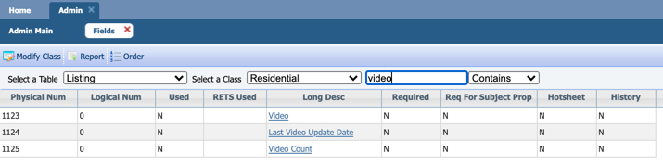

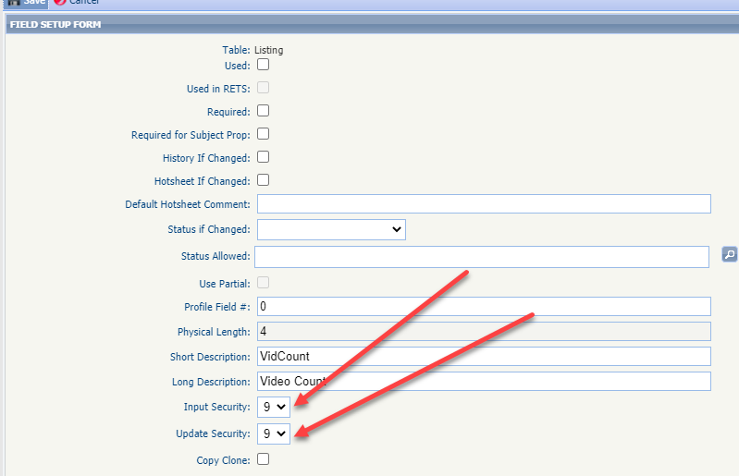

Listings – New “Add” button in Listing Toolbar
A new “Add” button in the Maintain Listings toolbar provides quick access to add a new listing of any class. This will simplify the steps needed to add a new Partial or Full listing.

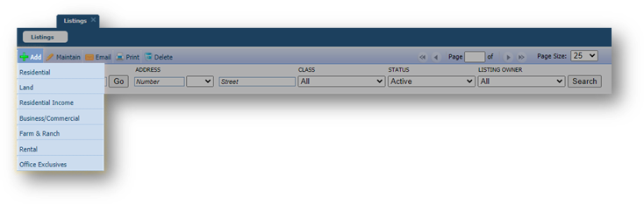

Listings – New Listing navigation simplification
When maintaining a listing in the past, you had to save your listing in order to see additional options to add or maintain photos, add an open house etc. Now for both Partial and Full listings, all of the additional menu options are available to you without having to save first.
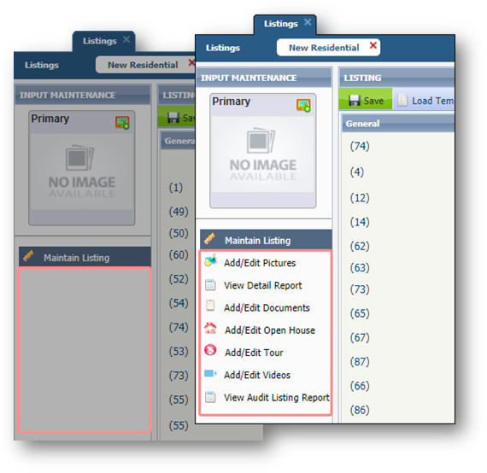

Listings - Improved Handling of Street Address fields
We’ve improved Paragon’s handling of address fields to help ensure data integrity. When Low House Number, Address-Unit and Address-Suite are enabled, those fields will display as part of the green-highlighted street address fields in Listing Input and in Search.
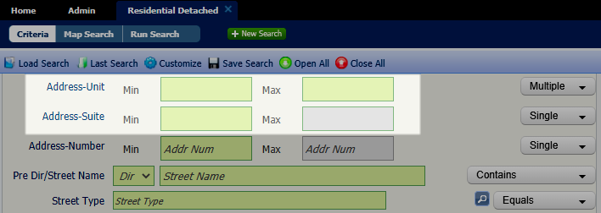
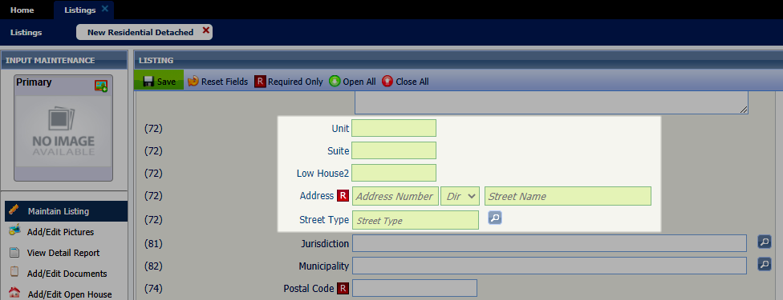

Additionally, when Required Only is selected in LIM, if any part of the street address is required, all the green-highlighted street address fields will remain visible.
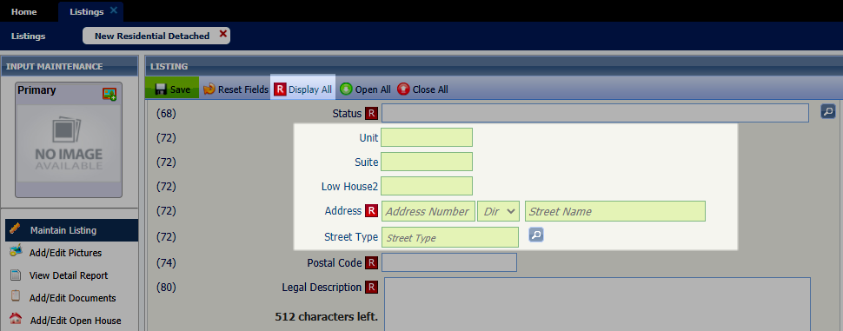
Notes: Low House does not appear as a separate field in Paragon Search modules but is included when searching the Address Street Number field.

Listings - Price Analysis Widget
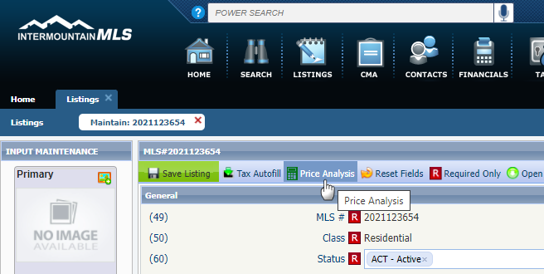
Black Knight is very excited to announce the release of the Price Analysis feature, which can be used by agents to determine pricing by viewing the Potential Buyers and any available AVMs if enabled. The feature can be accessed from the menu bar of the Listing Input Form for a current Full, Partial or Subject Property Listing.

Clicking the option launches an interactive modal displaying the Potential Buyers in Paragon.

The number of Potential Buyers is based on contacts whose saved search notifications include search criteria that match the listing in focus.

Armed with the Potential Buyers and the AVMs, agents can enter a New Price into the interactive widget and click the Recalculate Buyers to determine the effective change on potential buyers.
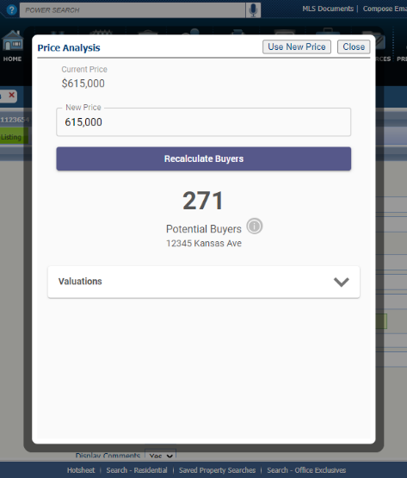
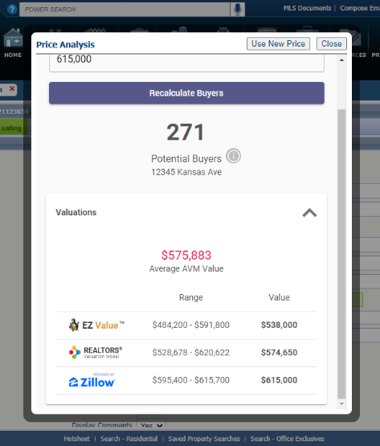
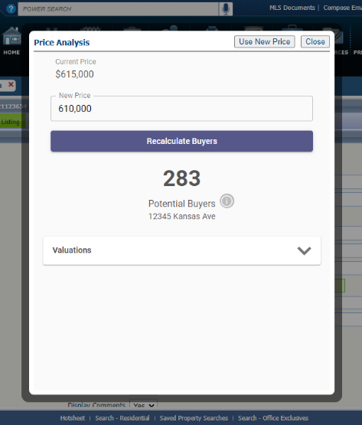
From here, the agent can click the “Use New Price” button and the widget will auto-pop the new price onto the form or they can close the widget to end. This is an incredible tool that agents can show clients or potential clients to help determine pricing and/or to help motivate to list.

And there’s more to come! Coming in 5.87, we’ll be adding another metric to the Price Analysis widget called Location Score, which will display the relative hotness of the postal area for the listing compared to other postal areas.

Partial Listing – Removed the Log Off toolbar button
The Log Off button has been removed from the Listings Maintenance toolbar. This addresses a defect that was introduced in 5.80 with the login screen update. Users can easily assume identity from the user menu.
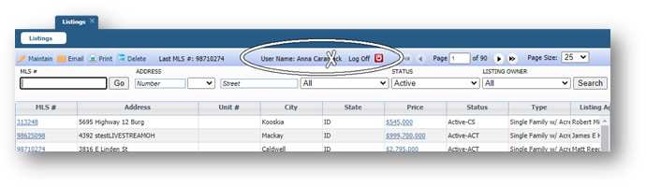

Photos –Easier to Read Instructions for Uploading Your Photos
The instructions for uploading your images in Listing Input, Agent Photos, Office Logos, etc., have been simplified, while retaining all functionality.
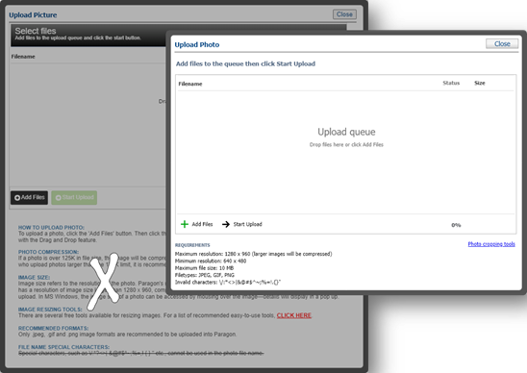

Prospecting – Reminder to approve listings for Agent Preview
When using Agent Preview and Collaboration Center, listings do not appear in Collaboration Center until they are approved by the agent. To remind agents that they must approve their listings so they appear in Collaboration Center, a new warning message displays when the Collaboration Center Welcome Email is sent initially or resent via Resend Invitation. The warning remains on screen until the user closes it.
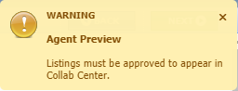

Prospecting – Updates to Expiring Notifications
To Simplify and improve user experience, the expiring notifications dialog window has been enhanced to include the Contact Name, the Last Accessed and Last Notified Dates. Also included is the ability to enable/disable or extend the notifications for another year with a single click!
Additionally, when a search is extended, Paragon will run the search against current prospecting restrictions and return the usual error message if any criteria in the search is now prohibited.
Old View: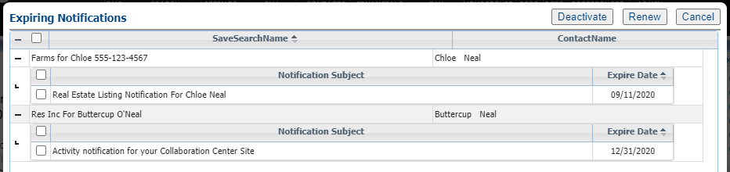
New View: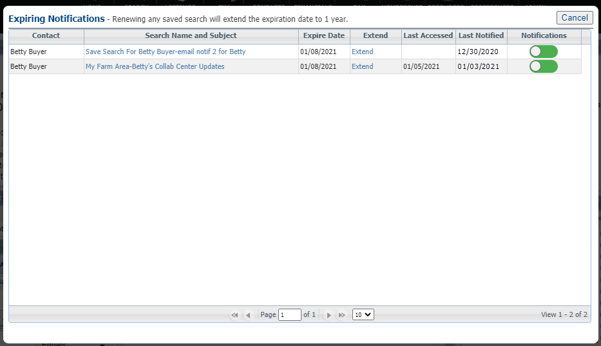

Search - Enhanced Access to Integrations and Paragon Tools
Does your Action Icons column look like the following? Wouldn’t it be nice if you could view more data and fewer icons but still have access to the integrations and tools? Well, you’re in luck.
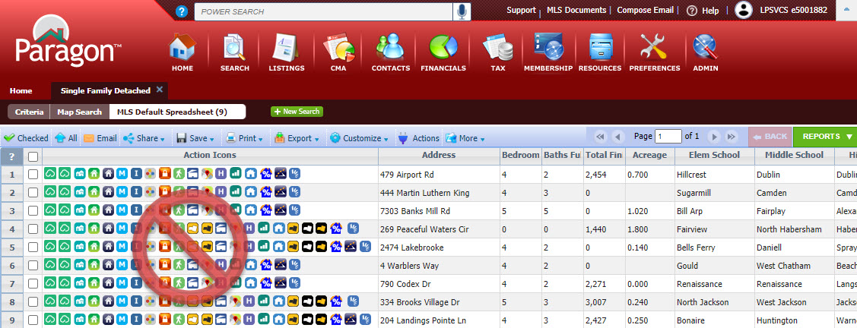
In 5.81, we enhanced the way users access Integrations and other Paragon System Actions from the spreadsheet search report as well as the detail views. The Action Icons column of the spreadsheet has been modified to display a single icon to provide access and more viewing space for data.
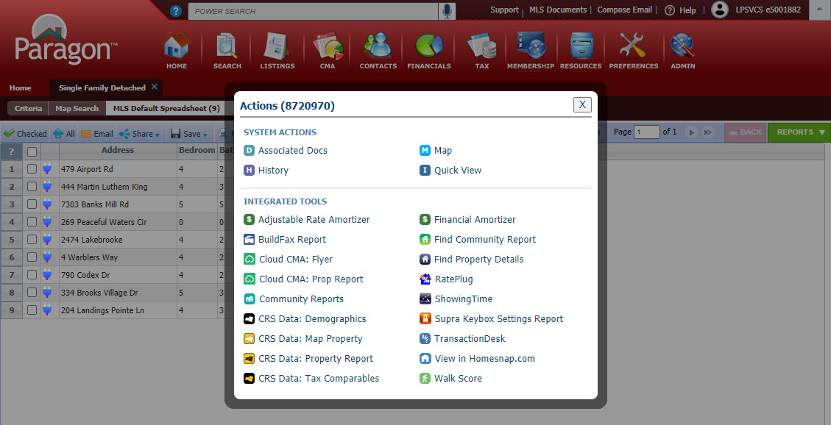

In addition to the column in the spreadsheet, a new Actions button was added to the menu bar.
This does a couple of things. One, from the spreadsheet report view it provides access to actions that users can take when multiple records are selected. The Actions dialog box includes logic to display the available options based on whether one or some records are selected. 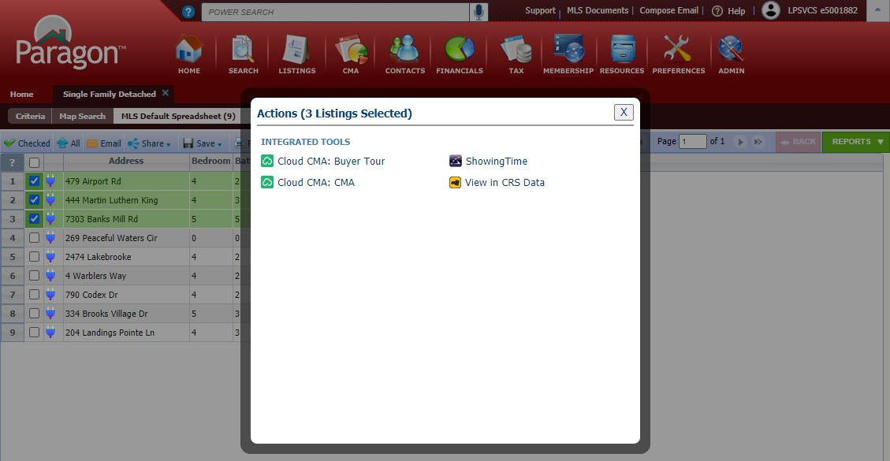
Two, it makes Integrations and Paragon Tools available from ConnectView (and any other detail view). Clicking on the button will display all the available options for the record in view.
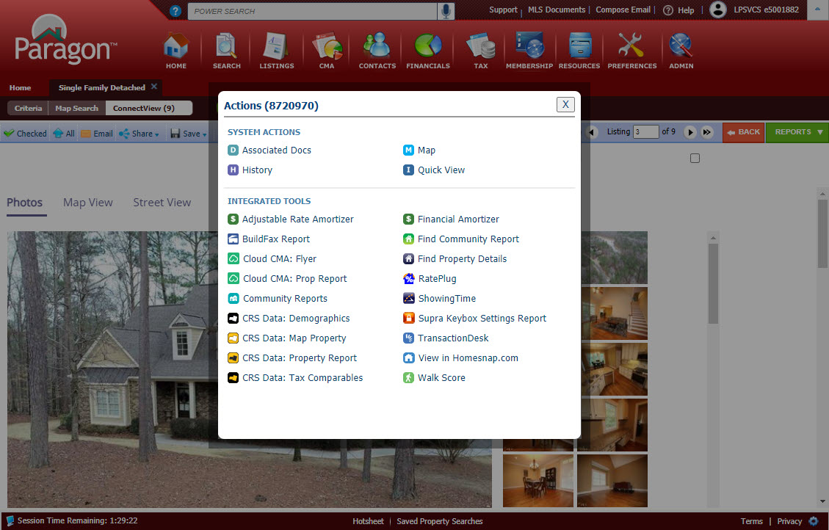

This effectively removes the need to have the icons embedded into custom reports. Previously, if the icon was not present in the report being viewed, users would have to return to the spreadsheet search report or pull up the All Fields Detail or another report containing icons in order to access the action.
Other Menu Changes
In addition to adding the new Actions button, the previous Actions menu was succinctly renamed “More” since it includes the overflow of menu options that do not fit in the toolbar.
Before 5.81
After 5.81
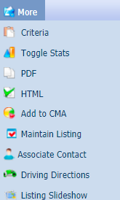

You will also notice in the overflow menu to the right that the multi-select integrations such as Cloud CMA, ShowingTime and View in CRS are no longer present (if your MLS subscribed, that is). They now reside under the new Actions menu as previously shown when more than one record is selected in the spreadsheet.

In summary, following are the benefits of this great new feature:
- Access to integrations from ConnectView or any other detail view
- All integrations accessible from central location
- More space for listing data on spreadsheet due to narrower column in spreadsheets
- Actions button in toolbar is context sensitive
(i.e. displays single-option integrations when only one listing is selected or multi-option integrations when multiple listings are selected)
- Access to integrations from any detail view even if Action icons are not in report
- No need to hover over an icon to “discover” what it is – the label is displayed with the icon
- Action icons no longer needed in custom reports

Search – Add Date Modified to Saved Property Searches grid
To assist users with managing saved searches, a Modified date column has been added to the grid in Search > Saved Property Searches. The grid can be sorted by the Modified date by clicking on the column header.
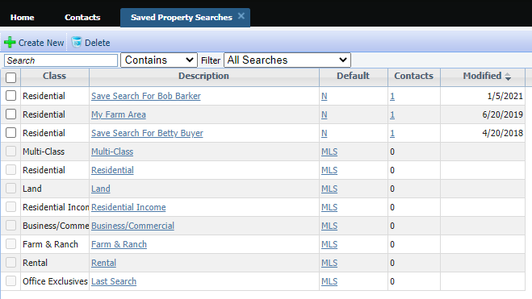

Search – Clarify access to Download Documents functionality
The option to allow bulk download of Associated Documents was displaying even when no valid documents were available. To avoid confusion, the Download Documents option will be hidden when public documents are not enabled on the site. When public documents are enabled, the Download Documents option is available but disabled unless the user is on the Associated Documents report.
Public Documents enabled = Download Documents enabled: 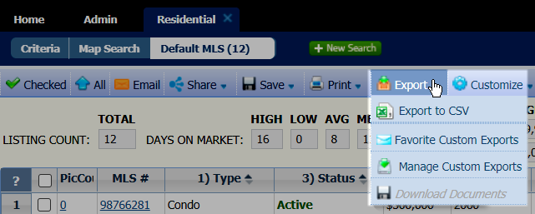
Download Documents enabled from the Associated Docs report:
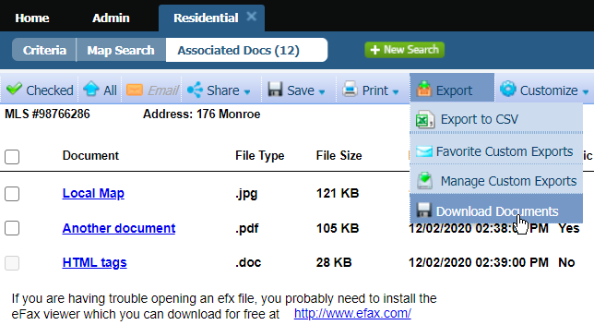

Power Search – Remove voice icon from incompatible browsers
The voice option on Power Search is currently only valid for the Chrome browser. To avoid confusion, the voice search icon has been removed from all other browsers.

Power Search – Exclude Offices when “Include in Roster= N”
If an office record has the Include in Roster flag off, users below security level 7 are unable to view those offices in the Membership Roster. To avoid confusion, when the user’s security level does not allow visibility of those offices, they will be excluded from the Power Search results.

Property Watch – Suspend Notifications based on security level
This enhancement fixes an issue where Property Watch notifications were being sent out even if the user fell below the specified security level for Property Watch. If a user falls below the MLS-specified security level, no email notifications will be sent to the agent for new alerts, but the alerts will be retained in Paragon. If the user’s security level changes in future to a valid setting for Property Watch notifications, notifications will resume.

Reports – Listing Report menu enhancements
The Listing Reports Menu now indicates the user’s preferred default reports for Search Reports and Detail Reports.
The user can change their preference from this screen.
Note: Selected preferences will be reflected in User Preferences | System Preferences | Results Options
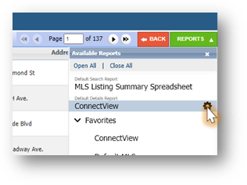
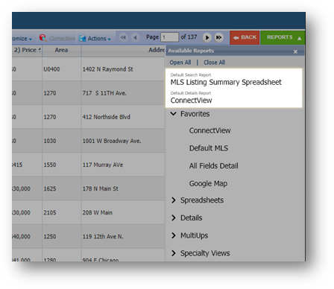

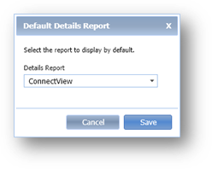

Reports - Add Purge Date to Partial Listings table
To assist you in tracking when your partial listings will be purged from the system, a new column has been added called Purge Date. It will calculate and display the date partial listings will be purged from the system.
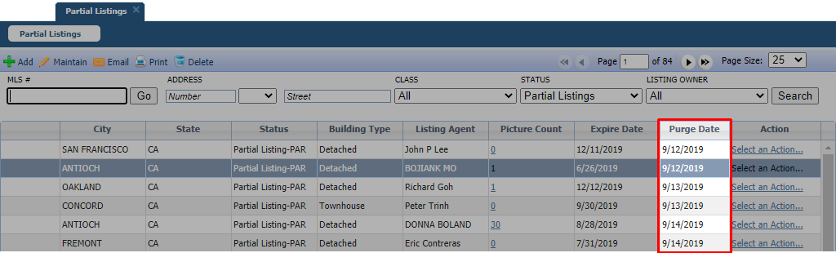

Preferences –Results Preference UI Update
The Result Options page in User Preferences and in the Preferences Wizard has been reorganized so that related options are grouped together. Unnecessary text has been removed to create a more user-friendly layout.
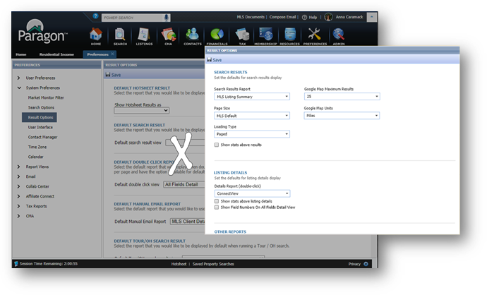

Preferences – Broker Syndication
We are excited to introduce a new (optional) feature for Broker Syndication in Paragon!

If your MLS has chosen to participate in Broker Syndication, the Broker/Manager will receive a message in MLS Messaging when they log into Paragon.
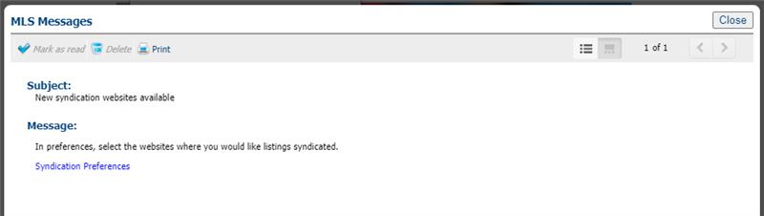

Broker/Manager-level users (5+) can modify syndication options in their user preferences for all offices in their firm and grant their Agents the ability to choose the syndication settings for their listings as well.
The Broker/Manager will set up their office syndication settings per office. In the broker’s system preferences they can choose to turn on/off syndication per office. They can also deny or allow the agent the ability to choose their own participation setting.

In the example below this Broker of South Office – 1468 has declined the syndication of all their office listings to 123.com, but allowed agents in their office the ability to send their individual listings. They opted in for syndication to ziprealty.com and also allowed their agents to opt out. On xyz.com they opted in for syndication but did not allow their agents to opt out. For their branch office North Office – 4561 they didn’t opt in to syndicating listings for any of the websites.
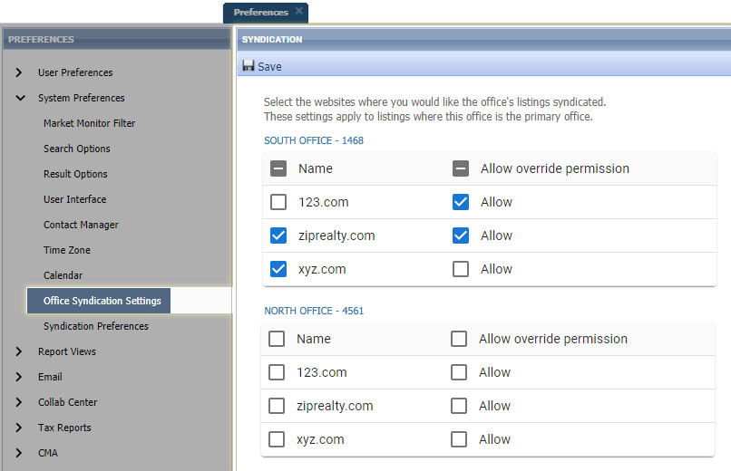

Agent-level users (4-) can modify syndication options in their System Preferences. If the Broker has allowed Syndication override, the Agent will see the following in their Syndication Preferences.
The Agent, if allowed by the Broker, can opt in or out of syndication by checking or unchecking the box. If the name is greyed out, the agent is not allowed to change that syndication.
In the example below the agent who belongs to the South Office – 1468 has the option to syndicate their own listings to 123.com even though all office listings will not be sent; turn off syndication to ziprealty.com for their own listings even though all office listing would normally be sent; but is not allowed to alter xyz.com participation (all office listings will be sent).
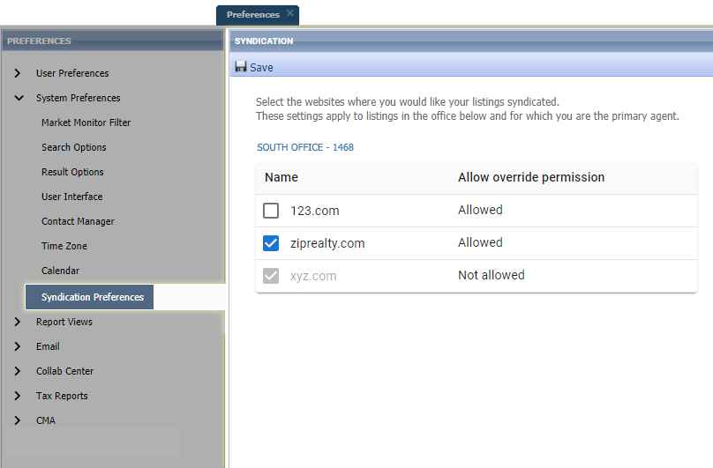

Note: Individual listings included in syndication honor the participation settings of the Primary List Agent (LA1).
Addresses are redacted when "Internet Address Display" (existing Paragon field) is set to "No" in Listing Maintenance.

Preferences - Hotsheet and Tour/Open House Reports
Changing your report preferences for Hotsheet and Tour/Open House just got easier! You can now change your default result options for Hotsheet and Tour/Open House right from the available reports drop-down.
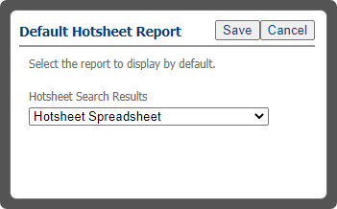
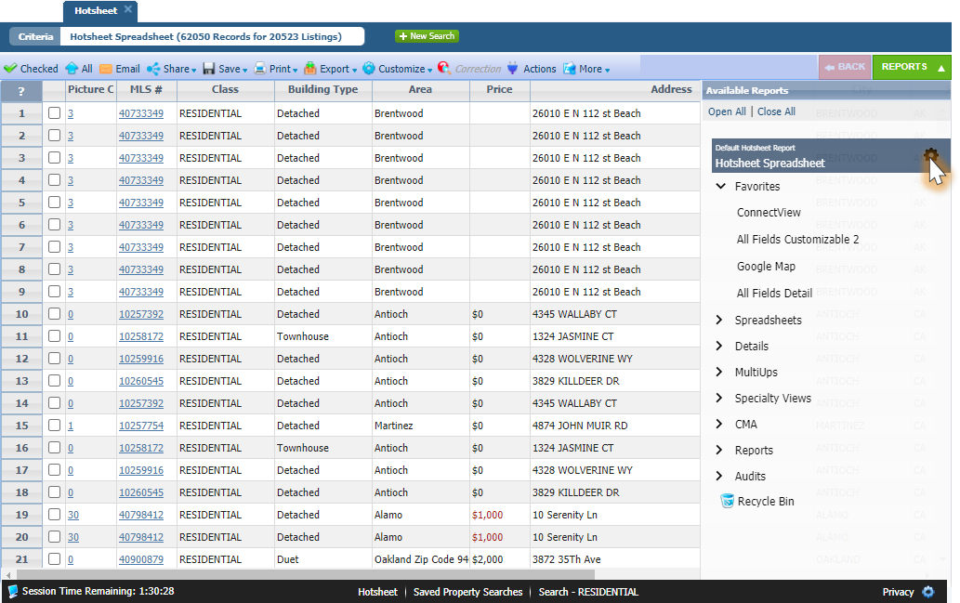
Clicking the gear icon opens a dialog box where you can set your default report preference

Preference Wizard – Message Body and Email Signature pages
To clarify the workflow in the Preferences Wizard, the Required ‘R’ icon has been added to the Name field, and the Default checkbox is selected on both the Message Body and Email Signature pages. This ensures that any changes made to these pages will be saved. The default can be changed through Preferences when additional Message Bodies or Email Signatures are created.
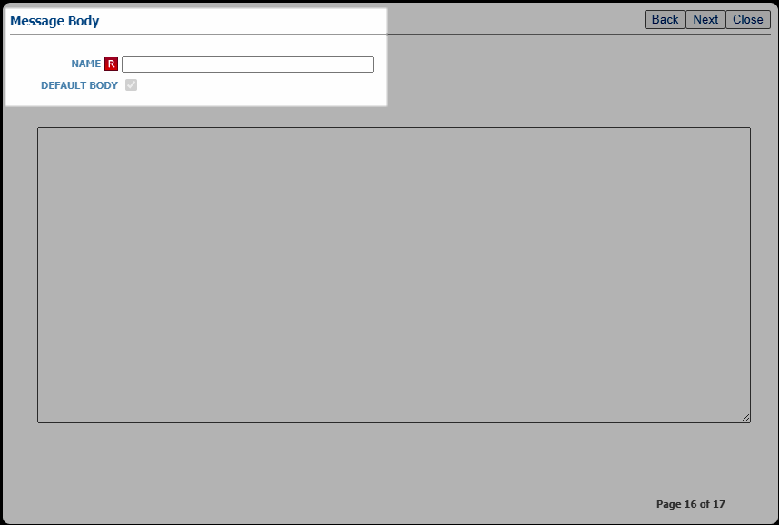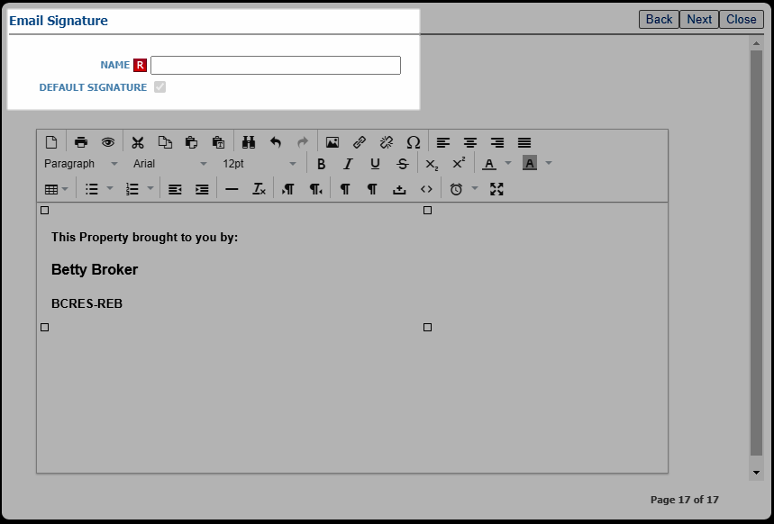

UI Changes – Expiring Notifications
Based on user feedback, we made a few changes to the new Expiring Notifications modal. The columns were rearranged to put the two action columns -Extended and Notifications (on/off) at the end of the row. 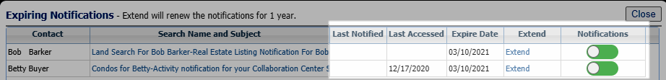
We also noticed the explanatory text by the modal header was missing when opening the modal from the Messages widget. That’s been fixed so the text always displays. 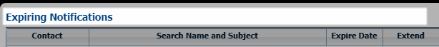

UI Changes – Updated Button Styles
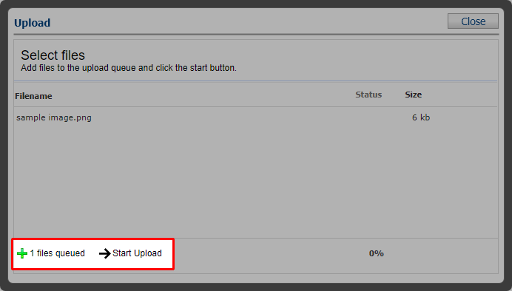
The buttons in the Upload dialog boxes have been updated with a lighter weight style that matches other buttons throughout Paragon. When the mouse pointer is hovering over the button, the button highlights to communicate that it’s actionable.

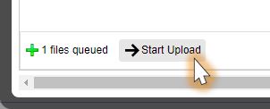

UI Changes – Miscellaneous Updates
On the Contact’s Saved Search pages, we refined the user interface by removing some extra space in the Activity table and an unnecessary scrollbar in the Comments table.
Existing Saved Search page:
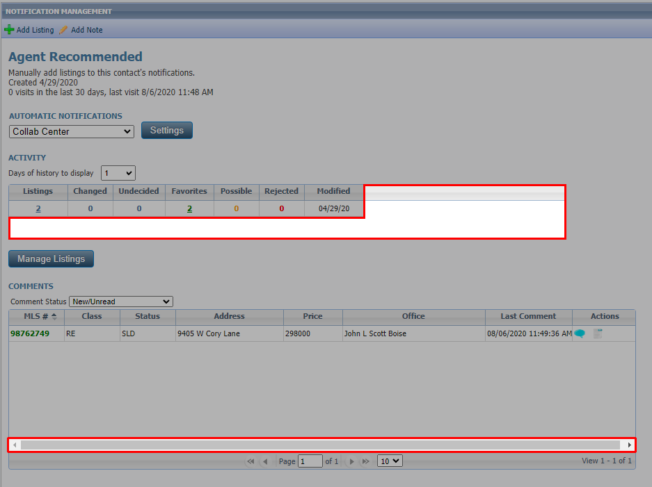

Updated Saved Search page: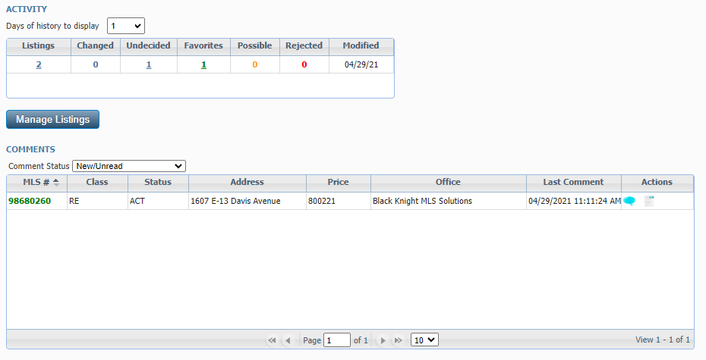
In the Comments dialog box we changed the pane title from “Messages” to “Comments” and the commit button from “Comment” to “Submit” to be more uniform and standard.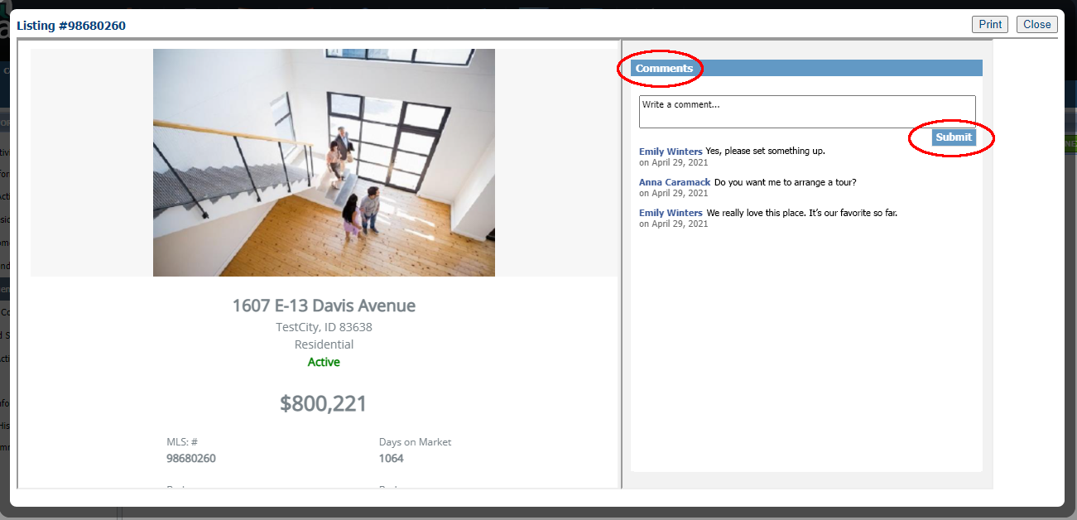
In the Agent Recommended heading we changed the word “client’s” to “contact’s.”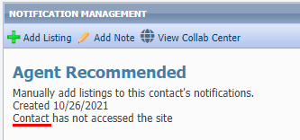

Search – More control when sharing to Facebook
When sharing to Facebook from Paragon and Collaboration Center, you now have more control where your posts will display in Facebook and the content of the post. For example, instead of displaying Look at these Listings, the user will be able to type in any verbiage of their choosing. Also, users can share via the various options like Story, Group, etc.

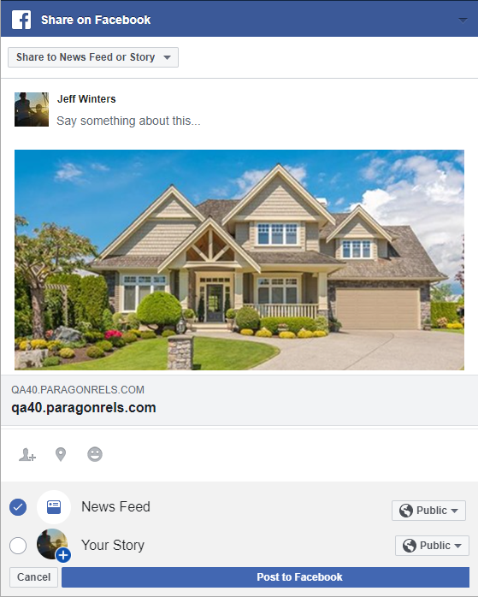

Contacts – Disable Contact Notifications when primary email is removed
A message has been added which allows the user to confirm changes if the primary email address has been removed for a contact who has automatic notifications enabled. If the user confirms the change, the system will disable all automatic notifications for buyer activity, seller activity, and agent recommended.
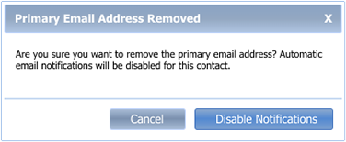

When a primary email address has been edited, and the contact has automatic notifications enabled, the user was previously presented with this confirmation message when focus left the email address field.
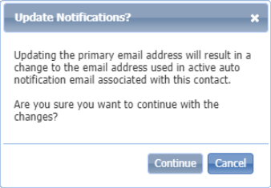
We’ve updated the message to be more concise and we changed it to display upon Save rather than when focus leaves the email address field.
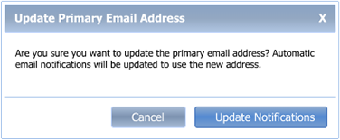

Simplification of the Email Footer
To simplify the appearance of emails from Paragon, we have removed the full URL for the “Link to Listings” as well as the extra text and full URL for the Opt Out functionality. The full URLs were needed years ago when certain browsers did not support text links. In addition, if a user currently has text-only email, the “Click Here to View Listings” still displays the full URL, so the additional data in the footer was superfluous.
Now recipients will see a simple and familiar “Unsubscribe” option in the footer of the email.
Email body and footer prior to 5.82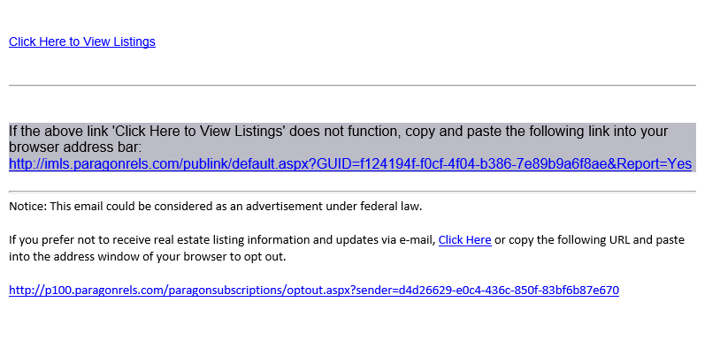
Email body and footer post 5.82

Update notification end date on Agent recommendation
Your Contacts’ Agent Recommended carts automatically have notifications turned on for Collaboration Center…and those notifications have the same one-year default expiration date as any other Collaboration Center notifications. With this enhancement, any time you add a new listing to the Agent recommended cart, the system will check the notification end date and automatically extend the notification end date for another year if the end date has passed.

Verbiage update for listing syndication user preference
We have clarified the instruction text and the permission column header in user preferences for listing syndication to help explain the process
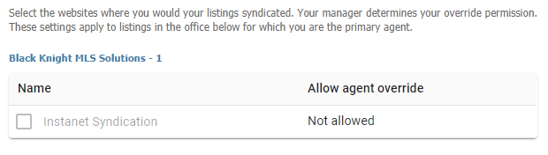

Rename “Default T/OH” label in the Tour and Open House Reports Tree
To help clarify the labels for Tour and Open House defaults in the reports tree we have renamed them to be more consistent.
Previous Label: Updated Label:
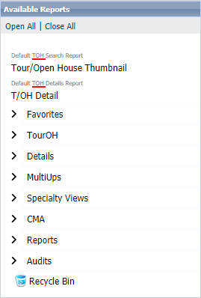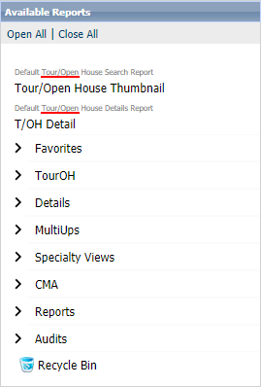

Update Toggle Switch Style

We reversed the toggle switch to align with the industry standard (thumb is to the right when on) and added refined color and mouse-over effects to provide action affordability.
Off | On
 | 

Enhanced ShowingTime Icon webservice call to send all records
Paragon calls a ShowingTime webservice, which determines whether the ShowingTime icon should display or be hidden in the Actions menu or on reports. Previously, Paragon was only checking records in the Active or Pending status category. This was not an issue until some customers stared using off-market statuses for “Coming Soon” listings. Now Paragon will be checking all statuses and the icon will appear or be hidden as expected for all records

UI Updates – Clean up unnecessary white space in ConnectView
To utilize all the screen space, we removed some of the unnecessary white space that was at the top of ConnectView.
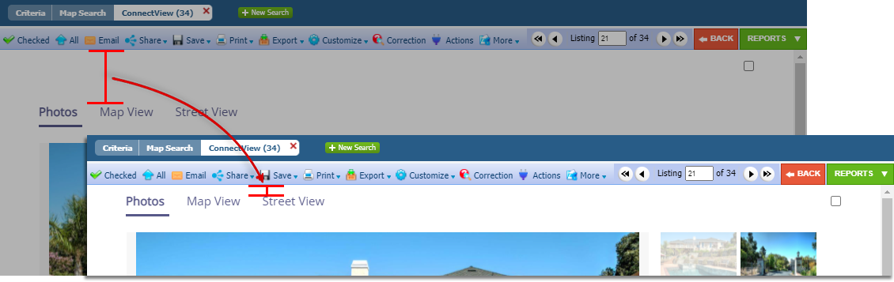

Update to Financial Calculators (US)
The following updates were applied to the Financial Calculators
- Updated font to match Paragon fonts
- Disabled the email feature – this function was enabled in error during a previous update. The calculators require a Paragon session and as a result, emailing them to clients is not an option.
- Collapsed the graphs by default – this helps reduce scrolling

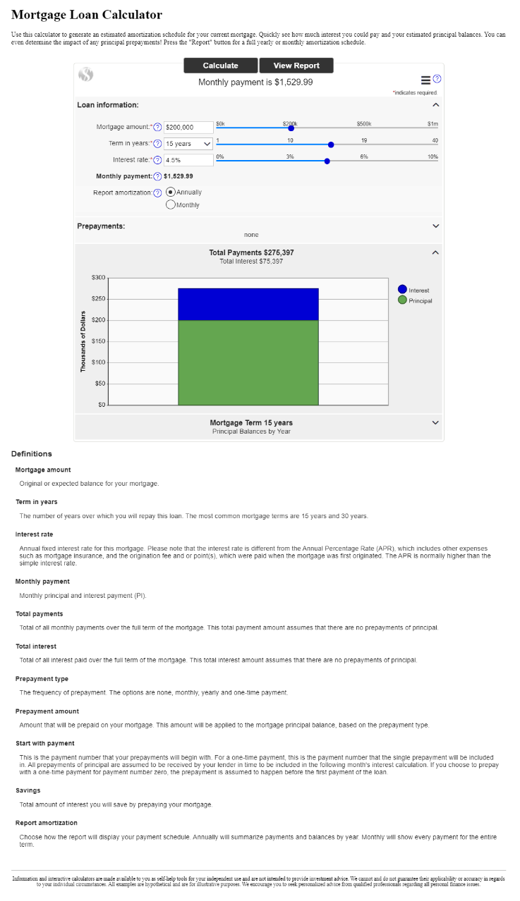
- Removed the Definitions from the bottom of the calculator. The text is located under the info tip question marks. Repeating them at the bottom was unnecessary and caused more scrolling.

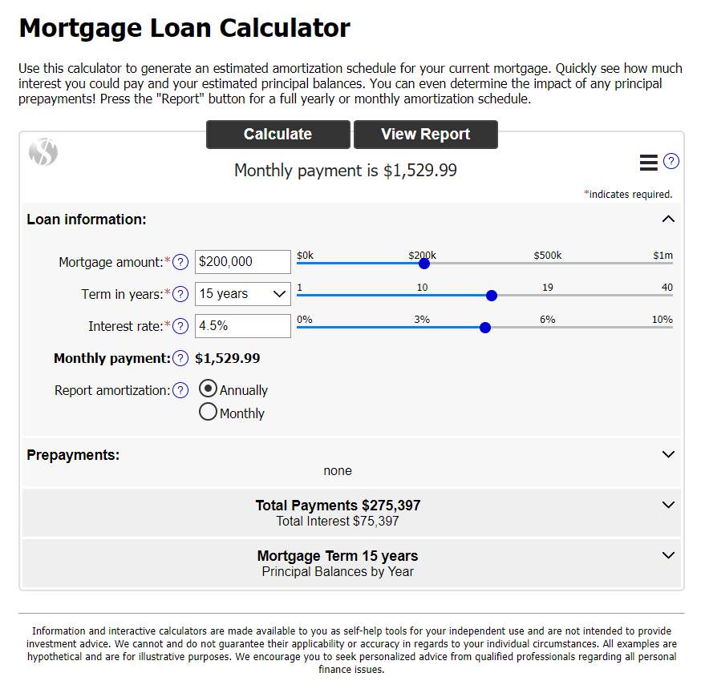

CMA – Standardize references to the CMA Preference Wizard
References to the CMA Preferences Wizard have been standardized across the CMA module, to clarify for the user that all instances are referencing the same Wizard.

CMA – Add field name for Address 2 to Cover Page
When Address 2 is used as part of the listing address, there wasn’t a field name associated with the data when viewing the CMA Cover Page. This enhancement adds the long description to the Subject Property display on the Cover Page.
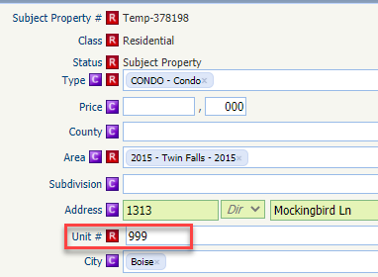
Subject Property with Address 2

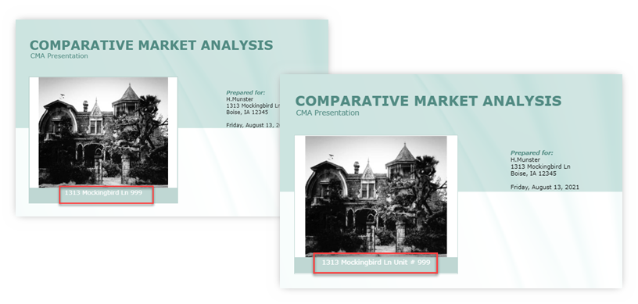
Cover Page missing Address 2 label
Updated Cover Page with Address 2 label

Collaboration Center - Radius
Radius searching in the Collaboration Center has been made easier for you and/or your clients to search. Users can simply enter an address, click submit and your radius is ready to go! We have also updated the help verbiage to assist you while searching.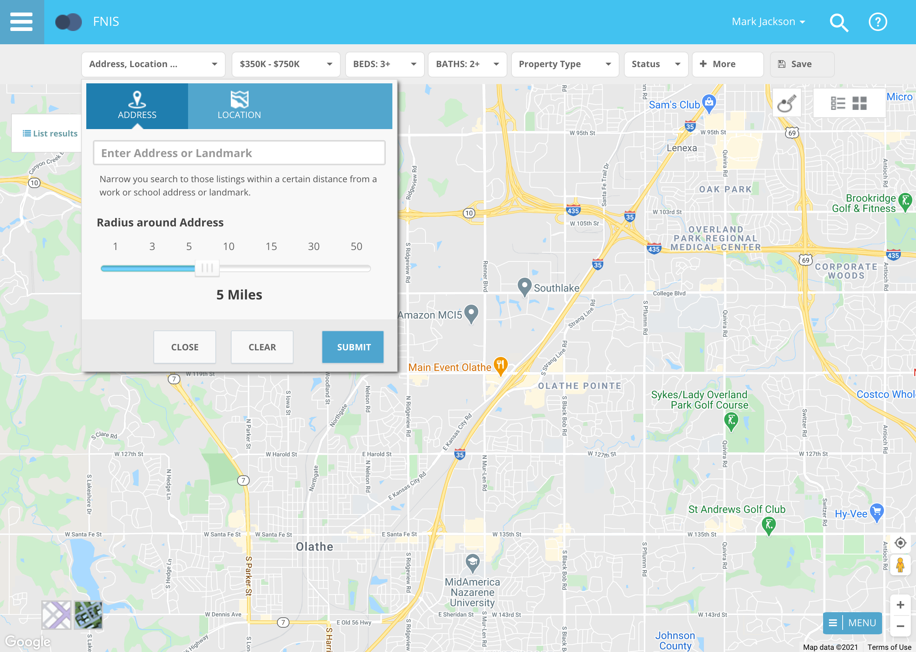

Collaboration Center - Compare Workflow
The compare workflow is a feature that allows you and/or your client to compare listings side by side while in the Collaboration Center.
To improve this workflow, Black Knight added a compare icon next to the folder icon. This will appear on each listing. To compare two listings, start by clicking this new icon next to the first listing you want to compare. The icon will turn orange and you will see a count of 1. Click the compare icon on a second listing to launch the compare screen. After you are finished comparing the two listings, click close to end the compare feature and remove your selections.
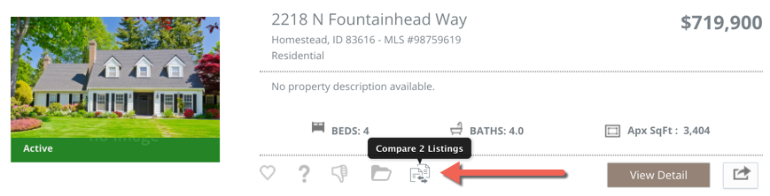
NOTE: A tooltip appears over the compare icon, “Compare 2 Listings”

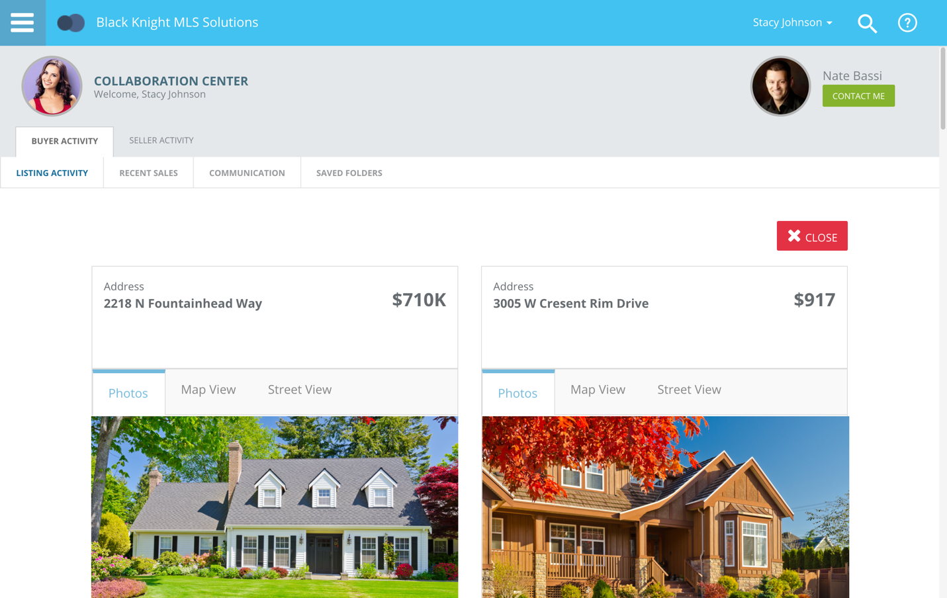

Collaboration Center – Change Search radius to an input field and change default to 1 mile/km
For Contacts who can create their own searches in Collaboration Center, they will now find the Address Search’s Radius field easier to use. We’ve removed the slider and switched it to an input field and changed the default amount from 5 miles to 1 mile. Users can input distances up to 50 miles/80 km.
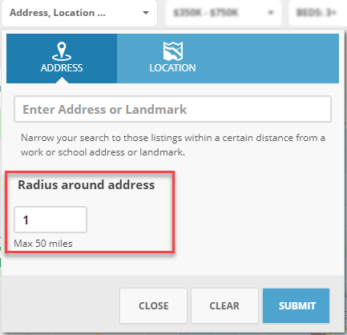

Collaboration Center – Disabled Notifications for inactive clients
The notifications in Collaboration Center are now disabled whenever a contact goes from active to inactive. This will prevent notifications from auto sending when a contact is no longer active with the agent.

Collaboration Center – Updates to Collab Center mobile property search
The Map search in Collaboration Center was missing a Save option when on a mobile device. Although the user could create a search on a mobile device, they couldn’t save it. We’ve added the Save button, updated the icons for drawing a shape and changing views, and all these tools were moved off the map and into the top app bar.
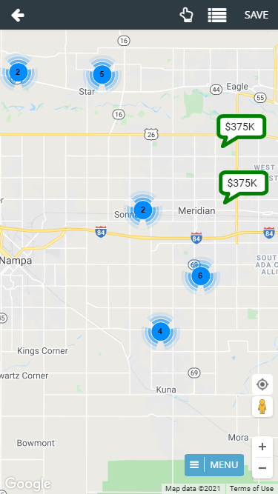

Collaboration Center – Consumer Mortgage Center
Black Knight is excited to announce the new enhanced Mortgage Center within the Collaboration Center! We have updated the mortgage calculator, and with Black Knight’s recent acquisition of Optimal Blue, we have a new tool that can provide highly accurate real-time and historical rate trends for your clients! Optimal Blue provides the technology used by major lenders to manage rate locks for the mortgage applications. This rate lock data is aggregated and anonymized to generate unique analytics that provide an accurate picture of exactly what rates are being quoted by major lenders.
The Consumer Mortgage Center will include:
- A new interactive mortgage calculator that allows consumers to enter a down payment, interest rate and terms.
- Consumers can request a customized quote directly from the Mortgage Center.
- A rate indices widget that allows consumers to see current rates and trends over time.
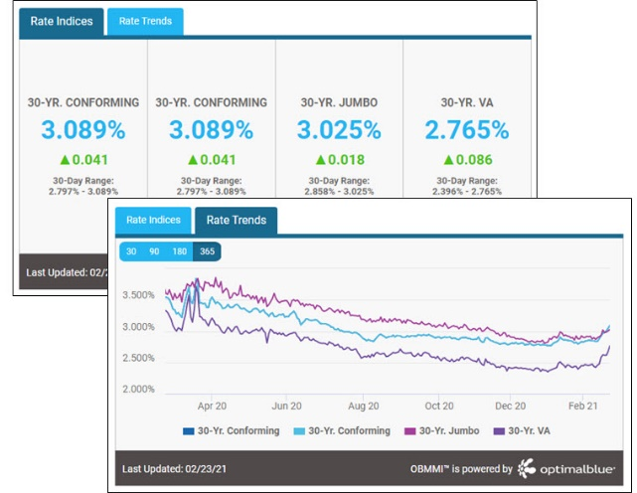
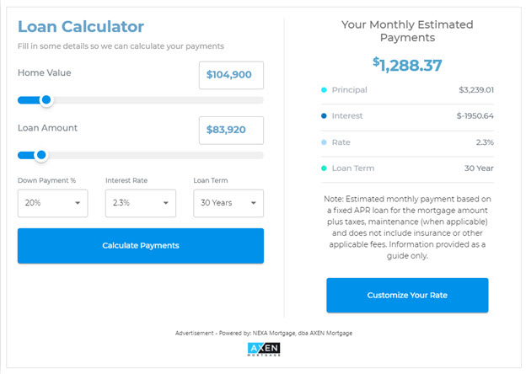
The new Mortgage Center gives the consumer all the tools they need, to know what to expect when shopping for a new loan.
The display is powered by a mortgage lender named Nexa Mortgage dba Axen Mortgage (“Axen”) and is an advertisement.

Collaboration Center – Shortcut App Icon
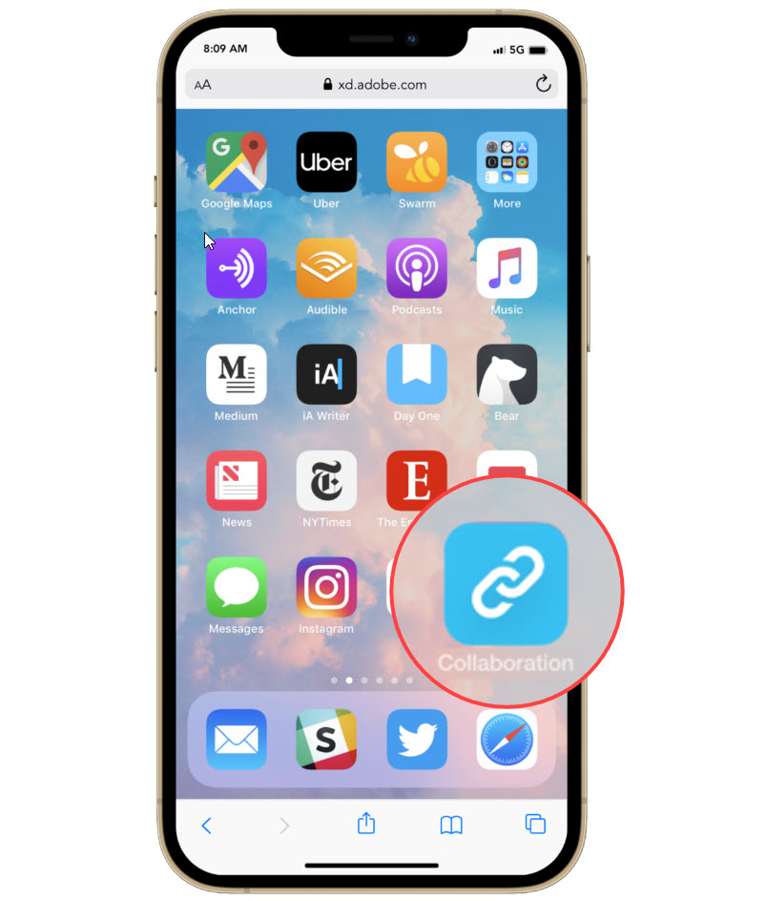
Your Clients can save an icon for Collaboration Center to their home screen on their mobile devices. We have updated the default icon with more of an app-like appearance.

Collaboration Center – Property Search Changes
The Collaboration Center property search has undergone minor changes to help enhance the search process. Below are just a few of the changes that were introduced.

Layers Control
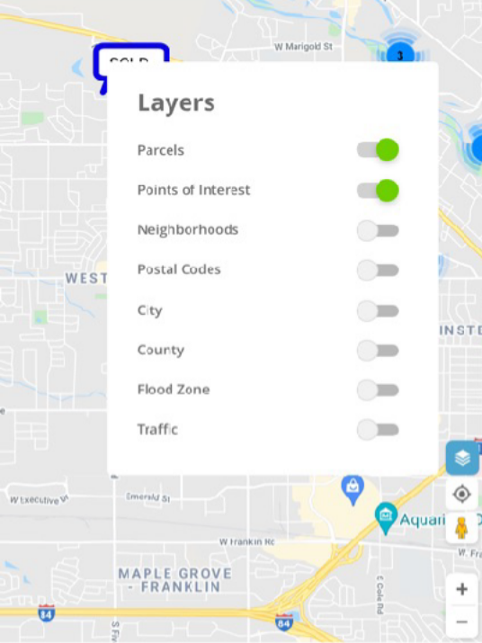
A new layer icon was added to the bottom right navigation controls. This new icon replaces the “Menu Options” button that was previously located on the map. This allows your clients to quickly enable any layer on the map. In addition, the parcel label is enabled by default. This will allow your clients to see parcel lines around properties when zoomed in on the map.



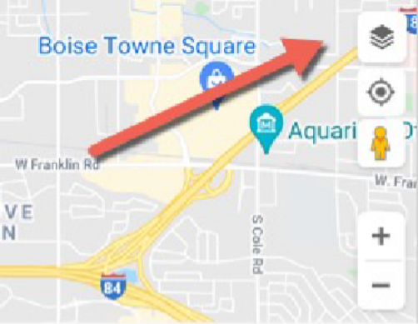
Default and Toggle Mode
Icon added above the “My Location” icon; the icon turns blue when enabled

Reset
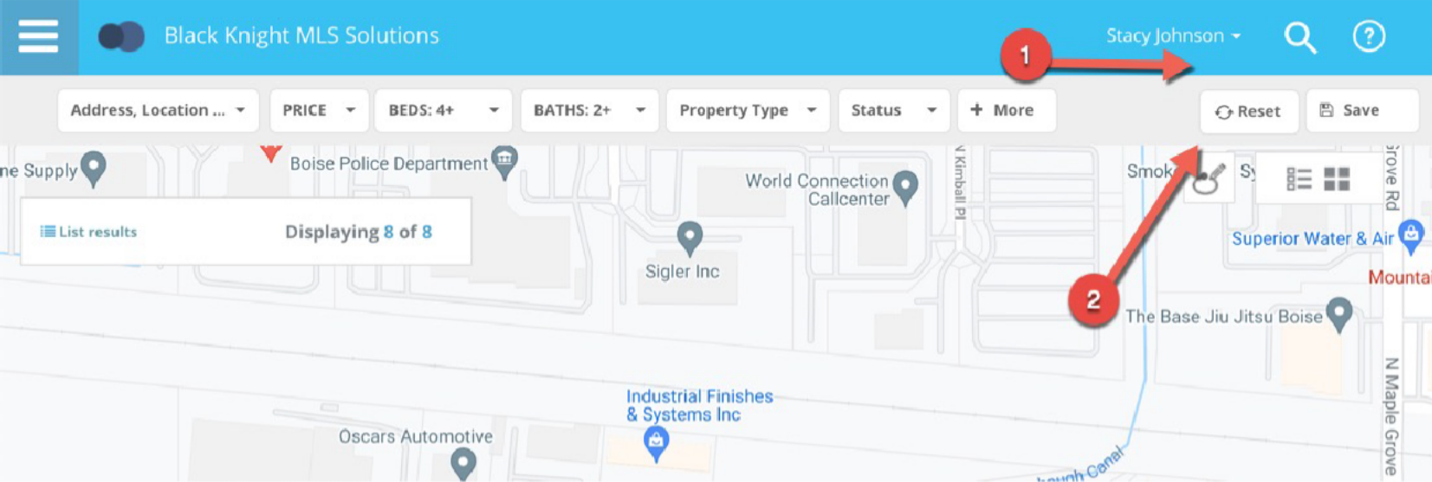
A new reset button has been added to the Collaboration Center search bar. This reset option will allow a user to reset the property search back to the default criteria as when first opened. This way if you get lost or if you want to start your search over you can click the reset button.
Price Range
Previously, the Collaboration Center search defaulted to a price range of $350K - $750K. In some housing markets, that range wouldn’t produce any results. Some markets are much higher and some are much lower. Rather than providing a default price range, the property search will no longer default to any range. It should return all prices based on the map viewing area.
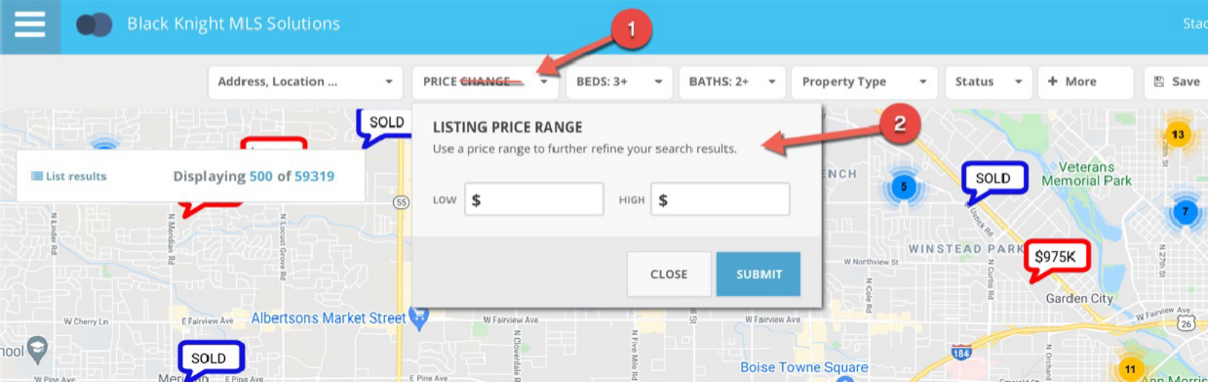
Another change to the price component is the removal of the price slider. We found that the slider was difficult to move in increments that made it easy to set a min and max price, and it also maxed out at 3.4 million dollars. Now the price contains a min and max input field that the client can use to input their own price ranges. The top label has also been renamed to just say “Price”.

Default Statuses

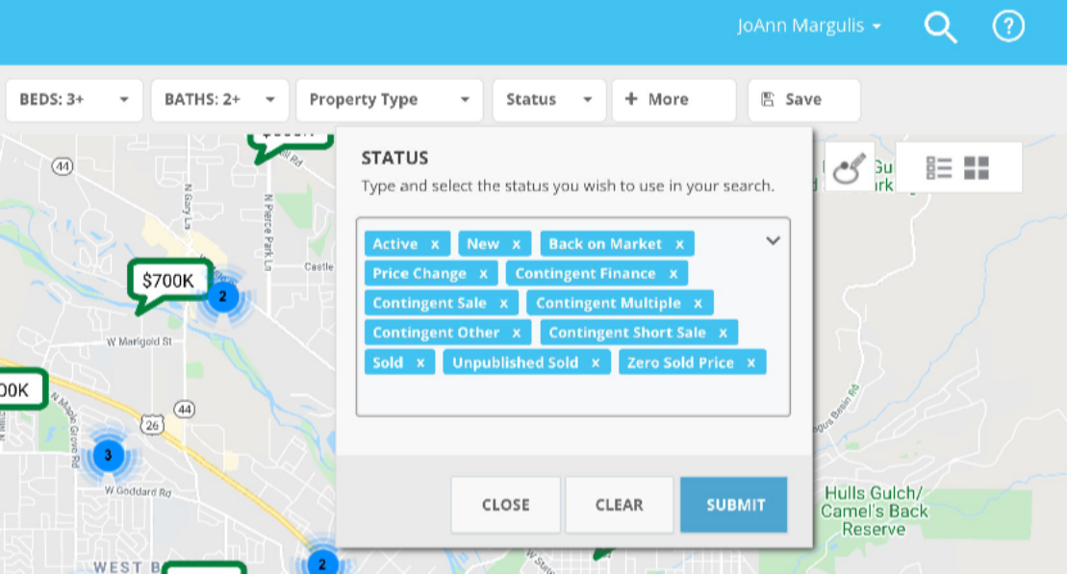
The status control contains allowable search statuses a client can use to search for listings. Prior to this release, the status control would only default to the first sub-status of active, even if you had additional active sub-statuses Now the control defaults to all allowable statuses that are available.
Example
This is an example of a system that allows for active, contingent and sold listings to be found on the map.

Status Control
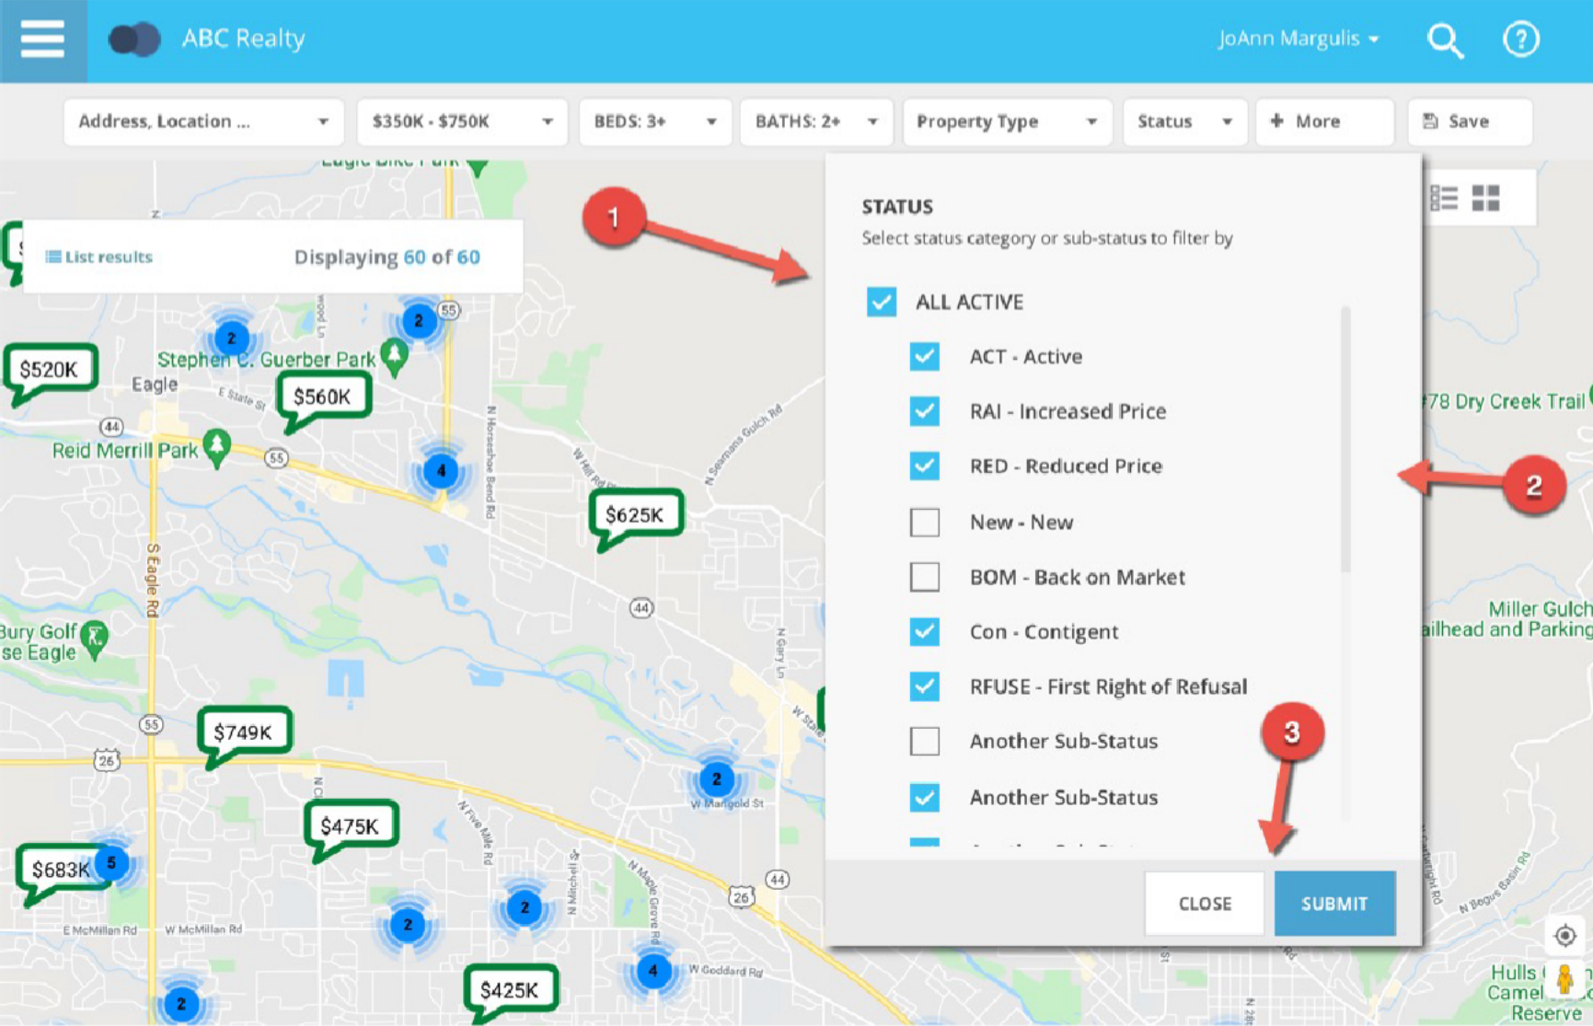
Along with defaulting to all allowable statuses, the interface and selection controls were updated. The previous lookup control required the client to either type a status or open a full screen modal to choose from a list of available statuses. Now the statuses are all visible on the control and you can easily check or uncheck the statuses you want.
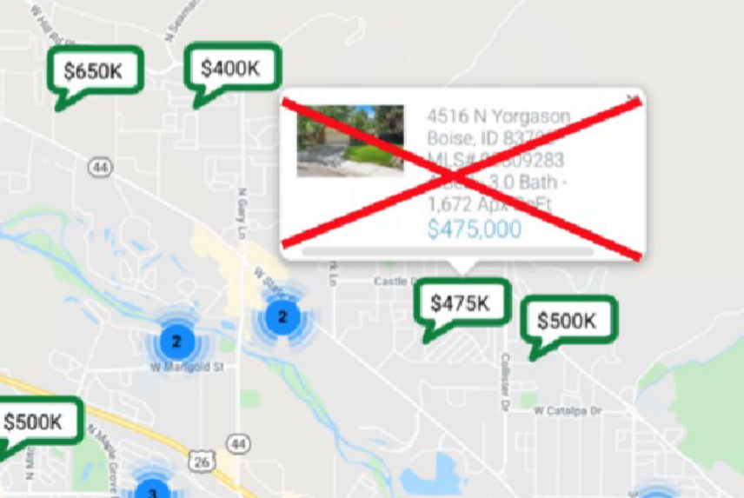
Hover Removed
While hovering over a pin, the Collaboration Center showed a hover control above the pin. This was duplicate information found in the mini preview when clicking or tapping on a pin. It has been removed.

Collaboration Center – Property Search Moved to Main Tab

Action Item: N/A
To help promote property search in the Collaboration Center for your contacts, we have created a property search feature tab on the dashboard. This allows the search feature to be more visible to your contact. The tab contains the same search features and is only found on the larger resolutions (PCs, tablets), and has no impact to mobile users.

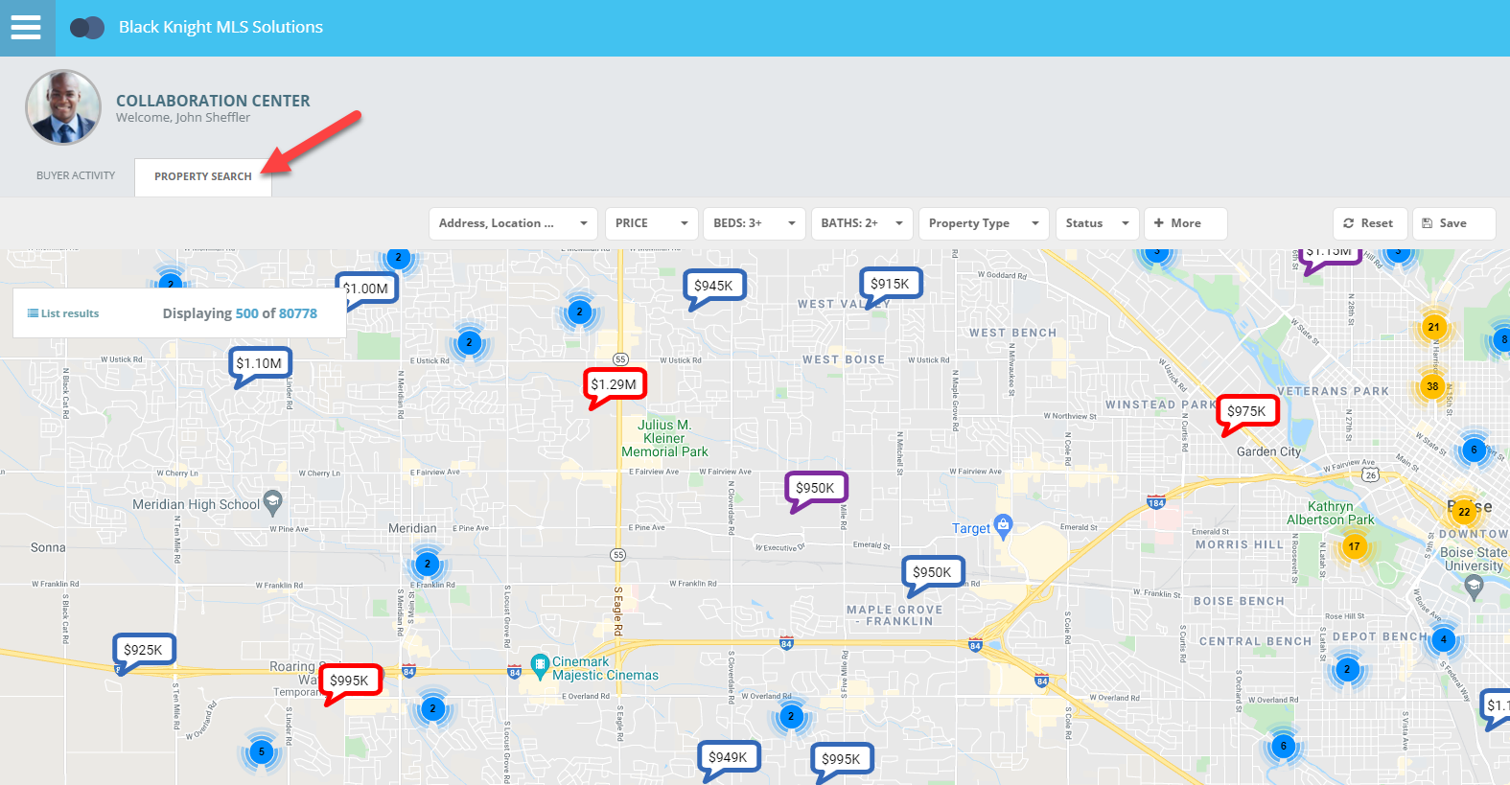

Additional Enhancements

Admin – Disable Off Market Status checkbox on Active statuses
To ensure the integrity of Active Statuses, the “Off Market Status” checkbox will now display as disabled for all statuses in Status Category 1, Active.
The “Off Market Status” option is never valid for Active statuses, so disabling it will prevent it from being accidentally enabled. It is still a valid option for all other status categories.
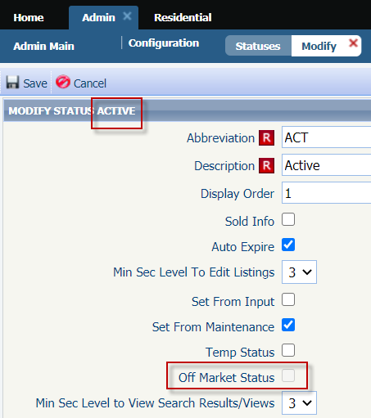

Admin – Update to Label in Status Setup
Have you had to ask around your office or call your SSM to ask what the “Maintain Field” or “Detail Security” levels do from the Modify Status admin? We’re happy to announce that you’ll never have to ask around or make that call again. We’ve renamed the labels to have a much clearer description.

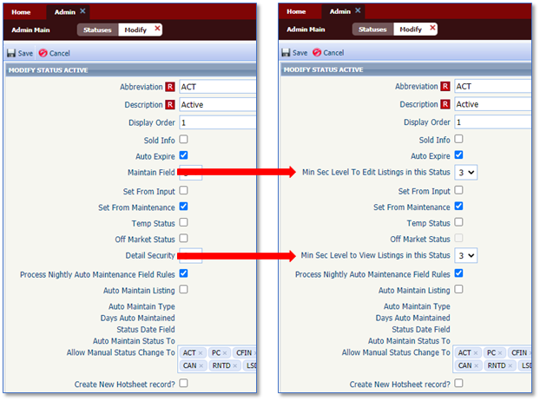

Admin – Unique User Logins Report Additions
We are excited to add new attributes to the Unique User Logins report to assist you in determining when the user first logged in and see their email address, preferred phone number and agent type.
- First Login
- Email Address
- Agent Phone (Preferred #)
- Agent Type
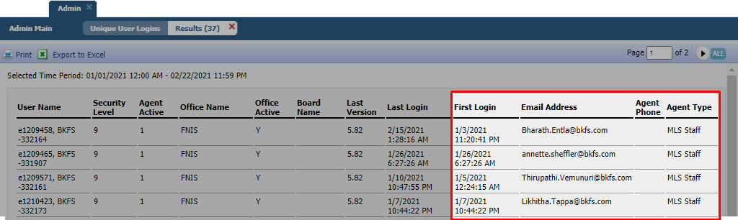

Admin – Updates to Changed Users and Changed Office Reports
To bring added benefit to the Changed Users and Changed Offices reports, users can now search by Board ID, in addition to Date Range.
We’ve also added the office Board ID (Member of Board field) and the Last Change Date to both reports. Click the Last Change Date to view the audit report for even more details!
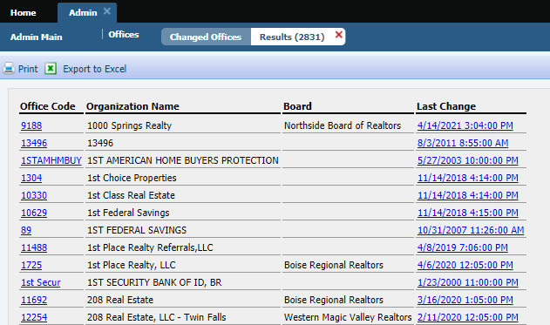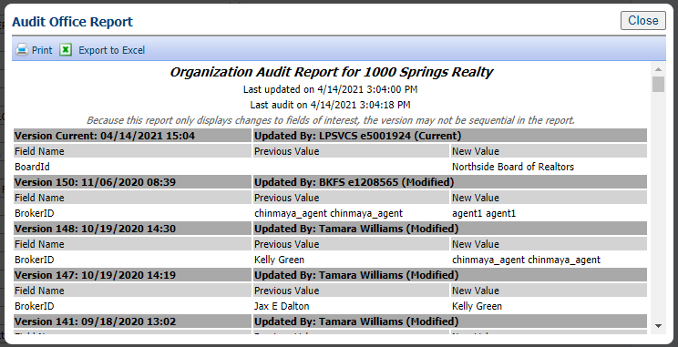
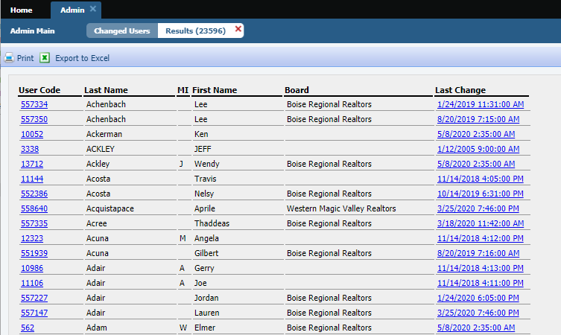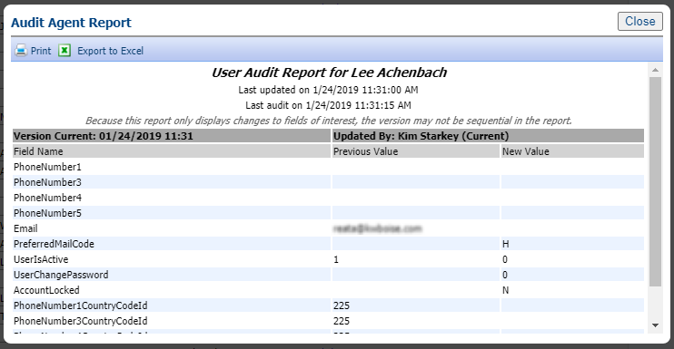

Board Configuration Enhancement for Intelligent Analytics
We have enhanced the board configuration for Intelligent Analytics to support multi-board customers where one board might utilize CRS Data and the other may utilize Paragon Tax. What are Intelligent Analytics? Great question. Intelligent Analytics are data and services made available to CRS Data and Paragon Tax customers as well as any customer who chooses to subscribe for a monthly fee. Subscribers receive the following features: Enhanced Data on the Parcel-Click Property Panel, Integrated Public Record Search from the Map View, Public Record section for the ConnectView and Paragon Connect Detail View, Public Record Property Watch and Alerts. For more information about Intelligent Analytics, contact your Black Knight sales representative.

Admin – UI Tour for Paragon Release Notes
We are excited to announce that Admin users will now have the Paragon Release Notes at their fingertips as we have added a popup UI tour. This is key as new Paragon major releases occur approximately every six to eight weeks and it’s important to communicate release changes to all your members. This popup will lead you to the secure Admin site where you can access the Release Tool Kit at any time. If you do not have a login for the administration site, contact your SSM to get one. This option will only appear for level 7 or higher users.
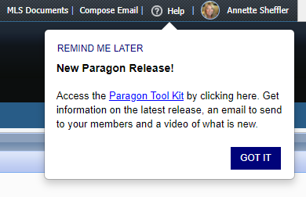

Admin – RETS Profile field for Web API client
Paragon’s Web API client uses your existing RETS profiles. When assigning the Web API to a user’s Allowed Paragon Clients, it’s no longer necessary to include the RETS client to enable the RETS Profile field. The RETS Profile field will be enabled if either RETS or Web API is included in the user’s Allowed Paragon Clients.
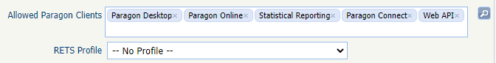

Admin – New fields added to Agent and Office grids

Action Item: N/A

For multi-board Paragon systems, we’ve added Member of Board to the Agent and Office grids and added a filter for that column. Visible boards will be based on the user’s security level. The Member of Board field displays the Office’s Member of Board value.

If Boards are not enabled on your system, the column and filter will be hidden.

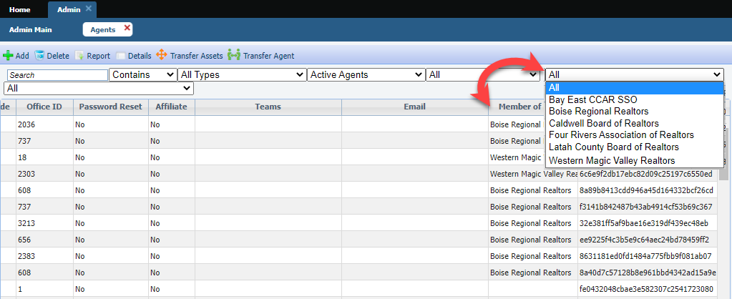
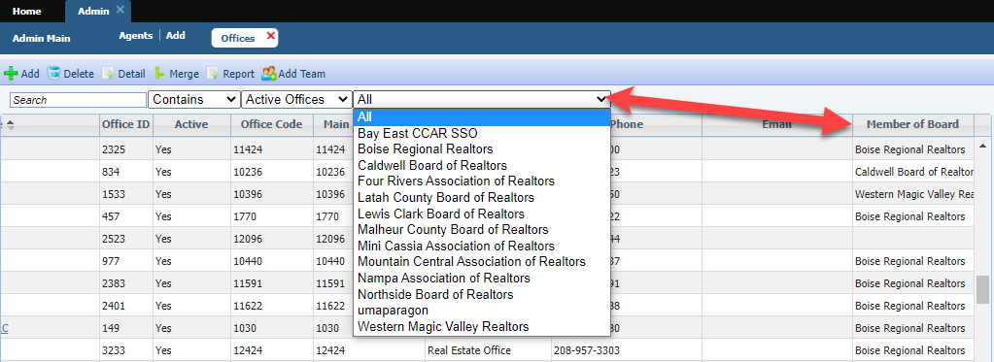

Admin – Remove DCL button

Action Item: N/A
In Admin, the DCL button has been removed from the toolbar since DCL has been retired.
