**Paragon Simplification 2023**

**Paragon Enhancements for releases** **5.93 to 5.98**

Searching - Property Search Agent and Office Field Auto-Complete Enhancements 3

Searching -Team Name Field Expansion 4

Share Listings - Share via Text Custom Message 5

Listing Input – Fix column sort on Tour and Open House grids 6

Listing Input– Geocode Boundary Warning 6

Mapping - Generate Driving Directions by Map Pin Location (i.e., Geocodes) 7

Multiple Board-level messages 8

Views and Reports – Tours and Open Houses on Custom Reports 8

Statistical Reporting – # Expired added to Market Statistics 10

Statistical Reporting – Market Activity by Location 11

Statistical Reports – Market Activity by Location and Month 12

Statistical Reporting – Display City, State in Market Activity by Location 13

Statistical Reports – Roll up zip code statistics in Market Activity by Location 14

Collaboration Center – Display agent’s Office address on notification emails 15

Collaboration Center - Rename Agent Pick to Recommended 16

Collaboration Center – Improved Agent Photo Handling 16

Collaboration Center – Consistent Price formatting in Collaboration Center and CollabLink views 17

Additional Enhancements 18

Admin – Broker Attribution has been Expanded to LIM 18

Admin - Enabling the new Paragon Connect Print Solution through TPI 19

Admin – Allow Agents to Control the Display of AVMs in Collaboration Center and CollabLink 20

Admin - Statistical Reports – Pending/Under Contract Report 23

Admin – LIM Specify Market Geocode Boundaries 24

Admin - Views and Reports – Tour and Open House Report Elements 24

Admin – View multiple board-level Homepage Messages 26

Admin - Paragon Professional Multi-Factor Authentication (MFA) Enhancements 27

Admin - New Optional Menu Options from Paragon Connect to Paragon Professional – Admin and Statistics 30

Opt-in link on Mobile Settings 30

Audit Login includes Browser and OS 31

**Searching - Property Search Agent and Office Field Auto-Complete Enhancements**

We have made changes to all property search Agent dropdown fields so that they now display the agent’s user code and whether the agent is inactive. The list will sort by first and last name, then status with the active agents appearing first.

We have also made a change to all property search Office dropdown fields to identify the inactive offices. The list will sort by name then status with the active offices appearing first.

**Note:** The office user code was already displaying in the list prior to this release.

**Figure 1: Agent Property Search Field (Note - Abbi Johnson’s Figure 2: Office Property Search Field**

**active record displays first)**

**Searching -Team Name Field Expansion**

To accommodate longer team names, the Team Name field has been increased to 100 Characters.

**Share Listings - Share via Text Custom Message**

Agents can now add an optional custom message when sharing listings through the Share via Text feature from the property Search results. This custom message field allows up to one hundred characters and the message can be previewed in the Share dialog window. Once the text is sent, it will be recorded in the contact’s Message History.

**Listing Input – Fix column sort on Tour and Open House grids**

Users can now sort the Tour or Open House records in LIM by any of the columns.

**Listing Input– Geocode Boundary Warning**

A new feature in Listing Input and Maintenance will trigger a warning if listings geocode is outside boundaries specified by your MLS. When a listing is saved, a field rule will verify the listing’s geocode coordinates to those specified by your MLS as the desired market area. If any of the coordinates are outside those boundaries, a warning is returned.

**Mapping - Generate Driving Directions by Map Pin Location (i.e., Geocodes)**

Property Search Driving Directions will now support directions based on the listing’s map pin location. The user will have two options to find the driving directions by: Address or Map Pin Location. Whichever option is chosen will apply to all listings that were selected.

This new feature will default to Address when accessed, which is currently what’s used today but the user can easily change it to Map Pin Location.

**Multiple Board-level messages**

 For multiple-board systems, users with offices belonging to more than one board will now be able to see login messages for all of their offices. The most recent message displays in the widget first; use the page tools to view additional messages. Viewing the messages in List view will display the messages in posted date order.

**Action Item:** N/A

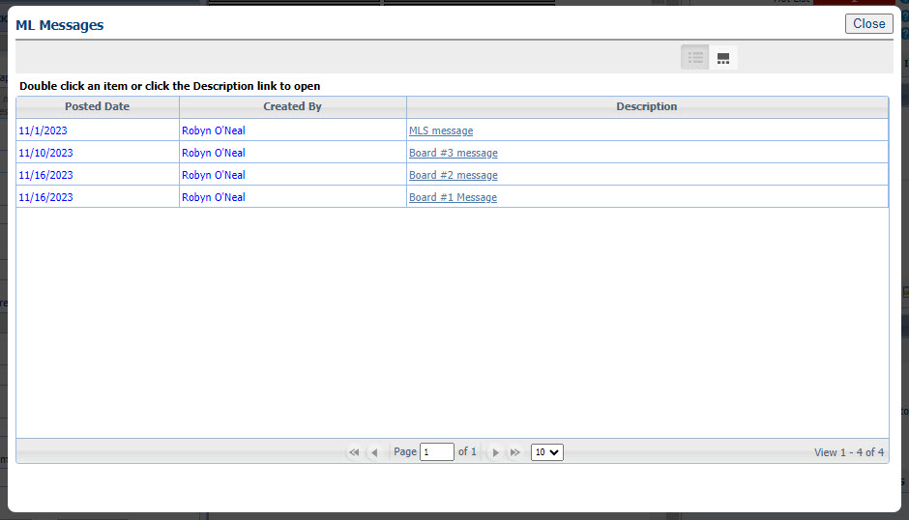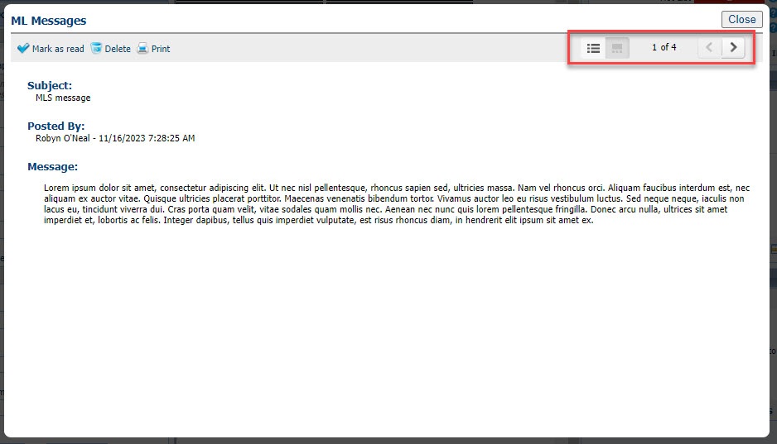

**Views and Reports – Tours and Open Houses on Custom Reports**

Two new report elements are available in the Custom Views report editor. Upcoming Open Houses (Listing View) and Upcoming Tours (Listing View) allow you to add the next three tours or open houses to any custom report view. The elements can be formatted with all the usual tools in the custom view’s editor.

Clicking on the data in the report opens the same modal as the Tour and Open House action icons, so all upcoming events can be viewed or printed.

**Statistical Reporting** – **# Expired added to Market Statistics**

A column for number of expired listings was added to the bottom grid of the Market Statistics report. The display of Expired listings is now consistent with the display of Sold listings on the grid. The preview image and explanatory text on the landing page was also updated.

Action item: N/A

**Statistical Reporting – Market Activity by Location**

Per customer request, the Market Activity by Zip and Month report has been upgraded to allow users to group the report results by other location fields besides zip/postal code. A new option on the criteria page allows the user to specify how the results are displayed: by State/Province, City, Area, or Zip/Postal Code.

**Statistical Reports – Market Activity by Location and Month**

Per customer request, the Market Activity by Zip and Month report has been upgraded to allow the results to display by State/Province, Area, City, or Zip/Postal Code. A new Display By dropdown on the criteria page allows the user to select their preferred display of the results. On the report results, the former Zip/Postal Code column will display the selected Display By option. The report has also been renamed to Market Activity by Location and Month.

**Statistical Reporting – Display City, State in Market Activity by Location**

By customer request, when Display By=City is selected for the Market Activity by Location and Month report, listings will be grouped by both city and state, and the location column will display both the city and state. This is necessary for accurate results where multiple states in the service area have common city names. Table

**Statistical Reports – Roll up zip code statistics in Market Activity by Location**

Per multiple customer requests, the Market Activity by Location > Display by Zip will roll up results into the main five-digit zip code, instead of breaking out each zip+4 into a separate line. This will provide a more complete picture of activity within a specific zip code.

Note: Canadian customers using Postal Code will not be affected by this change.

Updated Market Activity by Zip; results rolled up into main zip code

*Current report with each zip+4 broken out*

**Collaboration Center – Display agent’s Office address on notification emails**

Based on user feedback, the agent’s address displayed on Collaboration Center emails will default to the agent’s office address. Because the office address is required for emails to be sent from Paragon, this ensures that an address will always display.

## Collaboration Center - Rename Agent Pick to Recommended

The Agent Pick section label on the Collaboration Center has been updated from Agent Picks to Recommended.

**Collaboration Center – Improved Agent Photo Handling**

Some formatting changes have been made to the handling of the agent image uploaded in Paragon Professional, to improve the display of the image in Collaboration Center. The image size was changed to allow better resolution, and code was corrected that was causing the image to display off center.

**Collaboration Center – Consistent Price formatting in Collaboration Center and CollabLink views**

To present a more consistent user experience, the Price field in Collaboration Center and CollabLink views has been given a standard format. On the detail, grid, thumbnail, and Property History, the price now displays the full price, rather than a shortened version. Example: $123,456, instead of $1.2k. Map pins will continue to show the shortened price.

If the non-disclosure configuration setting is enabled, the price on status category two, Sold, displays the word “Sold” rather than zero, on all views: detail, grid, thumbnail, map, and Property History. [Existing configuration setting COLLABCENTER_NON_DISCLOSURE_REQUIRED.]

# Additional Enhancements

**Admin – Broker Attribution has been Expanded to LIM**

**Action Item:** Contact your SSM to Enabled this field.

To allow broker attribution selection on a listing-by-listing basis, we have added a new LIM field, “Broker Attribution Override” (phys num 543). This field is **disabled by default**, you must contact your SSM to enable it. Please note that this field cannot be set to Required.

This new field allows up to fifty freeform characters for entry of a phone number or email address. This field is not searchable in property searches but is viewable on listing reports. When populated on a listing, it will override the value the broker has set for the IDX/VOW data feeds in Paragon Preferences and the value entered on the listing will go out in the data feeds instead. To revert this back to the value set by the broker in Preferences, simply clear out the value entered on the listing.

Upon saving a value for this field on the listing, LIM will display a notification message indicating that it will override what the broker has set up in Preferences and will display the current Preference value. The notification will only display when the field goes from empty to populated with a value.

This field is also available for selection in IDX Smart framing views.

**NOTE:** The MLS determines the security level for who can input and update this field.

Figure 1: Paragon - Broker Attribution Override LIM field and grid notification

Figure 2: PC - Broker Attribution Override LIM field and notification

## Admin - Enabling the new Paragon Connect Print Solution through TPI

**Action Item:** New integrations have been added that will allow users to print listing data leveraging the default Agent and Consumer reports configured within Paragon Professional. As an administrator, verify that the reports automatically populated for this new feature work as expected. Then contact your SSM to let them know if you want this enabled immediately or if any report selection changes need to be made. Two weeks after the release the agent printable report will be enabled for all levels of user access.

**Steps to verify new Print feature:**

* As an administrator with staff-level access log into Paragon Connect
* View the detail report for any listing.
* From the overflow menu select the new Print option
* Click on both report options available from the print menu to confirm the appropriate Paragon reports load in a new tab for printing.
* Contact your SSM if you would like to enable these options immediately OR if the populated reports do not load or are not the preferred reports to be used.

By default, these points will be enabled for staff-only access. Administrators **must** reach out to their SSMs after validating these report selections and let your SSM know if any changes are needed.

**Admin – Allow Agents to Control the Display of AVMs in Collaboration Center and CollabLink**

**Action Item:** Contact your SSM to enable the new Admin field.

An Admin field has been added to allow MLSs to establish whether they want to permit agents to determine if AVMs display on their listings in Collaboration Center and CollabLink based on the existing VOW AVM listing field value. The new Admin feature, “Display AVM per Listing VOW Setting” can be found in Admin > Collab Center under the Detail Report section.

**Figure 1: Admin > Collab Center Feature**

**Admin Feature is OFF**

**If Display AVM per Listing VOW Setting = OFF (unchecked),** AVMs in Collaboration Center/CollabLink will function as they do today.

**Admin Feature is ON**

Display AVM per Listing VOW Setting works with the VOW AVM listing field (phys # 638) and the settings in Preferences > Collab Center > Automated Valuations.

This feature only controls whether the AVMs display in Collaboration Center and CollabLink for a particular listing, NOT whether the listing itself displays.

* **If Display AVM per Listing VOW Setting = On (checked), and VOW AVM = Yes**, the AVMs specified in Preferences > Collab Center > Automated Valuations will display in Collaboration Center and CollabLink for that listing. If no AVMs are selected in Preferences, no AVMs will display for that listing.
* **If Display AVM per Listing VOW Setting = On (checked), and VOW AVM = No**, no AVMs will display for that listing, even if AVMs are selected in Preferences.

**Figure 2: VOW AVM Listing Field**

**Note:** The VOW AVM field display name is determined by the MLS and may not actually display as “VOW

AVM’ for your MLS, but its physical number will be 638 in Admin > Fields.

**Figure 3: Preferences > Collab Center > Automated Valuations**

**Admin - Statistical Reports – Pending/Under Contract Report**

**Action Item:** Contact your SSM to change the security level on the reports.

The new Pending/Under Contract reports returns the listings with a Contract Date in the specified date range. Property data includes Contract Date, Current Status, and Current DOM, total number of listings, total volume, and average DOM. The report can be run by Agent, Office, Firm, or MLS.

The Pending/Under Contract reports are set to security level 7; please contact your SSM to change the security level.

**Admin – LIM Specify Market Geocode Boundaries**

**Action Item:** Notify your SSM if you want to set up geocode boundaries for listing input and maintenance.

Per customer request, specific geocode boundaries can be set for your market area, to assist users with correctly geocoding listings on input. By specifying the latitudes and longitudes of your general market area, a field rule will check the pin placement on the listing when the listing is saved or re-geocoded. If the pin placement is outside any of the geocode boundaries, a warning will display.

**Admin - Views and Reports – Tour and Open House Report Elements**

**Action Item:** To enable these features, add the elements to any custom report view.

Two new report elements are available in the Custom Views report editor. Upcoming Open Houses (Listing View) and Upcoming Tours (Listing View) allow you to add the next three tours or open houses to any custom report view. The elements can be formatted with all the usual tools in the custom views editor.

Clicking on the data in the report opens the same modal as the Tour and Open House action icons, so all upcoming events can be viewed or printed.

**Admin – View multiple board-level Homepage Messages**

**Action Item:** N/A

This enhancement fulfills a customer request to expand visibility of board-level homepage messages to those offices with multiple board affiliations. Previously, a user could only see the MLS-level homepage message and the homepage message for their office’s primary board. This enhancement allows users to see homepage messages for any board their office is affiliated with. When selected, the Board button on the homepage messages toolbar opens a series of tabs for all boards with an active homepage message. The default is still the user’s office primary board message.

Note: This does not impact customers that do not have multiple boards in their Paragon system.

**Admin - Paragon Professional Multi-Factor Authentication (MFA) Enhancements**

**Action Item: Manually add an email and/or phone number to the record in Paragon if one has not already been added.**

**What is MFA?**

Multi-Factor Authentication (MFA) is an electronic security measure that protects individuals and organizations by requiring users to provide at least two authentication factors to be granted access to an application or account.

**How will this affect you?**

With the 5.80 release (10/3/23 for P100 and 10/10/23 for Production Customers), certain users logging into Paragon Professional will be required to authenticate via MFA. MFA is intended for MLS Admin users, security level 7 and above and is based on the setting for Admin > Configuration > “LOGIN_MFA_SECURITY_LEVEL”. For security levels that meet or exceed the configuration threshold, those individual users will be impacted.

Admins will be asked if they want to receive the MFA code through email or text message depending on whether they have an email and/or phone number populated. If only one field is populated in Paragon, that one option will appear and will be auto selected (see screenshots below). The email that will be used is the email address in your Agent record (saved in ***Admin > Agents***). The phone number that will be used is the number setup in ***Preferences > User Preferences > Mobile Account Settings*.**

When using MFA, Admins will receive a code via email or text that will expire within 15 minutes and is allowed (3) attempts to log in. A successful attempt will authenticate the user, granting them access to Paragon Professional, and the user will not have to authenticate again for some period of time. If an incorrect code is entered 3 times, the user will have to start the authentication process over. If no email or phone is setup, the user will see a message indicating that they need to contact their Board administrator for login support.

Admins will need to ensure that they manually add an email and/or phone number in the appropriate areas of Paragon. **Note: MFA will not affect MLSs that have their own login dashboard solution, nor does it affect login access to Paragon Connect.**

Figure 1: MFA email address setup

Figure 2: MFA phone number setup

Figure 3: MFA authentication code via text

Figure 4: MFA authentication code via email

Figure 5: MFA login screens

**Admin - New Optional Menu Options from Paragon Connect to Paragon Professional – Admin and Statistics**

**Action Item: Contact your SSM to enable new menu options for Admin and Statistics**

For users who use Paragon Connect as their primary system we are offering the addition of two new items into the Paragon Connect menu. These menu items will provide quick access to two main features that are only available within Paragon Professional: Admin and Statistics.

If you are interested in enabling these menu options for your system, two new, independent configurations will need to be enabled by your System Support Manager. The configurations set the minimum Security Level required to view these menu options. **Both menu options are hidden by default.**

**Admin Menu Option:** New option to allow your system administrative users (Security Level 7 or 8) to have a quick menu option to launch the admin panel of Paragon Professional. Users meeting the minimum Security Level will see a new option in the Paragon Connect menu for “Admin”. Selecting this option will open a new browser tab. The tab will automatically sign the user into Paragon Professional and display the Admin panel without any main menu navigation options.

**Statistics Menu Option:** New option to allow your users (Security Level 2-8) to have a quick menu option to launch the Statistics panel of Paragon Professional. Users meeting the minimum Security Level will see a new option in the Paragon Connect menu for “Statistics”. Selecting this option will open a new browser tab. The tab will automatically sign the user into Paragon Professional and display the Statistics panel without any main menu navigation options.

**Opt-in link on Mobile Settings**

A link to opt-in a user’s mobile phone number has been added to Preferences > User > Mobile Account Settings. This functions the same as the opt-in link on a contact phone record. Clicking the link will send the user an email allowing them to opt their mobile number in to receive text messages from Paragon. This was specifically enabled for the multi-factor authentication challenge code, but is valid for all text messages coming from Paragon.

**Audit Login includes Browser and OS**

The Audit Login and the Unique User Logins reports now include options for browsers and operating systems.

Both audit search forms now include 4 additional fields allowing staff users to filter these reports to specific versions.

The audit reports also display the browser and operating systems for the specific login records.

This new information makes it easier to troubleshoot isolated browser or operating system issues and identify user login-pattern data.