
08

08
Fall

Fall

Paragon 10.3 & 10.4 Release Enhancements

March 2025

1. Corrected Paragon Issues 2
2. MLS Customizations and Administration 4
2.1. Character increase for CMA Disclaimer 4
3. Paragon 4
3.1. New Universal Property Identifier Fields 4
3.2. Disable Auto-Notifications for Listings Hidden from Collab Center 4
4. Paragon Connect & Collab Center 4
4.1. Paragon Connect Corrections and Improvements 4
4.2. Enhancing Power Search for a Smoother Experience 5
4.3. Enhancing Power Search for a Smoother Experience 5
4.4. Improved Address Search for Better Visibility 6
4.5. Expose Photo Descriptions in Image Alt Text 6
4.6. CMA Adjustments in Printed Reports 7

Corrected Paragon Issues
Ticket# | Module | Organization | Summary
TK-17790 | RETS | MLSL - MLS Listings | MLSL Parallel Timestamp Updating to Pacific time causing old listings to be pulled
TK-20389 | Contacts | BCRES - REB2 Residential;RANWMLS - REALTOR Assoc of NE WI | P5 - Seller Side Email Report not enabling after clients register
TK-20736 | Contacts | BCRES - REB2 Residential;SCKMLS - South Central Kansas MLS (Wichita) | Lazy load seems to freeze instead of loading next set of results
TK-21552 | CMA |  | EasyCMA Ingestion process is missing listing updates
TK-21816 | Search | RAE - REALTOR Assoc of Edmonton | Paragon Connect Mutli Class Search
TK-21949 | Field Rules | MAXEBRDI - MAXEBRDI MLS | P5 - Not Available Rules for "Area (TCAR)" and "Sub Area (TCAR)" Field Not Functioning Properly
TK-13647;TK-13722;TK-22188;TK-15955;TK-15668 | Search | CARMLS - CARMLS, Inc. (Arkansas);DMLS - Doorify MLS (Triangle);MAAR - Memphis Area AOR;MIMLS - MiRealSource;MLSBOX - Greater Baton Rouge AOR;PARMLS - Pensacola AOR;RAE - REALTOR Assoc of Edmonton;RANWMLS - REALTOR Assoc of NE WI;RMLSA - Regional MLS Alliance (Peoria) | Default Residential Search is being overwritten
TK-22488 | Contacts | BCRES - REB2 Residential | Users reporting "error loading grid" when trying to access new contact activity
TK-22630 | MLS Docs | TBRMLS - Tallahassee BOR | Some MLS/System Documents Unable to Open in Paragon Connect App
TK-22667 | Data | SDMLS - San Diego MLS | TPI ShowingTime Quick Link in PC not Displaying
TK-22650 | View/Reports | DMLS - Doorify MLS (Triangle) | DMLS- Specific features are not displaying values in the spreadsheet view
TK-22727 | Email | RAE - REALTOR Assoc of Edmonton | Office Logo does not appear in sent Welcome CC emails when sending from PC
TK-22726 | Email | RAE - REALTOR Assoc of Edmonton | Invite Email Template for CCR Mobile app is missing Unsubscribe Link
TK-22738 | Search | NA - Not Applicable | CCR - Changes to Property Search fields not updating in web or mobile app
TK-22769 | Dashboard | VALLEYMLS - ValleyMLS / NALMLS (Huntsville) | Apostrophe character in Office Name breaking homepage and all paragon usability
TK-22795;TK-22750 | General UI | DMLS - Doorify MLS (Triangle) | DMLS - Specific listings fail to load, produces "An error occurred" message
TK-22802 | General UI | SCWMLS - South Central Wisconsin (Madison) | Collab Center > Recent Sales showing 'Undisclosed Address' on thumbnail view for all listings
TK-22730 | Email | BCRES - REB2 Residential;COLUMBIA - ConsolidatedMLS;LAWBOR - Lawrence BOR;RAE - REALTOR Assoc of Edmonton | Base Opt In Link URL gives false message when opting user back in
TK-22831 | CMA |  | EasyCMA - Suggested price issues
TK-22951 | View/Reports | RAE - REALTOR Assoc of Edmonton | Rename P5 Client "Collab Center Premium" to just "Collab Center"
TK-23002 | Messaging | RAE - REALTOR Assoc of Edmonton | PC Expire Notice showing for listings that should not Auto-Expire
DEV-15862 | Mapping or Geo-coding | PRIMEMLS - Prime MLS (NEREN) | CC & PC > Enabled Lightbox parcel lines are displayed when the layer icon is clicked
DEV-15615;DEV-15714 | Dashboard | VALLEYMLS - ValleyMLS / NALMLS (Huntsville) | PC - Apostrophe character in Office Name breaking Pendo
MOB-85 | Third Party | RAE - REALTOR Assoc of Edmonton | Android >GeoJet integration is not working like iOS

MLS Customizations and Administration

Character increase for CMA Disclaimer
If your system uses the optional, special disclaimer specifically for CMAs (found in CMA_DISCLAIMER), the character limit for this option has been increased from 255 to 1024. If you need to modify the disclaimer, please note any increase in text may also require adjustments to your CMA report displays to accommodate.

Paragon

New Universal Property Identifier Fields
We added two new fields to the Paragon database for future use in tracking universal property ID values to listings. These fields are intended for background purposes and should not be modified. The fields currently do not contain any data. They will not appear on Listing Input Forms, but will appear in RETS Metadata once a RETS Refresh has been completed.

Disable Auto-Notifications for Listings Hidden from Collab Center
The existing option to hide listings in specific statuses from the Collaboration Center was not applied to automated emails. With this release any changes to hidden listings will no longer be sent via automated notification.

Paragon Connect & Collab Center

Paragon Connect Corrections and Improvements
- Update to default font colors for better visibility
- Corrections for loading content while scrolling when device zoom is greater than 100%
- Corrections for showing Message Center notice of listings that should not automatically expire
- Update to the Help Link on Collab Center to reference the new help site
- Improvement to include the Match My Contacts link to the Published Listings overflow menu

Enhancing Power Search for a Smoother Experience
We have separated the "Near Me" search icon from the search bar, making it more visually distinct and easier to use as a standalone feature. This update enhances clarity and creates a more seamless search experience. These refinements, driven by user feedback, apply to both the Power Search module in Paragon Connect and the address search bar in Collaboration Center.
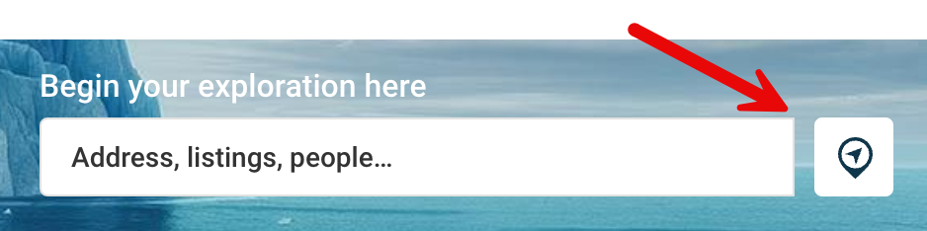

Enhancing Power Search for a Smoother Experience
We've made another enhancement to Power Search in Paragon Connect! Now, the current location option appears as soon as you open the Power Search page, giving you instant access to the map for a faster way to find listings near you. A quicker, more seamless search experience—right from the start!

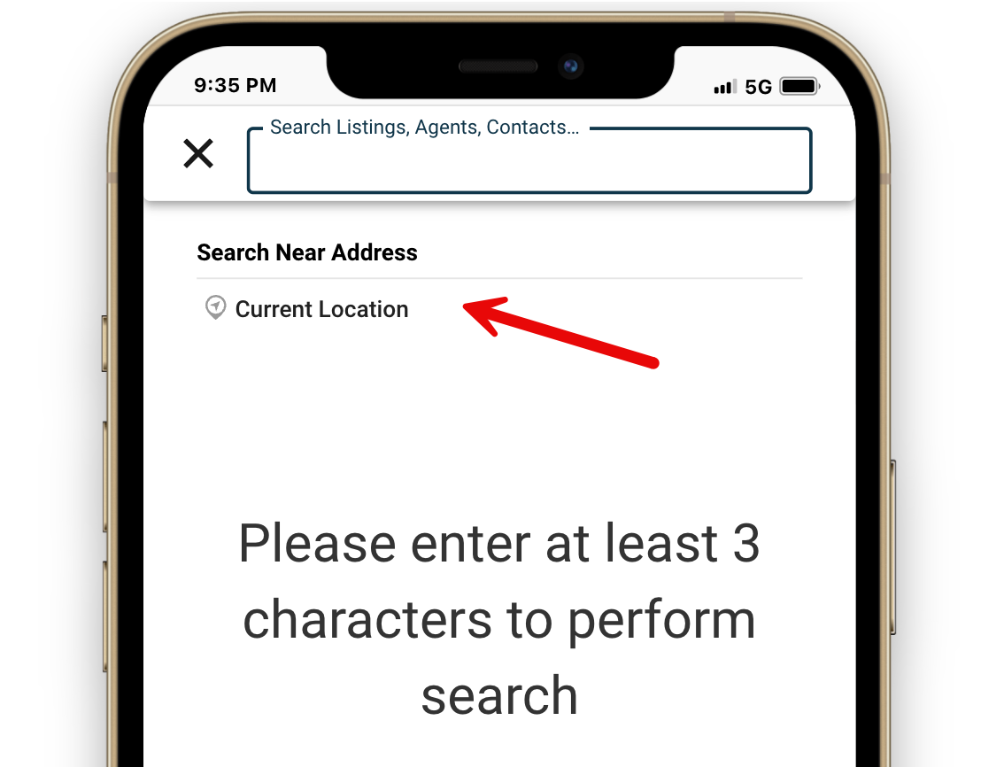

Improved Address Search for Better Visibility
We've streamlined the address search in Power Search, reducing the results from five to three. This update improves visibility, ensuring important content isn't hidden by the keyboard on certain phones. A cleaner, more user-friendly experience, right at your fingertips.

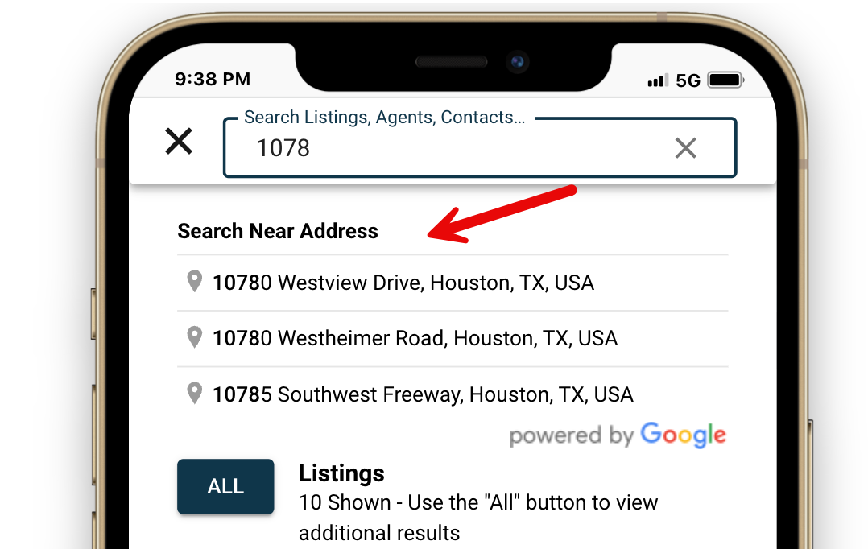

Expose Photo Descriptions in Image Alt Text
We're enhancing accessibility across Paragon Connect, Collaboration Center, and CollabLink by improving image alt text for listing photos. Now, photo labels and descriptions will be included, ensuring a more inclusive experience for all users.

CMA Adjustments in Printed Reports
Now, your CMA adjustments seamlessly carry over to printed and PDF reports, ensuring your customizations are always reflected. With this update, the “Summary of Comparable Properties” page will now include both default and manual adjustments, giving you a polished, professional report every time.

