08

08

**Fall**

**Fall**

Paragon 11.1 Release Enhancements

April 2025

1. Corrected Paragon Issues 2

2. MLS Customizations and Administration 2

2.1. No new options 2

3. Paragon Suite 2

3.1. Corrections and Improvements 2

3.2. EasyCMA Settings moved to main Settings 3

3.3. EasyCMA Footer Updates 3

3.4. Collaboration Center – Default Interest Rate Update 4

3.5. Paragon Connect – Email button in Agent/Office Detail 4

3.6. New Message History – Paragon Connect 5

3.7. Share Unpublished Listings 6

3.8. Power Search All - Updates 6

3.9. Showing Requests Now Logged in Message History 7

3.10. Rotate Phone – Photo Gallery 7

3.11. Mobile App Setup Workflow Updated 8

# Corrected Paragon Issues

|  |  |  |  |
| --- | --- | --- | --- |
| Ticket# | Module | Organization | Summary |
| [TK-22790](https://jirabkmls.atlassian.net/browse/TK-22790?atlOrigin=eyJpIjoiMjBhNWIzMmFjMjdiNGE1YzhhZTE4YmM0ZjA0MDM4ZWYiLCJwIjoiZXhjZWwtamlyYSJ9) | Print | CR - California Regional MLS;SCWMLS - South Central Wisconsin (Madison) | Print PDF Displaying HTML for Open House information on custom reports |
| TK-23057 | LIM | GALMLS - Greater Alabama MLS;KMA - Kentucky MLS Alliance | Updating to Sold Status with Selling Agent 2, no Selling Agent 1, breaking Sold Stats Reporting |
| TK-22832 | Login/SSO |  | MIMLS - Implement SSO Link to Relevate from PC Native with Paragon as the IDP |
| [TK-23351](https://jirabkmls.atlassian.net/browse/TK-23351?atlOrigin=eyJpIjoiMjBhNWIzMmFjMjdiNGE1YzhhZTE4YmM0ZjA0MDM4ZWYiLCJwIjoiZXhjZWwtamlyYSJ9) | WebAPI | MRED - Midwest Real Estate Data | P160:MRED - OpenMLS InternetTracking Endpoint Returning Records with Earlier EventTimestamp than Specified in Filter |
| [TK-23466](https://jirabkmls.atlassian.net/browse/TK-23466?atlOrigin=eyJpIjoiMjBhNWIzMmFjMjdiNGE1YzhhZTE4YmM0ZjA0MDM4ZWYiLCJwIjoiZXhjZWwtamlyYSJ9) | Print | VALLEYMLS - ValleyMLS / NALMLS (Huntsville) | ValleyMLS: Using Print + Concessions Amount data is removed. |
| [TK-23510](https://jirabkmls.atlassian.net/browse/TK-23510?atlOrigin=eyJpIjoiMjBhNWIzMmFjMjdiNGE1YzhhZTE4YmM0ZjA0MDM4ZWYiLCJwIjoiZXhjZWwtamlyYSJ9) | View/Reports | PARMLS - Pensacola AOR;PRIMEMLS - Prime MLS (NEREN) | "Price Per SqFt" Field not displaying values in Connect |
| [TK-23525](https://jirabkmls.atlassian.net/browse/TK-23525?atlOrigin=eyJpIjoiMjBhNWIzMmFjMjdiNGE1YzhhZTE4YmM0ZjA0MDM4ZWYiLCJwIjoiZXhjZWwtamlyYSJ9) | Search | BCRES - REB2 Residential | BCRES: Specific listings will not load on PC Detail - shows UI Console error |

# MLS Customizations and Administration

## No new options

# Paragon Suite

## Corrections and Improvements

* Corrections for the Price/Sqft value to display properly on spreadsheet views
* Improvement to include “Request a Showing” emails sent from CollabCenter in the Paragon > Sent Message history

## EasyCMA Settings moved to main Settings

We moved the settings for EasyCMA from the CMA Dashboard to the main Settings menu.

You can now find EasyCMA settings for Adjustments, Comparables, etc by going to the main menu, selecting Settings, then choosing EasyCMA.

For quick access, we added a settings icon, a gear image, to the EasyCMA dashboard to quickly link you to the EasyCMA settings.

## A screenshot of a computer AI-generated content may be incorrect.EasyCMA Footer Updates

We've updated the EasyCMA report to ensure compliance and consistency. The custom footer has been replaced with the official MLS-configured disclaimer, set directly by your MLS. To streamline this process, the CMA footer option previously found in settings has been removed. Now, every report reflects the most accurate and authorized information.

## Collaboration Center – Default Interest Rate Update

The Detail Report in the Collaboration Center includes a built-in mortgage calculator, empowering your buyers to estimate monthly payments with ease. One key input is the interest rate, which can be customized through your configuration settings. For MLS customers without a custom rate set, we've updated the default from 4% to 6%—ensuring estimates better reflect today’s market conditions and provide a more realistic picture for your buyers.

## Paragon Connect – Email button in Agent/Office Detail

The email button in the Agent/Office section of the Detail Report in Paragon Connect just got an upgrade! Previously, tapping the button would launch your device’s default email app. Now, it seamlessly opens our built-in email module—making it easier than ever to share a link to the report directly. It’s a faster, smarter way to communicate and ensures the agent you’re emailing gets exactly what they need.

## New Message History – Paragon Connect

A powerful new addition has arrived in the My Content menu—introducing the Message History module. This centralized hub gives you instant access to all the messages you've sent to clients, whether it's an auto email, a manual email, or even a text message.

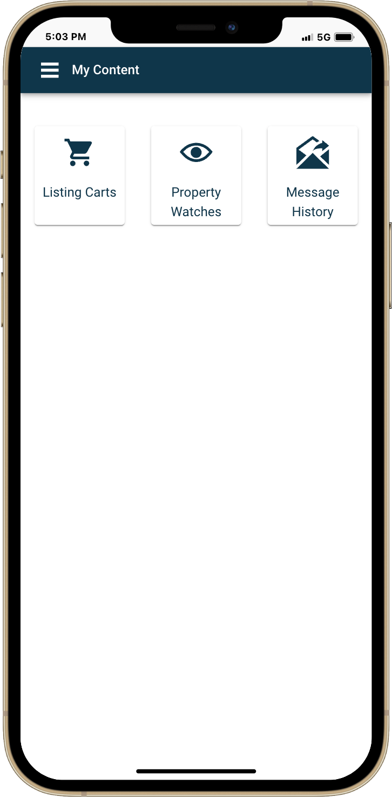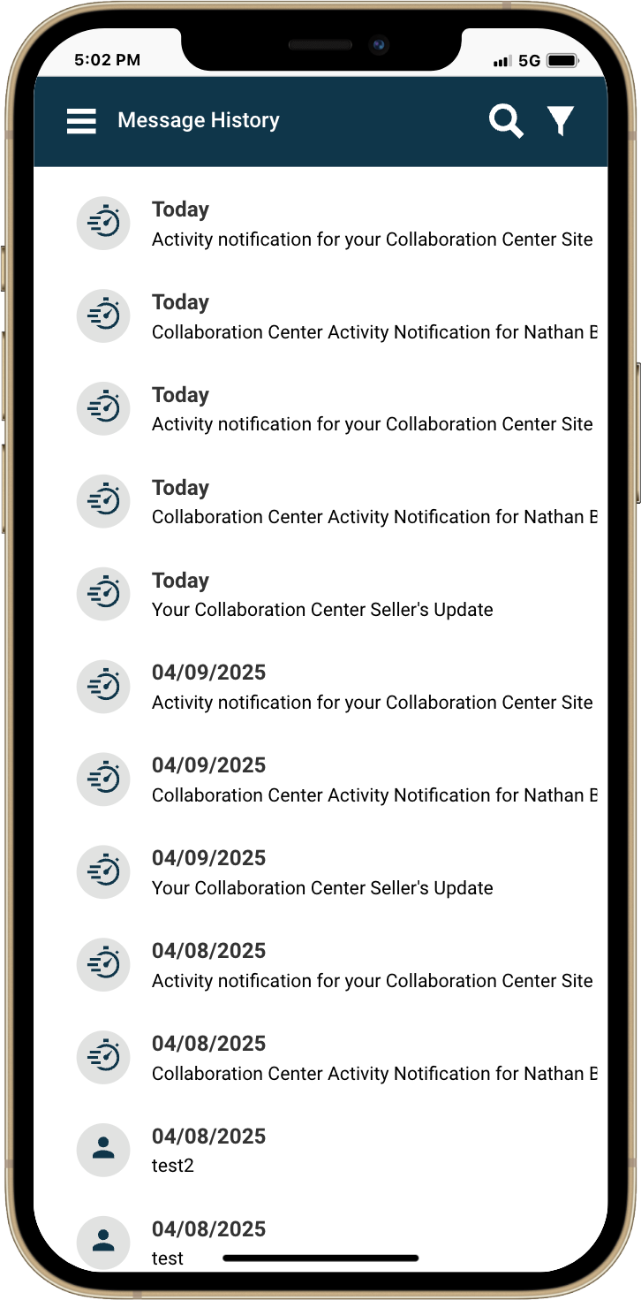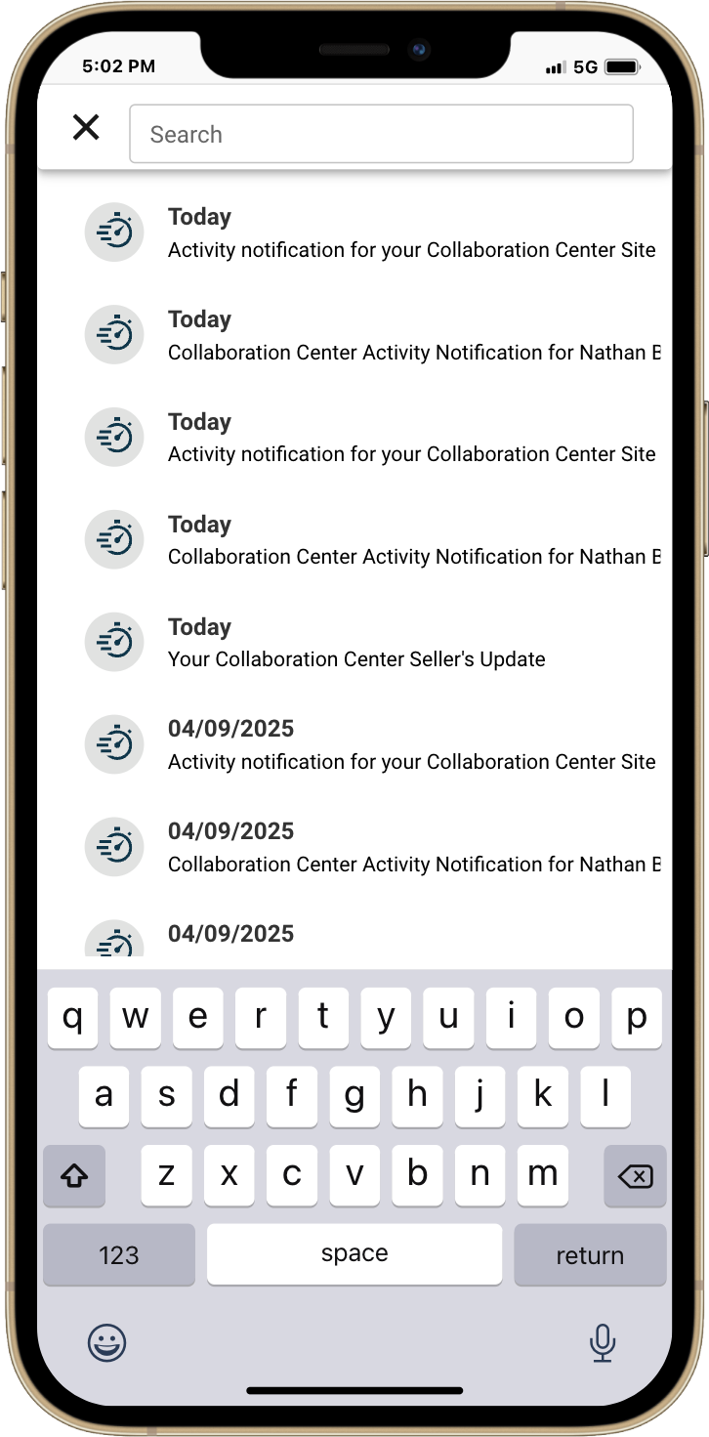With smart filters and enhanced search capabilities, you can now search not just by message title, but also by specific email addresses—making it easier than ever to find exactly what you're looking for. No more jumping from contact to contact. Everything you need is in one convenient place, designed to save you time and keep your communication organized.

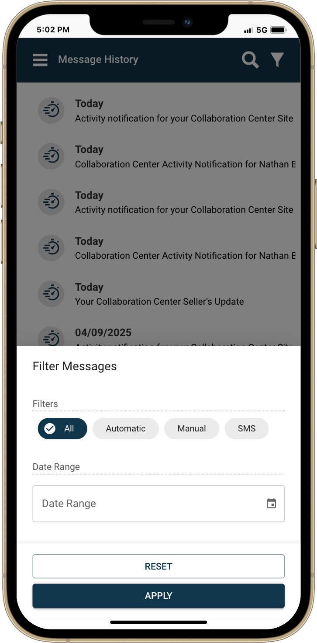

## Share Unpublished Listings

New in Paragon Connect—you can now share unpublished listings with ease! Whether you want to email, text, or copy a link, this feature makes it simple to give clients a preview or verify listing details before going live. The shared version is a public-facing report, ensuring that all agent-only information remains private while still providing a polished, professional experience for your clients.

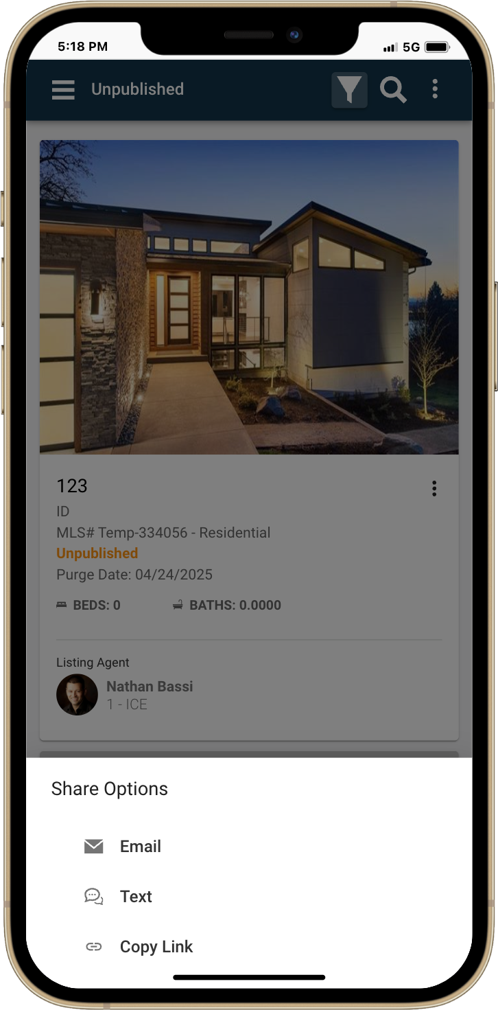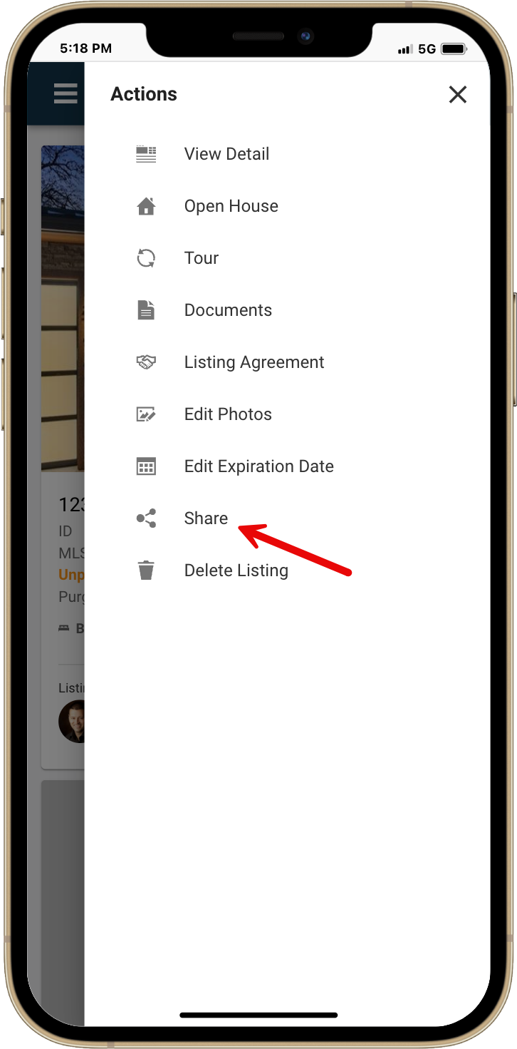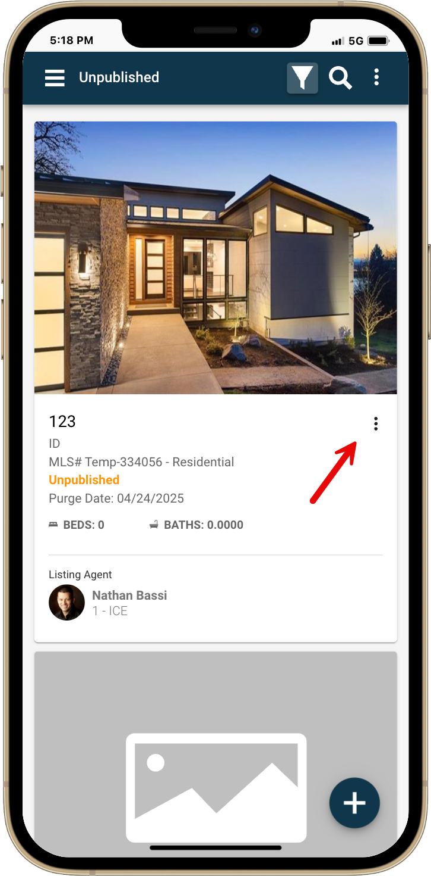

## Power Search All - Updates

In our previous release, we introduced the powerful new Power Search feature—giving you the ability to view all results, not just those returned by our Elastic Search algorithm. Now, we’ve taken it a step further with smart refinements to make your search even more intuitive.

Listing results are now automatically sorted by status category, starting with Status Category 1, so you see the most relevant listings first. Plus, we've enhanced the “name” search capabilities—you can now search by either first or last name making it easier than ever to find Users or Listings for a specific agent. It's all about faster, more targeted results—right at your fingertips.

## Showing Requests Now Logged in Message History

When your contacts use the Request a Showing feature in the Collaboration Center, those emails will now appear directly in their message history. Previously, these notifications were only stored in the Sent Messages folder under Contacts in Paragon Pro, making them harder to track.

With this update, all showing requests are now conveniently stored in the message history within both Paragon Pro and Paragon Connect. You'll find them right alongside your other client communications—no more digging or switching screens. It's a faster, more organized way to stay connected and in control of your client interactions.

## Rotate Phone – Photo Gallery

A better photo viewing experience is here! Now in both Paragon Connect and the Collaboration Center mobile apps, you can rotate your phone horizontally to enjoy full-screen photos in the gallery. Zoom in with a simple pinch to see every detail up close—giving you and your clients a clearer, more immersive view of each property.

## Mobile App Setup Workflow Updated

Available with the 1.1.3 Agent Mobile app - In stores mid-April

We've refreshed the setup experience in the Paragon Connect mobile app, giving it a cleaner, more polished look with updated visuals—while keeping all the same great functionality.

For organizations that bypass SSO dashboards and require members to create a password, we’ve made that process even smoother. In these specific cases, users will now see a dedicated screen prompting them to create a password during setup. For everyone else, the flow remains unchanged, but everyone sees the update interface!

This enhancement simplifies onboarding and makes it easier to guide users through secure password creation when needed.

