08

08

**Fall**

**Fall**

Paragon 11.2 Release Enhancements

April/May 2025

1. Corrected Paragon Issues 2

2. MLS Customizations and Administration 3

2.1. No new options 3

3. Paragon Suite 3

3.1. Corrections and Improvements 3

3.2. Improved Partial/Unpublished Listing Retention 3

3.3. Agent Recommendations with Default Comments 4

3.4. Quick Actions Widget Updates 5

3.5. A New Way to View Reports 5

3.6. Multiple Voice Tones – Restb.ai Remarks 6

3.7. Contact Manual Email Templates 7

3.8. New UI Tour to Boost Listing Ad Engagement 8

# Corrected Paragon Issues

|  |  |  |  |
| --- | --- | --- | --- |
| Ticket# | Module | Organization | Summary |
| TK-17644 | WebAPI | NTREIS - North Texas REIS | OpenMLS: [NTREIS] AOR Lookups Not Being Generated |
| TK-23712 | Print | RAE - REALTOR Assoc of Edmonton | Price Increase/Decrease Arrow is incorrect when printing in PC |
| TK-23671 | View/Reports | CARMLS - CARMLS, Inc. (Arkansas) | Listing Without Pics Report has incorrect name when printed "Active Listings Without Pics" |
| TK-22820 | Search |  | How Sold does not yield accurate results in PC |
| TK-23057 | Statistics | GALMLS - Greater Alabama MLS;KMA - Kentucky MLS Alliance | Sold Stats Reports breaks if Selling Agent is missing |
| TK-23463 | LIM | RANWMLS - REALTOR Assoc of NE WI | RANW: Apostrophe in Street Name changes LIM Setup on All Classes |
| TK-23468 | Tour/Open House | MAXEBRDI - MAXEBRDI MLS | Tour/Open House Search error with Status |
| TK-23511 | Search | PRIMEMLS - Prime MLS (NEREN) | PC listing results Sort options are incorrect |
| TK-23353;K-22993;TK-23124 | PowerSearch | PRIMEMLS - Prime MLS (NEREN) | P140 DI showing 0 consumers frequently |
| TK-22757;TK-22909 | Email | CR - California Regional MLS;RAE - REALTOR Assoc of Edmonton;SCWMLS - South Central Wisconsin (Madison) | Phone Icon Not Displaying Properly In Top-Left Corner of Collab Center Notifications |
| TK-2907 | Other |  | When exporting listings from a datashare that uses photo url's process errors |
| DEV-16054 | Conversion: Export | MRED - Midwest Real Estate Data | PETL: Change When [cnv_getconverteditemcounts] SPROC Is Run |
| DEV-16030 | Data Mapping | MRED - Midwest Real Estate Data | PETL: [MRED] Make "source_system_contact_key" Field Mappable |

# MLS Customizations and Administration

## No new options

# Paragon Suite

## Corrections and Improvements

* Correction for showing the proper price change arrow when printing
* Correction for the Sold Stats report giving an error if Selling Agent value is missing
* Correction for handling related Field Rules for Address when there are apostrophes in street name
* Correction for the listing results Sort Options
* Update to replace the Black Knight logo for the ICE EZ Value AVM

## Improved Partial/Unpublished Listing Retention

Partial and unpublished listings will now be deleted based on their **Update Date** instead of the Input Date. This ensures that recently modified partials are retained, giving agents more flexibility to complete and publish listings without losing progress. This change helps prevent accidental purging of active work and aligns the cleanup process with real agent activity.

The new purge date will be displayed in LIM for both Paragon and Connect as well as the automated emails notifying of the upcoming deletion.

## Agent Recommendations with Default Comments

In a previous release, we introduced an optional comment field for agents when recommending a listing. If a comment was added, consumers using the Collaboration Center mobile app received a push notification highlighting the recommendation.

However, if no comment was entered, no notification was sent—reducing visibility for the consumer.

To improve engagement, we’ve now added a default placeholder comment: "Here is a listing for your review." If the agent does not enter a custom comment, this default will be used and a push notification will be sent. This ensures that every recommendation draws attention, even without a personalized message.

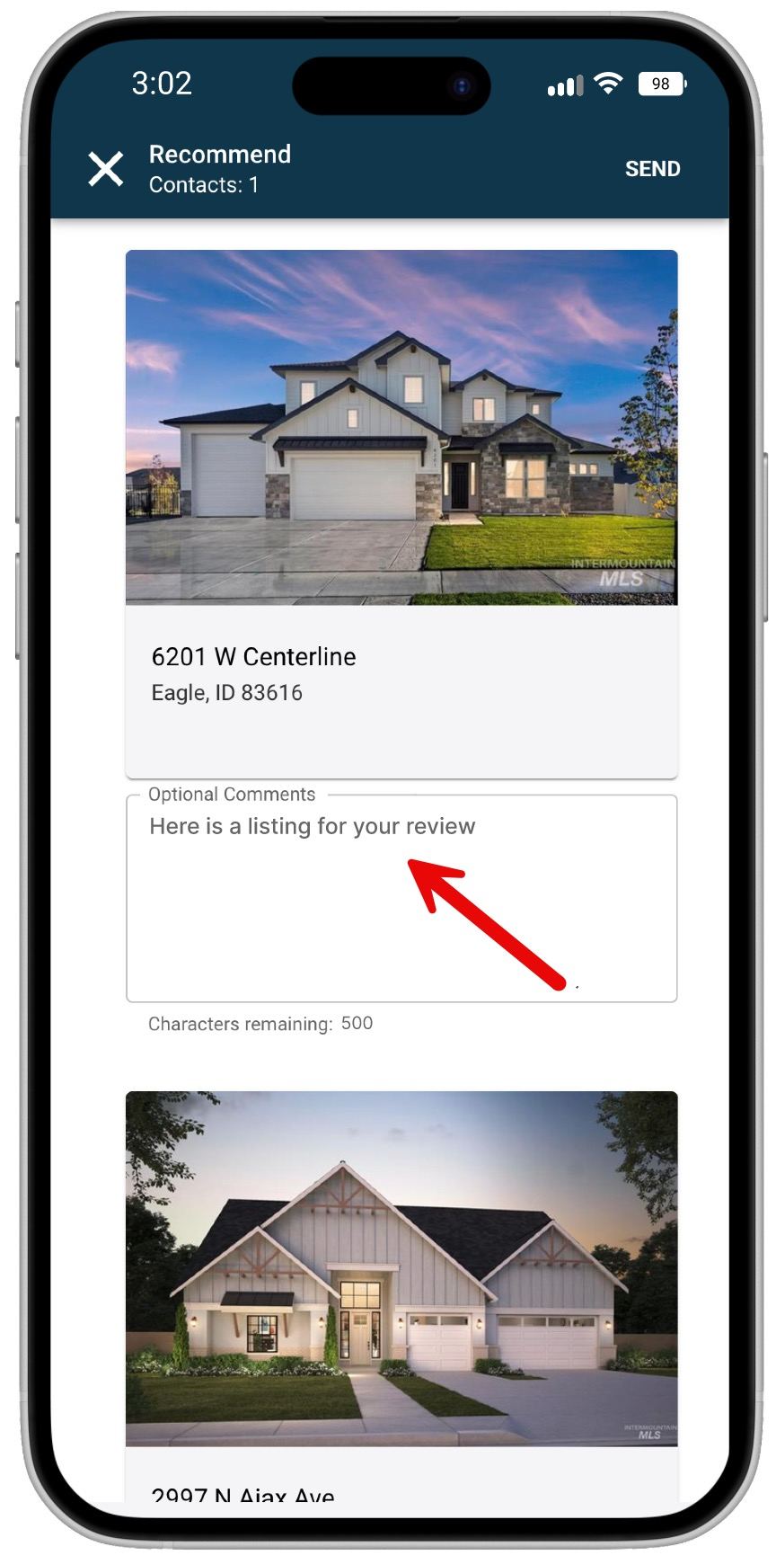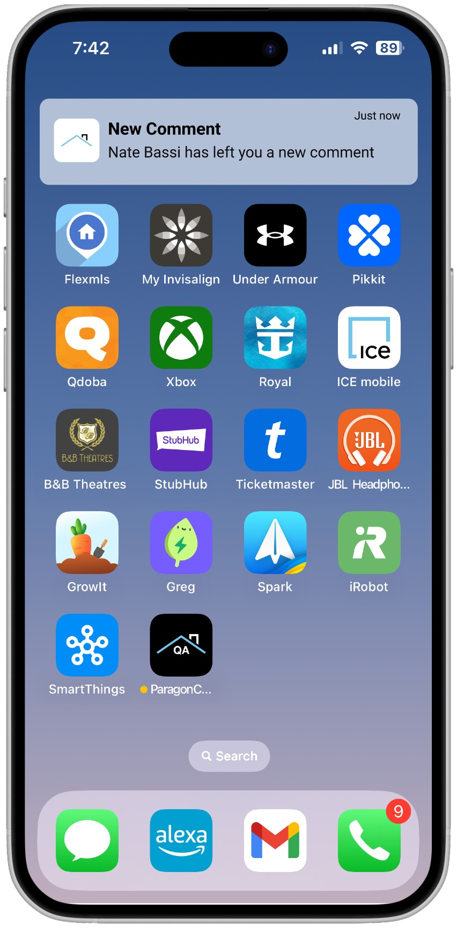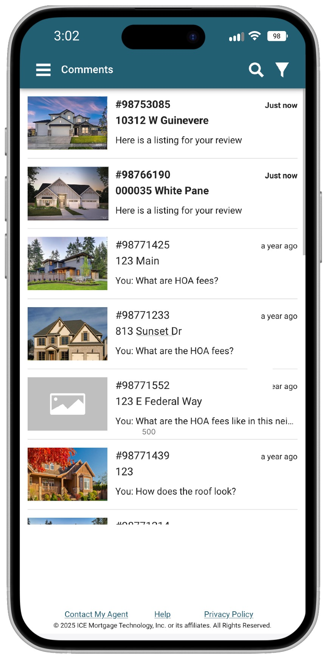

## Quick Actions Widget Updates

We’ve made a few changes to the Quick Actions widget in Paragon Connect. With Power Search now featured prominently in the top banner, it has been removed from Quick Actions. The Property Watch link was also removed, as it now has its own dedicated widget.

Based on agent feedback, we’ve added a new Quick Action: "Create New CMA." This lets agents quickly launch a new CMA directly from the dashboard.

## A New Way to View Reports

As we gear up to introduce new reports, we’ve improved how you access them—making the experience cleaner, faster, and more intuitive.

Now, when you click or tap the View Switcher icon, reports will appear in a sleek side sheet instead of a bottom drawer or pop-up dialog. This new layout offers more space, better organization, and easier navigation across all available reports.

To help you stay oriented, the active report you’re viewing will now be subtly highlighted with a background effect—making it easy to see exactly where you are.

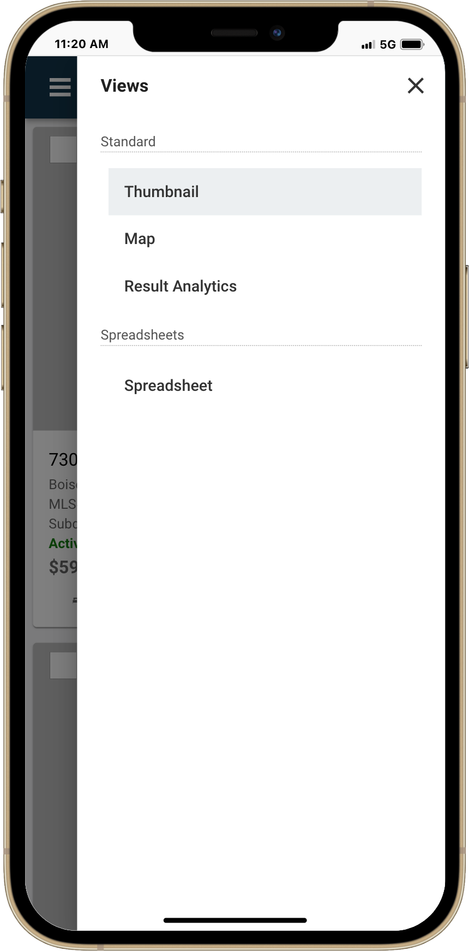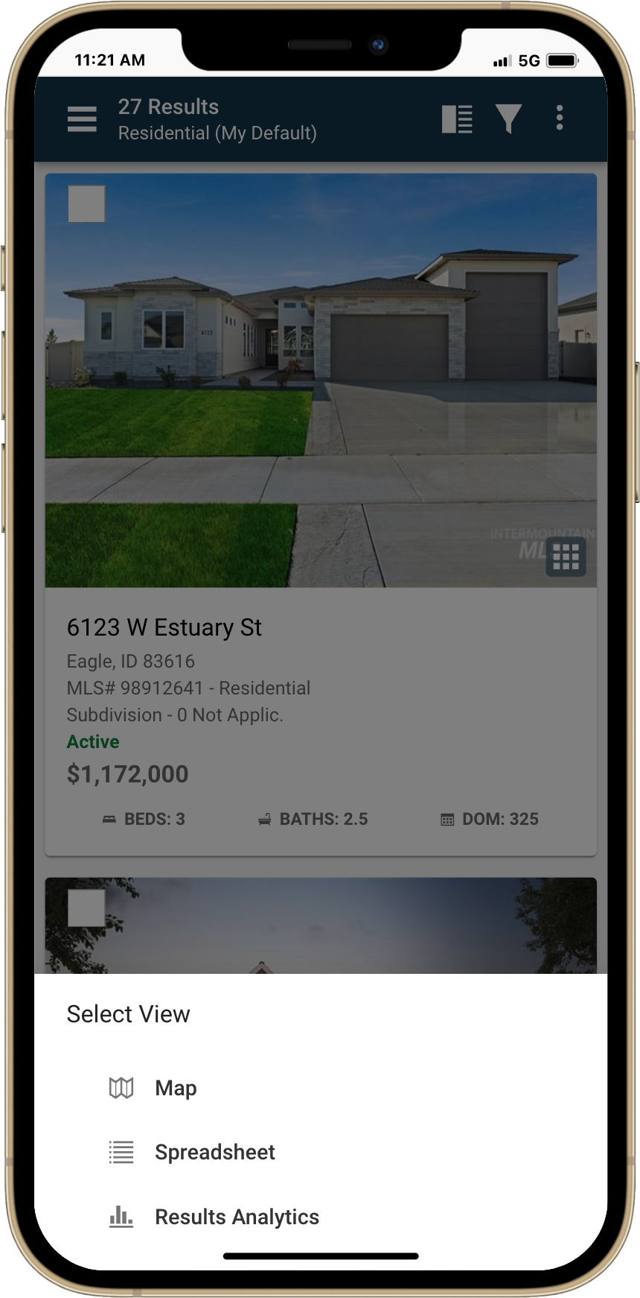

Current Menu

Updated Menu

## Multiple Voice Tones – Restb.ai Remarks

If you're already using Restb.ai to auto-generate your remarks field, you're going to love this upgrade.

We’ve expanded the feature to let you choose from five unique voice styles. Previously, all remarks used the default "Standard" voice—but now, you can tailor the tone to better fit your listing and audience.

Choose from:

* Standard (default)
* Playful
* Professional
* Conversational
* Concise

Whether you want to keep it light, buttoned-up, or straight to the point—you’re in control of the tone.

## A screenshot of a message AI-generated content may be incorrect.Contact Manual Email Templates

Contact emails sent manually from Collaboration Center or CollabLink now feature an updated design. The new templates are cleaner, mobile-responsive, and fully compatible with both light and dark modes.

Each email includes the Paragon Connect logo at the top, along with sender details and the message—presented in a modern, easy-to-read layout.

## New UI Tour to Boost Listing Ad Engagement

A new UI Tour has been added to the Paragon Listing Input Formif your system is participating with Listing Ads by Zeta.

This new content helps remind agents of this effective advertising opportunity. When users access this feature, they'll see a prompt titled **“Start Advertising Now!”** encouraging them to activate a Listing Ad and promote their listing through targeted campaigns on Facebook and Instagram.

