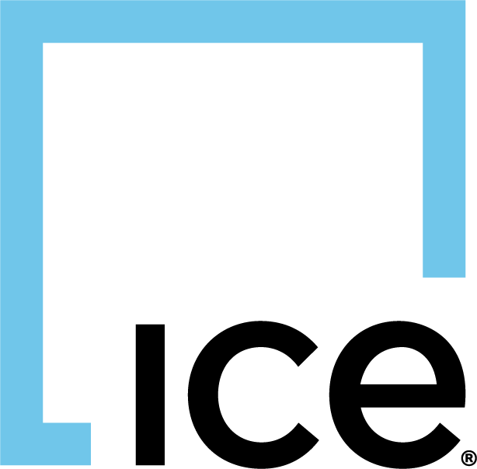
08

08
Fall

Fall

Paragon 11.3 Release Enhancements

May 2025

1. Corrected Paragon Issues 2
2. MLS Customizations and Administration 3
2.1. Upgrade to Reverse Prospecting in Paragon Connect 3
2.2. National Branded Themes 3
3. Paragon 4
3.1. Additional Viewable Records in Tour & Open House 4
3.2. Pro Reverse Prospecting Now Launches in Paragon Connect 5
4. Paragon Connect 7
4.1. Search Customization Just Got Smarter 7
4.2. Near Me Search Now Customizable 12
4.3. Introducing National Branded Themes 13
4.4. Smarter Tooltips for a Smoother Experience 17
4.5. Expiring Listing Alerts-Now as Push Notifications 18
4.6. Improved Listing Emails from Paragon Connect 19
4.7. Sharper, Clearer Interface Enhancements 20

Corrected Paragon Issues
Ticket# | Module | Organization | Summary
TK-23990 | Email | COLUMBIA - ConsolidatedMLS;VALLEYMLS - ValleyMLS / NALMLS (Huntsville) | Consolidated: Sharing EasyCMA is prompting members for credentials
TK-23253 | Associated Documents | PRIMEMLS - Prime MLS (NEREN) | PC LIM - Document Types in pick list only display Abbreviation Values
TK-23848 | General UI | PRIMEMLS - Prime MLS (NEREN) | COLLABCENTER_MORTGAGE_INTEREST_RATE not being applied to CollabLink
TK-23634 | Search | COLUMBIA - ConsolidatedMLS | Hotsheet report is not respecting Sort order for Print and Print+
TK-23718 | Search | MIMLS - MiRealSource | Search using 'Original MLS #' field produces error
TK-23634 | Search | COLUMBIA - ConsolidatedMLS | Hotsheet report is not respecting Sort order
TK-8187 | Tour/Open House | PACMLS - Pacific Regional MLS;PRIMEMLS - Prime MLS (NEREN);SJSR - South Jersey Shore Regional MLS | Expand T/OH Maintenance to show more than 10 records
TK-9300 | PowerSearch | RAE - REALTOR Assoc of Edmonton | Powersearch - doesn't return multiple matches when part of an alphanumeric MLS# has been entered
TK-13473 | LIM | CARMLS - CARMLS, Inc. (Arkansas);CCAR - Coastal Carolinas AOR;HSBOR - Hot Springs BOR;MIMLS - MiRealSource;NWBORMLS - Northwest Wyoming Board of REALTORS;TBAY - Thunder Bay Real Estate Board;TBRMLS - Tallahassee BOR;TOPEKAMLS - Topeka BOR (Sunflower) | mls_MinorUpdate cannot insert duplicate records in SavedSearchesAreas

MLS Customizations and Administration

Upgrade to Reverse Prospecting in Paragon Connect
In December of 2024 we launched the new version of Reverse Prospecting in Paragon Connect. All customers were opted into this new feature at that time. If you chose to disable this new feature for your system, please review the new changes to Paragon Professional which automatically direct users to this feature in Connect when starting the Reverse Prospecting process in Paragon Pro.
If you are now ready to enable the new Reverse Prospecting, reach out to your Service Executive (formerly known as SSM).
If you choose to disable the new Reverse Prospecting, the new Paragon Pro changes noted for Reverse Prospecting below will not be visible/enabled for your system and you will continue to have the original Reverse Prospecting functionality.

National Branded Themes
This release includes a new set of pre-defined color themes inspired by the top 20 brokerages across North America. This is the first step in supporting a fully customizable color palette theme builder where users may choose any color combination they want.
If a prominent brokerage within your market is not included in the initial list and you'd like to request a theme, please contact your Support Executive (formerly known as SSM) with the national brokerage name, along with its primary and secondary brand colors. While we’re eager to expand the list, we are prioritizing brands with the broadest coverage and are unable to support every brokerage at this time.

Paragon

Additional Viewable Records in Tour & Open House
We’ve updated the Tour/Open House (T/OH) section in Listing Maintenance to improve visibility and usability for agents managing multiple open house records. Previously, the grid displayed only the first 10 entries, making it easy to miss additional records—especially on smaller screens or when not viewed in full-screen mode. With this update, the grid now displays up to 20 records by default, making it easier to review and manage listings with a high number of scheduled tours or open houses at a glance.

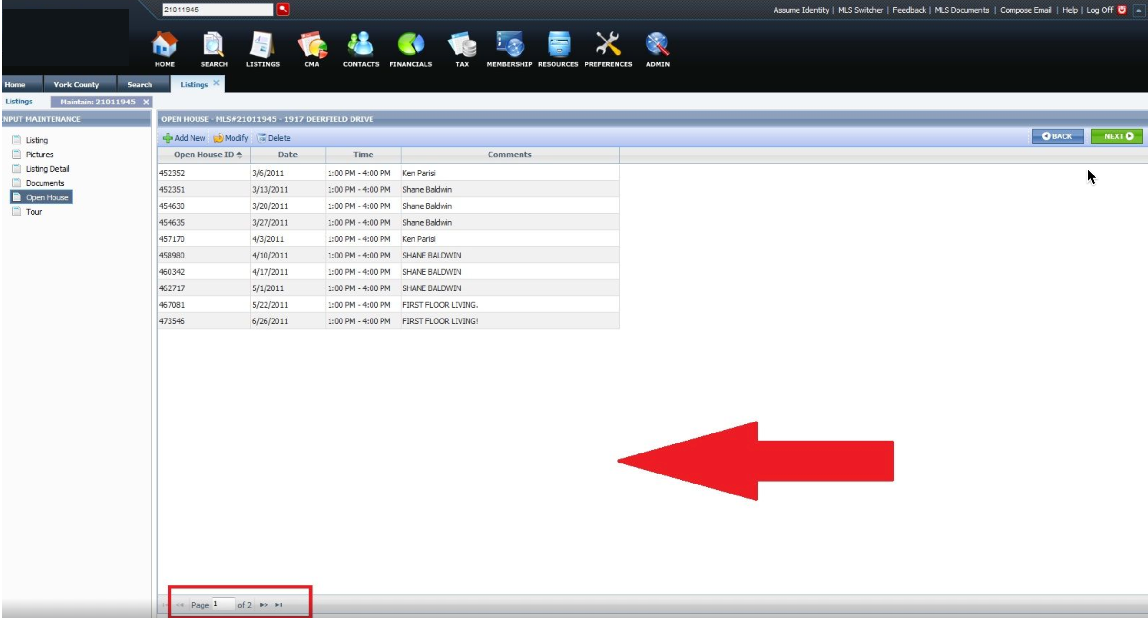

Pro Reverse Prospecting Now Launches in Paragon Connect

Reverse Prospecting Report
We’ve streamlined your workflow by upgrading how Reverse Prospecting is accessed in Paragon. Now, when you go to Contacts > Reverse Prospecting in Paragon, you’ll be seamlessly redirected to the improved version in Paragon Connect.
This enhanced experience opens in a new browser tab and automatically loads the Reverse Prospecting page for your selected listing—no extra logins required. Just select a listing and click Launch Report to get started.
It’s a smarter, more modern way to connect your listings with interested buyers.
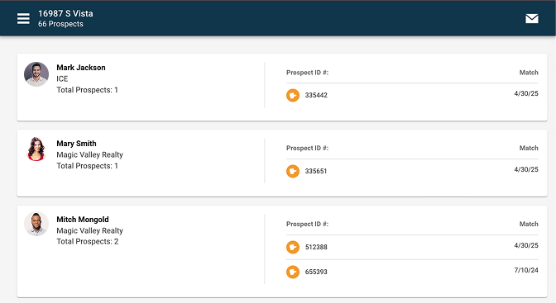

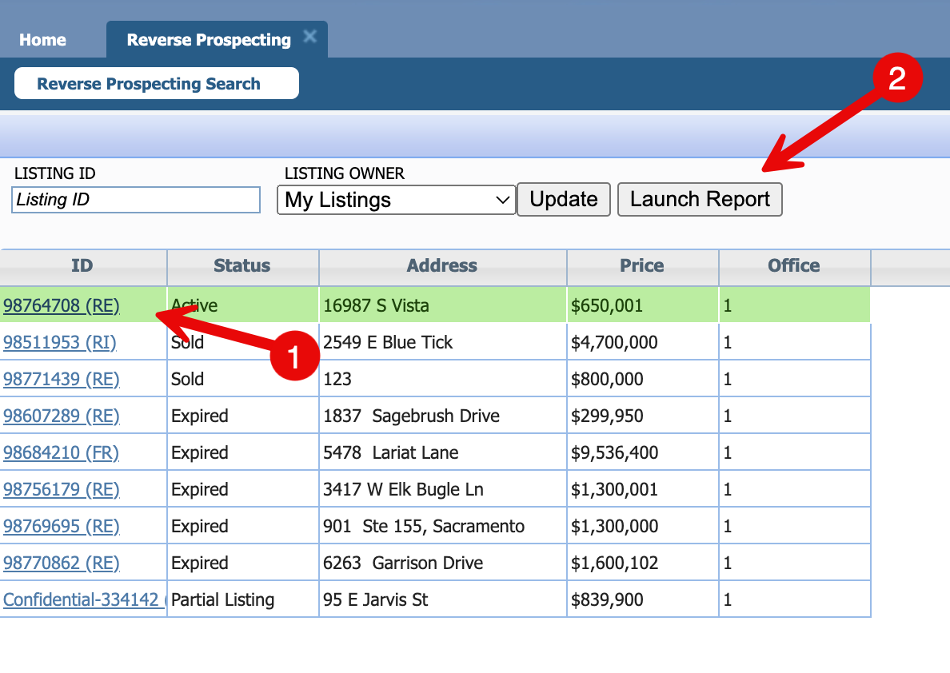

Reverse Prospecting Contact Manager
To align with the upgraded Reverse Prospecting experience in Paragon Connect, we’ve made several updates to how contact information is displayed in Paragon.
You’ll now see a clearer reference to each contact’s Reverse Prospecting ID (formerly labeled as "Alias") throughout the system. This includes updates to the Contact grid, Contact Information, and Contact Summary pages—ensuring consistency and clarity when working with reverse prospecting data.
In addition, the contact search has been improved to allow searching by Contact ID, making it easier to find and manage records tied to Reverse Prospecting.
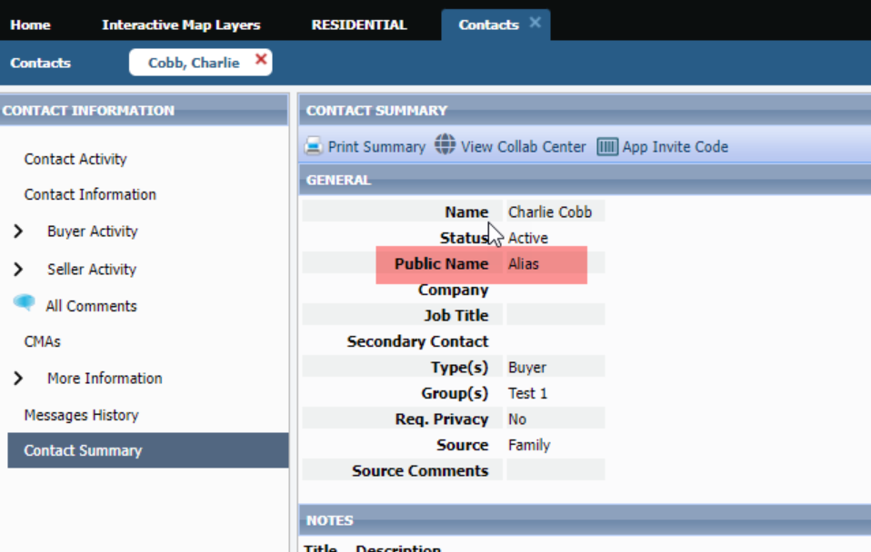
These changes help ensure a more modern and unified experience across both Paragon and Paragon Connect.
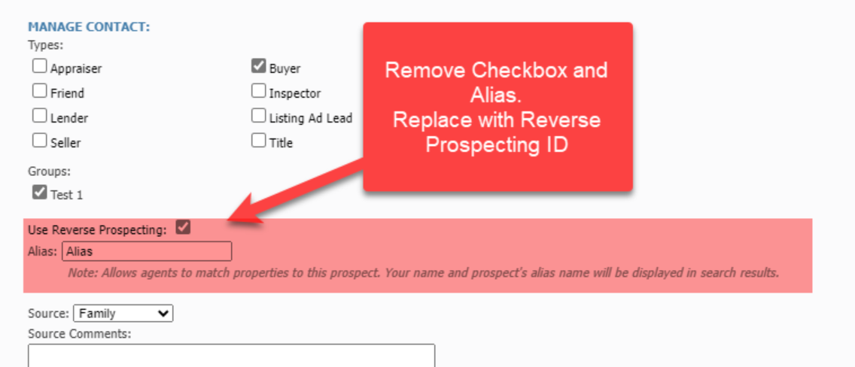
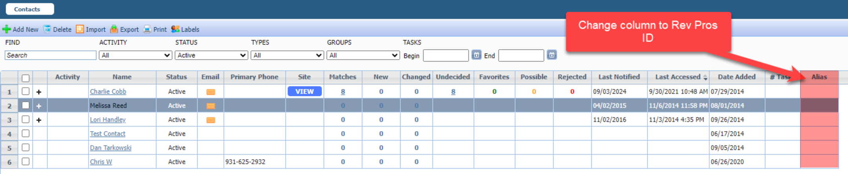

Paragon Connect

Search Customization Just Got Smarter
Paragon Connect introduced powerful search customization tools in past releases—giving users the ability to set default criteria, layouts, and more. But we didn’t stop there.

Your feedback continues to drive our evolution. That’s why we’ve reimagined the entire customization experience to make updating searches faster, easier, and more intuitive. Here are some updates below:

Overflow Menu:
Previously, the overflow menu included three separate options: Customize Fields, Update Template, and Modify Containers.

To simplify the process, we’ve combined key features into a single, unified module—now accessible through one streamlined option: Customize Fields.
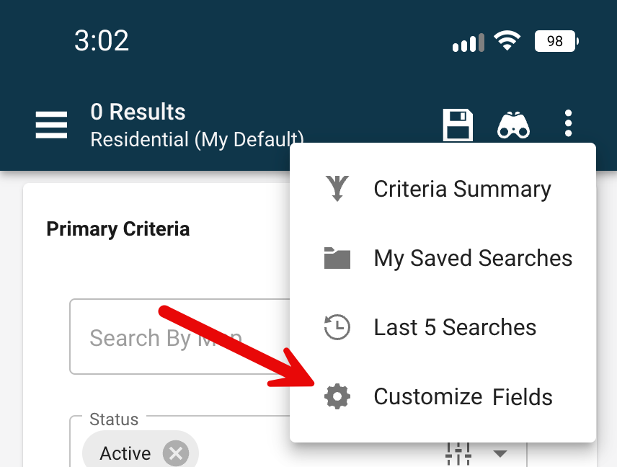
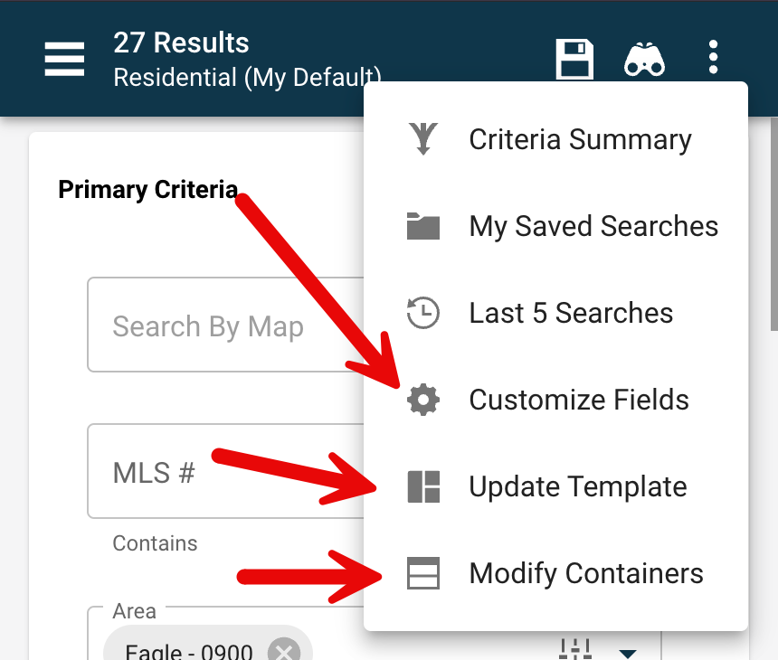

Updated Menu
Current Menu

Customize Fields & Containers:
Your search form customization still works just like before—you can easily add, remove, and reorder fields. But now, we’ve taken it a step further.

With this update, you can also add, edit, and organize containers—all within the same streamlined modal.

- Tap the + Add button at the bottom to insert a new container or new fields.
- Use the pencil icons on each container header to rename, reorder, or delete containers on the fly.
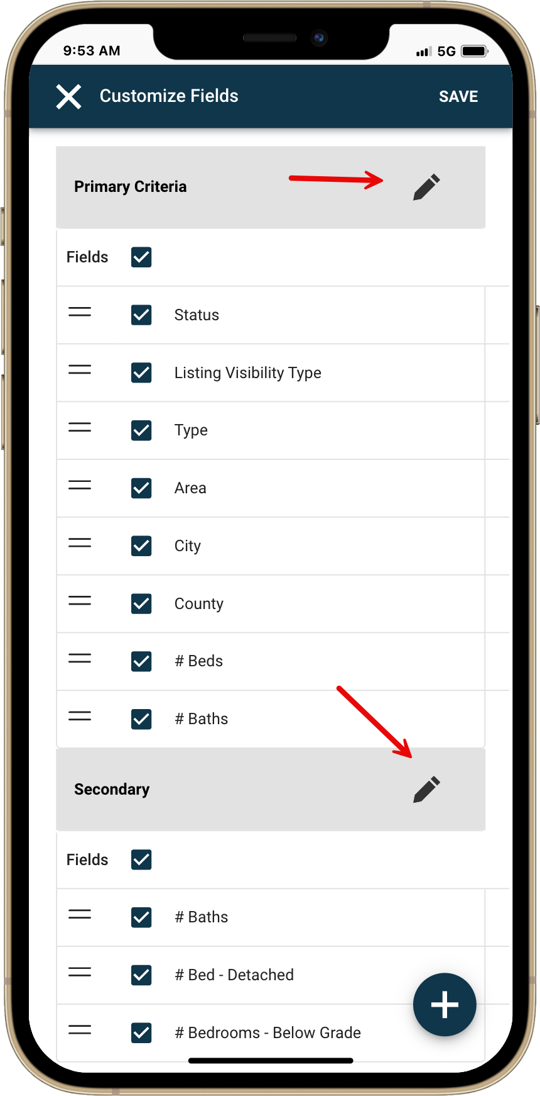
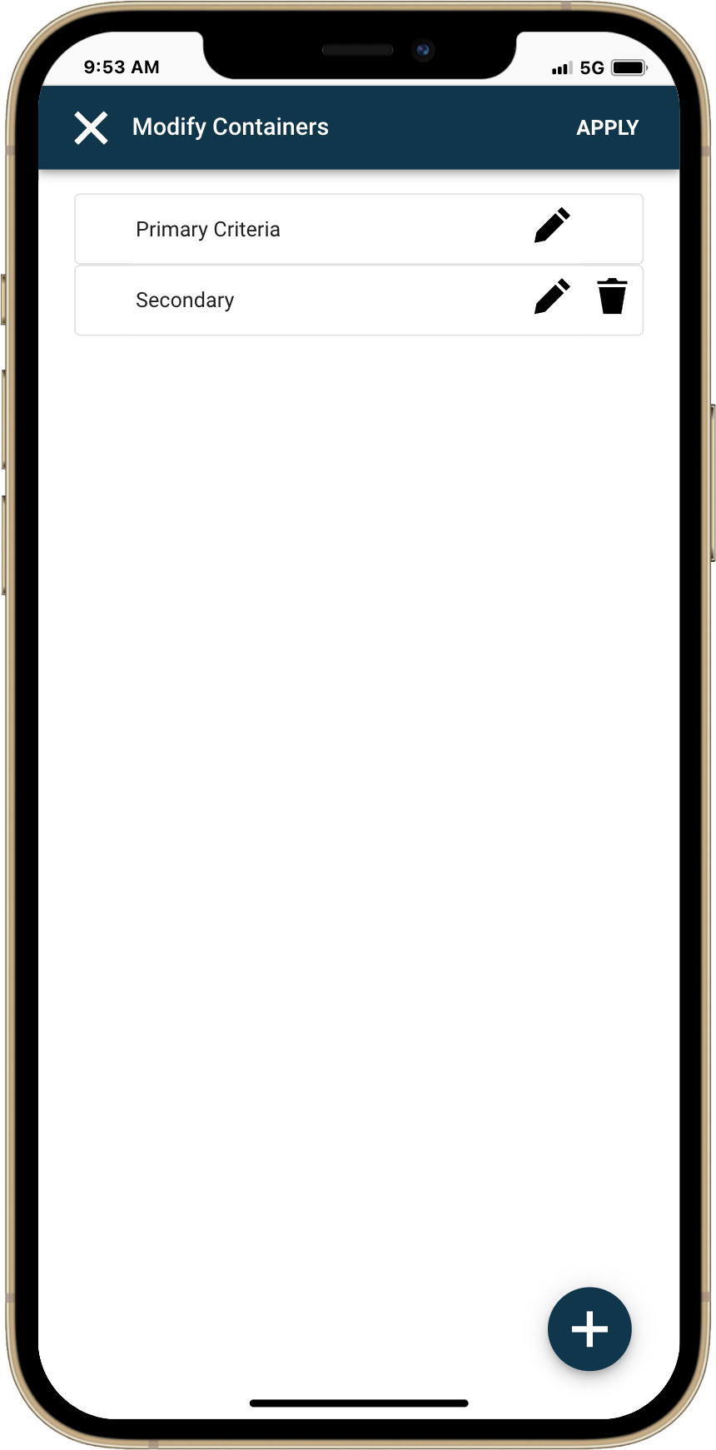
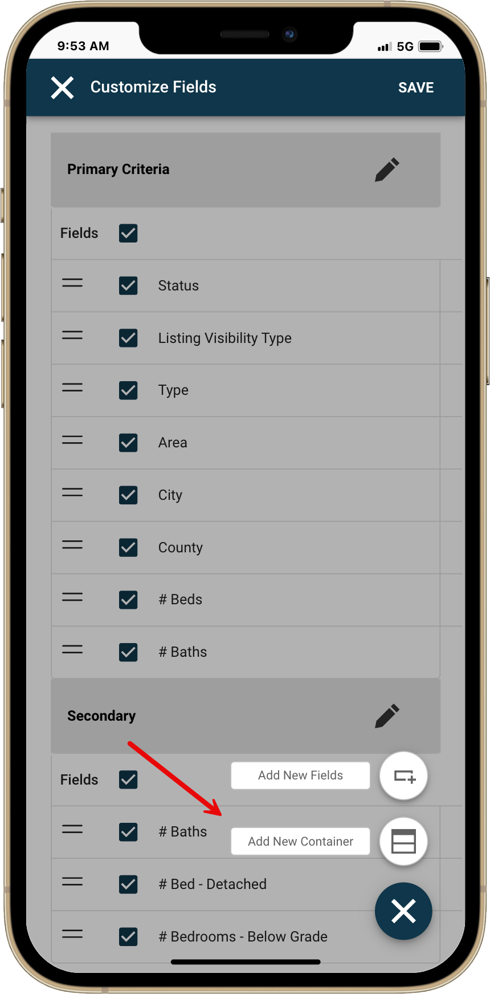

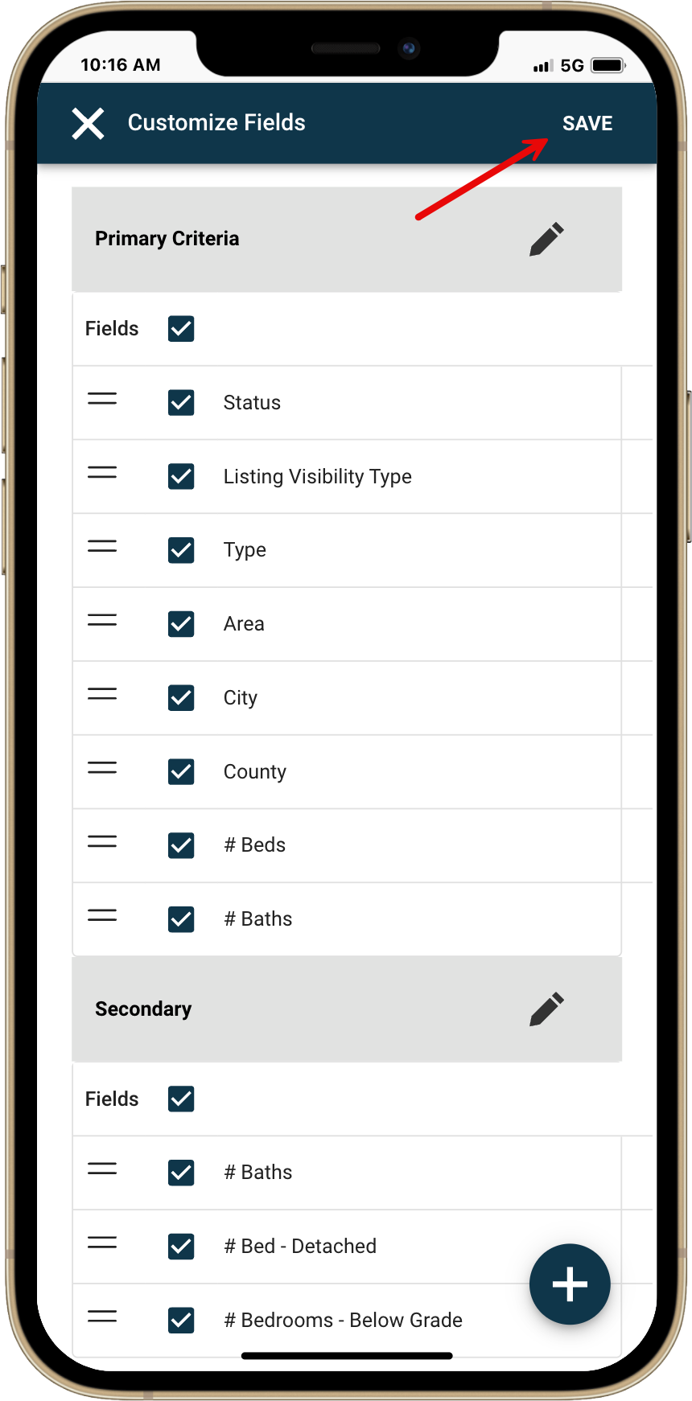
Auto Save/Update Field Layout (Default Search)
We’ve simplified how you manage your default searches by introducing auto-save for field layout changes—no extra steps required.

Here’s how it works:
When you're working on a default search, any fields you add, remove, or reorder will automatically save to your default layout. No need to manually update your template after making changes.

Note: This auto-save applies only to field layouts—not your search criteria—and only when editing a default search, not a saved search.

Saved Search
When working with a saved search, no changes are auto-saved. Since these searches are often linked to contacts, we’ve prioritized your control to avoid unintended updates that could affect search results or notifications.

If you make changes to a saved search layout, simply click Save when you're ready—nothing is updated until you choose to do so.

How to Update Criteria:
So far, we’ve focused on customizing fields and containers—but what if you want your default search to include specific criteria every time?

Let’s say you always want the Residential search form to start with Active status pre-selected. Once you’ve added your desired criteria and customized your form, just click the Save icon. You’ll notice an updated dialog with two radio button options:

- Save Search – Saves your current criteria as a new saved search.
- Save Default Template – Applies your current layout and criteria to your default search form.

Select Save Default Template and click Save—your personalized default is now ready to go, every time.
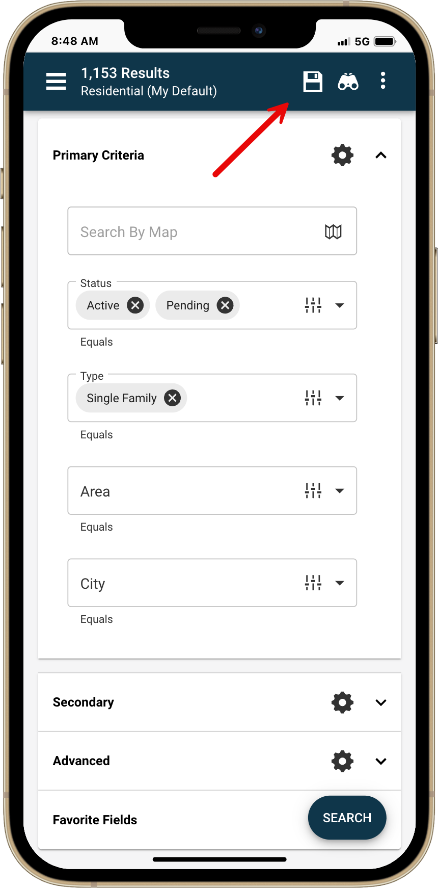
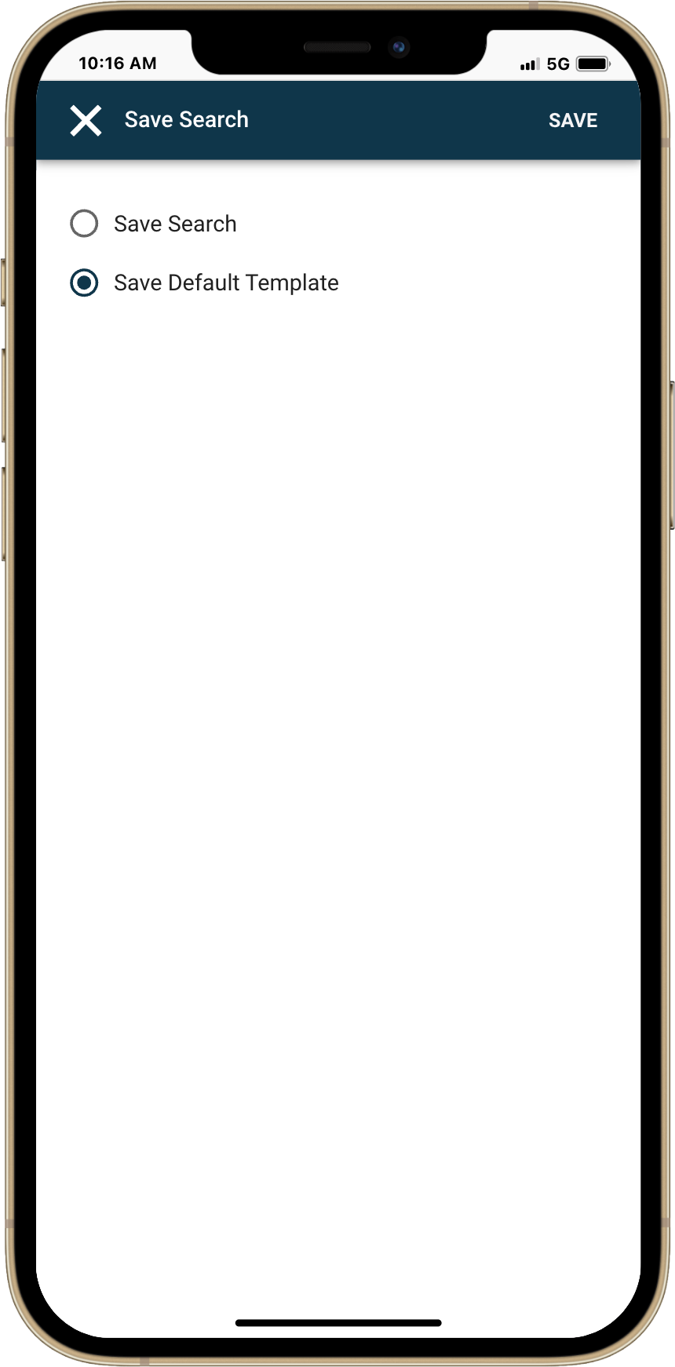
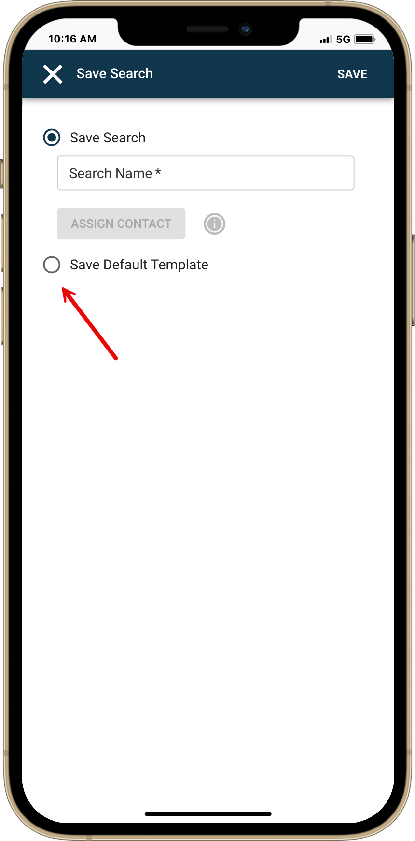

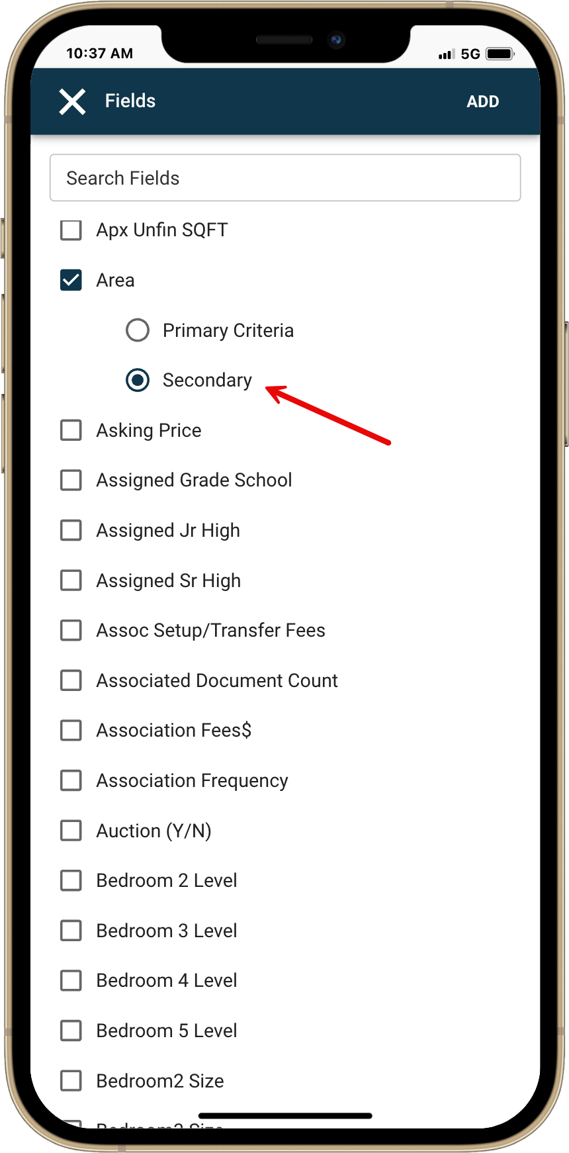
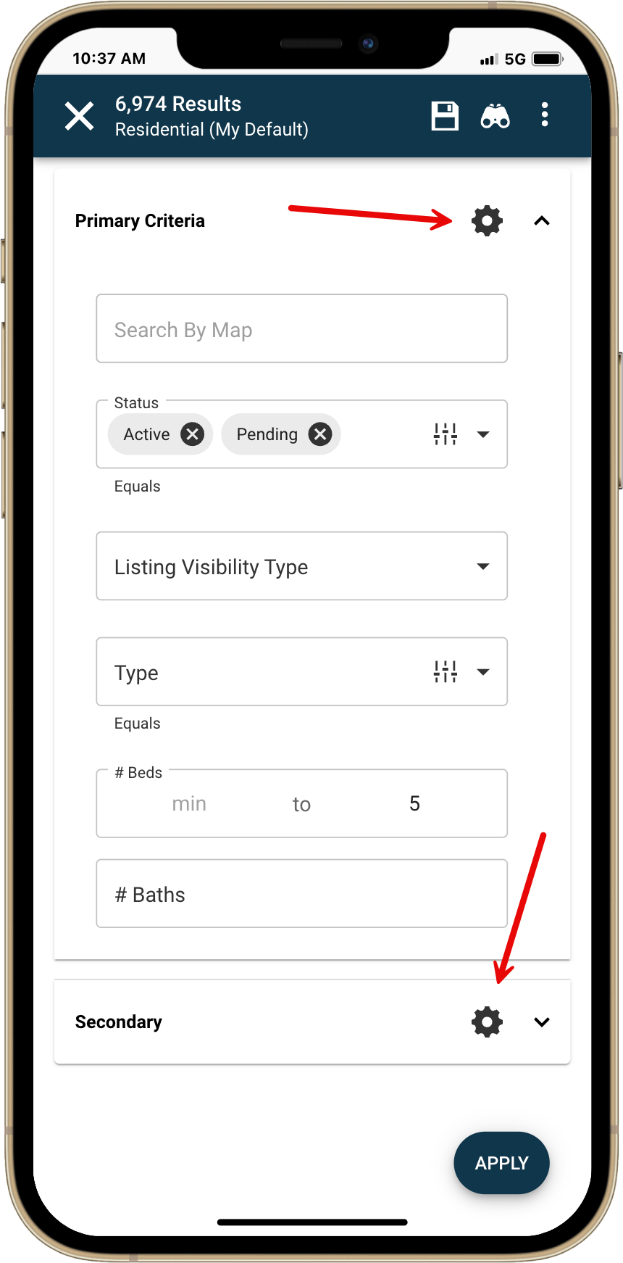
New – Customize Option:
Loving the new customization features? We’re not done yet. We’ve added a customization icon directly on each container within your property search form—making it easier than ever to tailor your search experience.

Many users aren’t aware search customization is available. With this new front-and-center icon, it’s now instantly accessible. Just click the icon to open the customization panel—just like from the overflow menu.

The best part? When you add new fields from this view, they’ll automatically be added to the container you launched from—making the process faster and more intuitive.

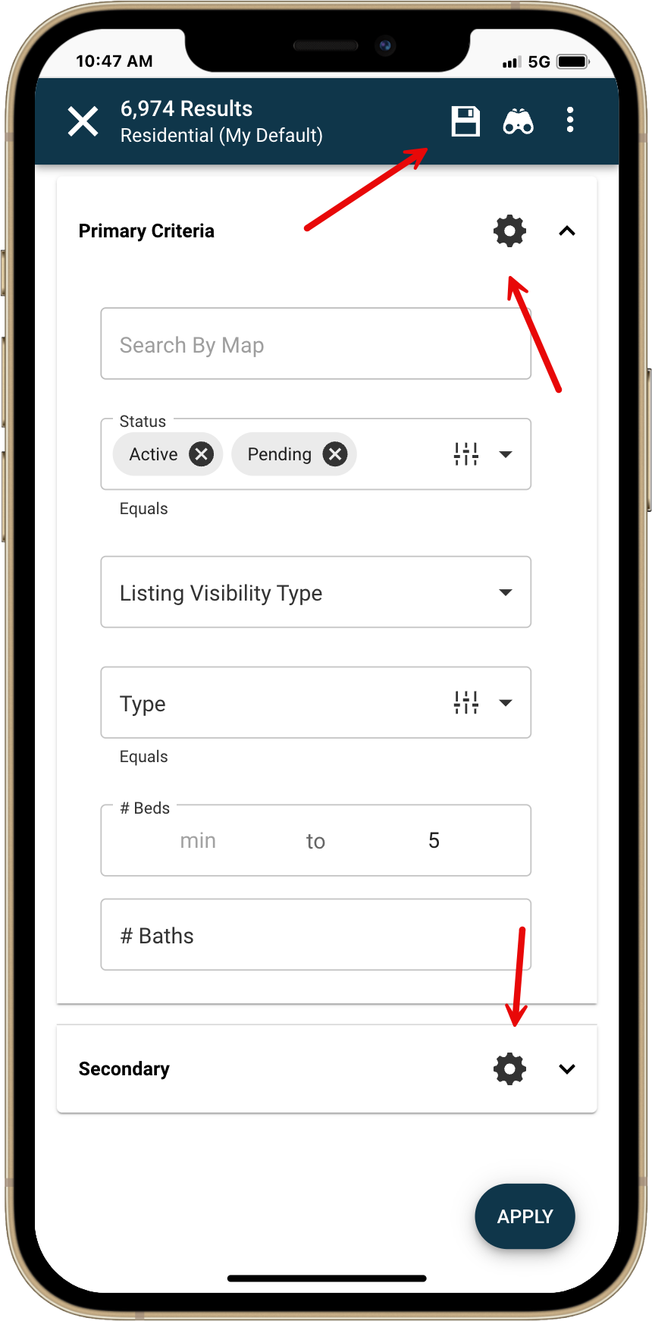
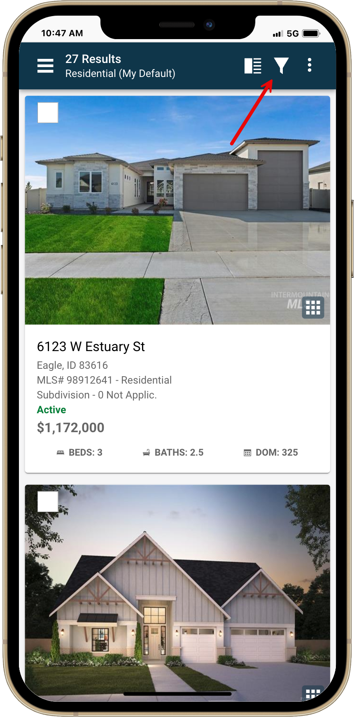
Customize and Save from Results/Filter
Want even more flexibility? Now you’ve got it.

In Paragon Connect, you’ve always been able to adjust your search criteria using the filter icon while viewing results. But until now, you couldn’t change fields, containers, or update your default setup from this view.

With this release, that all changes. You can now fully customize your search—add or modify fields, adjust containers, and even update your default layout—directly from any property class search results.

It’s powerful, seamless customization—right when and where you need it.

Near Me Search Now Customizable
Yes, you read that right—Near Me search is now customizable in Paragon Connect!

You can now add, remove, and reorder fields and containers, just like in other searches. Even better—you can set your own default criteria and save it, so every time you run a Near Me search, it works exactly the way you want.

For example, want your Near Me results to always show only Active listings? Just open the filter, select "Active" for the status field, tap the new Save icon, and choose "Save Default Template." That’s it—your Near Me search will now default to Active listings every time.

Smarter searches, your way—right where you are.

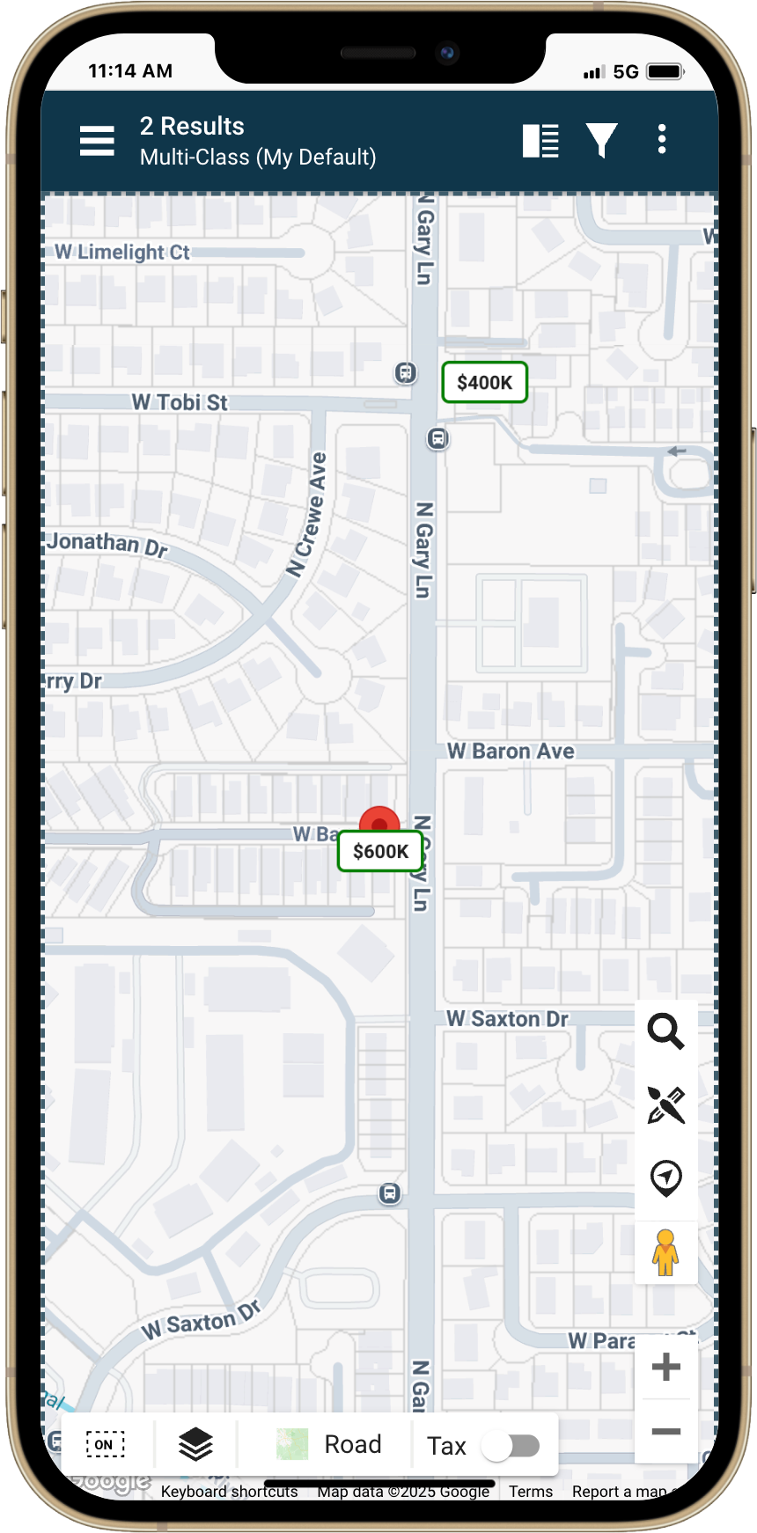
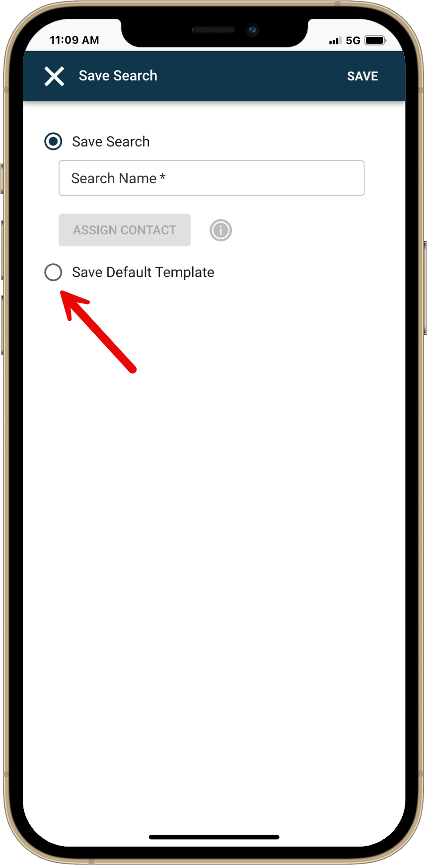
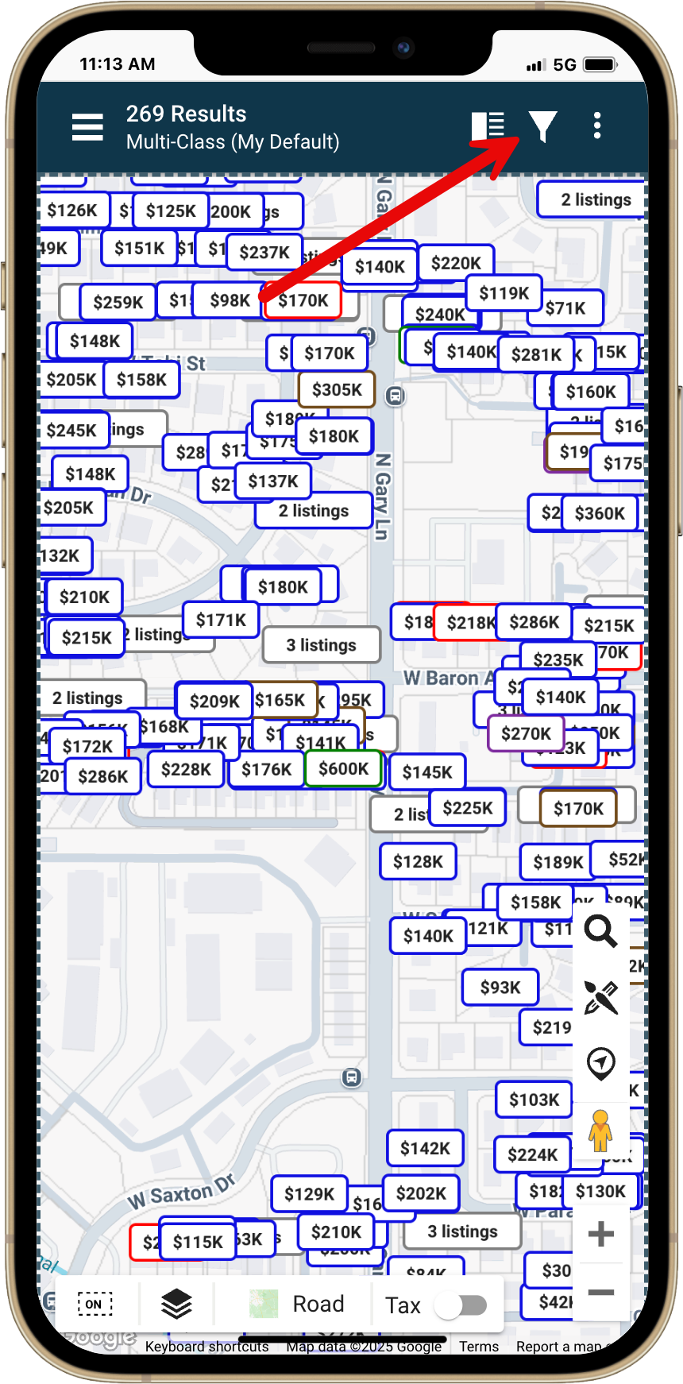
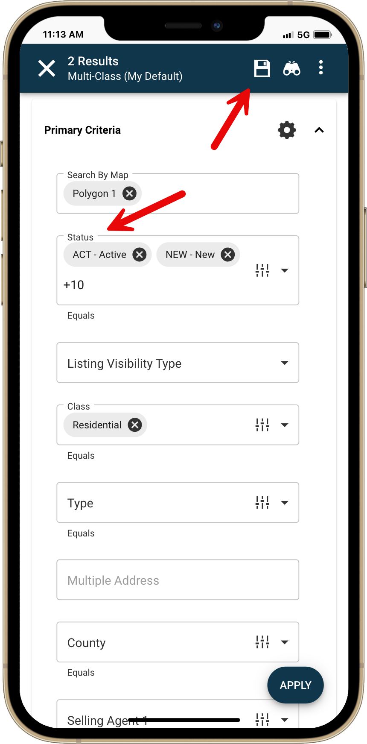

Introducing National Branded Themes
Last year, we added five new themes and bold graphic banners to give Paragon Connect a more personalized touch. Now, we’re excited to launch the next phase: National Branded Themes.

With this update, you can choose from 20 color themes inspired by national brokerages across the U.S. and Canada. These themes are based solely on the brand colors—they do not affect your brokerage's logo, name, or any identifying information. This enhancement is visual only, giving you the option to align your experience with familiar national brand colors.

This feature is available exclusively in Paragon Connect for now, with plans to expand to the Collaboration Center in a future release.

Looking ahead, we’re preparing for the final phase of this initiative: the Custom Theme Builder. This will empower users and brokerages to create their own unique themes using their exact brand colors, unlocking complete white-labeling control. With this future tool, you'll be able to fully align the Paragon Connect experience with your brand identity—ensuring consistency, professionalism, and a personalized touch across the platform.
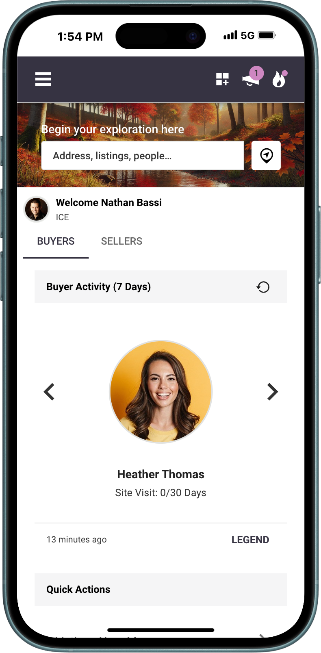
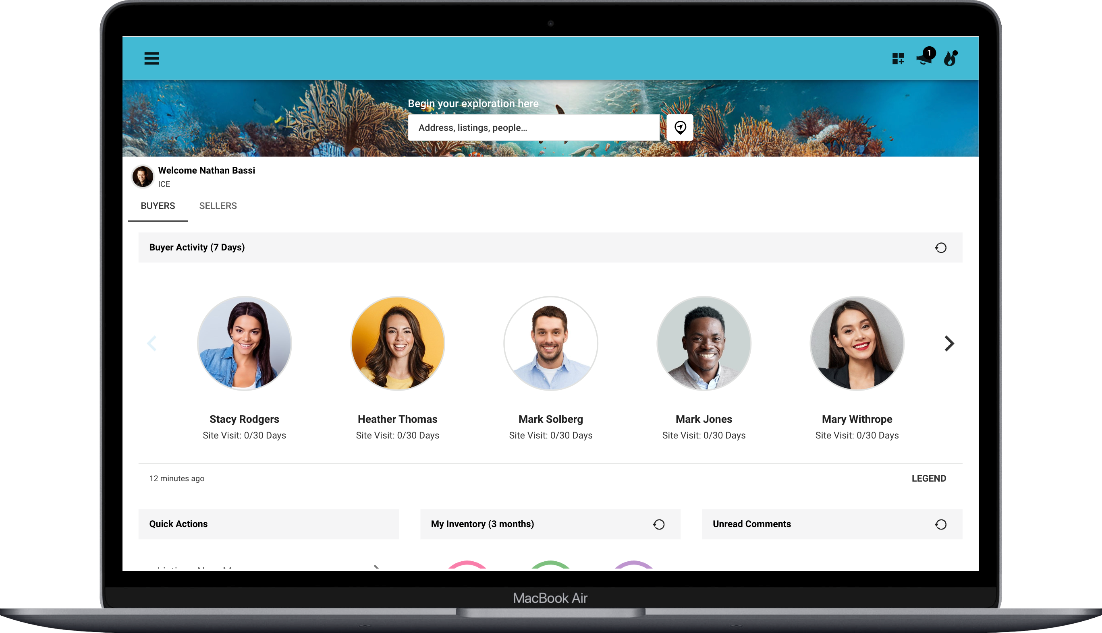

How to Update Your Paragon Connect Theme
Ready to personalize your Paragon Connect experience? Here’s how to update your theme:
- Open Settings
From the left navigation menu, select Settings, then choose System.
- Go to Color Themes
On the System page, select Color Themes. This will open a new page where you can update your theme color or banner graphic. We’ll cover banner graphics in more detail later—let’s focus on color for now.
- Choose Your Theme
Under the Color section, you’ll see two options:
  - The original default themes released previously
  - A new section for National Branded Themes
- Select a Branded Theme
Simply choose the brokerage you’d like to use as your color theme and click Save. This will apply the selected color scheme to your Paragon Connect interface.
Want to preview before applying? Click Preview button to see how the theme will look.
- What if your brokerage isn’t listed?
We’ve added an info button next to the national themes section. Clicking this will display the message:
“If your brokerage is not listed, it means the theme isn't available yet. But don't worry, more brokerage themes are coming soon!”
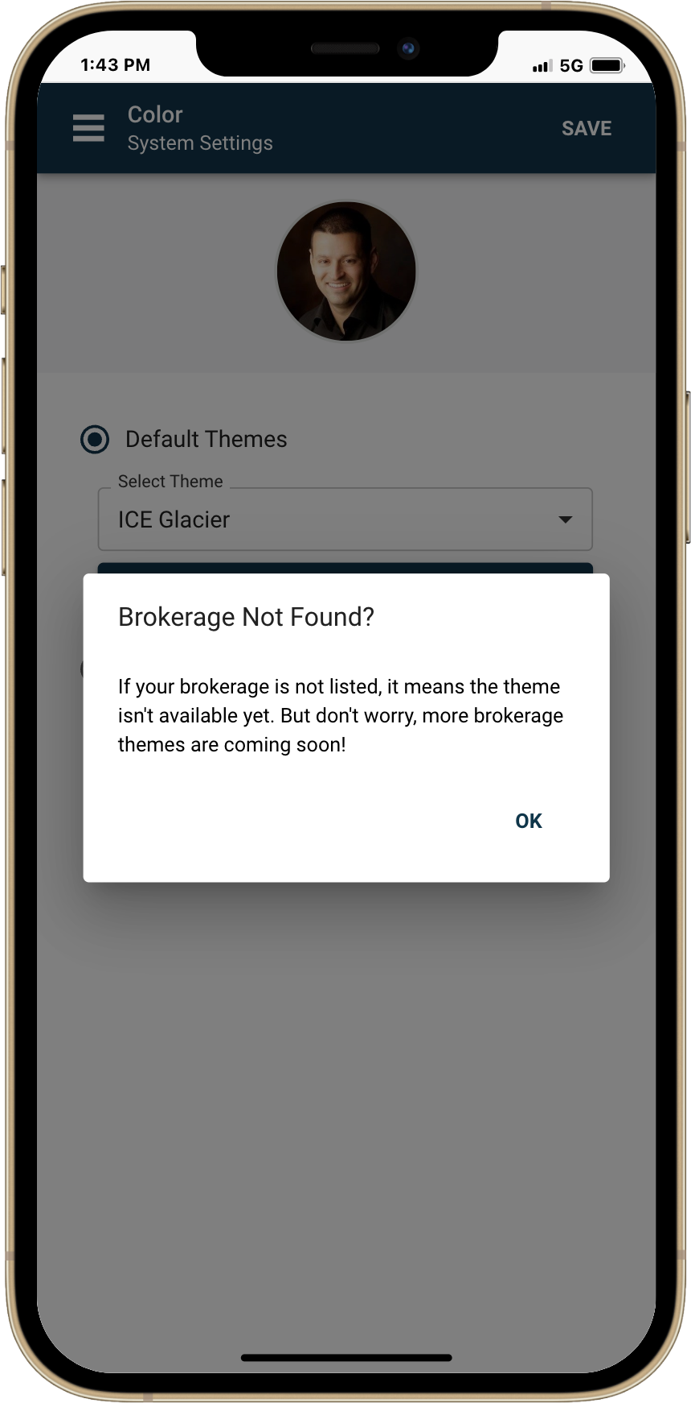
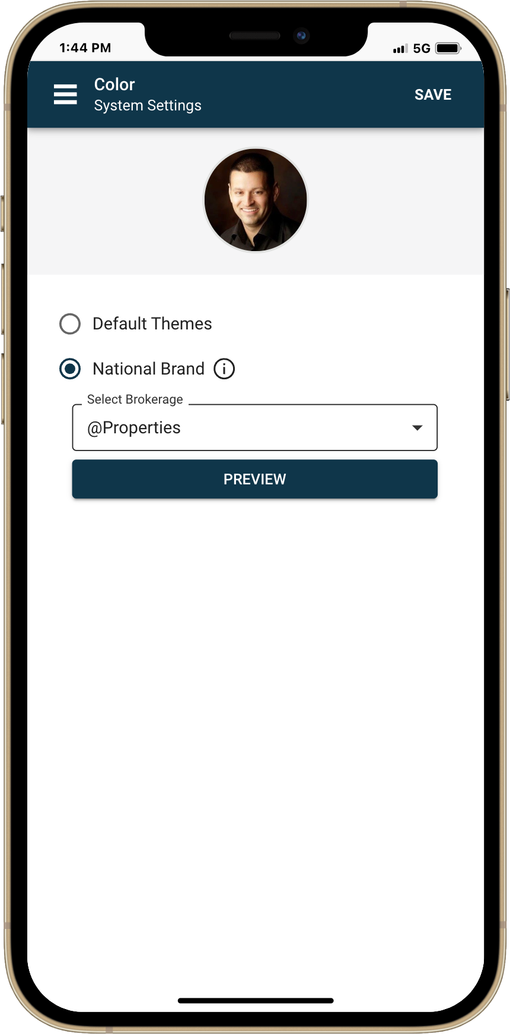
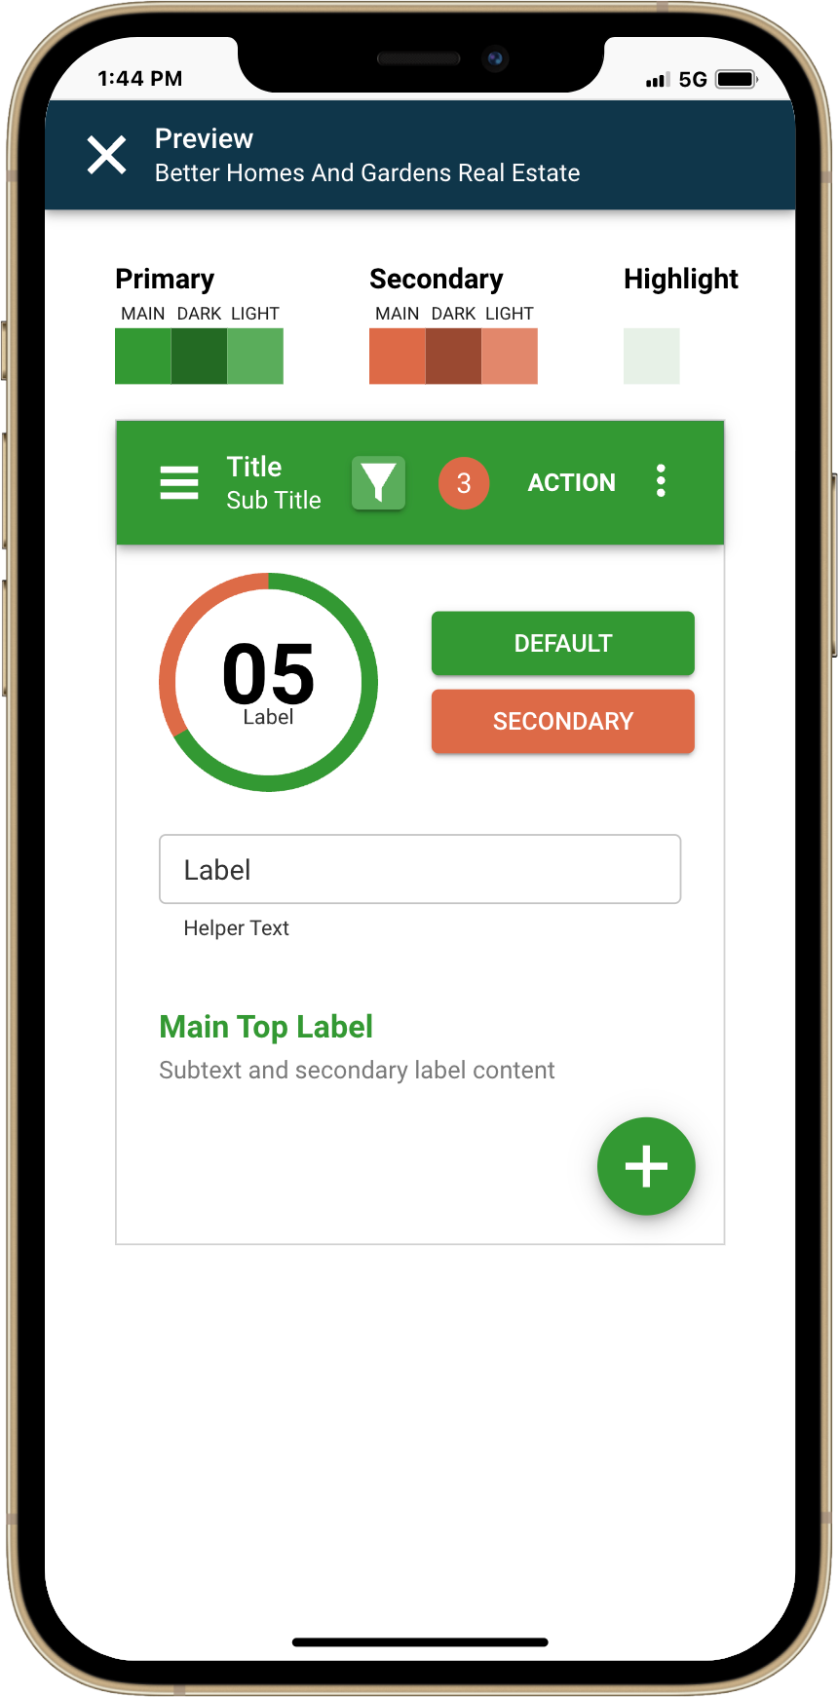
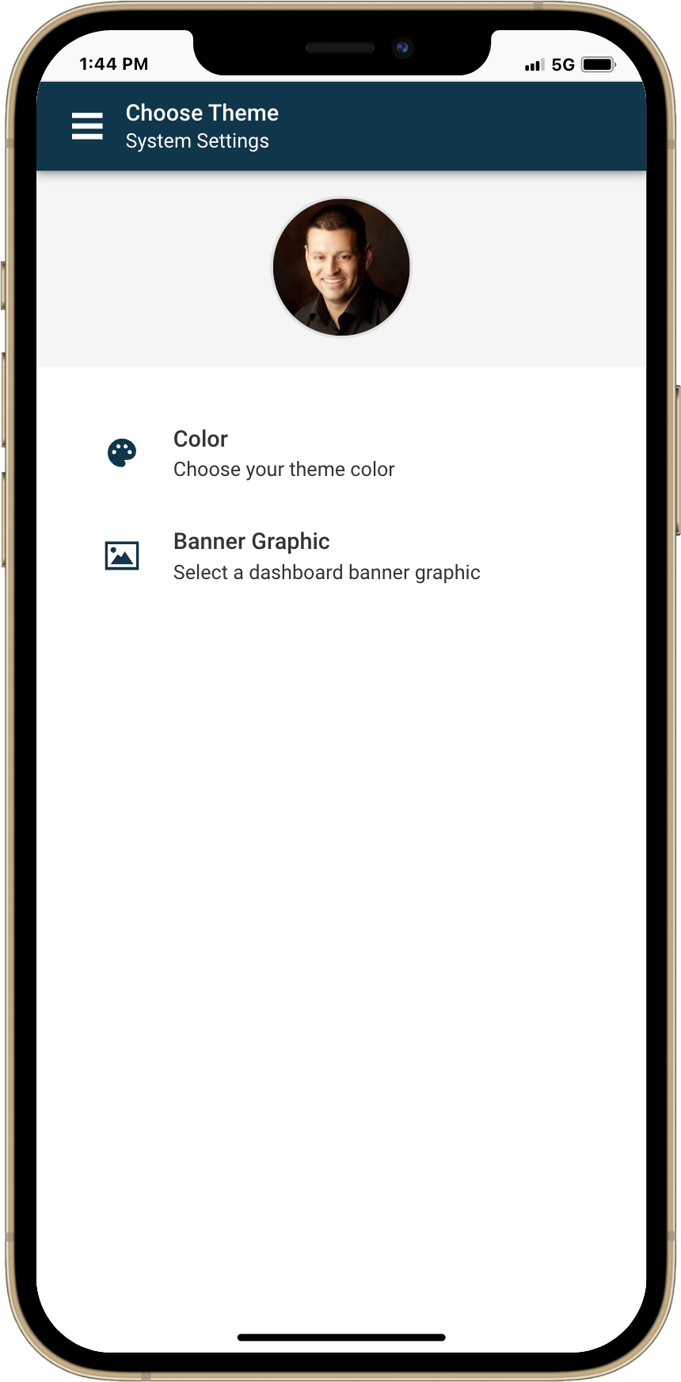
Explore the National Brands Now Available as Theme Options
Below is a list of national brokerages featured in this launch of branded color themes. You can choose any of these to personalize your Paragon Connect experience with a look that reflects your brand’s identity.
@Properties | Redfin
Anywhere | Royal LePage
Berkshire Hathaway | Samson Properties
Better Homes and Gardens Real Estate | Side
Century 21 | Sotheby's International Realty Canada
Coldwell Banker | The Real Brokerage Inc
Compass | Realty One
Douglas Elliman | RE/MAX
eXp Realty | Keller Williams Realty
Fathom Realty | HomeSmart
Hanna Holdings Inc.

Broker-Level Settings? We Hear You.
Looking for office-wide settings that apply to everyone in your brokerage? While broker-level controls aren’t currently available in Paragon or Paragon Connect, we know this is a popular request and it’s something we’re considering as we look ahead to future enhancements.
Introducing Graphic Banner Freedom
Alongside our new theme color options, we’re introducing even more flexibility with independent graphic banners. Previously, banners were tied to specific themes—but not anymore.
We’re incredibly grateful to serve such a wide and diverse range of customers across North America, and we wanted to reflect that richness through customizable options that celebrate your unique locations and styles. Now, you can choose from 30+ stunning background options showcasing a variety of locations, landscapes, and timeframes—from coastal scenes to mountain views and everything in between.
We couldn’t let Paragon have all the fun. Paragon Connect users now get the same rich customization to truly make their experience their own.

How to Change Your Graphic Banner in Paragon Connect
Want to personalize your experience even more? Here’s how to update your graphic banner:
- From the left navigation menu, go to Settings.
- Select System, then choose Color Theme.
- Click on the Graphic Banners tab.
You’ll see a gallery of 30+ banner options showcasing a variety of landscapes, locations, and styles. Simply select the one you like and click Save. Your new banner will appear immediately in Paragon Connect.
Feel free to revisit this setting anytime to try out a new look—changing your banner is quick and easy!

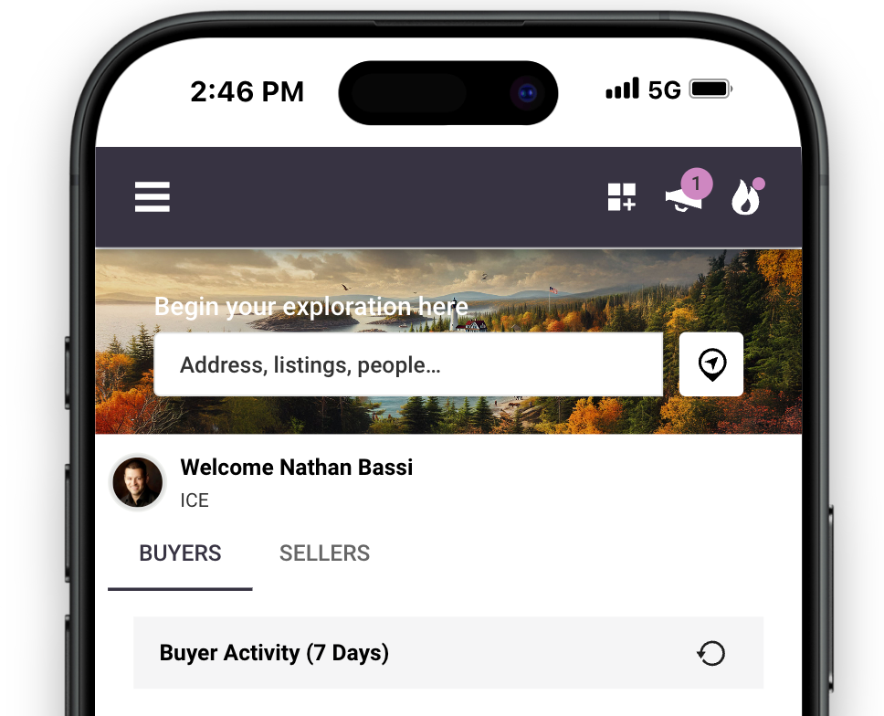

Smarter Tooltips for a Smoother Experience
Paragon Connect and the Collaboration Center use icons throughout the application to keep actions quick and intuitive. To make your experience even smoother, we’ve introduced enhanced tooltips—designed to boost clarity and streamline your workflow.

On larger-screen devices like laptops and desktops, these new tooltips are a major upgrade. They appear nearly instantly (compared to the previous 2.5-second delay) and feature larger, more legible text, making it easier to understand each icon at a glance.

It’s all part of helping you get comfortable with the interface faster—and navigate with greater confidence.

Old Tooltip

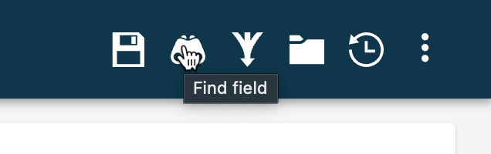
New Tooltip

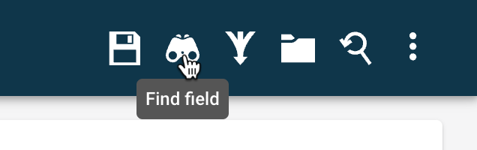

Expiring Listing Alerts-Now as Push Notifications
Until now, both our agent and consumer apps have supported push notifications for new comments—helping you stay connected. Now, we’re taking it a step further.

We’re excited to introduce a new push notification for listings nearing expiration. Previously, you’d receive an email alert when a listing was set to expire within a certain number of days. With this update, if you're using our agent mobile app, you’ll also receive a real-time push notification—right on your phone.

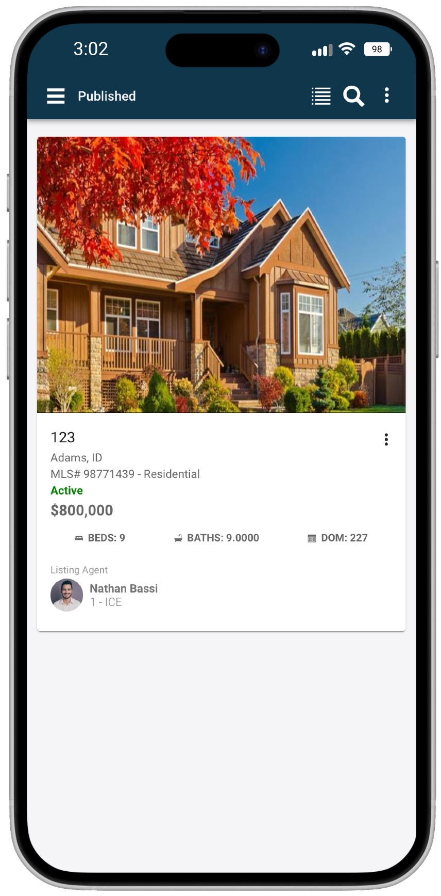
Tap the alert, and you’ll be taken directly to your Listing Maintenance page, where we’ll automatically filter and show you only the listings that are approaching expiration. It’s a faster, smarter way to manage your active inventory—so you can act before time runs out.
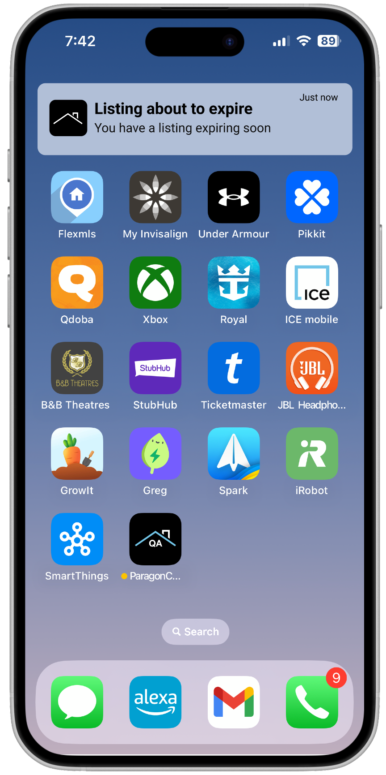

Improved Listing Emails from Paragon Connect
Manually Share Listings
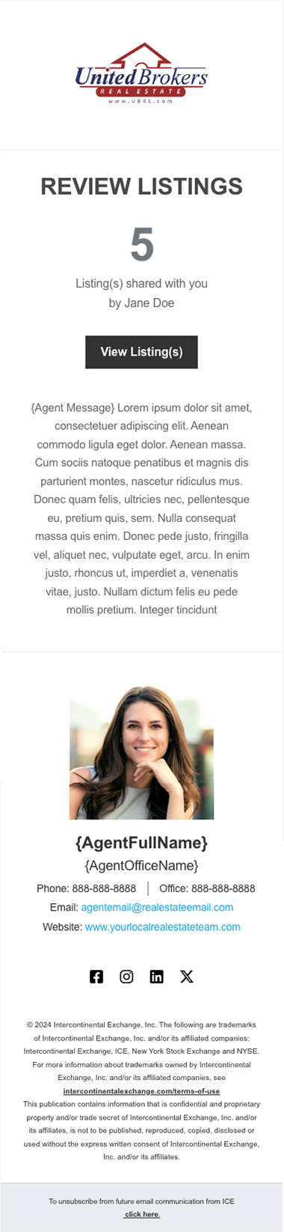
We’ve enhanced the email experience when agents share listings directly from Paragon Connect—making messages clearer, more engaging, and designed to drive clients into the CollabLink for full property details.
Now, when an agent shares one or more listings, the email includes a clean, modern layout with the agent’s office logo, a short message, and a clear call-to-action. If the agent doesn’t provide a subject line, the system automatically creates one like “Your agent has shared 3 listings with you.”
Clients will see a “View Listings” button that takes them directly into the CollabLink—opening to a listing detail view if one listing was sent, or a thumbnail view if multiple properties were shared. The email also includes the agent’s name, message, and signature block, ensuring a professional and personalized touch.
These updates make shared listing emails more effective and easier for clients to engage with—while still appearing in your Sent Messages just like before.

Sharper, Clearer Interface Enhancements
You’ll start to see a more refined and readable experience throughout Paragon Connect, Collaboration Center, and our mobile apps. We’ve been rolling out updates to improve the clarity and visual consistency of our interface—focusing on enhanced font colors, bold text usage, and updated icon styling.
These changes bring better contrast, improved legibility, and a more modern aesthetic. While the tweaks may seem small, they collectively deliver a noticeably sharper and more accessible user experience across the platform.
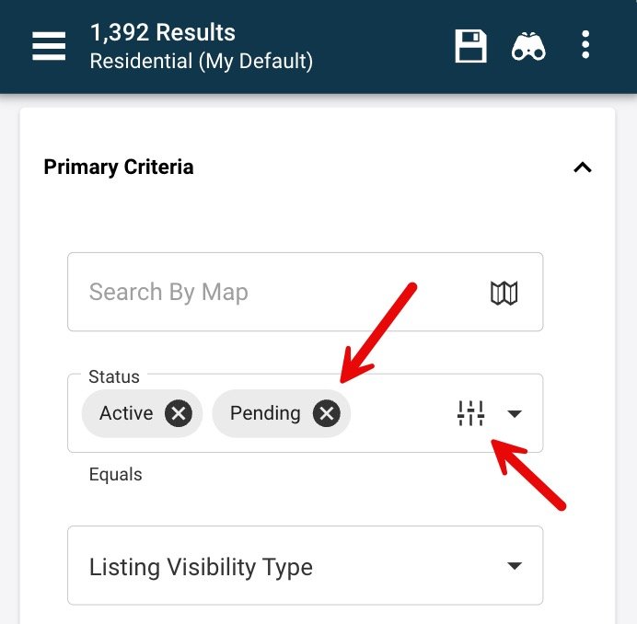
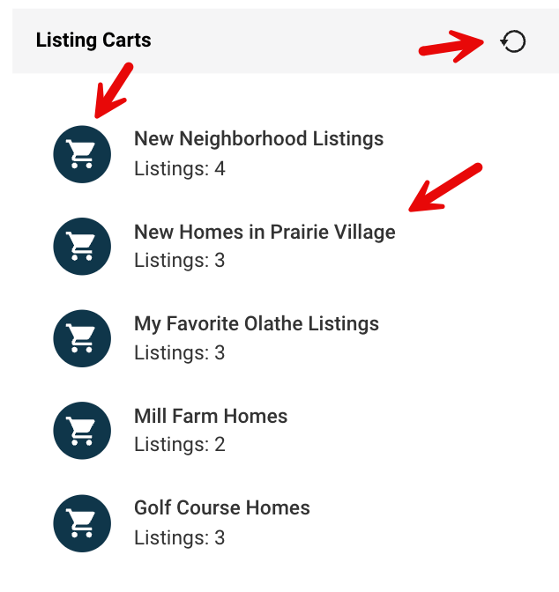
This is part of our ongoing effort to make sure every detail supports a clean, professional, and easy-to-use interface.
