08

08

**Fall**

**Fall**

Paragon 11.4 & 11.5 Release Enhancements

June 2025

1. Corrected Paragon Issues 2

2. MLS Customizations and Administration 4

2.1. New Admin link to Paragon Pro 4

3. Paragon Connect 5

3.1. New Tax Search option in Paragon Connect 5

3.2. New CMA Summary View 6

3.3. Icon Enhancements in the App Bar 8

3.4. New Navigation Links with Seamless SSO Access 9

# Corrected Paragon Issues

|  |  |  |  |
| --- | --- | --- | --- |
| Ticket# | Module | Organization | Summary |
| [TK-24138](https://jirabkmls.atlassian.net/browse/TK-24138?atlOrigin=eyJpIjoiMjBhNWIzMmFjMjdiNGE1YzhhZTE4YmM0ZjA0MDM4ZWYiLCJwIjoiZXhjZWwtamlyYSJ9) | General UI | RAE - REALTOR Assoc of Edmonton | Theme highlight color white not reflected on Hotsheet Alerts |
| [TK-24139](https://jirabkmls.atlassian.net/browse/TK-24139?atlOrigin=eyJpIjoiMjBhNWIzMmFjMjdiNGE1YzhhZTE4YmM0ZjA0MDM4ZWYiLCJwIjoiZXhjZWwtamlyYSJ9) | General UI | RAE - REALTOR Assoc of Edmonton | Theme Colors not carried to Settings > Office Grant Identity icon always purple despite theme selected |
| [TK-24106](https://jirabkmls.atlassian.net/browse/TK-24106?atlOrigin=eyJpIjoiMjBhNWIzMmFjMjdiNGE1YzhhZTE4YmM0ZjA0MDM4ZWYiLCJwIjoiZXhjZWwtamlyYSJ9) | CMA | NA - Not Applicable | Next icon on CMA adjustments page shows a broken image |
| [TK-24035](https://jirabkmls.atlassian.net/browse/TK-24035?atlOrigin=eyJpIjoiMjBhNWIzMmFjMjdiNGE1YzhhZTE4YmM0ZjA0MDM4ZWYiLCJwIjoiZXhjZWwtamlyYSJ9) | LIM | PARMLS - Pensacola AOR | PARMLS: Field rule not allowing save on listing when address empty |
| [TK-23877](https://jirabkmls.atlassian.net/browse/TK-23877?atlOrigin=eyJpIjoiMjBhNWIzMmFjMjdiNGE1YzhhZTE4YmM0ZjA0MDM4ZWYiLCJwIjoiZXhjZWwtamlyYSJ9) | Email | RAE - REALTOR Assoc of Edmonton | Message History Filter removed after viewing a message |
| TK-23881;TK-24074 | Email | BCCLS - REB2 Commercial;BCRES - REB2 Residential;CCAR - Coastal Carolinas AOR;CREN - Colorado Real Estate Network, Inc;MAAR - Memphis Area AOR;WVMLS - Willamette Valley MLS | Forwarding Manual sent messages shows Text prompt |
| [TK-23844](https://jirabkmls.atlassian.net/browse/TK-23844?atlOrigin=eyJpIjoiMjBhNWIzMmFjMjdiNGE1YzhhZTE4YmM0ZjA0MDM4ZWYiLCJwIjoiZXhjZWwtamlyYSJ9) | View/Reports | BCRES - REB2 Residential | Disclaimer not displaying in the Collab center |
| [TK-20438](https://jirabkmls.atlassian.net/browse/TK-20438?atlOrigin=eyJpIjoiMjBhNWIzMmFjMjdiNGE1YzhhZTE4YmM0ZjA0MDM4ZWYiLCJwIjoiZXhjZWwtamlyYSJ9) | Login/SSO |  | SSO Issue found with Service Monitoring workflow |
| [TK-23509](https://jirabkmls.atlassian.net/browse/TK-23509?atlOrigin=eyJpIjoiMjBhNWIzMmFjMjdiNGE1YzhhZTE4YmM0ZjA0MDM4ZWYiLCJwIjoiZXhjZWwtamlyYSJ9) | Search | PRIMEMLS - Prime MLS (NEREN) | Including 'Sold $/SqFt Fin ABV Grade' field in search criteria produces error |
| [TK-1516](https://jirabkmls.atlassian.net/browse/TK-1516?atlOrigin=eyJpIjoiMjBhNWIzMmFjMjdiNGE1YzhhZTE4YmM0ZjA0MDM4ZWYiLCJwIjoiZXhjZWwtamlyYSJ9) | Other | BCRES - REB2 Residential | (FF-01) Requested Showing > Create feature flag to enable new Requested Showings functionality |
| [TK-10852](https://jirabkmls.atlassian.net/browse/TK-10852?atlOrigin=eyJpIjoiMjBhNWIzMmFjMjdiNGE1YzhhZTE4YmM0ZjA0MDM4ZWYiLCJwIjoiZXhjZWwtamlyYSJ9) | Hotsheet | BCRES - REB2 Residential;RAE - REALTOR Assoc of Edmonton | Hotsheet Search ignores preference for Load Default Search Criteria |
| TK-4935;DEV-4799 | View/Reports | BCAR - Baldwin County AOR;DMLS - Doorify MLS (Triangle);TEXARKMLS - Texarkana BOR;WYO - Wyoming MLS | Trying to copy report view from one class to another is yielding an error |
| TK-24299 | RAE - REALTOR Assoc of Edmonton | Print | Print Public Connect View shows PRIVATE remarks |
| TK-24270;DEV-16730 | CR - California Regional MLS;RRAR - Reelfoot Regional AOR;SDMLS - San Diego MLS | LIM | PC LIM - Can't add new listing with Value Range Pricing |
| [TK-24257](https://jirabkmls.atlassian.net/browse/TK-24257?atlOrigin=eyJpIjoiMjBhNWIzMmFjMjdiNGE1YzhhZTE4YmM0ZjA0MDM4ZWYiLCJwIjoiZXhjZWwtamlyYSJ9) | SPTBGMLS - Spartanburg MLS | Third Party | ShowingTime Integration not appearing for listings in Paragon Connect for Spartanburg |
| [TK-23243](https://jirabkmls.atlassian.net/browse/TK-23243?atlOrigin=eyJpIjoiMjBhNWIzMmFjMjdiNGE1YzhhZTE4YmM0ZjA0MDM4ZWYiLCJwIjoiZXhjZWwtamlyYSJ9) | PRIMEMLS - Prime MLS (NEREN) | Contacts | Should not automatically delete saved searches when deleting a contact |
| [TK-24184](https://jirabkmls.atlassian.net/browse/TK-24184?atlOrigin=eyJpIjoiMjBhNWIzMmFjMjdiNGE1YzhhZTE4YmM0ZjA0MDM4ZWYiLCJwIjoiZXhjZWwtamlyYSJ9) |  | Tax | Tax Autofill not displaying in PC when Board Filters applied to Tax Db |
| [TK-13736](https://jirabkmls.atlassian.net/browse/TK-13736?atlOrigin=eyJpIjoiMjBhNWIzMmFjMjdiNGE1YzhhZTE4YmM0ZjA0MDM4ZWYiLCJwIjoiZXhjZWwtamlyYSJ9) | SELKIRK - Selkirk AOR | CMA | CMA- Contemporary theme- Comparable report vertical Report and Photo Overlap |
| [DEV-16674](https://jirabkmls.atlassian.net/browse/DEV-16674?atlOrigin=eyJpIjoiMjBhNWIzMmFjMjdiNGE1YzhhZTE4YmM0ZjA0MDM4ZWYiLCJwIjoiZXhjZWwtamlyYSJ9) | PRIMEMLS - Prime MLS (NEREN) | Tax | Tax Search > Street View image on the Details are not updating when navigating PREV/NEXT |

# MLS Customizations and Administration

## New Admin link to Paragon Pro

We are making it easier for system administrators to access staff-only functions. A new Admin option will appear for staff-level users within the Paragon Connect menu. This new link makes it easy to jump into Paragon Pro when you need to make administrative changes. While this option currently links to the existing admin functions within Pro, this will be updated when we begin building admin functions directly within Connect next year.

# Paragon Connect

## New Tax Search option in Paragon Connect

We’re excited to bring a powerful new feature to Paragon Connect: Tax Search. Agents can now search, view, and autofill tax record information directly from their mobile or desktop device—all within a streamlined, modern interface.

From the hamburger menu, simply select Tax to launch the new Tax Search page, where you can select your tax repository, county, and enter property-specific criteria. Once your search is complete, you’ll be taken to a refreshed Tax Results view, featuring an intuitive card layout that displays each matching record. From here, you can quickly take action with Details and Autofill links—depending on your access level.

Clicking into a property brings up a new Tax Detail View. This page offers all the detailed tax information you expect, plus added functionality like Watch/Unwatch, access to third-party tax integrations, and Autofill options for seamless listing creation. Users can also move between results using the Prev/Next navigation for faster review.

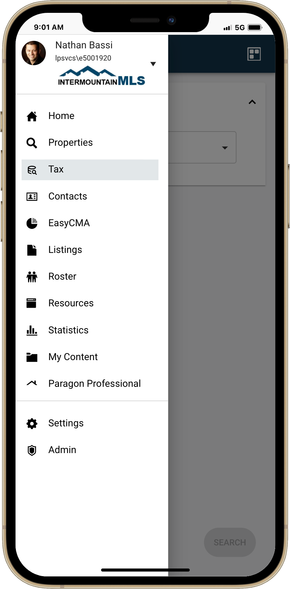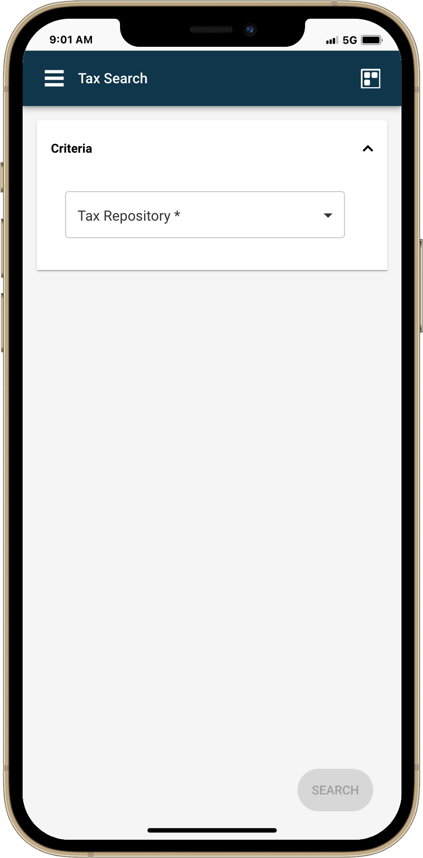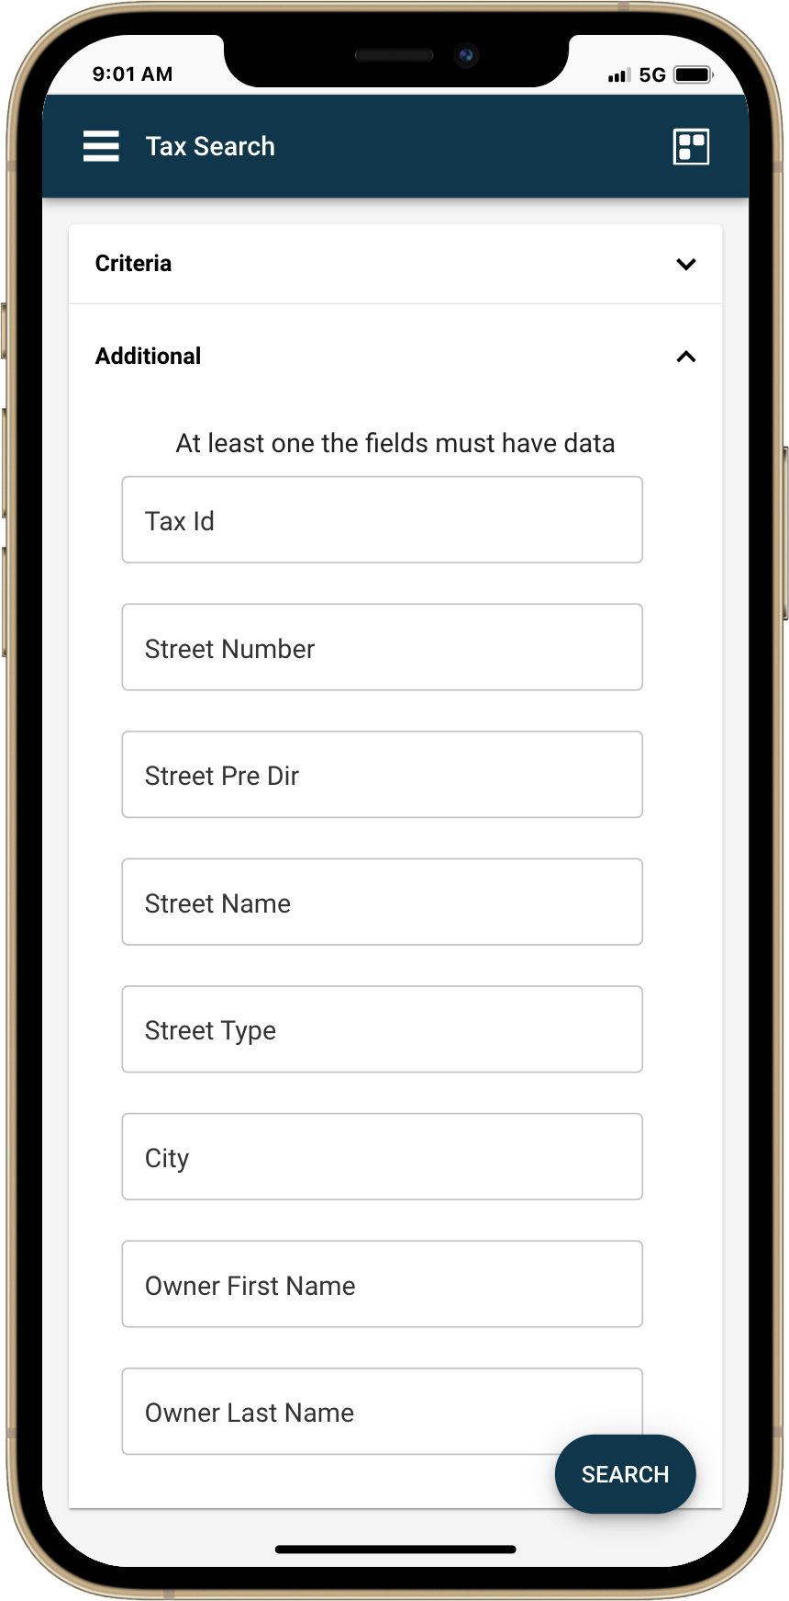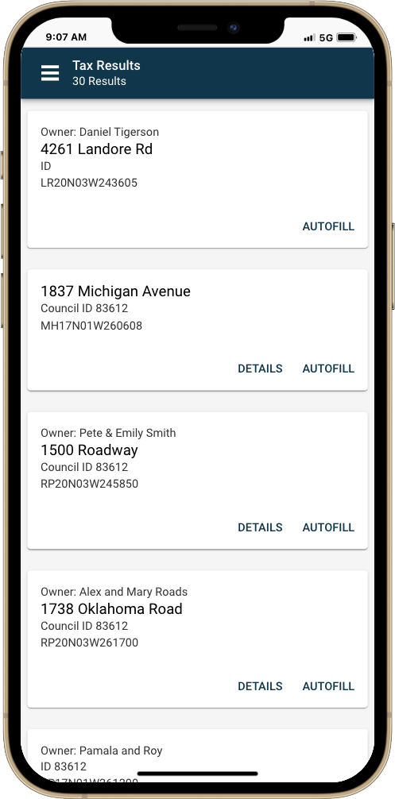

This update also replaces the older LIM Autofill process—so anytime you start a listing using Tax Autofill, you’ll automatically be guided through this new and improved workflow.

## New CMA Summary View

We’re excited to introduce the CMA Summary View, a powerful new report available in Paragon Connect. This view is designed to provide a clear, organized breakdown of comparable listings to help support your pricing strategies, market education, and listing presentations.

**Key Features of the Report:**

* **Organized Tables by Class & Status**  
  Each section of the report focuses on a specific class/status combo, making it easy to isolate and interpret key segments of the market.
* **Interactive Filtering**  
  You can **filter the listings** shown in the report to focus on the most relevant comparables for your scenario.
* **Sticky Table Headings**  
  As you scroll, column headers remain visible for easy reference—especially helpful with larger result sets.
* **At-a-Glance Market Analytics**  
  At the end of each table, you'll find **calculated metrics** for that group, including **average, median, mean, and maximum values**, giving you immediate insight into market performance.

**Important Notes:**

* The CMA Summary report supports **up to 150 listings**. If your search results exceed this limit, the report option will be disabled.
* The report uses **standard, non-customizable fields** available across most platforms.
* **Click the Print icon** in the action bar to generate a printable version.

**How It Works:**

1. **Run a property search** using any criteria you choose.
2. **Click the View Switcher icon** to open the side sheet.
3. **Select "CMA Summary"** under the **Standard** section of the available views.
4. **Filter and check only the listings** you want included in the analysis.
5. You can also **share, add to cart, get directions**, and use other standard actions just like with any other view.
6. Click or tap on the **photo** to launch the **detail report**.

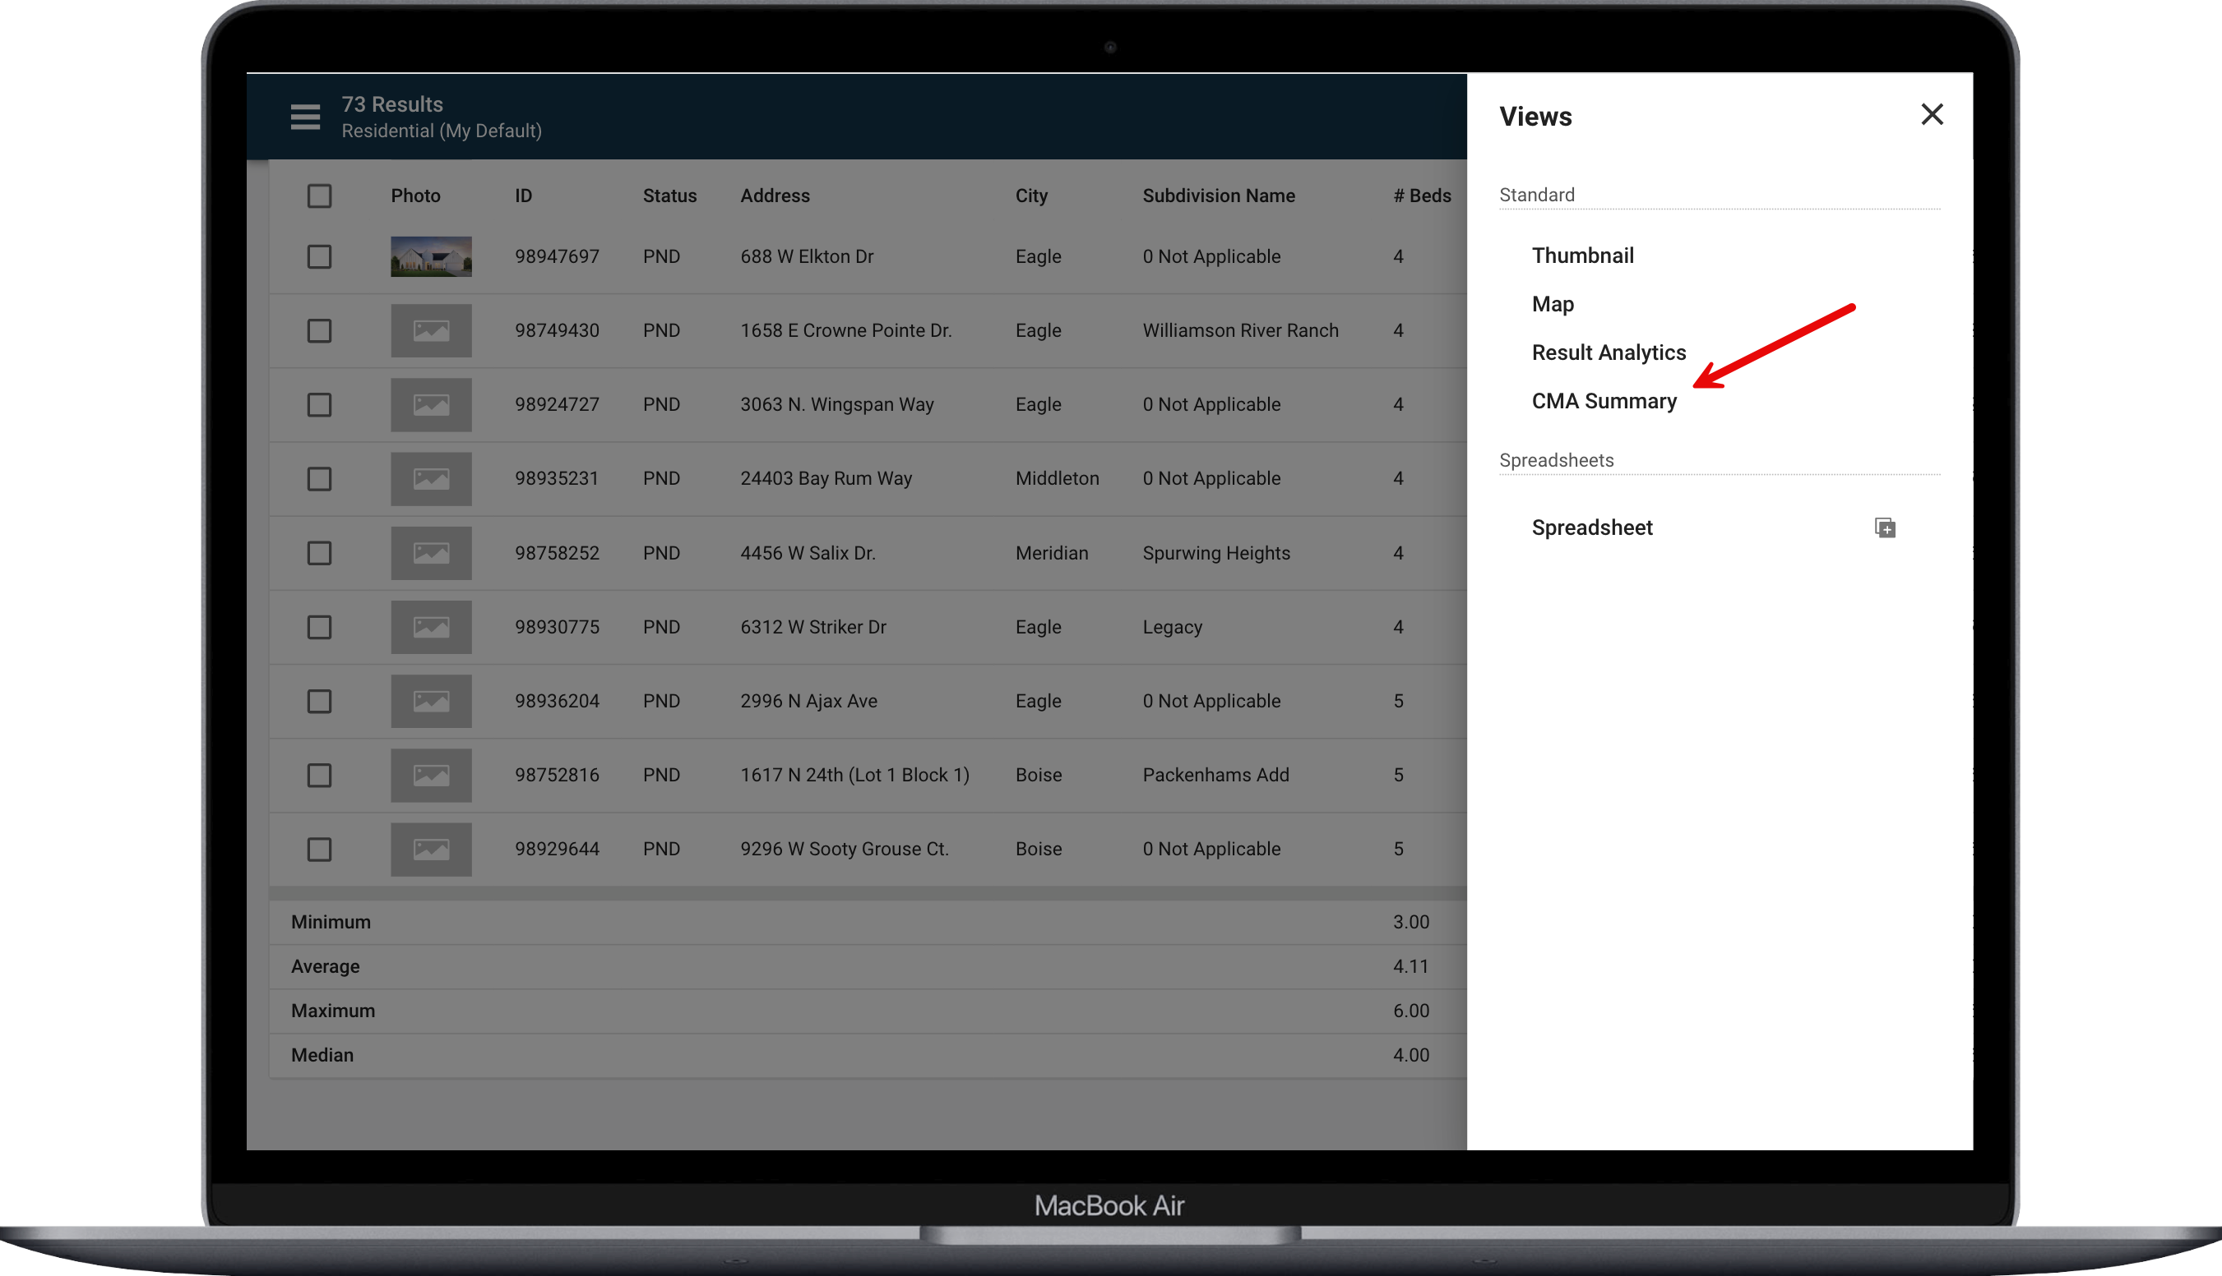

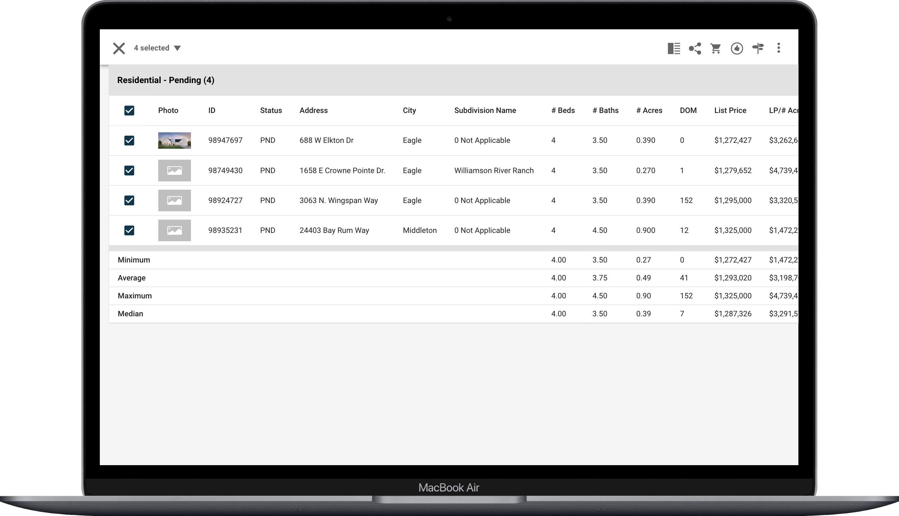

## Icon Enhancements in the App Bar

We’ve made several visual updates to the icons across the Paragon Connect app to improve clarity and consistency—especially based on user feedback.

**What's New:**

* **More Icons on Larger Screens**  
  On larger devices, you’ll now consistently see up to **six icons** displayed in the app bar for easier navigation.
* On smaller screens like mobile, this remains limited to **three icons**, with the final icon always acting as **overflow** when additional options are available.
* **Updated Iconography Based on Feedback**  
  We’ve refined several icons to align with familiar real estate app standards:
  1. **Filter Icon**: The funnel icon has been replaced with a new filter symbol commonly used across real estate platforms.
  2. **Search Icon**: The binoculars icon has been replaced with a more recognizable **magnifying glass** for search.
  3. **Consumer App Invite**: If enabled, the invite feature now uses a **key icon** instead of a roof icon.
  4. **Listing Form Updates**:
     + **Find:** The binoculars icon updated to a **search** icon
     + **Required Field**: The flag icon is now an **asterisk**, matching form input standards.
     + **Validate Address Location**: Updated to a **map pin icon** with a map visual.
     + **Price Analysis**: Now uses a **price check** icon.
     + **Tour**: Switched to a **flag icon** for clearer representation.

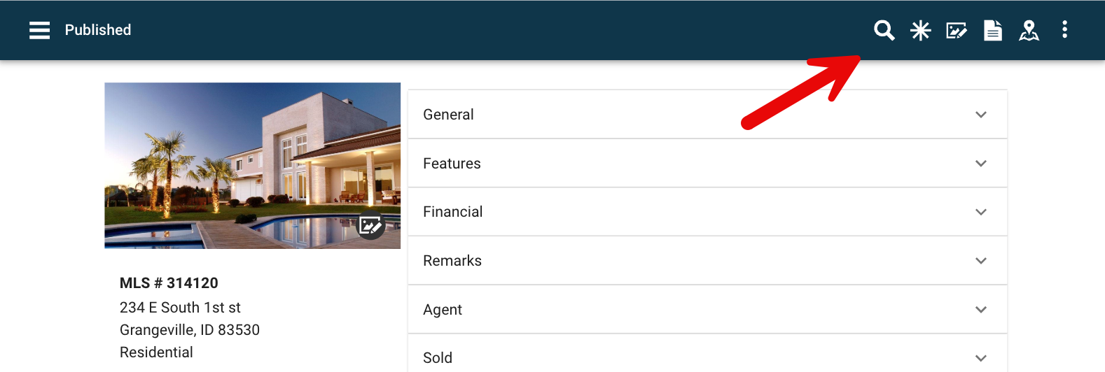We’ll continue refining the user experience based on your insights. Keep the feedback coming!

New Filter Icon

## New Navigation Links with Seamless SSO Access

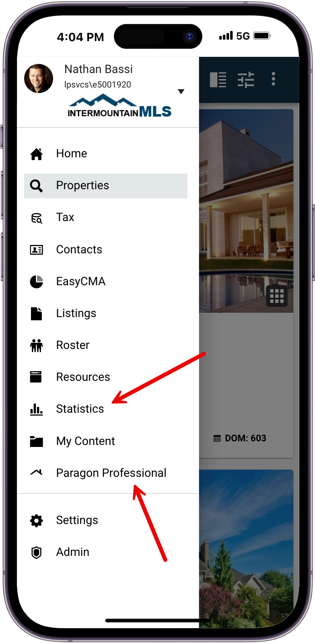We’ve added two convenient navigation links to Paragon Connect, making it easier than ever to move between tools without interruption.

* **Paragon Professional**  
  Quickly access your full Paragon system directly from Paragon Connect. With **single sign-on (SSO)**, you’ll be taken straight into Paragon—no additional login required.
* **Statistics**  
  A new menu link now takes you directly to Paragon’s **Statistics module**. Just click, and you're in—authenticated automatically via SSO.

These additions streamline your workflow and make switching between platforms effortless.