
08

08
Fall

Fall

Paragon 11.6 & 12.0 Release Enhancements

July 2025

1. Corrected Paragon Issues 2
2. MLS Customizations and Administration 5
2.1. Remove Editing Access for MLS ID field 5
3. Paragon 5
3.1. Add Media Permission to Videos 5
3.2. New Ownership Search fields in Hotsheet 5
4. Paragon Connect 6
4.1. Accessing Third-Party Integrations 6
4.2. Request a Showing - Tracking & Alerts 7
4.3. Multiple Spreadsheets 9
4.4. Messaging Banner – Improving Communication 10
4.5. End User License Agreement (EULA) in Paragon Connect 11
4.6. New Ownership Filters for Hotsheet Searches 12
4.7. New Hotsheet Alerts Widget on Your Dashboard 13
4.8. Create Your Own Custom Theme 14
4.9. New Photo Upload Progress Bar 15

Corrected Paragon Issues
Ticket# | Module | Organization | Summary
TK-24702 | Search | IMLS - Intermountain MLS | Searching Days on Market field in PC does not yield results
TK-24699 | LIM | SEAMLS - Southeast Alaska MLS | Maintaining Partials/Listings gives Nightly Process display notice
TK-24697 | LIM | IRMLS - Indiana Regional MLS;PARMLS - Pensacola AOR | Error with pulling up recovered listing
TK-24598 | Other | DMLS - Doorify MLS (Triangle) | Connect: Sellers section only scrolls to 20 listings - she has 43 Active listings
TK-24573 | Statistics | CARMLS - CARMLS, Inc. (Arkansas);CREN - Colorado Real Estate Network, Inc;GALMLS - Greater Alabama MLS;IMLS - Intermountain MLS;MAXEBRDI - MAXEBRDI MLS;SDMLS - San Diego MLS;SMLSA - Strategic MLS Alliance;VALLEYMLS - ValleyMLS / NALMLS (Huntsville) | Average and Median Price per Graph not functioning.
TK-24558 | Hotsheet | FLINTHILLS - Flint Hills AOR;VALLEYMLS - ValleyMLS / NALMLS (Huntsville) | Hotsheet Search giving error: Error retrieving data from server
TK-24528 | Other | BCCLS - REB2 Commercial;BCRES - REB2 Residential;RAE - REALTOR Assoc of Edmonton | Photo Match - Adjust verbiage to indicate matches are AI generated
TK-24527 | WebAPI | GOREALTORS - Greater Owensboro Realtor Association | OpenMLS: P60 GOREALTORS - OpenMLS Throwing Sequence Contains More Than One Matching Element
TK-24321 | Data | GPRMLS - Great Plains Regional MLS | P70: GPRMLS - LVT Freeze/Thaw dates not populating correctly
TK-24109 | Third Party | SANCAPMLS - Sanibel And Captiva Islands AOR | TPI MLSAdvantage is not working for Sanibel and Captiva MLS
TK-24359 | Email | COLUMBIA - ConsolidatedMLS | Consolidated: Collab Center Email Profile Picture not displaying
TK-24343;TK-24513 | Contacts | CCAR - Coastal Carolinas AOR | CCAR - Multiple Agents Report Missing Message Body in Email Notifications for contacts.
TK-24353 | Admin | SMLSA - Strategic MLS Alliance | SMLSA: Collab Center App Invite Code generated as contact's GUID
TK-24303 | LIM | PRIMEMLS - Prime MLS (NEREN) | Price Analysis Tool not loading Potential Buyers Count for a Partial Listing
TK-24298;TK-24301 | Login/SSO | RAE - REALTOR Assoc of Edmonton | Collab Center "Link is no longer available" error, Different GUID
TK-24232 | Third Party | CARMLS - CARMLS, Inc. (Arkansas);IMLS - Intermountain MLS;KMA - Kentucky MLS Alliance;LGVBOARD - Longview BOR;MIDKANSAS - Mid-Kansas MLS;MIMLS - MiRealSource;NELBOR - Northeast LA AOR;NSAR - NS and PEI Real Estate Associations;NWBORMLS - Northwest Wyoming Board of REALTORS;RANWMLS - REALTOR Assoc of NE WI;SANCAPMLS - Sanibel And Captiva Islands AOR;WESTKY - Western Kentucky Regional MLS;YUMA - Yuma AOR | Picture of property not showing when agent click "Share on Facebook"
TK-24218 | Third Party | MAXEBRDI - MAXEBRDI MLS | Restb.ai labels not respecting board-level config
TK-24042;TK-24105 | WebAPI |  | OpenMLS: Correct the Casing on ObjectIdType Field for RESO Compliance
TK-24534;TK-24535 | View/Reports |  | Provide Visibility to the Paragon Director Auditing
TK-24107 | View/Reports | DBQMLS - East Central Iowa | East Central Iowa- Year to Year Stats Report Displays Incorrect Median Sale Information
TK-8063;TK-24033 | WebAPI | BCAR - Baldwin County AOR | P60:BCAR- OpenMLS Web API Returned Error "Sequence contains more than one matching element" and Error Loading Grid with Enum Mapping
TK-23866 | Other | RAE - REALTOR Assoc of Edmonton | UI(03): Display New Licensing Agreement Page in Paragon Connect
TK-22605 | Print | PRIMEMLS - Prime MLS (NEREN) | Error Printing Hotsheet Report from PowerSearch Results
TK-22558 | CMA | SEAMLS - Southeast Alaska MLS | CMA Adjustment buttons non-functional
TK-9807 | Configuration | RANM - New Mexico MLS | Make MLS ID (MLSID) field MLS Info uneditable
DEV-16238 | PETL | PARAGONMLS - Paragon Demo | PETL: Auto Add Lookups has created duplicate entries for the same value
DEV-16883 | Other | RAE - REALTOR Assoc of Edmonton | UI(04): Printing the EULA
DEV-9970 | WebAPI | CREN - Colorado Real Estate Network, Inc;GALMLS - Greater Alabama MLS | OpenMLS: SourceSystemName is Blank on Exported Mapping Sheet if a Formula is Used

MLS Customizations and Administration

Remove Editing Access for MLS ID field
Within the Paragon Pro Admin section, there is a page called MLS Information. On this page the MLSID value assigned to each system is visible. Previously, this value was available for editing by staff members, but once established this value should never change. We updated this page so the MLSID value remains visible but is no longer eligible for editing. This will prevent any unintentional issues.

Paragon

Add Media Permission to Videos
If your system allows Video links to be uploaded to listing, this feature has been expanded to use the Media Permission field. You may now define if uploaded video links are Public or Private.
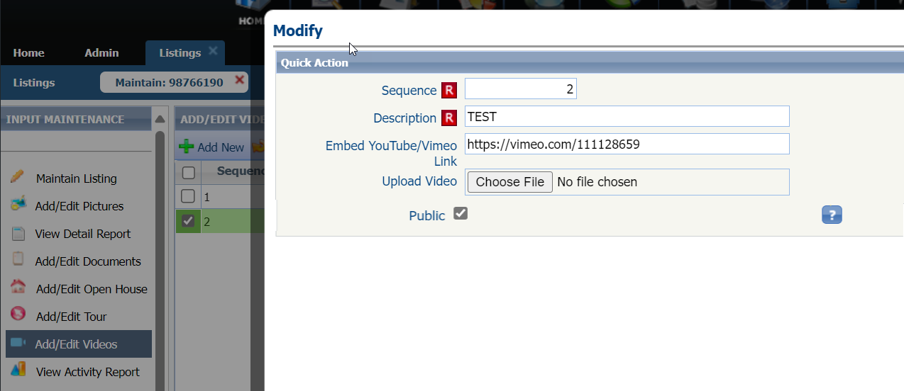

New Ownership Search fields in Hotsheet
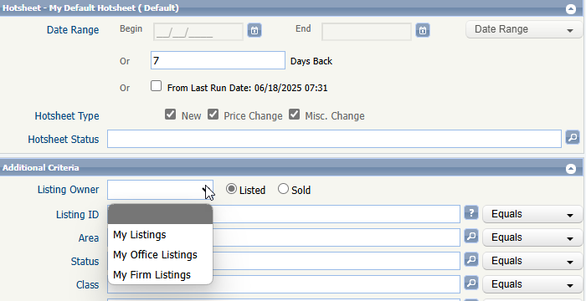
The Paragon Hotsheet search form has been updated to include a new search filter for listing Ownership.

This new addition gives greater flexibility to hotsheet searching in general and allows customized hotsheets to be enabled with Alerts for the new Hotsheet Alerts widget for the Paragon Connect dashboard.

Paragon Connect

Accessing Third-Party Integrations
Navigating to your favorite third-party integration just got a whole lot easier in Paragon Connect.
Previously, accessing integrations from a thumbnail, spreadsheet, or detail report opened a dialog window filled with link names—making it harder to quickly spot the tool you needed. Now, we’ve redesigned this experience to make it faster and more intuitive.
When you click or tap the Third-Party Integration (TPI) icon, a new side sheet will slide out, presenting each available integration in a clean, single-column list. Each entry is clearly labeled and paired with its corresponding TPI icon, so you can find and launch the right tool with ease.
Looking ahead, we’re exploring ways to make this even better—like adding sections and categories to help you organize and prioritize your third-party tools.
This is just the beginning of a more organized, integrated experience. Stay tuned for more!
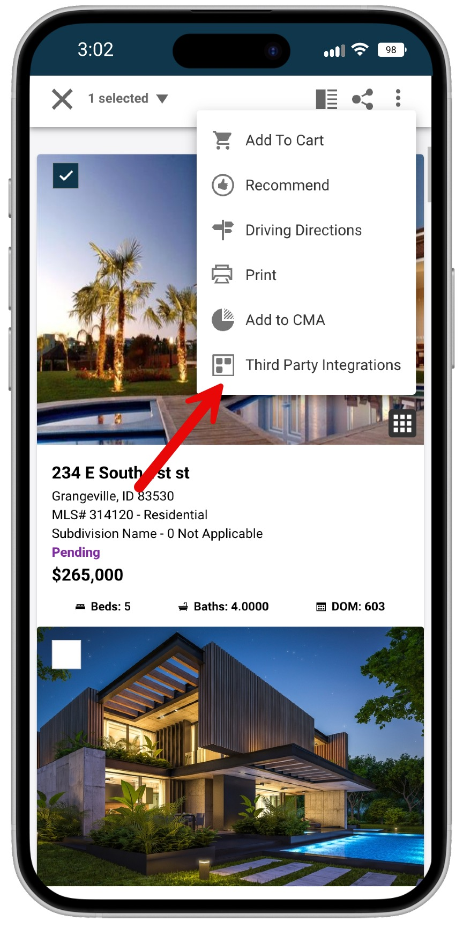
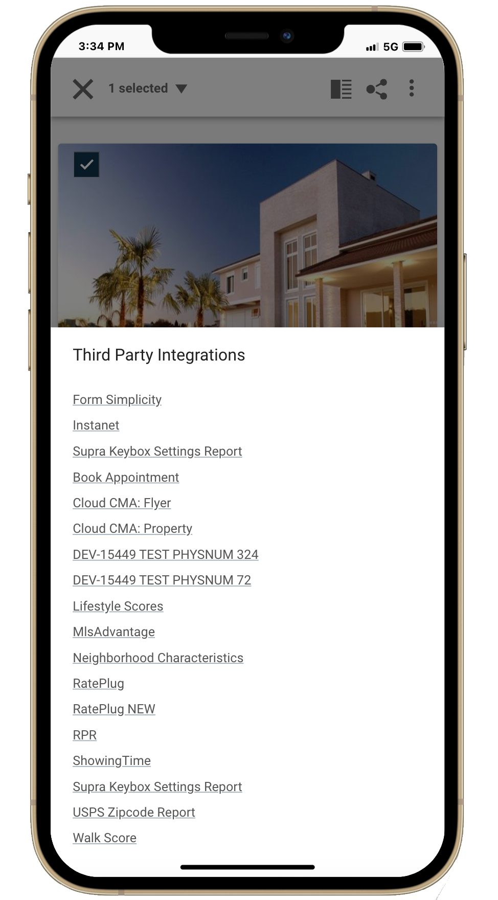
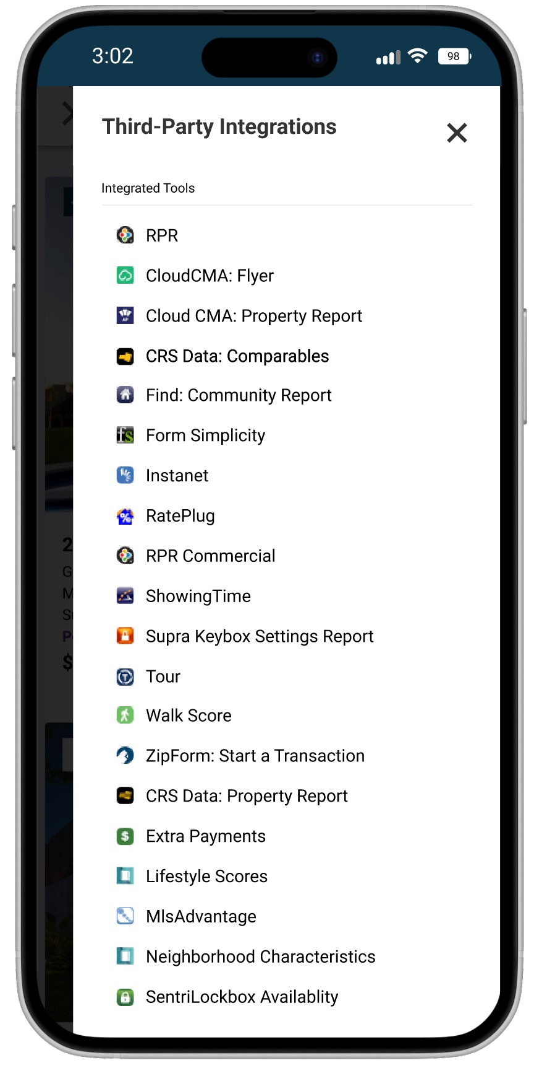
Old Layout
New Layout
Note: This is a sample list of Third-Party Integrations and may not reflect those available in your system.

Request a Showing - Tracking & Alerts
We’ve made it easier than ever to stay on top of showing requests from your buyers in the Paragon Connect application.
Previously, when a buyer clicked “Request a Showing,” an email was sent to their agent—but that was the only place the request lived. There were no system alerts or central place to track upcoming requests. That changes now.
With this update, we’ve introduced multiple new ways to manage and track showing requests:
- New “Requested Showings” Section
A dedicated area in the My Content menu now displays all upcoming showing requests. Use built-in filters to narrow by date and quickly find specific request windows.
- Contact-Level Visibility
Showing requests now appear on the contact detail page, allowing you to see requests tied to individual buyers. Perfect for managing active clients or prioritizing hot leads.
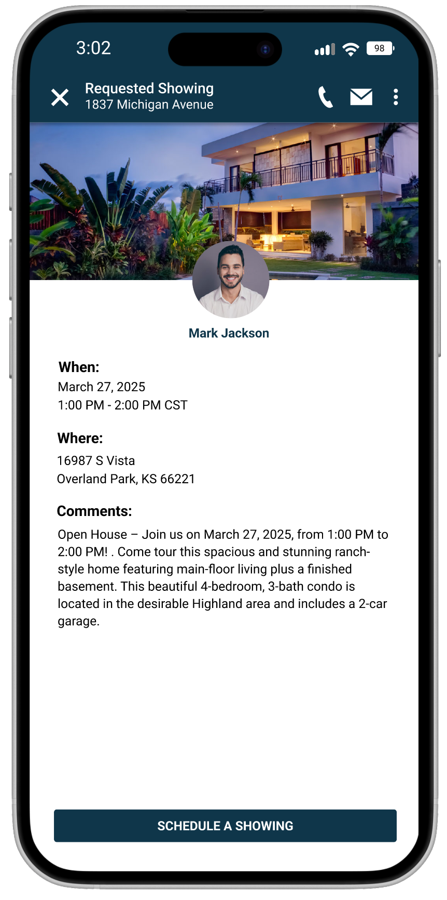
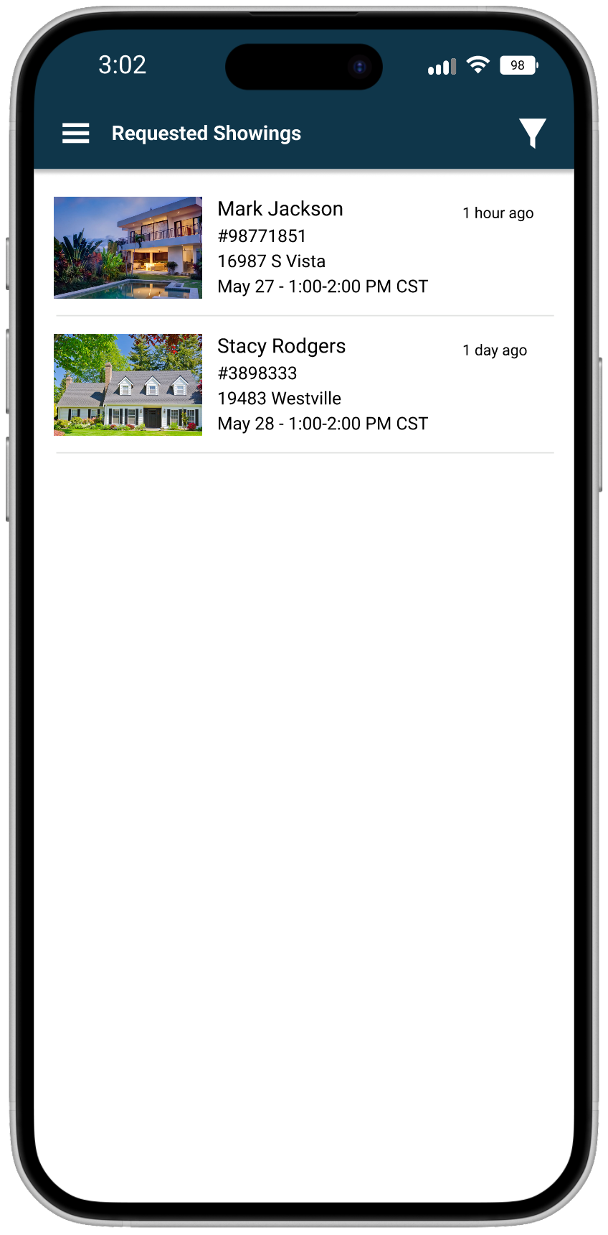
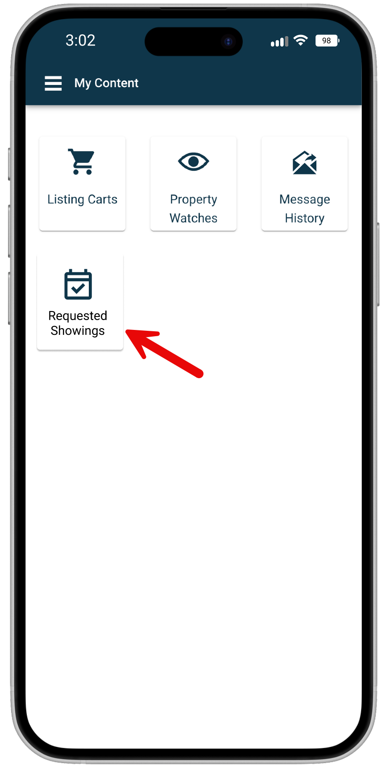
- Push Notifications
Stay connected on the go. You’ll now receive real-time push notifications (if you have the Paragon Connect mobile app) for every new showing request—ensuring you’re informed even when you’re away from your desk.

These updates give you full visibility and timely alerts, so you’re always in control and ready to respond.
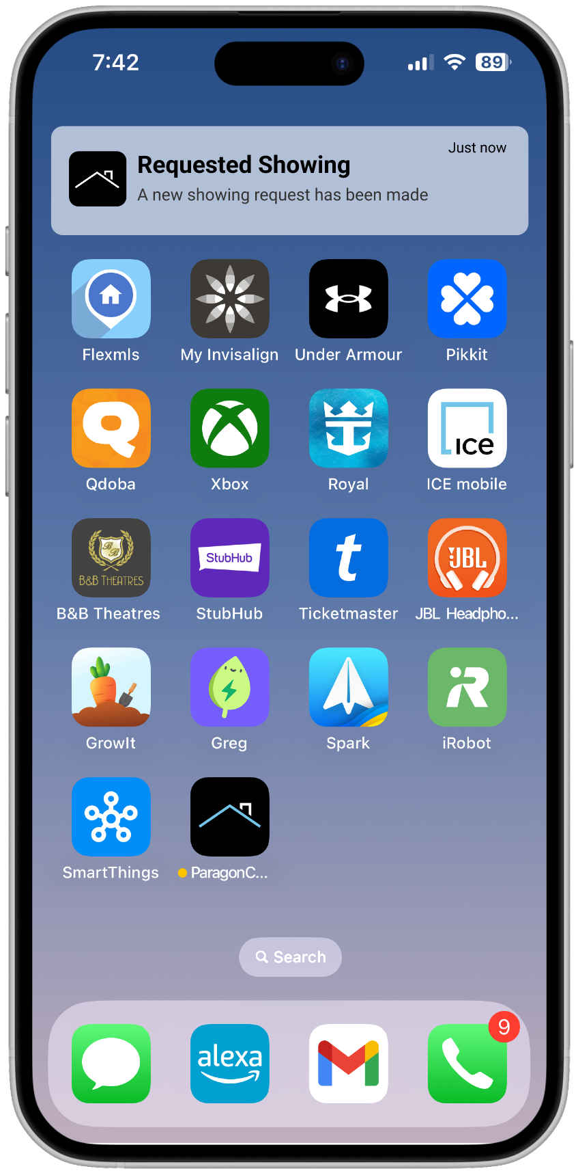

Multiple Spreadsheets
We’re thrilled to introduce a major upgrade to the listing results experience in Paragon Connect—you can now create and manage up to five custom spreadsheets per class.
Previously, each class-based search offered just one customizable spreadsheet. Now, you have the flexibility to build multiple spreadsheet views tailored to your specific needs. Whether you're tracking active listings for a client, comparing price trends, organizing properties by neighborhood, or setting up a quick-view layout for different search types—this new feature gives you more control and efficiency than ever before.
Each spreadsheet can be independently customized with its own field selections and column order, making it easy to switch between views depending on your focus.
How It Works:
- Open a class-based search as you normally would by click on the view switcher icon.
- Look for the new copy icon next to your spreadsheet name.
- Click the copy icon to duplicate your current spreadsheet layout.
- Give your new spreadsheet a custom name in the dialog that appears—something that helps you quickly identify its purpose.
- Once saved, you’ll have a new spreadsheet with the same fields, layout, and customizations as the original.
- Customize this new spreadsheet however you’d like—change fields, rearrange columns, or adjust the layout to fit your specific needs.
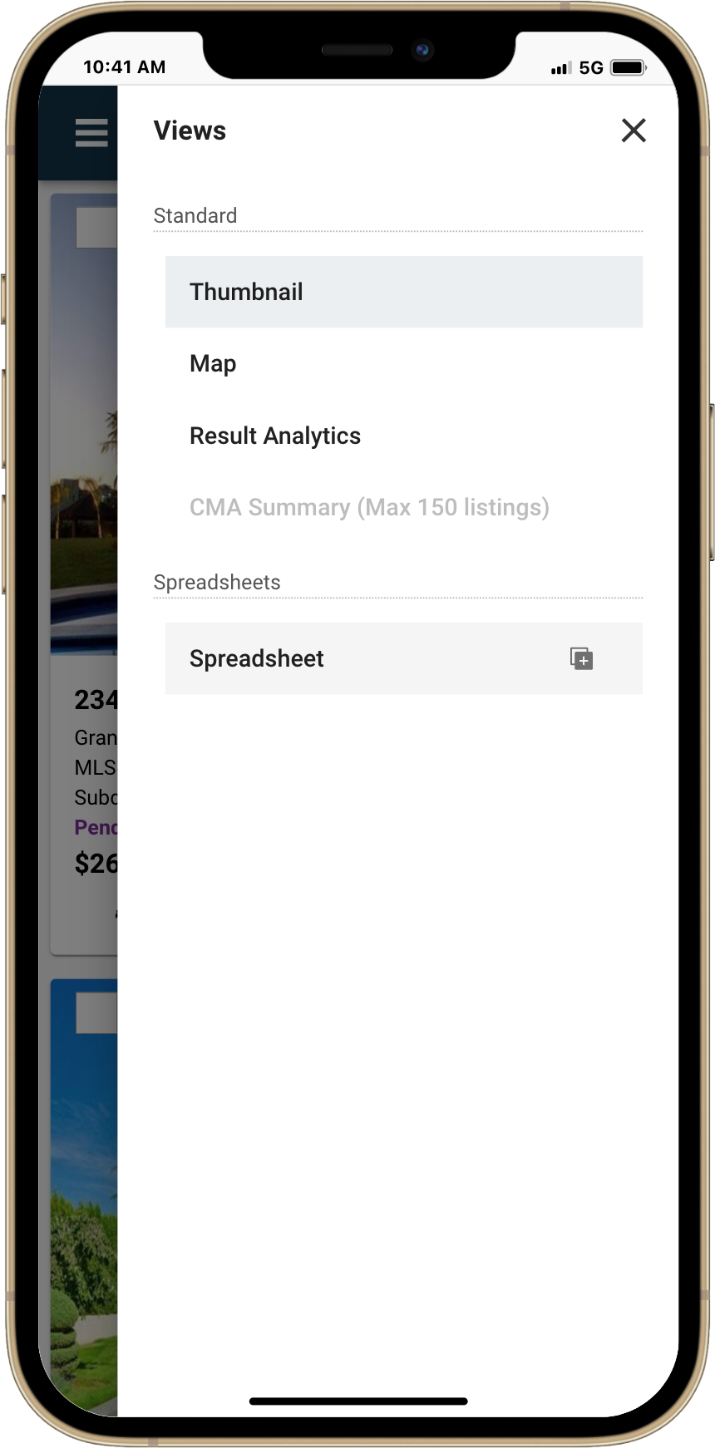
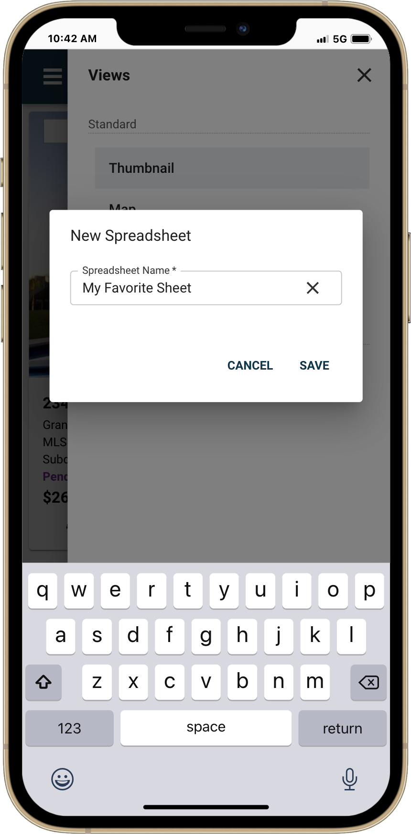
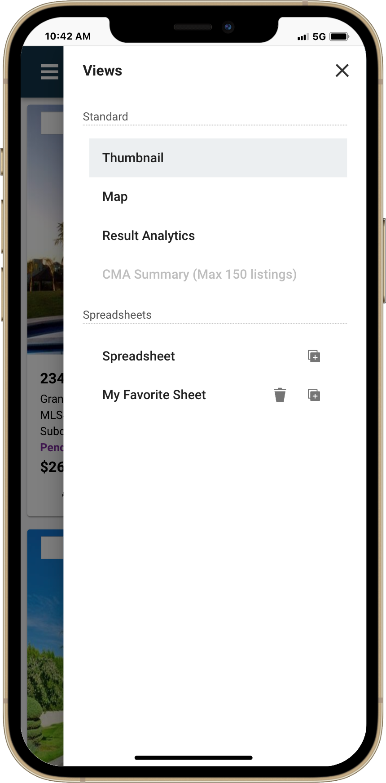
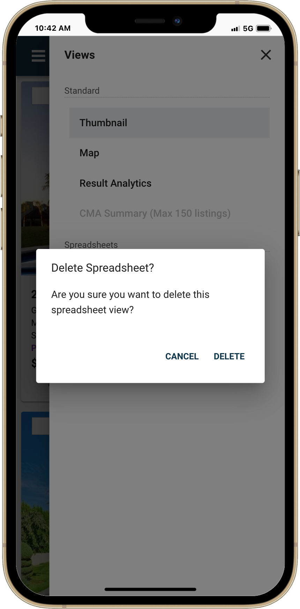
- If you no longer need a spreadsheet, you can delete it at any time to keep things organized. Note: At least one spreadsheet must always be available. If only one exists, it cannot be deleted.

Messaging Banner – Improving Communication
Keeping users informed just got easier. System Administrators in Paragon Connect have long been able to send targeted messages using the existing Paragon Admin System Message feature—reaching individuals, offices, firms, agent types, or entire boards. These messages appear under the megaphone icon in the top app bar, with a badge indicating new communications.
Now, we’re taking that a step further.
To ensure important messages don’t go unnoticed, we’ve introduced a new message banner that appears directly on the landing page. This makes it easier than ever for users to see—and act on—critical updates.
How it works:
- Single Message Display: If only one message is sent, the banner will display the subject and a short preview. Users can choose to read it or dismiss it.
- Persistent Reminders: If the banner is closed without reading the message, it will reappear at next login until the message is viewed or expires.
- Multiple Messages: If there are several unread messages, the banner will state: “You have X unread messages!” with a subtext: “You have important messages that need your attention.”
- Message Viewer with Navigation: Clicking View opens the first unread message, with easy navigation to flip through additional messages. A message is only marked as read once it’s viewed.
- Banner-Only for Messages: This banner enhancement applies only to admin system messages, not system alerts.
- Global Banner Visibility: Whether users land on the dashboard or a specific listing (e.g., via Reverse Prospecting), the banner will appear—ensuring visibility no matter where they enter the system.
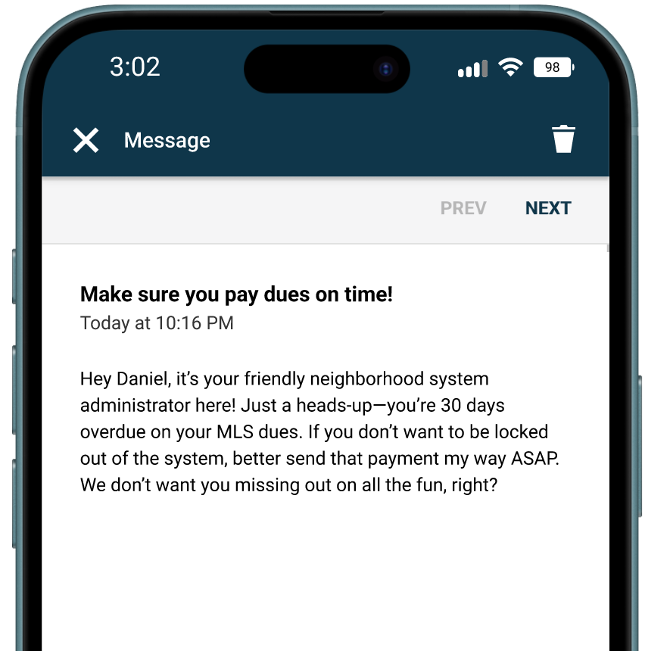
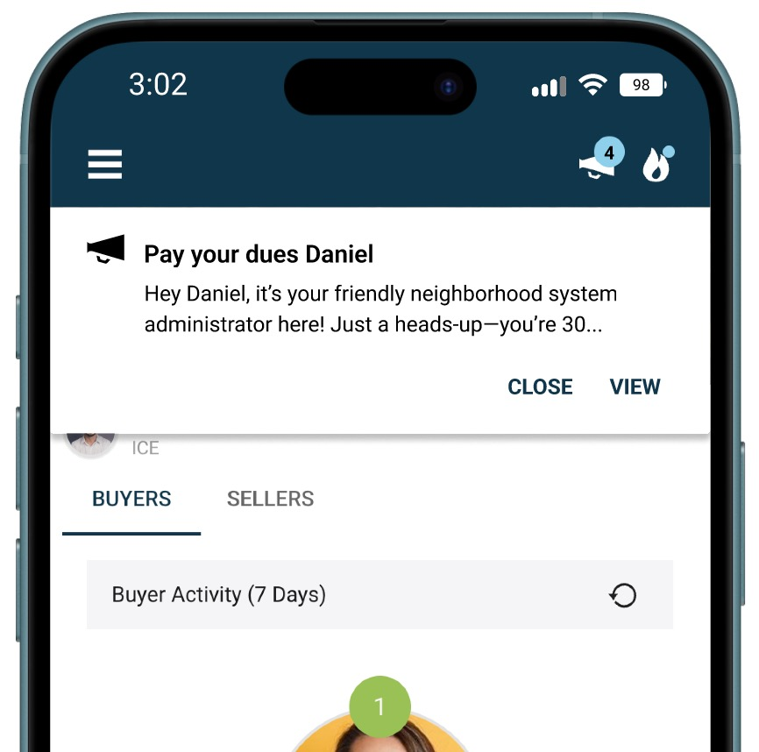
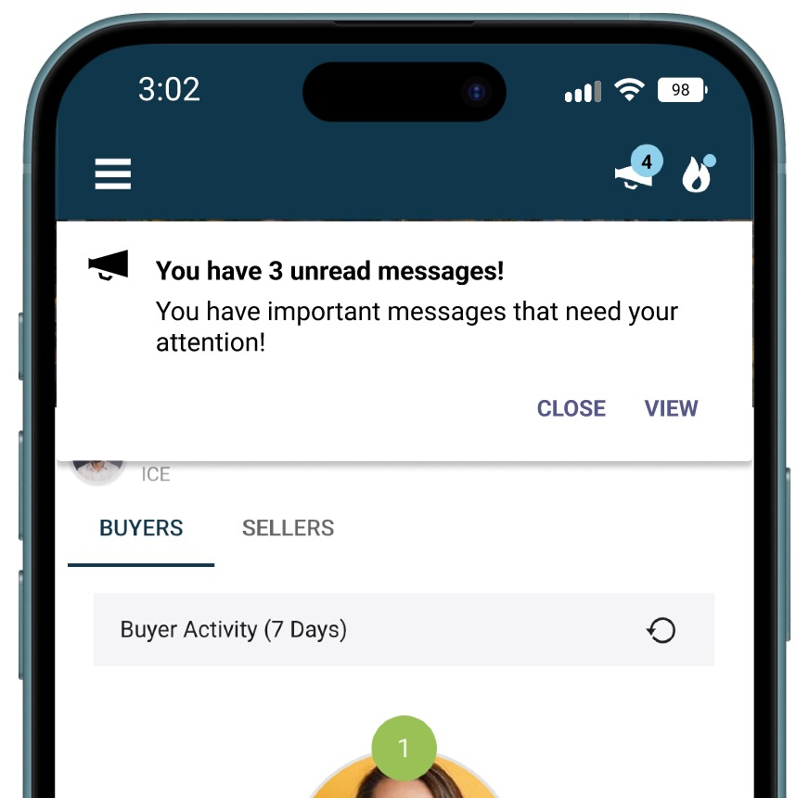
This update is just one of many steps we’re taking to improve communication, training, and engagement tools within Paragon Connect. Stay tuned—more enhancements

End User License Agreement (EULA) in Paragon Connect
Paragon Connect now supports the End User License Agreement (EULA) functionality previously available only in Paragon Pro. This enhancement ensures that all users can review and acknowledge required agreements directly within Paragon Connect.

What’s New:

- An optional EULA page has been added to Paragon Connect, allowing users to view, print, accept, or decline license agreements.

- If any agreements are pending, they will automatically appear upon login.

- Access to Paragon Connect will be granted only after all EULAs are accepted.

- Users who decline any agreement will see a message stating that access is denied, followed by a return to the EULA page.

- If multiple EULAs are required, they will be presented one at a time for review and response.

- EULAs can be reactivated and presented again to all users, including those who previously accepted them.

This update brings consistency across platforms and ensures that important usage agreements are acknowledged before accessing the system.
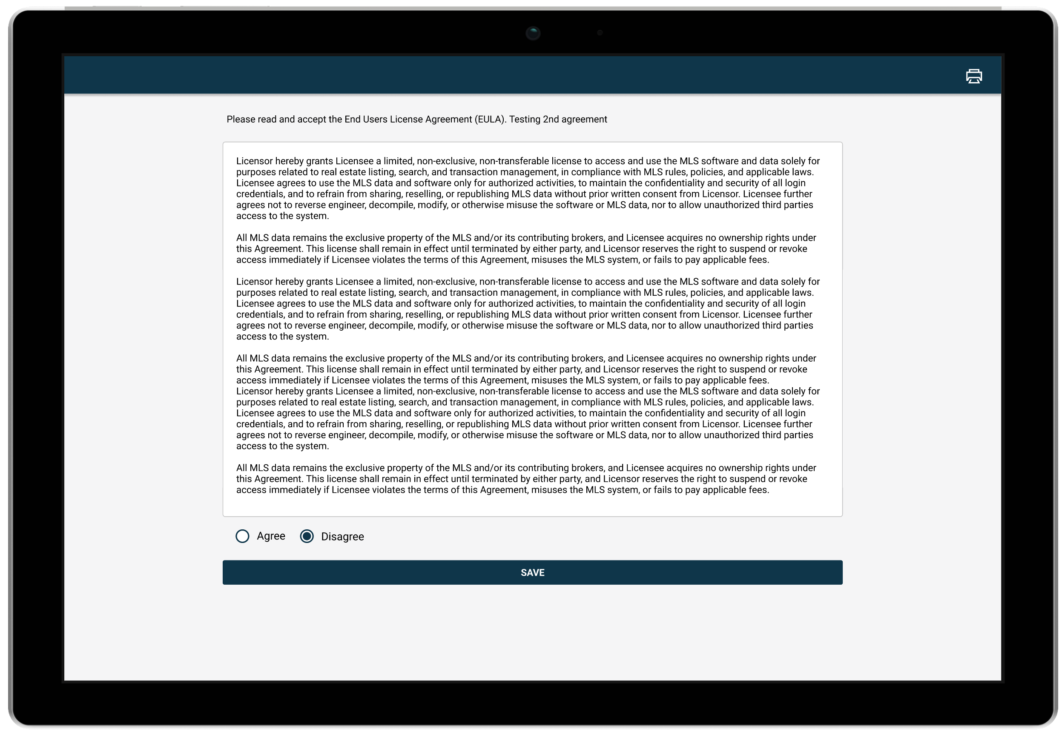

New Ownership Filters for Hotsheet Searches
We’ve enhanced Hotsheet searches to give you more control over the listings you monitor. With the new Listing Owner filter, you can now target alerts based on whether a listing is yours, belongs to your office, or is part of your firm’s inventory. Combined with a new List/Sell toggle, these options allow you to zero in on the side of the transaction that matters most—whether you’re tracking new listings or recent sales activity. This update helps streamline your workflow and ensures you receive alerts that are more relevant to your business.

What’s New
All Hotsheet search forms—both default and saved—now include:

New Field: Listing Owner
A single-select lookup that lets you filter results by:

- My Listings
- My Office Listings
- My Firm Listings (Note: This field is optional and will not be pre-filled.)

Advanced Option: List/Sell Filter
Choose whether to apply the ownership filter to:

- Listed (default) – Filters based on the listing side of the transaction
- Sold – Filters based on the selling side of the transaction

How It Works
- You can only select one ownership value at a time.
- Typing into the field will show matching options, or click the caret to open a lookup modal.
- The new field appears at the top of the “Criteria” section on every Hotsheet form.
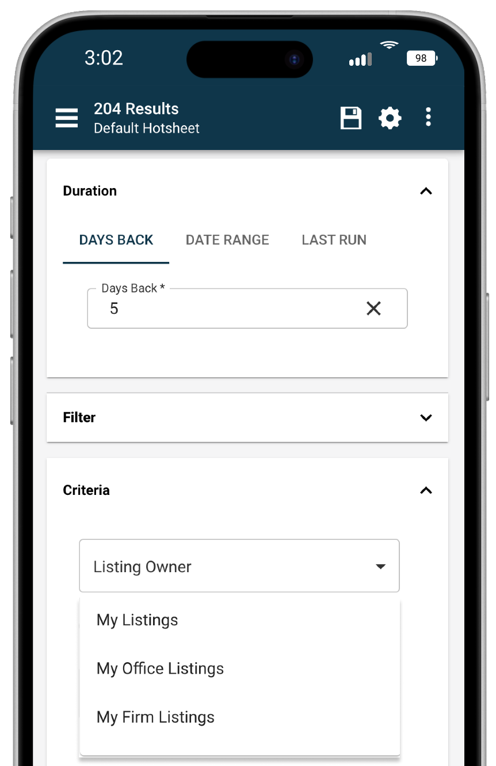
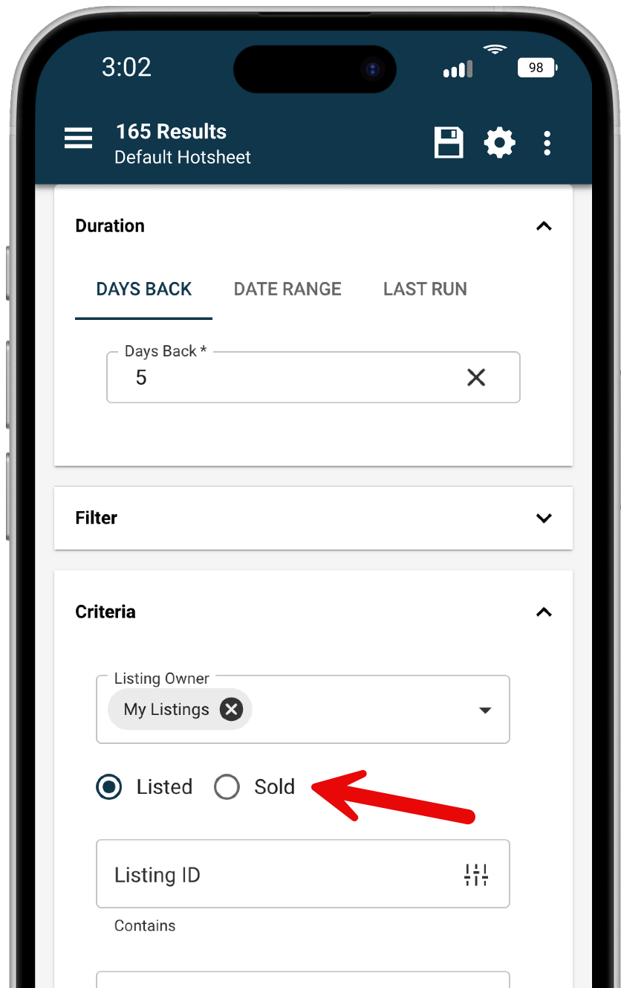
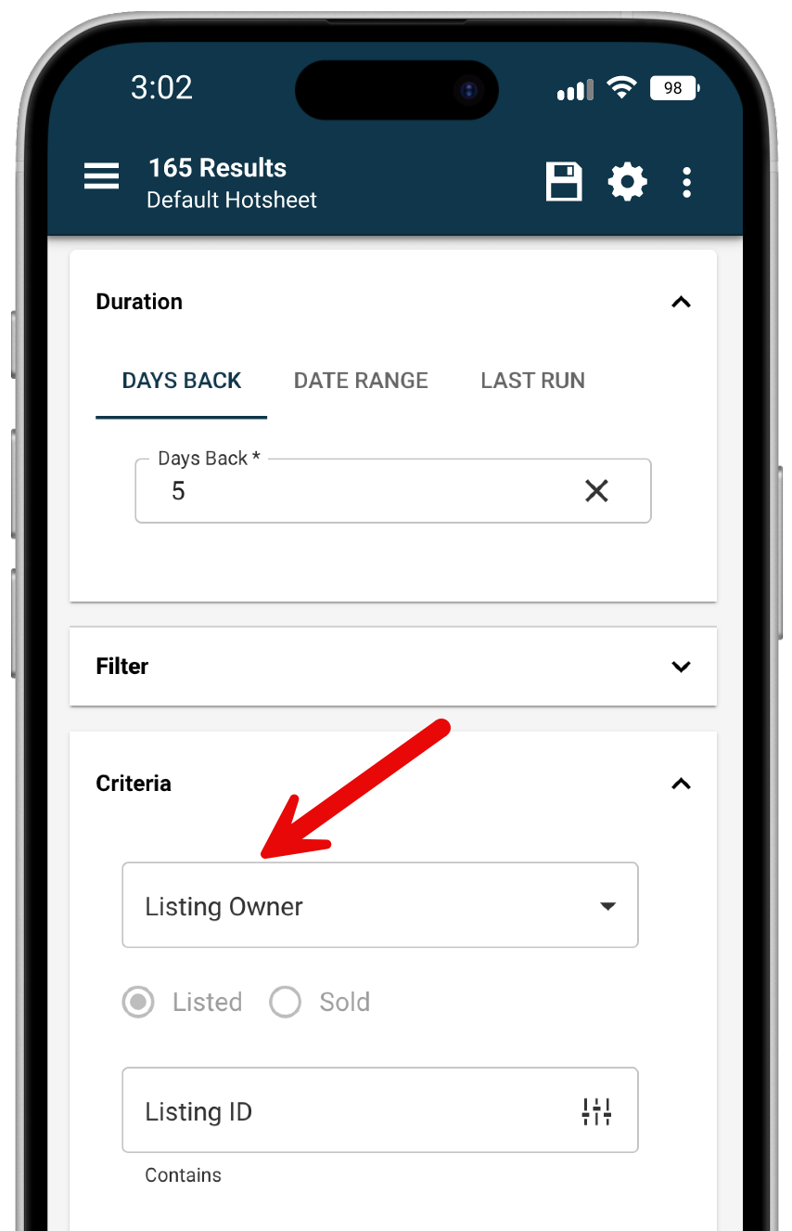
- Searches using these new fields can be saved, and the values will populate correctly when reloaded.

New Hotsheet Alerts Widget on Your Dashboard
You now have a Hotsheet Alerts widget on your Paragon Connect dashboard. This feature brings you quick access to your saved alerts every time you log in—offering a familiar market monitor experience with even greater control over your search criteria, all without leaving your home screen.

The widget displays your saved Hotsheet searches in a scrollable list. Each alert shows:

- The number of new matches since your last run (click to view listings)
- An “All” button to view all results for that Hotsheet
- The Hotsheet name and last run date (click the name to open the search form with prefilled criteria)

At the top of the widget, you’ll find:

- A Refresh button to update alert counts
- An Overflow Menu with:
  - Manage Hotsheets – opens the full Hotsheet manager
  - Create New Hotsheet – opens a blank Hotsheet search form
  - Default Sort – lets you choose how alerts are ordered:
  - By activity (default)
    - By name (A–Z)
    - Your choice is saved for future sessions

Other helpful features include:

- Expand/Collapse toggle to view 4–5 alerts or up to 8
- “View All” link if you have more than 8 alerts, taking you to your full Hotsheet management page
- A timestamp showing the last time the widget was refreshed
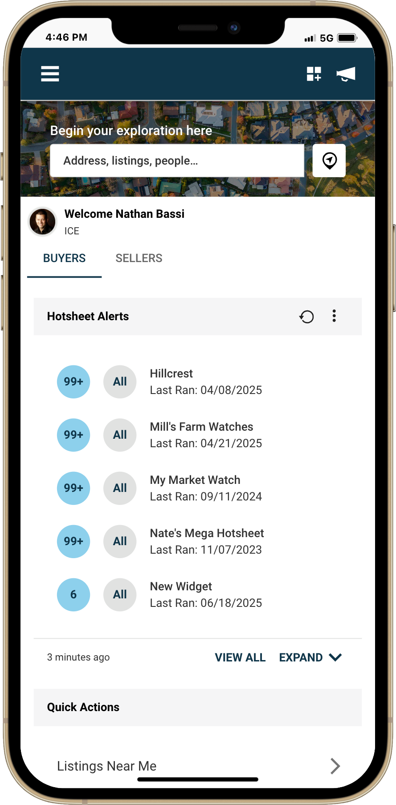
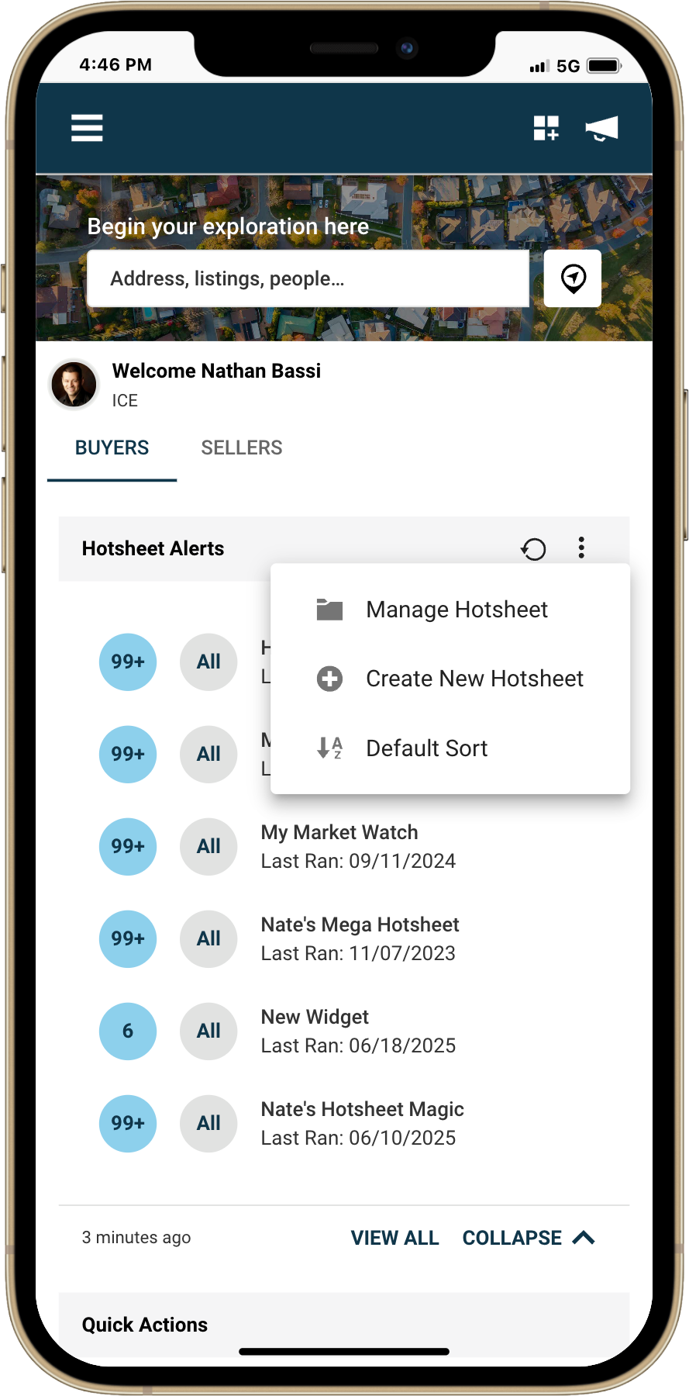
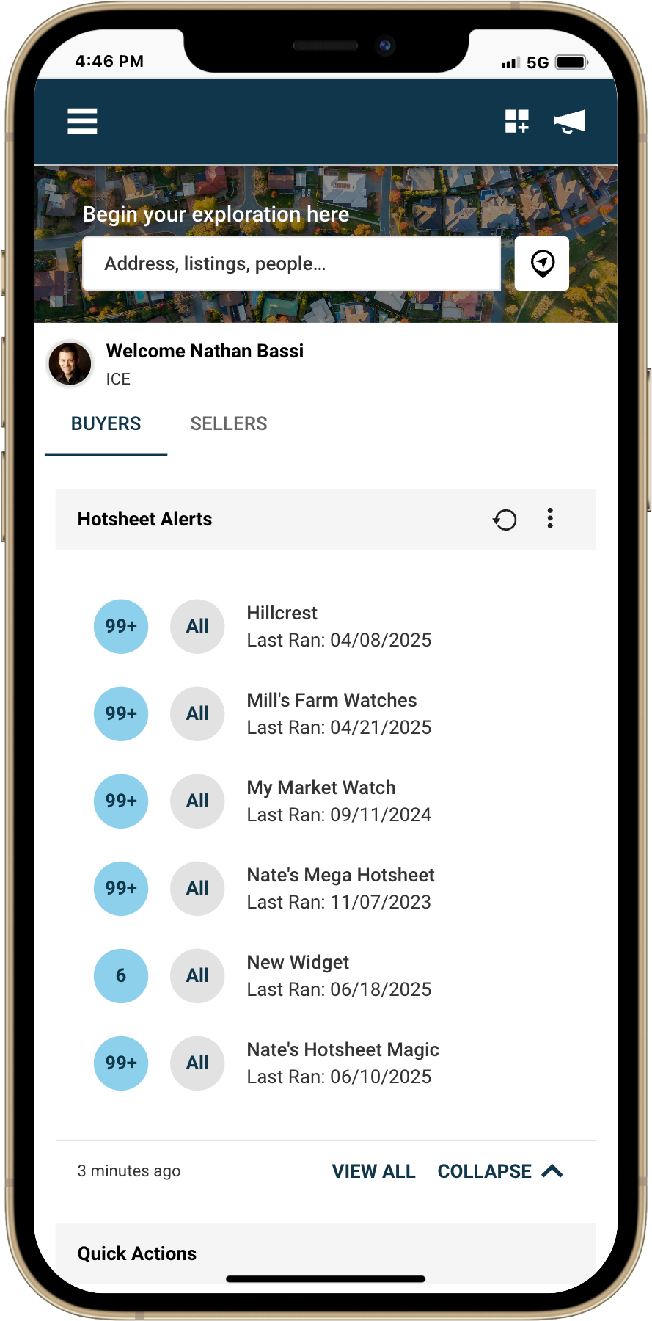

Create Your Own Custom Theme
You can now create a Custom Theme in Paragon Connect, giving you more control over your interface colors. Whether you’re aiming to match your brokerage’s brand or simply want to personalize your workspace with colors you enjoy, this new feature makes it easy to design a theme that reflects your style. This enhancement is available exclusively in Paragon Connect and brings a more flexible, tailored visual experience to your daily workflow. This new option is available under:
Menu > Settings > System > Choose Theme > Color Theme > Color
What’s New:
- A new "Custom Theme" radio button is available.
- Selecting "Custom Theme" allows you to define:
  - Primary color using a color picker tool
  - Secondary color using the same picker tool
How It Works:
- Click the eyedropper icon to launch the color picker and select or enter a HEX code.
- Selected values will appear in read-only fields next to the color bars.
- Previously saved custom colors will auto-fill when you revisit this setting.
- Your theme will not go live until you click Save.
Preview Feature:
- The Preview button is disabled until both primary and secondary colors are selected.
- When enabled, the preview modal will display your theme across the interface.
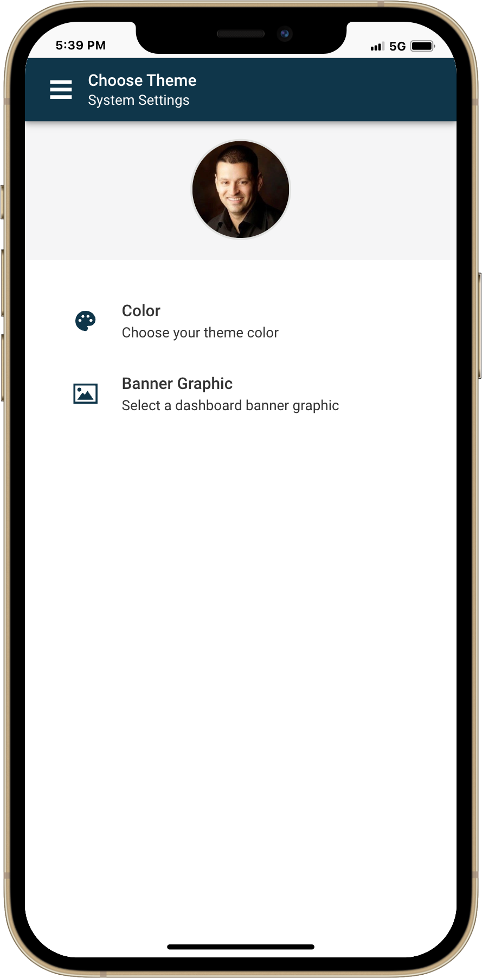
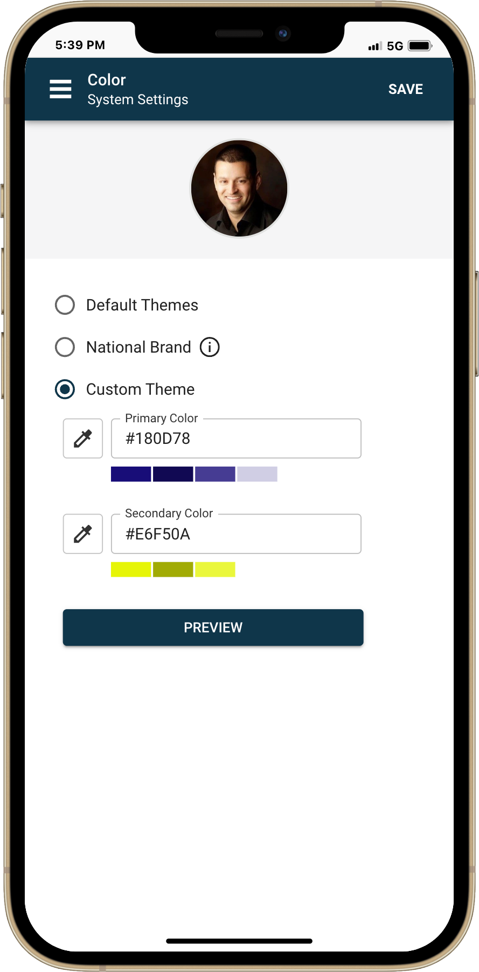
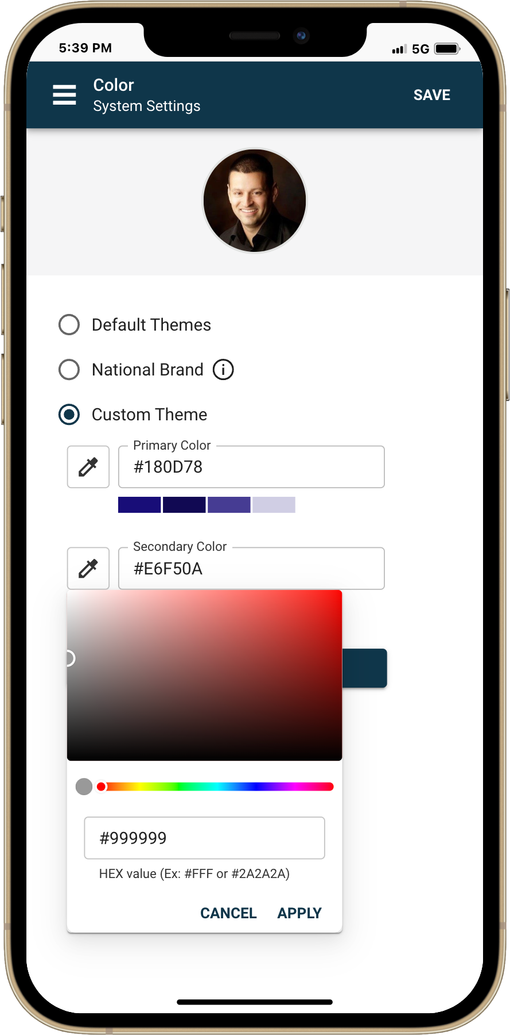
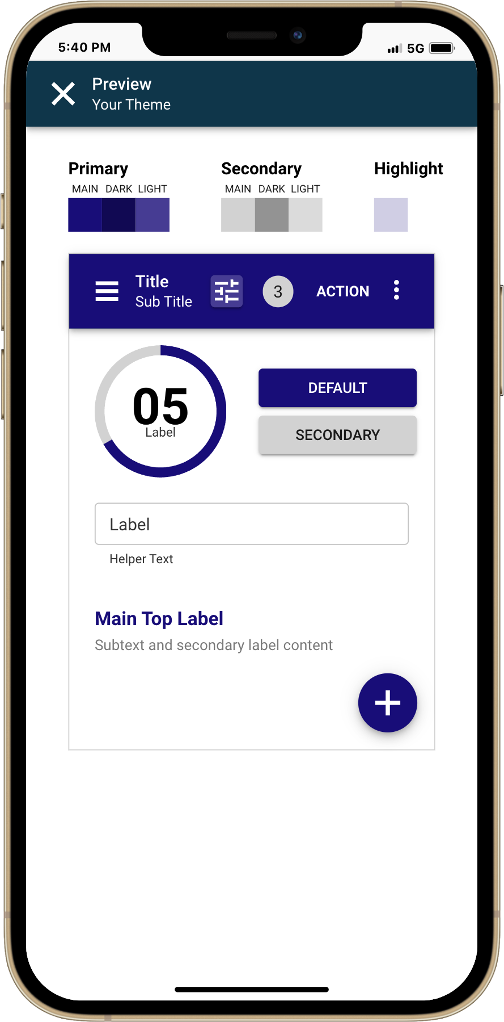
- The app bar subtitle in preview will say: "Your Theme"

New Photo Upload Progress Bar
We are improving your listing photo upload experience with the introduction of a new Photo Progress Bar—designed to give you better visibility and control when uploading multiple images.
What’s New:
- A new visual progress bar now appears during photo uploads
- You'll see both upload progress and percentage completed, offering a clearer view than the previous generic loading animation
- This improvement helps you track uploads more accurately and efficiently
Even Better Upload Performance:
In addition to the new visual feedback, we’ve also removed the total file size limitation that previously restricted how many photos you could upload at once. Now, you can upload more images—faster and with greater flexibility -- without hitting an overall batch file size cap.
These enhancements make uploading photos smoother, faster, and more reliable than ever.
