
08

08
Fall

Fall

Paragon 11.0 Release Enhancements

March/April 2025

1. Corrected Issues 2
2. MLS Customizations and Administration 4
2.1. New Optional Agent Mobile App “Create Password” page 4
2.2. Update to Restb.ai Compliance Reporting 5
3. Paragon Product Updates 5
3.1. Mobile App Corrections and Improvements 5
3.2. Easily Add Documents to Your EasyCMA Reports 6
3.3. EasyCMA Document Library 7
3.4. Restb.ai Photo Match 8
3.5. Easy Navigation with Detail Reports – Collaboration Center 9

Corrected Issues
Ticket# | Module | Organization | Summary
TK-15066 | Paragon | Search | COLUMBIA - ConsolidatedMLS;CREN - Colorado Real Estate Network, Inc;GPRMLS - Great Plains Regional MLS;IRMLS - Indiana Regional MLS;MAXEBRDI - MAXEBRDI MLS;MIDKANSAS - Mid-Kansas MLS;MIMLS - MiRealSource;RAARMLS - NorthWest Illinois Alliance of REALTORS® (formally Rockford);RANWMLS - REALTOR Assoc of NE WI;VALLEYMLS - ValleyMLS / NALMLS (Huntsville) | Hotsheet Search not sorting by Sort order Specified
TK-13692 | WebAPI | WebAPI | PRIMEMLS - Prime MLS (NEREN);SMLSA - Strategic MLS Alliance | OpenMLS: Syntax Error When Using Append Button for Features in Mapping Tool
TK-21863 | Paragon Connect;PC - Mobile App | Search | BCAR - Baldwin County AOR | iPhone > Clicking map pin intermittently do not load the images on the property detail
TK-22820 | Paragon | Search | PRIMEMLS - Prime MLS (NEREN) | Criteria for How Sold Field not retained in Saved Search
TK-22854 | Paragon | CMA | DMLS - Doorify MLS (Triangle) | CMA "Error Creating the CMA Packet"
TK-22952 | CCR;Collab Center;Paragon Connect | Contacts | NGLRMLS - Northern Great Lakes MLS | NGLRMLS-Saved Search for Contact John & Nancy Hope does not match Collab Center Results
TK-22955 | WebAPI | WebAPI | SCWMLS - South Central Wisconsin (Madison) | OpenMLS: P50 SCWMLS - Throwing Could Not Be Bound When Using Literal String as Formula for PropertyType
TK-22963 | Paragon | Preferences | BCCLS - REB2 Commercial;BCRES - REB2 Residential | Preferences Wizard displaying code on Assume ID page
TK-23012 | Paragon | LIM | GOREALTORS - Greater Owensboro Realtor Association | Users unable to add valid VIMEO link to Listings
TK-23098 | Paragon;Paragon Connect | Email | RAE - REALTOR Assoc of Edmonton | Subscribe (Opt In) does not require clients to click a confirmation link- they are automatically opted in
TK-22951 | CCR;Paragon | View/Reports | RAE - REALTOR Assoc of Edmonton | CollabCenter client should not show in Access Compliance Report
DEV-15661 | Paragon;Paragon Connect | View/Reports | DMLS - Doorify MLS (Triangle) | P5 DMLS- Specific features are not displaying values in the spreadsheet view

MLS Customizations and Administration

New Optional Agent Mobile App “Create Password” page
An update to the agent mobile app is coming shortly after the 11.0 Paragon release. This mobile app update will include new ICE Branding colors for the initial login pages.
For customer systems using the built-in mobile app login, we added a new optional page giving users the opportunity to create a password that will be stored in Paragon.
If you use an external SSO method and passwords are not stored within the Paragon system, we have a new option to make using the mobile app login easier. This option will advise users to establish a new password to use the mobile app, independently of their current MLS login credentials.
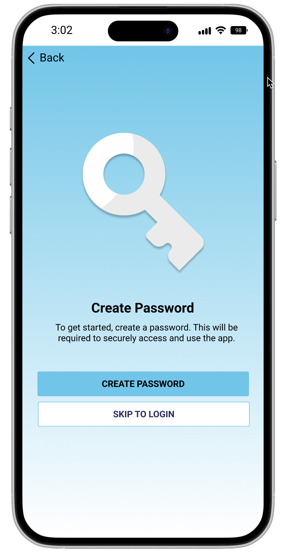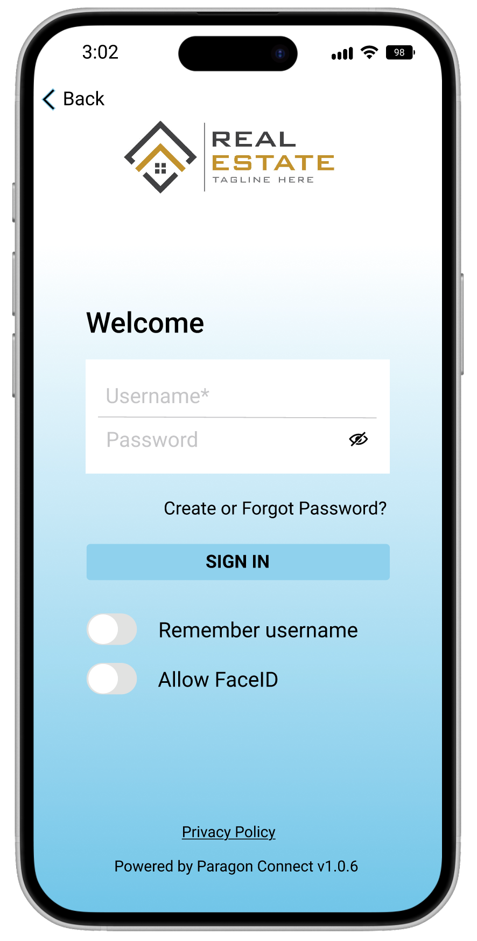

Contact your SSM if you would like to enable this optional page.

Update to Restb.ai Compliance Reporting
For customers who have licensed Restb.ai Compliance, the Paragon Admin reporting tool has been updated. The Compliance search form now includes a new “Last Run Date” feature. The search form also remembers the last set of criteria entered for the logged in user.
After running the report, the next time you log in the form will pre-populate with the same criteria and will update with the exact timestamp of the previous report. This makes it easer to quickly see all the violations that happened since the last time the report was executed.

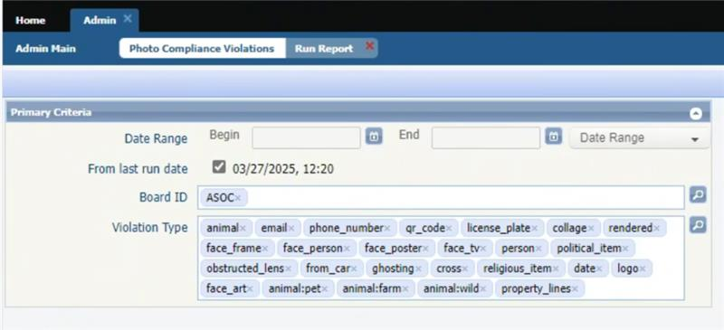

2.1. Restb.ai Compliance Data available as RETS Resource
For customers who have licensed Restb.ai Compliance, the compliance data can be made available via a new RETS Resource. This data is appropriate for MLS/Board Administrators for internal audits or for third-party compliance systems.
Contact your SSM if you would like to enable this Resource.

Paragon Product Updates

Mobile App Corrections and Improvements
Agent and Consumer App updates will be available with the 1.1.3 version coming to the app stores mid-April.
- Improvement for Photo Detail View to support landscape mode/orientation
- Improvement for Agent app ICE branding color changes for initial login pages
- Optional improvement for a new “Create Password” page prior to agent initial login workflow
- Correction for CollabCenter Invite Code copy issue on Android
- Correction for device font changes affecting the general UI on agent app
- Correction for the link from the Update App message on agent app
  - NOTE: Users will see an error after clicking the Update link with this release, but it will be corrected for all releases going forward

Easily Add Documents to Your EasyCMA Reports
We’re excited to introduce a powerful new update that gives you even more control over your EasyCMA reports. You can now upload and attach your own PDF documents, helping you create truly customized and professional presentations for your clients.
Add one or multiple PDFs—such as marketing materials, agent introductions, service overviews, or property flyers—directly into any CMA report. These documents will be included in both the digital version and the print-ready version of your report.
You can now add, delete, and even reorder documents within your CMA, giving you the flexibility to tailor every report to your exact needs.

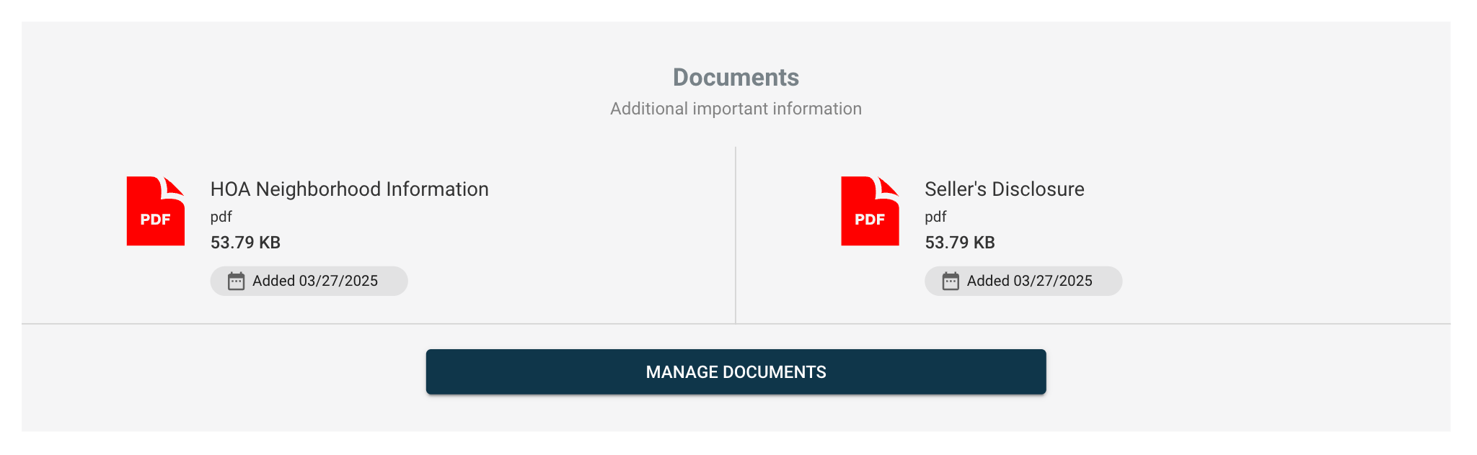

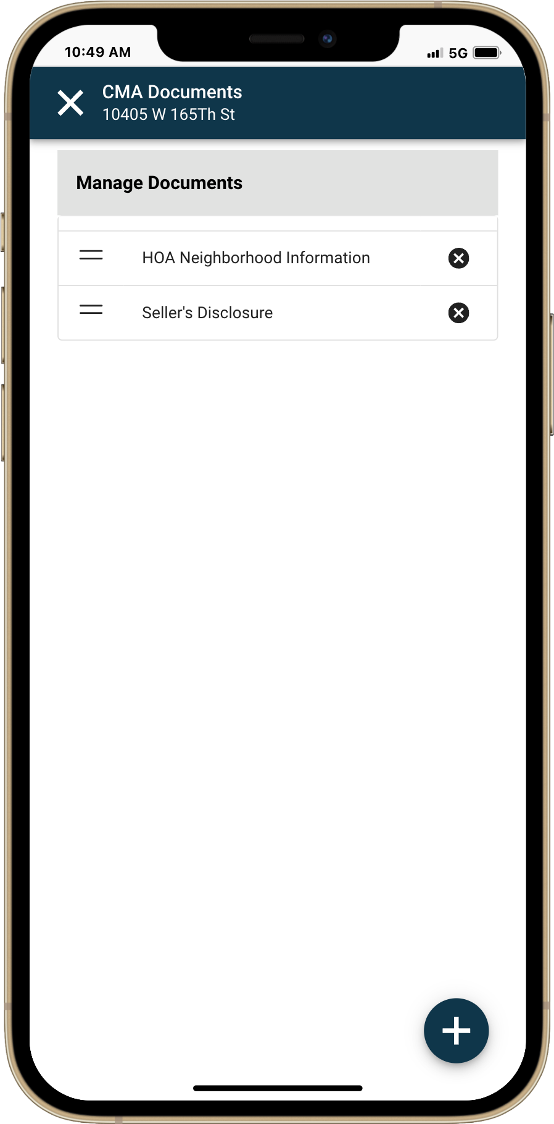
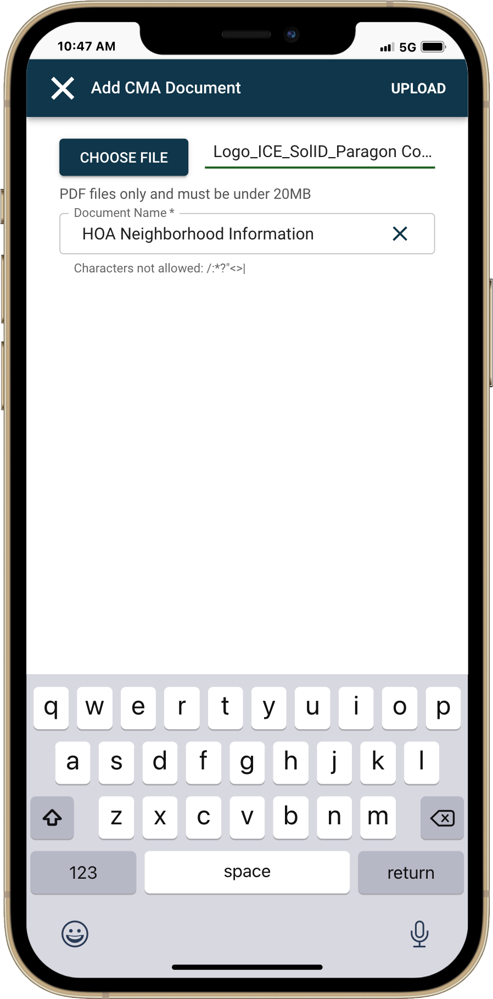
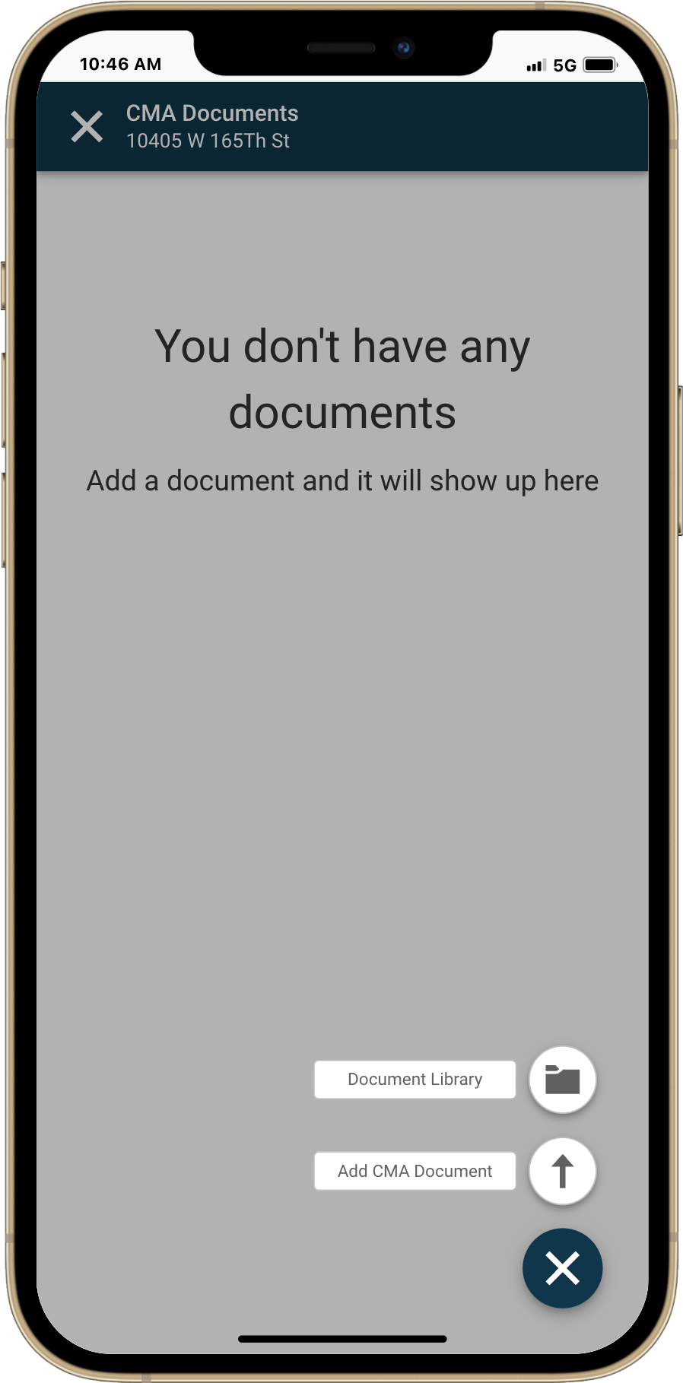
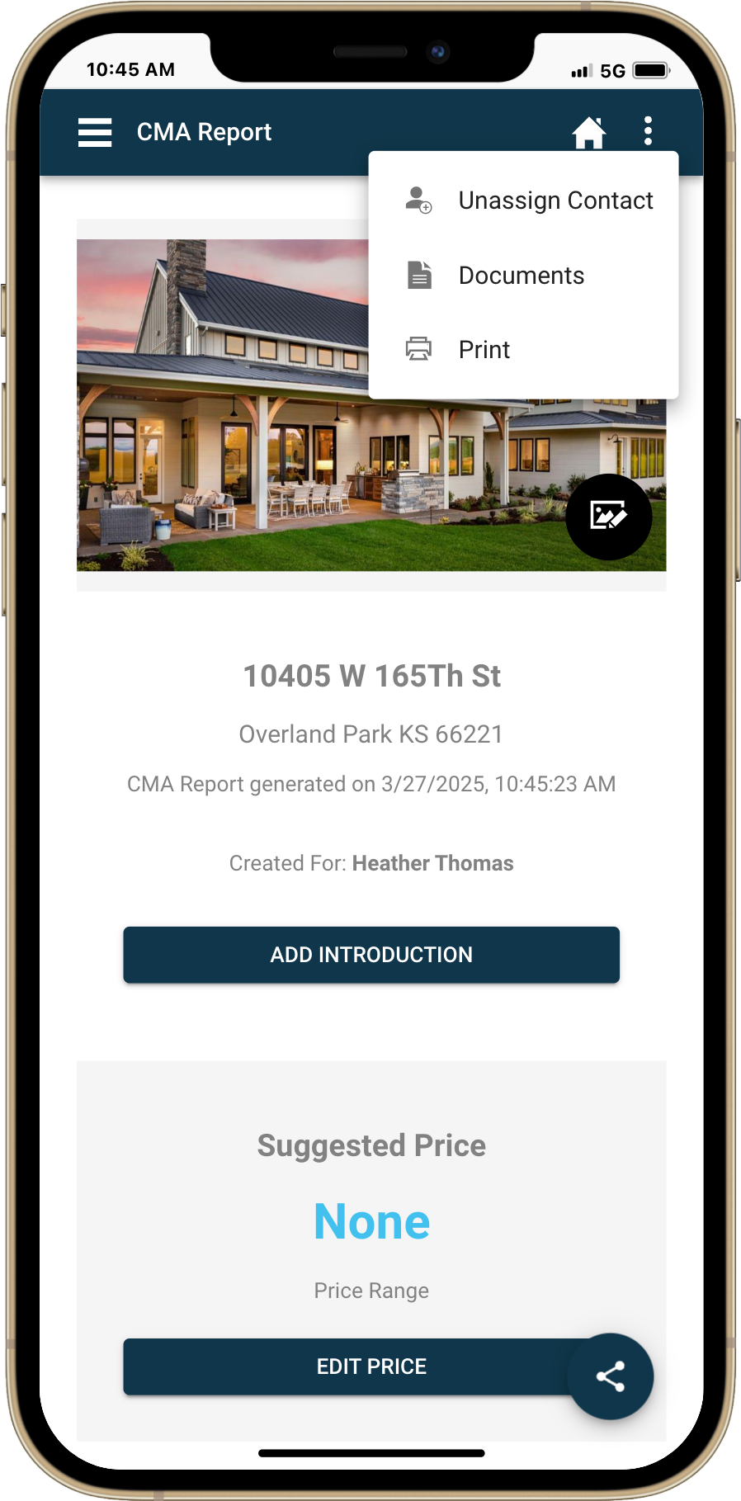

EasyCMA Document Library

We’ve also launched the CMA Document Library, a dedicated space where you can store your frequently used PDF files. Located in your CMA settings, this feature makes it easy to manage and organize the documents you rely on most.

Save time by uploading your standard materials once and reusing them across multiple reports. You can even mark any document with a star to have it automatically included in every new CMA report you create. This keeps your presentations consistent while streamlining your workflow.

With this update, EasyCMA gives you more flexibility and control to build polished, professional reports that make an impact.
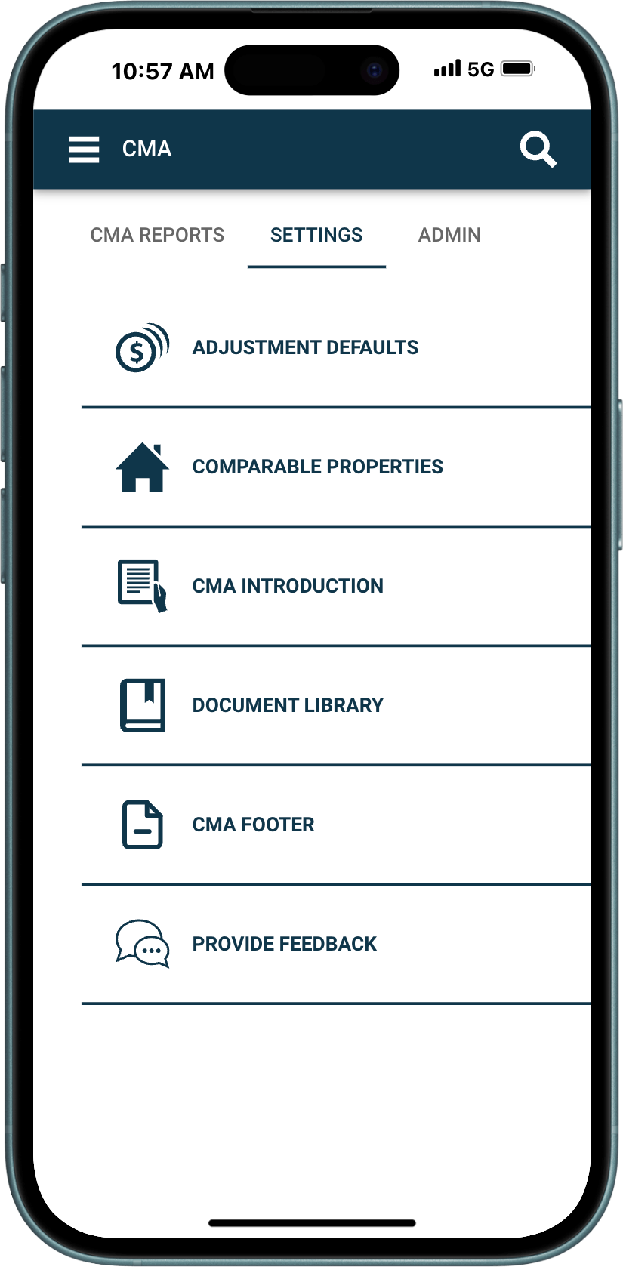
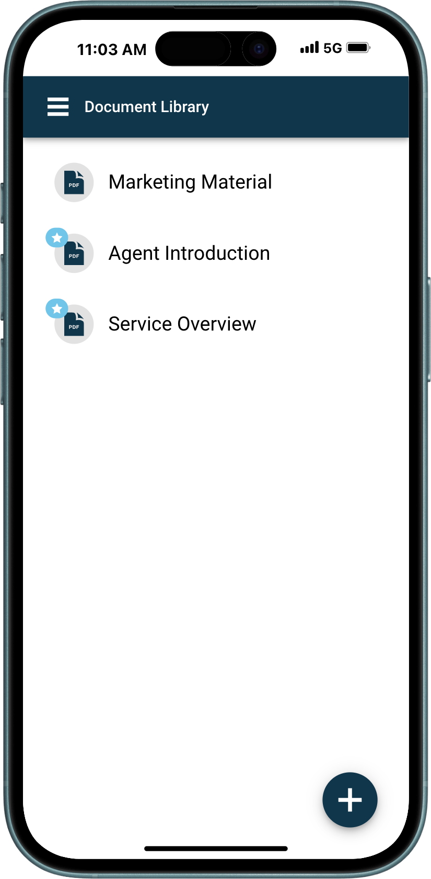
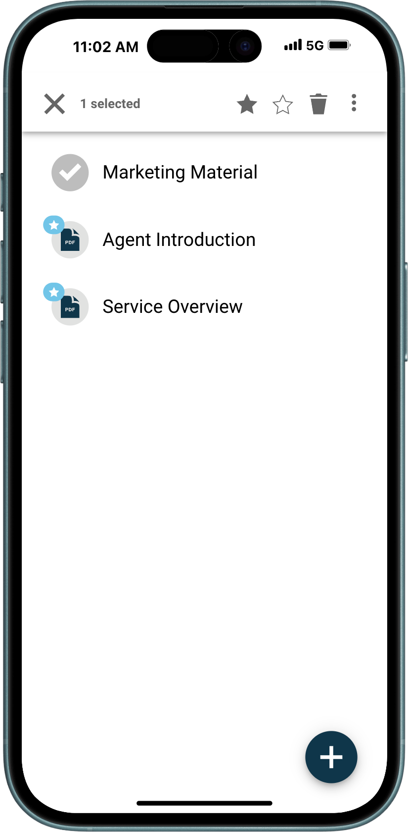
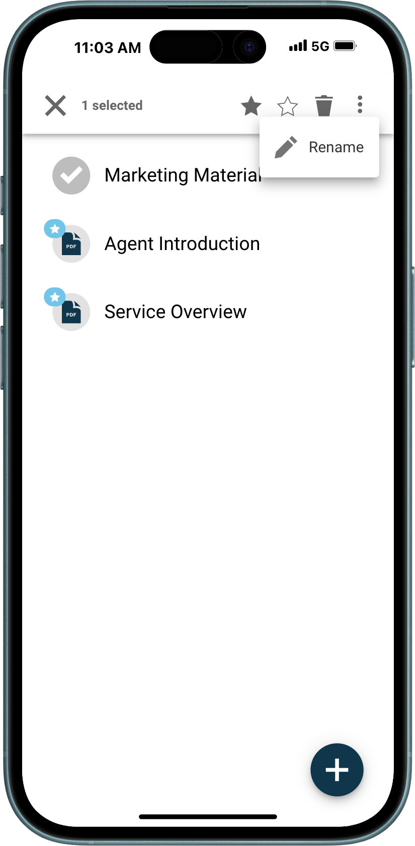

Restb.ai Photo Match

For our customers using Restb.ai, we’re excited to introduce the newest innovation: Photo Match.
This powerful new feature lets you upload or snap a photo of a design element, room style, or unique feature found in a home or listing. The system will then search for and display similar active listings based on what it sees in the image.
Results appear in a convenient thumbnail view, allowing you to quickly view matching photos alongside key listing details. Each result includes a match confidence score, giving you insight into how closely the AI believes the photo aligns with your original image.
Photo Match is available in both Paragon Connect and the Collaboration Center. The feature is currently turned off by default, but we’ll be reaching out to our Restb.ai users soon to discuss enabling it for your organization.
Get ready to search in a whole new way with the visual power of AI.
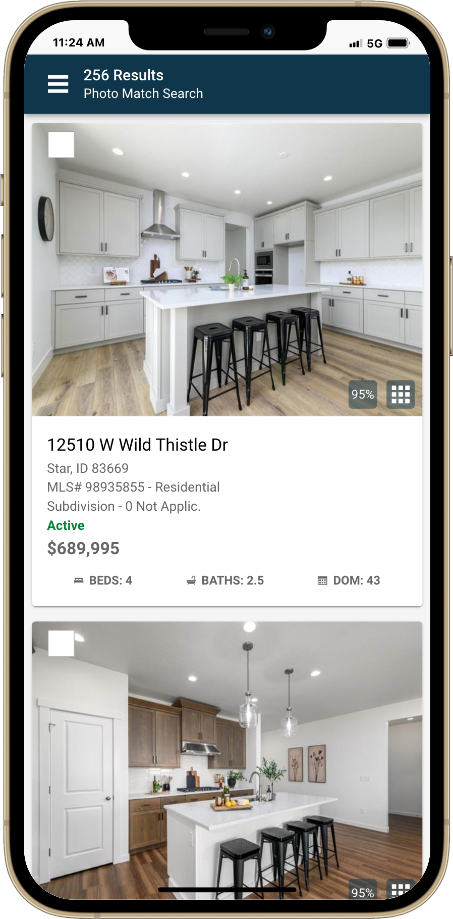
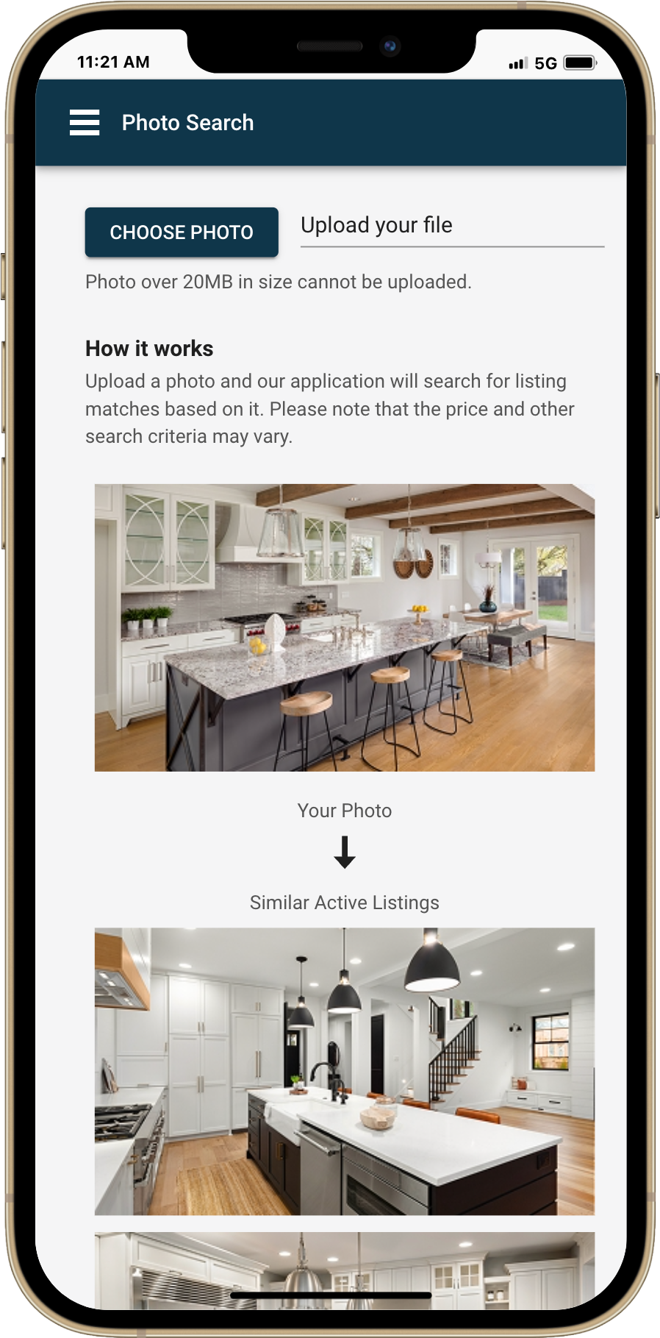
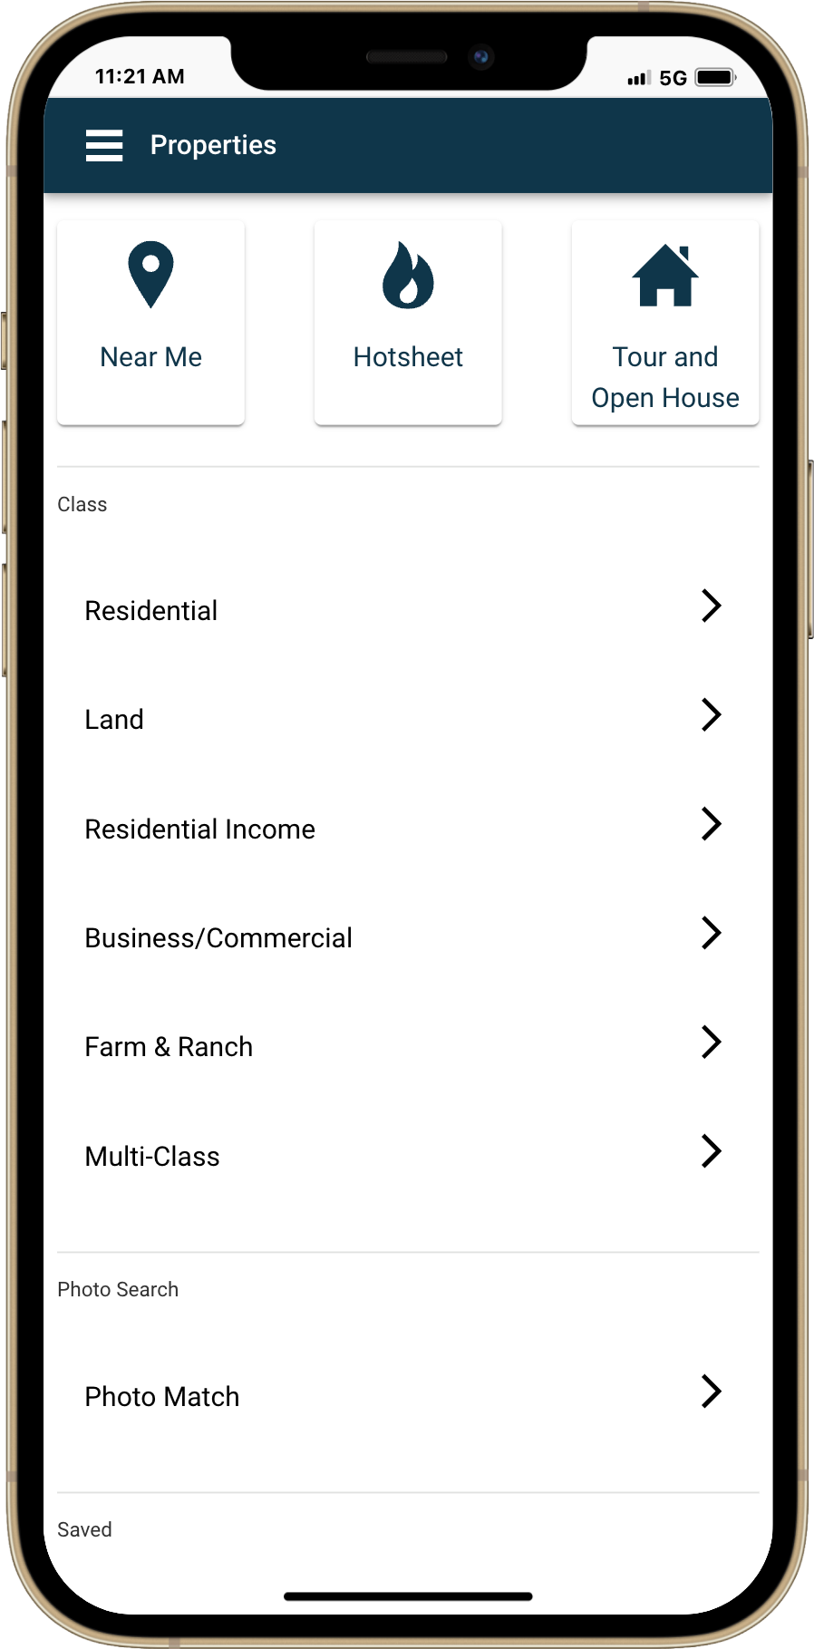

Easy Navigation with Detail Reports – Collaboration Center
We’ve added intuitive navigation, making it easier than ever for your contacts and prospects to browse listings. Now, when viewing a detail report, they can simply move forward or backward through selected listings—no need to go back and forth to the results page.

This streamlined experience makes exploring properties more seamless and user-friendly, helping your clients stay engaged and informed every step of the way.

