08

08

**Fall**

**Fall**

Paragon 12.1 Release Enhancements

July 2025

1. Paragon Features 2

1.1. Share Multiple Listings via Email (Collaboration Center) 2

1.2. New Manual Share Email Template (Collaboration Center) 3

1.3. Media Gallery View 4

1.4. Radius Distance Label on Map 5

1.5. Set Your Default Landing Page in Paragon Connect Mobile 6

# New Features

## Share Multiple Listings via Email (Collaboration Center)

We’ve enhanced the listing sharing experience in the Collaboration Center. Buyers can now select and share multiple listings (up to 6) in a single email — making it easier for recipients to view and compare options all in one place.

**What's New**

* **Multi-Select Sharing from Thumbnail View**

Users can now select multiple listings from any thumbnail results view and click the Share icon.

* **Expanded Email Capability**

The email sharing feature now supports up to six listings per email, matching the capacity of update emails.

* **Streamlined Sharing Modal**

Choosing the Email option from the Share menu will open the familiar email modal, with no changes to behavior from single-listing sharing — making the experience seamless and intuitive.

**How It Works**

* Go to Collaboration Center > Thumbnail Results View
* Select up to six listings
* Click the Share icon
* Choose Email from the sharing options
* Complete and send your email as usual

**Why It Matters**

This update eliminates the need to send listings one at a time, reducing effort for buyers and avoiding clutter in recipient inboxes.

## New Manual Share Email Template (Collaboration Center)

Our latest update introduces a refreshed email template that makes shared listings clearer, more personal, and easier to act on. Every time a buyer emails listings—whether it’s one property or six—the message now:

* Clearly identifies the buyer in the **“From”** line and throughout the content.
* Uses a clean header with the **Office/Broker logo** for instant brand recognition.
* Highlights how many listings are being shared and provides a single **“View Listing(s)”** call-to-action that routes recipients to the right place (detail view for one listing, thumbnail view for multiples).
* Presents the buyer’s personal note and the agent’s contact block in a consistent, professional layout.
* Ends with required disclaimers in an unobtrusive footer.

This cohesive design ensures recipients immediately understand who sent the listings, how many there are, and what to do next—while reinforcing your brand and the agent’s expertise.

**Why It Matters**

A polished, informative email boosts engagement and encourages faster feedback—helping buyers make confident decisions with less back-and-forth or confusion.

## Media Gallery View

A new Media Gallery has been added to Paragon Connect, offering a streamlined, full-page view of all listing media in one convenient place. This updated experience replaces the old, tabbed layout on the listing detail page and now allows you to quickly access photos, videos, documents, and maps—even from the thumbnail view. Previously, tapping a listing would only open the photo gallery—now it opens the full media gallery, giving you a more complete view of the property’s media content right from the start. The gallery opens in a full-page modal and includes:

* **Photos, Videos, Documents, and Map tabs**
* **The Map tab always appears and now includes StreetView within the same view, eliminating the need for a separate tab**
* **Other tabs are shown only if the corresponding media exists**
* **If only the Map is available, the tab shifts to the far left for better alignment**
* **Tabs scroll horizontally on smaller devices for easy navigation**
* **Layout supports both portrait and landscape orientation for an optimized mobile experience**

The Videos, Documents, and Map tabs each provide a consistent viewing experience, with content shown only if present in the listing.

This new gallery also replaces the photo viewer in Collab Center and Collab Link, showing only photos and documents marked as public. Private media will not appear unless the user has the appropriate permissions.

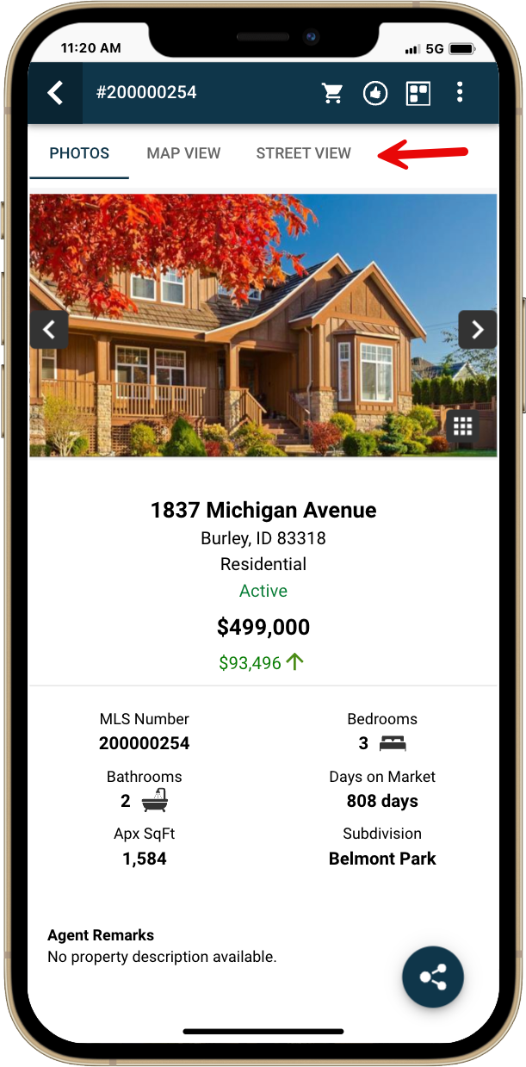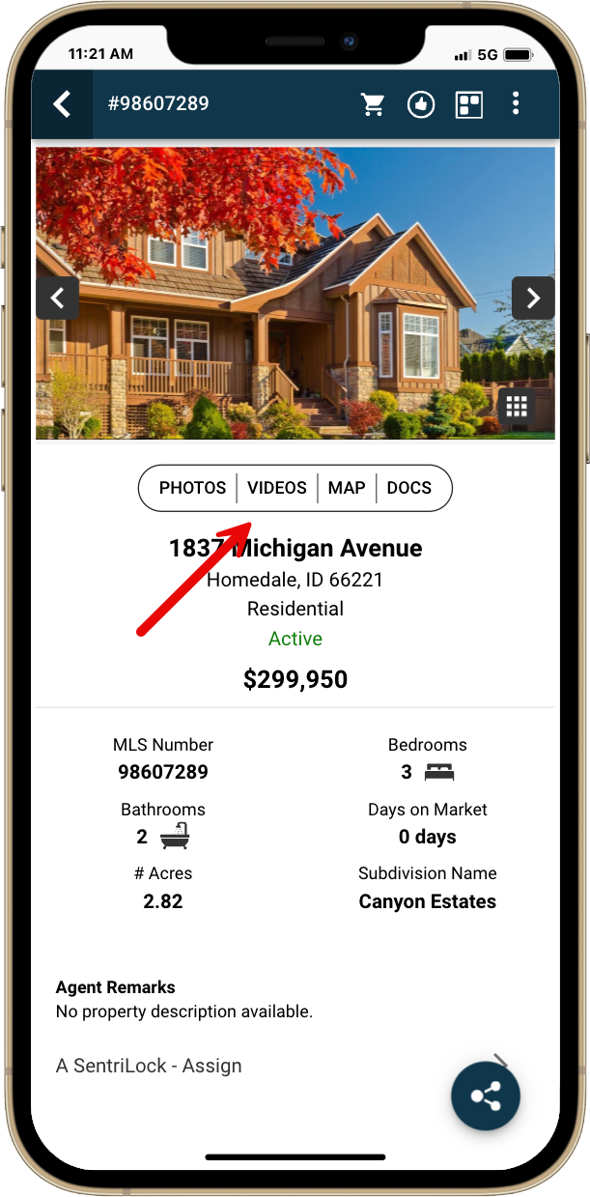

Old Layout

New Layout

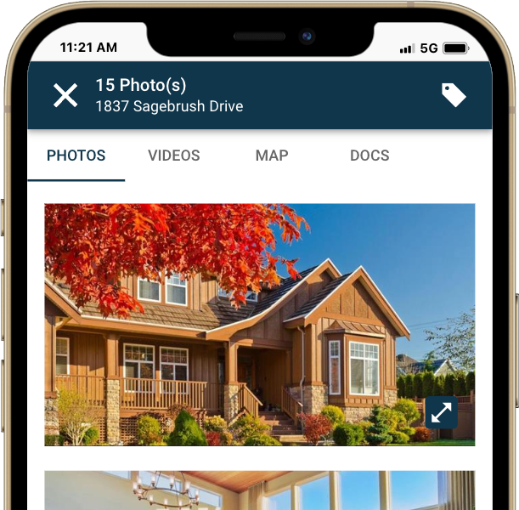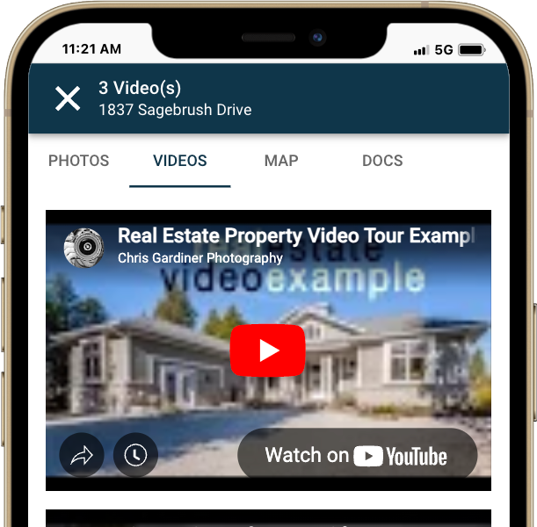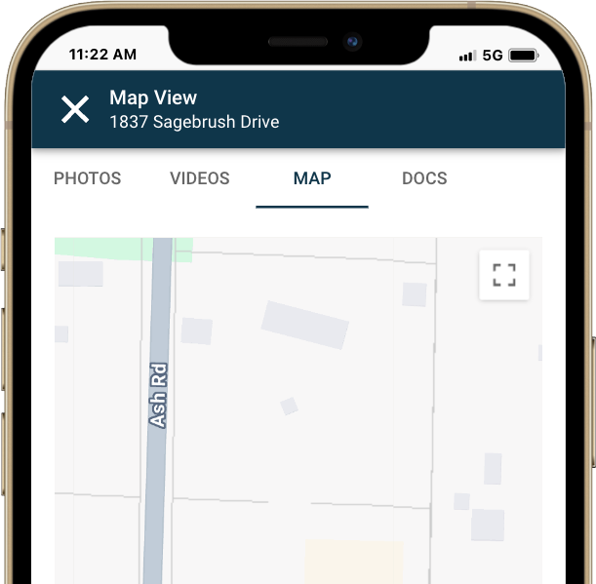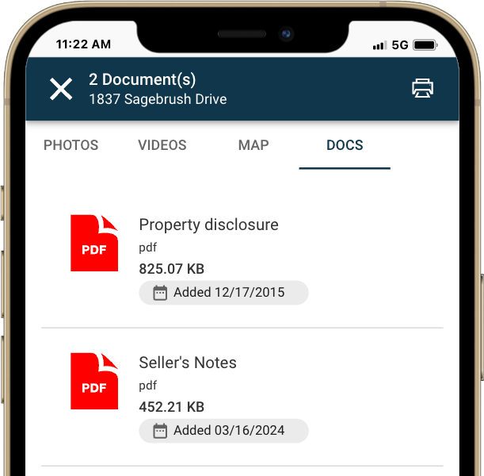

## Radius Distance Label on Map

Users can now get instant visual feedback when creating custom search areas on the map in both Paragon Connect and Collaboration Center by displaying the radius size after drawing a radius shape. This enhancement helps users better understand the area they’ve selected and improves overall map usability.

**What’s New:**

* After completing a radius draw on the map, a label appears in the center showing the distance (e.g., **3.10 mi** or **5.10 km**)
* The label displays **only after** the radius is drawn—**not during** the drawing process
* Distance is based on your unit preference, set under:  
  **Settings > Result Options > Measurement**
* Supports both **miles (mi)** and **kilometers (km)**, shown with two decimal places

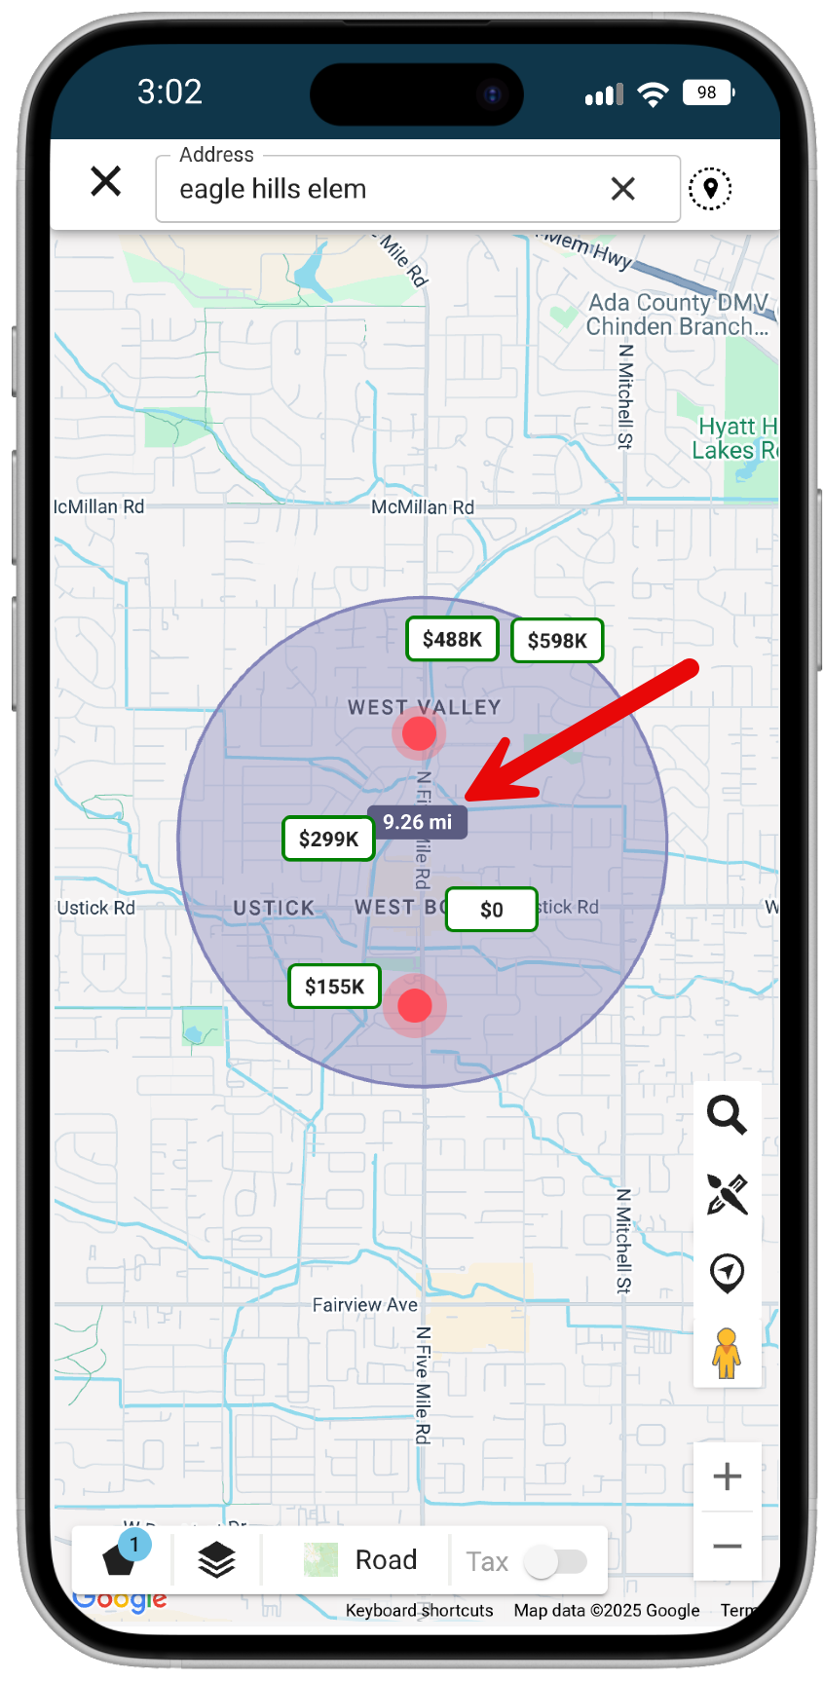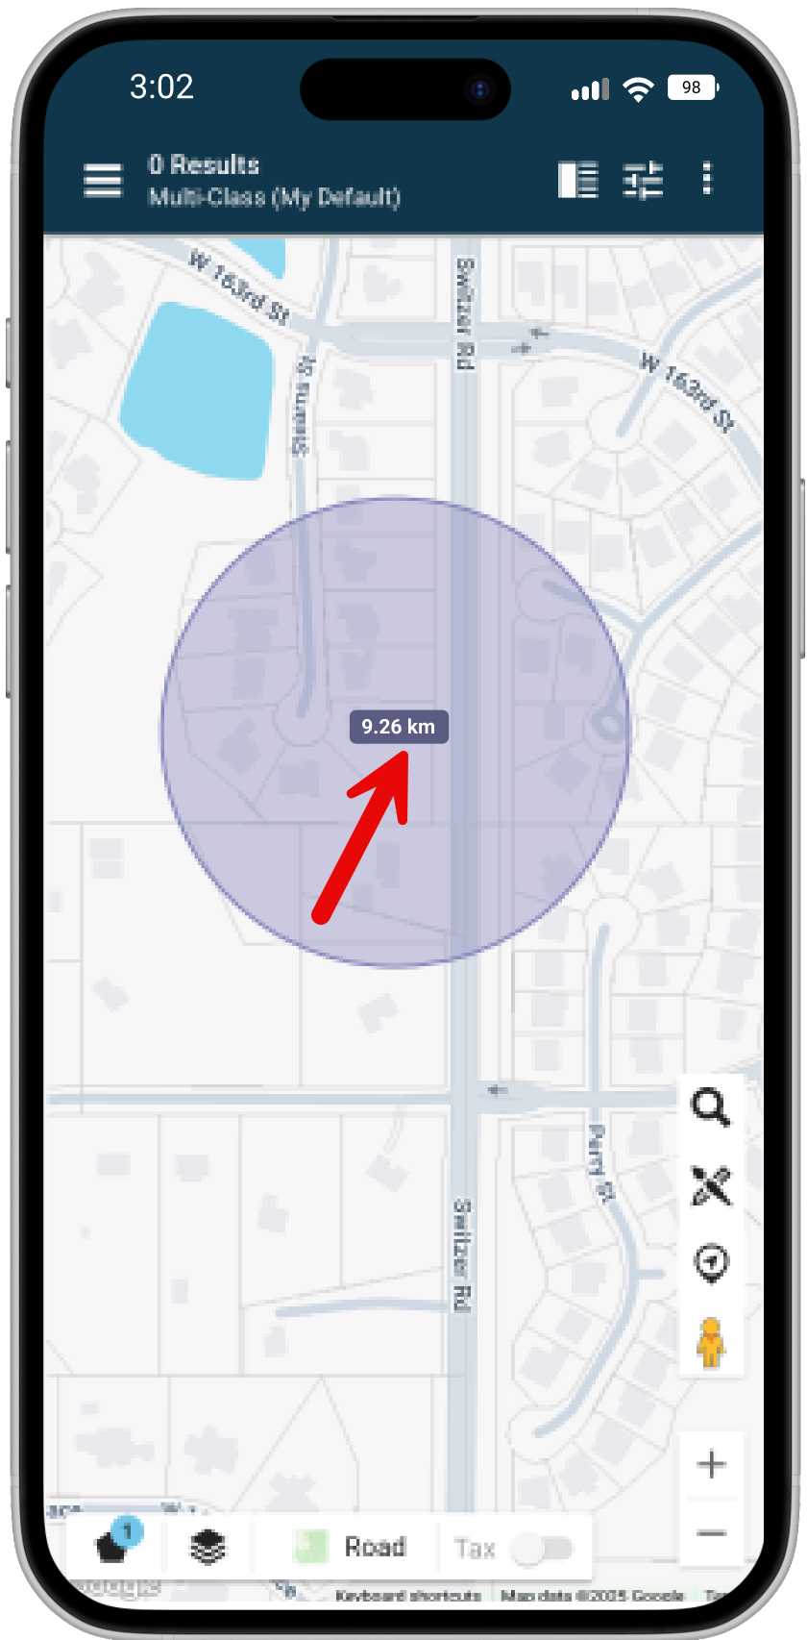

## Set Your Default Landing Page in Paragon Connect Mobile

Paragon Connect mobile users now have greater control over how they start their day in the app with the new Default Landing Page setting. This enhancement allows you to choose what you see first when launching the app—either the standard dashboard or the Near Me map search. Whether you prefer quick access to your dashboard tools or want to jump straight into nearby property searches, this setting lets you tailor the experience to fit your workflow.

**What’s New:**

* If your MLS has the mobile app enabled, and you view Settings within the Mobile App, a new Mobile setting will appear at the bottom of your settings page.
* A new setting, **“Default dashboard to map search,”** is available in this menu.

**How It Works:**

* By default, the toggle is off, and the app will continue to open to the dashboard as it does today.
* When you enable the toggle and save your settings, the app will launch directly into the **Near Me** map search instead of opening to the main dashboard.
* To apply the change, make sure to log out and log back in.

This gives you a faster way to jump into property searches nearby—right from the moment you open the app.

