08

08

**Fall**

**Fall**

Paragon 12.4 Release Enhancements

August 2025

1. MLS Customizations and Administration 2

1.1. Delayed Marketing Exempt Listing Functions (DMEL) 2

1.1.1. Delayed Marketing Summary of Changes 2

1.1.2. New DMEL Fields 2

1.1.3. New DMEL Field Rules 3

1.1.4. DMEL Automated Listing Updates 3

1.1.5. DMEL RETS Restriction 4

1.2. Passwords Removed from RETS 5

1.3. Expanded Media Type Options in RETS 5

1.4. Allow Video Links for Listings 5

2. Corrections and Improvements 6

3. New Features & Enhancements 7

3.1. Floor Plans Now Available in Paragon and Paragon Connect 7

3.2. Embed YouTube & Vimeo Videos in Paragon Connect 10

3.3. Paragon Photo Uploads: Remember Skip Labels 11

# MLS Customizations and Administration

## Delayed Marketing Exempt Listing Functions (DMEL)

In support of the new NAR Delayed Marketing Exempt Listing policy (DMEL), we have expanded our standard fields, added new automated Listing Update functionality, and extended our RETS restrictions options. This suite of changes is disabled by default but may be enabled for any customer by request. Also note, you may work with your Service Executive if additional functions are needed to support your local market rules.

### Delayed Marketing Summary of Changes

We’ve rolled out a series of enhancements to support **Delayed Marketing** in Paragon. Two new standard fields—*Delayed Marketing (Y/N)* and *Delayed Marketing End Date*—are now available across all systems, along with two new default field rules: a **Conditional Requirement Rule** (requiring an end date when Delayed Marketing = Y) and a **Validation Rule** (ensuring the end date is no more than 30 days in the future). These additions give MLSs and their members the tools to ensure data is both consistent and compliant from the start.

To further streamline operations, the **Auto-Maintain function** now automatically clears the Delayed Marketing flag and end date once the Delayed Marketing timeframe is reached, with all changes logged in nightly audit reports. All fields and rules are **disabled by default and ready** for admins to enable as needed. **Support (SE)** is available to guide configuration, and a **RETS refresh** will be required to ensure smooth integration with external systems.

### New DMEL Fields

We’ve added two new **standard fields** across all Paragon systems to provide stronger support for the **Delayed Marketing** feature. These fields are designed to give MLSs and their members more control, visibility, and flexibility when managing listings with delayed marketing requirements.

Both fields are **disabled by default** but available system-wide. Once enabled, they can be fully integrated into prospecting and search workflows and are eligible to be exposed in RETS/API for downstream vendors *(RETS refresh is required). Note: Fields may also be added to OpenMLS API and/or PIC (field mapping is required).*

**Delayed Marketing (Lookup Field)**

* Field Name: *Delayed Marketing?* (Yes/No)
* RETSStandard Name: DelayedMarketingYN
* Purpose: Identifies whether a listing is flagged for delayed marketing.
* Flexible setup with a simple **Yes/No lookup** option.

**Delayed Marketing End Date (Date Field)**

* Field Name: *Delayed Marketing End Date*
* RETS Standard Name: DelayedMarketingDate
* Purpose: Captures the exact end date for delayed marketing timeframe.
* Configured as a **date-only field** (no time component).

### New DMEL Field Rules

To streamline setup and ensure compliance, we’ve introduced four new default field rules that are automatically added to every system.

These rules are **disabled by default**, giving system admins full control to enable, adjust, or replace them as needed for individual customers. Once enabled, they provide built-in safeguards that ensure data accuracy and a smoother workflow.

1. Conditionally requires Delayed Marketing End Date when Delayed Marketing is Yes.
2. Validates that the Delayed Marketing End Date cannot extend more than 30 days into the future.
3. Validates that the Delayed Marketing End Date cannot be in the past.
4. Marks the Delayed Marketing End Date as not available unless Delayed Marketing is Yes.

**Key Benefits**

* **Streamlined Setup:** Rules are created automatically for every class, reducing admin effort.
* **Built-in Flexibility:** Disabled by default so you can configure them when and how you need.
* **Data Confidence:** Enforced checks ensure timelines and requirements are always accurate.

### DMEL Automated Listing Updates

We’re making it even easier to manage **Delayed Marketing** listings with a new **Auto-Maintain enhancement.** Starting now, the system will automatically remove the **Delayed Marketing Flag** and clear the **Delayed Marketing End Date** once the set date has passed—no manual work required. This update ensures listings transition smoothly and remain accurate without admins or agents having to track deadlines manually.

**How It Works**

* Each night, the system checks all listings with a **Delayed Marketing End Date**.
* If a listing’s end date has passed:
  + The **Delayed Marketing? value of Yes** is automatically updated to **No.**
  + The **Delayed Marketing End Date** is cleared (set to null).
  + Any enabled field rules are processed, ensuring compliance and consistency.
  + Changes are logged in the audit report and listing update dates are refreshed.
* A nightly history report provides a count of all updated listings.

**Key Benefits**

* **Hands-Free Compliance:** No need to manually monitor or update expired delayed marketing listings.
* **Data Accuracy:** Outdated dates and flags are automatically cleared, keeping listing data clean and reliable.
* **System-Wide Coverage:** Applies across all classes where Delayed Marketing is enabled.
* **Full Transparency:** Audit records and nightly reports track every change for accountability.

This enhancement ensures that **Delayed Marketing listings automatically stay up to date**, freeing up admins and agents to focus on serving clients instead of managing data.

### DMEL RETS Restriction

The Paragon RETS Servers have been expanded to include a new restriction to support Delayed Marketing listings.

Within the RETS Profile setup, a new option labeled “Delayed Marketing” is available.

When checked/enabled, the RETS server will prevent any listing where

Delayed Marketing = Yes from being included in the export.

The NAR policy states Delayed Marketing Exempt listings should not be included in IDX exports. If you choose to enable the new Paragon standard DMEL fields, it is recommended that you enable this new restriction for any IDX Profiles in your system. *Considerations: review how this restriction should/should not apply to any OpenMLS API and/or PIC feeds; you may choose not to use this restriction and allow downstream providers to use the listing field values to control external visibility.*

Note, each customer system defines their own unique RETS Profiles, for this reason customers must identify the profiles where this new restriction should be applied.

## Passwords Removed from RETS

ICE Mortgage Technology is enhancing its security posture and we have discontinued vendor access to user passwords through RETS/API. This change was last communicated via email in May 2025. Any Agent or ActiveAgent Resource that previously included the user Password value has been updated and the column has been removed. This change will be applied with the next RETS Metadata Refresh.

## Expanded Media Type Options in RETS/API

We’ve enhanced the options for listing media delivered through RETS and API, making access more flexible and consistent. Previously, only Listing Photo records were available within the Media Resource. With this release we expanded the **Media Type** lookup within the **Media resource** to support additional media types that may be available, including Videos and Floor Plans. Each of the media records, regardless of type, support the existing Media Permission field indicating if the file is deemed as public or private. *Note: For OpenMLS this change applies to MediaCategory.*

The existing RETS field: MED_listing_media_type_id now supports the following ID values:

* Value **1** = Photo
* value **3** = Video
* value **4** = Floor Plan

Queries may be made using the Media Type to specifically return media records of the indicated type. For backwards compatibility, when making a RETS query, if MED_listing_media_type_id is not specified, the system will continue to return listing photos only.

**Key Benefits**

* **Unified Access:** Multiple types of listing media are now available via the Media resource, streamlining how media is retrieved.
* **Floor Plan Support:** Floor plans can now be requested alongside photos, providing richer listing data.
* **Flexible Queries:** Defaults to photos for existing feeds but supports multiple media types when specified.

To provide additional media types via PIC, please coordinate with your Service Executive or reach out directly to Joe Brueske ([joe.brueske@ice.com](mailto:joe.brueske@ice.com)).

## Allow Video Links for Listings

We added support for uploading Video Links, for videos hosted on Vimeo and YouTube, inside of Paragon Pro back in 2023. With this release we are adding support for adding these same video links inside of Paragon Connect listing maintenance. If you would like to enable this option within your system, please reach out to your Service Executive.

* 1. **New Fields to support Floor Plans**

We added two new listing fields to support Floor Plans within Paragon. These fields are enabled automatically and are populated behind-the-scenes as Floor Plan records are added and modified. These fields are most helpful to downstream vendors and will be available within the Property Resources via RETS after a RETS Metadata refresh.

**Floor Plans Count**

* Field Name: *Floor Plans Count*
* RETS Standard Name: FloorPlansCount
* Purpose: Represents the count of Floor Plan records uploaded to a listing.

**Floor Plans Update Date**

* Field Name: *Floor Plans Update Date*
* RETS Standard Name: FloorPlansChangeTimestamp
* Purpose: Represents last time a Floor Plan record was modified for the listing.

# Corrections and Improvements

* Correction in Paragon Pro for allowing the Criteria Summary to remain visible within Print+
* Corrections for the Remarks field sporadically not displaying on printed views
* Improvement to send notification emails for new listing Comments from CollabCenter immediately; no longer relying upon the Prospecting Notification Frequency for these specific emails ensuring Agents and Contacts receive comments as quickly as possible
* Improvement to the Opt-In Subscription email removing the unnecessary text stating users must verify their request in the subsequent confirmation email

# New Features & Enhancements

## Floor Plans Now Available in Paragon and Paragon Connect

We’re excited to introduce a powerful new way to enhance your listings and better communicate a home’s layout to potential buyers. Floorplans are now fully supported in both **Paragon** and **Paragon Connect**, giving agents the ability to upload, manage, and present floorplans directly within the listing experience.

This new feature offers even more flexibility and control when showcasing a property. Whether you're helping buyers visualize the flow of a home or giving clients access to detailed layouts alongside photos and videos, floorplans add a valuable dimension to your marketing toolkit. And the best part? It's all built seamlessly into the platforms you already use.

**Upload and Manage Floor Plans**

Adding floorplans to your listings is simple and flexible. You can upload one or more files in PDF or standard image formats and choose whether each file is public or private depending on how you plan to use it.

* Upload multiple floorplans in PDF or image format
* Choose between **public** or **private** visibility for each file
* Easily **reorder**, **rename** or **delete** floorplans to stay organized and client-ready

This gives you full control over how floorplans are displayed and managed, so your listings stay polished and professional.

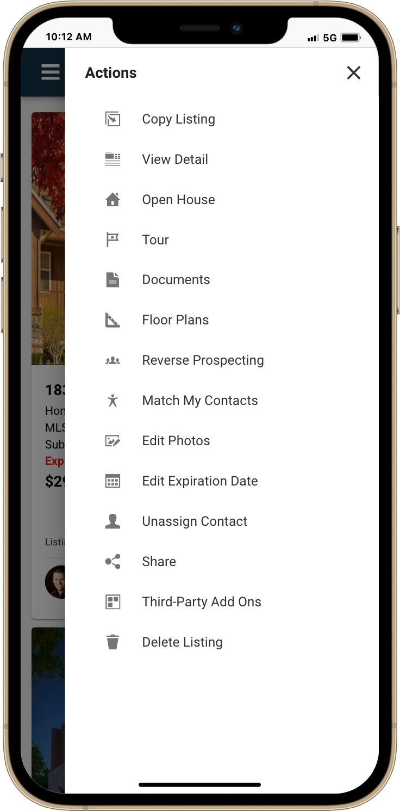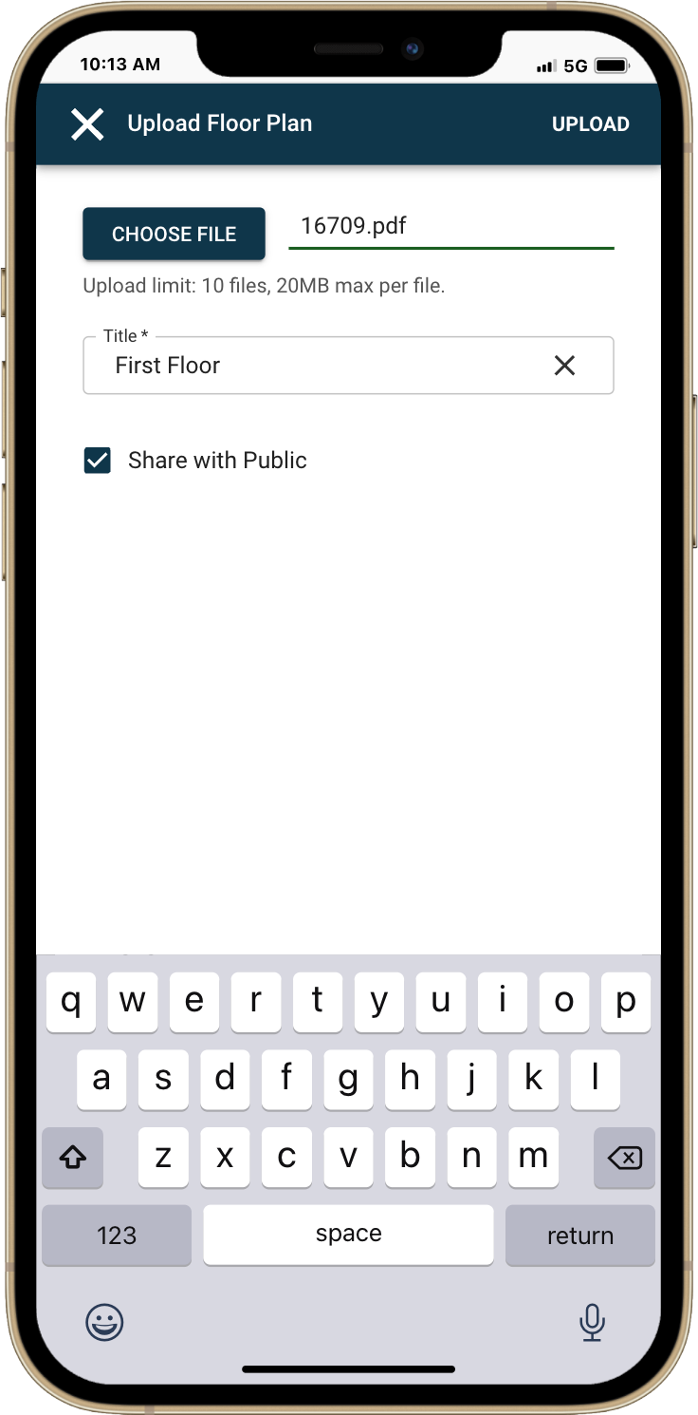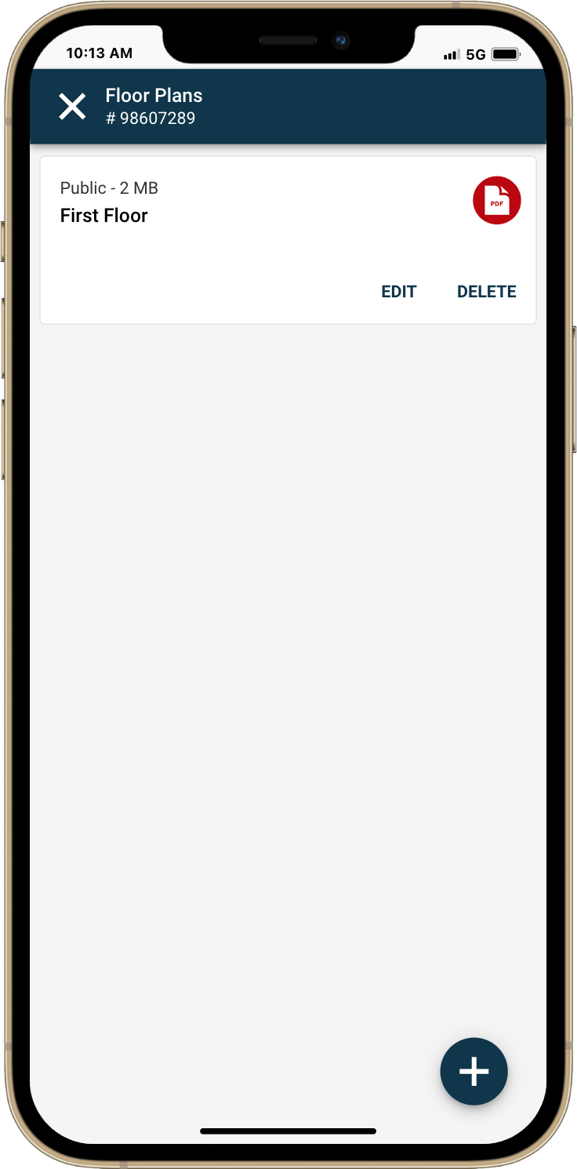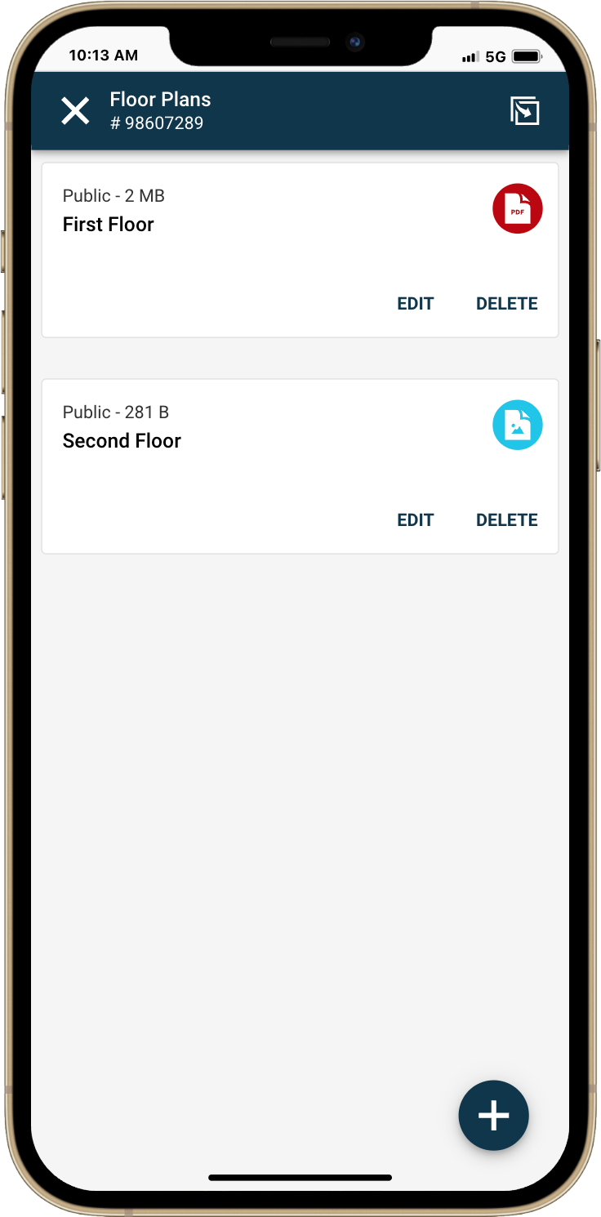

**View Floor Plans**

Floorplans can now be viewed alongside other listing media in the **Media Gallery** across **Paragon Connect** and the **Collaboration Center**. This ensures a consistent, accessible experience no matter where users engage with your listings.

* A new **Floor Plans tab** has been added to the Media Gallery
* Floorplans are viewable from almost any listing detail view
* Clients can quickly browse layouts along with photos, videos, and documents
* Add up to **10 floor plans** per listing
* Supported file types: **JPEG, GIF, PNG, HEIC, PDF**
* Choose to **share publicly** or keep it private

Whether you're in the field using Paragon Connect or your clients are exploring listings in the Collaboration Center, floorplans are now just a tap away.

This enhancement brings more depth to your listings and helps buyers connect with the space before ever stepping foot inside.

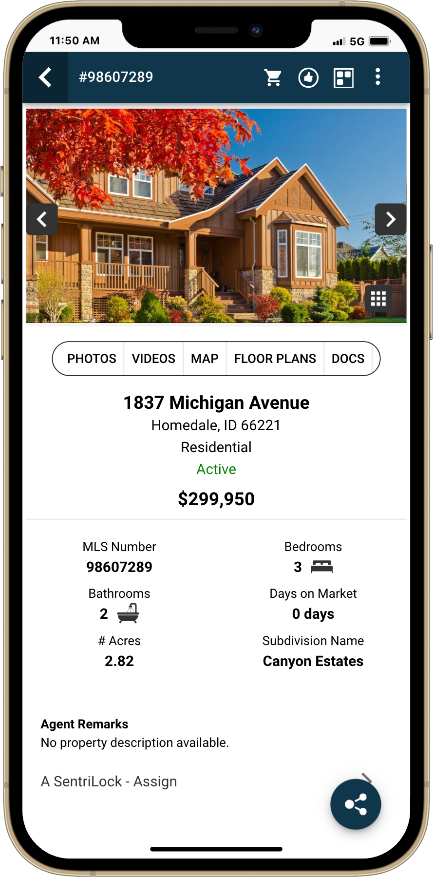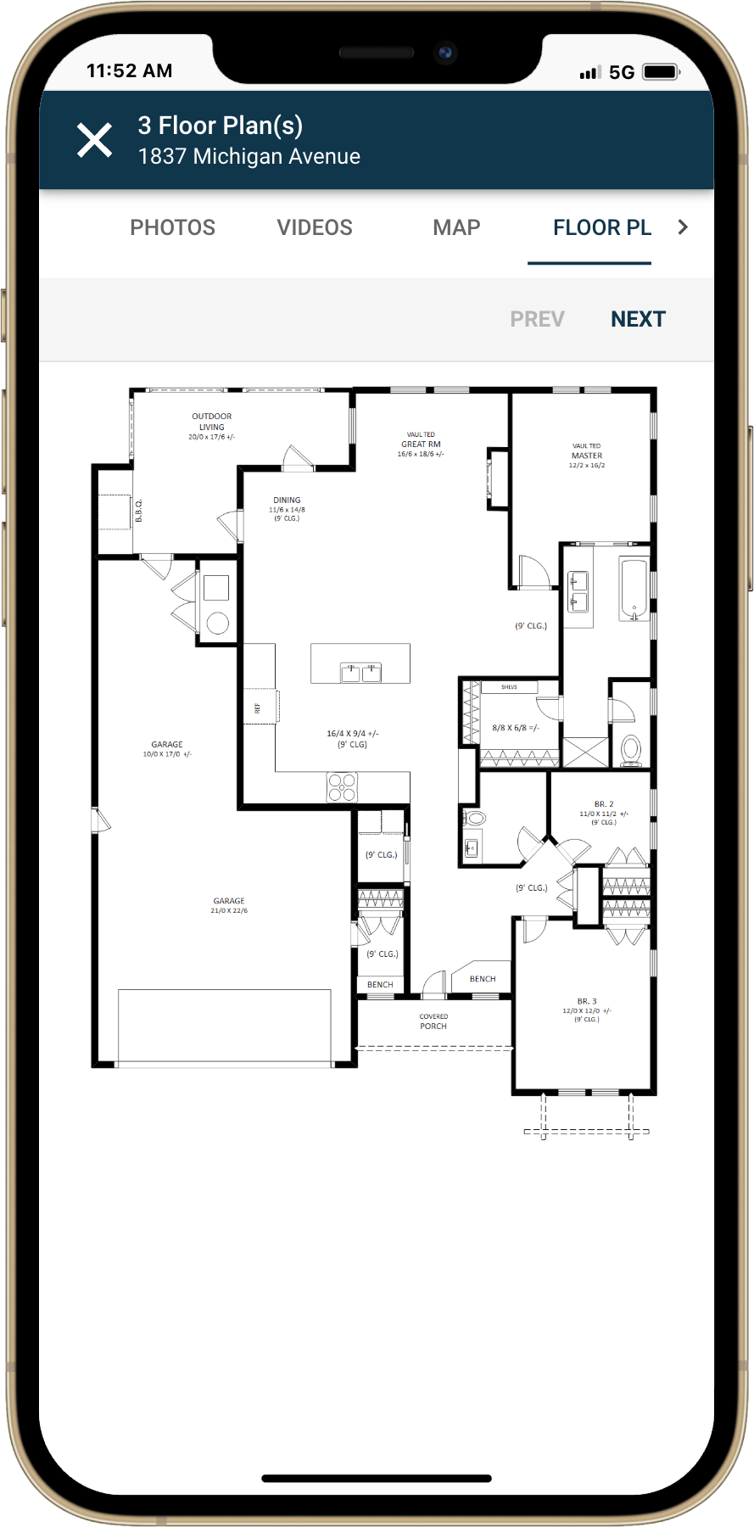

**Floor Plans in Paragon**Floor plans are now supported in Paragon with a seamless upload experience built directly into the listing workflow. You can add up to 10 floor plans per listing—just like in Paragon Connect—using JPEG, PNG, HEIC, PDF, or GIF files.

**How to Add Floor Plans in Paragon**

A new "Add/Edit Floor Plans" option has been added to the left panel of the Listing Input & Maintenance (LIM) form, just below Add/Edit Documents. This option is marked with a tilted yellow triangle icon and is available to users whose security level meets or exceeds the configured permission level.

**Accessing Floor Plans**

* Add New, Modify, and Delete buttons allow you to manage floor plans
* Each uploaded floor plan appears as a row in a table with the following details:
* Order (required)
* Title (required)
* Public (Y/N)
* Date uploaded
* A computer screen with a white screen

  AI-generated content may be incorrect.File Size (KB)

## Embed YouTube & Vimeo Videos in Paragon Connect

Video is now part of the story you tell with Paragon Connect. Seamlessly embed YouTube or Vimeo videos in your listings to captivate buyers and stand out in the market. This feature already exists in Paragon today and will only display in Paragon Connect if it is enabled in your Paragon system.

**What’s New**

* **Embed Video**– Paste a share link from YouTube or Vimeo, give it a title, and choose whether to make it public.
* **Edit with Ease** – Update your video link, title, or sharing preferences anytime—your listing stays fresh and relevant.
* **Cards** – Instantly see cards displayed with clear labels, titles, and action buttons for quick edits or removal.
* **Drag-and-Drop Reordering** – Arrange your videos in the perfect sequence to control the viewing experience.
* **Safe & Controlled Sharing** – Decide if your video is public with a single checkbox—checked by default for quick posting.

**Why It Matters**

From virtual walkthroughs to lifestyle features, video adds energy, emotion, and engagement to your listings. This update puts you in control of how that story is told—making your marketing sharper, your listings more dynamic, and your client experience unforgettable.

***Note:*** *These are embedded videos, not the same as virtual tour videos or links.*

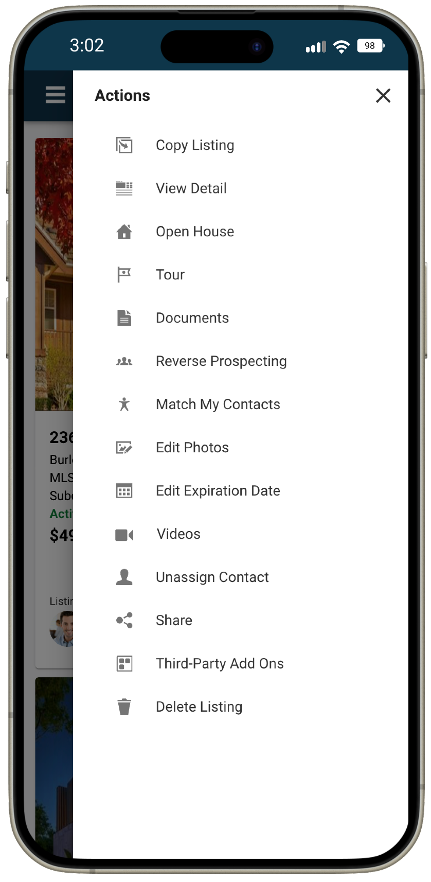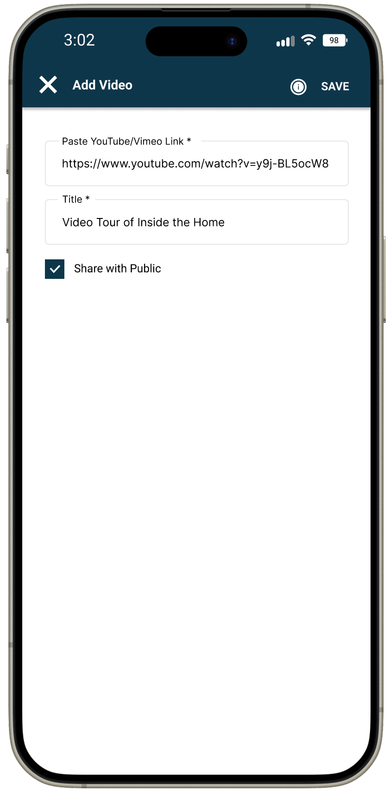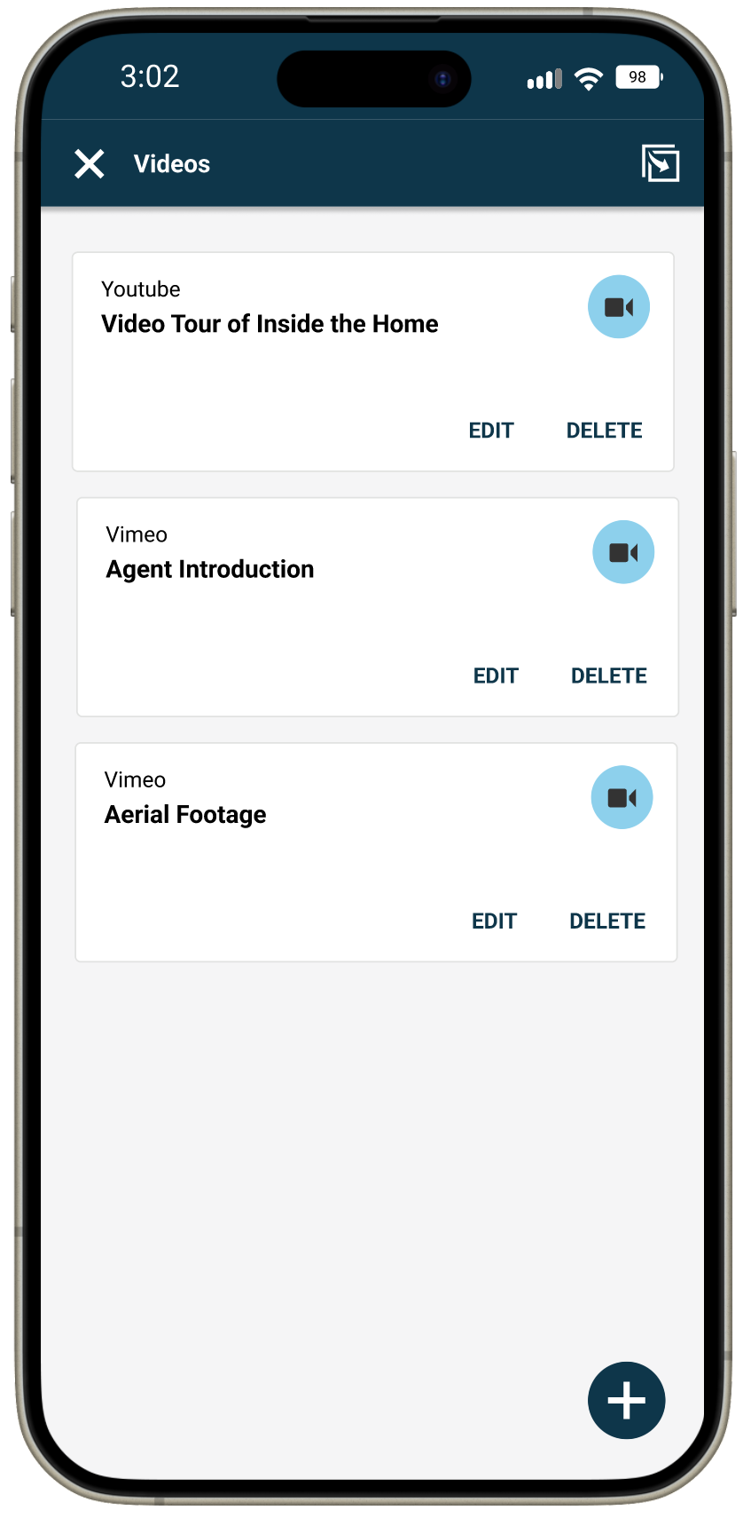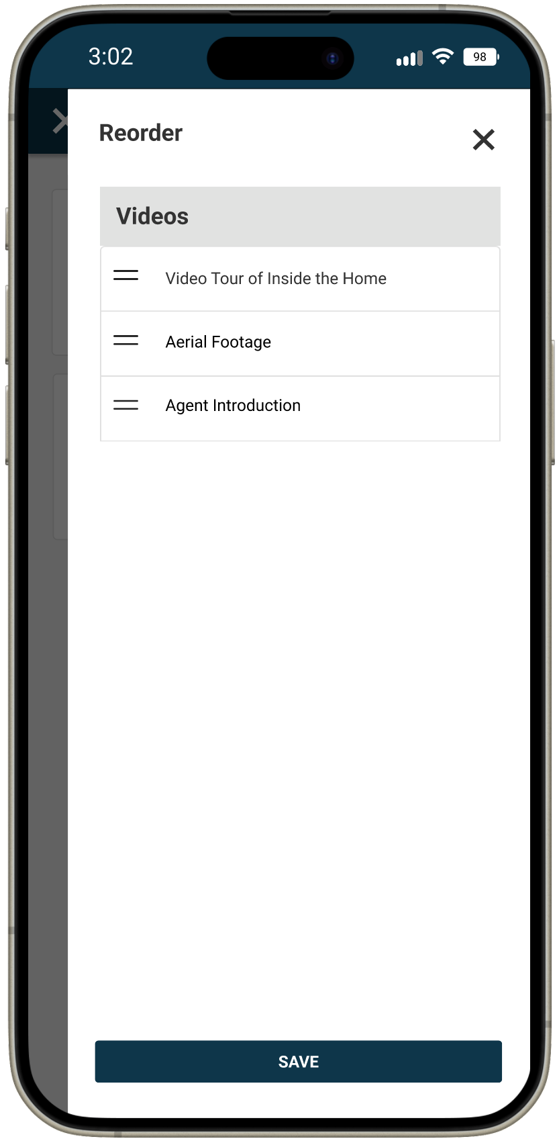

## Paragon Photo Uploads: Remember Skip Labels

We’ve made uploading photos in Paragon even more seamless. If your MLS has enabled Restb.ai photo labeling, the option to skip automatic photo labels is already available. With this update, Paragon will now remember your selection—so you don’t have to set it each time you upload photos.

**What’s new**

* Paragon now automatically saves your “Skip Auto Labels” choice.
* Once you select skip or use auto-labels, Paragon remembers it across sessions.
* Your choice is saved instantly whenever you change the checkbox.

**Why it matters**

* Saves time by eliminating repetitive selections.
* Delivers a consistent photo upload experience, tailored to how you work.
* Keeps things flexible—you can change the checkbox anytime, and Paragon will remember your choice.

**How it works**

* When the “Skip Auto Labels” checkbox is available in the Add Photos screen, Paragon will recall your last selection.
* If you log out and back in, your last choice is still saved.
* 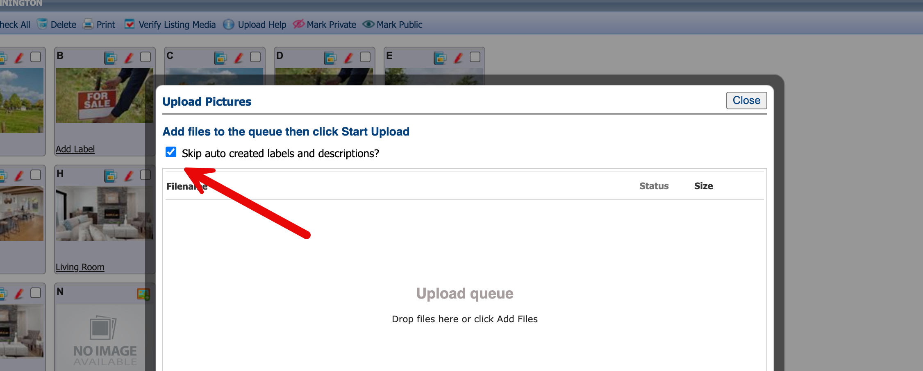Nothing else changes—checked means labels are skipped, unchecked means labels are applied.