Paragon 5.950 Release Enhancements
Updated on: 3-17-23.

Corrected Paragon Issues
Ticket# | Module | Organization | Summary
TK-7800 | Web API | NEREN, SCWMLS | Sends Descriptions When Lookups are Not Mapped
DEV-8878 | LIM | PRIMEMLS(NEREN) | Reword the Broker Attribution Override Field LIM Grid Message
TK-9072 | Hotsheet | BCRES-REB2 | When doing search with Hotsheet option, to go to next listing does not work
TK-9332 | Assoc Docs | GAMLS, ROAM, WIREX | Change timestamp on photos and associated documents when partials go live
TK-4903 | View/Reports | PRIMEMLS(NEREN) | Sort from customize/sort Menu Retains Sort even when no Fields are chosen
TK-11483 | Listing Photos | CWBR, MIMLS | Shared photos do not appear in ConnectView, Listing Detail in PC, Hotsheet search or PCLIM

MLS Customizations and Administration
All options in this section are either configurable via MLS Administration controls or by your System Support Manager as noted.

Statistical Reports – Pending/Under Contract Report

Action Item: Contact your SSM to change the security level on the reports.
The new Pending/Under Contract reports returns the listings with a Contract Date in the specified date range. Property data includes Contract Date, Current Status, and Current DOM, total number of listings, total volume, and average DOM. The report can be run by Agent, Office, Firm, or MLS.
The Pending/Under Contract reports are set to security level 7; please contact your SSM to change the security level.
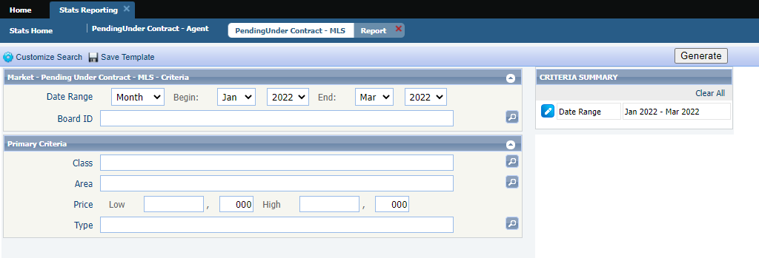
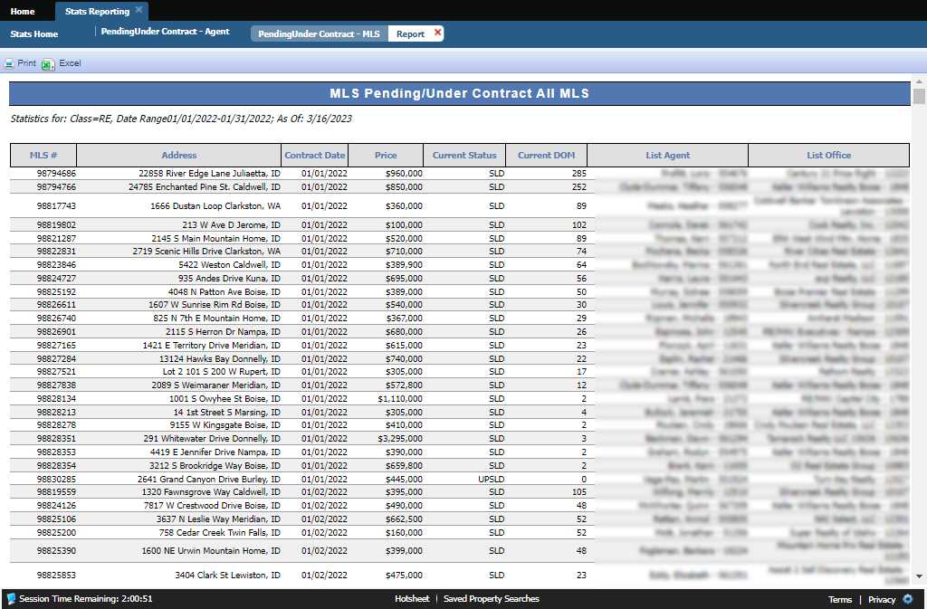

Agent Level Changes Paragon Professional
The following section contains changes that are active system wide and available to users based on their assigned security levels.

Statistical Reports – Market Activity by Location and Month

Per customer request, the Market Activity by Zip and Month report has been upgraded to allow the results to display by State/Province, Area, City, or Zip/Postal Code. A new Display By dropdown on the criteria page allows the user to select their preferred display of the results. On the report results, the former Zip/Postal Code column will display the selected Display By option. The report has also been renamed to Market Activity by Location and Month.
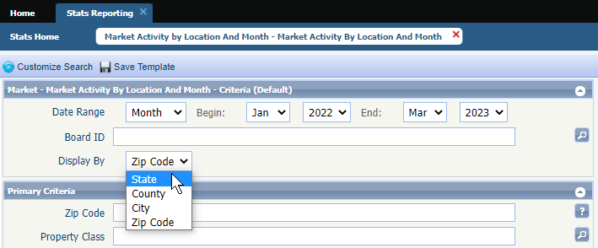
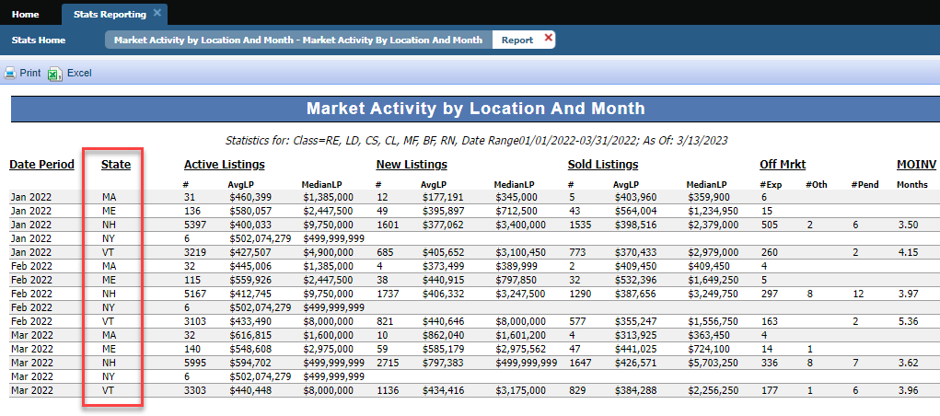

Paragon Connect
The following section contains changes that are active system wide and available to users based on their assigned security levels.

Interactive Map Layers in Listing Maintenance

Paragon Connect Listing Input Maintenance (LIM) now supports Interactive Map Layers. If Interactive Map Layers are enabled for your system, then data in configured fields will be validated against the corresponding map layers.

Corrections and Improvements

- Resending Welcome Email now includes the office address.
- Validate Map link now showing current listing map location.
- Third Party Integrations previously blocked without warning by Safari browser pop-up blocker.

Paragon Affiliate Connect
All options in this section are either configurable via MLS Administration controls or by your System Support Manager as noted.

Corrected Paragon Affiliate Connect Issues
Ticket # | Module | Summary
DEV-8570 | Agent Search | Change Batch size for searching if not on a phone.
DEV-8592 | Dashboard | Login delay performance for first time to CCA dashboard.
DEV-8999 | Preferences | Check box for not allowing agents to select affiliates if Broker is the only one selecting.

