Paragon 5.951 Release Enhancements
Updated on: 3-30-23

Corrected Paragon Issues
Ticket# | Module | Organization | Summary
TK-13608 | Market Monitor | IMLS, ValleyMLS, Huntsville | Customized sort in spreadsheet views will not save.
TK-11099 | Mapping  Geo-coding | RAE- Edmonton | Enhancement – Ability to generate Driving Directions off Geo-code
DEV-9173 | Statistical Reporting | PrimeMLS (NEREN) | Stats - Market Activity by Location = City is returning Minor Area data
DEV-9069 | Statistical Reporting | PrimeMLS (NEREN) | Stats Reports - Firm filter is returning all offices
DEV-9194 | Property Watch | PrimeMLS(NEREN) | Remove "Valuation Change" from My Property Watch
DEV-9015 | Re-Target | ValleyMLS | Need to modify RE-Target API Calls

MLS Customizations and Administration
All options in this section are either configurable via MLS Administration controls or by your System Support Manager as noted.

Admin – No changes

Action Item: None

Agent Level Changes Paragon Professional
The following section contains changes that are active system wide and available to users based on their assigned security levels.

Generate Driving Directions by Map Pin Location (i.e., Geocodes)

Property Search Driving Directions will now support directions based on the listing’s map pin location. The user will have two options to find the driving directions by: Address or Map Pin Location. Whichever option is chosen will apply to all listings that were selected.
This new feature will default to Address when accessed, which is currently what’s used today but the user can easily change it to Map Pin Location.
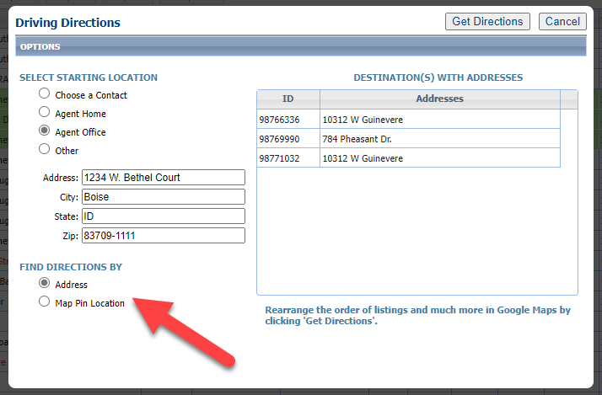

Collaboration Center
All options in this section are either configurable via MLS Administration controls or by your System Support Manager as noted.

Collaboration Center – No Changes

Paragon Connect
The following section contains changes that are active system wide and available to users based on their assigned security levels.

Corrections and Improvements
- Improvements to the loading time of the Dashboard
- Update of the Property Watch feature to the React interface.
- Correction for the “add field” button scrolling on the Customize Spreadsheet

Paragon Affiliate Connect
All options in this section are either configurable via MLS Administration controls or by your System Support Manager as noted.

Corrected Paragon Affiliate Connect Issues
Ticket # | Module | Summary
DEV-9104 | Help Overlay | Affiliate Connect Help Overlay is completely out of format. Please remove at this time.

Affiliate Connect – No Changes

