Paragon 5.952 Release Enhancements

**Updated on: 4-12-23**

# Corrected Paragon Issues

|  |  |  |  |
| --- | --- | --- | --- |
| **Ticket#** | **Module** | **Organization** | **Summary** |
| DEV-9201 | Web API | N/A | MemberStateOrProvince Metadata Fix |
| TK-13563 | Statistics | Prime MLS | Market Activity by Location report returns incorrect counties |
| TK-13334 | Mapping or Geo-coding | Prime MLS | Parcel Layer doesn’t align with Road Layer on Validate Map/Location Screen |
| TK-13225 | Tour/Open | BCRES | Multiple Open Houses display on CollabLink but not in Collab Center |
| TK-9806 | LIM | MAXEBRDI | Saving Additional Changes after continue input error |
| TK-11446 | CollabLink | CRMLS, PrimeMLS | Property History Does not display on Mobile view in Collablink |
| TK-13631 | Views/Reports | BCRES | Fix Address Sort on Spreadsheet |

# MLS Customizations and Administration

**All options in this section are either configurable via MLS Administration controls or by your System Support Manager as noted.**

**Admin – There are no admin changes.**

**Action Item:** None

**Agent Level Changes Paragon Professional**

**The following section contains some changes that are active system wide, and some may only be available to users based on their assigned security levels.**

**Statistical Reporting – Display City, State in Market Activity by Location**

By customer request, when Display By=City is selected for the Market Activity by Location and Month report, listings will be grouped by both city and state, and the location column will display both the city and state. This is necessary for accurate results where multiple states in the service area have common city names.

# Collaboration Center

**All options in this section are either configurable via MLS Administration controls or by your System Support Manager as noted.**

**Collaboration Center – Consistent Price formatting in Collaboration Center and CollabLink views**

To present a more consistent user experience, the Price field in Collaboration Center and CollabLink views has been given a standard format. On the detail, grid, thumbnail, and Property History, the price now displays the full price, rather than a shortened version. Example: $123,456, instead of $1.2k. Map pins will continue to show the shortened price.

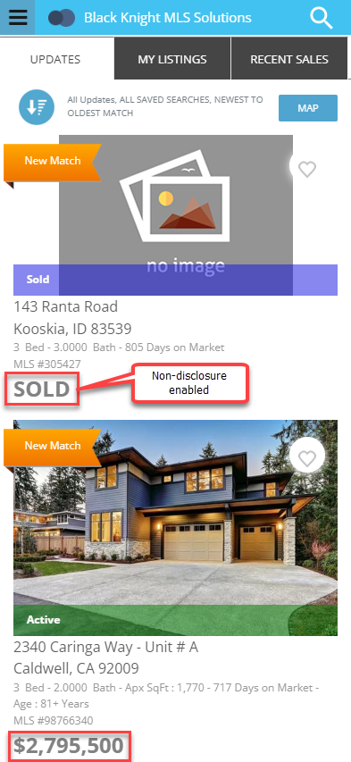If the non-disclosure configuration setting is enabled, the price on status category 2, Sold, displays the word “Sold” rather than 0, on all views: detail, grid, thumbnail, map, and Property History. [Existing configuration setting COLLABCENTER_NON_DISCLOSURE_REQUIRED.]

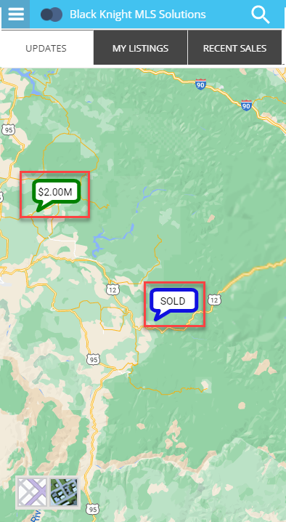

**Paragon Connect**

**The following section contains changes that are active system wide and available to users based on their assigned security levels.**

**Settings**

Paragon Connect main menu has a new option for Settings. This option will be used to edit and define your agent photo, password (if applicable), and other options. It will expand over time as new settings become available.

**Corrections and Improvements**

* Correction for tax autofill results
* Corrections for the resend Welcome email to use custom subject
* Corrections for Tour and Open House search criteria using Area and Status
* Correction for standard map layer alignment
* Update to the appearance of the My Content menu

# Paragon Affiliate Connect

**All options in this section are either configurable via MLS Administration controls or by your System Support Manager as noted.**

# Corrected Paragon Affiliate Connect Issues

|  |  |  |
| --- | --- | --- |
| **Ticket #** | **Module** | **Summary** |
|  |  |  |
|  |  |  |

**Nothing for Affiliate Connect**