Paragon 5.953 Release Enhancements

**Updated on: 4-25-23**

# Corrected Paragon Issues

|  |  |  |  |
| --- | --- | --- | --- |
| **Ticket#** | **Module** | **Organization** | **Summary** |
| TK-13850 | Email | MLSBOX | Agent unable to email from Reverse Prospecting when using ‘ |
| TK-13738 | Collab Center | MAXEBRDI | Collab Center Display AVM per Listing VOW setting check box not working |
| TK-516, TK-556 | Tour/Open House | CRMLS | T/OH: allow tour and open house fields on Paragon Listing Reports |
| TK-12596 | UI | TriangleMLS | Field Rule Groups UI Grid List Throws Error Loading Grid |
| TK-12247 | CMA | NGLRMLS, OBRMLS, SEDWAR, SELKIRK, TARMLS | Error Generating CMA "error creating the CMA packet" |
| TK-12207 | Admin | BCRES – REB2l | Admin Firms Showing No Results on Sec 7 Account |
| TK-11755 | View/Reports | PRIMEMLS | Not All State Abbreviations are Completely Shown in All Capital Letters in Lookup Autocomplete Fields |
| TK-10807 | LIM | PRIMEMLS | Certain Setup Allows for Users to Enter No State |
| TK-12099 | Property Watch/Alert | GAMLS , NNRMLS, TSierra | Property Watch - no new alerts since 01/12/22 |
| TK-10824 | Mapping or Geo-coding | NSAR | Validate Map Zoom Level is NOT adjusting when updated via LIM |
| TK-9752 | Contacts | BCRES, CRMLS, RAE-Edmonton | Page cannot be displayed for Collab Center comments |
| TK-7676 | Views/Reports | CAPEMAY | Market Share Detail Report and High Result Count |
| TK-7062 | Search | BCRES, RAE-Edmonton | Remove listing carts from PowerSearch results |

# MLS Customizations and Administration

**All options in this section are either configurable via MLS Administration controls or by your System Support Manager as noted.**

**LIM – Specify Market Geocode Boundaries**

**Action Item:** Notify your SSM if you want to set up geocode boundaries for listing input and maintenance.

Per customer request, specific geocode boundaries can be set for your market area, to assist users with correctly geocoding listings on input. By specifying the latitudes and longitudes of your general market area, a field rule will check the pin placement on the listing when the listing is saved or re-geocoded. If the pin placement is outside any of the geocode boundaries, a warning will display.

**Views and Reports – Tour and Open House Report Elements**

**Action Item:** To enable these features, add the elements to any custom report view.

Two new report elements are available in the Custom Views report editor. Upcoming Open Houses (Listing View) and Upcoming Tours (Listing View) allow you to add the next three tours or open houses to any custom report view. The elements can be formatted with all the usual tools in the custom views editor.

Clicking on the data in the report opens the same modal as the Tour and Open House action icons, so all upcoming events can be viewed or printed.

**Agent Level Changes Paragon Professional**

**The following section contains some changes that are active system wide, and some may only be available to users based on their assigned security levels.**

**LIM – Geocode Boundary Warning**

A new feature in Listing Input and Maintenance will trigger a warning if a listing’s geocode is outside boundaries specified by your MLS. When a listing is saved, a field rule will verify the listing’s geocode coordinates to those specified by your MLS as the desired market area. If any of the coordinates are outside those boundaries, a warning is returned.

**Views and Reports – Tours and Open Houses on Custom Reports**

Two new report elements are available in the Custom Views report editor. Upcoming Open Houses (Listing View) and Upcoming Tours (Listing View) allow you to add the next three tours or open houses to any custom report view. The elements can be formatted with all the usual tools in the custom views editor.

Clicking on the data in the report opens the same modal as the Tour and Open House action icons, so all upcoming events can be viewed or printed.

**Share via Text Custom Message**

Agents can now add an optional custom message when sharing listings through the Share via Text feature from the property search results. This custom message field allows up to 100 characters and the message can be previewed in the Share dialog window. Once the text is sent, it will be recorded in the contact’s Message History.

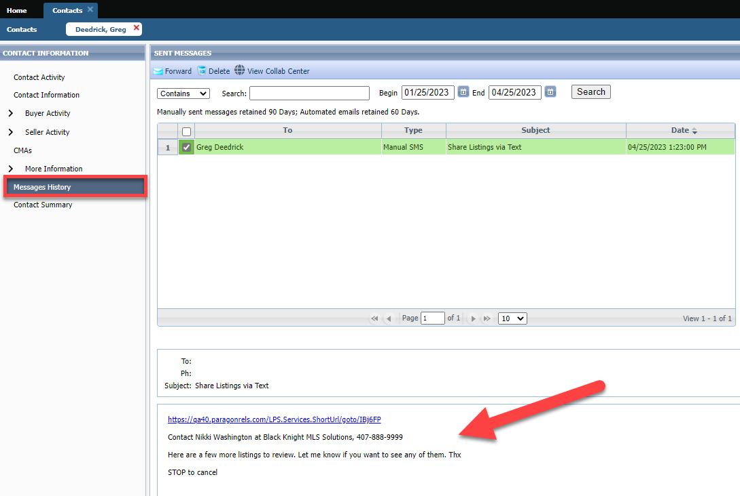

# Collaboration Center

**All options in this section are either configurable via MLS Administration controls or by your System Support Manager as noted.**

**Collaboration Center – Improved Agent Photo Handling**

Some formatting changes have been made to the handling of the agent image uploaded in Paragon Professional, to improve the display of the image in Collaboration Center. The image size was changed to allow better resolution, and code was corrected that was causing the image to display off center.

**Paragon Connect**

**The following section contains changes that are active system wide and available to users based on their assigned security levels.**

**Dashboard**

A brand-new version of the Dashboard is now available within Paragon Connect. The new dashboard contains a fresh-face for all the data and features previously available and includes a few new options.

The dashboard still promotes the most recent Contact activity and Comments. This version also provides:

* Display of your Office Logo
* New streamlined view for reading and responding to recent contact comments.
* New Quick Action links to give fast access to frequent features.
* Upgraded Power Search that provides auto-display of matching results.

**Property Search**

Property Class search pages have been updated to use the upgraded look and feel already applied to Hotsheet and Open House searches. This new search interface is faster, utilizes more visible text/fonts, and remains in sync with your default search in Paragon Professional. Users may save searches, view recent searches, apply filters to see search criteria, and update the criteria used in their default search.

**Map View**

The Map View has also been updated to use the latest look and feel. This option is available for viewing listing results from a property search, along with the Thumbnail and Spreadsheet views. Standard map layers and free-hand drawing options are available. If enabled, users may also select parcels from the Parcel Layer to view public record data or enable a Property Watch.

**Corrections and Improvements**

* Layout adjustment for Spreadsheet view on mobile devices
* Display proper decimal values on the listing detail view
* Update Resend Welcome Email to use proper subject an agent photo
* Modify default filters applied to Published Listings
* Display alternate City value
* Error fix for modifying Tour for a Partial listing

# Paragon Affiliate Connect

**All options in this section are either configurable via MLS Administration controls or by your System Support Manager as noted.**

# Corrected Paragon Affiliate Connect Issues

|  |  |  |
| --- | --- | --- |
| **Ticket #** | **Module** | **Summary** |
| TK-12388 | Agent Search | Change batch size when searching if not on phone to bring back additional matches |