Paragon 5.955 Release Enhancements

**Updated on: 5-22-23**

# Corrected Paragon Issues

|  |  |  |  |
| --- | --- | --- | --- |
| **Ticket#** | **Module** | **Organization** | **Summary** |
| DEV-8724 | Web API | N/A | Fix to Allow Rare Super Long URI Queries |
| DEV-9361 | Web API | N/A | Fix Display Bug With Duplicate Lookup Value After First Ext Value is Renamed |
|  |  |  |  |
|  |  |  |  |

# MLS Customizations and Administration

**All options in this section are either configurable via MLS Administration controls or by your System Support Manager as noted.**

**LIM – Specify Market Geocode Boundaries**

**Action Item:** Notify your SSM if you want to set up geocode boundaries for listing input and maintenance.

Per customer request, specific geocode boundaries can be set for your market area, to assist users with correctly geocoding listings on input. By specifying the latitudes and longitudes of your general market area, a field rule will check the pin placement on the listing when the listing is saved or re-geocoded. If the pin placement is outside any of the geocode boundaries, a warning will display.

**Paragon Connect - Tax Autofill for Paragon Tax**

**Action Item:** None

The Add Listing process now supports Tax Autofill for Paragon Tax. Setup by Black Knight will be required before this feature is available for all current Paragon Tax customers. Teams are working to complete this setup and you will be notified when this feature is ready for use in your market.

**Agent Level Changes Paragon Professional**

**The following section contains some changes that are active system wide, and some may only be available to users based on their assigned security levels.**

**Team Name Field Expansion**

To accommodate longer team names, the Team Name field has been increased to 100 characters.

**LIM – Geocode Boundary Warning**

A new feature in Listing Input and Maintenance will trigger a warning if a listings geocode is outside boundaries specified by your MLS. When a listing is saved, a field rule will verify the listing’s geocode coordinates to those specified by your MLS as the desired market area. If any of the coordinates are outside those boundaries, a warning is returned.

**Statistical Reports – Roll up zip code statistics in Market Activity by Location**

Per multiple customer requests, the Market Activity by Location > Display by Zip will roll up results into the main five-digit zip code, instead of breaking out each zip+4 into a separate line. This will provide a more complete picture of activity within a specific zip code.

Note: Canadian customers using Postal Code will not be affected by this change.

Updated Market Activity by Zip; results rolled up into main zip code

Current report with each zip+4 broken out

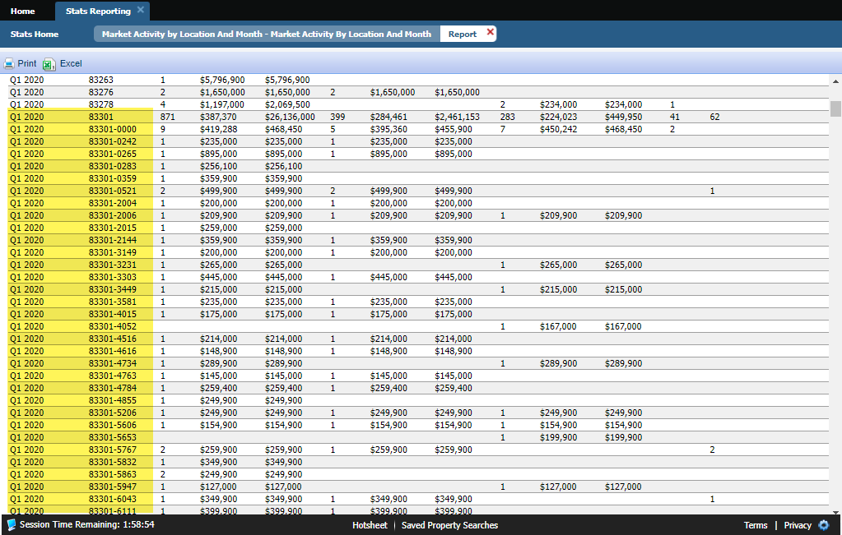

# Collaboration Center

**All options in this section are either configurable via MLS Administration controls or by your System Support Manager as noted.**

**Collaboration Center – No Collaboration Center Changes**

**Paragon Connect**

**The following section contains changes that are active system wide and available to users based on their assigned security levels.**

**Seller Dashboard**

Updated versions of the Seller Dashboard and Activity pages are now available. These updates move the same features and functions for monitoring your Contacts’ properties for sale into the latest, fastest interface.

**Not Available Rules in Listing Maintenance**

Listing Maintenance pages for adding and editing listings has been updated to support “Not Available” field rules. These conditional logic rules allow fields to remain hidden from view until specific conditions are met and the fields becomes visible.

**Tax Autofill for Paragon Tax**

The Add Listing process now supports Tax Autofill for Paragon Tax. Setup by Black Knight will be required before this feature is available for all current Paragon Tax customers. Teams are working to complete this setup and you will be notified when this feature is ready for use in your market.

**Corrections and Improvements**

* Updated interface for Listing Carts
* Access to add/edit Associated Documents is now available from the Published Listings overflow menu
* Improvements to loading of the Contact Summary page
* Additional options are available under Settings for Collaboration Center setup and Notifications
* Corrections for display of Sqft or Acreage on Detail View
* Correction for lookup relationships on Tour, Open House, and Hotsheet search forms

# Paragon Affiliate Connect

**All options in this section are either configurable via MLS Administration controls or by your System Support Manager as noted.**

# Corrected Paragon Affiliate Connect Issues

|  |  |  |
| --- | --- | --- |
| **Ticket #** | **Module** | **Summary** |

**Web API**

**The options in this section are not configurable and are standardized across all customers.**

**Export Web API Mapping Button**

Data Dictionary (DD) mapping requires spreadsheets to be used at various junctures to discuss the implementation. Copying the spreadsheets from the tool itself was a simple option. Detailed spreadsheets could only be created through backend access. No longer!

A new button labeled ***Export Mapping*** has been added to the ***Data System Resource Mapping*** page in the ***OpenMLS*** ***Web API Mapping Tool***.

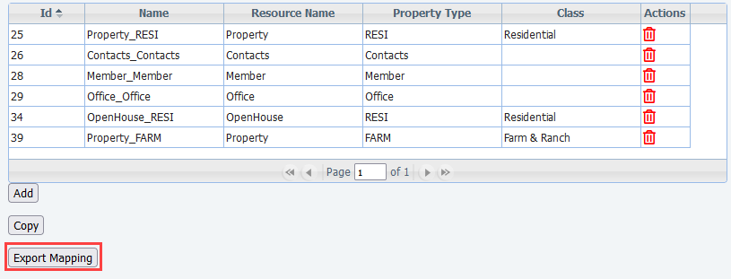

*Figure 2 - Data System Resource Mapping Screen*

When clicked, a modal/colorbox will appear requesting you to name your file. Please notice the file format is shown, currently Microsoft Excel. Simply click the ***Export Report*** button in the top right, and open, or download, the file.

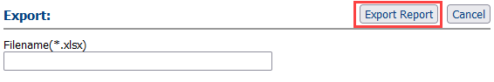

*Figure 3 - Name and Export File Colorbox*

Within the spreadsheet, you’ll find the Resources and Classes separated in their own tabs. This helps with organization and reduces confusion. The ***SourceSystemName*** column holds the ***RETS System Name***. This will assist in matching the DD Fields with RETS. *Very* helpful with vendors.

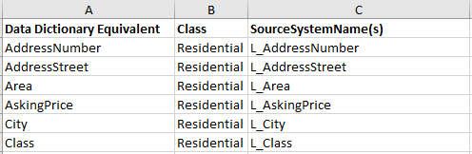

*Figure 4 - Example Export of Residential Class*

**Preparing for Data Dictionary 2.0**

RESO has been notifying vendors the Data Dictionary (DD) 2.0 will be more about field compliance than changes to the field sets. As such, 2.0 has less flexibility regarding local fields and lookup enumerations. In some rare situations, if a Paragon Feature Category or Lookup is partially mapped to a DD field, the unmapped Paragon values were being sent out. This was initially intended to help make your data be more visible to vendors. To ensure you are confident in your data, we are adjusting the API in this release to ensure this does not happen.

In the mapping example below, if the Listing had Storage and Tennis, Tennis will not be sent out because it is not mapped. We recommend any customers who handle their own mapping to review RESO’s [***DD 2.0 Draft Standards***](https://ddwiki.reso.org/display/DDW20/)if you feel 2.0 certification may be in your future.

*Figure 5 - Paragon Value Mapping Example*

OpenMLS already creates lookups for all enumerations when direct field mapping is in place. This is where no value mapping is done, like City or Subdivision. This way, when new values are created, data mapping users don’t have to create a new mapping.

**This change will affect Web API Metadata. If you are an OpenMLS customer, please instruct your Web API vendors to repull metadata and lookups to minimize disruptions.**