Paragon 5.950 – 5.955 Release Enhancements

**Updated on 6-2-2-23**

**(changed image)**

Corrected Paragon Issues 3

MLS Customizations and Administration 6

**Admin - Statistical Reports – Pending/Under Contract Report** 6

**LIM – Specify Market Geocode Boundaries** 7

**Views and Reports – Tour and Open House Report Elements** 7

Agent Level Changes Paragon Professional 9

**Statistical Reports – Market Activity by Location and Month** 9

**Statistical Reporting – Display City, State in Market Activity by Location** 10

**Generate Driving Directions by Map Pin Location (i.e., Geocodes)** 10

**Statistical Reports – Roll up zip code statistics in Market Activity by Location** 11

**LIM – Geocode Boundary Warning** 12

**Views and Reports – Tours and Open Houses on Custom Reports** 12

**Share via Text Custom Message** 14

**Team Name Field Expansion** 15

Collaboration Center 16

**Collaboration Center – Consistent Price formatting in Collaboration Center and CollabLink views** 16

**Collaboration Center – Improved Agent Photo Handling** 17

Paragon Connect 18

**Corrections and Improvements** 18

**Settings** 19

**Dashboard** 19

**Property Search** 20

**Map View** 20

**Full Lookup and Feature Options** 21

**Listing Maintenance Updates** 21

**Seller Dashboard** 22

**Not Available Rules in Listing Maintenance** 22

**Tax Autofill for Paragon Tax** 23

Web API 24

**WEB API - L_LastDocUpdate is Added to OpenMLS Web API Mapping Tool** 24

**Export Web API Mapping Button** 24

**Preparing for Data Dictionary 2.0** 26

Paragon Affiliate Connect 27

Corrected Paragon Affiliate Connect Issues 27

# Corrected Paragon Issues

|  |  |  |  |
| --- | --- | --- | --- |
| **Ticket#** | **Module** | **Organization** | **Summary** |
| TK-7800 | Web API | NEREN, SCWMLS | Sends Descriptions When Lookups are Not Mapped |
| DEV-8878 | LIM | PRIMEMLS(NEREN) | Reword the Broker Attribution Override Field LIM Grid Message |
| TK-9072 | Hotsheet | BCRES-REB2 | When doing search with Hotsheet option, to go to next listing does not work |
| TK-9332 | Assoc Docs | GAMLS, ROAM, WIREX | Change timestamp on photos and associated documents when partials go live |
| TK-4903 | View/Reports | PRIMEMLS(NEREN) | Sort from customize/sort Menu Retains Sort even when no Fields are chosen |
| TK-11483 | Listing Photos | CWBR, MIMLS | Shared photos do not appear in ConnectView, Listing Detail in PC, Hotsheet search or PCLIM |
| TK-13608 | Market Monitor | IMLS, ValleyMLS, Huntsville | Customized sort in spreadsheet views will not save. |
| TK-13439 | Market Monitor | CARMLS, CREN, IMLS, ValleyMLS, Huntsville | Will not sort by DOM in spreadsheets |
| TK-11099 | Mapping  Geo-coding | RAE- Edmonton | Enhancement – Ability to generate Driving Directions off Geo-code |
| DEV-9173 | Statistical Reporting | PrimeMLS (NEREN) | Stats - Market Activity by Location = City is returning Minor Area data |
| DEV-9069 | Statistical Reporting | PrimeMLS (NEREN) | Stats Reports - Firm filter is returning all offices |
| DEV-9194 | Property Watch | PrimeMLS(NEREN) | Remove "Valuation Change" from My Property Watch |
| DEV-9015 | Re-Target | ValleyMLS | Need to modify RE-Target API Calls |
| DEV-9201 | Web API | N/A | MemberStateOrProvince Metadata Fix |
| TK-13563 | Statistics | Prime MLS | Market Activity by Location report returns incorrect counties |
| TK-13334 | Mapping or Geo-coding | Prime MLS | Parcel Layer doesn’t align with Road Layer on Validate Map/Location Screen |
| TK-13225 | Tour/Open | BCRES | Multiple Open Houses display on CollabLink but not in Collab Center |
| TK-9806 | LIM | MAXEBRDI | Saving Additional Changes after continuing input error |
| TK-11446 | CollabLink | CRMLS, PrimeMLS | Property History Does not display on Mobile view in Collablink |
| TK-13631 | Views/Reports | BCRES | Fix Address Sort on Spreadsheet |
| TK-13850 | Email | MLSBOX | Agent unable to email from Reverse Prospecting when using ‘ |
| TK-13738 | Collab Center | MAXEBRDI | Collab Center Display AVM per Listing VOW setting check box not working |
| TK-516, TK-556 | Tour/Open House | CRMLS | T/OH: allow tour and open house fields on Paragon Listing Reports |
| TK-12596 | UI | TriangleMLS | Field Rule Groups UI Grid List Throws Error Loading Grid |
| TK-12247 | CMA | NGLRMLS, OBRMLS, SEDWAR, SELKIRK, TARMLS | Error Generating CMA "error creating the CMA packet" |
| TK-12207 | Admin | BCRES – REB2l | Admin Firms Showing No Results on Sec 7 Account |
| TK-11755 | View/Reports | PRIMEMLS | Not All State Abbreviations are Completely Shown in All Capital Letters in Lookup Autocomplete Fields |
| TK-10807 | LIM | PRIMEMLS | Certain Setup Allows for Users to Enter No State |
| TK-12099 | Property Watch/Alert | GAMLS , NNRMLS, TSierra | Property Watch - no new alerts since 01/12/22 |
| TK-10824 | Mapping or Geo-coding | NSAR | Validate Map Zoom Level is NOT adjusting when updated via LIM |
| TK-9752 | Contacts | BCRES, CRMLS, RAE-Edmonton | Page cannot be displayed for Collab Center comments |
| TK-7676 | Views/Reports | CAPEMAY | Market Share Detail Report and High Result Count |
| TK-7062 | Search | BCRES, RAE-Edmonton | Remove listing carts from PowerSearch results |
|  |  |  |  |
| TK-14024 | CMA | REALCOMP - Realcomp II Ltd | CMA Choose Theme instructions are missing word |
| TK-13904 | CMA | NCWV - North Central West Virginia | Unable to customize color of CMA comparable price analysis |
| TK-13908 | Tour/Open House | BCRES - REB2 Residential | Listings showing wrong OpenHouse Date & different format in Collab Center |
| TK-3829 | Field Rules | PRIMEMLS - Prime MLS (NEREN) | Field rule for geocode boundaries |
| TK-10063 | Field Rules | MIMLS - MiRealSource, RMLSA | Request to Allow Modification of List Agent by Broker Level Users in Same Office |
| TK-3041 | Collab Center | CCAR - Coastal Carolinas AOR, Longview, MAXEBRD, MLSBOX, RAE, SCWMLS, Ulster, Valley MLS, PrimeMLS | Collab Center Agent Image/Photo Appearing Grainy/Blurry on Notification E-mails |
| DEV-8724 | Web API | N/A | Fix to Allow Rare Super Long URI Queries |
| DEV-9361 | Web API | N/A | Fix Display Bug With Duplicate Lookup Value After First Ext Value is Renamed |
|  |  |  |  |
| DEV-8724 | Web API | N/A | Fix to Allow Rare Super Long URI Queries |
| DEV-9361 | Web API | N/A | Fix Display Bug With Duplicate Lookup Value  After First Ext Value is Renamed |
| DEV-8724 | Web API | N/A | Fix to Allow Rare Super Long URI Queries |
| DEV-9361 | Web API | N/A | Fix Display Bug With Duplicate Lookup Value  After First Ext Value is Renamed |
| DEV-9846 | Messaging | All | Add space and reword Share via Text custom message label |
| DEV-9827 | LIM | BCAR - Baldwin County AOR | "Feature Category" Code Value with 3 Characters Can Keep LIM from Opening |
| TK-13374 | Email | RAE - REALTOR Assoc of Edmonton | Agent Image is blank on forwarded Collab Center email |
| TK-13721 | Statistics | MAXEBRDI - MAXEBRDI MLS | Stats Reports: Market Activity by Zip - eliminate the +4 breakout |
| TK-13809 | Admin | MAXEBRDI - MAXEBRDI MLS | Extra Long Load Time on Admin and Other pages |
| TK-13928 | Admin | CWBR - Central Wisconsin BOR | Num fields cannot have 0 for Number of Decimals (0-6) |
| TK-13922 | Admin | CAAR - Charlottesville/Augusta/  Harrisonburg-Rockingham | Admin Office Record Freezes once change is made to Options section |
| TK-13892 | Admin | MLSBOX - Greater Baton  Rouge AOR, ValleyMLS/NALMLS | Available fields don't initially load when customizing hotsheet report |
| TK-13812 | Teams | BCRES - REB2 Residential | P5: Requesting Paragon Team Name Fields to Allow More Characters |
| DEV-8610 | LIM | TBRMLS - Tallahassee BOR | API: Video Management Pro: Upload video file |
| DEV-7886 | Hotsheet | All | Modify Hotsheet Report to be paginated |

# MLS Customizations and Administration

**All options in this section are either configurable via MLS Administration controls or by your System Support Manager as noted.**

**Admin - Statistical Reports – Pending/Under Contract Report**

**Action Item:** Contact your SSM to change the security level on the reports.

The new Pending/Under Contract reports returns the listings with a Contract Date in the specified date range. Property data includes Contract Date, Current Status, and Current DOM, total number of listings, total volume, and average DOM. The report can be run by Agent, Office, Firm, or MLS.

The Pending/Under Contract reports are set to security level 7; please contact your SSM to change the security level.

**LIM – Specify Market Geocode Boundaries**

**Action Item:** Notify your SSM if you want to set up geocode boundaries for listing input and maintenance.

Per customer request, specific geocode boundaries can be set for your market area, to assist users with correctly geocoding listings on input. By specifying the latitudes and longitudes of your general market area, a field rule will check the pin placement on the listing when the listing is saved or re-geocoded. If the pin placement is outside any of the geocode boundaries, a warning will display.

**Views and Reports – Tour and Open House Report Elements**

**Action Item:** To enable these features, add the elements to any custom report view.

Two new report elements are available in the Custom Views report editor. Upcoming Open Houses (Listing View) and Upcoming Tours (Listing View) allow you to add the next three tours or open houses to any custom report view. The elements can be formatted with all the usual tools in the custom views editor.

Clicking on the data in the report opens the same modal as the Tour and Open House action icons, so all upcoming events can be viewed or printed.

**Agent Level Changes Paragon Professional**

**The following section contains some changes that are active system wide, and some may only be available to users based on their assigned security levels and configured by your MLS.**

**Statistical Reports – Market Activity by Location and Month**

Per customer request, the Market Activity by Zip and Month report has been upgraded to allow the results to display by State/Province, Area, City, or Zip/Postal Code. A new Display By dropdown on the criteria page allows the user to select their preferred display of the results. On the report results, the former Zip/Postal Code column will display the selected Display By option. The report has also been renamed to Market Activity by Location and Month.

**Statistical Reporting – Display City, State in Market Activity by Location**

By customer request, when Display By=City is selected for the Market Activity by Location and Month report, listings will be grouped by both city and state, and the location column will display both the city and state. This is necessary for accurate results where multiple states in the service area have common city names. Table

**Generate Driving Directions by Map Pin Location (i.e., Geocodes)**

Property Search Driving Directions will now support directions based on the listing’s map pin location. The user will have two options to find the driving directions by: Address or Map Pin Location. Whichever option is chosen will apply to all listings that were selected.

This new feature will default to Address when accessed, which is currently what’s used today but the user can easily change it to Map Pin Location.

**Statistical Reports – Roll up zip code statistics in Market Activity by Location**

Per multiple customer requests, the Market Activity by Location > Display by Zip will roll up results into the main five-digit zip code, instead of breaking out each zip+4 into a separate line. This will provide a more complete picture of activity within a specific zip code.

Note: Canadian customers using Postal Code will not be affected by this change.

Updated Market Activity by Zip; results rolled up into main zip code

*Current report with each zip+4 broken out*

**LIM – Geocode Boundary Warning**

A new feature in Listing Input and Maintenance will trigger a warning if listings geocode is outside boundaries specified by your MLS. When a listing is saved, a field rule will verify the listing’s geocode coordinates to those specified by your MLS as the desired market area. If any of the coordinates are outside those boundaries, a warning is returned.

**Views and Reports – Tours and Open Houses on Custom Reports**

Two new report elements are available in the Custom Views report editor. Upcoming Open Houses (Listing View) and Upcoming Tours (Listing View) allow you to add the next three tours or open houses to any custom report view. The elements can be formatted with all the usual tools in the custom view’s editor.

Clicking on the data in the report opens the same modal as the Tour and Open House action icons, so all upcoming events can be viewed or printed.

**Share via Text Custom Message**

Agents can now add an optional custom message when sharing listings through the Share via Text feature from the property Search results. This custom message field allows up to one hundred characters and the message can be previewed in the Share dialog window. Once the text is sent, it will be recorded in the contact’s Message History.

**Team Name Field Expansion**

To accommodate longer team names, the Team Name field has been increased to 100 Characters.

# Collaboration Center

**All options in this section are either configurable via MLS Administration controls or by your System Support Manager as noted.**

**Collaboration Center – Consistent Price formatting in Collaboration Center and CollabLink views**

To present a more consistent user experience, the Price field in Collaboration Center and CollabLink views has been given a standard format. On the detail, grid, thumbnail, and Property History, the price now displays the full price, rather than a shortened version. Example: $123,456, instead of $1.2k. Map pins will continue to show the shortened price.

If the non-disclosure configuration setting is enabled, the price on status category two, Sold, displays the word “Sold” rather than zero, on all views: detail, grid, thumbnail, map, and Property History. [Existing configuration setting COLLABCENTER_NON_DISCLOSURE_REQUIRED.]

**Collaboration Center – Improved Agent Photo Handling**

Some formatting changes have been made to the handling of the agent image uploaded in Paragon Professional, to improve the display of the image in Collaboration Center. The image size was changed to allow better resolution, and code was corrected that was causing the image to display off center.

**Paragon Connect**

**The following section contains changes that are active system wide and available to users based on their assigned security levels.**

**Corrections and Improvements**

* Resending Welcome Email now includes the office address
* Validate Map link now showing current listing map location
* Third Party Integrations previously blocked without warning by Safari browser pop-up blocker
* Improvements to the loading time of the Dashboard
* Update of the Property Watch feature to the React interface
* Correction for the “add field” button scrolling on the Customize Spreadsheet
* Correction for tax autofill results
* Corrections for the resend Welcome email to use custom subject
* Corrections for Tour and Open House search criteria using Area and Status
* Correction for standard map layer alignment
* Update to the appearance of the My Content menu
* Layout adjustment for Spreadsheet view on mobile devices
* Display proper decimal values on the listing detail view
* Update Resend Welcome Email to use proper subject an agent photo.
* Modify default filters applied to Published Listings
* Display alternate City value
* Error fix for modifying Tour for a Partial listing
* Listing Detail View now includes display for Team name and contact details
* Additional options for Settings are available including Collab Center Links and Social Media Accounts
* Correction for alternate City values displaying on the Detail View
* Correction for lookup relationship filters not applying properly for Open House and Hotsheet searches
* Updated interface for Listing Carts
* Access to add/edit Associated Documents is now available from the Published Listings overflow menu
* Improvements to loading of the Contact Summary page
* Additional options are available under Settings for Collaboration Center setup and Notifications
* Corrections for display of Sqft or Acreage on Detail View
* Correction for lookup relationships on Tour, Open House, and Hotsheet search forms

**Settings**

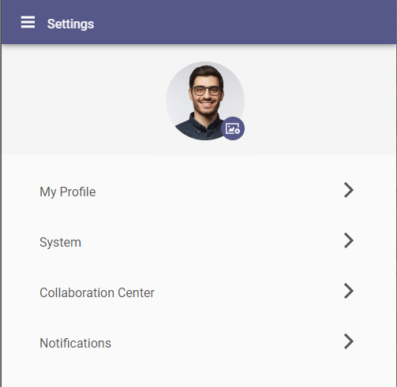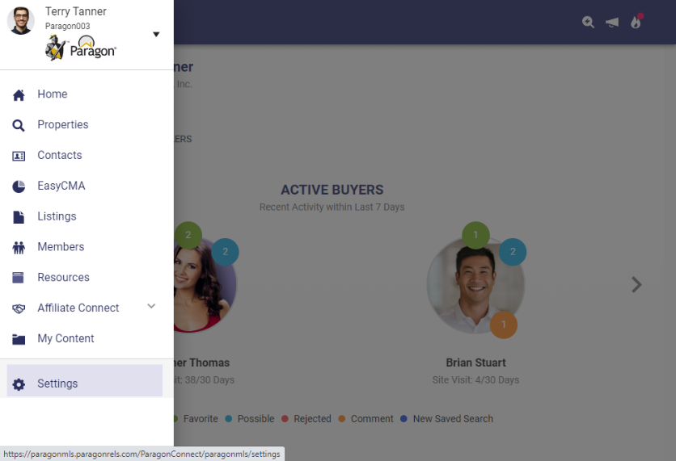Paragon Connect main menu has a new option for Settings. This option will be used to edit and define your agent photo, password (if applicable), Collaboration Center and Notification settings, and other options.

The Settings area will expand over time as new preferences and options become available.

**Dashboard**

A brand-new version of the Dashboard is now available within Paragon Connect. The new dashboard contains a fresh face for all the data and features previously available and includes a few new options.

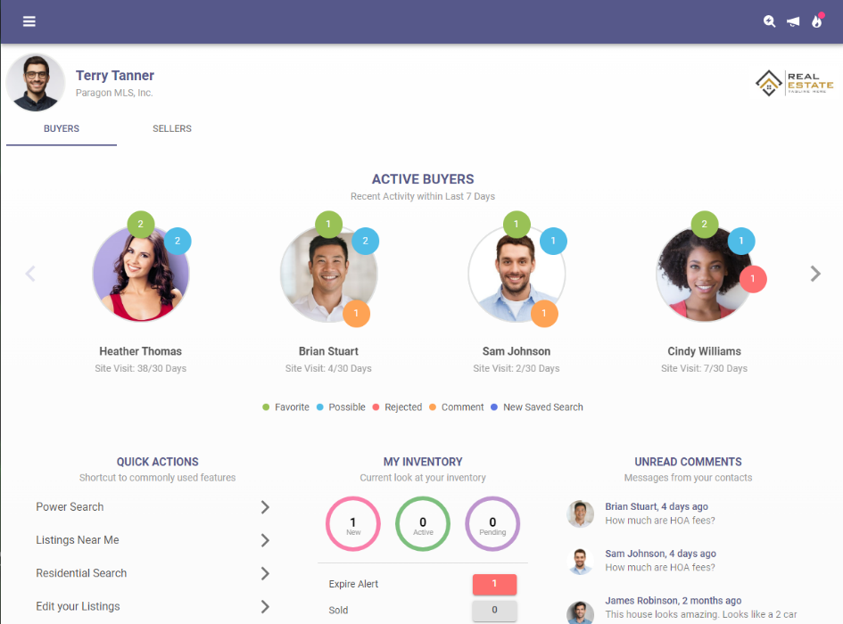The dashboard still promotes the most recent Contact activity and Comments. This version also provides:

* Display of your Office Logo
* New streamlined view for reading and responding to recent contact comments.
* New Quick Action links to give fast access to frequent features.
* Upgraded Power Search that provides auto-display of matching results.

**Property Search**

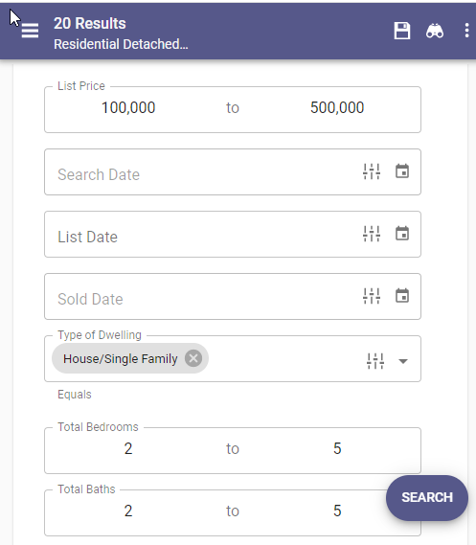Property Class search pages have been updated to use the upgraded look and feel already applied to Hotsheet and Open House searches.

This new search interface is faster, utilizes more visible text/fonts, and remains in sync with your default search in Paragon Professional.

Users may save searches, view recent searches, apply filters to see search criteria, and update the criteria used in their default search.

**Map View**

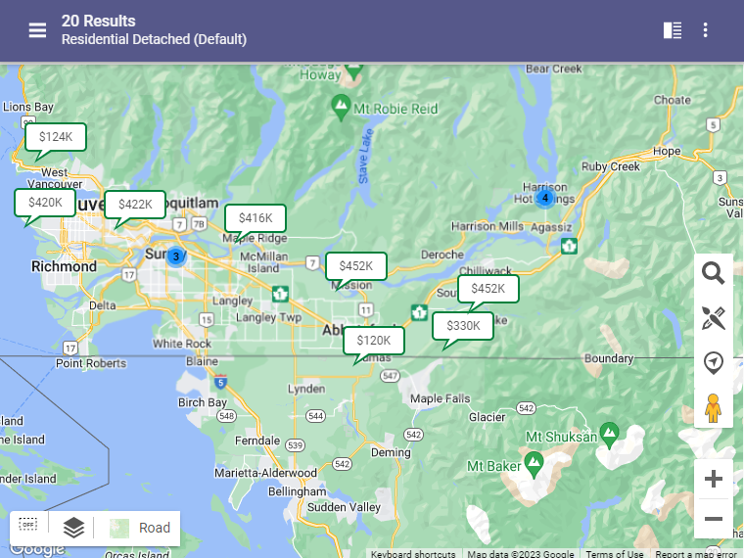The Map View has also been updated to use the latest look and feel. This option is available for viewing listing results from a property search, along with the Thumbnail and Spreadsheet views.

Standard map layers and free-hand drawing options are available. If enabled, users may also select parcels from the Parcel Layer to view public record data or enable a Property Watch.

**Full Lookup and Feature Options**

Lookup and Feature fields on search forms and listing maintenance now include the ability to see all available options in a new popup window view. This new option works alongside the existing auto-complete type-ahead feature.

Users can quickly type into a field to auto-complete a lookup value or open the new window to scroll through all available options. You can also search for options within the new modal view.

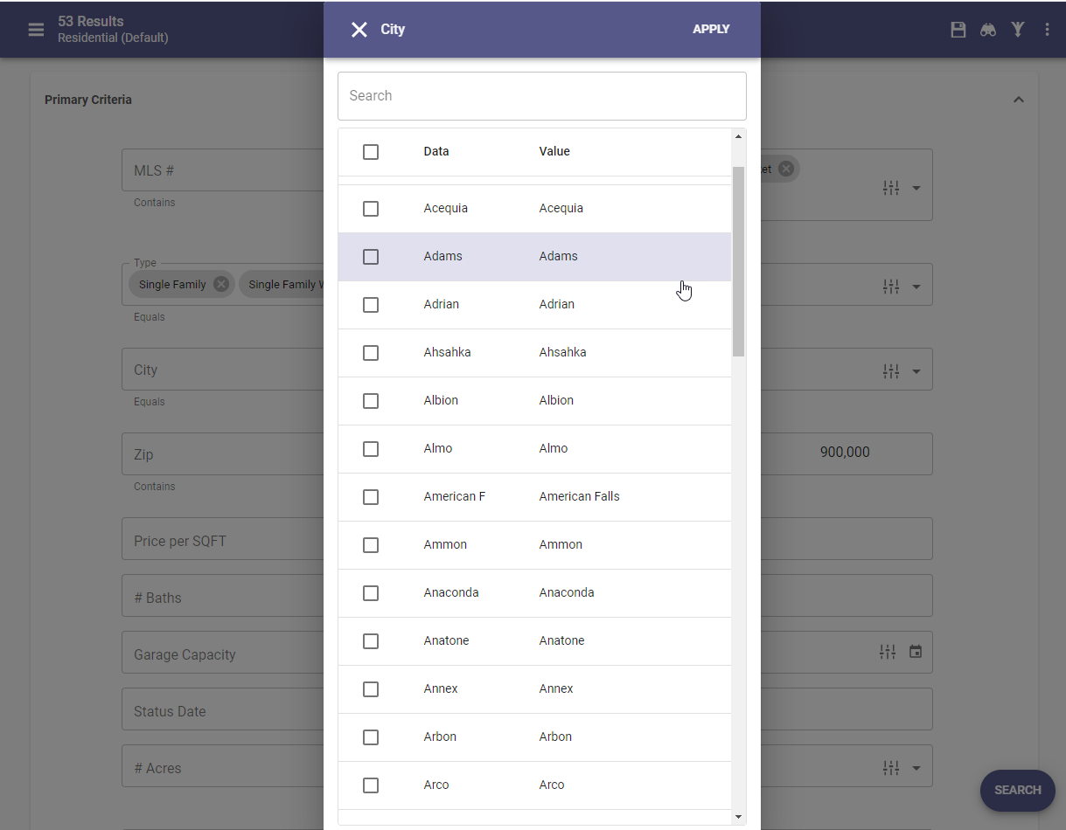

**Listing Maintenance Updates**

* Office fields on the listing maintenance form will now automatically populate when any corresponding agent field is entered.
* Listing Input Maintenance (LIM) now supports Interactive Map Layers. If Interactive Map Layers are enabled for your system, then data in configured fields will be validated against the corresponding map layers.

**Seller Dashboard**

Updated versions of the Seller Dashboard and Activity pagers are now available. These updates move the same feature and functions for monitoring your Contacts’ properties for sale into the latest, fastest interface.

**Not Available Rules in Listing Maintenance**

Listing Maintenance pages for adding and editing listings has been updated to support “Not Available” field rules. These conditional logic rules allow fields to remain hidden from view until specific conditions are met and the fields become visible.

**Tax Autofill for Paragon Tax**

The add Listing process now supports Tax Autofill for Paragon Tax. Setup by Black Knight will be required before this feature is available for all Paragon Tax Customers. Teams are working to complete this setup and you will be notified when this feature is ready for use in your market.

**Web API**

**All options in this section are either configurable via MLS Administration or by your System Support Manager as noted.**

**WEB API - L_LastDocUpdate is Added to OpenMLS Web API Mapping Tool**

Data Dictionary standards list the ***DocumentsChangeTimestamp*** field in the Property resource to be used for system generated timestamp of when the last update or change to the documents for this listing was made. The Paragon field is called ***Listings Last Doc Update***.

As a timestamp field, this can be used as a $filter to pull listings where documents have been updated for a certain timeframe.

/Property?$filter=DocumentsChangeTimestamp ne 2023-04-24

**Export Web API Mapping Button**

Data Dictionary (DD) mapping requires spreadsheets to be used at various junctures to discuss the implementation. Copying the spreadsheets from the tool itself was a simple option. Detailed spreadsheets could only be created through backend access. No longer!

A new button labeled ***Export Mapping*** has been added to the ***Data System Resource Mapping*** page in the ***OpenMLS*** ***Web API Mapping Tool***.

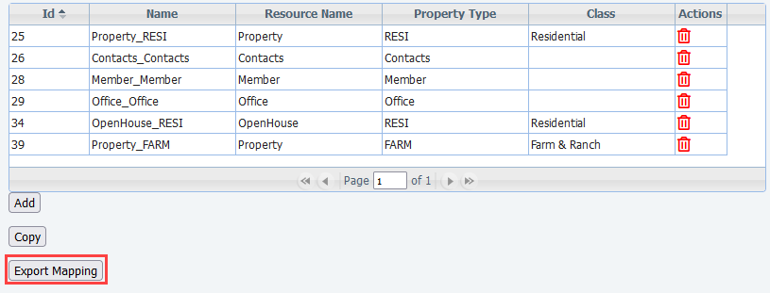

*Figure 1 - Data System Resource Mapping Screen*

When clicked, a modal/colorbox will appear requesting you to name your file. Please notice the file format is shown, currently Microsoft Excel. Simply click the ***Export Report*** button in the top right, and open, or download, the file.

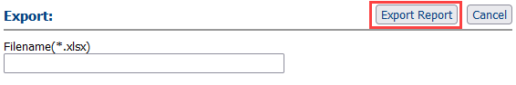

*Figure 2 - Name and Export File Colorbox*

Within the spreadsheet, you’ll find the Resources and Classes separated in their own tabs. This helps with organization and reduces confusion. The ***SourceSystemName*** column holds the ***RETS System Name***. This will assist in matching the DD Fields with RETS. *Very* helpful with vendors.

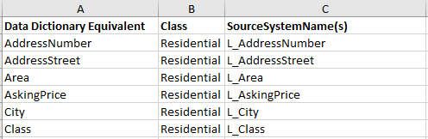

*Figure 3 - Example Export of Residential Class*

# Paragon Affiliate Connect

**All options in this section are either configurable via MLS Administration controls or by your System Support Manager as noted.**

# Corrected Paragon Affiliate Connect Issues

|  |  |  |
| --- | --- | --- |
| **Ticket #** | **Module** | **Summary** |
| DEV-8570 | Agent Search | Change Batch size for searching if not on a phone. |
| DEV-8592 | Dashboard | Login delay performance for first time to CCA dashboard. |
| DEV-8999 | Preferences | Check box for not allowing agents to select affiliates if Broker is the only one selecting. |
| DEV-9104 | Help Overlay | Affiliate Connect Help Overlay is completely out of format. Please remove at this time. |
| TK-12388 | Agent Search | Change batch size when searching if not on phone to bring back additional matches |