Paragon 5.961 Release Enhancements

**Updated on: 6-16-2023**

# Corrected Paragon Issues

|  |  |  |  |
| --- | --- | --- | --- |
| **Ticket#** | **Module** | **Organization** | **Summary** |
| DEV-10069 | View/Reports | All | New T/OH elements always left-justify |
| DEV-10055 | Admin | All | Paragon: Admin>Agents and Offices images are overlapping in information screens. |
| DEV-9995 | PowerSearch | All | Price range not finding results in Power Search unless low price contains a comma |
| DEV-9988 | Tour/Open House | All | Collab Center blue Open House banner cleanup |
|  |  |  |  |
|  |  |  |  |
|  |  |  |  |
|  |  |  |  |
|  |  |  |  |
|  |  |  |  |
|  |  |  |  |
|  |  |  |  |
|  |  |  |  |
|  |  |  |  |
|  |  |  |  |

# MLS Customizations and Administration

**All options in this section are either configurable via MLS Administration controls or by your System Support Manager as noted.**

**No changes for Admin**

**Agent Level Changes Paragon Professional**

**The following section contains some changes that are active system wide, and some may only be available to users based on their assigned security levels.**

**Statistical Reports – AvgSP and MedianSP added to Market Activity by Location**

Per customer request, the Market Activity by Location and Month report now includes the average sale price (AvgSP) and median sale price (MedianSP) in the Sold Listings section.

# Collaboration Center

**All options in this section are either configurable via MLS Administration controls or by your System Support Manager as noted.**

**Collaboration Center – Remove Open House info banner.**

To clean up the appearance of the open house information on photos, the Collaboration Center-specific info banner was removed. The banner displayed inconsistently, and if the text watermark was enabled at the bottom of the photo, the banner overlapped the text watermark, causing the appearance of duplicate text. The Open House text watermark information will still display, if enabled, and Open House information will display in the Collaboration Center detail view.

**Collaboration Center – Include Secondary email on Seller Email Report**

If a contact’s record includes the option to include the spouse/secondary email on notifications, the Sell Side > Seller Report will now include that secondary email address in the email notifications.

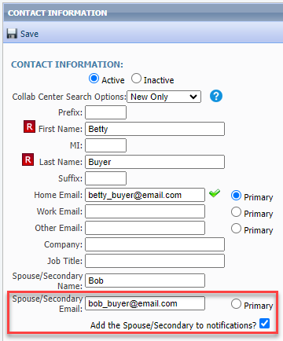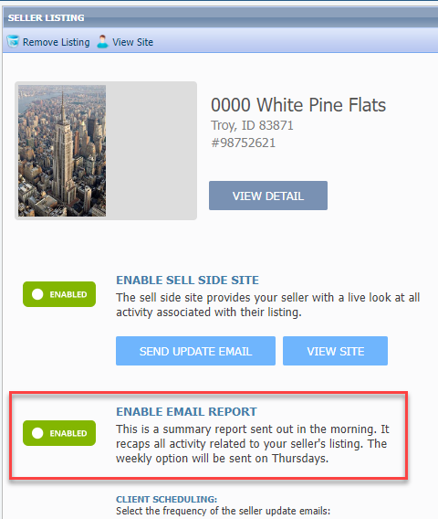

**Paragon Connect**

**The following section contains changes that are active system wide and available to users based on their assigned security levels.**

**New Near Me Search**

Busy agents need super-fast access to find listings when they are out in the field, so we added a new one-click option to find listings near you, wherever you are. On the initial landing page there is a new map icon in the top menu bar that uses your current location to open the map centered on your location and displays listings near you. This search option uses your default multi-Class search form to allow access to all listing. From the map you can use the new Criteria Filter to quickly change your search parameters to find just the right properties you need.

You can also access this new Near Me search option from the Dashboard Quick Actions and from the Properties Search menu.

**Corrections and Improvements**

* Correction so Quick Searches saved in Paragon Pro are available within Paragon Connect – My Saved Searches
* Correction to display the Contact photo when displaying unread messages from the Dashboard.

# Paragon Affiliate Connect

**All options in this section are either configurable via MLS Administration controls or by your System Support Manager as noted.**

# Corrected Paragon Affiliate Connect Issues

No changes for Affiliate Connect