Paragon 5.962 Release Enhancements
Updated on: 4-10-23

Corrected Paragon Issues
Ticket# | Module | Organization | Summary
DEV-9970 | OpenMLS | PrimeMLS | Mapping Export Field Names Corrected
DEV-10063 | OpenMLS | ValleyMLS | Fixed Tax Field Issue for /Paragon System
TK-14796 | Messaging | BCRES - REB2 Residential, IRMLS, SJSR | Paragon: Message History emails Time stamp is not correct displaying with System Time.
DEV-10079 | Data Mapping | SCWMLS - South Central Wisconsin (Madison) | Web API: City Field is Not Populating Values
DEV-10069 | View/Reports | All | New T/OH elements always left-justify
DEV-9486 | Admin | TBRMLS - Tallahassee BOR | Video Mgmt - deployment script for INPUT_MAINT_VIDEO_TYPE config
DEV-5914 | LIM | TBRMLS - Tallahassee BOR | UI: Video Management Pro: Upload video file
TK-4327 | View/Reports | MIMLS - MiRealSource, RANM, REALCOMP | Fields added to the All Fields Customizable are not displaying
DEV-2615 | Admin | REALCOMP - Realcomp II Ltd | Hotsheet search result errors

MLS Customizations and Administration
All options in this section are either configurable via MLS Administration controls or by your System Support Manager as noted.

Admin – No admin changes

Agent Level Changes Paragon Professional
The following section contains changes that are active system wide and available to users based on their assigned security levels.

No Agent changes for Paragon Professional

Collaboration Center
The following section contains some changes that are active system wide, and some may only be available to users based on their assigned security levels.

No Collaboration Center Changes

Paragon Connect
The following section contains changes that are active system wide and available to users based on their assigned security levels.

Customize Property Search Form

Paragon Connect now allows users to modify the fields used on the property class search forms. Users may choose to customize the Containers and the Fields within each container making it easy to search for any and all kinds of listing data. You can also drag and drop fields from one container to another!

After making any adjustments to the form containers and fields be sure to save as a custom search or use the Update Default Template option if you want access to the new additions going forward.

Print all PDF Associated Documents

When viewing the Listing Detail View there is a section to display all Associated Documents. This section now includes a new option to combine any PDF documents into a single file and allow you to print them all at once. This new Print PDF option does not include any other document types.

Confirm Map Location for New Listings

When adding a new listing, if the exact map location is required and the auto-generated placement of the map pin is correct, the user no longer has to move the pin to save the location to meet the requirement. Users may use the new “Confirm” option to verify the current map pin placement is correct and proceed to publish the new listing. The previous workflow required the user to manually move the pin slightly, even if the auto-generated placement was correct.
Users will continue to have the option to manually move the auto-generated placement of the pin as needed.
This new confirmation-process is only available when adding new listings.

Corrections and Improvements

- Correction for improper cursor placement in Date Range fields.
- Correction for setting LVT Frozen Time value for DOM when changing listing status.
- Improvement to always show the Hotsheet Alert icon on the Dashboard, even in mobile view.
- Communication history for comments on listings between the Agent and Consumer is now available from the Contact Summary page. These comments were previously available only from the Dashboard.
- Improvement in the Customize Spreadsheet layout making it easier to find and add new fields to your spreadsheet view.

Paragon Affiliate Connect
All options in this section are either configurable via MLS Administration controls or by your System Support Manager as noted.

Corrected Paragon Affiliate Connect Issues
Ticket # | Module | Summary

No Affiliate Connect Changes
Nothing for Affiliate Connect

OpenMLS RESO API
Any options in this section are either configurable via MLS Administration or by your System Support Manager as noted.

Server-Driven Paging with OData.nextLink
As a technology leader we strive to bring quality of life improvements when requested. To this extent, ahead of RESO’s ratification of Web API Core 2.1.0 specifications, we’ve added the @Odata.nextLink annotation to the message body per OData’s 4.0 Control Information specifications. This will allow client-side API users to link directly to the next page of results.
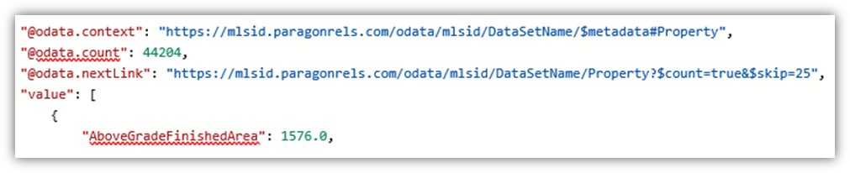
Figure 1 - Message Body When $top Is Not Used
Pagination results ($top) default to 25 records per page. When a $skip is sent in the initial request without $top, the nextLink will add 25 to the original $skip value. If $top is less than 25 records, a nextLink will not be included, because one is not needed.
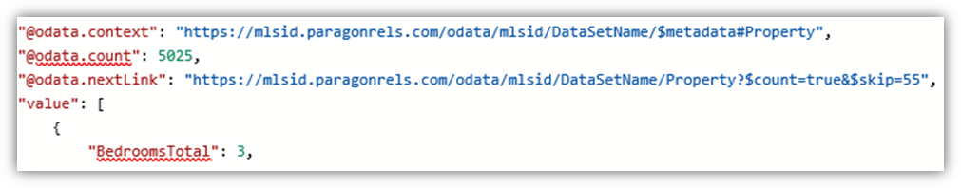
Figure 2 - Message Body When Initial Query Used $skip=30 – 30+25=55
The links follow the configurable RETS Profiles Max Records setting, which defaults to 2,500 records.
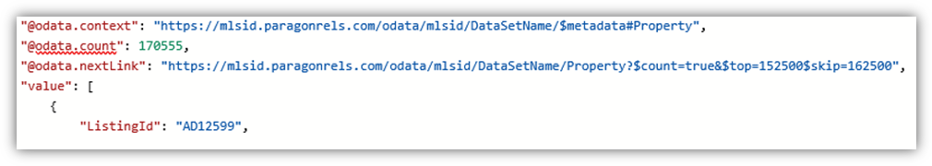
Figure 3 - Message Body When Initial Query Used $top=150000&$skip=160000
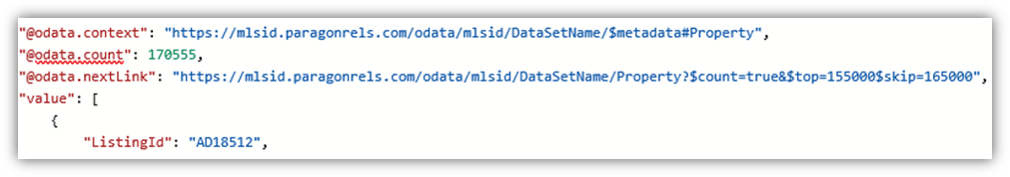
Figure 4 - Second Message Body When Initial Query Used $top=150000&$skip=160000

