Paragon 5.963 Release Enhancements
Updated on: 7-18-23

Corrected Paragon Issues
Ticket# | Module | Organization | Summary
DEV-10365 | Collab Center/CollabLink  /View/Reports | TBRMLS - Tallahassee BOR | Video Upload - videos without URLs should be omitted from views
TK-13922 | Admin | CAAR – Charlottesville  /Augusta/  Harrisonburg-Rockingham | Admin Office Record Freezes once change is made to Options section
TK-13117 | Data | MAXEBRDI - MAXEBRDI MLS | MAX-Error pulling membership roster
TK-10290 | Mapping or  Geo-coding | IMLS - Intermountain MLS | P5: Allow Force Manual Geocoding  setting to allow for single click acknowledgment

MLS Customizations and Administration
All options in this section are either configurable via MLS Administration controls or by your System Support Manager as noted.

Admin – Nothing for Admin

Agent Level Changes Paragon Professional
The following section contains some changes that are active system wide, and some may only be available to users based on their assigned security levels.

Confirm Map Pin Location for Listings

When adding or editing a listing, if the user is required to manually place the map pin but the auto-generated placement of the pin is correct, the user no longer has to move the pin to save the location to meet the requirement. Users may use the new “Confirm” option to verify that the current map pin placement is correct and proceed with saving the listing. The previous workflow required the user to manually move the pin slightly, even if the auto-generated placement was correct.
Users will continue to have the option to manually move the auto-generated placement of the pin as needed.
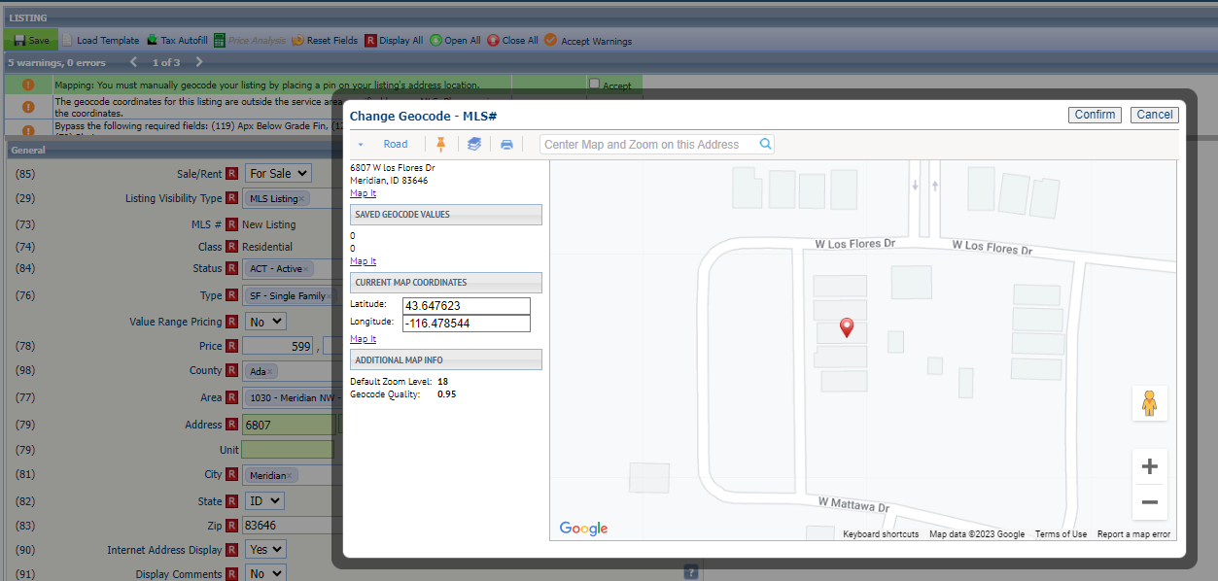

Collaboration Center
All options in this section are either configurable via MLS Administration controls or by your System Support Manager as noted.

Collaboration Center – Nothing for Collaboration Center

Paragon Connect
The following section contains changes that are active system wide and available to users based on their assigned security levels.

Membership Search

The Members menu item in Paragon Connect has a brand-new look. Users may search for Agents or Offices similarly to the Roster search functions in Paragon. Results include the option to view Roster Detail reports for agents and offices and include convenient quick links to call and email.

Corrections and Improvements

- Improvement to show full lookup options for enabled Document Types when adding/editing listing Associated Documents.
- Improvement to display existing Room/Unit/Green (RUG) data on the Listing Maintenance form. These fields are not editable but are visible on the form. Support for adding and editing RUG data will be coming soon.
- Improvement to show any Third-Party Integrations enabled for Listing Maintenance under the Published Listings overflow menu.
- Correction for sorting by price on spreadsheet views.
- Correction for Realist Tax Autofill failing to return matched property results.
- Correction for photo changes to reflect proper action in Listing Photo Audit Report.

Paragon Affiliate Connect
All options in this section are either configurable via MLS Administration controls or by your System Support Manager as noted.

Corrected Paragon Affiliate Connect Issues
Ticket # | Module | Summary

Nothing for Affiliate Connect

