

**PARAGON - INNOVATING THE WAY AGENTS DO BUSINESS**

**Paragon Release 5.960-5.963**

We (enter your MLS Name here) wanted you to be the first to know about the latest enhancements to your Paragon MLS System. All enhancements are designed to help you navigate through the system and enhance your experience with Paragon.  Below is a list of the enhancements and links to view videos or PDFs of the new features. We encourage you to continue reading and let us know what you think on the [Paragon MLS Facebook site](https://www.facebook.com/ParagonMLS/). Also make sure you click “Like” on the Facebook site to view what’s new with Paragon more frequently.

**WHAT’S NEW!**

**PARAGON**

**Statistical Reports – AvgSP and MedianSP added to Market Activity by Location**

Per customer request, the Market Activity by Location and Month report now includes the average sale price (AvgSP) and median sale price (MedianSP) in the Sold Listings section.

**Confirm Map Pin Location for Listings**

When adding or editing a listing, if the user is required to manually place the map pin but the auto-generated placement of the pin is correct, the user no longer has to move the pin to save the location to meet the requirement. Users may use the new “Confirm” option to verify that the current map pin placement is correct and proceed with saving the listing. The previous workflow required the user to manually move the pin slightly, even if the auto-generated placement was correct.

Users will continue to have the option to manually move the auto-generated placement of the pin as needed.

**Collaboration Center**

**Collaboration Center – Remove Open House info banner.**

To clean up the appearance of the open house information on photos, the Collaboration Center-specific info banner was removed. The banner displayed inconsistently, and if the text watermark was enabled at the bottom of the photo, the banner overlapped the text watermark, causing the appearance of duplicate text. The Open House text watermark information will still display, if enabled, and Open House information will display in the Collaboration Center detail view.

**Collaboration Center – Include Secondary email on Seller Email Report**

If a contact’s record includes the option to include the spouse/secondary email on notifications, the Sell Side > Seller Report will now include that secondary email address in the email notifications.

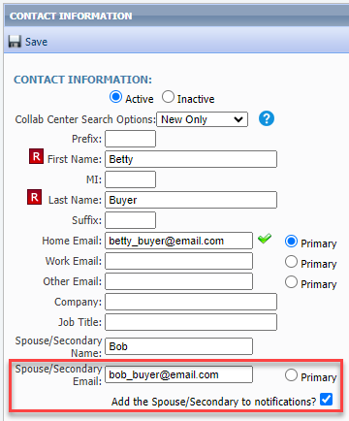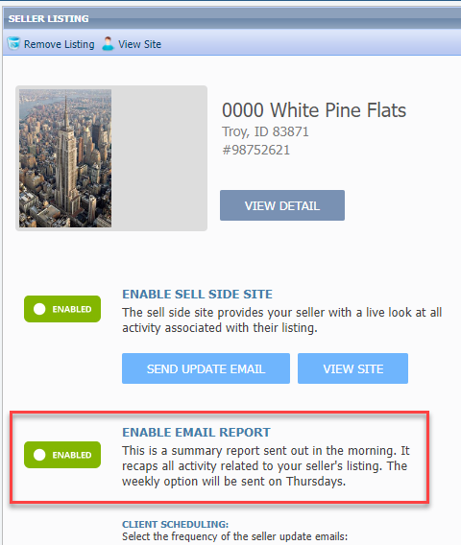

**Collaboration Center – Improved Agent Photo Handling**

Some formatting changes have been made to the handling of the agent image uploaded in Paragon Professional, to improve the display of the image in Collaboration Center. The image size was changed to allow better resolution, and code was corrected that was causing the image to display off center.

**Paragon Connect**

**Corrections and Improvements**

* Correction for the Sqft/Acreage field label displayed on the Detail View.
* Correction for listing photos that do not display on Hotsheet results.
* Adjustment to cursor placement when modifying date range values.
* New option to rename existing Hotsheet searches.
* New access to maintain Tours & Open Houses from the Published listing’s results view.
* New access to modify personal phone preferences under Settings.
* Correction so Quick Searches saved in Paragon Pro are available within Paragon Connect – My Saved Searches
* Correction to display the Contact photo when displaying unread messages from the Dashboard.
* Correction for improper cursor placement in Date Range fields.
* Correction for setting LVT Frozen Time value for DOM when changing listing status.
* Improvement to always show the Hotsheet Alert icon on the Dashboard, even in mobile view.
* Communication history for comments on listings between the Agent and Consumer is now available from the Contact Summary page. These comments were previously available only from the Dashboard.
* Improvement in the Customize Spreadsheet layout making it easier to find and add new fields to your spreadsheet view.
* Improvement to show full lookup options for enabled Document Types when adding/editing listing Associated Documents.
* Improvement to display existing Room/Unit/Green (RUG) data on the Listing Maintenance form. These fields are not editable but are visible on the form. Support for adding and editing RUG data will be coming soon.
* Improvement to show any Third-Party Integrations enabled for Listing Maintenance under the Published Listings overflow menu.
* Correction for sorting by price on spreadsheet views.
* Correction for Realist Tax Autofill failing to return matched property results.
* Correction for photo changes to reflect proper action in Listing Photo Audit Report.

**Driving Directions for Multiple Listings**

The Driving Directions option has been expanded to allow support for multiple listings. Driving directions were previously available for a single listing. Users may now select multiple listings on their desktop or mobile device to use Google Maps for plotting directions between listings.

**New Near Me Search**

Busy agents need super-fast access to find listings when they are out in the field, so we added a new one-click option to find listings near you, wherever you are. On the initial landing page there is a new map icon in the top menu bar that uses your current location to open the map centered on your location and displays listings near you. This search option uses your default multi-Class search form to allow access to all listings. From the map you can use the new Criteria Filter to quickly change your search parameters to find just the right properties you need.

You can also access this new Near Me search option from the Dashboard Quick Actions and from the Properties Search menu.

**Customize Property Search Form**

Paragon Connect now allows users to modify the fields used on the property class search forms. Users may choose to customize the Containers and the Fields within each container making it easy to search for any and all kinds of listing data. You can also drag and drop fields from one container to another!

After making any adjustments to the form containers and fields be sure to save as a custom search or use the Update Default Template option if you want access to the new additions going forward.

**Print all PDF Associated Documents**

When viewing the Listing Detail View there is a section to display all Associated Documents. This section now includes a new option to combine any PDF documents into a single file and allow you to print them all at once. This new Print PDF option does not include any other document types.

**Confirm Map Location for New Listings**

When adding a new listing, if the exact map location is required and the auto-generated placement of the map pin is correct, the user no longer has to move the pin to save the location to meet the requirement. Users may use the new “Confirm” option to verify the current map pin placement is correct and proceed to publish the new listing. The previous workflow required the user to manually move the pin slightly, even if the auto-generated placement was correct.

Users will continue to have the option to manually move the auto-generated placement of the pin as needed.

This new confirmation-process is only available when adding new listings.

**Membership Search**

The Members menu item in Paragon Connect has a brand-new look. Users may search for Agents or Offices similarly to the Roster search functions in Paragon. Results include the option to view Roster Detail reports for agents and offices and include convenient quick links to call and email.

**Member Search**

**Office Search**

