Paragon 5.970 Release Enhancements

**Updated on: 2023.**

# Corrected Paragon Issues

|  |  |  |  |
| --- | --- | --- | --- |
| **Ticket#** | **Module** | **Organization** | **Summary** |
| TK-13531 | Fields | Realcomp | Realcomp - RUG Fields not respecting Viewable setting |
| DEV-10409 | OpenMLS |  | Added odata.nextLink Support in POST Queries |

# MLS Customizations and Administration

**All options in this section are either configurable via MLS Administration controls or by your System Support Manager as noted.**

**Admin – No Admin items**

**Agent Level Changes Paragon Professional**

**The following section contains some changes that are active system wide, and some may only be available to users based on their assigned security levels.**

**No Changes Paragon Professional**

# Collaboration Center

**All options in this section are either configurable via MLS Administration controls or by your System Support Manager as noted.**

**Collaboration Center – No changes to Collaboration Center**

**Paragon Connect**

**The following section contains changes that are active system wide and available to users based on their assigned security levels.**

**Bulk Photo Labels**

Photo labels and descriptions are a great way to provide details for marketing listings. The photo maintenance section of Paragon Connect was just upgraded to offer a convenient option for setting or modifying labels and descriptions for all the photos for a listing in a single view.

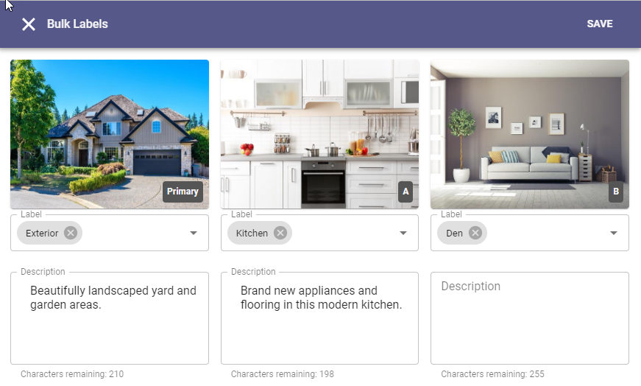

After selecting to edit listing photos, the overflow menu includes a new option called “Bulk Labels”. From this Bulk Labels page users will see any label and description options enabled for their system and will be able to easily set values for one or all photos at one time.

**Room/Unit/Green fields in LIM**

The listing maintenance feature in Paragon Connect now supports adding and editing Room, Unit, and Green, aka RUG, fields. If the RUG options are enabled for your system, these will appear as new sections on your listing maintenance form.

Data for rooms, units, and green info display as cards in their own designated RUG section. Users may add new entries or modify existing entries to complete their listings.

**Corrections and Improvements**

* Correction for searching Members by Full Name
* Corrections for searching Offices by City and State/Province
* Correction for driving directions using the incorrect destination location
* Update to show map pin labels as “listings” instead of “units” when multiple listings appear at the same location
* Update to include new filter options for viewing My Saved Searches

# Paragon Affiliate Connect

**All options in this section are either configurable via MLS Administration controls or by your System Support Manager as noted.**

# Corrected Paragon Affiliate Connect Issues

|  |  |  |
| --- | --- | --- |
| **Ticket #** | **Module** | **Summary** |

**No Changes to Affiliate Connect**

**OpenMLS Web API**

**With this major release, we’ve focuses on cleaning up metadata. If options are configurable by either MLS Administration or your System Support Manager, they are noted.**

**Removing Paragon Short Values in Lookups**

When direct field mapping is used in OpenMLS and no enumeration mapping is created, OpenMLS will automatically generate the lookups. To ensure all lookups were unique, we included the short value in parentheses.

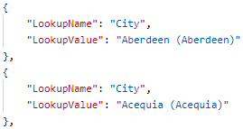

*Figure 1 - Paragon Short Value in Parentheses*

The [LookupValue](https://ddwiki.reso.org/display/DDW17/LookupValue+Field) needs to be a human-friendly display name. Even though Short Value in parentheses is friendly and understandable, most vendors won’t have need of this value. To make data easily readable, we will no longer display the Short Value unless there are lookups that share the same Long Description. **This only affects systems where Lookups are generated automatically. eg: /Paragon endpoints** If your Feature and Lookup enumerations are manually mapped, this change will **not** affect you.

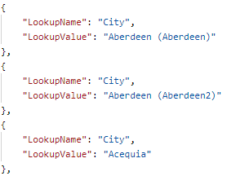

*Figure 2 - Paragon Short Values in Prentheses only for Duplicate Descriptions*

**Enforcing Explicit Enumeration Mapping in Metadata**

RESO Data Dictionary (DD) 2.0 will focus on compliance. Prior to this release, if Paragon Feature or Lookup enumerations were partially mapped, the unmapped values were being sent out as well. This will no longer happen.

In the example below, if the agent chose Storage and Tennis on this Feature. Tennis will not be sent out because it is not mapped.

*Figure 1 - Paragon Value Mapping Example*

**Create a Sum from Multiple Feature Values**

It’s not uncommon to group count options in a Feature Category. eg: Garage Spaces This gives users flexibility, but does not match DD standards. We’ve added a new summation method to the Formula Editor (). The features_sum() sum the selected Feature values which are mapped to this field. The External Value must be a number. This leverages the current feature() formula. This means you can include comma delimited features in the parenthesis.

|  |  |
| --- | --- |
| Before | After |

*Figure 1 - Before and After Sumation Functionality*

*Figure 2 - Various Features Mapped to a Number Field*

**System Generated Lookups vs Manual Mapped Enumerations**

This release allows for data mappers to ability to truly “map it and forget it”. With the changes above, when a Feature or Lookup is mapped to a List Type field where RESO has not defined enumerations, the system now cleanly generates Lookups for you. There is no need to define those using the Value Mapping () tool. This eliminates the need to manually map new enumerations when added to your system.

To take full advantage of this functionality, your system must have the RETS_DYNAMIC_METADATA_OPTION set to fully dynamic. This can be completed by your SSM. When a new enumeration is added to an **existing lookup or feature,** a Lookup refresh can be run in the background without disruption to RETS or RESO API. Once completed, your vendors can repull metadata from either system to see the new value.

*Figure 1 - Blue Flag Indicates No Enumeration Mapping*



*Figure 2 - Green Flag Indicates Enumeration Mapping*

*Figure 3 - New City is Now Skipped Because Other Cities are Mapped*

For customers wishing to make scripted removal of enumeration mappings on fields, please contact your SSM. This would most likely be location fields, like City. We can assist with. **Please Remember: Any mapping changes will affect your API Metadata. If you are an OpenMLS customer, please instruct your Web API vendors to repull metadata and lookups once this process is complete.**

**RETS**

**The items in this section are configurable per MLS by your System Support Manager.**

**Added Manual Geocode Field to Listing Table**

To allow flexibility in geocoding, we’ve added a new flag to the Property Resources in RETS. This is a flag called “Is Manual Geocode”. This flag was not enabled by default for this release. To enable, please contact your SSM. This new field will, of course, require a RETS Refresh.

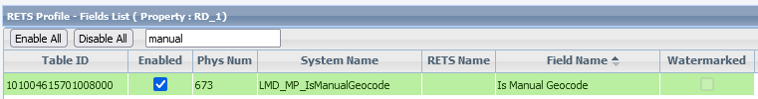

*Figure 1 - LMD_MPIsManualGeocode*

Like all other fields, this field can be managed in the RETS Profiles editor within Paragon Pro’s Admin section. The System Name for the field is LMD_MPIsManualGeocode. It will send out a value of ‘1’ when the listing in question is manually geocoded.