Paragon 5.971 Release Enhancements

**Updated on: 8/14/2023.**

# Corrected Paragon Issues

|  |  |  |  |
| --- | --- | --- | --- |
| **Ticket#** | **Module** | **Organization** | **Summary** |
| DEV-9878 | Web API |  | Fix to when Features() Method is allowed |
| DEV-10558 | Web API |  | Fix error when using PhoneNumber with $filter |
| DEV-8667 | WebAPI | PRIMEMLS - Prime MLS (NEREN), SCWMLS | Create Web API Tool AutoMapping for Multiple New Fields |
| DEV-10560 | Admin | MAXEBRDI - MAXEBRDI MLS | Hide Restrict User Code for Tour and Open House Searchable and Viewable Checkbox |
| TK-14160 | Membership/Roster | REALCOMP - Realcomp II Ltd | Modifying criteria in Roster search opens additional internet tab instead of updating results |

# MLS Customizations and Administration

**All options in this section are either configurable via MLS Administration controls or by your System Support Manager as noted.**

**Admin – View multiple board-level Homepage Messages**

**Action Item:** N/A

This enhancement fulfills a customer request to expand visibility of board-level homepage messages to those offices with multiple board affiliations. Previously, a user could only see the MLS-level homepage message and the homepage message for their office’s primary board. This enhancement allows users to see homepage messages for any board their office is affiliated with. When selected, the Board button on the homepage messages toolbar opens a series of tabs for all boards with an active homepage message. The default is still the user’s office primary board message.

Note: This does not impact customers that do not have multiple boards in their Paragon system.

**Agent Level Changes Paragon Professional**

**The following section contains some changes that are active system wide, and some may only be available to users based on their assigned security levels.**

**No Changes In Paragon Professional**

# Collaboration Center

**All options in this section are either configurable via MLS Administration controls or by your System Support Manager as noted.**

**Collaboration Center – No changes to Collaboration Center**

**Paragon Connect**

**The following section contains changes that are active system wide and available to users based on their assigned security levels.**

**Assume Identity – Phase 2**

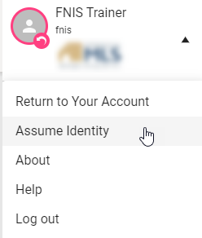

Paragon Connect now provides users a way to assume the identity of other users based upon the setup defined in Paragon Professional.

Within the hamburger menu, users who are authorized to use the Assume Identity will see a new option in the account drop-down area.

Users will see a list of people they are authorized to assume.

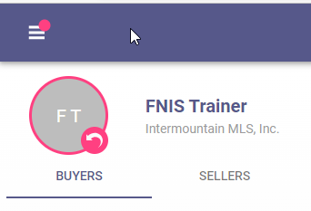When an identity is assumed, Paragon Connect will display pink highlighting around the current user profile and a pink badge over the menu . This pink badge provides a visual indicated letting users know another identity is being used no matter where you are within the application.

**Corrections and Improvements**

* Improvements to Contacts including option for uploading Contact photo, displaying, and editing additional data
* Correction for CloudCMA integration to pass proper listing ID value
* Correction to show the proper Yes/No Office Status value on the roster card

# Paragon Affiliate Connect

**All options in this section are either configurable via MLS Administration controls or by your System Support Manager as noted.**

# Corrected Paragon Affiliate Connect Issues

|  |  |  |
| --- | --- | --- |
| **Ticket #** | **Module** | **Summary** |

**No Changes to Affiliate Connect**

**OpenMLS RESO API**

**Any options in this section are either configurable via MLS Administration or by your System Support Manager as noted.**

**No feature changes this release.**