Paragon 5.971 - 5.972 Release Enhancements

**Updated on: 8/25/2023.**

# Corrected Paragon Issues

|  |  |  |  |
| --- | --- | --- | --- |
| **Ticket#** | **Module** | **Organization** | **Summary** |
| DEV-9878 | Web API | All | Fix when Features() Method is allowed |
| DEV-10558 | Web API | All | Fix when using PhoneNumber with $filter |
| DEV-8667 | Web API | Prime MLS | Automap DOM and CDOM fields. |
| DEV-10560 | Admin | MAXEBRDI - MAXEBRDI MLS | Hide Restrict User Code for Tour and Open House Searchable and Viewable Checkbox |
| TK-14160 | Membership/Roster | REALCOMP - Realcomp II Ltd | Modifying criteria in Roster search opens additional internet tab instead of updating results |
| DEV-10785 | Web API | Various | Fix some lookups not auto-generating |
| DEV-10563 | Statistical Reports | NSAR and PEI | Stats - Market Activity by Location doesn't respect Board ID filter |

# MLS Customizations and Administration

**All options in this section are either configurable via MLS Administration controls or by your System Support Manager as noted.**

**Admin – View multiple board-level Homepage Messages**

**Action Item:** N/A

This enhancement fulfills a customer request to expand visibility of board-level homepage messages to those offices with multiple board affiliations. Previously, a user could only see the MLS-level homepage message and the homepage message for their office’s primary board. This enhancement allows users to see homepage messages for any board their office is affiliated with. When selected, the Board button on the homepage messages toolbar opens a series of tabs for all boards with an active homepage message. The default is still the user’s office primary board message.

Note: This does not impact customers that do not have multiple boards in their Paragon system.

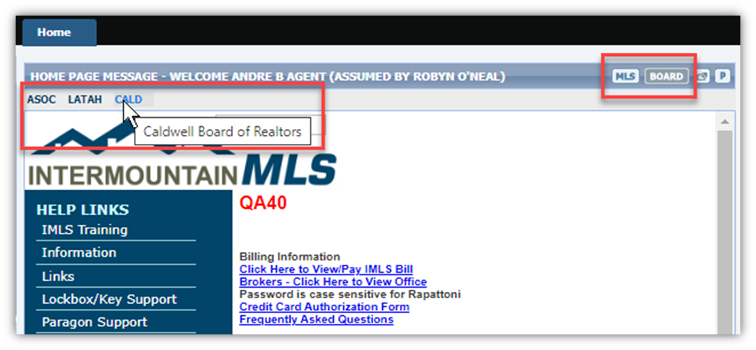

**Agent Level Changes Paragon Professional**

**The following section contains some changes that are active system wide, and some may only be available to users based on their assigned security levels.**

**No Changes to Paragon Professional**

# Collaboration Center

**All options in this section are either configurable via MLS Administration controls or by your System Support Manager as noted.**

**No changes to Collaboration Center**

**Paragon Connect**

**The following section contains changes that are active system wide and available to users based on their assigned security levels.**

**Assume Identity – Phase 2**

Paragon Connect now provides users a way to assume the identity of other users based upon the setup defined in Paragon Professional.

Within the hamburger menu, users who are authorized to use the Assume Identity will see a new option in the account drop-down area.

Users will see a list of people they are authorized to assume.

When an identity is assumed, Paragon Connect will display pink highlighting around the current user profile and a pink badge over the menu. This pink badge provides a visual indicated letting users know another identity is being used no matter where you are within the application.

**Product Feedback**

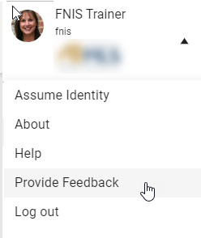

Paragon Connect has a new option allowing users to provide feedback regarding their experience with the application. Users can provide an overall rating based upon a 5 Star value and include general comments. Feedback is sent directly to the Black Knight Product Team.

This new option is available in the User Account section of the Paragon Connect menu.

**Corrections and Improvements**

* New option for uploading Contact photo under the Contacts module
* Update to the Thumbnail Views to include display of Price Change Arrows when display of price changes are configured
* Correction for CloudCMA integration to pass proper listing ID value
* Correction to show the proper Yes/No Office Status value on the roster card

**OpenMLS RESO API**

**To use the added functionality, you’ll need to already be utilizing the Room, and Unit tables in Paragon and RETS. Mapping from the Listing table is not supported at this time.**

**Added PropertyRooms and PropertyUnitTypes for Data Dictionary 1.7**

For customers who are mapping their own data, the new resource can be mapped from the **Resource Mapping** tab inside **Data Mapping: Data Dictionary** from **Admin**. Simply click the Add button, choose which RETS class to link it to, and you’re off.

*Figure 1 - PropertyRooms in DD Resource Mapping Tab*

The fields can be mapped using click-and-drag or formulas. Please reference RESO’s [PropertyRooms](https://ddwiki.reso.org/display/DDW17/PropertyRooms+Resource) and [PropertyUnitTypes](https://ddwiki.reso.org/display/DDW17/PropertyUnitTypes+Resource) wiki for reference.

*Figure 2 - PropertyUnitTypes Field Mapping Tab*

Please remember that OpenMLS API translator uses similar pieces that RETS does. If these resources are not enabled in a **RETS Profile**, the API user will a **401 Unauthorized** HTTP error.

*Figure 3 - RETS Profile Resource List*

**Correcting RESO Lookup Values**

We identified and are running a script to correct an intermittent naming issue that affected predefined RESO lookup values. Effective as of: **UAT – 8/31/2023**, **Pre-Release 9/5/2023**, **Production 9/12/2023**. We recommend all vendors hit the /Lookup resource to get any updated values.

*Figure 1 – Naming Issue Example; No Spaces or Special Characters*