Paragon 5.973 Release Enhancements

**Updated on: 2023.**

# Corrected Paragon Issues

|  |  |  |  |
| --- | --- | --- | --- |
| **Ticket#** | **Module** | **Organization** | **Summary** |
| DEV-10841 | Web API | N/A | Show formula in Incompatible Mapping Popup |
| DEV-10563 | Statistics | NSAR - NS and PEI Real Estate Associations | Stats - Market Activity by Location doesn't  respect Board ID filter |
| TK-12862 | View/Reports | REALCOMP - Realcomp II Ltd | Field Pref boxes not respecting Viewable  field settings when customizing Spreadsheets and Reports |

# MLS Customizations and Administration

**All options in this section are either configurable via MLS Administration controls or by your System Support Manager as noted.**

**Admin – No Changes to Admin**

**Agent Level Changes Paragon Professional**

**The following section contains some changes that are active system wide, and some may only be available to users based on their assigned security levels.**

**No Changes to Paragon Professional**

# Collaboration Center

**All options in this section are either configurable via MLS Administration controls or by your System Support Manager as noted.**

**Collaboration Center – No changes to Collaboration Center**

**Paragon Connect**

**The following section contains changes that are active system wide and available to users based on their assigned security levels.**

**Export Listings from Spreadsheets**

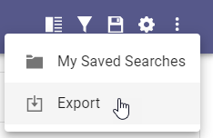

Paragon Connect spreadsheet views now support an option to export listing data. While viewing any results in a spreadsheet view, users may use the overflow menu to export all, or just selected, listings.

Listing data will be exported to a CSV file using the columns of data included in the current spreadsheet. The CSV download may be opened in applications like Excel.

**Report Listing Issue**

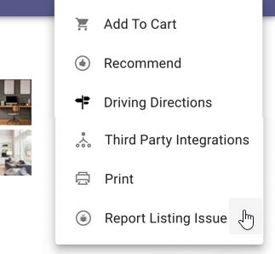

Paragon Connect Listing Detail View now supports the option to report an issue with listing data.

Users may select this option when viewing any single listing. A new email form allows users to provide details regarding the potential listing problem. The email is sent to the system administrator.

This feature follows the same email distribution choice defined within Paragon Professional.

**Corrections and Improvements**

* Improvement to support the Geocode Boundary Configuration added previously in Paragon Professional is now available for Paragon Connect. This optional configuration prevents listings from being mapped outside of the defined market area.
* Improvement to the Contacts module to support adding and editing multiple email addresses per contact.
* Improvement to display Room, Unit, and Green (RUG) data on the Listing Detail View, when these RUG fields are enabled per system.
* Improvement for displaying photos on the Listing Detail View by increasing the size of the main photo and expanding the area for additional photos.
* Correction for Driving Directions map report which loads blank intermittently.

**OpenMLS RESO API**

**Any options in this section are either configurable via MLS Administration or by your System Support Manager as noted.**

**No changes to OpenMLS RESO API**