Paragon 5.980 – 5.984 Release Enhancements

**Updated on November 21, 2023**

Corrected Paragon Issues 2

MLS Customizations and Administration 4

**Admin - Paragon Professional Multi-Factor Authentication (MFA) Enhancements** 4

**Admin - New Optional Menu Options from Paragon Connect to Paragon Professional – Admin and Statistics** 7

**Opt-in link on Mobile Settings** 7

**Audit Login includes Browser and OS** 8

Agent Level Changes Paragon Professional 9

**Multiple Board-level messages** 9

Collaboration Center 10

**Collaboration Center – No changes to Collaboration Center** 10

Paragon Connect 11

**Corrections and Improvements** 11

**New Display Options for Listing Photos** 12

**Agent Auto-Notification Emails link to Listing Details** 12

**New Display for Contact Email Opt-Out** 13

13

OpenMLS RESO API 14

**Added PropertyGreenVerification for Data Dictionary 1.7** 14

**Added Concatenated L_Address for Data Dictionary 1.7 Mapping** 16

# Corrected Paragon Issues

|  |  |  |  |
| --- | --- | --- | --- |
| **Ticket#** | **Module** | **Organization** | **Summary** |
|  |  |  |  |
| Various | Web API | N/A | Some RUG system fields hidden in mapping tool |
| DEV-10912 | Web API | N/A | External Fields Doesn’t Refresh When Custom Field Added |
| DEV-9090 | Listing Maintenance | NNRMLS – Northern Nevada Regional MLS | NNRMLS reports Zip Field's Info Tip not displaying in listing input |
| DEV-11163 | Web API | N/A | Corrected DB Duplicate Mapping Issue for RUG |
| DEV-11152 | Collab Center - Third Party | GREENVILLE - Greater Greenville AOR | The "DisplayIcon" Custom Method is not working for Local Logic widgets |
| TK-15434 | Statistics | SILVERCITY - Silver City-Grant BOR, TOPEKAMLS | Month End Report: Median Sold $ of Residential Listings Closed Repeating $ Amount |
| TK-15723 | Third Party | COLUMBIA - ConsolidatedMLS, SDMLS | Property Watch does not work for customers in Paragon Pro |
| DEV-11039 | General UI | BCRES - REB2 Residential, PRIMEMLS, RAE | Twitter - Replace bluebird icon with X |
| TK-15323 | Preferences | CARMLS - CARMLS, Inc. (Arkansas), WVMLS | The Preference Wizard is displaying no Image Box |
| TK-15077 | View/Reports | CR - California Regional MLS | Issue with Font Size on Emailed Reports with Open House/Tours Information |
| TK-14526 | Assume Identity | BCRES - REB2 Residential, PRIMEMLS, RAE | Deleting user from allowed Assume Identity list in Prefs logs user out upon delete confirmation for SSO ONLY. |
| DEV-11340 | Admin | All | Broken default image on Agent Admin profile |
| TK-15854 | Dashboard | GOREALTORS - Greater Owensboro Realtor Association | Homepage ShowingTime Widget sending incorrect Agent ID and not respecting config values |
| TK-15917 | View/Reports | MIMLS - MiRealSource | PC Spreadsheet - Associated/Shared Photos do not display on spreadsheet view |
| TK-12492 | Admin | CARMLS - CARMLS, Inc. (Arkansas) | P100 CARMLS: Duplicate Compliance Report Not Returning Results |
| DEV-11524 | OpenMLS API | N/A | Fix AOR Lookup Not Properly Being Declared |
| DEV-10355 | OpenMLS API | N/A | Improved Handling of LookupName Creation for Non-MultiClass Compatible Paragon Fields |
| DEV-11108 | Search | All | Public Record Map Search Pin Selection Produces an Error when Parcel Lines is not Enabled in Preferences |
| DEV-11456 | Login/SSO | N/A | Increased Outseer Timeout to 15 secs |
| DEV-11460 | Third Party | N/A | Removed Homebot Deep Integration Code |
| DEV-11480 | Contacts | N/A | Code related to DEV-11460 Inadvertently caused an Error Accessing Contacts |
| DEV-11466 | Web API | Prime MLS | Cannot Map Fields in Property/Boat and No Error is Thrown |
| DEV-11473 | Listing Photos | N/A | Photo Guid Miscellaneous Cleanup to ParagonGuid and CribGuid image providers |
| DEV-11477 | Search | All | Assign "No Name" when Saved Search has no Defined Name so the Search can be Accessed |
| DEV-11481 | Contacts | All | Contacts List Missing Actions Bar Buttons at Top of the Page |
| TK-13481 | Search | OABRMLS - Great Plains Regional MLS | Saved Search Notifications Changing Time after Daylight Savings Time |
| TK-10897 | Search | RMLSA - Regional MLS Alliance (Peoria) | Map Search No Longer Opens to the Map, but Starts with Criteria then Jumps to the Map After One Field is Entered |
| DEV-11072 | Web API | Prime MLS | Mapping Failed Error When Trying to Map Fields in Property_BOAT and Property_LAND |
| TK-16331 | Views/Reports | OABRMLS - Great Plains Regional MLS, PRIMEMLS - Prime MLS (NEREN), TAOSMLS - Taos County MLS, TYLERTEXAS - Greater Tyler AOR | ‘D’ icon link to Associated Documents on Reports Emailed from Paragon using Publink are Giving an Error |

# MLS Customizations and Administration

**All options in this section are either configurable via MLS Administration controls or by your System Support Manager as noted.**

**Admin - Paragon Professional Multi-Factor Authentication (MFA) Enhancements**

**Action Item: Manually add an email and/or phone number to the record in Paragon if one has not already been added.**

**What is MFA?**

Multi-Factor Authentication (MFA) is an electronic security measure that protects individuals and organizations by requiring users to provide at least two authentication factors to be granted access to an application or account.

**How will this affect you?**

With the 5.80 release (10/3/23 for P100 and 10/10/23 for Production Customers), certain users logging into Paragon Professional will be required to authenticate via MFA. MFA is intended for MLS Admin users, security level 7 and above and is based on the setting for Admin > Configuration > “LOGIN_MFA_SECURITY_LEVEL”. For security levels that meet or exceed the configuration threshold, those individual users will be impacted.

Admins will be asked if they want to receive the MFA code through email or text message depending on whether they have an email and/or phone number populated. If only one field is populated in Paragon, that one option will appear and will be auto selected (see screenshots below). The email that will be used is the email address in your Agent record (saved in ***Admin > Agents***). The phone number that will be used is the number setup in ***Preferences > User Preferences > Mobile Account Settings*.**

When using MFA, Admins will receive a code via email or text that will expire within 15 minutes and is allowed (3) attempts to log in. A successful attempt will authenticate the user, granting them access to Paragon Professional, and the user will not have to authenticate again for some period of time. If an incorrect code is entered 3 times, the user will have to start the authentication process over. If no email or phone is setup, the user will see a message indicating that they need to contact their Board administrator for login support.

Admins will need to ensure that they manually add an email and/or phone number in the appropriate areas of Paragon. **Note: MFA will not affect MLSs that have their own login dashboard solution, nor does it affect login access to Paragon Connect.**

Figure 1: MFA email address setup

Figure 2: MFA phone number setup

Figure 3: MFA authentication code via text

Figure 4: MFA authentication code via email

Figure 5: MFA login screens

**Admin - New Optional Menu Options from Paragon Connect to Paragon Professional – Admin and Statistics**

**Action Item: Contact your SSM to enable new menu options for Admin and Statistics**

For users who use Paragon Connect as their primary system we are offering the addition of two new items into the Paragon Connect menu. These menu items will provide quick access to two main features that are only available within Paragon Professional: Admin and Statistics.

If you are interested in enabling these menu options for your system, two new, independent configurations will need to be enabled by your System Support Manager. The configurations set the minimum Security Level required to view these menu options. **Both menu options are hidden by default.**

**Admin Menu Option:** New option to allow your system administrative users (Security Level 7 or 8) to have a quick menu option to launch the admin panel of Paragon Professional. Users meeting the minimum Security Level will see a new option in the Paragon Connect menu for “Admin”. Selecting this option will open a new browser tab. The tab will automatically sign the user into Paragon Professional and display the Admin panel without any main menu navigation options.

**Statistics Menu Option:** New option to allow your users (Security Level 2-8) to have a quick menu option to launch the Statistics panel of Paragon Professional. Users meeting the minimum Security Level will see a new option in the Paragon Connect menu for “Statistics”. Selecting this option will open a new browser tab. The tab will automatically sign the user into Paragon Professional and display the Statistics panel without any main menu navigation options.

**Opt-in link on Mobile Settings**

A link to opt-in a user’s mobile phone number has been added to Preferences > User > Mobile Account Settings. This functions the same as the opt-in link on a contact phone record. Clicking the link will send the user an email allowing them to opt their mobile number in to receive text messages from Paragon. This was specifically enabled for the multi-factor authentication challenge code, but is valid for all text messages coming from Paragon.

**Action Item:** N/A

**Audit Login includes Browser and OS**

The Audit Login and the Unique User Logins reports now include options for browsers and operating systems.

Both audit search forms now include 4 additional fields allowing staff users to filter these reports to specific versions.

The audit reports also display the browser and operating systems for the specific login records.

This new information makes it easier to troubleshoot isolated browser or operating system issues and identify user login-pattern data.

**Agent Level Changes Paragon Professional**

**The following section contains some changes that are active system wide, and some may only be available to users based on their assigned security levels and configured by your MLS.**

**Multiple Board-level messages**

 For multiple-board systems, users with offices belonging to more than one board will now be able to see login messages for all of their offices. The most recent message displays in the widget first; use the page tools to view additional messages. Viewing the messages in List view will display the messages in posted date order.

**Action Item:** N/A

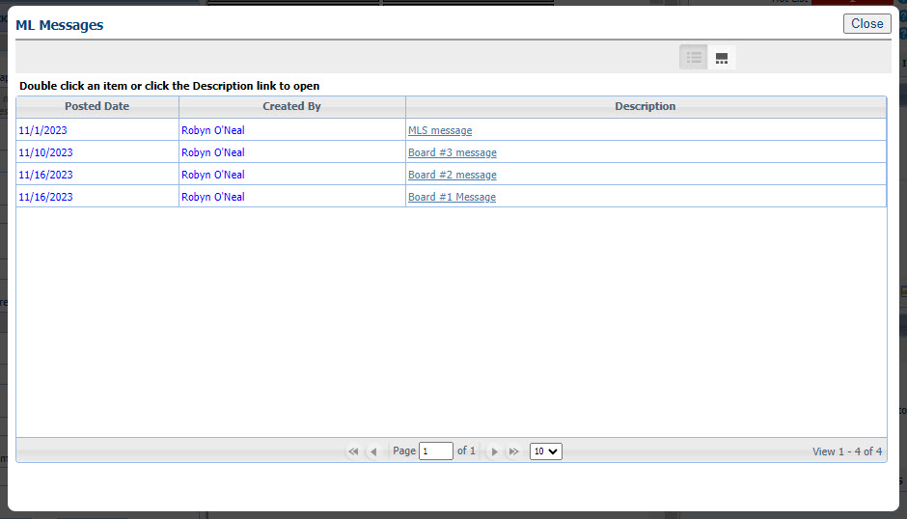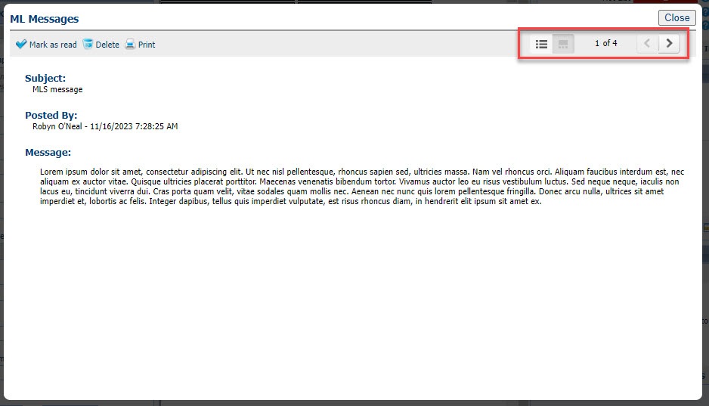

# Collaboration Center

**All options in this section are either configurable via MLS Administration controls or by your System Support Manager as noted.**

**Collaboration Center – No changes to Collaboration Center**

**Paragon Connect**

**The following section contains changes that are active system wide and available to users based on their assigned security levels.**

**Corrections and Improvements**

* Improvement to add and modify additional information for Contacts including phone numbers, emails, and spouse information.
* Correction to allow the agent search feature on Assume Identity to accept both first and last names.
* Correction to display the proper Office Website on Office Roster report.
* Correction to display field short values on spreadsheets when selected.
* Improvement to PowerSearch Member results cards to match the new results cards available from a standard Members search.
* Correction to show listing photos shared via Association setup option on the spreadsheet view.
* Correction to EasyCMA to fix the Comp Search Filter behavior when entering min or max values.
* Improvement to link to the Public Records Detail View from the Tax Autofill Results cards when the tax providers are Paragon Tax or CRS
* Improvement to the Dashboard quick link for Create a Listing to offer tax autofill option when enabled.
* Correction to retain any customized fields added to the search form after viewing results then returning to the search form.
* Correction for the Mortgage Center text fields on the Listing Detail View to remain editable from Power Search results.
* Correction to display Assume Identity option when explicit permissions have been granted.
* Improvement to link to Public Record Detail View from Tax-Autofill results cards
* Correction to hide Feature Categories from search form when configured to be disabled for searching.
* Correction to remove the broken Phone Label image appearing in some prospect notification emails.
* Correction to display the complete list of Assume Identity users for Staff Level Admins
* Correction when the “Too Many Listings Found” message covers the secondary search containers.
* Correction for searching by Listing ID field on the Tour/Open House search form.

**New Display Options for Listing Photos**

We enhanced the viewing options for Listing Photos. While on the Listing Detail View, you will see a new “grid icon”. This icon opens a new full screen page to view all photos for the listing.

From the new all-photo screen, users can scroll through all the listing’s photos and easily toggle on/off the display of photo labels and descriptions.

A new “expand icon” appears for each individual photo. Selecting this expand-option displays the photo in full screen and allows a zoom-view feature so you can see all the details in the picture.

**Agent Auto-Notification Emails link to Listing Details**

When setting up prospecting auto-notification emails you can choose to have an “agent version” sent to yourself along with the “consumer version” that goes to your contact. Starting with this release your agent version of these emails will include links to view the included, matched listings within Paragon Connect.

There are two places where new links are included in the agent auto-notification emails:

The first link location is the **Total Update**s count at the top of the email. This count will now link you to the Thumbnail View in Paragon Connect for these matched listings.

The second link location is behind the **Primary Photo** for each matched listing displayed in the email.

The photo will now link you to the Listing Detail View in Paragon Connect for the individual matched listing.

**New Display for Contact Email Opt-Out**

Every Contact has the option to opt-out of receiving automated emails from the Paragon system.

If any individual Contact has opted out of receiving emails, Paragon Connect now highlights the email icon to quickly let agents identify these contacts.

Quick access to the Opt-In process is also available and may be sent to any contact who

would like to opt back into receiving emails.

**OpenMLS RESO API**

**All options in this section are either configurable via MLS Administration or by your System Support Manager as noted.**

**Added PropertyGreenVerification for Data Dictionary 1.7**

For customers who are mapping their own data, the new resource can be mapped from the **Resource Mapping** tab inside **Data Mapping: Data Dictionary** from **Admin**. Simply click the Add button, choose which RETS class to link it to, and you’re off.

*Figure 1 - PropertyGreenVerification in DD Resource Mapping Tab*

The fields can be mapped using click-and-drag or formulas. The Paragon Green fields were built to be DD compliant. This should be a one-to-one mapping. Please reference and information about each field, please use RESO’s [PropertyGreenVerification](https://ddwiki.reso.org/display/DDW17/PropertyGreenVerification+Resource) section of their wiki.

*Figure 2 - PropertyGreenVerification Field Mapping Tab*

Please remember that OpenMLS API translator uses similar pieces that RETS does. If these resources are not enabled in a **RETS Profile**, the API user will receive a **401 Unauthorized** HTTP error.

*Figure 3 - RETS Profile Resource List*

**Added Concatenated L_Address for Data Dictionary 1.7 Mapping**

For customers who are mapping their own data, the L_Address RETS field can be used in the **Field Mapping** tab inside **Data Mapping: Data Dictionary** from **Admin**. Open an existing Data Set, then a property resource, and find List**ings Address** in the “Phys Num 6” grouping. Use click-and-drag mapping to match it with RESO’s **UnparsedAddress**, or use the white-green map icon to create a custom External Field.

*Figure 1 – Listings Address Seen in Available RETS Fields*

*Figure 2 – Listings Address Mapped to UnparsedAddress*

L_Address is a special calculated RETS field, like DOM, and will automatically send out the same string you see in RETS.

*Figure 3 – Resulting Data from L_Address to UnparsedAddress*