Paragon 5.980 Release Enhancements

**Updated on: September26, 2023.**

# Corrected Paragon Issues

|  |  |  |  |
| --- | --- | --- | --- |
| **Ticket#** | **Module** | **Organization** | **Summary** |
| Various | Web API | N/A | Some RUG system fields hidden in mapping tool |
| DEV-10912 | Web API | N/A | External Fields Doesn’t Refresh When Custom Field Added |
| DEV-9090 | Listing Maintenance | NNRMLS – Northern Nevada Regional MLS | NNRMLS reports Zip Field's Info Tip not displaying in listing input |

# MLS Customizations and Administration

**All options in this section are either configurable via MLS Administration controls or by your System Support Manager as noted.**

**Admin - Paragon Professional Multi-Factor Authentication (MFA) Enhancements**

**Action Item: Manually add an email and/or phone number to the record in Paragon if one has not already been added.**

**What is MFA?**

Multi-Factor Authentication (MFA) is an electronic security measure that protects individuals and organizations by requiring users to provide at least two authentication factors to be granted access to an application or account.

**How will this affect you?**

With the 5.80 release (10/3/23 for P100 and 10/10/23 for Production Customers), certain users logging into Paragon Professional will be required to authenticate via MFA. MFA is intended for MLS Admin users, security level 7 and above and is based on the setting for Admin > Configuration > “LOGIN_MFA_SECURITY_LEVEL”. For security levels that meet or exceed the configuration threshold, those individual users will be impacted.

Admins will be asked if they want to receive the MFA code through email or text message depending on whether they have an email and/or phone number populated. If only one field is populated in Paragon, that one option will appear and will be auto selected (see screenshots below). The email that will be used is the email address in your Agent record (saved in ***Admin > Agents***). The phone number that will be used is the number setup in ***Preferences > User Preferences > Mobile Account Settings*.**

When using MFA, Admins will receive a code via email or text that will expire within 15 minutes and is allowed (3) attempts to log in. A successful attempt will authenticate the user, granting them access to Paragon Professional, and the user will not have to authenticate again for some period of time. If an incorrect code is entered 3 times, the user will have to start the authentication process over. If no email or phone is setup, the user will see a message indicating that they need to contact their Board administrator for login support.

Admins will need to ensure that they manually add an email and/or phone number in the appropriate areas of Paragon. **Note: MFA will not affect MLSs that have their own login dashboard solution, nor does it affect login access to Paragon Connect.**

Figure 1: MFA email address setup

Figure 2: MFA phone number setup

Figure 3: MFA authentication code via text

Figure 4: MFA authentication code via email

Figure 5: MFA login screens

**Admin - New Optional Menu Options from Paragon Connect to Paragon Professional – Admin and Statistics**

**Action Item: Contact your SSM to enable new menu options for Admin and Statistics**

For users who use Paragon Connect as their primary system we are offering the addition of two new items into the Paragon Connect menu. These menu items will provide quick access to two main features that are only available within Paragon Professional: Admin and Statistics.

If you are interested in enabling these menu options for your system, two new, independent configurations will need to be enabled by your System Support Manager. The configurations set the minimum Security Level required to view these menu options. **Both menu options are hidden by default.**

**Admin Menu Option:** New option to allow your system administrative users (Security Level 7 or 8) to have a quick menu option to launch the admin panel of Paragon Professional. Users meeting the minimum Security Level will see a new option in the Paragon Connect menu for “Admin”. Selecting this option will open a new browser tab. The tab will automatically sign the user into Paragon Professional and display the Admin panel without any main menu navigation options.

**Statistics Menu Option:** New option to allow your users (Security Level 2-8) to have a quick menu option to launch the Statistics panel of Paragon Professional. Users meeting the minimum Security Level will see a new option in the Paragon Connect menu for “Statistics”. Selecting this option will open a new browser tab. The tab will automatically sign the user into Paragon Professional and display the Statistics panel without any main menu navigation options.

**Agent Level Changes Paragon Professional**

**The following section contains some changes that are active system wide, and some may only be available to users based on their assigned security levels.**

**No Changes to Paragon Professional**

# Collaboration Center

**All options in this section are either configurable via MLS Administration controls or by your System Support Manager as noted.**

**Collaboration Center – No changes to Collaboration Center**

**Paragon Connect**

**The following section contains changes that are active system wide and available to users based on their assigned security levels.**

**New Display Options for Listing Photos**

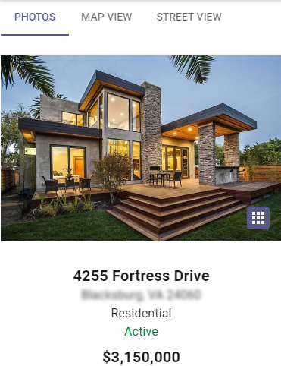We enhanced the viewing options for Listing Photos. While on the Listing Detail View, you will see a new “grid icon”. This icon opens a new full screen page to view all photos for the listing.

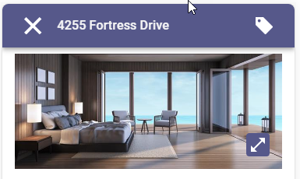From the new all-photo screen, users can scroll through all the listing’s photos and easily toggle on/off the display of photo labels and descriptions.

A new “expand icon” appears for each individual photo. Selecting this expand-option displays the photo in full screen and allows a zoom-view feature so you can see all the details in the picture.

**Corrections and Improvements**

* Improvement to add and modify additional information for Contacts including phone numbers, emails, and spouse information.
* Correction to allow the agent search feature on Assume Identity to accept both first and last names.
* Correction to display the proper Office Website on Office Roster report.
* Correction to display field short values on spreadsheets when selected.

**OpenMLS RESO API**

**To use the following functionality, you’ll need the Green Data enabled in Paragon and RETS. Mapping from regular Listing fields is not supported.**

**Added PropertyGreenVerification for Data Dictionary 1.7**

For customers who are mapping their own data, the new resource can be mapped from the **Resource Mapping** tab inside **Data Mapping: Data Dictionary** from **Admin**. Simply click the Add button, choose which RETS class to link it to, and you’re off.

*Figure 1 - PropertyGreenVerification in DD Resource Mapping Tab*

The fields can be mapped using click-and-drag or formulas. The Paragon Green fields were built to be DD compliant. This should be a one-to-one mapping. Please reference and information about each field, please use RESO’s [PropertyGreenVerification](https://ddwiki.reso.org/display/DDW17/PropertyGreenVerification+Resource) section of their wiki.

*Figure 2 - PropertyGreenVerification Field Mapping Tab*

Please remember that OpenMLS API translator uses similar pieces that RETS does. If these resources are not enabled in a **RETS Profile**, the API user will receive a **401 Unauthorized** HTTP error.

*Figure 3 - RETS Profile Resource List*