Paragon 5.981 Release Enhancements

**Updated on: October 10, 2023.**

# Corrected Paragon Issues

|  |  |  |  |
| --- | --- | --- | --- |
| **Ticket#** | **Module** | **Organization** | **Summary** |
| DEV-11163 | Web API | N/A | Corrected DB Duplicate Mapping Issue for RUG |
| DEV-11152 | Collab Center - Third Party | GREENVILLE - Greater Greenville AOR | The "DisplayIcon" Custom Method is not working for Local Logic widgets |
| TK-15434 | Statistics | SILVERCITY - Silver City-Grant BOR, TOPEKAMLS | Month End Report: Median Sold $ of Residential Listings Closed Repeating $ Amount |
| TK-15723 | Third Party | COLUMBIA - ConsolidatedMLS, SDMLS | Property Watch does not work for customers in Paragon Pro |
| DEV-11039 | General UI | BCRES - REB2 Residential, PRIMEMLS, RAE | Twitter - Replace bluebird icon with X |
| TK-15323 | Preferences | CARMLS - CARMLS, Inc. (Arkansas), WVMLS | The Preference Wizard is displaying no Image Box |
| TK-15077 | View/Reports | CR - California Regional MLS | Issue with Font Size on Emailed Reports with Open House/Tours Information |
| TK-14526 | Assume Identity | BCRES - REB2 Residential, PRIMEMLS, RAE | Deleting user from allowed Assume Identity list in Prefs logs user out upon delete confirmation for SSO ONLY. |

# MLS Customizations and Administration

**All options in this section are either configurable via MLS Administration controls or by your System Support Manager as noted.**

**Admin – No changes for Paragon Admin**

**Action Item: None**

**Agent Level Changes Paragon Professional**

**The following section contains some changes that are active system wide, and some may only be available to users based on their assigned security levels.**

**No Changes to Paragon Professional**

# Collaboration Center

**All options in this section are either configurable via MLS Administration controls or by your System Support Manager as noted.**

**Collaboration Center – No changes to Collaboration Center**

**Paragon Connect**

**The following section contains changes that are active system wide and available to users based on their assigned security levels.**

**Agent Auto-Notification Emails link to Listing Details**

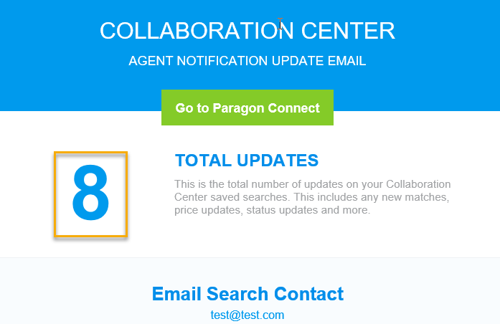When setting up prospecting auto-notification emails you can choose to have an “agent version” sent to yourself along with the “consumer version” that goes to your contact. Starting with this release your agent version of these emails will include links to view the included, matched listings within Paragon Connect.

There are two places where new links are included in the agent auto-notification emails:

The first link location is the **Total Update**s count at the top of the email. This count will now link you to the Thumbnail View in Paragon Connect for these matched listings.

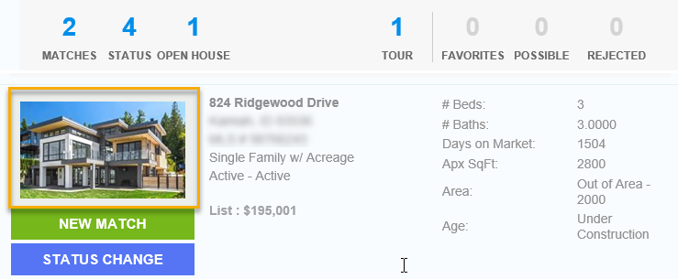

The second link location is behind the **Primary Photo** for each matched listing displayed in the email.

The photo will now link you to the Listing Detail View in Paragon Connect for the individual matched listing.

**Corrections and Improvements**

* Improvement to PowerSearch Member results cards to match the new results cards available from a standard Members search.
* Correction to show listing photos shared via Association setup option on the spreadsheet view.
* Correction to EasyCMA to fix the Comp Search Filter behavior when entering min or max values.

**OpenMLS Web API**

**All options in this section are either configurable via MLS Administration controls or by your System Support Manager as noted.**

**Added Concatenated L_Address for Data Dictionary 1.7 Mapping**

For customers who are mapping their own data, the L_Address RETS field can be used in the **Field Mapping** tab inside **Data Mapping: Data Dictionary** from **Admin**. Open an existing Data Set, then a property resource, and find List**ings Address** in the “Phys Num 6” grouping. Use click-and-drag mapping to match it with RESO’s **UnparsedAddress**, or use the white-green map icon to create a custom External Field.

*Figure 1 – Listings Address Seen in Available RETS Fields*

*Figure 2 – Listings Address Mapped to UnparsedAddress*

L_Address is a special calculated RETS field, like DOM, and will automatically send out the same string you see in RETS.

*Figure 3 – Resulting Data from L_Address to UnparsedAddress*