Paragon 5.982 Release Enhancements

**Updated on: October 24, 2023.**

# Corrected Paragon Issues

|  |  |  |  |
| --- | --- | --- | --- |
| **Ticket#** | **Module** | **Organization** | **Summary** |
| DEV-11340 | Admin | All | Broken default image on Agent Admin profile |
| TK-15854 | Dashboard | GOREALTORS - Greater Owensboro Realtor Association | Homepage ShowingTime Widget sending incorrect Agent ID and not respecting config values |
| TK-15917 | View/Reports | MIMLS - MiRealSource | PC Spreadsheet - Associated/Shared Photos do not display on spreadsheet view |
| TK-12492 | Admin | CARMLS - CARMLS, Inc. (Arkansas) | P100 CARMLS: Duplicate Compliance Report Not Returning Results |

# MLS Customizations and Administration

**All options in this section are either configurable via MLS Administration controls or by your System Support Manager as noted.**

**No Changes to Admin - Paragon**

**Agent Level Changes Paragon Professional**

**The following section contains some changes that are active system wide, and some may only be available to users based on their assigned security levels.**

**No Changes to Paragon Professional**

# Collaboration Center

**All options in this section are either configurable via MLS Administration controls or by your System Support Manager as noted.**

**No changes to Collaboration Center**

**Paragon Connect**

**The following section contains changes that are active system wide and available to users based on their assigned security levels.**

**New Display for Contact Email Opt-Out**

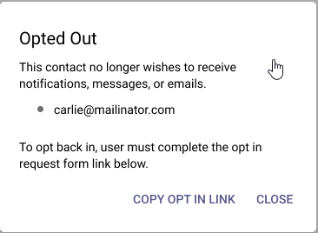

Every Contact has the option to opt-out of receiving automated emails from the Paragon system.

If any individual Contact has opted out of receiving emails, Paragon Connect now highlights the email icon to quickly let agents identify these contacts.

Quick access to the Opt-In process is also available and may be sent to any contact who

would like to opt back into receiving emails.

**Corrections and Improvements**

* Improvement to link to the Public Records Detail View from the Tax Autofill Results cards when the tax providers are Paragon Tax or CRS
* Improvement to the Dashboard quick link for Create a Listing to offer tax autofill option when enabled
* Correction to retain any customized fields added to the search form after viewing results then returning to the search form
* Correction for the Mortgage Center text fields on the Listing Detail View to remain editable from Power Search results
* Correction to display Assume Identity option when explicit permissions have been granted

**OpenMLS RESO API**

**To use the following functionality, you’ll need the Green Data enabled in Paragon and RETS. Mapping from regular Listing fields is not supported.**

**No changes for OpenMLS RESO API**