Paragon 5.983 & 5.984 Release Enhancements

**Updated on: November 21, 2023**

# Corrected Paragon Issues

|  |  |  |  |
| --- | --- | --- | --- |
| **Ticket#** | **Module** | **Organization** | **Summary** |
| DEV-11524 | OpenMLS API | N/A | Fix AOR Lookup Not Properly Being Declared |
| DEV-10355 | OpenMLS API | N/A | Improved Handling of LookupName Creation for Non-MultiClass Compatible Paragon Fields |
| DEV-11108 | Search | All | Public Record Map Search Pin Selection Produces an Error when Parcel Lines is not Enabled in Preferences |
| DEV-11456 | Login/SSO | N/A | Increased Outseer Timeout to 15 secs |
| DEV-11460 | Third Party | N/A | Removed Homebot Deep Integration Code |
| DEV-11480 | Contacts | N/A | Code related to DEV-11460 Inadvertently caused an Error Accessing Contacts |
| DEV-11466 | Web API | Prime MLS | Cannot Map Fields in Property/Boat and No Error is Thrown |
| DEV-11473 | Listing Photos | N/A | Photo Guid Miscellaneous Cleanup to ParagonGuid and CribGuid image providers |
| DEV-11477 | Search | All | Assign "No Name" when Saved Search has no Defined Name so the Search can be Accessed |
| DEV-11481 | Contacts | All | Contacts List Missing Actions Bar Buttons at Top of the Page |
| TK-13481 | Search | OABRMLS - Great Plains Regional MLS | Saved Search Notifications Changing Time after Daylight Savings Time |
| TK-10897 | Search | RMLSA - Regional MLS Alliance (Peoria) | Map Search No Longer Opens to the Map, but Starts with Criteria then Jumps to the Map After One Field is Entered |
| DEV-11072 | Web API | Prime MLS | Mapping Failed Error When Trying to Map Fields in Property_BOAT and Property_LAND |
| TK-16331 | Views/Reports | OABRMLS - Great Plains Regional MLS, PRIMEMLS - Prime MLS (NEREN), TAOSMLS - Taos County MLS, TYLERTEXAS - Greater Tyler AOR | ‘D’ icon link to Associated Documents on Reports Emailed from Paragon using Publink are Giving an Error |

# MLS Customizations and Administration

**All options in this section are either configurable via MLS Administration controls or by your System Support Manager as noted.**

**Opt-in link on Mobile Settings**

A link to opt-in a user’s mobile phone number has been added to Preferences > User > Mobile Account Settings. This functions the same as the opt-in link on a contact phone record. Clicking the link will send the user an email allowing them to opt their mobile number in to receive text messages from Paragon. This was specifically enabled for the multi-factor authentication challenge code, but is valid for all text messages coming from Paragon.

**Action Item:** N/A

**Audit Login includes Browser and OS**

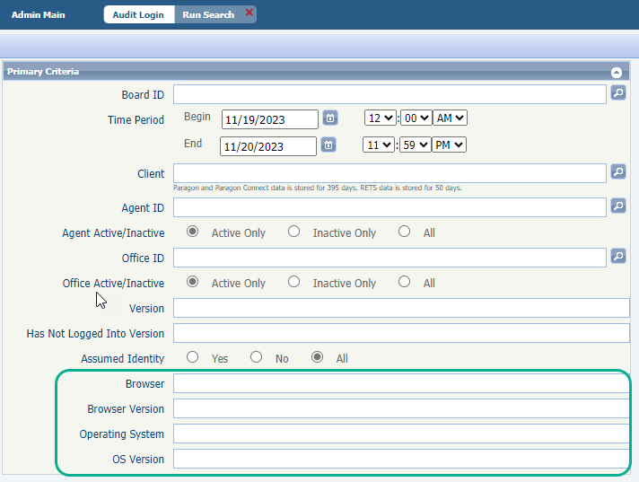The Audit Login and the Unique User Logins reports now include options for browsers and operating systems.

Both audit search forms now include 4 additional fields allowing staff users to filter these reports to specific versions.

The audit reports also display the browser and operating systems for the specific login records.

This new information makes it easier to troubleshoot isolated browser or operating system issues and identify user login-pattern data.

**Agent Level Changes Paragon Professional**

**The following section contains some changes that are active system wide, and some may only be available to users based on their assigned security levels.**

**Multiple Board-level messages**

 For multiple-board systems, users with offices belonging to more than one board will now be able to see login messages for all of their offices. The most recent message displays in the widget first; use the page tools to view additional messages. Viewing the messages in List view will display the messages in posted date order.

**Action Item:** N/A

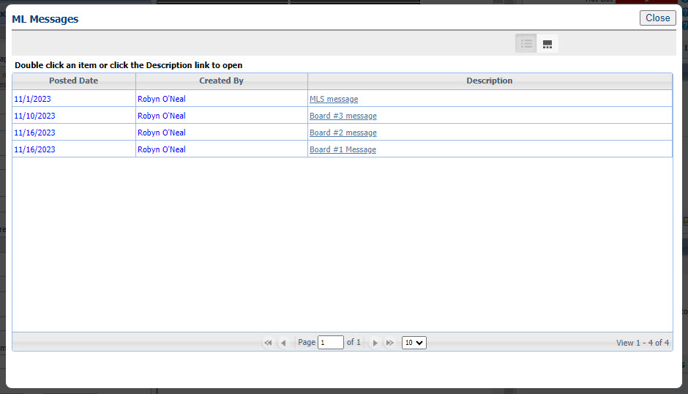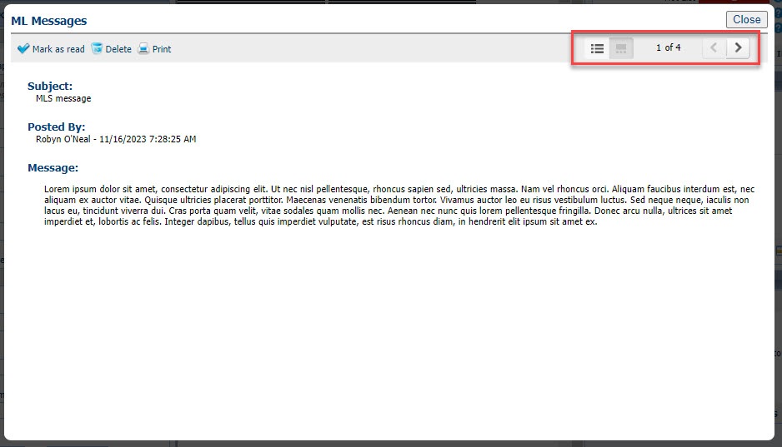

# Collaboration Center

**All options in this section are either configurable via MLS Administration controls or by your System Support Manager as noted.**

**Collaboration Center – No changes to Collaboration Center**

**Paragon Connect**

**The following section contains changes that are active system wide and available to users based on their assigned security levels.**

**Corrections and Improvements**

* Improvement to link to Public Record Detail View from Tax-Autofill results cards
* Correction to hide Feature Categories from search form when configured to be disabled for searching.
* Correction to remove the broken Phone Label image appearing in some prospect notification emails.
* Correction to display the complete list of Assume Identity users for Staff Level Admins
* Correction when the “Too Many Listings Found” message covers the secondary search containers.
* Correction for searching by Listing ID field on the Tour/Open House search form.

**OpenMLS RESO API**

**To use the following functionality, you’ll need the Green Data enabled in Paragon and RETS. Mapping from regular Listing fields is not supported.**

**OpenMLS – No changes to OpenMLS RESO API**