Paragon 5.990-5.991 Release Enhancements
Updated on: January 4, 2024

MLS Customizations and Administration
All options in this section are either configurable via MLS Administration controls or by your System Support Manager as noted.

Admin – No Admin Changes

Agent Level Changes Paragon Professional
The following section contains some changes that are active system wide, and some may only be available to users based on their assigned security levels.

Improved Display for Collaboration Center Email History

The Message History section of the Contact Menu stores copies of all emails sent to your Contacts, including automated notification messages for Collaboration Center. One drawback to the copies of these automated messages is that they do not include details for all the listings that may be included in the email update. With this release we are changing the Collaboration Center automated email history to include counts of all matched listings along with quick links to view the listings in search results!

Going forward, the automated Collaboration Center emails for both Contacts and Agents will appear significantly different within the Message History.
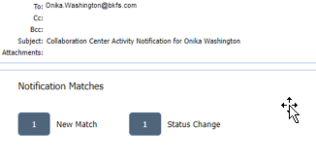

You will no longer see the formatted version of the email with images, instead you will see counts for each of the match-types included in the email. Each of the match counts will include a link that opens the matched listings within Paragon search results. With these new links you will have quick, easy access to view all the listings sent to your Contact’s Collab Center site.

Due to the formatting change of the Collaboration notification emails, you will no longer be able to forward these messages from the Message History.

This change does NOT impact or modify the emails currently sent to your Contacts in any way, those emails will continue to look and function exactly the same as they do today. Also, none of the manual emails, welcome emails, or seller emails will be affected. These will continue to display in their entirety within the Message History.

We are excited to bring this change which will also improve the overall speed of the system by freeing up server space used to house the formatted versions for the millions of automated emails generated each month.

New Photographer Access to Partial/Unpublished Listings

If your system allows “Photographer Access” to upload and modify listing pictures, those special Photographer-users will now be able to add photos to Partial/Unpublished listings. This feature expands the current photographer functionality and uses the same setup to honor access to all listings or those for designated offices.
The Listing Maintenance menu for Partial Listings will include an option for “Photo Administration” if the logged-in user is configured with “Photographer Access”. From there the photographer may access any authorized Partial listings to add and modify the pictures.

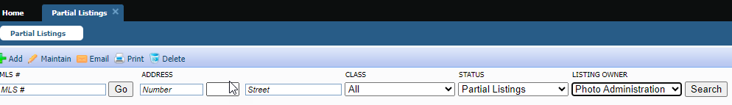

Corrections and Improvements

- Correction for the “Learn More” link available from the Email Opt In/Out email subscription site
- Correction to display message for multiple Open Houses on Collab Center and Collab Link
- Correction to the Contact “Needs Approval” count not matching the number of returned results
- Correction for the Administration feature “LIM Agent Filter” giving an error message

Collaboration Center
All options in this section are either configurable via MLS Administration controls or by your System Support Manager as noted.

Corrections and Improvements

- Correction to display message for multiple Open Houses on Collab Center and Collab Link

Paragon Connect
The following section contains changes that are active system wide and available to users based on their assigned security levels.

New Photographer Access to Partial/Unpublished Listings

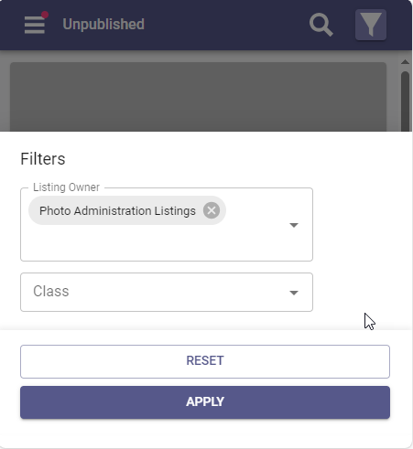
If your system allows “Photographer Access” to upload and modify listing pictures, those special Photographer-users will now be able to add photos to Partial/Unpublished listings. This feature expands the current photographer functionality and uses the same setup to honor access to all listings or those for designated offices.

When accessing Listings from the main menu and selecting Unpublished Listings, the Listing Owner filter will include an option for “Photo Administration” if the logged-in user is configured with “Photographer Access”. From there the photographer may access any authorized Unpublished listings to add and modify the pictures.

New Advanced Drawing Tools for Map Search

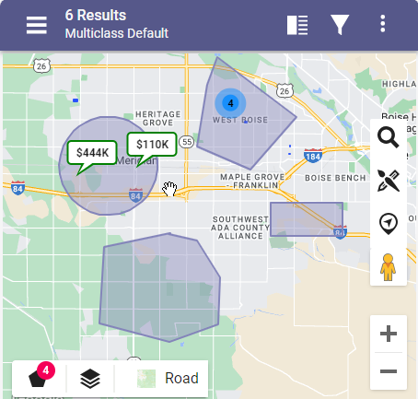
The Drawing Tool on the Map View, shown as a brush and pencil icon, now offers multiple ways to draw shapes to apply to your search criteria. Choose from a freehand draw, polygon, rectangle, or radius to look for properties within your shape.

Once shapes are created, a new Manage Shapes option will appear in the lower map menu. This menu displays additional options for all the shapes that appear on your Map View search. The badge count indicates the number of custom shapes created.

The new Manage Shapes menu allows you to modify the boundaries of any existing shape or delete shapes from the search. You may also set any shape to exclude listings from the search.

New Sort Options for Thumbnail View from Property Search

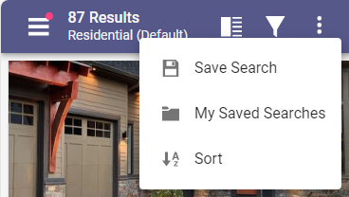
When viewing results from a standard property search, the Thumbnail View now offers a new Sort option in the overflow menu.

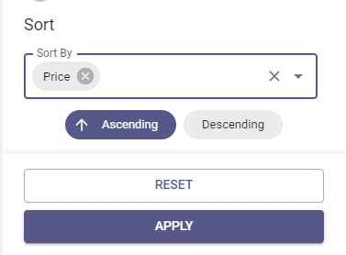

The Sort feature provides multiple options for sorting results, like by Listing ID, Price, Area, Square Feet.
After selecting the sort-field you can choose to sort the results in either ascending or descending order.

Corrections and Improvements

- Improvement to display specific, listing-maintenance-related Third-Party Integrations into the Listings menu (if configured for your system)
- Ongoing improvement to display more options within the top menu, moving the options out of the overflow so they are more easily accessible
- Correction to create an audit record when listing documents are uploaded
- Correction to retain customized search criteria values when switching to Map View
- Correction to display the proper Assume Identity option from Members search results
- Correction for retaining Area related values for the Last 5 Searches feature
- Correction to the End Date Range value for Hotsheet, Tour, and Open House searches

OpenMLS RESO API
To use the following functionality, you’ll need the Green Data enabled in Paragon and RETS. Mapping from regular Listing fields is not supported.

No OpenMLS RESO API

