# Agent Level Enhancements

# New Market Monitor Option to View the Open Houses and Tours Scheduled for Today

Market Monitor has been updated to allow users to display the current day’s Open Houses and Tours by entering a Days value of 0.

# Bing Map Upgraded to Version 8

The Bing Map Solution used throughout Paragon has been updated to the latest version of Bing, version 8.

# Collab Center: Buy-Sell Switcher Updated for Improved Tablet Functionality

Previously, for users who had access to both a CC2 buy-side site and a CC2 sell-side site could use the switcher to change between sites but from a tablet, the switcher did not properly display. The switcher has been moved to the hamburger menu to allow users to switch back and forth and go directly to a specific sell side site if more than one exists.

# Collab Center: Update to the “About Me” Modal

Previously, if a user clicked the “About Me” button from the sell-side site, the system would take them to the About Me modal on the buy-side site. This has been corrected.

# Collab Center: Empty Fields Will No Longer Appear

The Collab Center and the Collab Link Detail Views have been updated to no longer display fields that have no value entered. Columns and rows will automatically adjust to fit the available content for display.

# Collab Center: New Default Sort Option

The Collab Center default sort option has been updated from “Price: High to Low” to “Newest to Oldest Matches.” This allows users to quickly view the newest matches in any category first.

# Collab Center: New Tool Tips Available for Search

New Tool Tips have been added to the search icons for the Draw, Thumbnail, and Tile View options.

# Collab Center: New Option to Switch from Desktop View to Mobile View

A new link has been added to allow users to switch from the Desktop view to the Mobile View.

# Collab Center: Clickable Phone Numbers Now Available on Mobile Devices

When viewing any Collab Center from a mobile device, phone numbers will be clickable to allow users to quickly place a call to that number.

# Collab Center: New Photo Arrows Available on Mobile Devices

New arrow images have been added to the mobile view to indicate that additional images are available for the listing.

# MLS Customizations and Administration

All options in this section are configurable via MLS Administration controls or by your System Support Manager as noted.

# New History Sort Order Function Available Now

Several customers have requested the option to have historical data to be sorted by Listing Date. This new option has been added and will need to be configured by your SSM.

# Forgot Password Function: Auto-Complete Has Been Disabled

The Forgot Password function has been modified to no longer allow the Auto-Complete function on the form. This change will help prevent users with similar login ID values from accidentally attempting to changing passwords for other users when using a shared computer.

# Reset Password: A New Confirmation Window Has Been Added

A new confirmation pop-up has been added to the system requiring the Admin User to confirm that they what to start the password reset function for the user.

**Force Password Update: Passwords Are No Longer Visible**

The Force Password functionality has been updated to have the Password column and values removed.

**P4B: New Broker and Office Homepage Tools Are Available Now!**

Participating Brokers and Office Managers are now able to edit and maintain their Firm and Office homepages.

**P4B: New Quick Access Broker Statistics Now Available From Dashboard!**

The P4B Dashboard has been updated to include quick links to access a select group of Paragon statistical reports directly from the Dashboard.

**P4B: New Display for 3rd Party Integrations from the Dashboard**

The Dashboard menu has been enhanced so that third-party content can display in the frame on the right side of the page.

**New Filters Are Now Available for the Tax Database**

New filters have been added to the tax database to allow more controlled access to the data to specific users.

# Option to Create a “NEW” Hotsheet Entry on Status Change

A new option has been added to create a “NEW” Hotsheet entry when a listing is converted to a specific status.

# Corrected Issues and Notices

# Admin: The Send Password link has been removed for customers who manage passwords outside of Paragon

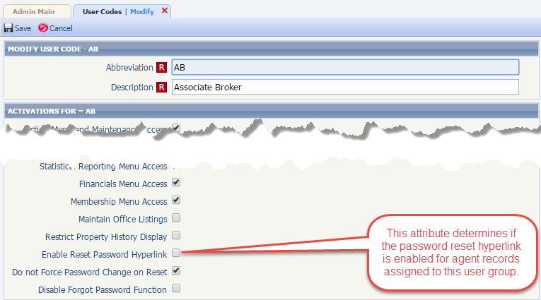Previously, for customers who manage passwords outside of Paragon, would still see the reset password link in the Agent Record. We have updated the system to prevent the link from appearing for those customers based on a new User Code option. This change will allow the reset password link to appear for only a specific set of users based on their User Code. Note: **This option is only available if the general membership is prohibited from changing its passwords**.

# Preferences: 3rd Party Preferences Has Been Removed

Several years ago, there was a folder added to User Preferences called “Third Party Preferences.” This was going to be where BK would link to all of the third-party user preference option. As it turned out, the only options that were ever available were “Voice Alerts,” which was retired in June of 2016, and ShowingTime. Plus, there was an inherent design flaw in that if the MLS did not have either one, the folder was empty and didn’t do anything.

ShowingTime recently enhanced their integration requiring encrypted parameters for additional security. Unfortunately, the “Third Party Preferences” folder does not support the ability to encrypt parameters. As a result, the ShowingTime Setup link is being moved from this location to the PREFERENCES menu as shown below. In addition, by moving the setup to this location, ShowingTime Setup launches in a new Paragon tab which gives agents more workspace to configure ShowingTime. There are a few customers who had already moved ShowingTime Setup to the Resources menu. Those links will remain where they are. This change only applies to ShowingTime from the Third Party Preferences menu.

# Collab Center: Wrapping Issue with Square Foot has been corrected

Previously, if the SQFT label was customized to be longer than the standard SQFT, the field value would wrap regardless of the available space. This has been corrected.

# Collab Center: Display Issue with the Square Foot Field and Value have Been Corrected

The email notification for Collab Canter would always include a SQFT field with a value that displayed 6 decimal values. The email notification has been updated to only display the SQFT field when applicable and the additional decimal places have been removed.

# Collab Center: New Option to Remove Custom Folders Now Available

Previously, the option to remove a custom folder would not appear immediately after the folder was created. This has been corrected.

# Collab Center: Switch to Desktop Button Improved for Tablet Users

The size of the Switch to Desktop button has been increased when viewing a mobile report from a tablet to improve functionality.

# Collab Link Mobile View: Banner Image Removed for Improved Performance

To improve overall performance, we have removed the background image on the banner on the mobile devices. This saves the mobile device from loading this image and increases the performance when loading the overall page.

# Collab Center: MLS Number Added to Sell-Side Map Summary Box

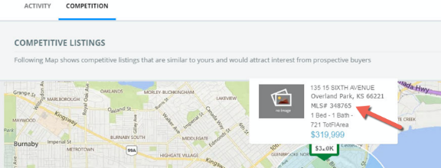When hovering over the map pins on the competition tab, a small summary box will appear with some listing information. The MLS # is now added to this small summary box.

# Errors and Warnings in Listing Maintenance

The workflow for saving listings in Paragon has been improved to draw the User to Errors/Warnings grid section at the bottom of the listing maintenance screen. When Errors/Warnings are presented. The first row is automatically highlighted in green and the verbiage at the heading of this section has been updated to read: **Attention: Resolve the following Errors/Warnings to Save this Listing. Double Click on the row to navigate to the field. (F8 for next row)**

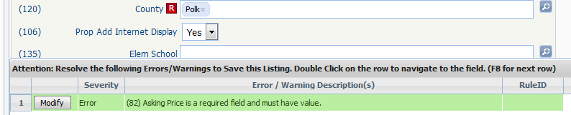

# Notice: Homepage Message

The Paragon Team has improved the Home Page Message function by included additional options for creating messages at the MLS, Board and Broker Levels (P4B Users only), as a result when an Admin User accesses the Home Page Message dialog, the right frame will appear to be blank as no message is selected by default. Simply select the Message from the left that you’d like to maintain. We’ll look into implementing some default verbiage on this screen in the near future.

# Additional Corrected Issues

| **Module** | **Reporting Customer(s)** | **Issue Corrected** |
| --- | --- | --- |
| Input Maintenance | Greenville, Huntsville, Paul Bunyan, REB3, Willamette | Photo labels do not save unless user selects tab or enter, or clicks in another field first. |
| Custom Layout Editor | West Central (MN), Gainesville | Modifying the Listing Image to Display for Custom View is not retaining modifications. |
| Views/Reports | Coastal Carolinas, Gallatin, Lincoln County, Freeport-Galena, Topeka | Map does not print on All Fields Detail when choosing to print. |
| Input Maintenance | Baton Rouge | Setting Tax ID field as required also makes it required for partial without notice |
| CMA | Several MLS Customers | Bad agent image picture quality on Cover Page of CMA Presentations for several themes. |
| Collab Center | Central Penn, MLS Listings, NEREN | CC2 Property Detail not displaying remarks when class remarks not physnum 41. |
| Admin - Listings | Las Cruces, Central Mississippi, Charlottesville, Grand Junction | Phantom listing comes up as result when searching an address in Power Search. |
| Collab Center | South Central Wisconsin, Pensacola | City lookup values with URLs display both description and URL in CC2 thumbnail & detail header. |
| Contact Management | MiRealSource, Triangle | CC2 search default issues when CLIENT_CONNECT_SEARCH_OPTION = 4 |
| Collab Center | Sandicor, Nova Scotia, Triangle, MiRealSource | Property Search Map not loading and More + section missing fields in CC2 search. |
| Collab Center | Nova Scotia | Google search of property provides clickable URL to CC2 sites |
| Admin - Listings | South Central Wisconsin, Nova Scotia | Cannot delete listing in LIM if listing has been added to a CC folder by a contact/agent. |
| Nightly Processing | Memphis | Nightly History logs since 5.57 show "Nightly Process Is In Progress..." and have strange counts |
| CMA | Grand Junction, NEREN, REB3 | Subject property detail page map is showing display error. |
| Search Field (HomePage Banner) | Several MLS Customers | Classic Search Button jumps down a line when user clicks into Search Box. |
| RETS | Sandicor | Clicking disable all in RETS profile disabled system fields in RETS |
| Membership | Charlottesville | Email in Agent Roster is not hyperlinked but Agent Type is and brings up Compose email when clicked. |
| Property Views | All Paragon Mobile Customers | Listing Photos in Paragon Mobile not loading on the detail view, just displays a black screen. |
| CMA | Several MLS Customers | Adjusted price is being mis-calculated on CMA Summary in CMA. |
| Views/Reports | NEREN | Email modal does not open when the email address is clicked directly on Agent full report. |
| Admin - Agent | St. Augustine | Force password change displays passwords. |
| Paragon Mobile | Charlottesville | Vertical photos on Mobile view appear squished |
| Admin - Listings | Sandicor | Listing Photos show 0 photo count but have at least one photo |

# Agent Level Changes

**The following section contains changes that are active system wide** **and available to users based on their assigned security levels.**

# New Market Monitor Option to View the Open Houses and Tours Scheduled for Today

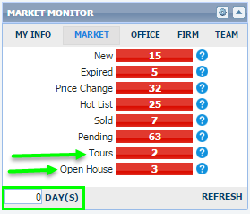Market Monitor has been updated to allow users to display the current day’s Open Houses and Tours by entering a Days value of 0.

# Bing Map Upgraded to Version 8

The Bing Map Solution used throughout Paragon has been updated to the latest version of Bing, version 8. There should be very minimal impact to Paragon Users as a result of this change. One item to note is that the Automatic option has been discontinued with the Bing Version 8 upgrade. This option allowed users to use their mouse scroll button to automatically zoom in from the Road to the Aerial to the Bird’s Eye map views and zoom out in the same fashion.

In lieu of future Mapping enhancements to Paragon including the eventual transition from Bing to Google, instead of removing the Automatic option in the Paragon interface, the system has been updated to make this option equivalent to the Road option. Users who select the Automatic option in Preferences will default to Road option while performing a Mapping Search, if the user selects the Auto option it will be the equivalent of selecting the Road option.

# Collab Center: Buy-Sell Switcher Updated for Improved Tablet Functionality

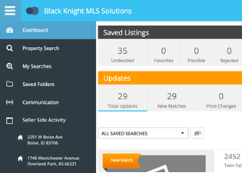Previously, for users who had access to both a CC2 buy-side site and a CC2 sell-side site could use the switcher to change between sites but from a tablet, the switcher did not properly display. The switcher has been moved to the hamburger menu to allow users to not only to switch back and forth but to also go directly to a specific sell side site if more than one exists.

# Collab Center: Update to the About Me Modal

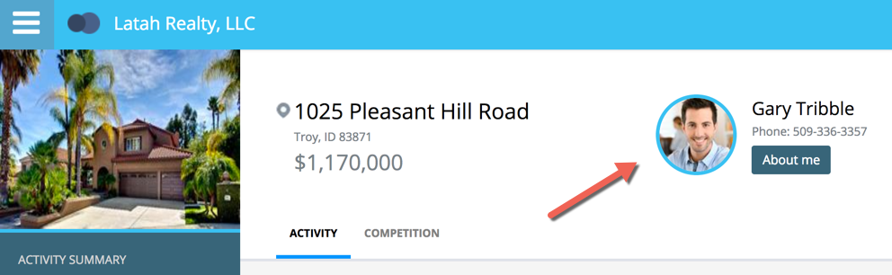Previously, if a user clicked the “About Me” button from the sell-side site, the system would take them to the About Me modal on the buy-side site. If the user did not have a buy-side site setup, the system would not allow Users to navigate back to the sell-side dashboard. This has been corrected and if no buy-side site is available, the user will be returned to where they previously were.

# Collab Center and Collab Link Views: Empty Fields Will No Longer Appear

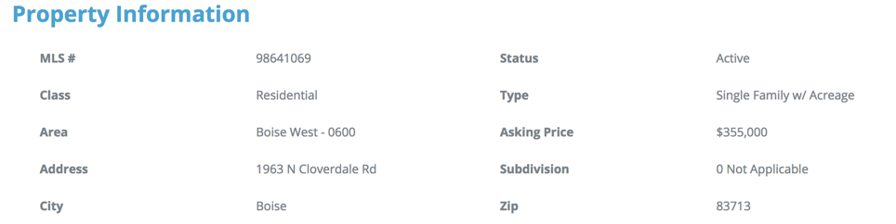The Collab Center Detail and the Collab Link Detail Views have been updated to no longer display fields that have no value entered. The Collab Center and Collab Link Property Information detail displays have been updated to only show fields that contain data. Columns and rows will automatically adjust to fit the available content for display.

# Collab Center: New Option to Switch from Desktop View to Mobile View

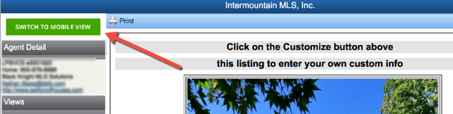A new link has been added to allow users to switch from the Desktop View to the Mobile View. This accomplishes two things.  One, it allows mobile users to navigate back to the mobile view if they click on the switch to desktop view.  Second, it allows all Publink users the ability to switch to the new CC2 Collab link view.

# Collab Center: Clickable Phone Numbers Now Available on Mobile Devices

When viewing any Collab Center from a mobile device, phone numbers will be clickable to allow users to quickly place a call to that number.

# Collab Center: New Photo Arrows Available on Mobile Devices

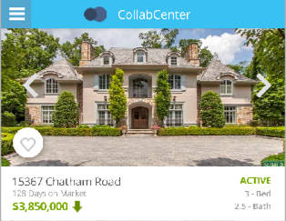New arrows have been added to the mobile view to indicate that additional images are available for the listing.

# MLS Customizations and Administration

**All options in this section are either configurable via MLS Administration controls or by your System Support Manager as noted.**

# New History Sort Order Function Available Now

Several customers have requested the option to have historical data to be sorted by Listing Date. The changes require background changes to implement. This new option will need to be configured by your SSM.

# Forgot Password Function: Auto-Complete Has Been Disabled

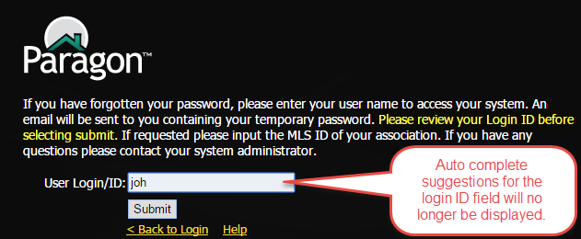The Forgot Password function has been modified to no longer allow the Auto-Complete on the form. This will prevent users with similar login ID values from accidentally changing passwords for other users when using a shared computer. The auto correct function has been disabled for the login ID field on the Forgot Password page. No other input fields were modified.

# Reset Password: A New Confirmation Window Has Been Added

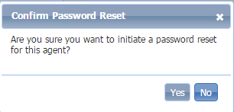A new confirmation pop-up has been added to the system requiring the Admin User to confirm that they want to start the password reset function for the user. The text that appears in the confirmation window can be customized. Please contact your SSM for additional information.

# Force Password Update: Passwords Are No Longer Visible

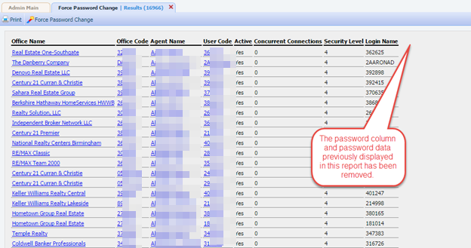The Force Password functionality has been updated to have the Password column and values removed. Prior to this release, the Password column and values were visible to staff level users. This has been corrected.

# P4B: New Broker and Office Homepage Tools Are Available Now!

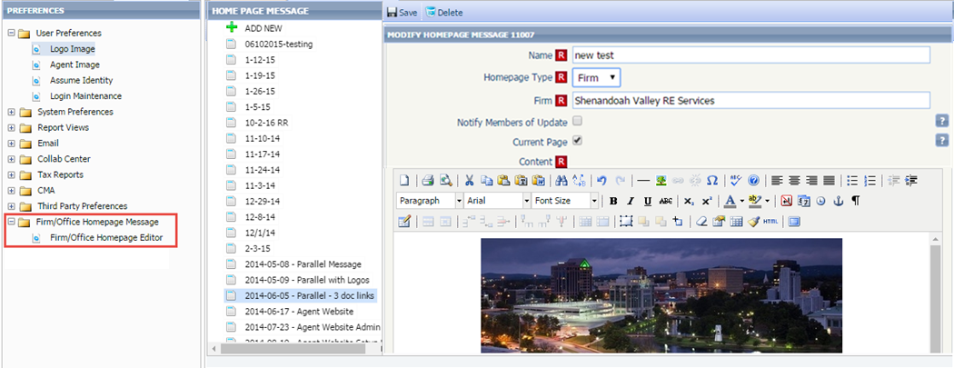Participating Brokers and Office Manager are now able to edit and maintain their Firm and Office homepages. We have expanded access to the Homepage editor to allow Paragon for Brokers (P4B) participants to edit and maintain their homepages. Prior to this release, the homepage editor was only available to staff level users. Now, those participating broker and/or office manager users will be able to edit their homepage. This is a configurable option only for P4B Subscribers.

# P4B: New Quick Access Broker Statistics Now Available From Dashboard!

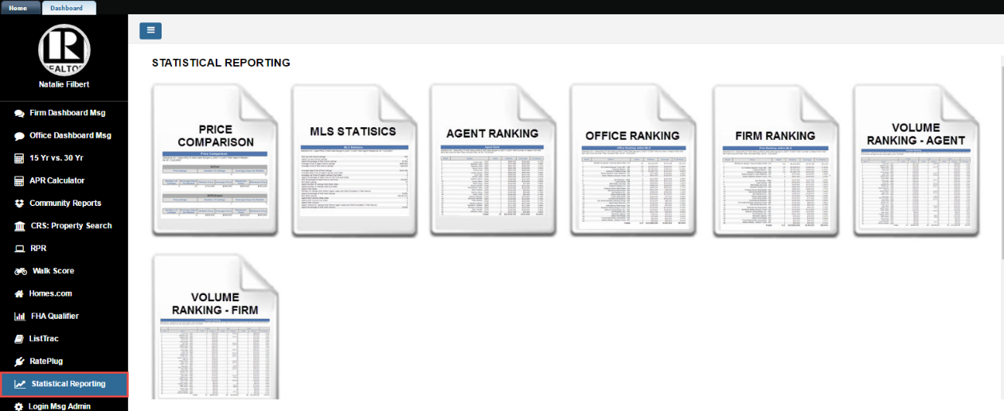The P4B Dashboard has been updated to include quick links to access a select group of Paragon statistical reports directly from the Dashboard! The statistical reports will be displayed in the main frame of the P4B dashboard when the Statistical Reporting menu option is selected. The report will be automatically generated using the sold listing status and a rolling year to the current month as search criteria (May 2016 – May 2017 for example). The MLS or Association retains the right to limit access to these reports independently of P4B eligibility. **All security level access controls to the reports currently in place will also be respected**.

The statistical reports available from the Dashboard include:

A. Broker Reports

1. Price Comparison Report
2. MLS Statistics Report
3. Agent Ranking Report
4. Office Ranking Report
5. Firm Ranking Report
6. Volume Ranking Report (Agent and Firm)
7. Average Days on Market Graph
8. Total Dollar Volume Sold by Month Graph
9. Inventory and Sales Graph
10. New Listings vs. Sold Listings Graph

B. Agent Reports

1. MLS Statistics Report
2. Days on Market Report
3. Agent Ranking Report
4. Volume Ranking Report
5. Sales Detail Report
6. Average Days on Market Graph
7. Total Dollar Volume Sold by Month Graph
8. Inventory and Sales Graph
9. New Listings vs. Sold Listings Graph

# P4B: New Display for 3rd Party Integrations from the Dashboard

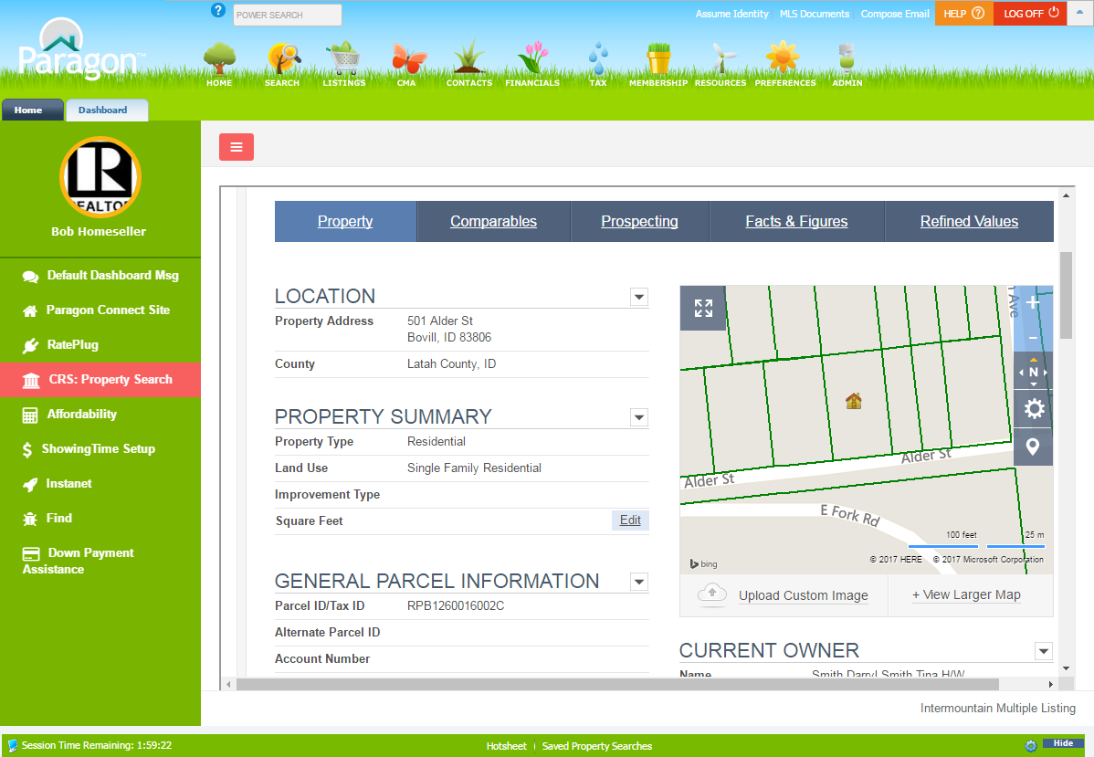Previously in the P4B Dashboard, third party integrations would only launch a new browser tab or window or modal. The Dashboard menu has been enhanced so that third-party content can display in the frame on the right side of the page. In addition, the third-party links in the left navigation can also be set to a specific order.

# New Filters Are Now Available for the Tax Database

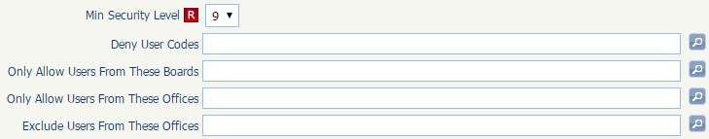New filters have been added to the tax database to allow more controlled access to the data to specific users. Previously, the tax autofill function for Paragon Tax and 3rd Party Tax Providers (such as CRS Data and Realist) was either “always on” or “always off” for all users. The following filters, which are used for third-party integrations, have been added to the Tax Autofill functionality.

**Note:** This is a BK Admin feature that is only accessible by BK users to setup per customer.

This will help hide Tax Autofill while it’s being set up and enable BK to enable it only for the MLS Admin for review prior to exposing to all users. In addition, it will help hide/display the feature for specific Boards, Offices, User Types, etc. which will directly support Association Autonomy and Paragon for Brokers.

# Option to Create a “NEW” Hotsheet Entry on Status Change

A new option has been added to create a “NEW” Hotsheet entry when a listing is converted to a specific status. On the status setup module, a new “Create New Hotsheet record” has been added, when checked a listing is updated to the specified status, the system will add a “NEW” Hotsheet record for the listing. 