# Agent Level Enhancements

# CC2: Introducing the New and Combined Display!

The layout of the Collab Center has been updated to a new design that better arranges the various items displayed on the Dashboard and makes certain features more visible. It has also been enhanced to have a combined look for both the Buy Side and the Sell Side! This new display allows the end user to quickly switch between their Buy Side options and their Sell Side information without having to use the hamburger menu. The help overlay has been updated to reflect these changes.

# CC2: The New Welcome Email Template

A new welcome email template has been created for the Collab Center. This new template contains helpful information and directions on how to use the site. Along with this helpful information, the template is responsive and will adjust to desktop and mobile applications.

# CC2 Sell Side: The Daily Option for Report

When the CC2 Sell Side is enabled, the email report has been updated to include a Daily option to allow the user to choose between Daily or Weekly updates to their contact regarding their listing that is on the market. The default setting for this report will be Weekly.

# CC2: New Message and Link Added to Emails Regarding Upcoming Improvements

A new message and link will be included in all Collab Center Agent and Consumer Notifications that will link the recipient to a preview of the future enhancements to CC2 Notifications that will be included in the October release.

# Last Search: Timestamp Now Included in Display

The Last Search functionality has been updated to include the date and time of when the search was last performed in the list of criteria. This additional display information will allow users to quickly see when a search was run allowing them to more easily determine which search they would like to select.

# LIM: Improved Interface

In response to user feedback, several improvements and updates have been made within LIM. These changes include a new green background for the Save Listing button throughout Listing Input and Maintenance to allow it to stand out more on the page. Action labels have been updated to have friendlier labels, such as “Listing” has been updated to appear as “Maintain Listing.” The modal that displays when a listing has been successfully saved to the system has been updated to appear with a “Congratulations” message along with recommended additional steps for additional actions for the user to do with the listing.

# Supra: New Quick Action to Unassign a Lockbox

Several customers have requested that we add a new quick action to allow users to have the option to quickly unassign a lockbox from a listing within Paragon. In response to this request, when users access Supra via LIM, a new option has been added to the Supra quick action form.

# MLS Customizations and Administration

All options in this section are configurable via MLS Administration controls or by your System Support Manager as noted.

# Subject Property: New Icons for Required Conversion Fields

Several customers have requested changes to the input and maintenance of Subject Properties to better indicate the fields that are required for converting a Subject Property to a Live Listing.

# Statistical Reports: New Option to Allow Users to Run Reports on Other Users

Customers have requested the option to allow users in their system to run statistical reports on other users outside their office. To support this option, a new configuration has been added to allow the statistical report search function to be expanded to others outside the user’s office or firm. The default setting for this configuration will be set to NO. Please contact your SSM if you would like to expand the statistical reports for your system.

# Introducing a New Option to Allow a Listing to be Associated with a Contact

Introducing a new option to allow a listing and contact to be associated with one another within Paragon! This will allow agents to quickly connect one of their listings with their contact(s) to enable the CC2 Sell Side for their contact.

# Third Party Integrations: Option to Use Display ID

Previously, when setting up Third Party Integrations, the vendor required the System ID value to be used as the Listing ID and this was hardcoded in the setup. Several new customers have been added that use alpha numeric values for listings. For these customers, a new field was added to the Paragon database called DisplayID. Since vendors expect the value that the MLS uses as the Listing ID, the integrations had to be enhanced so that the DisplayID would be passed instead of the SystemID. These vendors include DocCentral, Sentrilock, FormSimplicity and Centralized Showing Solutions. This code change will be seamless to end users.

# RETS: Lookup Relationships Now Available in RETS Metadata

We have added the lookup relationship information to the RETS metadata to aid those customers who use vendors that allow listings to be submitted via RETS Update. The addition of the lookup relationships will allow vendors to filter lookup values in their external applications and will reduce the number of options end users can select. This change will also help ensure that the data transmitted to Paragon via RETS is accurate thus reducing the time needed to save the listing data in Paragon.

NOTE: A RETS metadata refresh will be REQUIRED each time the lookup relationships are modified. Please contact your SSM with any questions you have regarding this new addition.

# Photo Audit Report Now Includes When Photos Have Been Edited

The Audit Listing Report has been updated to include when photos have been edited (rotated or cropped). When this type of change has been made, the report will include the Action of Edited with the date and time of the change.

# Corrected Issues

# Preferences Wizard Updated to Include User Preferences Options

It was discovered that several of the options currently available under Preferences > User Preferences did not appear within the Preferences Wizard. We have updated the Preferences Wizard to include the following options:

1. Assume Identity – If the end users is allowed to grant Assume Identity permissions for their account, the Assume Identity setup option will now be available in the Preferences Wizard.
2. Time Zone – This allows the user to select their preferred Time Zone.
3. Display Property Address on Hyperlink View – This allows users to select if the address should appear as a hyperlink on the desktop view of reports sent from Paragon. This does not impact the Collab Link mobile views as the listing address is already included.

# CC2: MLS # Added to Comment Email

Previously, when a new comment was added to a listing in CC2, the consumer would receive an email notification letting them know that a new comment has been added. It was discovered that the email message did not include the MLS # of the listing that comment was made on. We have corrected this issue with the 5.60 release so that when a consumer receives the New Comment email, the MLS # of the listing will be included.

# CC2: Additional Corrected Issues

|  |  |
| --- | --- |
| **Reporting Customer(s)** | **Issue Corrected** |
| Sandicor 4 | CC2 INITIAL COUNT: Adding initial count of number of listings found from search. |
| Wisconsin Real Estate Exchange/SCWMLS/WIREX | Enhancement for ability to replace PhysNum 8 on CC2 thumbnail view and listing detail top banner |
| MAXMLS / EBRD 3 | CC2 - Agent Recommended Listings issue |
| REB3 | CC2 requesting enhancement to identify the contact who emailed a listing from CC2 (client side) |
| Several Customers | CC2 - Add MLS# to comment thumbnail |
| Northern Great Lakes Realtors MLS (Traverse) | CC2 - Email Notifications - Cosmetic Changes |
| Several Customers | CC2 - iPad/Safari - Unable to exit picture screen bp60 |
| REB3 | CC2 - Prop Search - Zip and Area should respect Canadian information bp60 |
| Several Customers | CC2 - Seller Side - Enable email report will not enable unless Contact creates an account |

# Agent Level Changes

**The following section contains changes that are active system wide** **and available to users based on their assigned security levels.**

# CC2: Introducing the New Combined Display!

The layout of the Collaboration Center has been updated to a new design that better arranges the various items displayed on the Dashboard and makes certain features more visible. It has also been enhanced to have a combined look for both the Buy Side and the Sell Side! This new display allows the end user to quickly switch between their Buy Side options and their Sell Side information without having to use the hamburger menu. The new display includes some small changes to the location of some options but no functionality has been removed. The consumer will now see two tabs at the top of their CC2 site that will allow them to quickly flip between their Buyer Activity and Seller Activity pages. For those customers who have not yet enabled the CC2 Sell Side functionality, the Seller Activity tab will not appear.

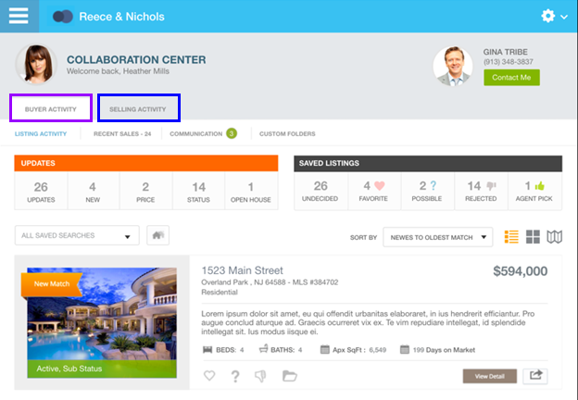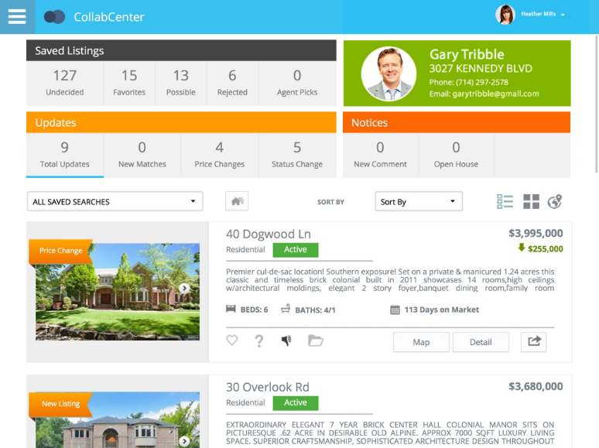

Figure A - **Old CC2 Dashboard**

Figure B - **New CC2 Dashboard**

To help the consumers to quickly see the changes we have made for the combined view, the Help overlay has been updated to indicate these changes. 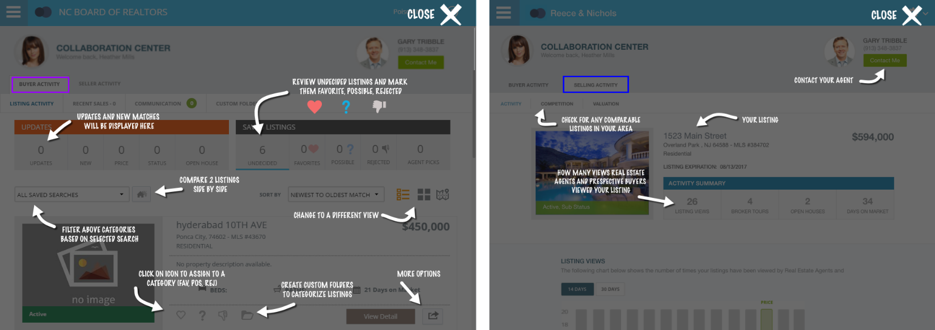

# CC2: The New Welcome Email Template

A new Welcome Email template has been created for the Collab Center (buyer side). This new template contains helpful information and directions on how to use the site. Along with this helpful information, the template is responsive and will adjust to desktop and mobile applications. The new Welcome Email includes an initial count of the number of listings found in the search allowing your prospective buyer to quickly see how listings match their associated search.

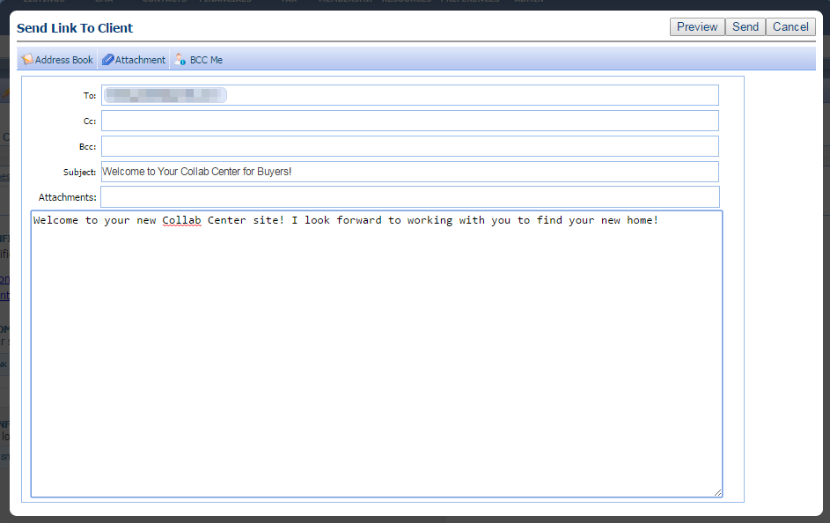The Welcome Email will include a link to all the consumer to quickly setup their password for their CC2 site and including addition information to help introduce them to their new site. Included in the changes to support the new Welcome Email, the rich text editor (contains the formatting options, images, etc.) has been removed to ensure the formatting within the Welcome Email remains consistent. Users will still be able to customize the text of the Welcome Email but they will no longer need to worry about formatting the text to create a clean presentation for their contact.

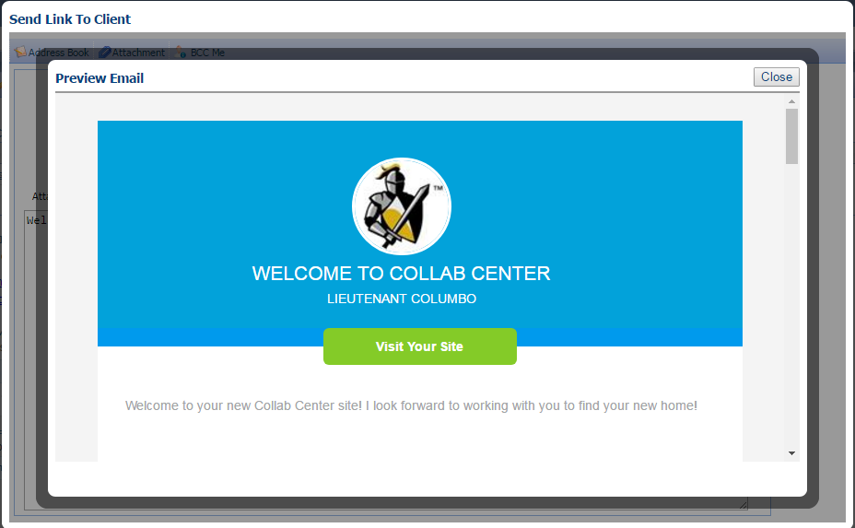A new Preview button has been added to the Welcome Email form to allow you to quickly see how your email will appear for your contact.

The new Welcome Email template also removes the need for a custom email signature as the template is designed to use your agent photo, office logo, email, phone and even your social networking links when available.

**IMPORTANT UPDATE – PLEASE NOTE: If you use the Default Email Body functionality for your emails, please review your setup via Preferences > Email > Message Body.**

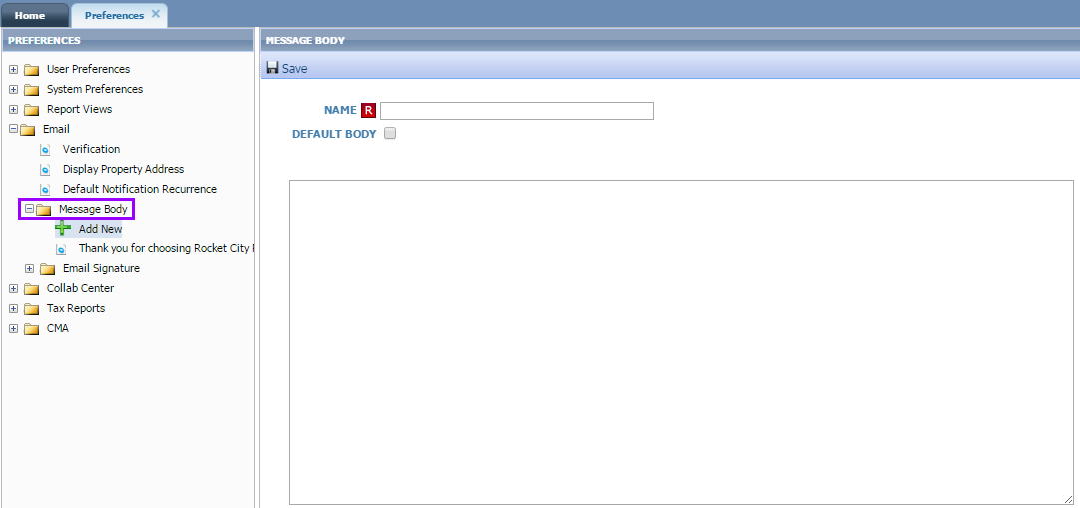With the removal of the rich text editor noted above, an update has also been made to the Default Message Body functionality available under Preferences > Email > Message Body. The rich text editor has been REMOVED from being available for creating this message body. This default message is used in several places throughout CC2 and in order to provide a clean, concise, and consistent format, the Default Message Body has been stripped of custom html formatting and images. Page breaks and layout will be retained but additional styling will no longer be supported.

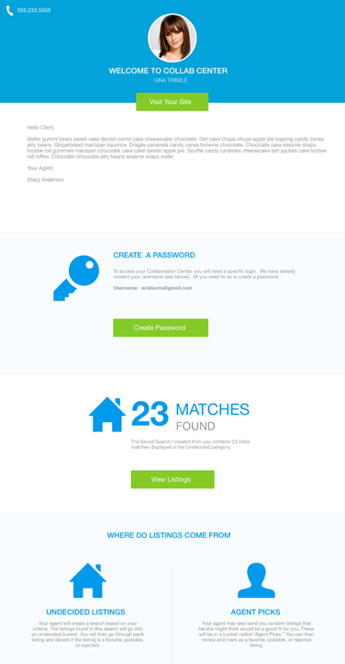This is an example of what the Welcome Email will look like in your contact’s inbox:

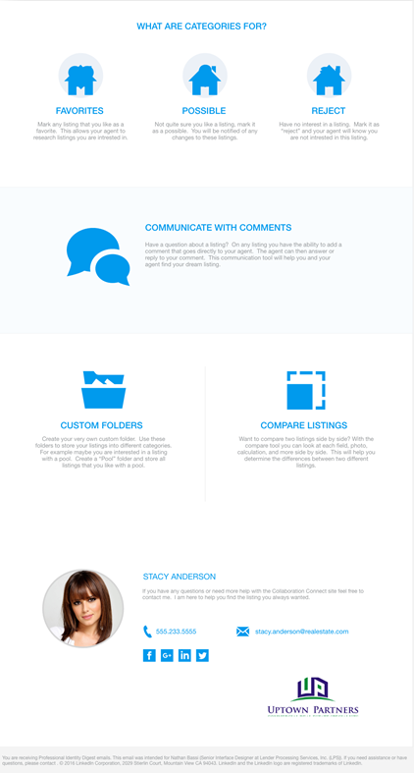

# CC2 Sell Side: The Daily Option for Report

# When the CC2 Sell Side is enabled, the email report has been updated to include a Daily option to allow the user to choose between Daily or Weekly updates to their contact regarding their listing that is on the market. The default setting for this report will be Weekly.

# Last Search: Timestamp Now Included in Display

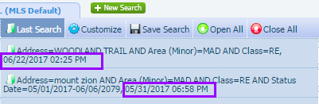The Last Search functionality has been updated to include the date and time of when the search was last performed in the list of criteria. This additional display information will allow users to quickly see when a search was run allowing them to more easily determine which search they would like to select.

# CC2: New Message and Link Added to Emails Regarding Upcoming Improvements

A new message and link will be included in all Collab Center [Agent](http://paragonconnect.paragonrels.com/collabcenterupdates-1) and [Consumer](http://paragonconnect.paragonrels.com/collabcenterupdates-2) Notifications that will link the recipient to a preview of the future enhancements to CC2 Notifications that will be included in the October release.

# LIM: Improved Interface

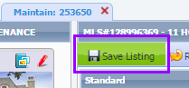In response to user feedback, several improvements and updates have been made within LIM. These changes include a new green background for the Save Listing button throughout Listing Input and Maintenance now to allow it to stand out more on the page.

Action labels have been updated to have friendlier labels, such as “Listing” has been updated to appear as “Maintain Listing.” Third Party Integrations have also been added to the left menu within the Maintain Listing interface.

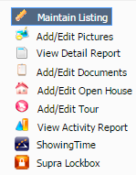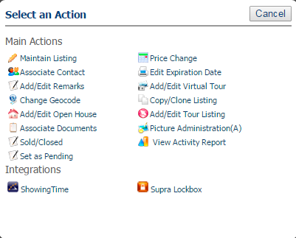

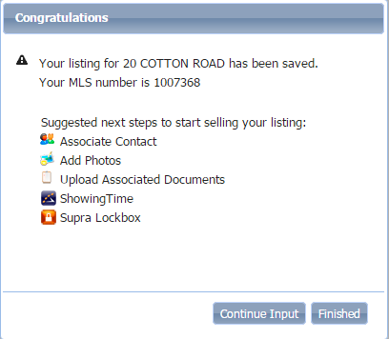The modal that displays when a listing has been successfully saved to the system has been updated to appear with a “Congratulations” message along with recommended steps for additional actions for the user to do with the listing.

# Supra: New Quick Action to Unassign a Lockbox

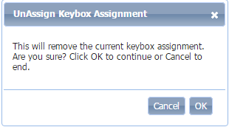Several customers have requested that we add a new quick action to allow users to have the option to quickly unassign a Supra lockbox from a listing within Paragon. In response to this request, when users access Supra via LIM, a new option has been added that appears as UnAssign. When the user selects the new UnAssign option, they will receive a message asking for them to confirm that they wish to disassociate a lockbox from the listing.

When they click the OK button, the Super UnAssign webpage will open in the Supra integration modal.

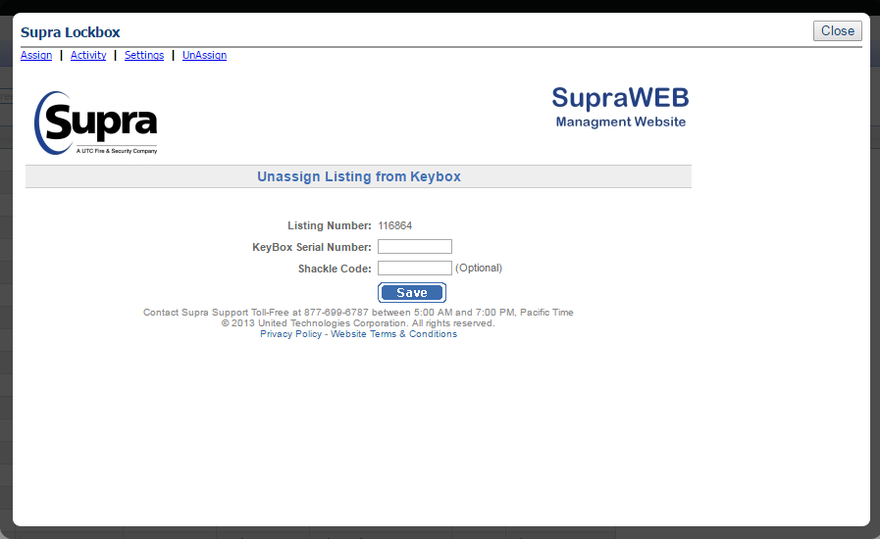The user will need to manually enter either the serial number or the shackle code into the form to process the request to unassign the lockbox. Please note: Supra does not currently support the functionality to prepopulate the lockbox information into the Unassign form. Once the process has been completed, the user will receive a confirmation message within the Supra window.

# MLS Customizations and Administration

**All options in this section are either configurable via MLS Administration controls or by your System Support Manager as noted.**

# Subject Property: New Icons for Required Conversion Fields

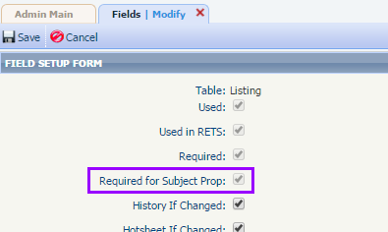Several customers have requested changes to the input and maintenance of Subject Properties to better indicate the fields that are required for converting a Subject Property to a Live Listing. Two changes have been made to the field setup functions to support this change. First, in the field setup form the field labelled as “Required for Temp Prop” has been updated to appear as “Required for Subject Prop”.

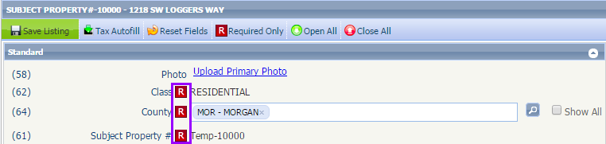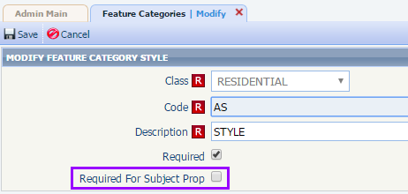Second, a new field labelled “Required for Subject Prop” has been added the feature category setup. When a field or feature field is set to be required for a Subject Property, the red “R” icon will appear on the Subject Property input form.

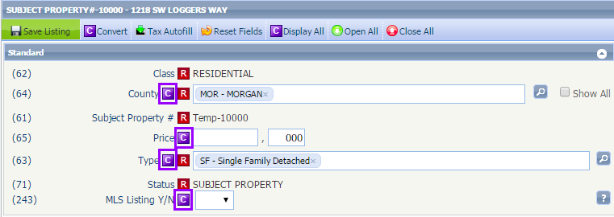When converting a Subject Property to a Live Listing, the fields and feature fields that are required for converting the Subject Property will be indicated by a new purple “C” icon next to the field label.

Clicking the Save Listing will save the Subject Property data but will not convert the Subject Property to a Live Listing. To process the conversion from Subject Property to a Live Listing, the user must complete the required conversion fields and then click the Convert button.

# Introducing a New Option to Allow a Listing to be Associated with a Contact

Introducing a new option to allow a listing and contact to be associated with one another within Paragon! This will allow agents to quickly connect one of their listings with their contact(s) to enable the CC2 Sell Side for their contact. When the functionality has been enabled for your system, users will see a new Associate Contact button when editing an existing listing.

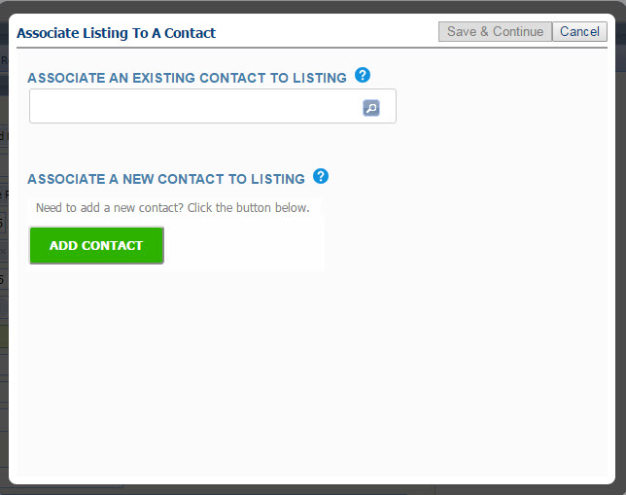When the Associate Contact button is clicked, the user will be presented with the new Associate Listing to a Contact modal that will allow them to choose either existing contacts or add a new contact.

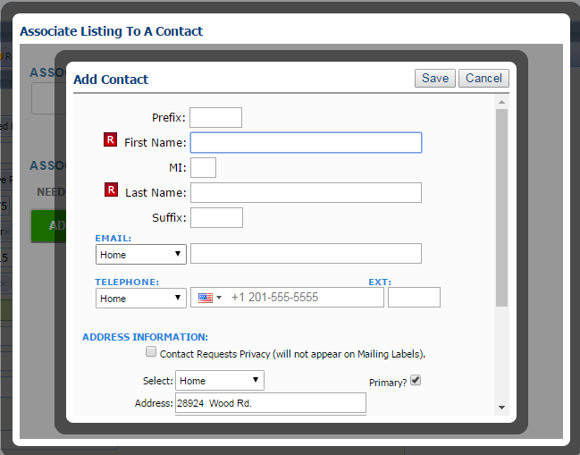If the user selects the Add Contact option, the system will prepopulate the Contact Address information with the Listing Address.

This autofill function will only be available when using the Add Contact option and will NOT be applied when an existing contact is selected for association with the listing. Once a Contact is associated with the listing, the Contact name will appear at the top of the input form next to the listing address.

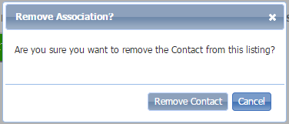To remove the association between the listing and the contact within LIM, the user will simply click the Associate Contact button and click the “X” next to the contact’s name. When the Save & Continue button is clicked, a dialog will appear if all contacts have been removed from the listing confirming that they want to remove the association.

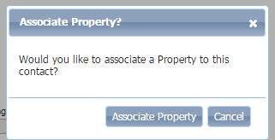An additional option for associating a contact and listing has been added within the Contact Manager. When a user saves a Contact record that has not been associated with a listing, a new prompt will appear asking if they would like to associate the contact to a listing. This prompt is configurable at the system level.

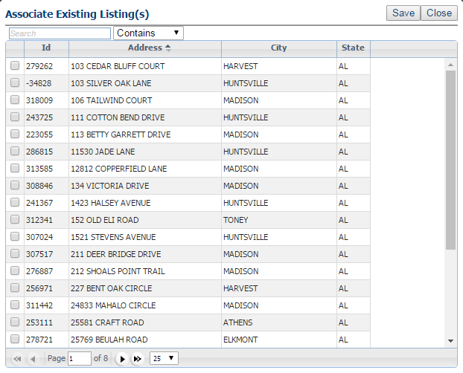When users click on the new Associate Property button, a window will open displaying all of the user’s listings. The user can then select the listing(s) that should be associated with the contact and click the Save button to save the association.

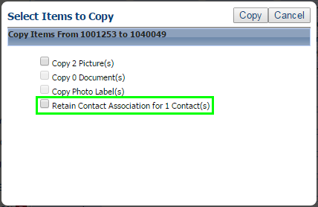The clone listing function has also been updated to support the Listing and Contact association. When a user clones a listing that is associated with one or more of their Contacts, a new option has been added to allow the association between the listing and contact(s) to be retained and carried over to the new listing.

# Statistical Reports: New Option to Allow Users to Run Reports on Other Users

Customers have requested the option to allow users in their system to run statistical reports on other users outside their office. This will allow users to identify strong buyer side agents throughout the system. To support this option, a new configuration has been added to allow the statistical report search function to be expanded to others outside the user’s office or firm. The default setting for this configuration will be set to NO.

Updating the configuration to YES will only impact the Agent Level statistical reports that include the Listing Owner search field. This functionality will not expose any addition statistical reports to the end user. All security functionality for Association Autonomy and Listing Visibility Types will remain unchanged regardless of changing the configuration.