# Agent Level Enhancements

# Updated Contact Notification Video - Now Available

The video in the Contact Manager that instructs agents on setting up notifications has been updated.

# Collab Center: Address 2 Line has been added to Listing Addresses

Listing addresses have been updated to include address line 2 in Collaboration Center Buy side and Sell side. You will now see data like the unit, apt, and suite numbers on addresses.

# Collab Center: New Agent Notification Emails

A new Email Notification template has been created for the Collaboration Center Agent Notifications. The new template has a similar look and feel as the new Welcome Email released in v5.60, including a responsive design that adjusts for desktop and mobile devices.

# Collab Center: New Customer Notification Email

Like the new Agent Notification Email, the new Collaboration Center Customer Notification Email has been updated. The new responsive design automatically adjusts for tablets and mobile devices.

# Collab Center: Updates to the Collaboration Center Notification Email Message Body

As previously communicated in order to support the new Notification Email formats, the rich text editor (which contains options for formatting, adding images, etc.) has been replaced with a basic editor. This ensures that the formatting within the Notification Email remains consistent. Users still have the ability to customize the text in the Collaboration Center Notifications, but will not need to worry about formatting. ***Also note that this change also includes the removal of the ability to include a preset E-mail Signature with the Collab Center Notifications.*** The new notification templates already include Agent contact information that is normally included in standard E-mail Signatures.

## **Subject Property: New Combined Maintain and Convert Feature**

# A new streamlined way to maintain and convert subject property listings is all in one place. The action option to convert a subject property has been removed and all properties will be maintained or converted by selecting the Maintain Subject Property hyperlink.

## **Improved Color Coding on Pop-up Messages**

The color coding has been improved on the pop-up messages that appear throughout the system to make them clearer. Each message type now has a different color and a new message type has been added.

# Auto-Save Added to CMA Wizard

When creating or modifying a CMA in the CMA Wizard, your progress will be saved automatically when you use the Next\Back buttons or when you click on a Step to move through the Create CMA steps.

# MLS Customizations and Administration

All options in this section are configurable via MLS Administration controls or by your System Support Manager as noted.

# Showing Time Basic: Icon added to Spreadsheet/Multi-up Views

The Showing Time Basic icon will now appear in the Spreadsheet, All Fields Detail, and All Fields Customizable 1 & 2.

## **Property History Report: Listings Prohibited by Association Autonomy have been Removed**

Paragon will no longer display listings that are prohibited by Association Autonomy permissions in the property history report. This ensures that agents and brokers cannot use the Property History Report to circumvent listing permissions implemented by other boards.

## **Property History Report: Listings with Exclusive Visibility Types have been Removed**

The property history report has been updated to prohibit listings with exclusive visibility types from display if they are matches to the subject listing. This ensures that the property history report cannot be used to circumvent prohibitions on viewing exclusive listings.

# Legacy E-mail Notifications: New Agent Reminder to Send Initial List of Saved Search Listings to Prospective Buyers

After the legacy email notification setup process has been completed for new contacts, a new message appears reminding the agent to email the buyer the initial list of listings. A link has also been added that will open all of the listings from that saved search making it easy to email immediately.

# RETS: Https Now Available for RETs Image Requests

RETs vendors can now request images via https instead of just http.

# Corrected Issues

# 

|  |  |  |  |  |
| --- | --- | --- | --- | --- |
| **Work Order** | **Seq** | **Module** | **Reporting Customer(s)** | **Issue Corrected** |
| 92621 | 1 | CMA | South Central Wisconsin | Closing a CMA without saving does not give prompt to save in Chrome and Opera |
| 111453 | 1 | Views/Reports | South Central (MO), Amador, Cape May, Cheyenne, Heart of Kentucky, Santa Fe, Triangle, Several Other Customers | Sorting by fields not in Listing tables (like Virtual Tour Field) causes an error. |
| 132971 | 1 | Email | Outer Banks, Gainesville, REB3, SCWMLS, St. Augustine, Topeka | Rich Text Editor-Email font size small at the beginning of email not respecting font settings |
| 133391 | 1 | HomePage Message | Beaumont, Amador, Central Penn, Eastern NY, Knox County | Nothing selected in sidebar when Admin>MESSAGING>Home Page Message opened |
| 133598 | 1 | CMA | Central Mississippi, Intermountain, Charlottesville, RANW, SWVMLS, Eastern NY Regional | Issue with agent photo size/alignment on CMA Cover Page |
| 133653 | 1 | Admin - Listings | Intermountain MLS, Nova Scotia, REB3, Triangle | iPad Listing Input Error |
| 134541 | 1 | Collab Center | Intermountain MLS, Central Penn | 5.60 - Scrollbar issues in Collab Center, Browser specific |
| 134860 | 2 | Collab Center | Sandicor, Several Other Customers | Collab Center is showing broken links on email a listing |
| 135131 | 1 | Admin Field Setup | NEREN | Unable to create new Feature Category, getting “the page you are attempting…” error |
| 134912 | 1 | Prospecting & Notifications | REB3 | Advanced search is not being filtered correctly in Prospecting |

# Agent Level Changes

**The following section contains changes that are active system wide** **and available to users based on their assigned security levels.**

# Updated Contact Notification Video - Now Available

The instructional video that walks agents through the steps on how to setup a notification has been updated.

# 

# Collab Center: Address 2 Line has been added to Listing Addresses

The addresses found in both the Collaboration Center Buy side and Sell side have been updated to include the address 2 information. You will now see data like the unit, apt, suite, etc. on addresses. This is also included in all Collab Center tablet and mobile reports.

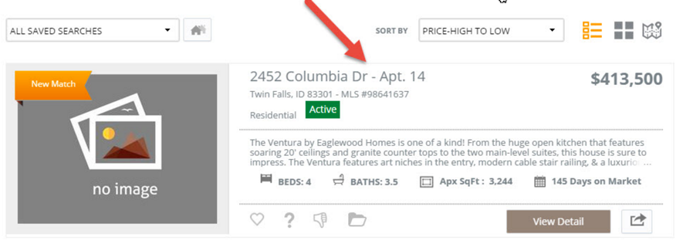

# Collab Center: New Agent Notification Emails

The new Agent Notification Email retains all of the functionality from the current emails, but displays it in a more up-to-date format that ties into the overall Collaboration Center look. The new Collab Center notifications were specifically designed to look good on tablet and mobile screens.

The new template begins with the number of Total Updates, followed by detailed information for each Contact and Search that has notifications. For each Contact, the new notification email includes the Contact’s email and phone, name of each Saved Search, the specific updates included for that search, and a thumbnail view of each ‘update’ listing. The existing Collaboration Center Notifications in Preferences still determines which type of updates are included in the Agent notification emails.

*Figure A* – Old Agent Notification

# 

*Figure B* – New Collab Center Agent Notification

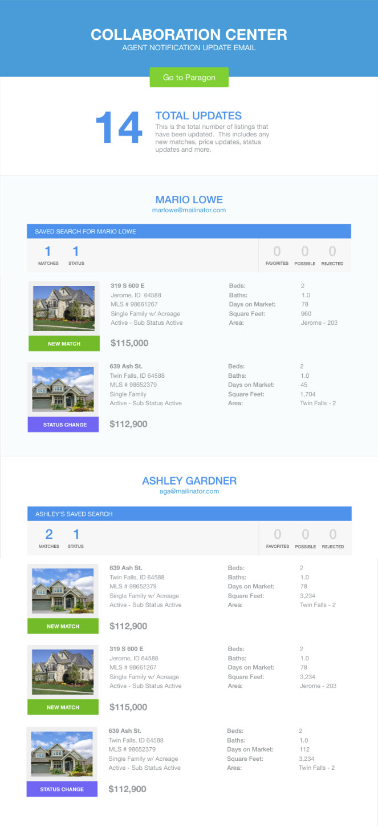

# Collab Center: New Customer Notification Email

Like the new Agent Notification Email, the new Customer Notification Email retains the content from the existing notifications, but displays it in a format consistent with the Collaboration Center. The responsive design automatically adjusts for tablet or mobile screens.

The Customer Notification template displays the agent’s phone number and image in the header, followed by the name of the Customer’s Saved Search, and a link to their Collaboration Center site. The agent’s Notification email message leads into the number of Total Updates, and a Listing Preview thumbnail report of the four most recent matches. Each Listing Preview includes the primary photo, the type of update, and listing Status, in addition to Address, Listing Number, and Price. Beds, Baths, Days on Market, and Square Feet display based on the MLS’s configuration settings. A link to View All Updates will take the Customer to their Collaboration Center site.

An Update Review section breaks out the type of updates included in the email and how many of each. Also included is a brief description of what triggers each type of update. Rounding out the notifications are a link to Reset Password, and the Agent’s contact information.

**PLEASE NOTE: The new email notification currently displays a Listing Preview section containing up to four of the most recent updates. This can be turned off via MLS configuration. Please contact your SSM if you’d like this listing preview turned off.**

*Figure A* – Old Customer Notification

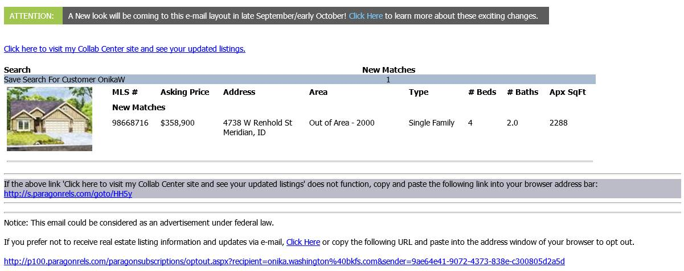

*Figure B* – New Customer Notification

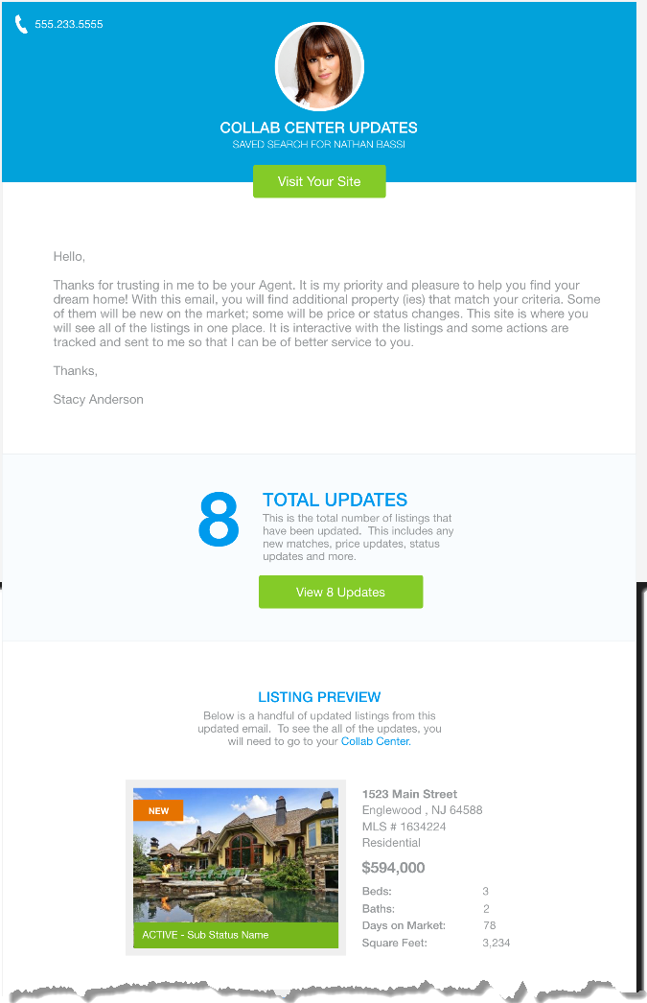

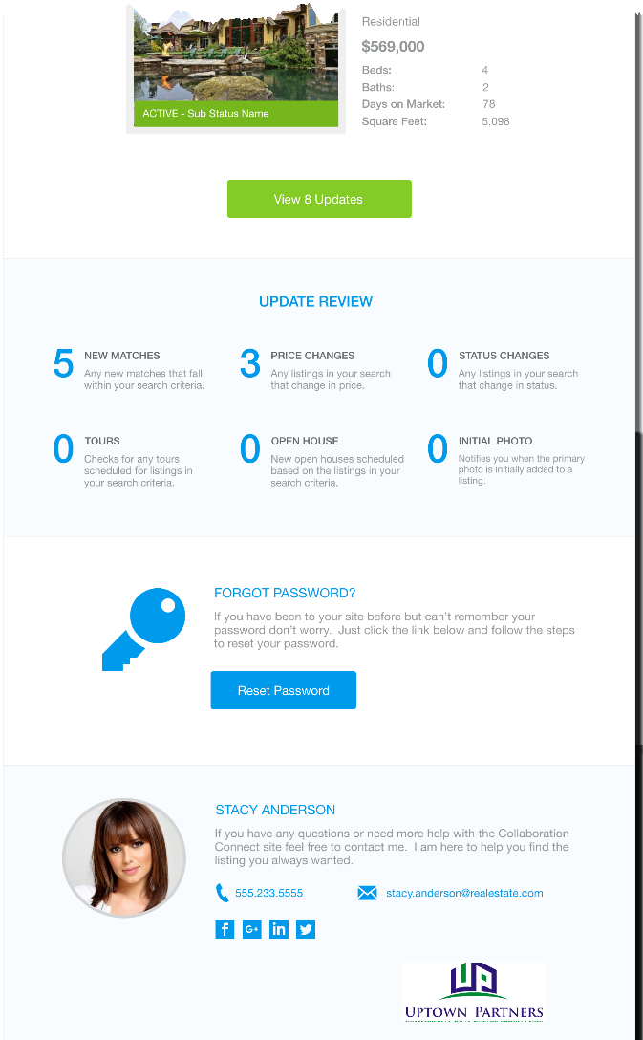

# Collab Center: Updates to the Collaboration Center Notification Email Message Body

In order to support the new Notification Email formats, the rich text editor (which contains options for formatting, adding images, etc.) has been removed. This ensures that the formatting within the Notification Email remains consistent. Users still have the ability to customize the text in the Collaboration Center Notifications, but will not need to worry about formatting.

The new Notification Email template also removes the need for a custom email signature, as the template is designed to use your agent photo, office logo, email, phone and even your social networking links when available.

**PLEASE NOTE:** If you use the Notification Settings Message Body, please review your setup in Contacts > View/Manage Contacts. Your existing text will be retained, but any formatting you included will be removed.

## **Subject Property: New Combined Maintain and Convert Feature**

A new streamlined way to maintain and convert subject property listings is all in one place. The action option to convert a subject property has been removed and all properties can be maintained and/or converted by selecting the Maintain Subject Property hyperlink. When an agent or broker maintains a subject property, the option to convert is automatically displayed in the functions ribbon. Saving changes to the subject property listing is done via the Save Subject Property button. The Required Only function ribbon option will display all fields to save a subject property or convert it with one click.

**Note:** The ‘Maintain Subject Property’ link will be updated to ‘Maintain\Convert Subject Property’ in an upcoming release to make it more descriptive.

# *Figure A* – Old Subject Property Select an Action menu *Figure B* – New Subject Property Select an Action menu

*Figure C* – **Old Subject Property Functions Ribbon**



**Improved Color Coding on Pop-up Messages**

The messages appear in a little green box that pops up on the screen when you attempt to save or make any number of changes to the system. Every pop-up message is in green regardless of the type of message it displays. In 5.61, we have altered the look of the pop-up messages to help you better understand the messages and how they affect workflow. There are four different types of pop-up messages now.

We have added individual colors to each pop-up message type along with an icon and a label. This helps the end user identify what type of message is displayed.

* Green messages indicate that a process or procedure was completed successfully.
* Yellow messages are warnings indicating that not enough information has been provided or additional steps must be taken. However, the user may continue.
* Red messages display when a process or procedure has failed or is prohibited. The user will be prevented from continuing that function.
* The new information messages are blue.

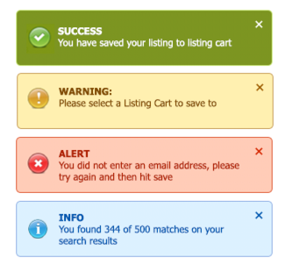

|  |
| --- |
|  |

# Auto-Save Added to CMA Wizard

When creating or modifying a CMA in the CMA Wizard, your progress will be saved automatically when you use the Next\Back buttons or when you click on a Step to move through the Create CMA steps.

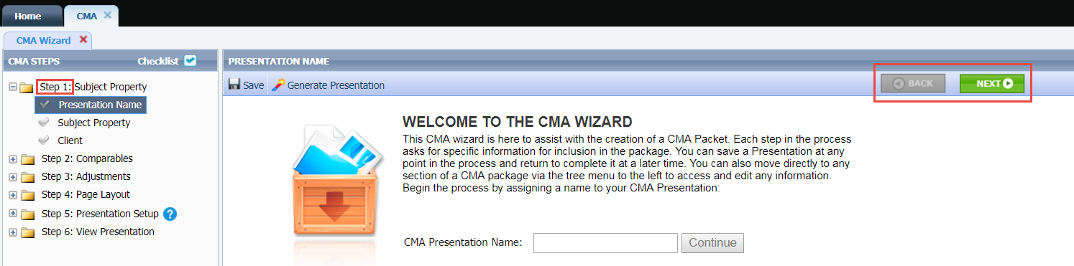

# MLS Customizations and Administration

**All options in this section are either configurable via MLS Administration controls or by your System Support Manager as noted.**

# Showing Time Basic: Icon added to Spreadsheet/Multi-up Views

A new Showing Time Basic icon will now appear in the Spreadsheet, All Fields Detail, and All Fields Customizable 1 & 2.

*Figure A* – **Spreadsheet** *Figure B* – **All Fields Detail**

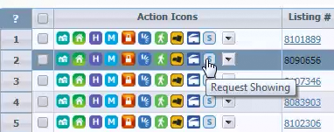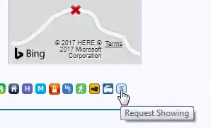

## **Property History Report: Listings Prohibited by Association Autonomy have been Removed**

Paragon will not display listings that are prohibited by Association Autonomy permissions in the property history report. This ensures that agents and brokers cannot use the Property History Report to circumvent listing permissions implemented by other boards. Note that screenshots displayed below for the Property History report listing visibility types are reflective of how the association autonomy changes will look.

**PLEASE NOTE:** **These changes may limit the ability to quickly determine the Cumulative Days on Market value for some listings for customers who have done so within the Property History.**

## **Property History Report: Listings with Exclusive Visibility Types have been Removed**

The property history report has been updated to prohibit listings with exclusive visibility types from display if they are matches to the subject listing. This ensures that the property history report cannot be used to circumvent prohibitions on viewing exclusive listings.

**PLEASE NOTE:** **These changes may limit the ability to quickly determine the Cumulative Days on Market value for some listings for customers who have done so within the Property History.**

*Figure A* – **No Prohibited listing visibility types displayed in the Property History Report**

# C:\Users\e5001900\AppData\Local\Temp\SNAGHTML199c9cc.PNG

*Figure B* – **Prohibited listings not being displayed in the Property History Report**

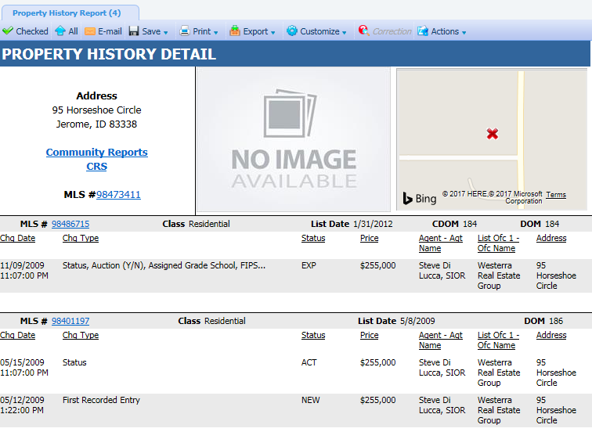

# Legacy Email Notification: New Agent Reminder to Send Initial List of Saved Search Listings to Prospective Buyers

The legacy email notification setup process allows you to send notifications to your buyers when changes occur within the saved search. However, when you first setup an email notification, the initial list of listings is not sent to your prospective buyer. The agent must manually send these listings. To help remind the agents about sending the initial email list, a pop-up message will present itself after an email notification is setup. This pop-up message confirms that the email notification was setup and reminds the agent to send that initial list of listings. In addition to the reminder, we include a link that will open a new tab with all of the listings from that saved search. This allows the agent to quickly email those listings to their prospective buyer.

*Figure A*– Agent Reminder Message

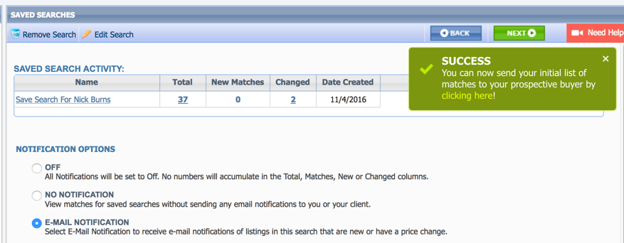

*Figure B* – Saved Search Listings after Clicking the Link in the Popup Message

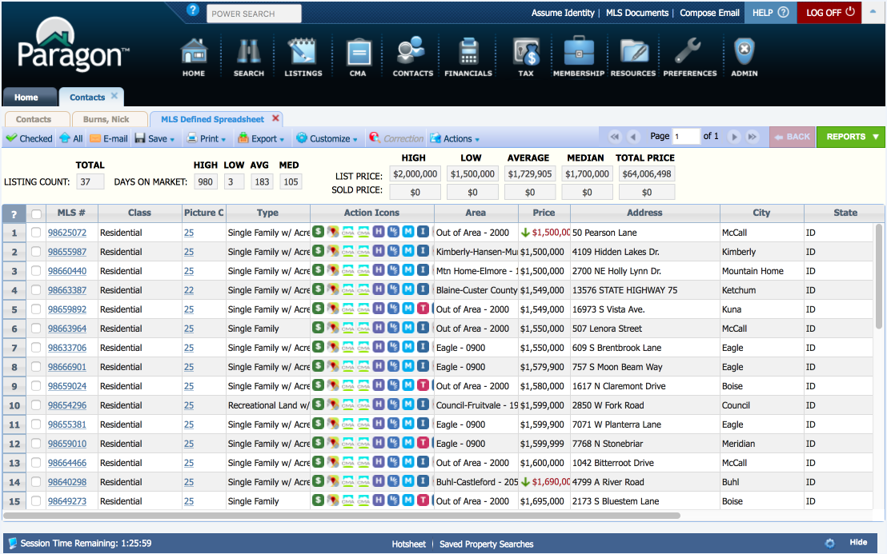

# RETS: Https Now Available for RETs Image Requests

RETs vendors can now request images via https instead of just http.