# Agent Level Enhancements

# Listing Display ID Added to the Change Geocode Window

The Change Geocode window has been updated to include the listing display ID at the top. This allows customers to see the ID without having to close the window.

# Audit Listing and Audit Detail Reports Now Indicate Geocode Updates

In order to support the change to a new geocode provider and to resolve the issue of receiving listing change emails for unseen geocode updates, the Audit Listing report and the Audit Detail report will now indicate changes made to the geocodes.

# Listings Available for Seller Side Restricted to Active and Pending Statuses

When setting up a client with a seller side site, you must first select a listing. The list of listings presented is populated with all of that listing agent’s properties included all listings regardless of status. In this release, we have filtered the list to only include listings where the status is Active or Pending. This prevents agents from accidentally assigning an off-market status listing to a contact.

# Collab Center Neighborhood and School Widget Temporarily Disabled

We are pleased to announce that we are in the process of upgrading the Neighborhood and School Widget found on the detail report within the Collaboration Center. The new widgets will be provided via a partnership with a company called Onboard. ***Our agreement with our current vendor ends on December 31, 2017 and until the integration with the Onboard widgets for Neighborhood and School Widgets are complete we will temporarily disabling this functionality on the Collaboration detail view.***

# Unused “Beds” and “Baths” Labels are Hidden in Collab Center

The listing reports in Collaboration Center and Email Notifications will now hide the labels for the Beds and Baths fields when a property class does not have specified Beds and/or Baths fields listed in the Class setup. Previously, the labels remained on the listing details even when the fields were not in use. All listing views in Collaboration Center and Collaboration Center Email Notifications for both Clients and Agents will hide the unused Beds and Baths fields.

# Collab Center Now Displays the Photo Labels and Descriptions

When a photo label and description is added to a listing photo, this information will display within the Collaboration Center detail report on the bottom portion of the photo. If the slideshow is run they will appear at the bottom of the slideshow as well. Likewise, they will also appear on the mobile view.

# Collab Center: Return to Listings in Mobile View is Available

In the mobile view, the Contact Me page didn’t have a way to get back to the home screen without clicking the browser ‘Back’ button. A new ‘Close’ button has been added to remedy this concern.

# Collab Center: Reflects when Multiple Open Houses are Offered

If a listing has multiple open houses added, the update screen would only show that the listing had an open house. It did not indicate that there were more than one open houses available. A description has been applied below the listing informing to the client that there are more than one open houses being offered.

# Collab Center: Comments to Client Contain More Information

In this release we have added the actual comment and the listing information to the notification emails. Previously, if a comment was added the client would just get a notification with a comment count. It did not show the comment or the listing information.

# Collab Center: Notifications Added for Customer Created Searches

In an effort to keep Agents notified of changes made by their clients in Collaboration Center, we have now introduced a notification option for when client creates a new search or modifies an existing search. It has been added to the list of items that agents can receive notifications on. Two new options have been added to the Collaboration Center preferences in Paragon, “Notify on new client search” and “Notify on modified client search”. Both of these options will be enabled by default.

# Agents Can Receive the Sell Side Report in Collab Center

We have now included options for the agent to receive the sell side report daily or weekly. Initially, this was only allowed for the client.

# Feature Category Added to Collab Center Search

The Features search in Collaboration Center combines all features into one simple form. Prior to this release, the Features field only searched on the feature category. This made it difficult when the feature descriptions were duplicated or if it was category related. Now Collaboration Center will search on both category and description. It will also show both in the results.

# Collab Center: Modify Password Reset Workflow

The Collaboration Center password reset functionality has been modified to conform to the more secure standards applied to Paragon. When a customer enters their email address and submits it for a password reset email the confirmation message displayed will be the same as is displayed in Paragon. The previous success or failure messages have been removed.

# Display Address2/Unit in Collaboration Center Email Notifications

In the prior release the Address 2 field was added to the Collaboration Center reports. This additional enhancement adds Address 2 to the listing info in the Agent and Client Collaboration Center email notifications.

# MLS Customizations and Administration

All options in this section are configurable via MLS Administration controls or by your System Support Manager as noted.

# New Geocoder Replaces Bing

# The Bing geocoder has been replaced with a New Solution. Customers will be able to enjoy improved geocoding throughout Paragon. There is no limitation on the new solution geocodes and they can therefore be displayed on any map. Although the new solution is in place with this release, the BK MLS Team will work with all Customers to develop an implementation and conversion plan over the next few months.

# Please Note: Some limitations may apply to our Canadian Customers.

# Collab Center: Contact Email Notification Listing Detail Configuration Enabled

The configuration to display summary listing information in the contact’s Collaboration Center notifications was disabled by default. We have changed this configuration to be enable by default. Any MLS who wishes not to display the first four listings displayed within the listing preview can have this turned off.

# Collab Center: Changes made for Association Autonomy

In order to provide Association Autonomy to allow customers maximum flexibility in configuring Collaboration Center, we have extended the MLS level Collaboration Center settings to the Board level. This functionality is turned off by default and requires a configuration change to enable it. Once the configuration is enabled, a new section will be displayed in each board record that allows member boards to configure Collaboration Center functionality in a more flexible manner.

# Collab Center: Password Requirements Added to Welcome Page

Collaboration Center uses the same password complexity requirements as Paragon. This is true for all customers even those that use a 3rd party to manage their passwords. In order to mitigate contact password errors, a hyperlink has been added to the Welcome page so anyone can view the password complexity requirements to access the application.

# Remove all Legacy Clients

Many times when Board and MLS staff add a new user to Paragon, they are presented with a list of Paragon clients that have legacy values that are not applicable to the user. In order to narrow the list of Paragon clients to only those that should be used, we have added a new function to remove/disable the unused Clients for MLS Staff.

# Allow Customization of Login Page

Many times users will attempt to find their Paragon Site using Google. Invariably the link they select in the Google search is not for their MLS and they will repeatedly attempt to log in. We have added functionality that allows customers to add a logo to the Paragon login page that will help users identify the correct MLS to log in to. If customers use Clareity for identification management they cannot use this new functionality.

# Fields Added to Open House

New Open House fields have been made available to all Paragon customers and will increase functionality in the Open House module when activated.

# Share Listings on Facebook

Agents will now have the ability to share their listings to their Facebook account from the Listing Input/Maintenance Quick Actions menu.

# Deletion of Paragon System Generated Emails

A new configuration has been added that determines how many days system generated emails are retained before they are automatically deleted. The default will be set to 90 days. The old configuration which controlled both manual and automated emails will remain but now only controls the number of days manual emails are retained and it will remain at its current setting.

# Corrected Issues

|  |  |  |  |  |
| --- | --- | --- | --- | --- |
| **Work Order** | **Seq** | **Module** | **Reporting Customer(s)** | **Issue Corrected** |
| 103507 | 1 | Statistical Reporting | MiRealSource | IE Freezes when generating the Year to Year report |
| 109462 | 1 | Views/Reports | Lewis-Clark, MAXEBRD, Northern Great Lakes | iPad cannot scroll down on Customize view screen-No scroll bar on right |
| 115486 | 1 | Statistical Reporting | Santa Fe, NEREN | Volume Ranking: Volume total is off and unit # was rounded, which was inaccurate |
| 126998 | 1 | Statistical Reporting | Eastern New York, CREN, Hudson County | Price Comparison - MLS Summary Report is not filtering results when using Board |
| 129239 | 1 | Statistical Reporting | MAXEBRD | Unable to generate stat reporting Graph |
| 129389 | 1 | Print/Print+ | Sandicor, CRIB | P150 - CR - Photos are not printing when using Print+ |
| 132715 | 1 | Input Maintenance | South Central Wisconsin, MAXEBRD | Unable to copy/clone photos on listings |
| 132838 | 1 | Collab Center | South Central Wisconsin | CC2 Property Search - map not initially loading |
| 133217 | 1 | Admin - Listings | Sandicor | Listings are displaying more photos in photo count than allowed |
| 133285 | 1 | CMA | South Central Wisconsin | SCWMLS - unable to copy/clone photos to subject properties |
| 134142 | 1 | Statistical Reporting | MiRealSource, Huntsville | Year to Year stats report generates for admins, but not members |
| 134970 | 1 | Statistical Reporting | Intermountain, Eastern New York, Greater Greenville, Indiana Regional, NEREN, Northern Great Lakes, Rockford, South Central Wisconsin, South Jersey Shore | Statistical reports/Price Comparison does not generate for Security level 6 and below |
| 135927 | 1 | CMA | Omaha, Baton Rouge | Convert option in Maintain subject property is available for all users regardless of security level |
| 135994 | 1 | RETS | REB3 | When adding an OH to an existing listing via RETS Update, reply returns Misc Update Error |
| 129230 | 1 | Collaboration Center | All | CC2 - Gap issue - Initial Photo upload, no CC2 notification or flag |
| 135817 | 1 | Contact Activity | Baldwin County, RANW, Sandicor | User is getting page unavailable error on sent collab center emails |
| 135994 | 1 | RETS | REB3 | When adding an OH to an existing listing via RETS Update, reply returns Misc Update Error |
| 135015 | 1 | Collaboration Center | SCWMLS, Topeka | Virtual Tour field not displaying correctly as link on Collab Center Detail View |

# Agent Level Changes

**The following section contains changes that are active system wide** **and available to users based on their assigned security levels.**

# Listing Display ID Added to the Change Geocode Window

The Change Geocode window has been updated to include the listing display ID at the top. This allows customers to see the ID without having to close the window.

*Figure A* – L.S. #

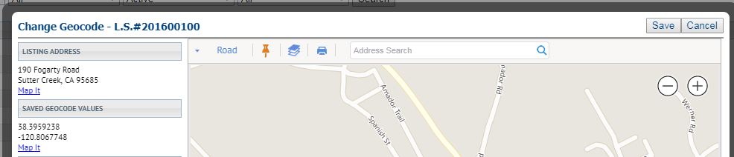

*Figure B* – Partial Listing #

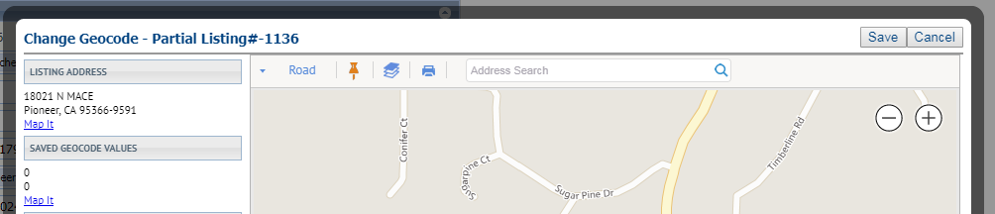

*Figure C* – Subject Property #

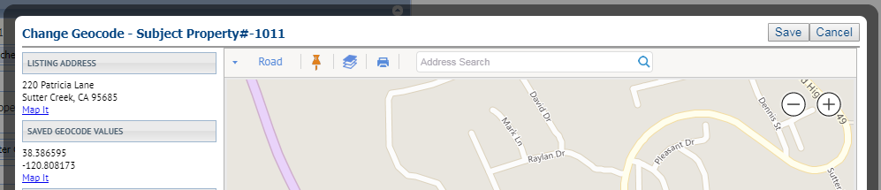

# Audit Listing and Audit Detail Reports Now Indicate Geocode Updates

In order to support the change to a new geocode provider and to resolve the issue of receiving listing change emails for unseen geocode updates, the Audit Listing report and the Audit Detail report will now indicate changes made to the geocodes via the Search By Map field name.

*Figure A* – Audit Listing Report

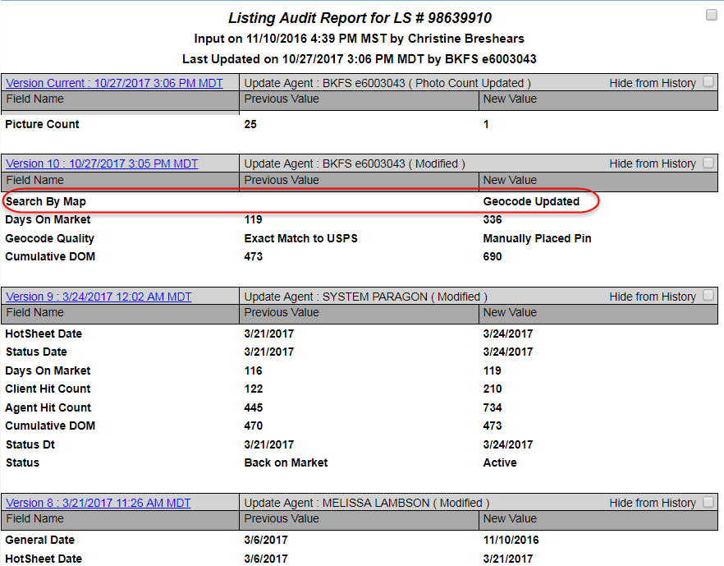

*Figure B* – Audit Detail Report

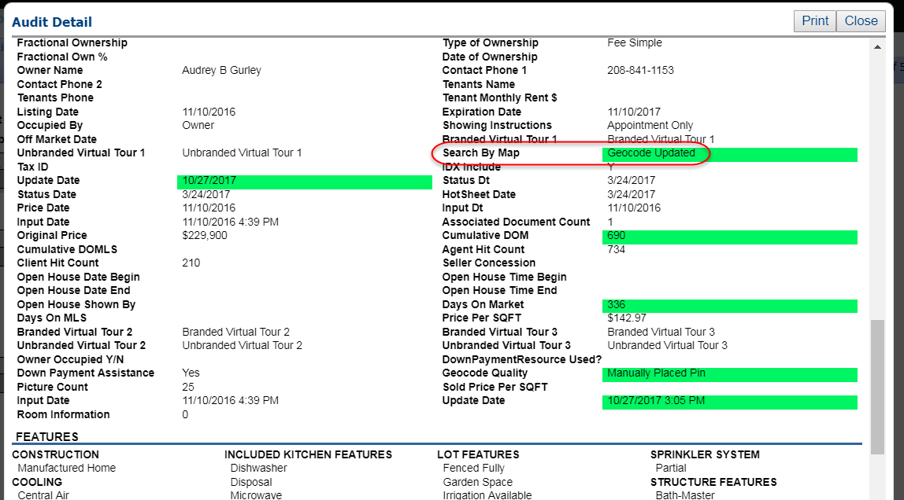

# Listings Available for Seller Side Restricted to Active and Pending Statuses

When setting up a client with a seller side site, you must first select a listing. The list of listings presented is populated with all of that listing agent’s properties included all listings regardless of status. In this release, we have filtered the list to only include listings where the status is Active or Pending. This prevents agents from accidentally assigning an off-market status listing to a contact.

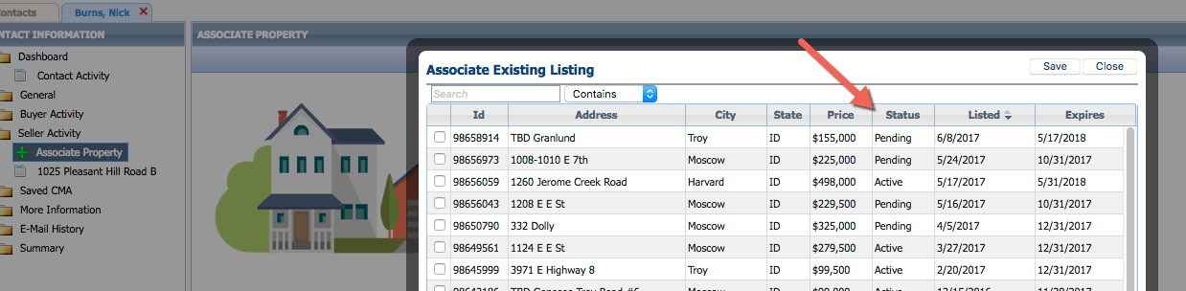

# 

# Collab Center Neighborhood and School Widget Temporarily Disabled

We are pleased to announce that we are in the process of upgrading the Neighborhood and School Widget found on the detail report within the Collaboration Center. The new widgets will be provided via a partnership with a company called Onboard. Onboard provides access to detailed information on every property and community in the US. Onboard widgets are 100% responsive and contain a wealth of information your consumers will love. **Our agreement with our current vendor ends on December 31, 2017 and until the integration with the Onboard widgets for Neighborhood and School Widgets are complete we will be temporarily disabling this functionality on the Collaboration detail view.** We will have a follow-up communication sent when the integration with the new vendor is complete

Figure A - Upcoming change to the CC2 Detail Neighborhood and Schools Widget

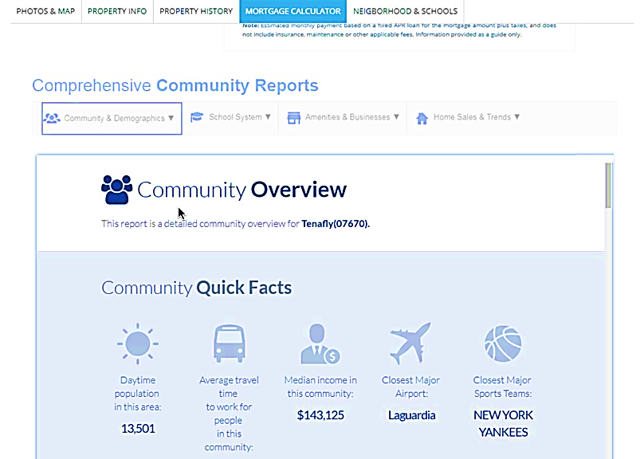

Figure B - Collab Center Detail with the Neighborhood and School Widget Turned Off

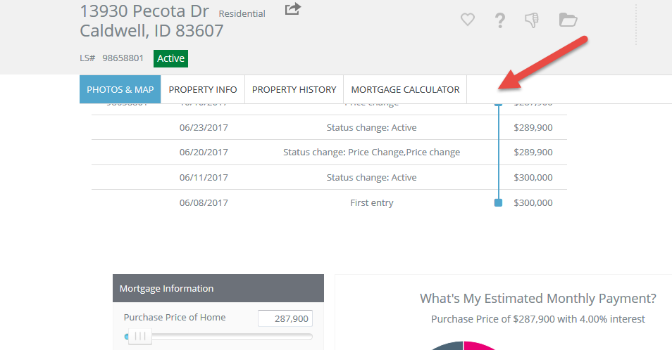

# Unused “Beds” and “Baths” Labels are Hidden in Collab Center

The listing reports in Collaboration Center and Email Notifications will now hide the labels for the Beds and Baths fields when a property class does not have specified Beds and/or Baths fields listed in the Class setup. Previously, the labels remained on the listing details even when the fields were not in use. All listing views in Collaboration Center and Collaboration Center Email Notifications for both Clients and Agents will hide the unused Beds and Baths fields.

*Figure A* – Listing Detail, Old Version

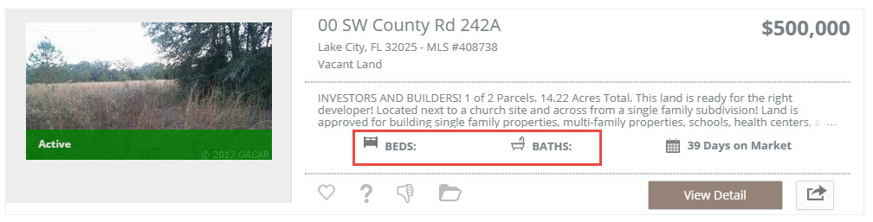

*Figure B* – Listing Detail, New Version

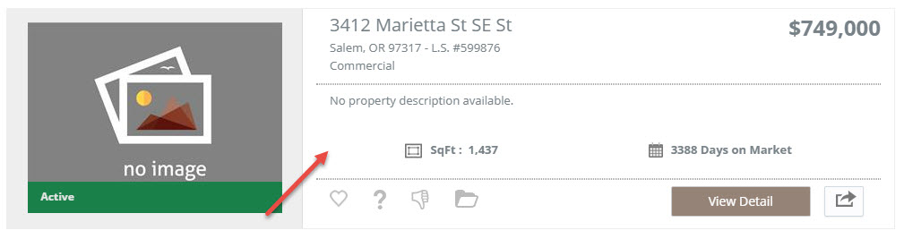

# Collab Center Now Displays the Photo Labels and Descriptions

When a photo label and description is added to a listing photo, this information will display within the Collaboration Center detail report on the bottom portion of the photo. If the slideshow is run they will also appear at the bottom of the slideshow. Likewise, they will also appear on the mobile view.

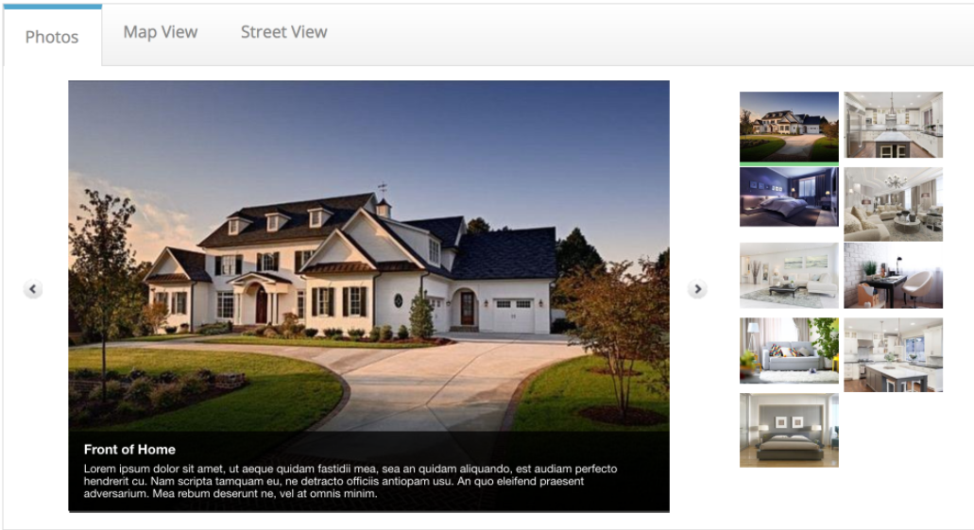

# Collab **Center: Return to Listings in Mobile View is Available**

In the mobile view, the Contact Me page didn’t have a way to get back to the home screen without clicking the browser ‘Back’ button. A new ‘Close’ button has been added to remedy this concern.

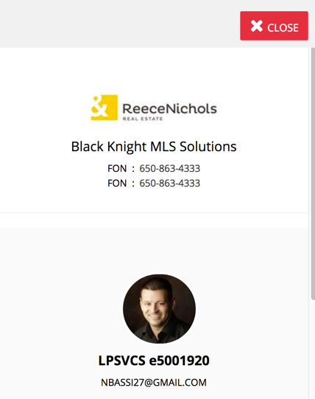

# Collab **Center:** Reflects when Multiple Open Houses are Offered

If a listing has multiple open houses added, the update screen would only show that the listing had an open house. It did not indicate that there were more than one open houses available. A description has been applied below the listing informing to the client that there are more than one open houses being offered.

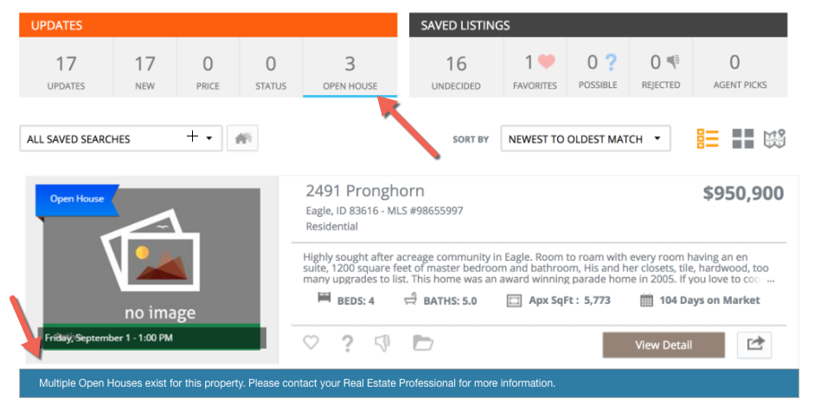

# Collab Center: Comments to Client Contain More Information

In this release we have added the actual comment and the listing information to the notification emails. Previously, if a comment was added the client would just get a notification with a comment count. It did not show the comment or the listing information.

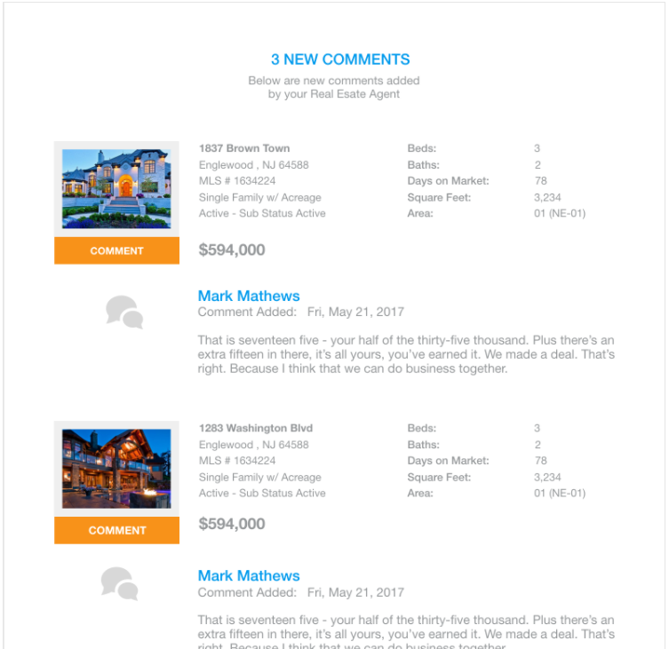

# **Collab Center: Notifications Added for Customer Created Searches**

In an effort to keep Agents notified of changes made by their clients in Collaboration Center, we have now introduced a notification option for when client creates a new search or modifies an existing search. It has been added to the list of items that agents can receive notifications on. Two new options have been added to the Collaboration Center preferences in Paragon, “Notify on new client search” and “Notify on modified client search”. Both of these options will be enabled by default.

*Figure A* – New Paragon Saved Search Options

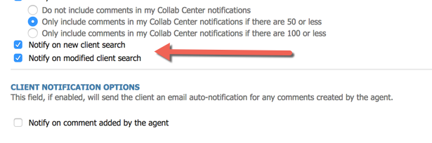

*Figure B* – Saved Search Changes

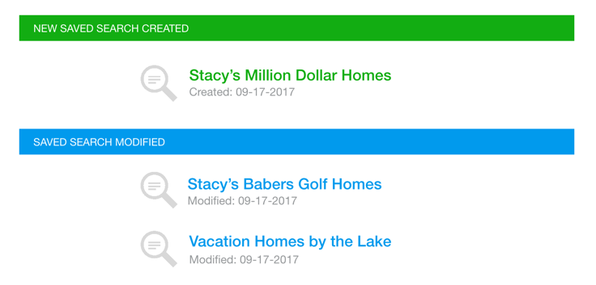

# Agents Can Receive the Sell Side Report in Collab Center

We have now included options for the agent to receive the sell side report daily or weekly. Initially, this was only allowed for the client.

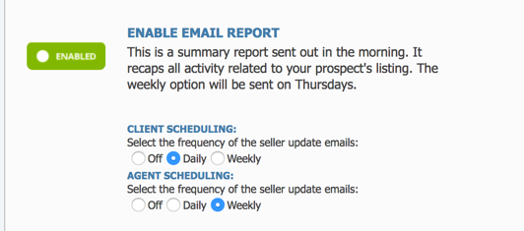

# **Feature Category Added to Collab Center Search**

The Features search in Collaboration Center combines all features into one simple form. Prior to this release, the Features field only searched on the feature. This made it difficult when the feature descriptions were duplicated or if it was category related. Now Collaboration Center will search on both category and description. It will also show both in the results.

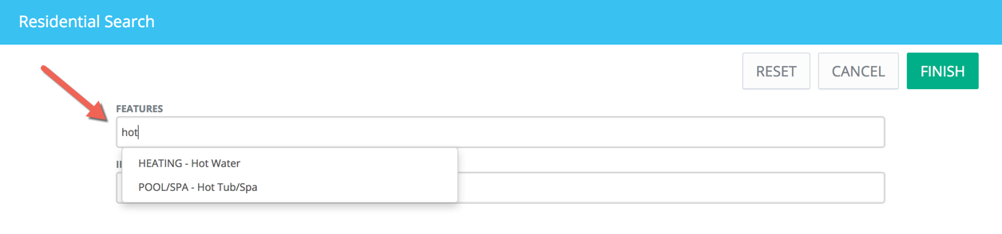

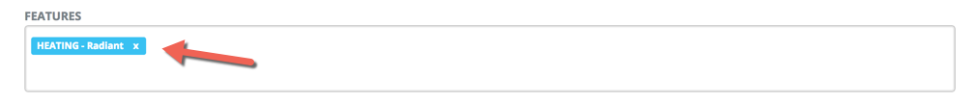

# **Collab Center: Modify Password Reset Workflow**

The Collaboration Center password reset functionality has been modified to conform to the more secure standards applied to Paragon. When a customer enters their email address and submits it for a password reset email the confirmation message displayed will be the same as is displayed in Paragon. The previous success or failure messages have been removed.

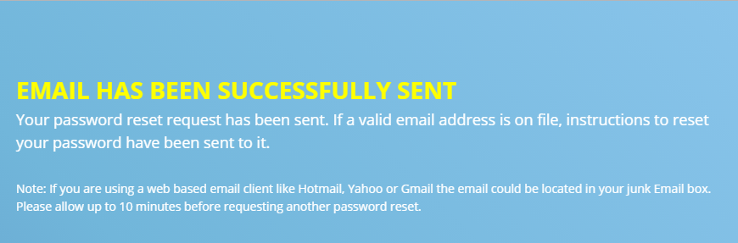

# 

# Display Address2/Unit in Collaboration Center Email Notifications

In the prior release, the Address 2 field was added to the Collaboration Center reports. This additional enhancement adds Address 2 to the listing info in the Agent and Client Collaboration Center email notifications.

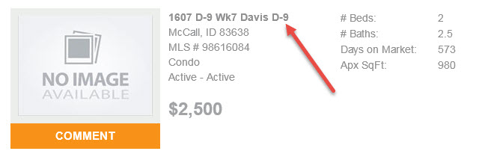

# MLS Customizations and Administration

**All options in this section are either configurable via MLS Administration controls or by your System Support Manager as noted.**

# New Geocoder Replaces Bing

# The Bing geocoder has been replaced with a New Solution. Customers will be able to enjoy improved geocoding throughout Paragon. There is no limitation on the new solution geocodes and they can therefore be displayed on any map. Although the new solution is in place with this release, the BK MLS Team will work with all Customers to develop an implementation and conversion plan over the next few months. Please Note: Some limitations may apply to our Canadian Customers.

**PLEASE NOTE:** **Only customers that plan to expose geocodes outside of Paragon or are sharing geocodes via RETS will need to have the old Bing codes re-geocoded using the New Solution.**

# 

# Collab Center: Contact Email Notification Listing Detail Configuration Enabled

The configuration to display summary listing information in the contact’s Collaboration Center notifications was disabled by default. We have changed this configuration to be ***enable*** by default. Any MLS who wishes not to display the first four listings displayed within the listing preview can have this turned off.

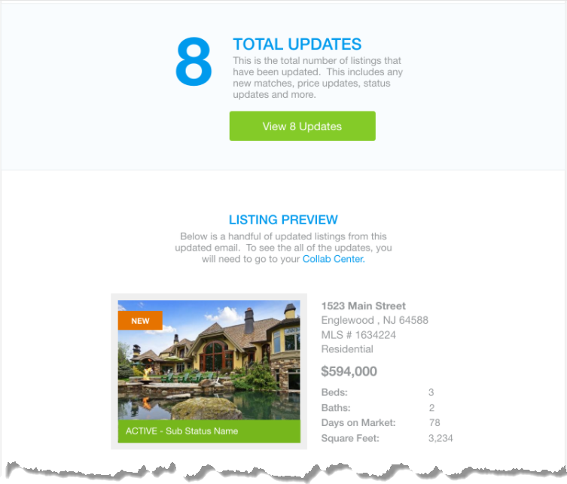

# Collab Center: Changes made for Association Autonomy

In order to provide Association Autonomy to allow customers maximum flexibility in configuring Collaboration Center, we have extended the MLS level Collaboration Center settings to the Board level. This functionality is turned off by default and requires a configuration change to enable it. Once this configuration is enabled, a new section will be displayed in each board record that allows member boards to configure Collaboration Center functionality in a more flexible manner.

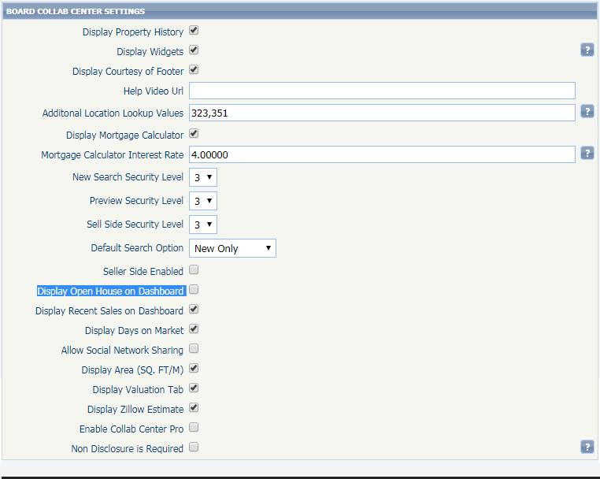

# Collab Center: Password Requirements Added to Welcome Page

Collab Center uses the same password complexity requirements as Paragon. This is true for all customers even those that use a 3rd party to manage their passwords. In order to mitigate contact password errors, a hyperlink has been added to the Welcome page so anyone can view the password complexity requirements to access the application.

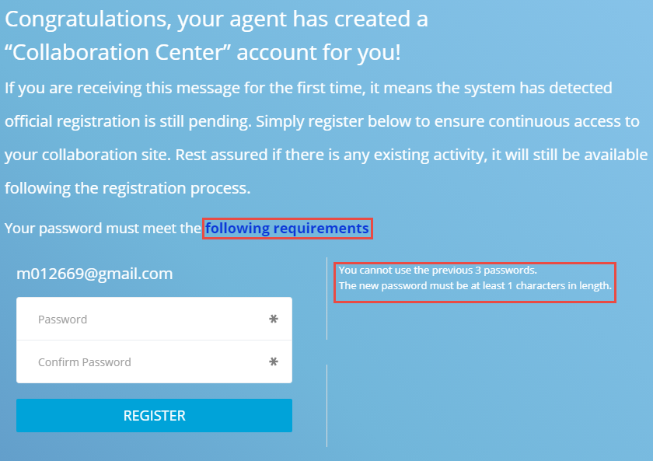

# Remove all Legacy Clients

Many times when Board and MLS staff add a new user to Paragon, they are presented with a list of Paragon clients that have legacy values that are not applicable to the user. In order to narrow the list of Paragon clients to only those that should be used, we have added a new function to remove/disable the unused Clients for MLS Staff. When using this function, a system support manager can change the security level required to use the Paragon client and can indicate if the client is applicable to 3rd Party Integrations.

**PLEASE NOTE:** **This functionality does not affect existing agent accounts or the default clients specified in the configuration settings.**

*Figure A* – Client Selection in Agent Maintenance

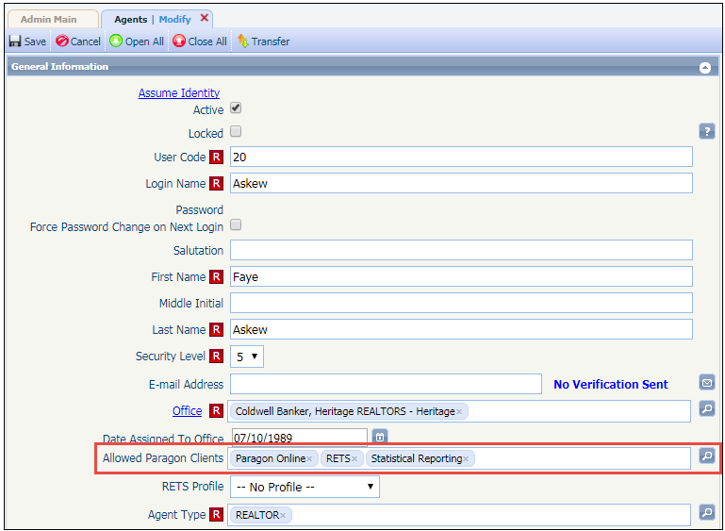

# Allow Customization of Login Page

Many times users will attempt to find their Paragon Site using Google. Invariably the link they select in the Google search is not for their MLS and they will repeatedly attempt to log in. We have added functionality that allows customers to add a logo to the Paragon login page that will help users identify the correct MLS to log in to. If customers use Clareity for identification management they cannot use this new functionality.

The logo may be any size up to a maximum of 600 X 250 pixels and must be in JPG or PNG format. Larger size files are better as we do not expand the image to fit the container allocated for it. The image is uploaded to the MLS Information module in Paragon using normal methods and is then displayed to all users when they access the Paragon login page.

*Figure A* – Image Upload

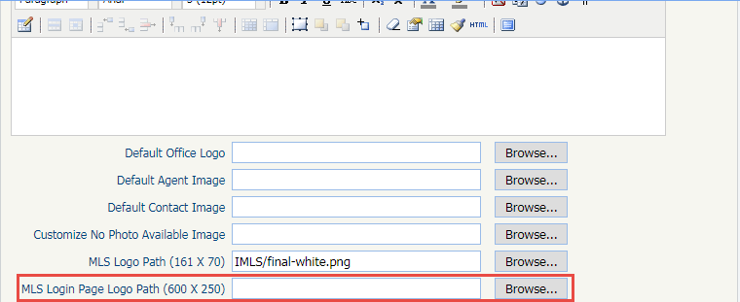

*Figure B* – Paragon Login Page with Logo

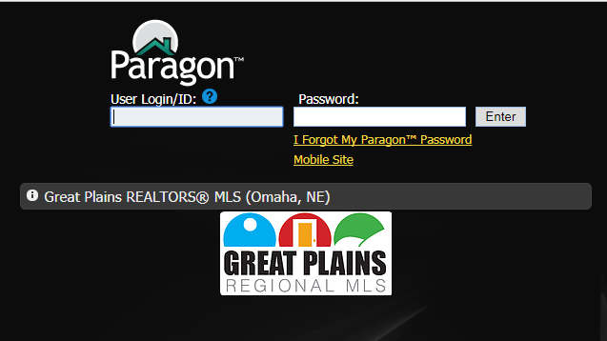

# Fields Added to Open House

New Open House fields have been made available to all Paragon customers that will increase functionality in the Open House module when activated. A longer Refreshment and Direction field has been added, the length of the existing open house tour Comment has been increased, an agent lookup which can be used to indicate the agent supervising the open house has been added along with a Yes/No field that customers can use to signify additional open house items such as treats/surprises that will be available, and an open house update field. Likewise, the Listing Input Maintenance form, reports, and views have all been updated to accomodate these additional fields.

**Note:** The new date field is not available for Listing Input Maintenance or reporting purposes and the open house fields cannot be added to a field preferences object but can be added individually to any open house custom report. Additional work may be needed to modify Tour/Open House searches, RETS, and other systems.

*Figure A* – Open House Module

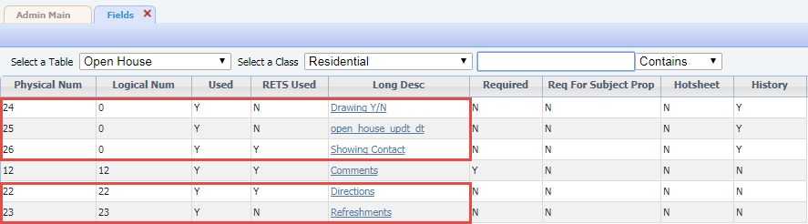

*Figure B* – Modify Open House

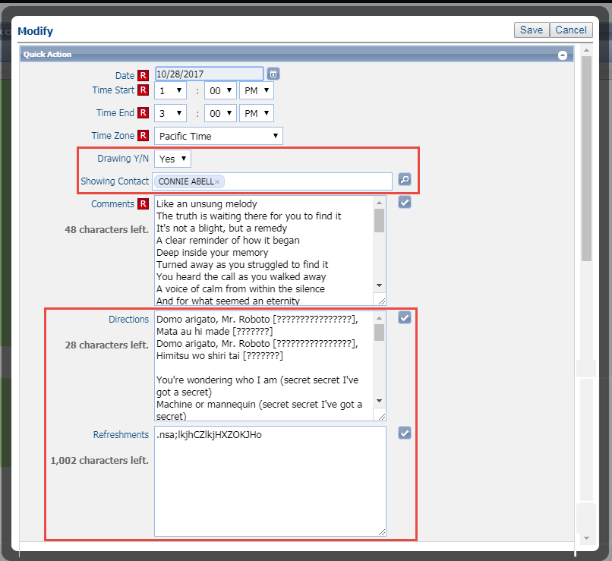

*Figure C* – Open House Field Preferences

The new fields cannot be added to legacy reports due to restrictions on the data available in them. However, the bit field and the showing agent field can be added to spreadsheet views.

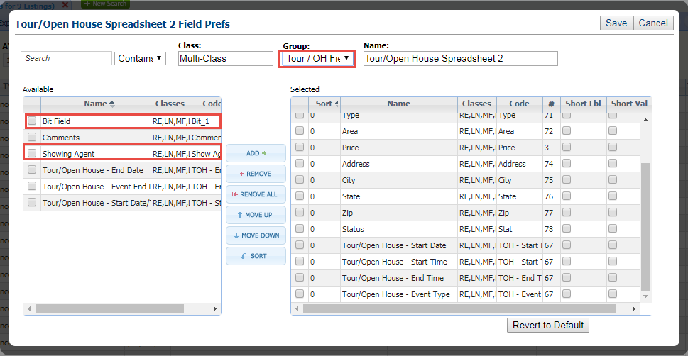

# Share Listings on Facebook

Agents now have the ability to share their listings to their Facebook account from the Listing Input/Maintenance Quick Actions menu. The Share to Facebook quick action item gives the listing agent the ability to share a listing preview. The posted listing preview includes the primary photo, a public remark, and a link to the Detail report in Collaboration Center. **Note:** The agent must have a Collaboration Center URL set up in Preferences > Collaboration Center Wizard for the Detail report link to function.

Built-in security in Listing Input/Maintenance controls the Share option to just the agents who have edit permissions on a listing; additional filters in the integration setup can restrict the Share option by Status, Listing Visibility Type, or Board. This function is configurable and will be disabled by default. Please contact your SSM to set up the Share to Facebook functionality.

*Figure A* – LIM Quick Action Menu *Figure B* – LIM Maintain Listing Menu

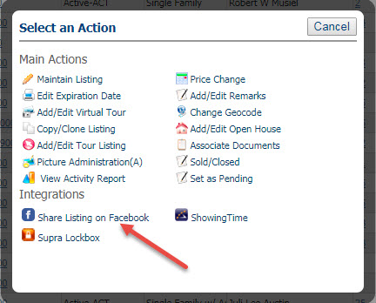 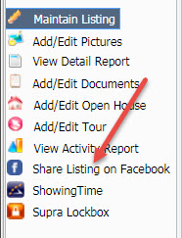

*Figure C* – Share to Facebook Modal

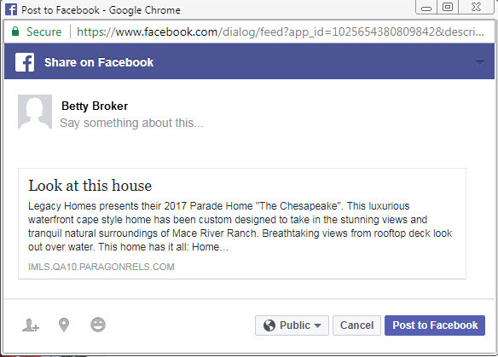

*Figure D* – Final Facebook Post

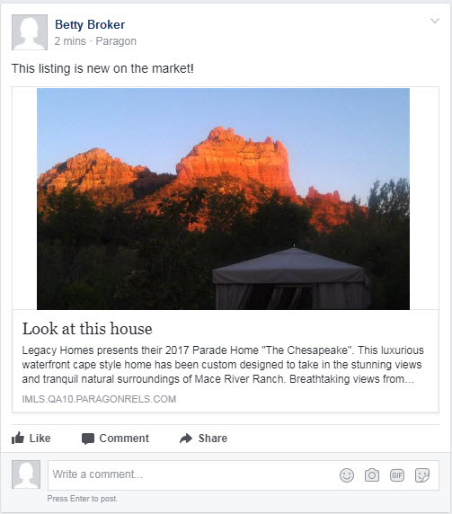

# Deletion of Paragon System Generated Emails

A new configuration has been added that determines how many days ***system*** generated emails are retained before they are automatically deleted. The default will be set to 90 days. The old configuration which controlled both manual and automated emails will remain but now only controls the number of days ***manual*** emails are retained and it will remain at its current setting.