# Agent Level Enhancements

# Hello Google Maps!

Google replaces Bing in Paragon and Collaboration Center (Collab Center)!  Now you and your Clients can enjoy the benefits of more up-to-date maps throughout Paragon.  As an added bonus, the Google Street View is included as a standard mapping feature.  Stay tuned for more mapping enhancements in the future!

# Expanded Details on the Property History Report

On the Property History Report, we have expanded the Change Type (Chg Type) field to display all activity for each change record, instead of truncating the data to one line.

# Sort by Office Dollar Volume on the Market Share Report

The Market Share Report has been modified to sort by office dollar volume. Each section of the report (Active, Sold – List, Sold – Sold and Pending) has been sorted independently of the other sections. The Market Share Report can be found in the Reports section after running a property search.

# Send Listing Reports as a PDF Attachment

You asked and we listened! Now send listing reports as a PDF attachment to an email. You can choose a group of listings and report views to add to the PDF. This option applies only when you are manually sending reports and does not apply to automated listing notifications in Collab Center. These changes are also implemented in Paragon Public records. Just a heads up, the maximum length of the PDF file is limited to 20 pages, so choose your listings carefully! *Also note that the HTML attachment type was removed from Paragon emails.*

# Field Rules Fixed When Converting Subject Properties

Enhancements were made to field rules allowing the listing and expiration dates to be updated as needed.

# Collab Center Contact Me Button Updated in the Mobile View

The Collaboration Center mobile view banner with the agent’s name now links to the agent’s profile and other contact information. The link has been converted into a button and the color updated to green making it easier to click and view information.

# Collab Center is Now “On Board” with Onboard Widgets

The Collaboration Center is getting an upgrade to the School and Neighborhood charts located on the Detail View. A new source of charts have been implemented to replace the previous Graphiq charts.

# Collab Center: Address Search

The location search control has been updated. The “Radius” tab has been relabeled to “Address”. The address field now allows you to type in an address to search. Also, a zero has been added to the radius scale and is the default address value. Consumers can also conduct an address search or a radius search using the same control.

# Mapping Features added to Collab Center

Remember the mapping options previously available in Client Connect? We’ve begun adding those features into the newly rebranded Collaboration Center.

# Visible Notification to Address Errors and Warnings in Listing Maintenance

When saving a listing and/or converting a partial listing to a standard listing, Paragon now displays a pop-up warning message when an error/warning is found. This helps call attention to the items that need to be addressed in the grid at the bottom of the screen to complete the process of updating or saving a listing.

# Address Overlay

When searching for properties in Quick Search, Property Searches and entering listings in Listing Input Maintenance, the address fields now have field mask overlays identifying the information to be placed in those fields.

# Agent Photo Visible

When an agent has their photo uploaded via the Preferences menu, the photo will display with the agent’s information when the agent name is clicked on in reports and listings. If no photo is available, the image will default to the Realtor logo or the default image as directed by the MLS. The Agent photo is also included in the Agent Maintenance screen for MLS Admins.

# MLS Customizations and Administration

All options in this section are configurable via MLS Administration controls or by your System Support Manager as noted.

# Welcome to a New Geocoding Solution!

All Paragon customers will be transitioned to a new Geocoding Service. This change only affects all newly entered listings going forward. ***More information will be shared in the future for those customers wishing to re-geocode their historical listings.***

# Rename Folders in MLS Documents

Previously in MLS Documents, folder owners could rename the folder description, but not the actual folder name. This enhancement allows the folder owner to rename both the Description and the Name of the folder. ***Please note that updating the Name of the folder will also update the link/URL to the folder.***

# Drag-and-Drop Sort Option for MLS Documents

Files in MLS Documents folders use to display by Date Saved, with the most recent file at the top. This has been enhanced to provide drag-and-drop functionality to the files within a folder, allowing them to be re-ordered within the folder. The new file order is automatically saved when the file is dropped into place.

# Statistical Reporting Enhancement by Member Board Affiliation

In some MLSs, many firms and offices are assigned to multiple boards. Agents and brokers assigned to these firms and offices are affiliated with only one or two boards. When users generate statistical reports there may be listings they would rather not have included based on the board affiliation of the primary listing instead of the Agent affiliation. If an office was affiliated with the selected board, all of its listings were reported even if the primary listing agent was not affiliated with the selected board.

In order to address this, the statistical reports were modified to determine listing activity based upon the board affiliation of the primary listing agent. Only listings in which the primary listing agent is affiliated with the selected boards will be reported.

# Team Fields Available in RETS

This enhancement includes list and sales team data in the following property centric RETS resources:

* Property
* Partial Property
* Tour
* Open House
* Hotsheet
* Media
* History
* Room/Unit/Green

# New Analytics Report on Paragon Views/Report Usage

Paragon now provides administrative users a simple method to analyze Listing Reports usage (from property search) in multiple BKMLS applications. The Report Activity Chart uses data captured by our activity tracking solution to display information over the last 90 days.

# Lookup Relationships for the State/Province Fields

This functionality will allow customers to create lookup relationships that include the Paragon State/Province field. Regional customers that cross state lines require the functionality to help improve listing input and searching errors especially when an MLS has similarly named areas, cities, or counties in their service area. These changes will affect Listing input and maintenance and all class specific searches.

# Ignore Pre Direction on Property History Report Matching

In several markets, the use of a street direction value can vary greatly. In one area all streets may have a pre direction value and in others a post direction value. In cases like these matching listings for CDOM/Property History has been enhanced to remove directional matching entirely based on MLS configuration.

# Open House Updates

Several new field options and changes have been made available to the Open House module.

# Office Code Displayed in Correction Emails

Paragon will no longer provide the system Office ID in correction emails. Instead it has been updated to include the appropriate Office Code making it easier to identify the office the correction applies to.

# Override Price Change Arrows

MLS Admin users can now access the price change function to include the Price Date and Previous Price fields. The Asking Price and Previous Price must be updated to match and the Price Date must be updated to 1 day later than when the system looks back to check price change statuses. The number of days that Paragon looks back is MLS specific. For example, if the MLS has set Paragon to look at prices 30 days back to determine price changes, the user would need to set the date to 31 days back to prevent the price change arrows from appearing. This is helpful when price changes are made accidentally and a correction needs to be made without invoking the price change arrrows.

# Corrected Issues

|  |  |  |  |  |
| --- | --- | --- | --- | --- |
| **Work Order** | **Seq** | **Module** | **Reporting Customer(s)** | **Issue Corrected** |
| 102151 | 1 | Admin - Field Setup | Coastal Carolinas, Greenville, IRMLS, Northern Great Lakes | Page unavailable/cannot be displayed when attempting to delete lookup relationship value. |
| 109463 | 1 | Views/Reports | Northern Great Lakes, REB3 | iPad cannot open 'Field Preferences' modal when customizing views |
| 111527 | 1 | Listing Conversion | Jackson MLS (JAAR), Lenawee, Memphis (MAAR), MiRealSource | Listings imported via parallel not triggering price change colors |
| 117676 | 1 | Email | Outer Banks, New River Valley, Paul Bunyan | Action icons not showing up on emailed All Fields Customizable Reports |
| 118089 | 1 | Quick Search | Beaufort County, ECAR, Omaha, IMLS, Iowa City, MAXEBRD, REB3, RAYAC< Rockford, Sedalia/Warsaw, SCWMLS, South Jersey Shore, Upper Peninsula | When pressing clear on quick search to run new search, the address num field operator defaults back to multiple instead of single. |
| 128812 | 2 | Email | Coastal Carolinas, Cheyenne, Charlottesville, CREN, Gainesville, Grand Junction, Omaha, Hudson County, Juneau, SJRS, Tahoe Sierra, Ulster, Yuma, Sandicor, IRMLS, IMLS, Maui, MiRealsource, SCWMLS | Insert Into Body- Listings not displayed when inserted into the body of the message of an email |
| 130635 | 1 | Statistical Reporting | MAXMLS / EBRD | Admin user unable to run Sales Detail for Agent report |
| 132854 | 1 | Search - Address | SCWMLS, Northern Ontario, REB3, Rutherford, Sandicor | When on the Ipad using the Chrome browser results do not scroll past about 8 results |
| 132971 | 1 | Email | Outer Banks, Gainesville, ECAR, Highland Lakes, IMLS, NKMLS, Northern Michigan, REB3, RANW, Omaha, Wichita Falls, Topeka, St. Augustine, SCWMLS | Rich Text Editor-Email font size small at the beginning of email not respecting font settings. |
| 134518 | 1 | Search - Address | REB3 | Power search sometimes showing duplicate listing when entering address |
| 134737 | 1 | Search - Address | NKMLS | Power Search returns two sold props but not active when searching by address |
| 135986 | 1 | CMA | Superior, Duluth, BCAR, IRMLS, Traverse, REB3, Triangle | Final Comments are not saving in CMA |
| 136142 | 5 | Seller Side Activity | RANW | CC2 - Seller Side Activity appears under menu when not enabled |
| 136166 | 1 | Third Party Integration | MiRealSource, IMLS | BuildFax Icons will not appear in reports for MIMLS |
| 136426 | 1 | Admin - Agent | Sandicor | Agent Transfer function is timing out |
| 136457 | 1 | Admin - System Setup Options | Sandicor | Response email from responding to manual emailed properties misspelled |
| 136951 | 1 | Login/Login Page | MiRealSource, Northern Ontario | Forgot password link not showing on log in screen |
| 136997 | 1 | RETS | Georgia MLS | RETS Update failing on QA environment |
| 137364 | 2 | Admin - Field Setup | NEREN | Audit keeps showing hiddenuserid 0 when changes are made to Organization fields |
| 124270 | 1 | Contact Activity | Sandicor, REB3 | Clean up UI Regarding Approval function in Agent Preview |
| 114209 | 1 | Development/Architecture | NEREN | Need to remove all references in Paragon to Voice Alerts and Search as they have been sunset. |
| 137259 | 1 | Collaboration Center | Kingston, Northern Ontario | Collab Center Agent Notification links to Clareity SAFEACCESS login |
| 112347 | 1 | Input Maintenance | Intermountain, NEREN | Tablet - iPad 3 - Chrome - "Select an Action" box slowly moves down the screen |

# Agent Level Changes

**The following section contains changes that are active system wide** **and available to users based on their assigned security levels.**

# Hello Google Maps!

Google replaces Bing in Paragon (except Advanced Mapping functionality, which will be done in a future release) and Collaboration Center (Collab Center)! Now you and your Clients can enjoy the benefits of more up-to-date maps throughout Paragon. As an added bonus, the Google Street View is included as a standard mapping feature. Stay tuned for more mapping enhancements in the future!

The map has been updated with Google Maps in the following areas:

* Map Searches:
  + ***The Map views/data is more up-to-date and is updated more frequently than Bing maps***
  + A new Hybrid View is available on the menu which is a combination of Aerial with map labels
  + When zoomed and using Aerial or Hybrid views:
* A 3D Tilt View () is available which mimics the former Bird’s Eye View
* Street View is available and can be seen wherever blueish lines appear on the map as you hover over it with the ‘Browse Street View’ icon ()
* Customers can rotate the map 90° () at a time for up to a 360° rotation
  + Points of Interest has been updated to an on/off switch instead of selecting the various POIs that are available, all or none will be displayed
  + Clusters work a little differently. They appear in at least three colors based on the number of listings within the cluster (blue, yellow, and red) and the Listing Overview panel only appears when clicking on a listing price. ***It will not appear when clicking on a sub-cluster***
  + Bird’s Eye View is no longer available
  + ***Distance measurements do not display when drawing a shape (), however the address radius function still exists***
  + ***The Place Marker () was no longer supported by Bing and was therefore removed as we switched to Google***
  + In Google, when drawing a polygon shape it appears as lines with connecting points that the customer has to connect to close and complete the shape, whereas in Bing, the polygon appeared as a closed shape after adding the second point
* Quick Search
  + All above features also apply to the Mapping Search found in Quick Search
* Driving Directions
  + ***The ability to zoom on the map is no longer available***, however, we are looking into enhancing this feature in an upcoming release
* Change Geocode window
* Map Icons that open a map window
* CMA
* Maps embedded in reports [e.g., All Fields Detail, Google Map report (formerly known as Bing Map report), etc.]
* Print/Print+
* Emailed Reports
* Publink – when listings are manually e-mailed or legacy listing notifications are accessed
* Listing Input Maintenance
* Preferences Menu features
* Preference Wizard
* Custom Views and Reports
* RETS
* IDX Smart Framing

*Figure A* *– Google Map (Paragon)*

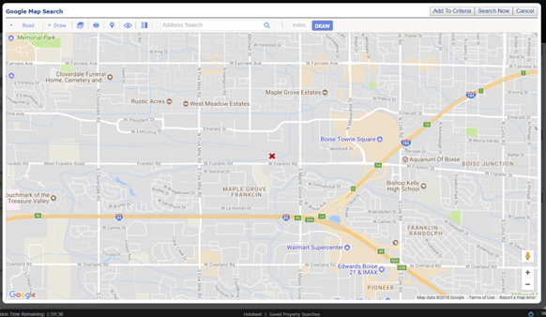

**For more information, Frequently Asked Questions (FAQs) and a handy site dedicated to showcasing the powerful Google Mapping changes in Paragon** [**GO HERE**](https://paragonrels.wixsite.com/paragon-info/google-mapping)**! Feel free to share this site with your Members and Users!**



*Figure B* – *Google Map Report* *(Paragon)*

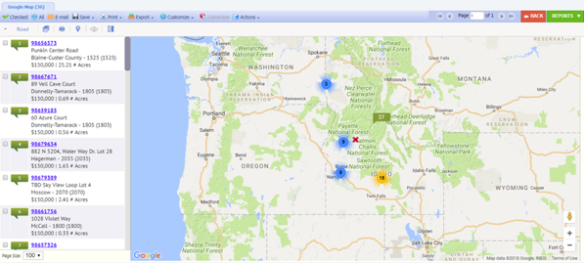

The Property Search and Results were also updated with Google Maps and its associated features incorporated. You will notice Google features displayed in the bottom right of the map which inlcudes the Locate Me, Street View, and Zoom controls. There is also a Menu control that allows users to turn points of interest on or off. Also, in the bottom left the map view can be changed between Road and Aerial.

*Figure C* *– Google Maps Property Search (Collab Center)*

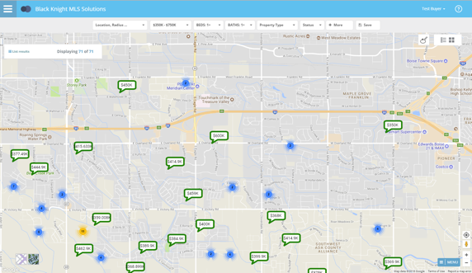

# Expanded Details on the Property History Report

On the Property History Report, we have expanded the Change Type (Chg Type) field to display all activity for each change record, instead of truncating the data to one line. ***This enhancement is retroactive for all existing history records.***

*Figure A* *– Old Version*

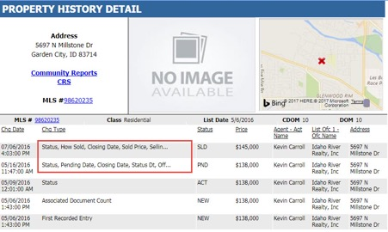

*Figure B – New Version*

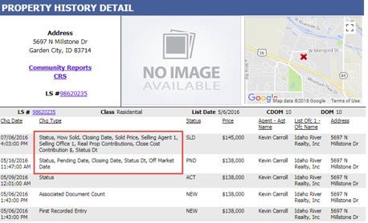

# Sort by Office Dollar Volume in the Market Share Report

The Market Share Report has been modified to sort by office dollar volume. Each section of the report (Active, Sold – List, Sold – Sold and Pending) has sorted independently of the other sections. The Market Share Report can be found in the Reports section after running a property search.

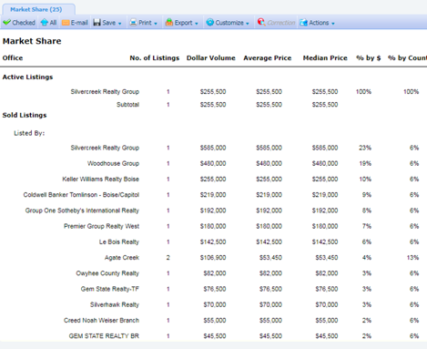

# Send Listings Reports as a PDF Attachment

Previously when a User selected a Report that had multiple listings per page (multi-ups) to e-mail as an attachment, only the first page was attached as a PDF. Users will now be able to successfully choose a group of listings and multi-up report views to attach to an email as a PDF file. Only the manual Paragon email process has been modified. These changes have been implemented in Paragon Public records also. The maximum length of the PDF file that is allowed is 20 pages. The retention rate of email attachments will match the retention rate of emails defined by customers.

**PLEASE NOTE:**

**If the attachment is longer than 20 pages, it will be cut off at 20.**

***The HTML attachment type was removed from Paragon emails.*** In some cases, multiple page HTML files were generating inconsistently and PDF formats are the most common format used.

The Print Plus function has been used in the email module to accomplish this change. The manual email dialog has been heavily modified to display warnings about email attachment lengths and to remove invalid references.

*Figure A – E-mail Reports window*

**NOTE: These reminder messages are only displayed when the “Attachment (PDF)” option is selected.**

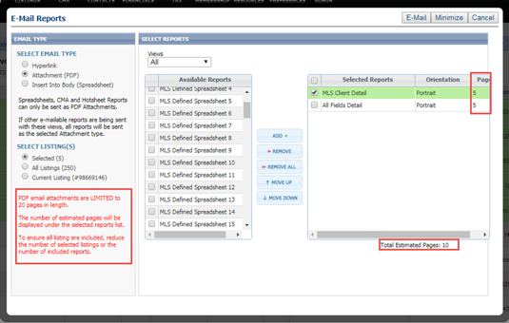

*Figure B – E-mail Confirmation window*

Users will now have to accept a warning after selecting listings and reports or they cannot continue with the emailing process.

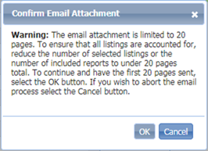

*Figure C* – *E-mail Attachment Name*

Each email attachment will be encoded with a name that indicates the creation of the attachment. The format is MMDDYYYYHHMMSS.PDF and is based off the user’s local time.

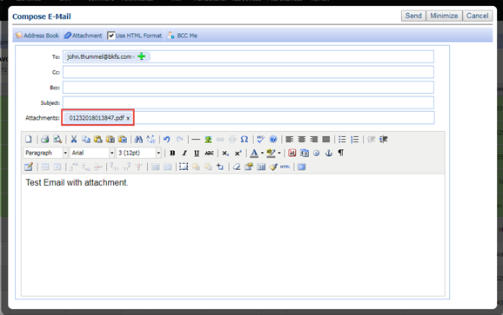

# Field Rules Fixed When Converting Subject Properties

Enhancements were made to field rules allowing the listing and expiration dates to be updated as needed.

*Figure A* – *Subject Property Error Message*

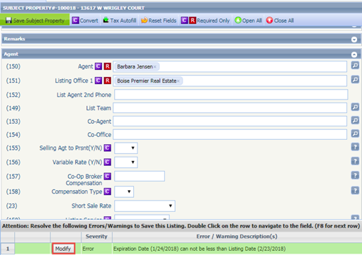

The user now has the opportunity to enter a Status and modify the Listing and Expiration Dates while converting the subject property to a listing.

*Figure B* – *Convert* *Subject Property Window*

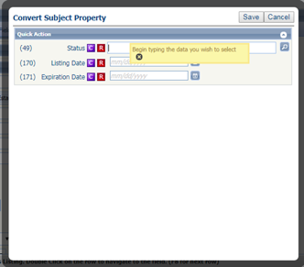

# Collab Center Contact Me Button Updated in the Mobile View

The Collaboration Center mobile view banner with the agent’s name now links to the agent’s profile and other contact information. The link has been converted into a button and the color updated to green making it easier to click and view information.



# Collab Center Now “On Board” with Onboard Reports

Collaboration Center is getting an upgrade to School and Neighborhood charts and reports. These new improved charts and reports provide Collab Center users with the detailed information they need to evaluate the area surrounding the homes they are interested in. ***This information is provided for U.S. Customers only at this time.***

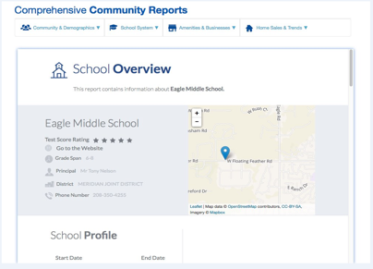

# Collab Center: Address Search

The location search control has been updated. The “Radius” tab has been relabeled to “Address”. The address field now allows you to type in an address to search. Also, a zero has been added to the radius scale and is the default address value. Consumers can conduct an address search or a radius search using the same control.

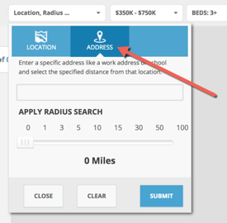

# Mapping Features added to Collab Center

Remember the mapping options previously available in Client Connect? We’ve begun adding those features into the newly rebranded Collaboration Center.

Here are a few examples:

* Aerial View
* Points of Interest
* Locate Me
* Street View

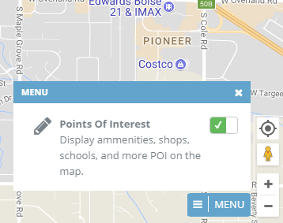

# Visible Notification to Address Errors and Warnings in Listing Maintenance

When saving a listing and/or converting a partial listing to a standard listing, Paragon now displays a pop-up warning message when an error/warning is found. This helps call attention to the items that need to be addressed in the grid at the bottom of the screen to complete the process of updating or saving a listing. The message will display advising that your listing has not been saved and you must address the errors/warnings listed below. **In addition, the listing and expiration dates will now display in red in the error grid. This makes it easier to identify the dates saved on the listing before accepting or modifying the information.**

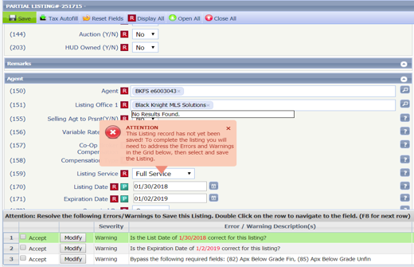

# Address Overlay

When searching for properties in Quick Search, Property Searches and entering listings in Listing Input Maintenance, the address fields now have field mask overlays identifying the information to be placed in those fields.

*Figure A* – *Quick Search Figure B* – *LIM*

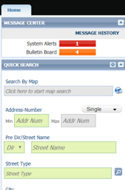 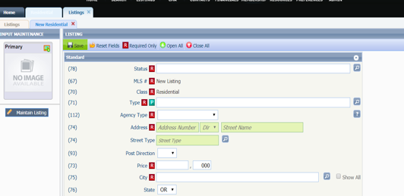

# Agent Photo Visible

When an agent has their photo uploaded via the Preferences menu, the photo will display with the agent’s information when the agent name is clicked on in reports and listings. If no photo is available, the image will default to the Realtor logo or the default image as directed by the MLS. The Agent photo is also included in the Agent Maintenance screen for MLS Admins.

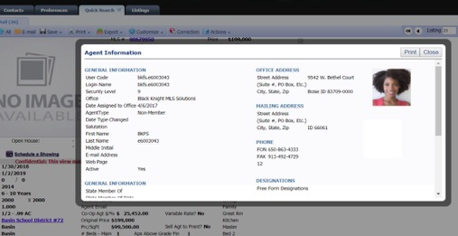

# MLS Customizations and Administration

**All options in this section are either configurable via MLS Administration controls or by your System Support Manager as noted.**

# Welcome to a New Geocoding Solution!

All Paragon customers will be transitioned to a new Geocoding Service. This change only affects all newly entered listings going forward. ***More information will be shared in the future for those customers wishing to re-geocode their historical listings.***

# Rename Folders in MLS Documents

Prior to this enhancement, in MLS Documents, folder owners could rename the folder description, but not the actual folder name. This enhancement allows the folder owner to rename either the Description or the Name of the folder. This change applies to the MLS, Board, Firm, and Office folders. ***Please note that updating the Name of the folder will also update the link/URL to the folder.***

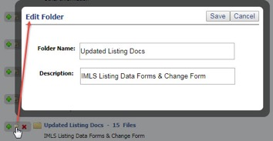

# Drag-and-Drop Sort Option for MLS Documents

Files in MLS Documents folders use to display by Date Saved, with the most recent file at the top. This has been enhanced to provide drag-and-drop functionality to the files within a folder, allowing them to be re-ordered within the folder. The new file order is automatically saved when the file is dropped into place. Any user who has permissions to add files to a folder can reorder those files.

**Please Note:** The files cannot be dragged to a different folder.

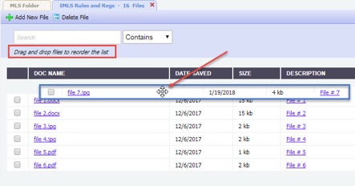

# Statistical Reporting Enhancement by Member Board Affiliation

In some MLSs, many firms and offices are assigned to multiple boards. Agents and brokers assigned to these firms and offices are affiliated with only one or two boards. When users generate statistical reports there may be listings they would rather not have included based on the board affiliation of the primary listing instead of the Agent affiliation. If an office was affiliated with the selected board, all of its listings were reported even if the primary listing agent was not affiliated with the selected board. In order to address this, the statistical reports were modified to determine listing activity based upon the board affiliation of the primary listing agent. Only listings in which the primary listing agent is affiliated with the selected boards will be reported.

The table below indicates how the board affiliation of an individual agent or broker is determined. The most concise description of the logic is: Individual board affiliation is a subset of the board affiliation of the agent\broker’s assigned office.

**PLEASE NOTE:** **This functionality will change the way statistical reports account for listing activity and accommodate both Agent/Board affiliation and Office/Board affiliation scenarios.**

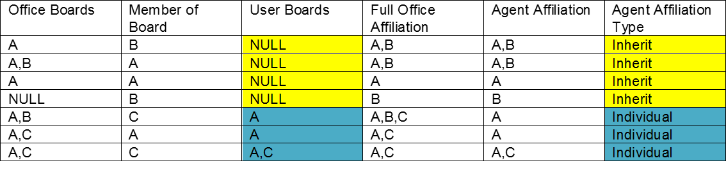

# Team Fields Available in RETS

This enhancement includes list and sales team data in the following property centric RETS resources:

1. Property
2. Partial Property
3. Tour
4. Open House
5. Hotsheet
6. Media
7. History
8. Room/Unit/Green

In order to activate the fields for use in RETS a metadata refresh must be performed. Both the Field Setup form’s RETS settings and the RETS Profile module have been modified to accommodate the team fields. The data stored in the listing table is the team ID value. We have added lookup references to the metadata so vendors may convert the team ID values to a displayable name. The team fields can be searched upon and/or included in query results.

*Figure A* – *Fields Setup Module*

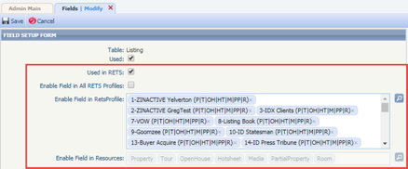

*Figure B* – *Fields in Existing Profile*

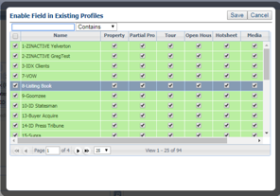

*Figure C* – *RETS Profile Module*

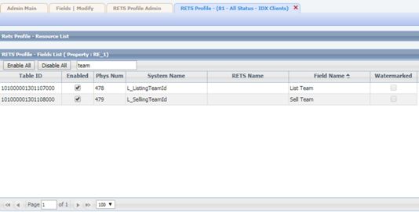

# New Analytics Report on Paragon Views/Report Usage

Paragon now provides administrative users a simple method to analyze report (from property search) usage in multiple BKMLS applications. The Report Activity Chart uses data captured by our activity tracking solution to display information over the last 90 days. The reporting time period is not configurable.

**Note:** If for some reason a customer does not have activity tracking functionality enabled, it will need to be activated for the report to display data.

*Figure A* – *Admin>Analytics>Analytic Reports*

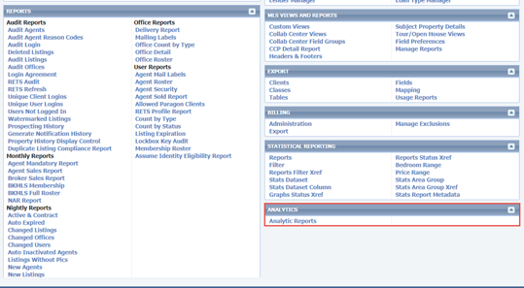

*Figure B* – *Analytic Reports*

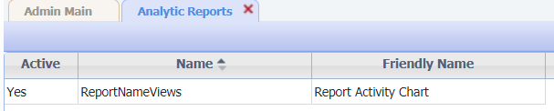

*Figure C* – *Report Activity Chart*

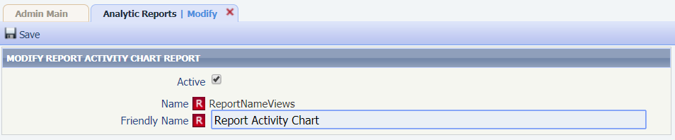

*Figure D* – *Admin>Reports>Analytic Reports*

The Report Activity Chart will be downloaded to the user’s local device as a CSV spreadsheet like several other Paragon reports. The user may modify the downloaded file as needed.

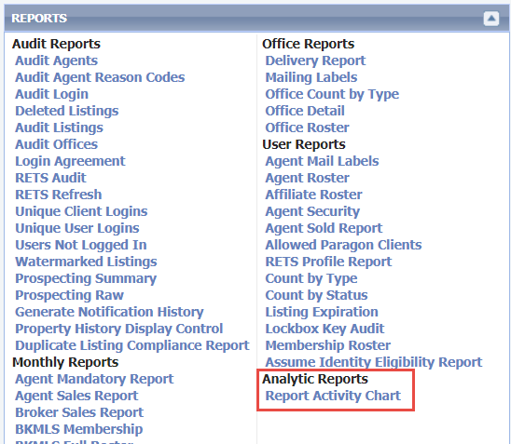

*Figure E* – *Download Message*

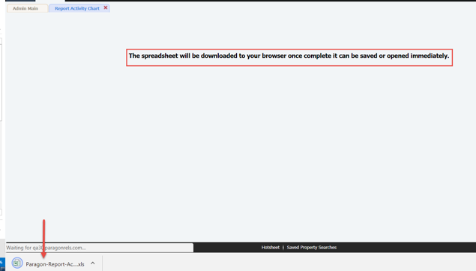

*Figure F* – *Sample CSV Reports*

Report activity is grouped by report name, report category, and application. The display order and sort is not configurable by default but can be manipulated in Excel.

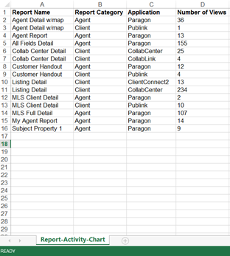

# Lookup Relationships for the State/Province Fields

This functionality will allow customers to create lookup relationships that include the Paragon State/Province field. Regional customers that cross state lines require the functionality to help improve listing input and searching errors especially when an MLS has similarly named areas, cities, or counties in their service area. These changes will affect Listing input and maintenance and all class specific searches.

*Figure A* – *Lookup Relationship*

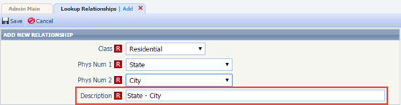

*Figure B* *– Lookup Relationship Values*

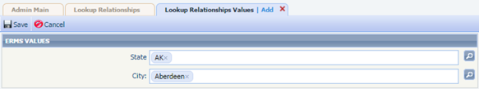

*Figure C* *– LIM Behavior*

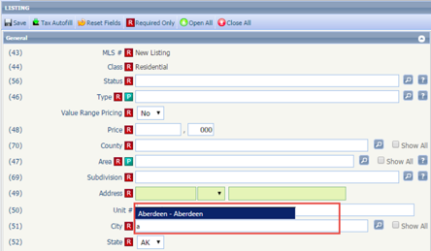

*Figure D* *– Search Behavior*

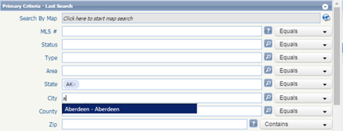

# Ignore Pre Direction on Property History Report Matching

In several markets, the use of a street direction value can vary greatly. In one area all streets may have a pre direction value and in others a post direction value. In cases like these matching listings for CDOM/Property History has been enhanced to remove directional matching entirely based on MLS configuration. **The Property History task must be initiated after changing the value of the configuration setting. The changes will only affect property address matching, all other matching criteria WILL NOT be modified.**

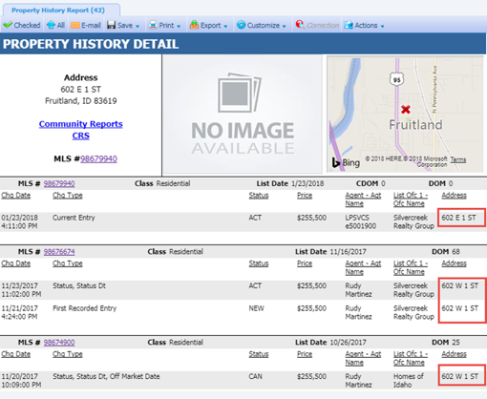

# Open House Updates

Several new field options and changes have been made available to the Open House module. Five new fields were added:

* + - Showing Agent ID: Houses the data for the agent/broker that will be attending the Open House event, utilizes standard Paragon agent lookups on input and search
    - Refreshments: New 1024 character field for refreshments
    - OH Drawing: New (Yes/No) field for Open House drawings
    - OH Directions: New 1024 character field for Open House directions
    - Source Date Modified: Additional date/time field to record when an Open House record is created or modified

The current Open House comment field in Paragon has been extended to 1024 characters as well. The new character and Yes/No fields can be accessed via the Fields Setup module and can be configured in the same manner as other fields. Note that the RETS Profiles have been modified to accommodate the new Open House fields.

The LIM module will be modified to include the new fields in the input screen. The Open House maintenance grid will not be modified.

*Figure A* *– OH Maintenance*

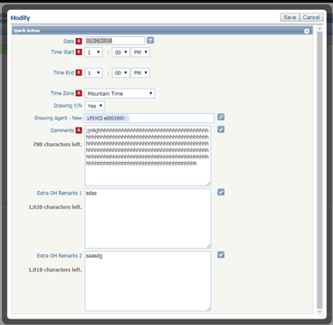

The Paragon and Collab Center Open House searches will be modified.

*Figure B* *– OH Search*

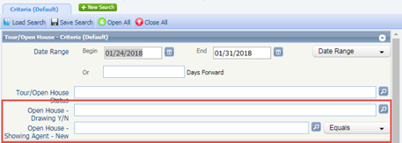

The new Open House fields will be available for all custom Open House report views.The new Open House fields will also be added to Collab Center reports.

*Figure C* *– Custom OH Report*

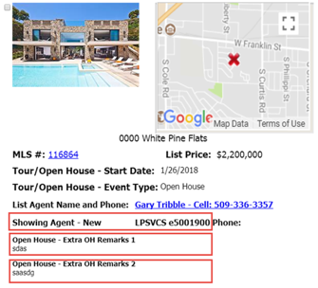

The new Open House fields will be limited in spreadsheets and legacy Open House views. Only those spreadsheet and legacy views that specifically allow access to the Tour/Open House field group are eligible for the new Open House fields with the exception of the new 1024 character fields.

*Figure D* *– Custom OH Report Preference*

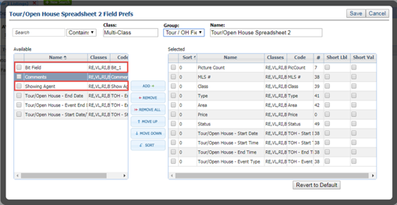

*Figure E* *– Custom OH Spreadsheet Report*

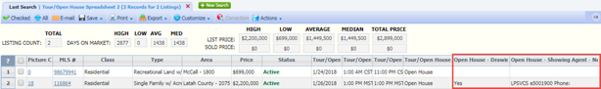

# Office Code Displayed in Correction Emails

Paragon will no longer provide the Office ID in correction emails. Instead the Office Code will be provided making it easier to identify the office the correction applies to.

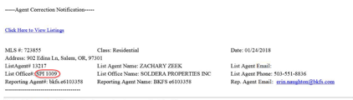

# Override Price Change Arrows

MLS Admin Users now have the ability to control when the Price Arrows function displays or not and now have access to the Price Date and Previous Asking Price fields when performing a price change. The Asking Price and Previous Asking Price must be updated to match and the Price Date must be updated to 1 day later than when the system looks back to check price change statuses. The number of days that Paragon looks back is MLS specific. For example, if the MLS has set Paragon to look at prices 30 days back to determine price changes, the user would need to set the date to 31 days back to prevent the price change arrows from appearing.

