# Agent Level Enhancements

# Announcing Homebot for Paragon and Collaboration Center!

Black Knight is excited to reveal a new Agent feature in Paragon and Collab Center called Homebot. Homebot is an innovative marketing and lead generation tool that directs monthly, interactive emails (called “Homebot Digest”) to homeowners about extremely valuable information on their property like:

* + - Home Value
    - Existing loans on their home
    - Home equity
    - How to save on interest payments
    - Down payment for an investment property or move-up home
    - Area rents
    - Refer a friend

Homebot is the tool that every Homeowner in the U.S. will absolutely LOVE to have! The information is extremely valuable in managing what could be the Homeowner’s largest and most important asset, their Home. *This exciting informational, collaboration tool will be made available by default to all Paragon Agents with the 5.64 release.*  Watch for a separate document with more details on Homebot.

# Collab Center: Preference Wizard Web Page Setup

Previously, some end users with iPads could not configure their Collaboration Center site as the Preferences Wizard is turned off when viewing Paragon on an iPad. To mitigate this concern, the Collab Center Site Information content has been added to the Collab Center section of User Preferences. This allows end users to configure their Collaboration Center Site regardless of the device being used.

# Collab Center: State Field Searches

Previously changes were made to Paragon that allow MLS customers to limit the number of States displayed to users when performing a search or inputting a listing. This change was made to increase the efficiency of users and help mitigate input errors. The state lookup limitations have now been added to Collaboration Center search.

# Collab Center: Hide Client Search Notification Options

The ability to hide the notification options for new or modified client searches has been added when that function is unavailable to the agent, based on security level.

The option to allow Collaboration Center clients to create or modify their own searches can be restricted by security level. If the agent’s security level is below the level set by the MLS, the option to create a search is now unavailable to their Collaboration Center clients. The notification options for **“Notify on New Client Search”** and “**Notify on Modified Client Search”** in the Preferences\Collab Center\Notification Options will now be hidden if the agent’s security level does not allow client searches in Collaboration Center.

# Collab Center: Map Layers Added

The Collaboration Center and CollabLink applications have been enhanced to include Map Layers. These are the same map layers found in Paragon which include Parcels, County, Flood, Traﬃc, Area, etc. Parcels cannot be to display parcel details at this time. Future enhancements may include the ability to view tax and parcel data from this layer.

# Collab Center: Access Listing Details Directly from the Listing Update Notification

A direct link has been added that will take the user to the Collaboration Center’s Listing Detail view from the listing summary of properties included in the client Listing Update email notifications. Closing the Listing Detail view will return the user to the Collaboration Center home page.

# Associated Documents in Collaboration Center

An option has been added for including public Associated Documents in Collaboration Center.

Enabling Associated Documents will add a new section to the Detail reports, with a link to each publicly viewable document for that listing. An Action icon that opens an Associated Documents screen will also be added to the Summary views. Clicking a document link opens that document on a separate screen using the program tied to the device that accesses and opens the document.

**Note:** To display in Collaboration Center, the Associated Documents must have Public (E-Mailable) set to Yes.

# Property History Reports Shows Reference Data

When users add the listing agent and office fields to the Property History they did not have an efficient way to review additional information about the agent or office without changing to another report view.

In order to promote consistency amongst report views and add quick access to pertinent information, the listing agent and office fields in the Property History report have been hyperlinked so that when a user clicks the hyperlinked listing agent or office names, the standard agent or office detail screen will display.

# Reorder Your Results on Google Map Report

Available by popular demand, the ability to reorder listings on the Google Map Report view is included in this release. Users can now drag and drop the results in any order that they would like on the report. This will cause the report to refresh so that the numbering associated with the listing in the results and on the map will match. This enhancement alleviates the need to toggle between the Google Map report and the spreadsheet view to reorder the results because previously reordering could only be done in spreadsheet result views.

# Improvements to Email Notifications

Currently, when a user deletes an email signature linked to one or more existing email notification there is no option to replace the deleted signature with another one. Users are forced to manually edit each affected notification to add a replacement email signature.

The email signature processes have been modified to provide users with an opportunity to modify email notifications with a new signature if they choose to. This change eliminates the need to manually modify email notifications. The user may also choose to permanently remove email signatures from the affected notifications.

# Email and Print Update for Estimated Pages

Per customer suggestion we’ve modified the Estimated Pages column heading to be more descriptive changing it from ‘Pages’ to ‘Est. Pages’.

# Rounding Listing Prices Over $1,000,000

Although infrequent, when a listing price is over $1,000,000, the listing marker on Map Searches in Paragon would usually round the price too high or too low. This has been corrected so that the rounding displays one decimal place.

# Precursor Performance Changes for Automatically Displaying Results on Map Search

In preparation for automatically displaying results when accessing the map search (i.e., Map Boundary) in the next Paragon release, a few performance improvements have been made, thus making results return faster:

* Results reflect lowest to highest system price, previously it displayed highest to lowest price.
* Listing data doesn’t load until the user clicks on a cluster or listing price marker.
* The number of columns returned in the results has been limited to a small few key fields.

Another major improvement is that listing map results will now return 2,500 listings instead of 500. Because of the performance improvements listed above, the results return faster.

# Listing Activity Data Retained for 120 Days

The Listing Activity displayed on the Listing Activity Report in Paragon Listing Maintenance and in the Sell Side of Collaboration Center has been refactored to retain this pertinent information for the previous 120 Days. This change promotes data accuracy and optimizes system performance.

# MLS Customizations and Administration

All options in this section are configurable via MLS Administration controls or by your System Support Manager as noted.

# Enhanced Admin Report on Usage of Listing Reports

New data has been added to the Report Activity Chart. Two new columns have been added; the Report Owner indicates the entity classification and the Report ID indicates the ID of each report.

# Minimum Photo Size for Listings

To ensure better quality photos are added to listings, a minimum photo requirement has been implemented to prevent uploading photos that are too small alleviating accidental upload of thumbnail sized photos instead of the full photo of the listing. If a photo is too small, the user will receive an error while attempting to upload it.

# Additional Categories for Market Monitor

This enhancement provides the MLS with the option to add ‘Back on Market’ and/or Rented/Leased as stand-alone categories in the Market Monitor’s Market, Office, and Firm sections.

Currently, Back on Market listings are only included in the Hot List of the Market Monitor and Rented/Leased are not currently available. This modification provides the MLS with the option of adding Back on Market and/or Rented/Leased as separate categories, via the Market Monitor Filter. The Rented/Lease category will display in Market Monitor using the MLS’s Status Category Description for Category 6. The MLS can also turn on a configuration that will allow agents to have access to modify the categories on their Market Monitor from Preferences\System\Market Monitor.

# Force Manual Geocode Required for Listing Input

Some MLS Customers would like to make users manually place the pin on listings (manual geocoding) for listing input and modifications. The current Admin\Mapping menu’s ‘Input Maint Required’ field has been changed to a drop down. The ‘Force Manual Geocoding’ option has been added and when selected will force users to manually geocode listings whenever a new or modified listing address is entered.

# Updates to Listing Audit and Property History Reports

There can be listings with a large number of audit records. The large number of audit records is generally associated with customer conversion cycles or parallel processes. When a listing has more than 999 audit records the Listing Audit and Property History reports did not report the history of a listing correctly. Additionally the Days on Market (DOM) value displayed on the Property History report was calculated incorrectly if a listing had more than 999 audit records. Both issues have been corrected.

# Power Search Now Adheres to Board Rules

Customers using Association Autonomy have requested changes to Power Search so that it respects the listing and membership participation settings of member boards. Legacy and advanced Power Search have been modified to adhere to Association Autonomy listing and membership participation settings.

# Collab Center: Third Party Integrations

Do you have a third-party integration in Paragon that you wish you could expose to consumers in the Collaboration Center? Now you can! In 5.64, MLS organizations can now enable any third-party integration available to them in Paragon. All you have to do is contact your SSM and they will work with you to setup that integration point inside of Collaboration Center.

# Corrected Issues

|  |  |  |  |  |
| --- | --- | --- | --- | --- |
| **Work Order** | **Seq** | **Module** | **Reporting Customer(s)** | **Issue Corrected** |
| 106746 | 1 | Input Maintenance | Missoula County, Ashland, CREN, Greater Tyler, Heart of Kentucky, Missoula County | Associated Document Count not returning correct values in conditional logic |
| 110434 | 1 | Input Maintenance | Spokane, Central Mississippi, Charlottesville, North Central Virginia, Nova Scotia | Agents able to use lookup relationship values that have not been approved |
| 113561 | 1 | Admin - Messaging | Cape Girardeau County, Higland Lakes, IRMLS, RANW | MLS Messaging not working correctly |
| 130300 | 1 | CMA | Great Plains (Omaha) | Page cannot be displayed on adjustments page in CMA |
| 132854 | 1 | Search - Address | South Central Wisconsin, REB3, Rutherford, Sandicor, Northern Ontario | Ipad Chrome does not scroll past about 8 results ios, ipad |
| 133400 | 1 | Collab Center | REB3 | Clients are able to search in Collab only on Mobile devices when New Search is set to level 9 |
| 136018 | 1 | Contact Management | REB3, NEREN | Agent Preview- Approving listings receive error |
| 136940 | 1 | Preferences | REB3, NEREN | When selecting Agent Preview in CC preferences an error message displays |
| 137725 | 1 | Collab Center | REB3 | When selecting a few listings for Agent Preview warning message shows System ID |
| 138148 | 1 | Mapping | Willamette, Rockford | When using print from the google map always prints aerial view |
| 138426 | 1 | Collab Center | Triangle MLS | DEFAULT MAP ZOOM LEVEL: By default the map zoom level for CC2 is zoomed in too far |
| 121785 | 33 | Search - Property | MAXMLS / EBRD, MiRealSource, NEREN | Power Search does not respect rules set by Board |
| 123716 | 1 | Views/Reports | REB3 | Ability to display Feature abbreviations on spreadsheets not functioning |
| 124201 | 1 | Mapping | Santa Fe, REB3 | Santa Fe- The pins on the map are rounding up too high and giving inaccurate price |
| 127268 | 2 | Market Monitor | NEREN | Setting MM filters after customizing does not refresh the MM listing counts automatically |
| 135163 | 1 | Third Party Integration | Baldwin County, Bayou | Sentrilock Assign Lockbox inoperable for BCAR due to limitation in configuration data |
| 135912 | 1 | Buy Side | RANW | Collab Center filter shows as "No Filter" and not All Updates |
| 136575 | 1 | Prospecting & Notifications | Western Kentucky | Email notifications not updated when default email signature deleted/replaced |
| 137566 | 1 | Buy Side | REB3 | Notifications for New Search and Modified search were added to Collab Center for Customers that don’t offer Collab Center search. |

# Agent Level Changes

**The following section contains changes that are active system wide** **and available to users based on their assigned security levels.**

# Announcing Homebot for Paragon and Collaboration Center!

Black Knight is excited to reveal a new Agent feature in Paragon called Homebot. Homebot is an innovative marketing and lead generation tool that directs monthly, interactive emails (called “Homebot Digest”) to homeowners about extremely valuable information on their property like:

* + - Home Value
    - Existing loans on their home
    - Home equity
    - How to save on interest payments
    - Down payment for an investment property or move-up home
    - Area rents
    - Refer a friend

This new Collaboration Center feature focuses on addressing the needs of Homeowners, Prospective Buyers, and Prospective Sellers. Part of our long term strategy for Collaboration Center is to be the common portal for all types of Clients: Home Buyer - >  Home Seller -> Homeowners -> Prospective Buyers\Sellers.  It is rapidly becoming a one-stop shop for all of our client’s needs.

We have leveraged a 3rd party company named, “Homebot” which we have integrated and embedded into Collaboration Center:

* It provides Homeowners with insight into the financial aspects of their existing home, focusing on the overall wealth building nature of real estate
* It provides Agents with a new tool to engage and incubate new Prospective Home Sellers as well as their existing client base
* It draws new Prospects to the Agent when coupled with Social Media and the Agent’s website
* It is a Premium feature that requires a separate subscription from either the Agent or Broker

This exciting informational, collaboration tool will be made available by default to all Paragon Users in the 5.64 release. Watch for a separate document with more details on Homebot.

# Collab Center: Preference Wizard Web Page Setup

Previously, some end users who brought iPads to training sessions could not configure their Collaboration Center site because the Preferences Wizard is turned off when viewing Paragon on an iPad. To mitigate this concern, we have added the Collab Center Site Information content to the Collab Center section of User Preferences. This allows end users to configure their Collaboration Center Site regardless of the device being used.

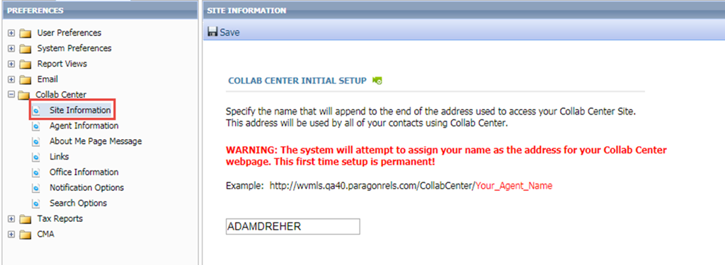

# Collab Center: State Field Searches

We previously made changes to Paragon that allow customers to limit the number of states displayed to users when performing a search or inputting a listing. This change was made to increase the efficiency of users and help mitigate input errors.

In order to maintain consistency amongst our applications, the state lookup limitations have been added to Collaboration Center.

*Figure A: State Lookup Setting*

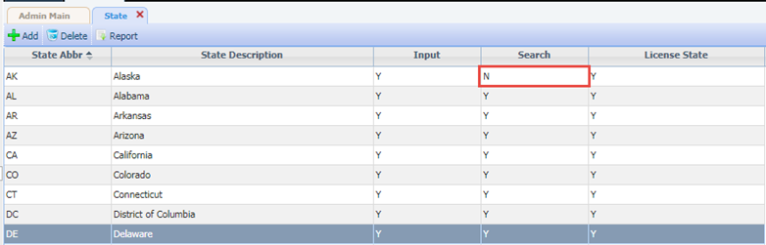

*Figure B: Collaboration Center Search*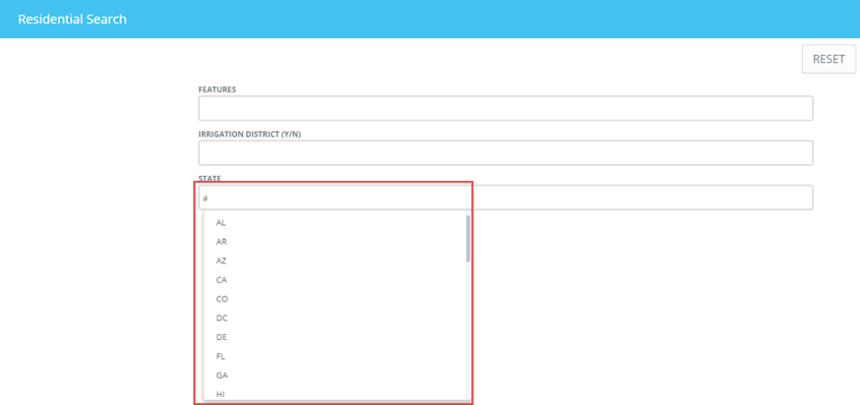

# Collab Center: Hide Client Search Notification Options

We’ve added the ability to hide the notification options for new or modified client searches when that function is unavailable to the agent, based on security level.

The option to allow Collaboration Center clients to create or modify their own searches can be restricted by security level. If the agent’s security level is below the level set by the MLS, the option to create a search is unavailable to their Collaboration Center clients. The notification options for **“Notify on New Client Search”** and “**Notify on Modified Client Search”** in the Preferences\Collab Center\Notification Options will now be hidden if the agent’s security level does not allow client searches in Collaboration Center.

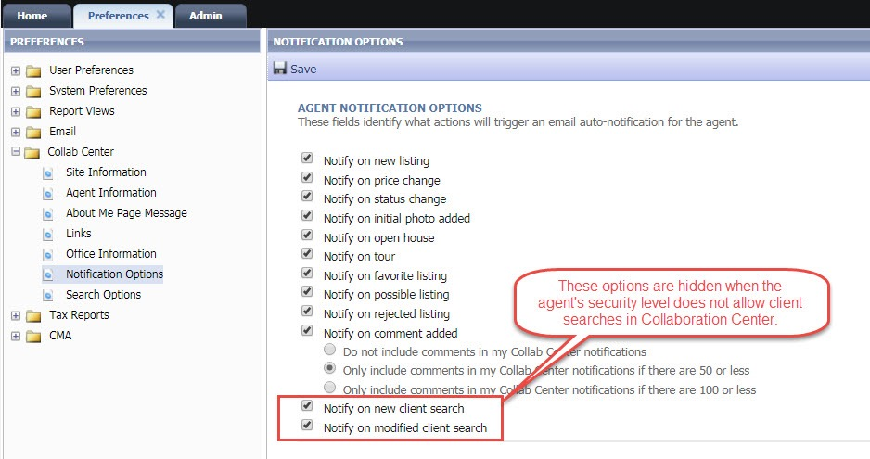

# Collab Center: Map Layers Added

The Collaboration Center and CollabLink applications have been enhanced to include Map Layers. These are the same map layers found in Paragon. Parcels, County, Flood, Traﬃc, Area, etc. Parcels cannot be clicked at this time to display parcel details. Future enhancements may include the ability to view tax and parcel data from this layer.

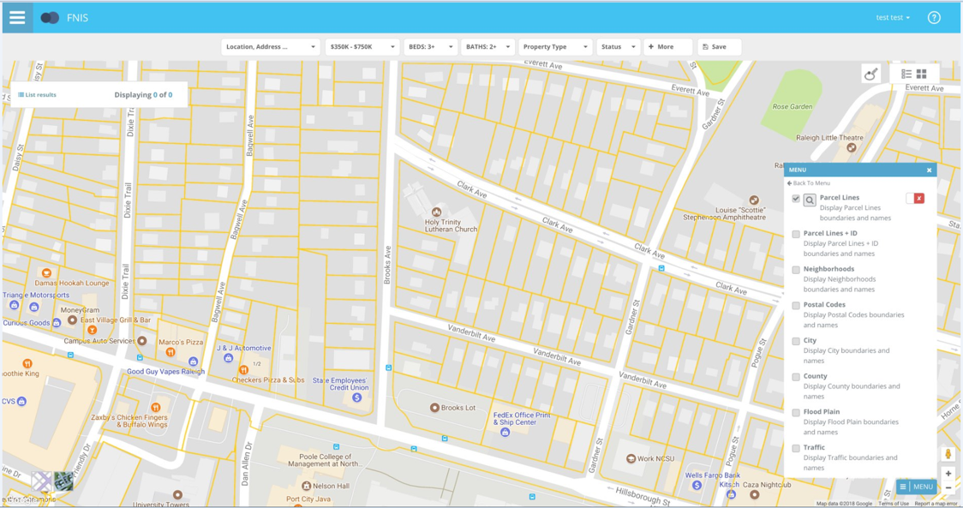

# Collab Center: Access Listing Details Directly from the Listing Update Notification

A direct link has been added that will take the user to the Collaboration Center’s Listing Detail view from the listing summary of properties included in the client Listing Update email notification. Closing the Listing Detail view will return the user to the Collaboration Center home page.

*Figure A: Desktop*

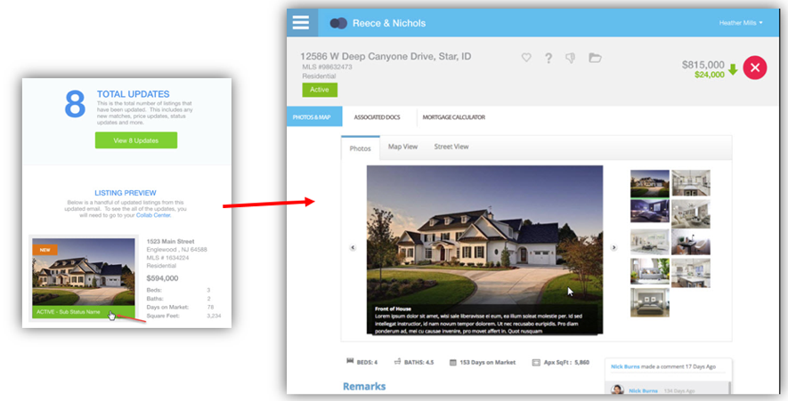

*Figure B: Mobile*

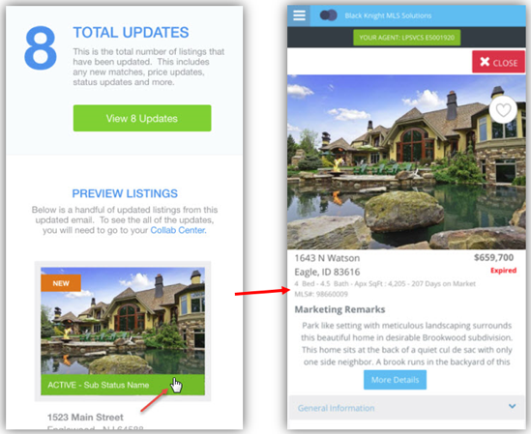

# Associated Documents in Collaboration Center

An option has been added for including public Associated Documents in Collaboration Center emails.

The MLS now has the option of adding a third party integration that will allow public Associated Documents to be viewed on Collaboration Center. Enabling Associated Documents will add a new section to the Detail reports, with a link to each publicly viewable document for that listing. An Action icon that opens an Associated Documents screen will also be added to the Summary views. Clicking a document link opens that document on a separate screen.

**Note:** To display in Collaboration Center, the Associated Documents must have Public (E-Mailable) set to Yes.

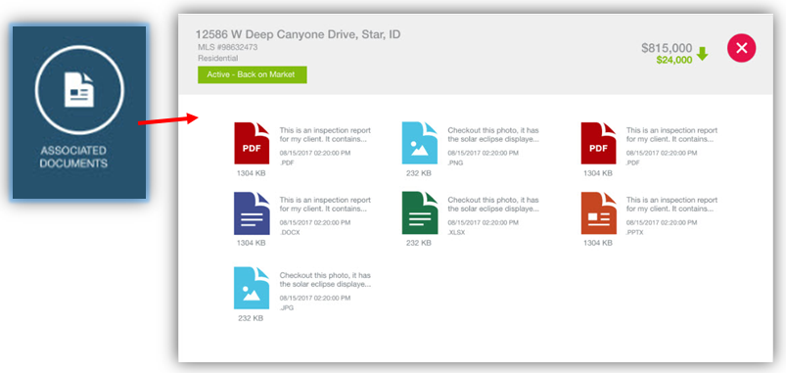

# Property History Reports Shows Reference Data

When users add the listing agent and office fields to the Property History they do not have an efficient way to review additional information about the agent or office without changing to another report view.

In order to promote consistency amongst report views, the listing agent and office fields in the Property History report have been hyperlinked. When a user clicks the hyperlinked listing agent or office names, the standard agent or office detail screen will display.

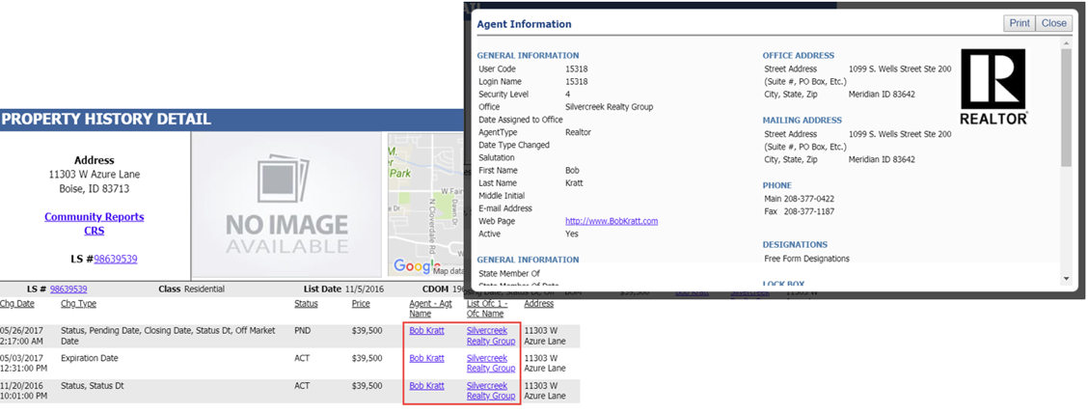

# Reorder Your Results on Google Map Report

Available by popular demand, the ability to reorder listings on the Google Map Report. Users can now drag and drop the results in any order that they would like on the report. This will cause the report to refresh so that the numbering associated with the listing in the results and on the map will match. This enhancements alleviates the need to toggle between the report and the spreadsheet view to reorder the results because previously reordering could only be done in spreadsheet result views.

You will notice that drag handles have been added to allow users to drag and drop the listing in the needed order.

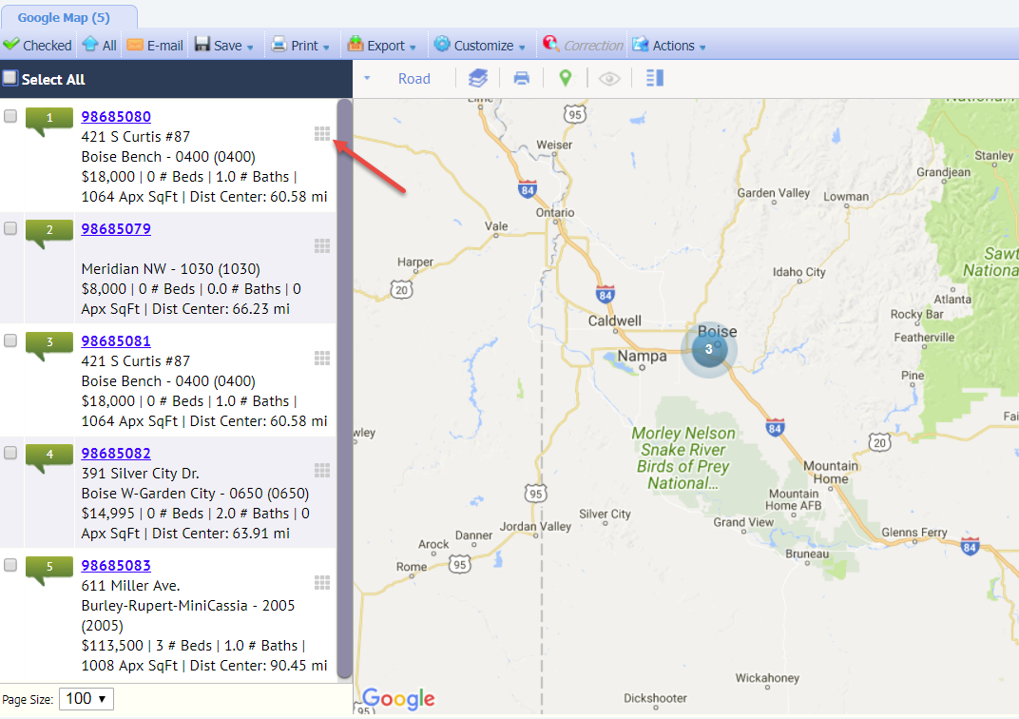

# Improvements to Email Notifications

Currently, when user delete an email signature linked to one or more existing email notifications there is no option to replace the deleted signature with another one. Users are forced to manually edit each affected notification to add a replacement email signature.

The email signature processes have been modified to provide users with an opportunity to modify email notifications with a new signature if they choose to. This change eliminates the need to manually modify email notifications. The user may also choose to permanently remove email signatures from the affected notifications.

This change only affects legacy email notifications. Collaboration Center notifications do not use manually designed email messages.

*Figure A: Single Signature*

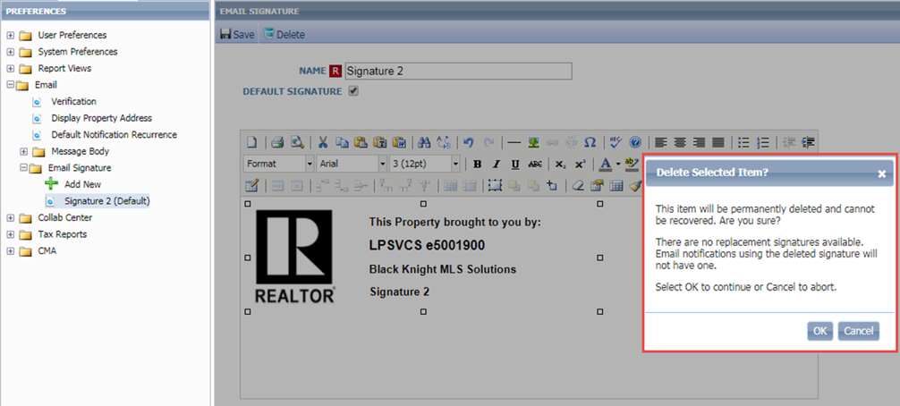

*Figure B: Multiple Signatures*

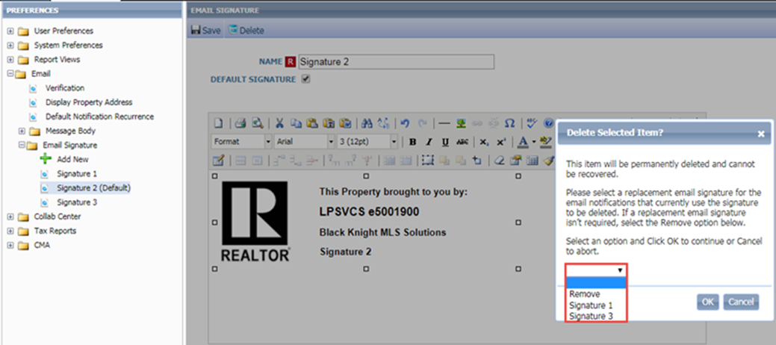

# Email and Print Update for Estimated Pages

Per customer suggestion we’ve modified the Estimated Pages column heading to make it more descriptive. Therefore, the column header label was changed from ‘Pages’ to ‘Est. Pages’.

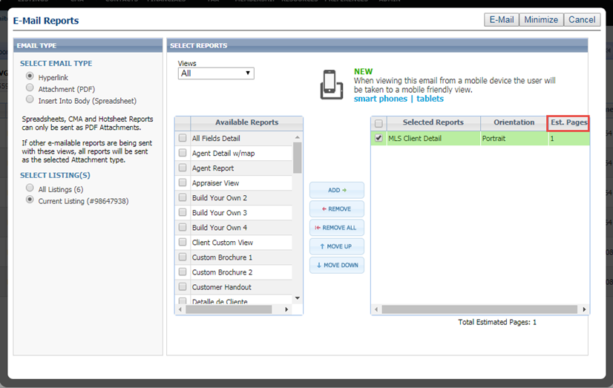

# Rounding Listing Prices Over $1,000,000

Although infrequent, when a listing price is over $1,000,000, the listing marker on Map Searches would usually round the price too high or too low. This has been corrected so that the rounding displays one decimal place.

Previously, the below example would have rounded to $2M.

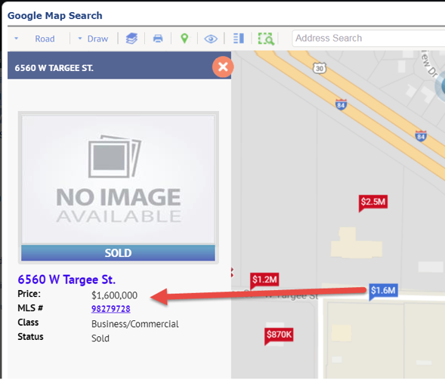

# Precursor for Automatically Displaying Results on Map Search

In preparation for automatically displaying results when accessing the map search (i.e., Map Boundary) in the next Paragon release, a few performance improvements have been made thus making results return faster:

* Results reflect lowest to highest system price, previously it displayed highest to lowest price.
* Listing data doesn’t load until the user clicks on a cluster or listing price marker.
* The number of columns returned in the results has been limited to a small few key fields instead of returning several fields.

Another major improvement is that results will now return 2,500 or more listings instead of 500. Because of the performance improvements listed above, the results return quickly.

# Listing Activity Data Retained for 120 Days

The Listing Activity displayed on the Listing Activity Report in Paragon Listing Maintenance and in the Sell Side of Collaboration Center has been refactored to retain this pertinent information for the previous 120 Days. This change promotes data accuracy and optimizes system performance.

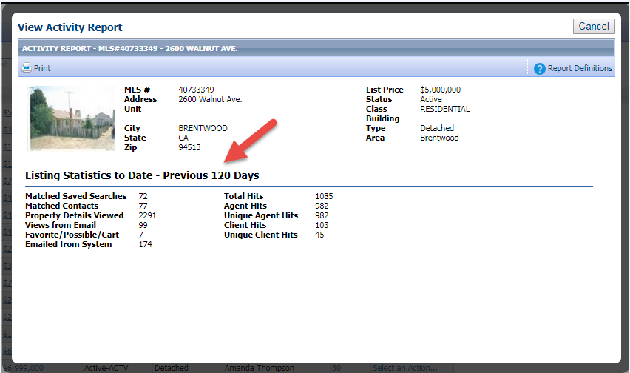

# MLS Customizations and Administration

**All options in this section are either configurable via MLS Administration controls or by your System Support Manager as noted.**

# Enhanced Admin Report on Usage of Listing Reports

Based upon suggested changes, new functionality has been added to the Report Activity Chart. Two new columns have been added; the Report Owner indicates the entity classification and the Report ID indicates the ID of each report.

The Report Owner column indicates the entity classification of the report. The classifications are:

* + - 1. MLS – The report is an MLS level report
      2. Board – The report is a board level report
      3. Firm – The report is a firm level report
      4. Office – The report is an office level report
      5. Agent – The report is an agent level report

The Report Owner is new data that is being tracked so this column will begin to show data over time as the information is collected. The Report ID column indicates the ID of each report included in the Report Activity Chart. This will alleviate concerns about reporting data for multiple reports with exact or similar names.

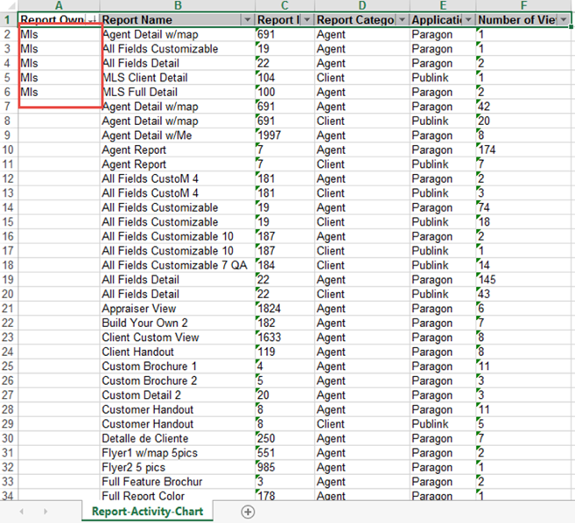

# Minimum Photo Size for Listings

To ensure better quality photos are added to listings, a minimum photo requirement has been implemented to prevent uploading photos that are too small alleviating accidental upload of thumbnail sized photos instead of the full photo of the listing. If a photo is too small, the user will receive an error while attempting to upload it.

*Figure A: Paragon’s Admin\MLS Information menu*

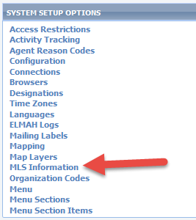

*Figure B: Modify Photo Size*

Select the Min Picture Resolution and select Save.

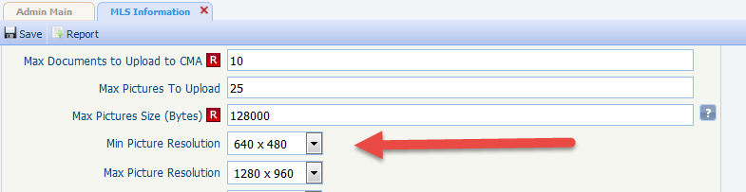

*Figure C: Photo Upload Error (photo too small or big)*

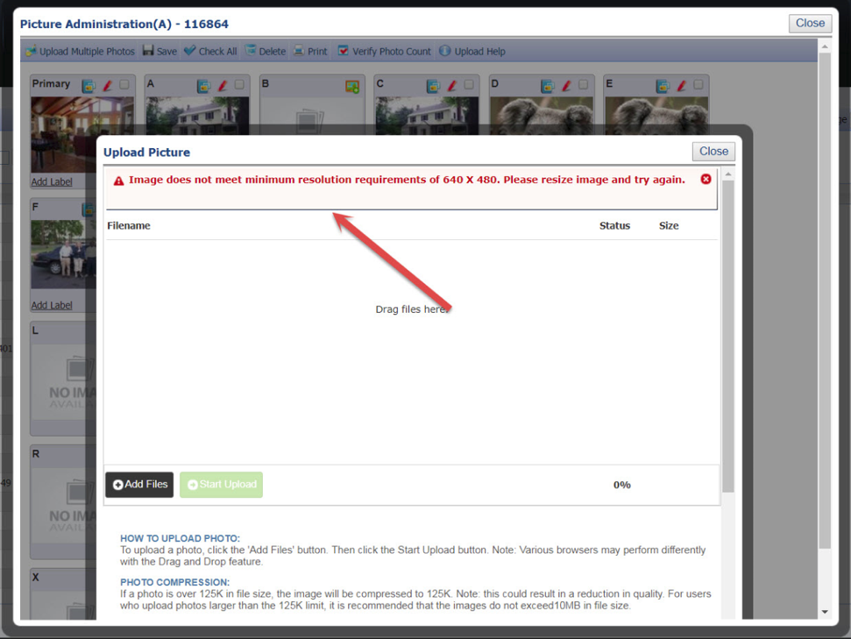

*Figure D: Photo Requirements Updated*

The photo requirements have been updated in the instructions in the Upload Primary Photo window under Image Size.

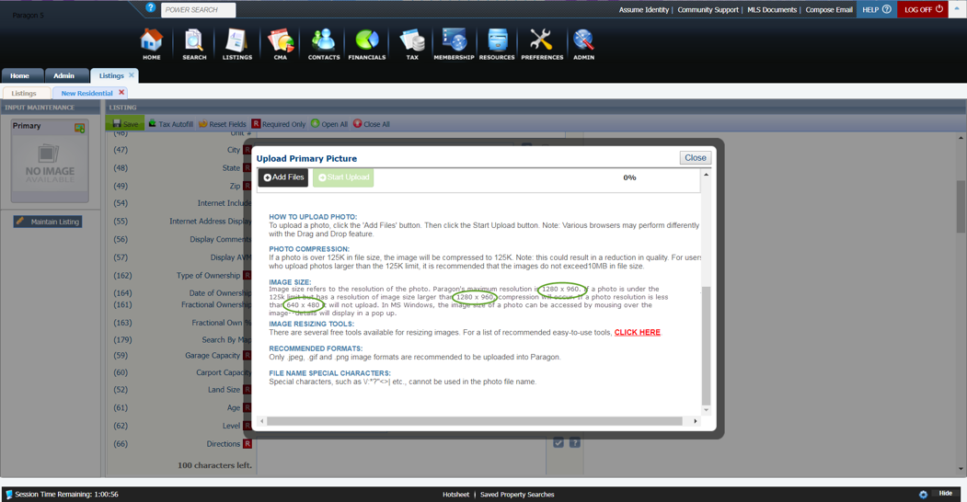

# Additional Categories for Market Monitor

This enhancement provides the MLS with the option to add ‘Back on Market’ and/or Rented/Leased as stand-alone categories in the Market Monitor’s Market, Office, and Firm sections.

Currently, Back on Market listings are only included in the Hot List of the Market Monitor and Rented/Leased are not currently available. This modification provides the MLS with the option of adding Back on Market and/or Rented/Leased as separate categories, via the Market Monitor Filter. The Rented/Lease category will display in Market Monitor using the MLS’s Status Category Description for Category 6. The MLS can also turn on a configuration that will allow agents to have access to modify the categories on their Market Monitor from Preferences\System\Market Monitor.

**PLEASE NOTE:** Back on Market and Rented/Leased will be excluded from the Market Monitor by default.

MLS’ who permit agents to modify their Market Monitor categories from Preferences may want to notify their agents of this new option. Because user preference settings override MLS defaults, changes to the MLS default categories will not apply to those agents who have already modified their Market Monitor. This also applies if an MLS once permitted agents to modify MM categories, and have since disabled that permission; any new MLS defaults will not be applied to those agents who previously modified their MM at the time when it was permitted.

*Figure A: Market Monitor Filter*

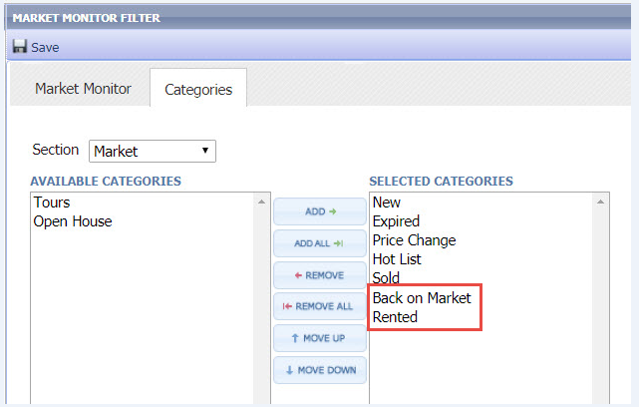

*Figure B: Market Monitor*

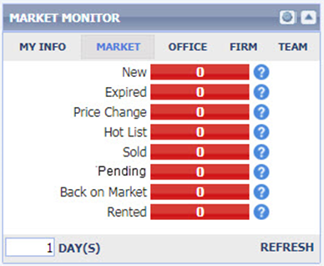

*Figure C: Status Category*

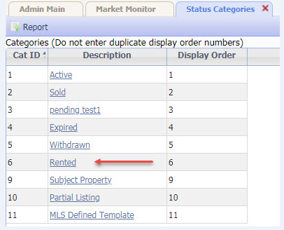

# Force Manual Geocode Required for Listing Input

Some customers would like to make users manually place the pin on listings (manual geocoding) in Listing Input Maintenance. The current Admin\Mapping menu’s ‘Input Maint Required’ field has been changed from a checkbox to a drop down field. The ‘Force Manual Geocoding’ option has been added and when selected will force all users to manually geocode listings whenever a new listing address is entered or an existing listing address is modified.

The ‘Validate Exact Match – Error’ and ‘Validate Exact Match – Warning’ are themes on how it worked prior to this enhancement which also applied to new or modified listing addresses. When ‘Validate Exact Match – Error’ is selected, if the geocoding on the listing address is less than an *exact match*, an error appears in the listing grid at the bottom of the screen forcing the user to manually move the PIN thus geocoding the property’s location (formerly when the ‘Input Maint Required’ checkbox was checked). ***One difference*** *from how this previously worked is that the user actually has to move the PIN or modify the latitude and/or longitude values in order to save the listing. Previously, the user could open the Change Geocode window, close it, and save the listing without actually moving the PIN or updating the geocode values.*

When ‘Validate Exact Match – Warning’ is selected, if the geocoding on the listing address is less than an *exact match*, a warning appears in the listing grid at the bottom of the screen which the user can accept and bypass the warning without manually correcting the geocodes (formerly when the ‘Input Maint Required’ was *not* checked).

**PLEASE NOTE:** Upon going to Production with this enhancement, this field will be defaulted to whichever option is equivalent to what the MLS currently has set for this field.

*Figure A: Admin\Mapping Setting*

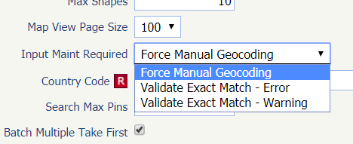

*Figure B: Force Geocode Error Message*

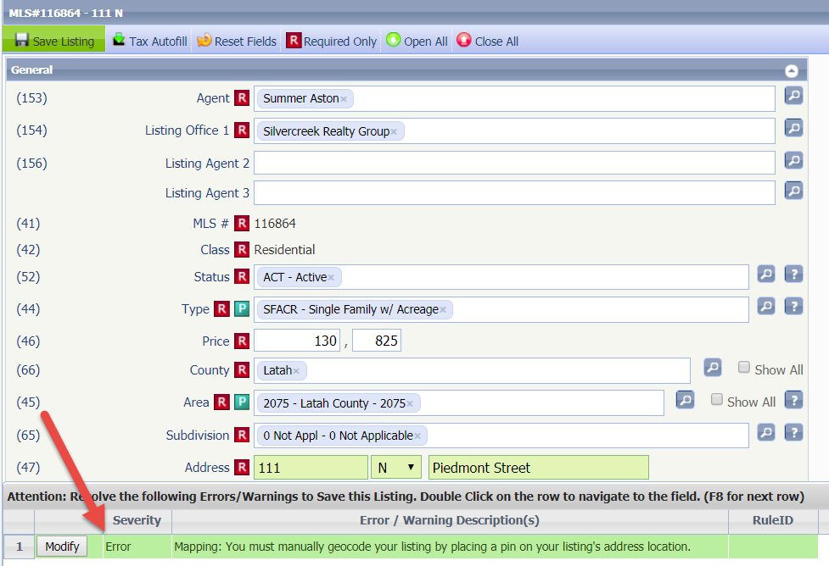

# Updates to Listing Audit and Property History Reports

There are listings with a large number of audit records. The large number of audit records is generally associated with long customer conversion cycles or parallel processes. When a listing has more than 999 audit records the Listing Audit and Property History reports do not report the history of a listing correctly. Additionally the Days on Market (DOM) value displayed on the Property History report was calculated incorrectly if a listing had more than 999 audit records.

The Listing Audit Report has been modified to display all audit records in descending order starting with the most current record.

**NOTE:** The report will take some time to render if there are a large number of audit records.

The Property History Report has been modified to display the current DOM value in the report header. The DOM for each record is calculated based upon the listing values on the record date.

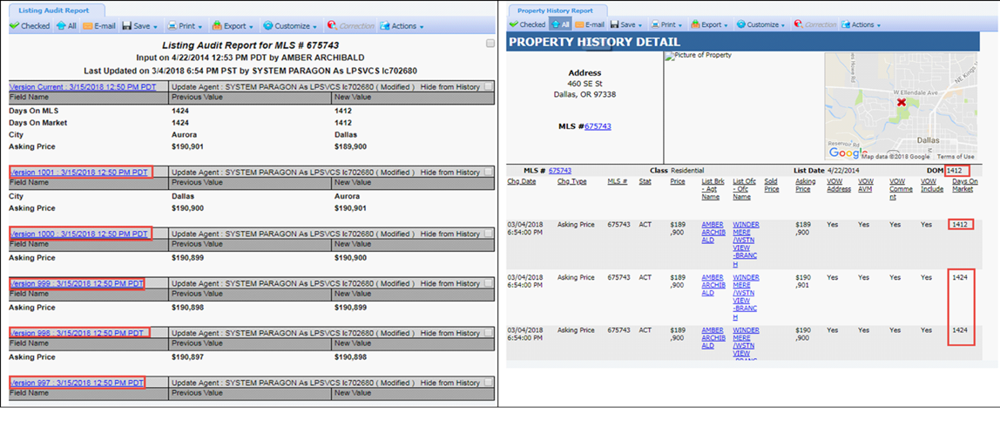

# Power Search Now Adheres to Board Rules

Customers using Association Autonomy have requested changes to Power Search so that it respects the listing and membership participation settings of member boards. Legacy and advanced Power Search have been modified to adhere to Association Autonomy listing and membership participation settings.

*Figure A: Sample* Association Autonomy Settings

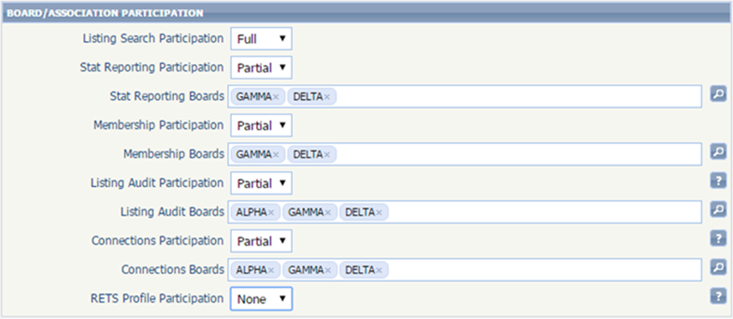

*Figure B: Legacy Power Search Results based upon Listing Participation Settings*

|  |  |
| --- | --- |
|  |  |
|  |  |

*Figure C: Advanced Power Search Results based upon Listing Participation Settings*

|  |  |
| --- | --- |
|  |  |

# Collab Center: Third Party Integrations

Do you have a third-party integration that you wish you could expose to Consumers in the Collaboration Center? Now you can! In 5.64, MLS organizations can now enable any third-party integration available to them in Paragon. All you have to do is contact your SSM and they will work with you to setup that integration point inside of Collaboration Center.

Let’s take a peek at how this integration works. Once an integration is setup, the consumer will be able to access these third-party integrations from any report available in the Collaboration Center site. Simply click on the share icon found on any report in the system and a new menu modal will open. This modal will contain all your share actions and any third-party integrations you have setup. We even have the ability to hide third party integrations in the situation where the third-party solution doesn’t work well on a smart phone.

