# Agent Level Enhancements

**The following section contains changes that are active system wide** **and available to users based on their assigned security levels.**

# Introducing “Paragon News”

A new Paragon News widget has been added to the top left communications section on the Home tab that will promote important news and announcements that BK MLS would like to disseminate to users. In some instances, there may be a “Learn More” button that can be clicked that will display a website providing lots of details associated with the news event.

**NOTE:** Individual users can move the widget around on the screen but it cannot be removed or minimized.

# Long Description of Lookup Values in User Preference

Users now have the ability to display the long description of lookup values in the search criteria. This functionality is intended to help new agents when inputting search criteria. The user will not be forced to memorize lookup codes that may be confusing. The Search Options section of User Preferences will display an option that enables long descriptions in search criteria. This functionality will be **disabled** by default.

# Limit Listing Used as a Subject Property for a CMA

The following is not applicable unless Association Autonomy is used to limit listing visibility by board:

The goal is to prevent users from creating CMA subject properties using listings to which they do not have permissions because of sharing limitations implemented by the boards within Paragon. When a user attempts to use a standard listing as a CMA subject property, Paragon will determine if the user has permissions to the listing. If so, the listing will be added as a subject property. If the user does not have permissions to use the listing it may not be added as a subject property. An error will display advising the user that they are prohibited from using the listing in the CMA.

# Modify Email Signature Deletion Message

Several customers suggested changes to the email signature message displayed when the user deletes their single default signature. The customers wanted to emphasize the additional work required to modify existing notifications if a replacement email signature does not exist.

# Enlarge Manual Email Dialog to Accommodate Report Options

Customers identified a cosmetic issue with the selected reports section of the Email and Print+ modals. It had an alignment issue that caused the section to always display a scrollbar. Customers requested that we resize the data to fit neatly into the allotted space.

# Third Party Integrations Update

In 5.64, we introduced third party integrations into the Collaboration Center. In 5.65, we are following up and adding this feature into the Collablink and the Public Detail views of Collaboration Center.

# Associated Documents Update

As a follow up to the addition of associated documents in the Collaboration Center in 5.64, we have now added it into the “Collablink” option as well.

# Center Map on Address Label Update

When accessing the map on map searches, the ‘Address Search’ box has been updated to say, “Center Map on this Address”.

# Load Addresses and Default Locations

Customers requested a way to easily access last entered addresses that they centered the map on when accessing the map search. They also wanted the ability to have multiple default addresses that they could pick from. We have introduced the ability to select from the last five addresses searched or from three key default addresses: agent physical address, agent mailing address, agent office address, and the board address.

# Help Overlay – Recent Sales

Over the course of the year, the Collaboration Center went through several interface updates. One of those updates included moving the “Recent Sales” feature to its own tab/section. This new tab did not include any tool tip or help information to describe what the Recent Sales feature is. We have now included a help overlay that will launch when first viewing this tab to help explain what this feature is. Users can also click on the help icon in the upper right hand corner to display the help overlay at any time.

# Paragon Mobile Now Uses Google Maps

As with our other BK MLS products, Paragon Mobile has been updated to use Google Maps.

# Improved Access to the CMA Preferences Wizard

It is important that a User setup their CMA Preferences for a smooth and ideal CMA creation experience. Therefore, we have made it easier to identify, access, and utilize the CMA Preference Wizard in Paragon. A few new options have been added to the system making it more flexible as to where the Preference Wizard can be accessed.

# Address 2 Added to Comparable Reports and CMA Maps

We have added Address 2 to the vertical and horizontal comparable reports to allow for correct addresses to be provided within the reports. It is important to note, that the address 2 field will only appear if the Address 2 field is turned on and populated for the MLS.

# Updated Font Colors and Map Legend in CMA

The font colors have been enhanced within the CMA to a black font. This resolved the issue of having too light of a font in some of the themes and removes the difficulty of reading lighter fonts. Additionally a Map Legend has been added to the CMA Map Page.

# MLS Customizations and Administration

All options in this section are configurable via MLS Administration controls or by your System Support Manager as noted.

# Secured URL for Paragon and Publink

Although some security measures were already in place, in an effort to increase that security, Paragon and Publink are being modified to display in full SSL throughout the applications.  You will notice that the web address and subsequent pages now begins with \\https.  In a near future release, Mobile, IDX, Client Collaboration Center, and Paragon Affiliate Connect will be switched to full SSL. This is an ongoing process whereby we’ll be monitoring system access and system performance, so stay tuned for additional information as it arises.

# Fields Added to RETS Profile Report

Additional information has been added to the RETS Profile Report for each agent. These fields will appear on the report even when not completed. For the fields to provide the value intended, requires Agents to fully complete their profile information. Additionally, accessing the RETS Profile Report has been made a little easier. It can now be accessed by selecting it from the tool bar within the profile administration.

# “Get Homebot” Button Added to Contacts

For MLS’s where Homebot is activated, in order to ease use and help increase the adoption rate for Homebot, a “Get Homebot” option is being added to the Contacts menu above the Contacts grid. If an agent does not yet have an account, the text will read “Get Homebot” and when clicked, will launch a new browser window/tab to begin the registration process.

# Homebot Client Registration in Collab Center

For MLS’s where Homebot is activated, in the event that an agent has not yet subscribed their contact to Homebot from the Contact Manager in Paragon, the MY HOME WEALTH tab in Collaboration Center will provide the subscription form so the contact can register themselves. Currently, if the contact is not subscribed, the MY HOME WEALTH tab is hidden. With this new feature, the tab will always be present if the agent has a Homebot account.

# Create Fields for Listing City/State/Zip for Reports

When adding a listing’s city, state/province, and zip/postal code to a custom report each of these elements must be added individually. Users have to make sure that each field is added in the correct order and formatted correctly which can be an arduous task. In order to help users add these values to reports more efficiently, a new report field has been created. This field will add the listing’s city, state or province, and zip or postal code in a single report element. This is an optional feature that can be used as needed.

# Introducing Paragon Affiliate Connect

Affiliate Connect is a feature of Paragon that facilitates communication between real estate agents, their affiliates, and their consumers (i.e., home buyers and sellers). Affiliates are the agents preferred team of home related specialists such as loan officers, settlement officers, home inspectors, etc. This feature allows MLSs to onboard and manage affiliates more easily. Agents can build and manage their affiliate teams and brokers can create and manage office-level affiliate teams that all agents within their office can utilize. Watch for news on this exciting new Paragon initiative and additional features that will be coming in future releases.

# Corrected Issues

|  |  |  |  |  |
| --- | --- | --- | --- | --- |
| **Work Order** | **Seq** | **Module** | **Reporting Customer(s)** | **Issue Corrected** |
| 135006 | 1 | Email | Omaha, ECAR, IRMLS, NEREN, REB3 | Making edits to the message body appear to apply, but the font changes size after clicking send |
| 138168 | 1 | CMA | New River Valley AOR (NRV), All Customers | Comparable Report Vertical not rendering statistics at bottom of page |
| 138876 | 1 | Collab Center | REB3, All Customers | Update Public CC Report: There are some left over neighborhood elements that need to be removed. |
| 139228 | 1 | Input Maintenance | East Central Association of REALTORS® (ECAR) | ECAR - Unable to validate map for MLS #30066047 |
| 139234 | 1 | Search - Address Archive | Silver City, CARMLS, Upper Peninsula | Address archive showing error when trying to view listings |
| 139331 | 1 | Mapping | North Central WV, MiRealSource, NEREN | Validate Mapping Link gives Page Cannot be displayed Error with Certain Listings |
| 139345 | 1 | RETS | MAXEBRD, Huntsville, Triangle MLS | Provider is unable to utilize RETS Update |
| 122151 | 3 | CMA | Tallahassee, Baton Rouge, CARMLS, Grand Junction, MAXEBRD, Nova Scotia, Outer Banks, Quad Cities, Plumas, RASM, RANW, REB3, SC Wisconsin, Waco, Willamette | CMA Summary in CMA Packet has incorrect page breaking |
| 137798 | 1 | Collab Center | All Customers | UPDATE PASSWORD PAGE: Too much verbiage and layout is too large. Causing workflow issues |
| 133172 | 1 | Mapping | REB3 | Users unable to change focus to a particular listing when in Google Map view |
| **122689** | **1** | **System** | **REB3, GAMLS, MAXEBRD, Charlottesville** | **Request to have Date/Timestamp Track Seconds and Milliseconds on LDR and L_Update** |

# Agent Level Changes

**The following section contains changes that are active system wide** **and available to users based on their assigned security levels.**

# Introducing “Paragon News”

A new Paragon News widget has been added to the top left communications section on the Home tab that will promote important news and announcements that BK MLS would like to disseminate to users. In some instances, there may be a “Learn More” button that can be clicked that will display a website providing lots of details associated with the news event.

**NOTE:** Individual users can move the widget around on the screen but it cannot be removed or minimized.

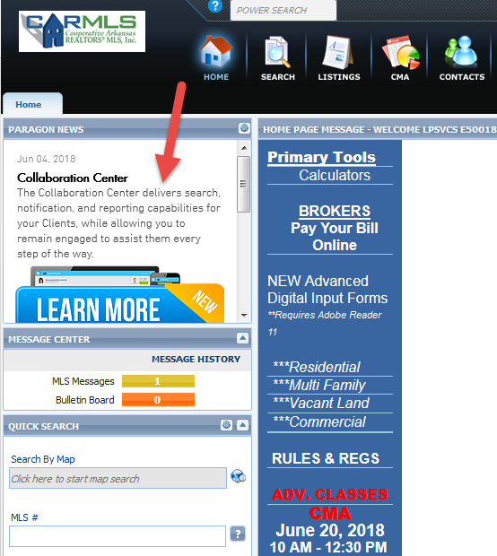

# Long Description of Lookup Values in User Preference

Users now have the ability to display the long description of lookup values in the search criteria. This functionality is intended to help new agents when inputting search criteria. The user will not be forced to memorize lookup codes that may be confusing. The Search Options section of User Preferences will display an option that enables long descriptions in search criteria. This functionality will be disabled by default.

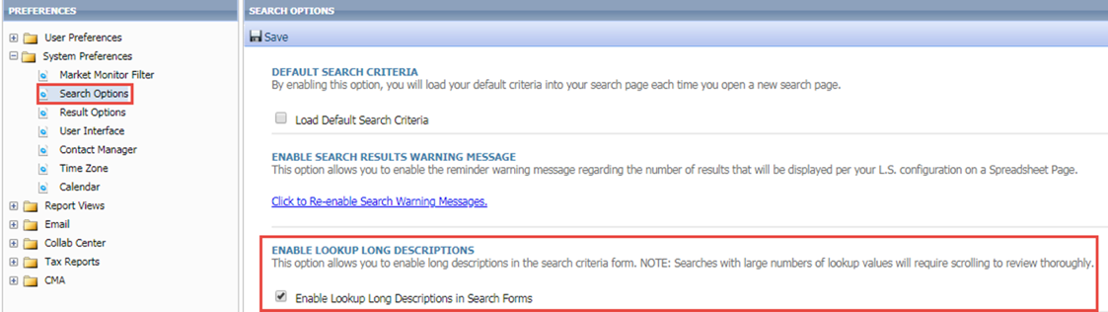

Once the end user has enabled the setting, all subsequent searches will display the long descriptions of lookup fields in the search criteria and criteria summary. The criteria summary will be limited to the display of 300 characters per lookup. This limitation was implemented to prevent the search criteria page from becoming difficult to navigate. If a lookup exceeds 300 characters, an ellipsis is displayed in the criteria summary. However, the search criteria form is not limited to a maximum number of characters.

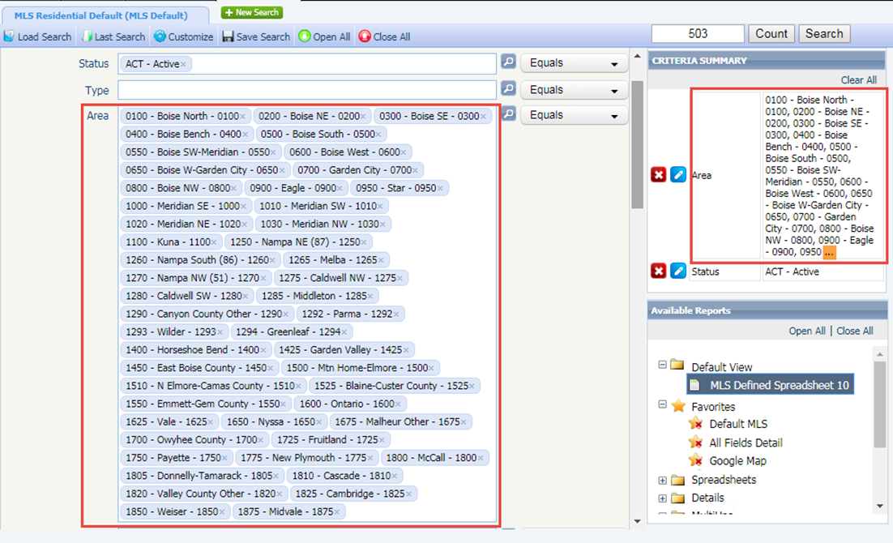

The Search Criteria Page available via Print + and the Criteria Summary report in the Actions Menu were also modified to display long descriptions of lookup values. Modification of other reports would have required significant resources for redesign and therefore, have ***not*** been modified.

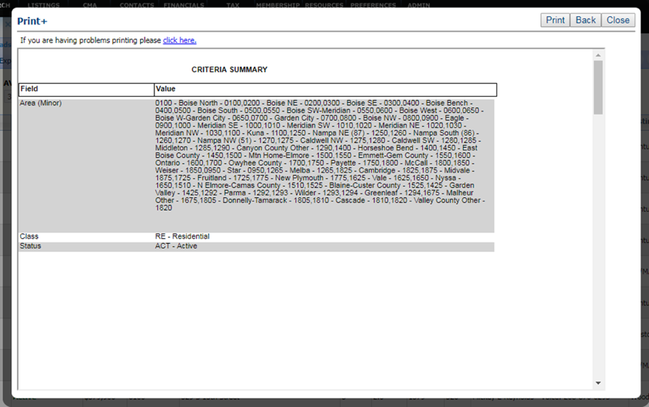

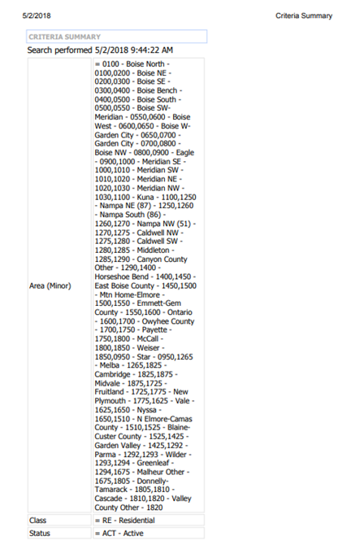

# Limit Listing Used as a Subject Property for a CMA

The following is not applicable unless Association Autonomy is used to limit listing visibility by board:

The goal is to prevent users from creating CMA subject properties using listings to which they do not have permissions because of sharing limitations implemented by the boards within Paragon. When a user attempts to use a standard listing as a CMA subject property, Paragon will determine if the user has permissions to the listing. If so, the listing will be added as a subject property. If the user does not have permissions to use the listing it may not be added as a subject property. An error will display advising the user that they are prohibited from using the listing in the CMA.

*Figure A: Adding a listing directly to the CMA via the CMA Wizard*

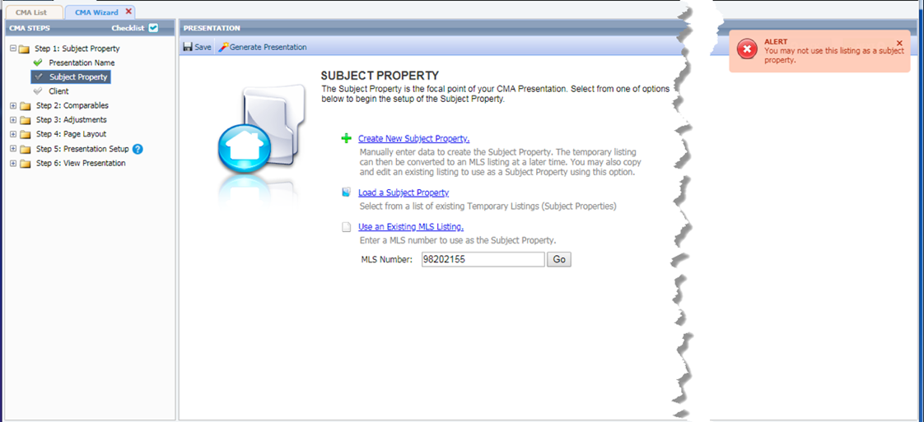

*Figure B: Add listing to Subject Property via LIM*

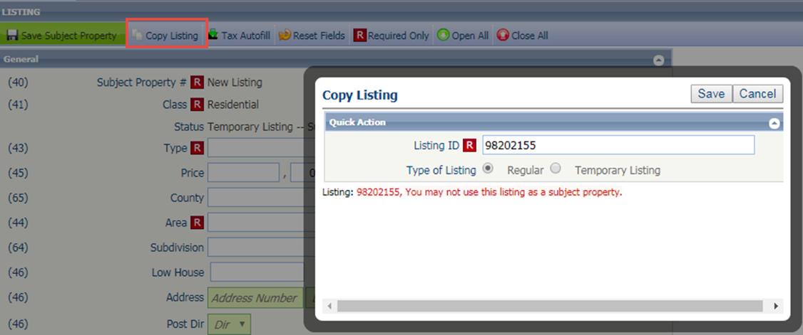

# Modify Email Signature Deletion Message

Several customers suggested changes to the email signature message displayed when the user deletes their single default signature. The customers wanted to emphasize the additional work required to modify existing notifications if a replacement email signature does not exist.

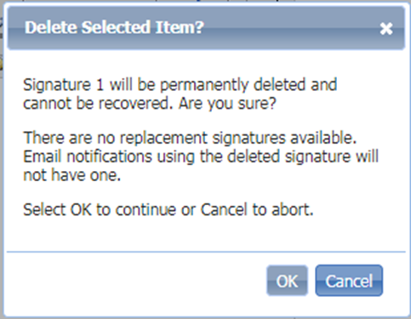 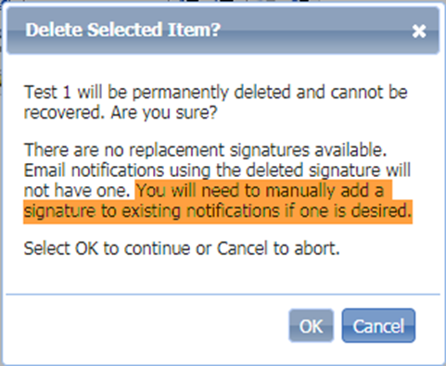

# Enlarge Manual Email Dialog to Accommodate Report Options

Customers identified a cosmetic issue with the selected reports section of the Email and Print+ modals. It had an alignment issue that caused the section to always display a scrollbar. Customers requested that we resize the data to fit neatly into the allotted space.

The Email and Print+ modals have been refactored to fit the default data into the selected reports section without the need for a scrollbar. If one of the columns is resized by a user, a scrollbar may be displayed and works as expected.

*Figure A: E-Mail Report Modal*

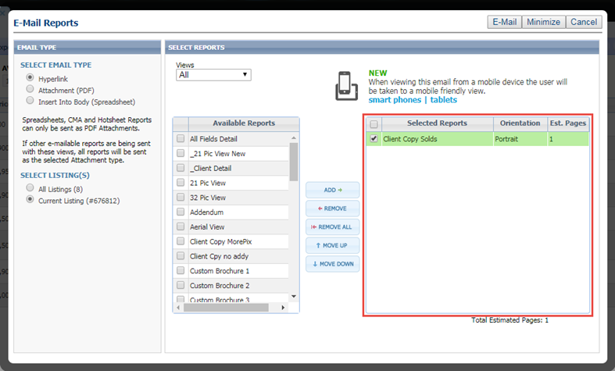

*Figure B: Print + Modal*

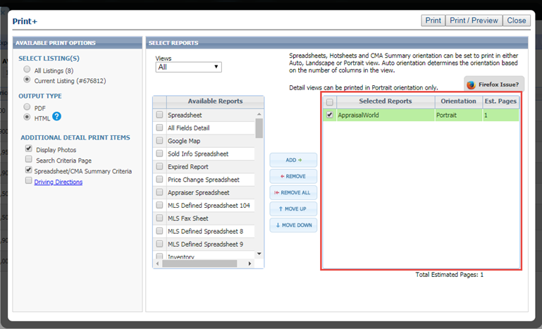

# Third Party Integrations Update

In 5.64, we introduced third party integrations into the Collaboration Center site. In 5.65, we are following up and adding this feature into the Collablink and the Public Detail view of Collaboration Center.

Collablink: This is the mobile view of emailed listings from Paragon. Consumers who open listing emails from their agents will go to a mobile friendly view called, “Collablink”.

Public Detail: If a prospective buyer emails a listing from the Collaboration Center to a friend, family member, etc., they will receive a link to that detailed view. That detailed view is a public view that shows a detailed report of the listing called, “Public Detail”.

# Associated Documents Update

As a follow up to the addition of associated documents in Collaboration Center in 5.64, we have now added it into the “Collablink” option as well. However, this was not included into the public detail report.

# Center Map on Address Label Update

When accessing the map on map searches, the ‘Address Search’ box has been updated to say, “Center Map on this Address”.

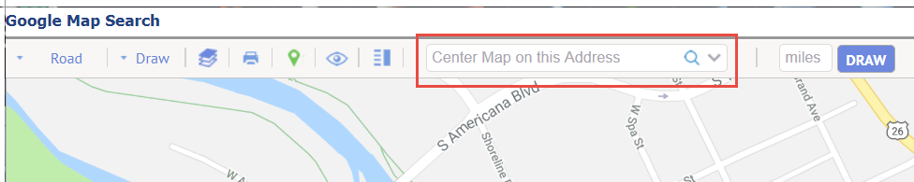

# Load Addresses and Default Locations

Customers requested a way that they could easily access last entered addresses that they centered the map on when accessing the map search. They also wanted the ability to have multiple default addresses that they could pick from. So we have introduced the ability to select from the last five addresses searched or from a few key default addresses: agent physical address, agent mailing address, agent office address, and the board address.

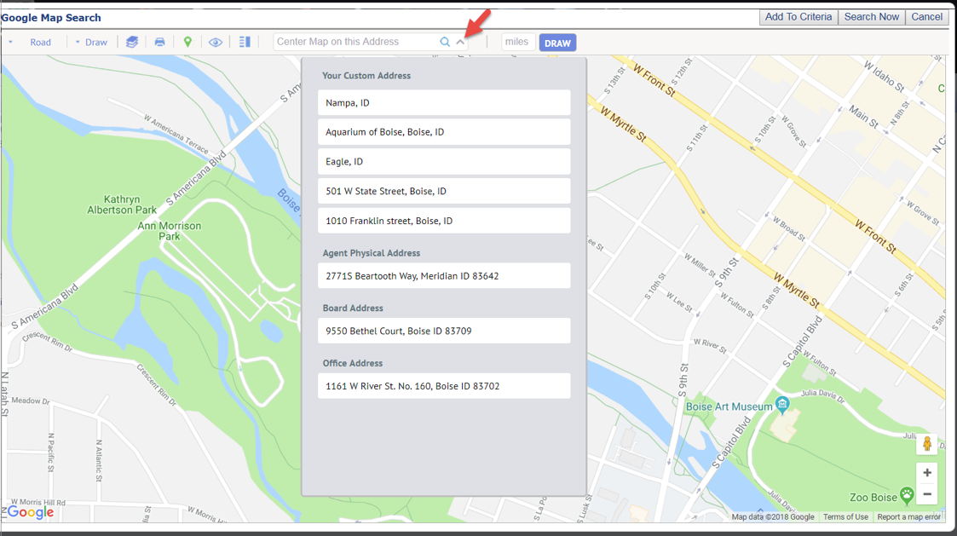

# Help Overlay – Recent Sales

Over the course of the year, the Collaboration Center went through several interface updates. One of those updates included moving the “Recent Sales” feature to its own tab/section. This new tab did not include any tool tip or help information to describe what the Recent Sales feature is. We have now included a help overlay that will launch when first viewing this tab. It will help explain what this feature is. You can also click on the help icon in the upper right hand corner to display the help overlay at any time.

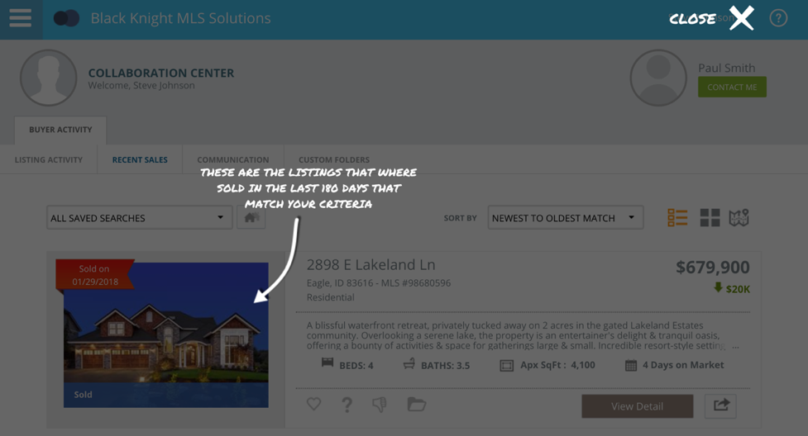

# Paragon Mobile Now Uses Google Maps

As with our other BK MLS products, Paragon Mobile has been updated to use Google Maps.

# 

# Improved Access to the CMA Preferences Wizard

It is important that a User setup their CMA Preferences for a smooth and ideal CMA creation experience. Therefore, we have made it easier to identify, access, and utilize the CMA Preference Wizard in Paragon. A few new options have been added to the system making it more flexible as to where the Preference Wizard can be accessed.

*Figure A: Added CMA Preference Wizard to CMA menu*

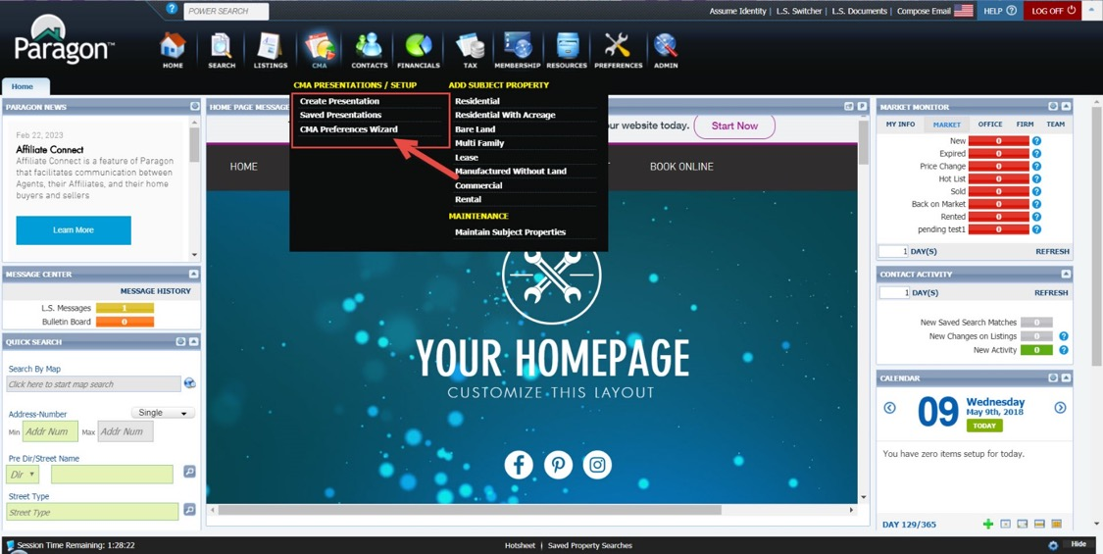

*Figure B: Added Link to CMA Preference Wizard* 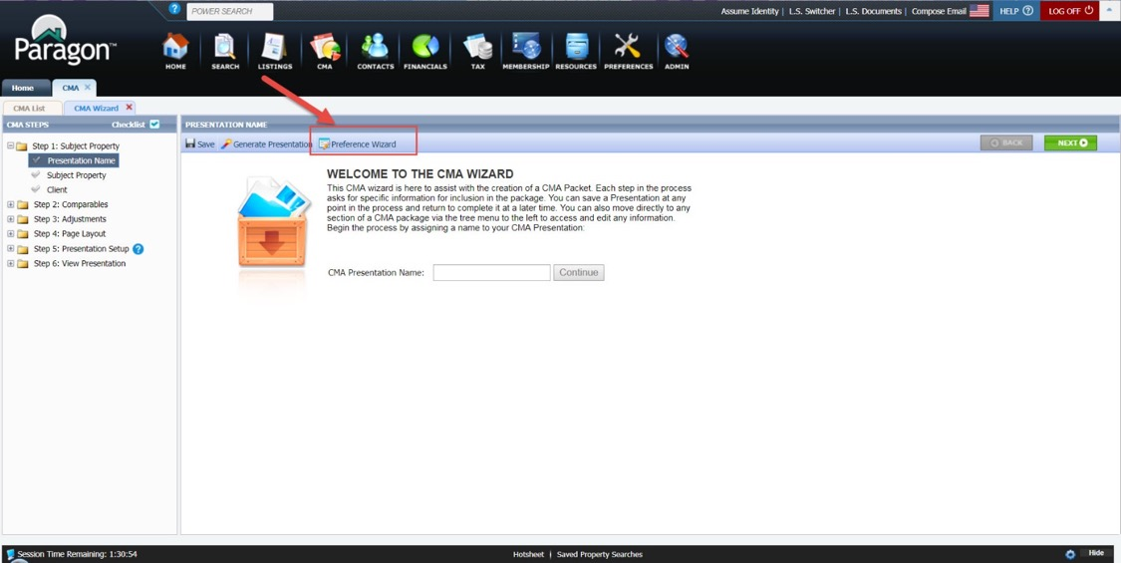

*Figure C: Added Link under Preferences Menu*

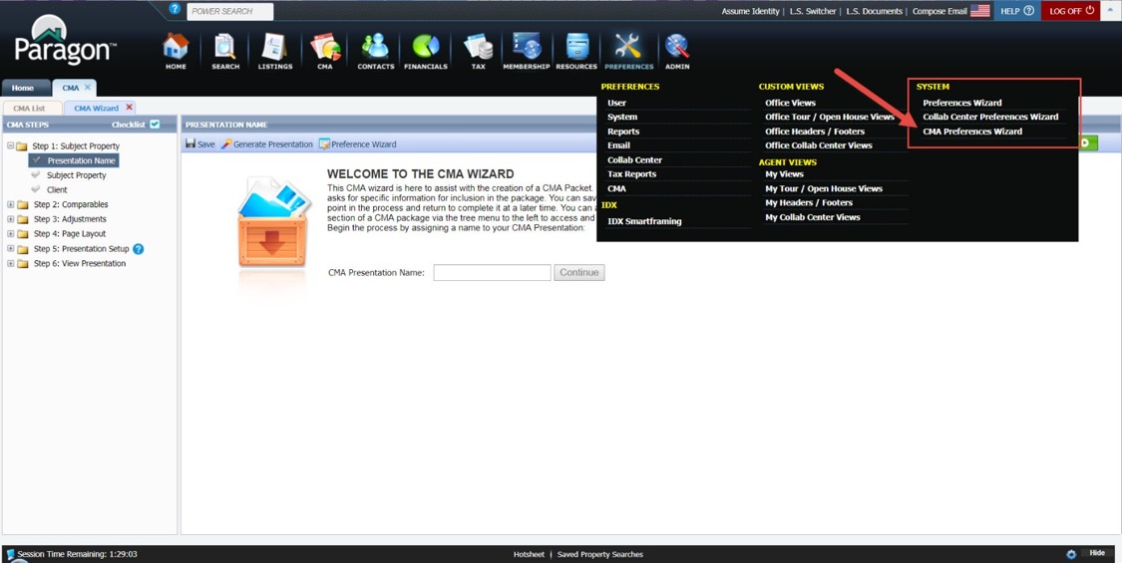

*Figure D: Welcome to CMA Wizard page*

When the user hovers over the Preference Wizard link it will give a warning that any changes in the CMA Preference Wizard may be overwritten by changes within the current CMA.

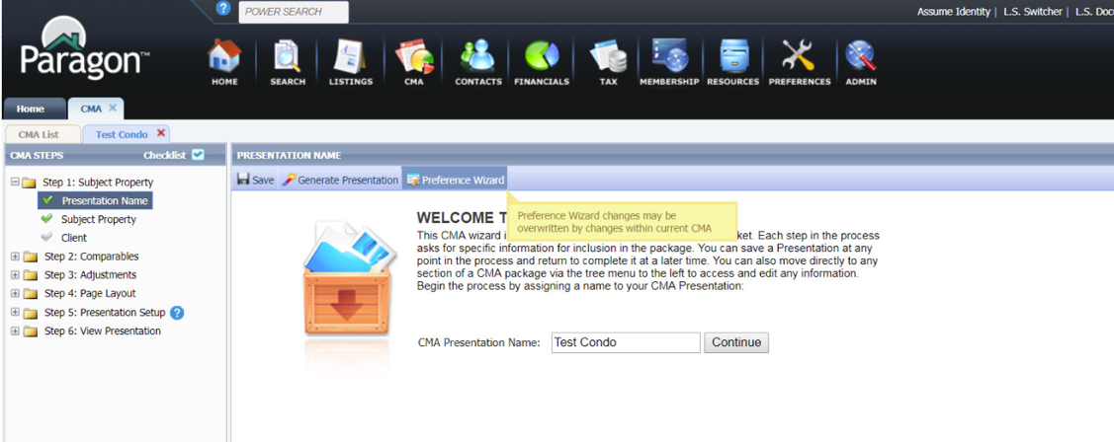

# Address 2 Added to Comparable Reports and CMA Maps

We have added Address 2 to the vertical and horizontal comparable reports to allow for correct addresses to be provided within the reports. It is important to note, that the address 2 field will only appear if the Address 2 field is turned on and populated for the MLS. When the field is turned on, it is not typically a required field.

*Figure A: Horizontal Comparable Report*

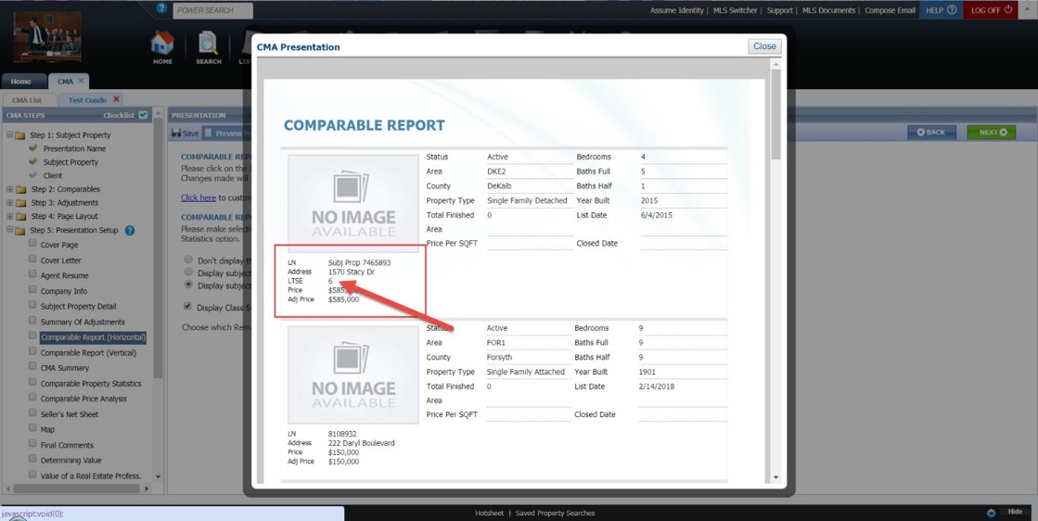

*Figure B: Vertical Comparable Report*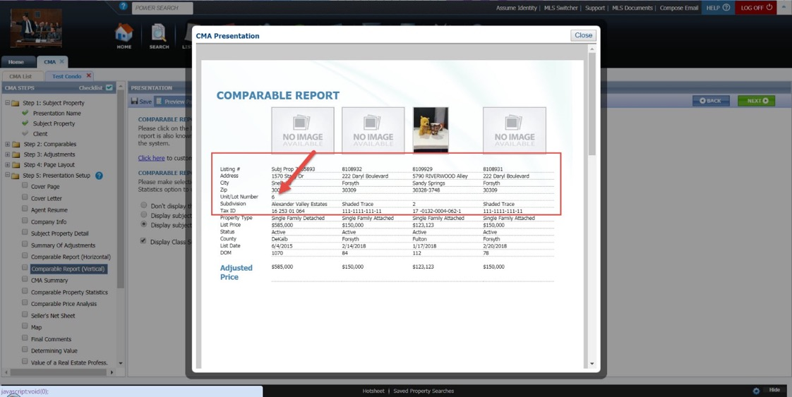

*Figure C: CMA Map*

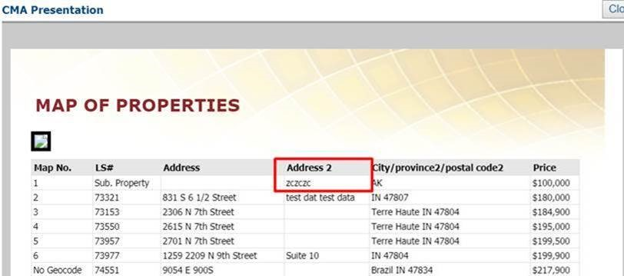

# Updated Font Colors and Map Legend in CMA

The font colors have been enhanced within the CMA to a black font. This resolved the issue of having too light of a font in some of the themes and removes the difficulty of reading lighter fonts. Every theme now has black font for the text within the body of the CMA.

Figure : Updated Black Font

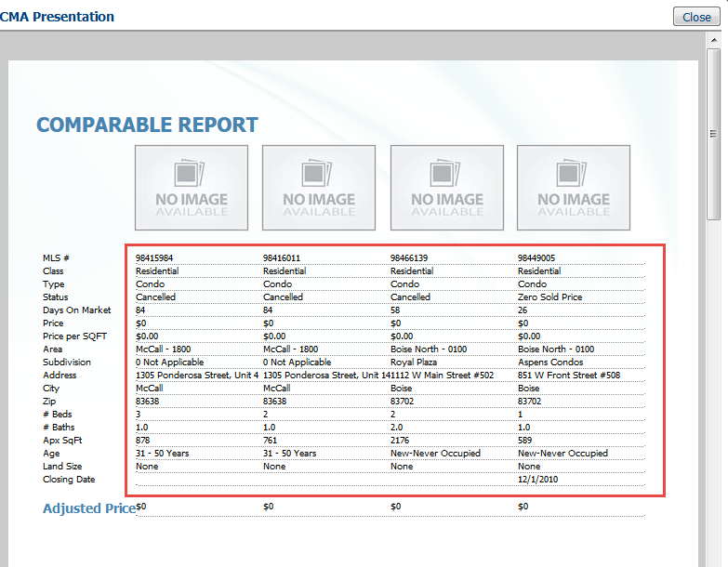

Figure : Map Legend

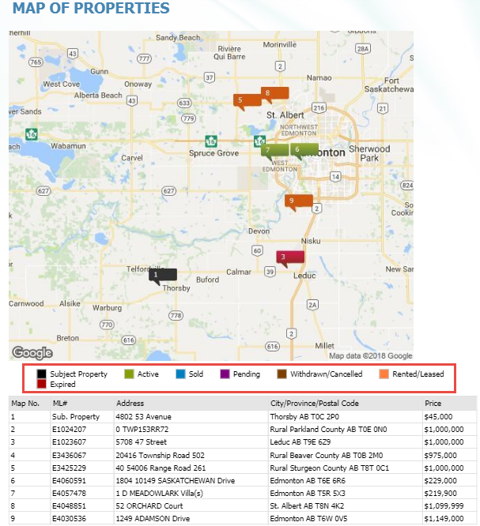

# MLS Customizations and Administration

**All options in this section are either configurable via MLS Administration controls or by your System Support Manager as noted.**

# Secured URL for Paragon and Publink

Although some security measures were already in place, in an effort to increase that security, Paragon and Publink are being modified to display in full SSL throughout the applications. You will notice that the web address and subsequent pages now begins with \\https. In a near future release, Mobile, IDX, Client Collaboration Center, and Paragon Affiliate Connect will be switched to full SSL. This is an ongoing process whereby we’ll be monitoring system access and system performance, so stay tuned for additional information as it arises. **Please Note:** For a smooth User Interface experience, it’s important that any external framed in web pages are also set to https where possible.

# Fields Added to RETS Profile Report

Additional information has been added to the RETS Profile Report for each agent. These fields will appear on the report even when not completed. For the fields to provide the value intended, requires Agents to fully complete their profile information. Additionally, accessing the RETS Profile Report has been made a little easier. It can now be accessed by selecting it from the tool bar within the Admin\RETS Profile Admin menu.

*Figure A: Admin\RETS Profile Admin menu*

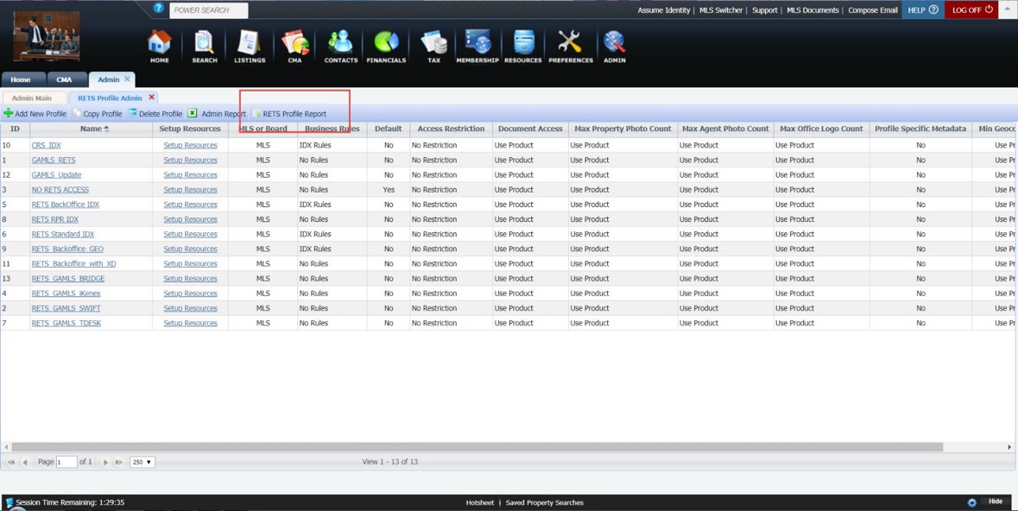

*Figure B: Row Selection*

Users can now select a row from RETS Admin and then select the Admin Report and it will prefill the search criteria for the user.

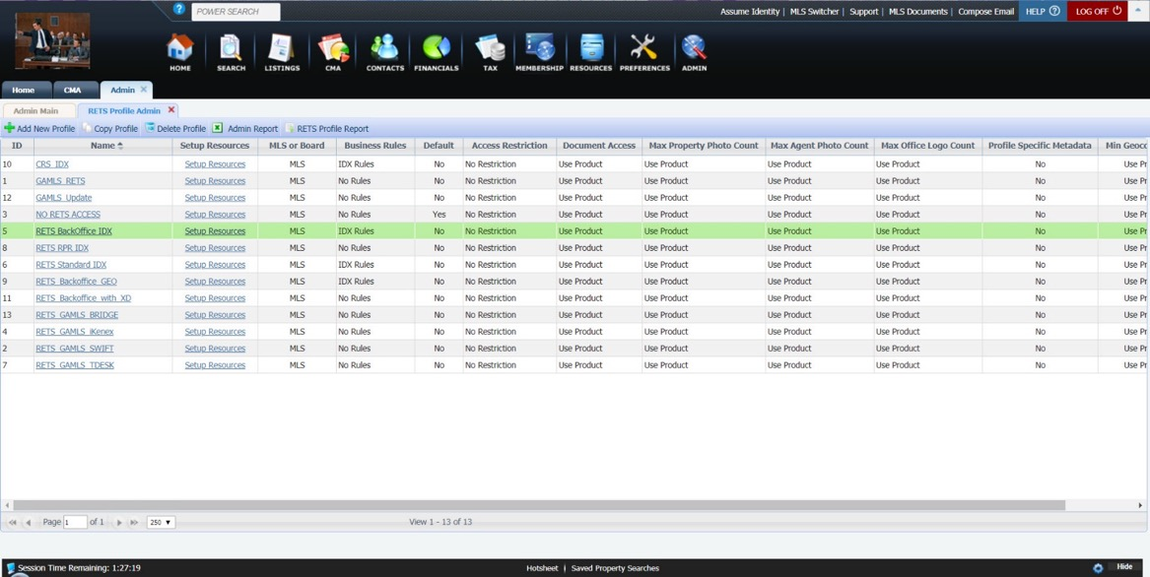

*Figure C: Report Criteria Prefilled*

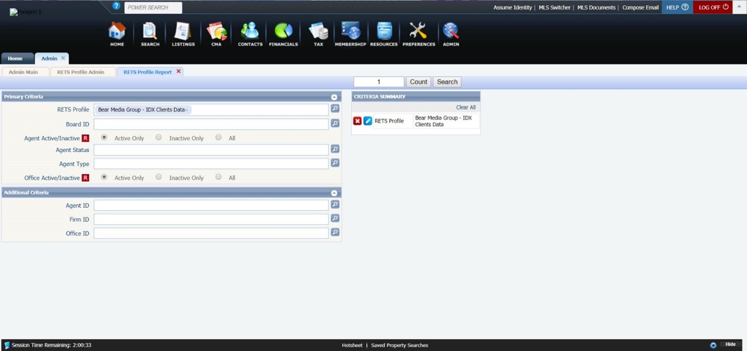

*Figure D: RETS Profile Report with New Fields*

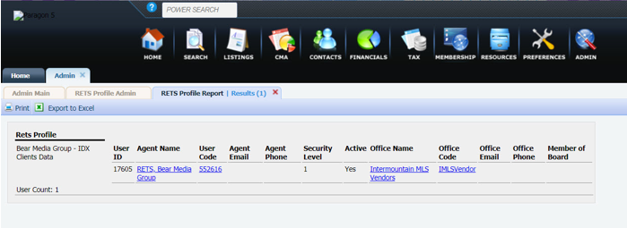

# “Get Homebot” Button Added to Contacts

For MLS’s where Homebot is activated, in order to ease use and help increase the adoption rate for Homebot, a “Get Homebot” option is being added to the Contacts menu above the Contacts grid. If an agent does not yet have an account, the text will read “Get Homebot” and when clicked, will launch a new browser window/tab to begin the registration process.

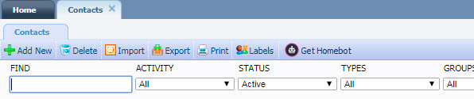

After the agent has registered, the next time the agent accesses Contacts, the text will read “Homebot” and take the agent directly to his/her Contacts Activity page in Homebot.

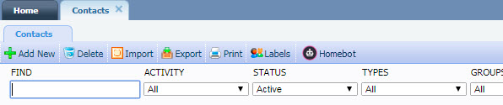

# 

# Homebot Client Registration in Collab Center

For MLS’s where Homebot is activated, in the event that an agent has not yet subscribed their contact to Homebot from the Contact Manager in Paragon, the MY HOME WEALTH tab in Collaboration Center will provide the subscription form so the contact can register themselves. Currently, if the contact is not subscribed, the MY HOME WEALTH tab is hidden. With this new feature, the tab will always be present if the agent has a Homebot account.

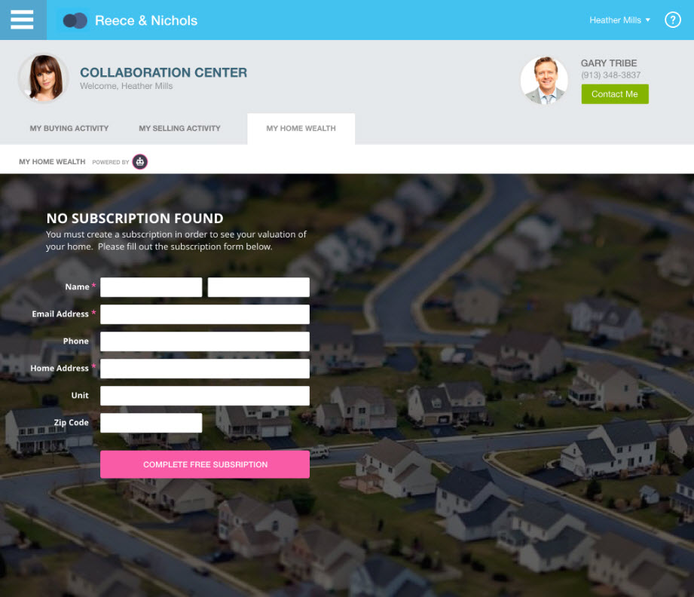

# 

# Create Fields for Listing City/State/Zip for Reports

When adding a listing’s city, state/province, and zip/postal code to a custom report each of these elements must be added individually. Users have to make sure that each field is added in the correct order and formatted correctly which can be an arduous task. In order to help users add these values to reports more efficiently, a new report field has been created. This field will add the listing’s city, state or province, and zip or postal code in a single report element. This is an optional feature that can be used as needed.

The new field will be included in the listing table for each listing class. If needed, the field can be enabled like any other listing table field. The default field name is Listing City State Zip. The field can be renamed if necessary.

Since the field is designed for reporting purposes, there are several field attributes that should not be enabled:

* + 1. Used in RETS
    2. Required (standard or subject property listings)
    3. History or Hotsheet if Changed
    4. Status Allowed
    5. Input and Update Security
    6. Type
    7. Searchable
    8. Collab Center Edit
    9. Sold

*Figure A: Field Setup Form*

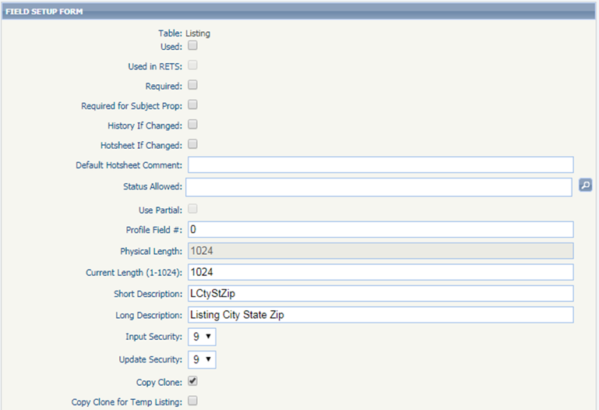

Once the field is enabled it can be added to custom reports, spreadsheet views, and legacy reports.

*Figure B: Report view*

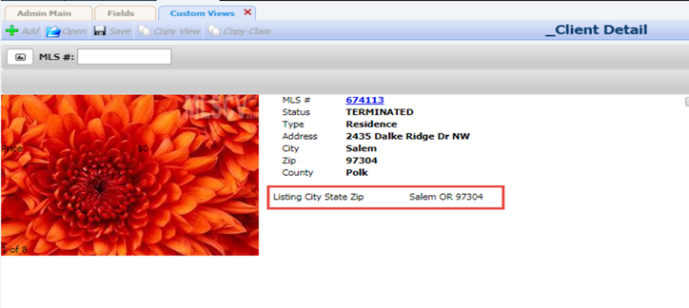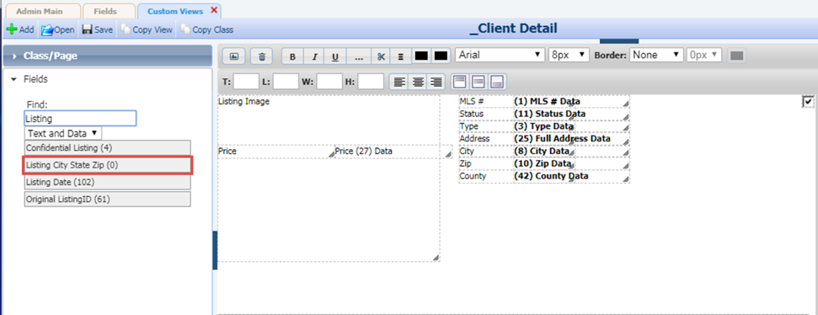

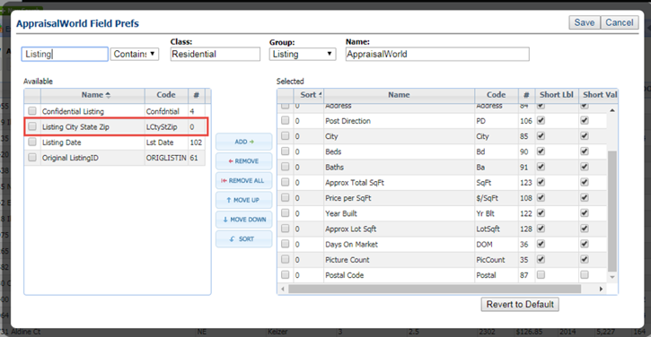*Figure C: Spreadsheet view*

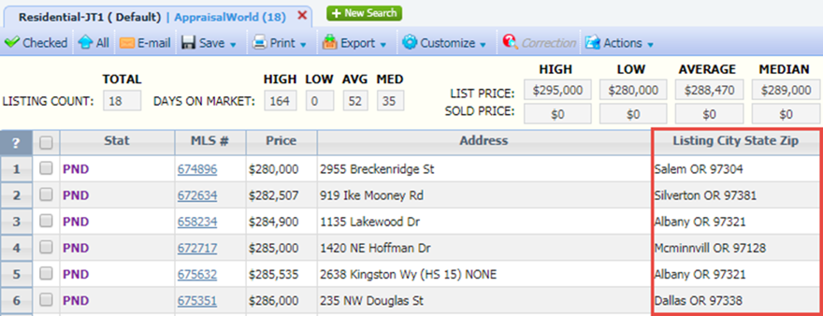

# Introducing Paragon Affiliate Connect

Affiliate Connect (AC) is a feature of Paragon that facilitates communication between real estate agents, their affiliates, and their consumers (i.e., home buyers and sellers). Affiliates are the agents preferred group\team of home related specialists such as loan officers, settlement officers, home inspectors, etc. This feature allows MLSs to onboard and manage affiliates more easily. Agents can build and manage their affiliate groups and brokers can create and manage office-level affiliate groups that all agents within their office can utilize. Watch for news on this exciting new Paragon initiative and additional features that will be coming in future releases.

Figure : Affiliate Connect in Four Easy Steps

