# Agent Level Enhancements

**The following section contains changes that are active system wide** **and available to users based on their assigned security levels.**

# Rich Text Editor (RTE) Upgrade to Latest Version

The Rich Text Editor in Paragon has been updated to a newer version to address a number of historically frustrating issues and incorporate better support and flexibility. The look of the RTE will change significantly but the functionality available will vary only slightly. Formatting of advanced messages will be enhanced with the update. The RTE has been upgraded in all locations that it is currently used throughout Paragon.

# Introducing Map Boundary

**You asked and we delivered!** Customers have wondered why when doing a map search and entering search criteria first, the map does not display listings until after a shape is drawn. Ask no longer. The map boundary will be turned *on* for everyone and will automatically display listings when the count of search results are equal to or less than the MLS setting for Search Max Pins. Map boundary functionality has also been integrated into the Google Map report.

# Center Map on Address - Update

After entering or selecting an address in the ‘Center Map on this Address’ box, the entered address no longer remains in the box after initiating the search. However, users can now hover the Mouse over the address marker to see the physical address of the marker.

# CMA: Horizontal Comparable Report Modification

Previously when listings with a large number of characters in the remarks field were included in the Horizontal Comparable Report it would cut off the remarks and adjustment data, if the listings on the page contained more lines than there was space on the page. This has been modified so that instead of cutting off the data, if the data for the last listing on the page cannot be completely displayed on the page, the entire listing is pushed to the next page of the report. In addition, a friendly Help button and associated message will now display when the user accesses the Customize CMA Field Preferences screen. Clicking the Help icon will display a warning about printing the report with remarks.

# Updates to CMA Adjustments

When users add a manual adjustment to the CMA presentation and click Save, the adjustment will automatically save to the Saved Adjustments list. When the user chooses to add a manual adjustment in the CMA Wizard, the user has the opportunity to select a previously used or saved adjustment which will appear in a drop down box when the user begins typing in the manually added adjustment field or the user can add a new adjustment description entirely. Although the adjusted field description will carry over to the other comparables, the adjusted value will only apply to the current comparable that is being viewed.

**NOTE:** Users can also add adjustments to the Saved Adjustment list through Preferences > CMA > Page Layout > Adjustments

# Focus on CMA Adjustment Field when Added

When the user adds a manual adjustment to CMA, focus will now jump to the field and place the cursor in it so that the user can begin typing without having to scroll down to the field.

# CMA: Adjustments Header Section Locked

The header section of the Adjustments page in the CMA Wizard is now locked so that as the user scrolls down on the page, the header information is always displayed at the top of the page.

# CMA: Relabelled Adjustments Back\Next Buttons

The Back\Next buttons on the Adjustments page to scroll through comparables has been relabelled to Prev Comp\Next Comp. This was done because customers would inadvertently click the Back\Next CMA wizard buttons when they intended to click the Back\Next comparable buttons.

# CMA: Display Count of Available Document Uploads Remaining

When users are adding a document via Step 5: Presentation Setup\Upload Document, the dialog that appears will now indicate how many remaining documents can be uploaded. The count of documents will decrease for each upload until there is no more space available.

# Add Hyperlink to CMA Comparables MLS#

When users access the CMA Comparables page, they will notice that the MLS# is now a hyperlink that when clicked will open a dialog that displays the default listing detail. The detail view that displays is based on the user preferences first and if none has been provided, will use the MLS configuration.

# CMA Map Legend Statuses

The status category names on the CMA map legend now matches what the MLS uses.

# Collab Center: Map Zoom

When viewing a detail report in Collaboration Center, the map section within the report was zoomed in too far. This has now been corrected to match each Paragon User’s Map Zoom setting or the MLS setting if the User preference option is not set.

# Increased Speed Printing Multiple PDF Reports using Print+

Several customers have reported Print+ concerns when generating a PDF file that contains multiple listings that are displayed on multiple report views. The enhancements focused on two aspects of the functionality:

* The length of time required to generate the report set.
* When the user’s device defaults to a download of the PDF file, the Print+ modal does not indicate that the download is complete.

# New Theme

­­Our tour around the country continues with our latest banner theme from the southwest. This theme features some traditional elements from the southwest. Watch the clouds fly by and maybe a few more fun items.

# MLS Customizations and Administration

All options in this section are configurable via MLS Administration controls or by your System Support Manager as noted.

# Reduction of Stored Photo Sizes and Browser Scaling

In the latest version of Paragon we have added an enhancement that will reduce the resource load required for the storage and display of listing photos. The changes are as follows:

* The number of stored system listing photo sizes will be reduced to 3 from 13. This will reduce the amount of storage required for photos. This change also frees resources used to create duplicate listing photos for each predefined size.
* When a report view requests a photo from Paragon, it will send a photo larger than required by the report. Paragon reports include code that instruct browsers in resizing listing photos so that they display correctly in the report and in the best quality possible.

**Please Note:** Some slight adjustments to listing photos on reports may be necessary if any impact is seen.

# Preferences Auto Count Setting Update

There have been so many improvements made to the map searches over the past few years that the Preferences\System Preferences\Search Options\‘Auto Count’ setting has been *removed*. This setting use to allow customers to turn map search result counts on or off. Although the setting has been removed from the screen, this feature remains behind the scenes and will default to *on* for all customers.

# Number of Allowed Shapes on Map Searches

Customers have asked that we increase the number of default shapes that can been drawn on the map search. Although this is controlled at the MLS level, we have taken the liberty of updating the Admin\Mapping\Max Shapes to seven for all customers that had it set to a lower value. Every Paragon User will now have the ability to draw at least seven shapes per map search.

# SSL Added to IDX Smart Framing, Affiliate Connect and Collaboration Center

IDX Smart Framing, Affiliate Connect and Collab Center pages have been modified to incorporate SSL. This will increase the security of the pages and mitigate modern browser errors indicating that the pages are insecure.

# Display Listing Office Brokerage Name in Collaboration Center Views

This enhancement fulfills a requirement for those MLS customers that have to display the Listing Office Name in the Collaboration Center views. Listing Office is already enabled on the Client Collaboration Center Detail view, however this enhancement displays the ‘Courtesy Of’ footer on the Tile, Thumbnail, and Map views. This function is configurable; please contact your SSM if this is a necessary option for your MLS.

# Collab Center: License # can be Displayed

In the Collaboration Center we now have the ability to display the License number where applicable. This is disabled by default and must be enabled by your SSM. When enabled it will display the license number wherever the agent information is displayed throughout the Collaboration Center site.

# Listing Field Additions for Native RESO DD Compliance

New fields have been added to the Paragon listing tables to accommodate future native RESO Data Dictionary compliance and growth needs.

# Advanced Listing Sharing: CollabLink and Facebook

In order to accommodate the sharing of multiple Paragon listings, new functionality has been added. This functionality also allows the user to share listings using multiple platforms. Listings may be shared in the following ways:

* A short URL which can be used to share listings in SMS, MMS, or instant messenger applications.
* Multiple listings may be shared to Facebook leveraging the current functionality utilized in Paragon and Collaboration Center. If customers allow single listing sharing to Facebook currently that functionality will continue to work the same.

# Corrected Issues

|  |  |  |  |  |
| --- | --- | --- | --- | --- |
| **Work Order** | **Seq** | **Module** | **Reporting Customer(s)** | **Issue Corrected** |
| 121646 | 1 | Statistical Reporting | East Central Iowa, Spartanburg | House Agent appears to skew Broker Sales Detail |
| 127304 | 1 | Market Monitor | Central Mississippi | Adding zip code value to Market Monitor causes it to go blank |
| 127551 | 1 | Print/Print+ | Duluth, CREN, Omaha, NEREN, NKMLS, REB3, Superior, Triangle | Printing Multiple PDF report forms takes a long time...status displayed is incorrect. |
| 138292 | 1 | Buy Side Communication | REB3 | CC2-Manage comments is not displaying comments for Agent Recommended |
| 138330 | 1 | CC2 - Buy Side | REB3 | MAP LAYERS ZOOM: Neighborhood and Postal Codes do not zoom when instructed to. |
| 138426 | 2 | Buy Side | REB3 | Zoom on Map in Detail view on Collab should be adjusted |
| 138989 | 1 | Third Party Integration | Birmingham, NEREN | ShowingTime Error: GetShowingTimeListingStatus When Using Market Monitor |
| 140024 | 1 | Admin - Office | Columbia SC, CARMLS, Birmingham, Northern Ontario | Admin-Office- Broker field returning an error when trying to select new broker |
| 140024 | 2 | Admin - Agent | Columbia SC, RANW, Birmingham | Agent Transfer - Primary Agent field returning an error when trying to select agent |
| 140024 | 3 | Tour/Open House | Birmingham, RANW | Open House - Host Agent field returning an error when trying to add an Open House |
| 134568 | 2 | Admin - Listings | Birmingham | First Photo Add Date Not Set When Listing Converted from Partial |
| 93738 | 2 | CMA | South Central Wisconsin, REB3, NRV | Map Legend needs to follow the Statuses that each Customer has. |
| 99490 | 1 | CMA | Gallatin, Hudson, IRMLS, NEREN, NRV, Northern Ontario, Pensacola, REB3, Willamette | Comparable Report (Horizontal) cuts off listing data for listings |
| 139105 | 1 | Buy Side Communication | REB3, NEREN, Nova Scotia | Copy/Paste Listing Number in Collab Notifications from Sent Items to Quick/Power Search No Results |
| 140426 | 1 | Third Party Integration | Intermountain MLS, NEREN, Sandicor | Need to update RatePlug URL for the RatePlug Calculator from http to https |

# Agent Level Changes

**The following section contains changes that are active system wide** **and available to users based on their assigned security levels.**

# Rich Text Editor (RTE) Upgrade to Latest Version

The Rich Text Editor in Paragon has been updated to a newer version to address a number of historically frustrating issues and incorporate better support and flexibility. The look of the RTE will change significantly but the functionality available will vary only slightly. **Access to the User Guide for the updated RTE can be** [**found here**](http://paragonconnect.paragonrels.com/images/Paragon-Rich-Text-Editor-User-Guide_072318.pdf)**.** Formatting of advanced messages will be enhanced with the update. Highlights of the changes are as follows:

* The updated RTE creates streamlined background code for the messages. The messages are displayed more reliably than in the past
* The Paste from Word function is merged into an integrated Paste function. When using generic Paste in the new editor the formatting from another application is retained if possible
* The Find and Find and Replace functions are combined in the new editor
* Table formatting functions are merged into a menu in the new editor
* The spellcheck functionality has been removed. Modern browsers provide spellchecking plugins
* The Help function has been removed. This functionality only provided information about the editor itself Detailed Help information was not provided
* The insert date/time functions have been merged into a single menu option

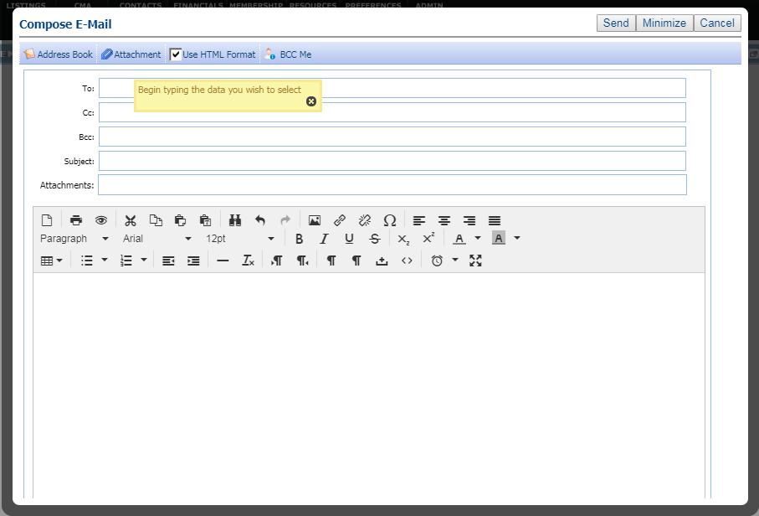

The RTE has been upgraded in all locations that it is currently used in Paragon. The modules affected are:

* Compose Email
* Calendar – Add/Edit Event
* CMA – Cover Letter, Agent Resume, Company Info, and Final Comments (CMA Module and Wizard)
* Contacts – Email Notification Options (Legacy and Collab Center Notifications)
* Preferences – Email Signature and Collab Center About Me Message
* P4B Dashboard – Login Msg. Admin, Dashboard Msg. Admin and Homepage Msg. Admin
* Admin – MLS Information Automation Email Body
* Admin – IDX Smart Framing Manage Contact Information – Contact Information
* Admin – Messaging – Homepage Message, Login Agreement, MLS Messaging and P4B Dashboard Message

# Introducing Map Boundary

**You asked and we delivered!** Customers have wondered why when doing a map search and entering search criteria first, the map does not display listings until after a shape is drawn. Ask no longer. As the default, map boundary will be turned *on* for everyone and will automatically display listings when the count of search results are equal to or less than the MLS setting for Search Max Pins when certain criteria is met. The map will open using as a best-fit zoom level so that all listings appear on the map. When there is no search result count on the map search, map boundary will default to *off* regardless of what the result count would have been and the map will open using the user’s default zoom level that is set in Preferences\System Preferences\Search Options\‘Custom Map Address and Zoom Level’ if available. If not available, it will use the MLS default zoom level set in Admin\Mapping\’Default Zoom Level’. If map boundary did not turn on automatically, the user can turn it on manually by clicking the new Map Boundary button.

Map boundary cannot be used with drawn shapes. If map boundary was *on* and the user draws a shape, it will automatically turn *off*. If the user then excludes (or deletes) the shape, map boundary will turn back *on* with the assumption that the user wants to exclude the shape from map boundary. However, this will not be true if map boundary was not on when initially accessing the map and the user manually turns it on and repeats the same steps.

**PLEASE NOTE:** When map boundary displays the listings as a best fit, if there are listings that are outliers, they will appear and can be checked to make sure that the address is correct as it will zoom out far enough to display listings that are in other states or countries if applicable.

Map boundary functionality has also been integrated into the Google Map report. When map boundary is added to the search criteria and the user views the results in the Google Map report, the report will open at the size and shape of the map boundary (without the actual shape being displayed) for the number of listings specified per page of the report. If the user zooms out far enough, they will then see the map boundary shape that reflects the original map search shape.

**NOTE:** Google Map Report - There will be minor repositioning and zoom level modifications of the shape in order to display all of the listings associated with the perspective page of the report when the report has multiple pages.

*Figure A: Map Boundary on*

Map boundary appears as a dotted green rectangle shape around the exterior of the map.

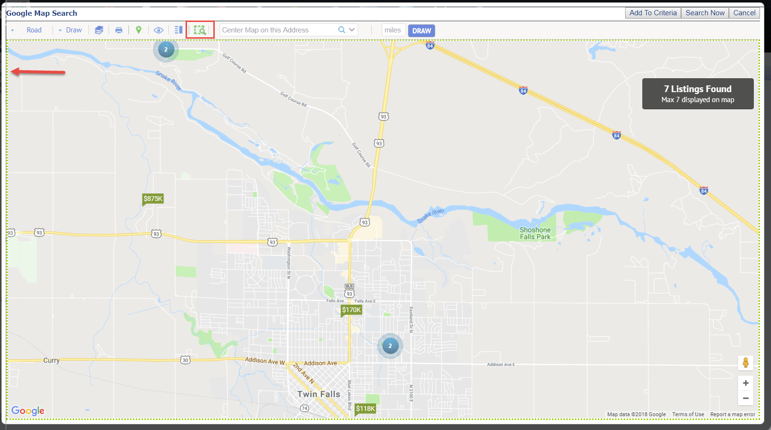

*Figure B: Google Map Report w/Map Boundary turned on*

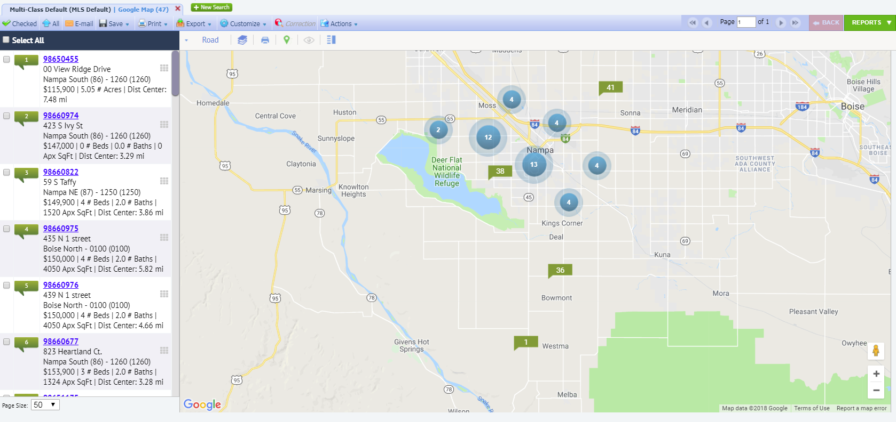

# Center Map on Address - Update

After entering or selecting an address in the ‘Center Map on this Address’ box, the entered address no longer remains in the box after initiating the search. However, users can now hover the Mouse over the address marker to see the physical address of the marker.

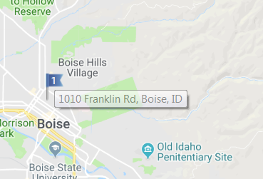

# CMA: Horizontal Comparable Report Modification

Previously when listings with a large number of characters in the remarks field were included in the Horizontal Comparable Report it would cut off the remarks and adjustment data, if the listings on the page contained more lines than there was space on the page. This has been modified so that instead of cutting off the data, if the data for the last listing on the page cannot be completely displayed on the page, the entire listing is pushed to the next page of the report. In addition, a friendly Help button and associated message will now display when the user accesses the Customize CMA Field Preferences screen. Clicking the Help icon will display a warning about printing the report with remarks.

*Figure A: Horizontal Report*

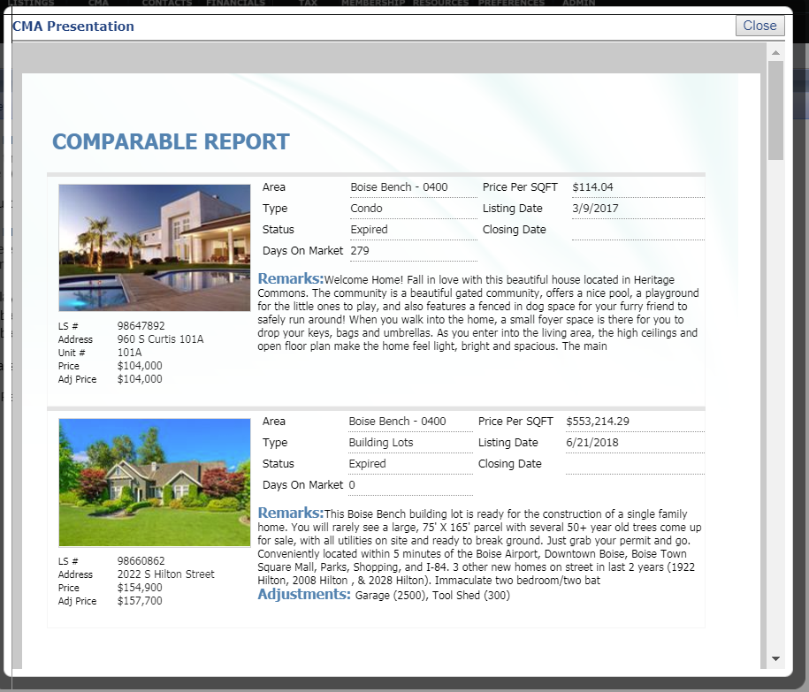

*Figure B: New Help button and Message*

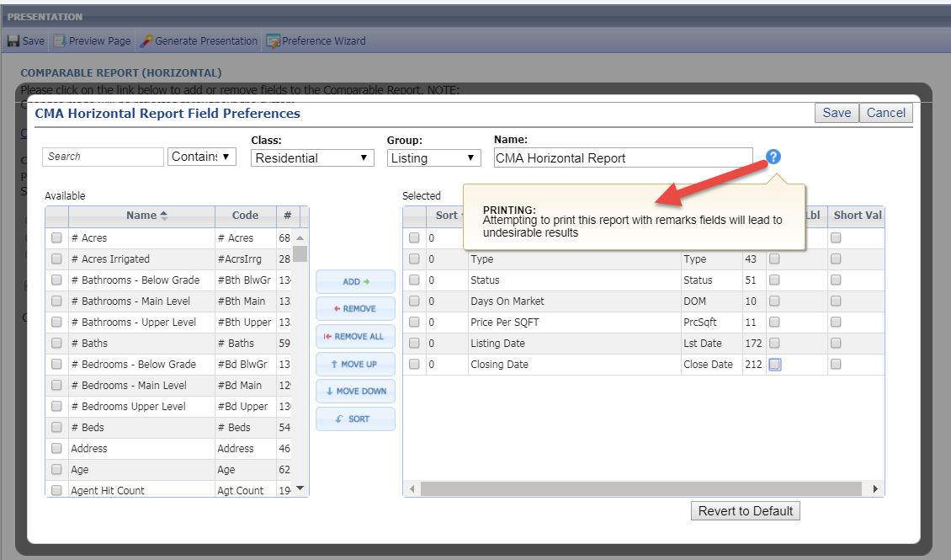

# Updates to CMA Adjustments

When users add a manual adjustment to the CMA presentation and click Save, the adjustment will automatically save to the Saved Adjustments list. When the user chooses to add a manual adjustment in the CMA Wizard, the user has the opportunity to select a previously used or saved adjustment which will appear in a drop down box when the user begins typing in the manually added adjustment field or the user can add a new adjustment description entirely. Although the adjusted field description will carry over to the other comparables, the adjusted value will only apply to the current comparable that is being viewed. If users delete an adjustment and there are values for that same adjustment on other comparables, they will remain. However, the adjustment row will continue to show up on the reports for all listings.

Users can search for adjustments within the Saved Adjustment list by selecting the ‘Saved Adjust’ button at the top of the CMA Adjustments page which has been redesigned to include an ‘Available’ and ‘Selected’ adjustment section. This allows users to quickly add previously used adjustments. Adjustments already contained in the presentation will be represented in the Selected section. After adding an item to the Selected section, the user will have the ability to order them to their liking and save them.

**Note:** Users can also add adjustments to the Saved Adjustment list through Preferences > CMA > Page Layout > Adjustments.

*Figure A: Adjustments Drop Down*

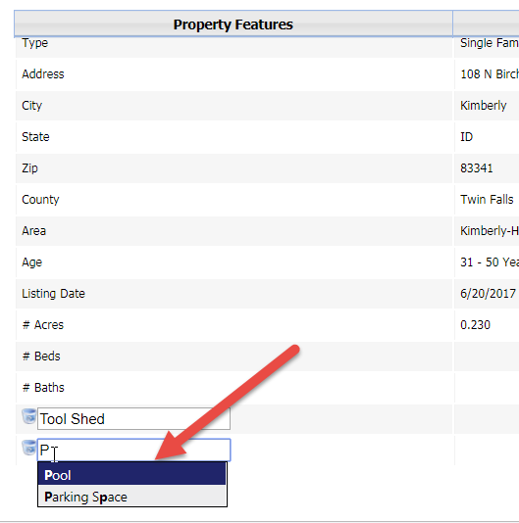

*Figure B: Saved Adjustments* 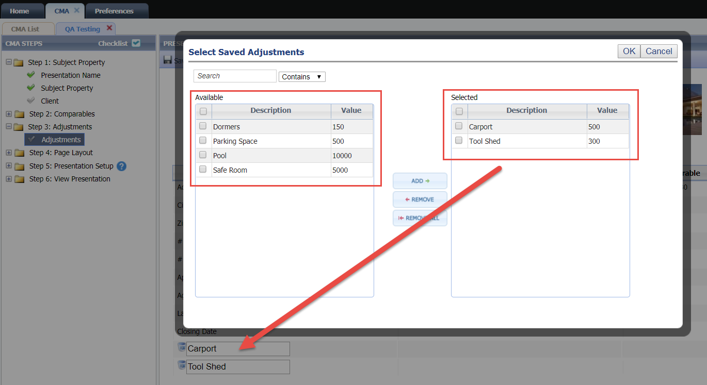

# Focus on Adjustment Field when Added

When the user adds a manual adjustment, focus will now jump to the field and place the cursor in it so that the user can begin typing without having to scroll down to the field.

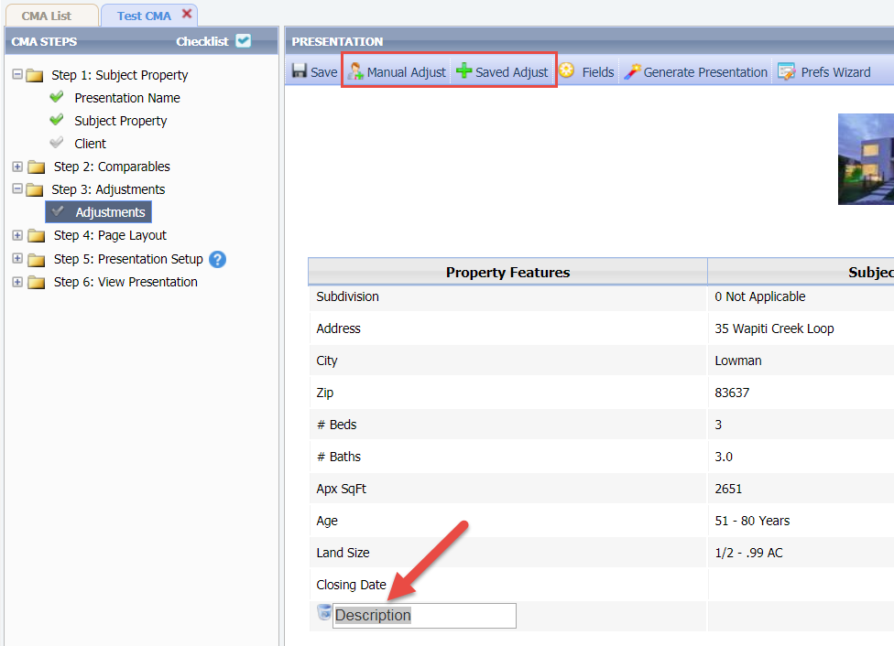

# CMA: Adjustments Header Section Locked

The header section of the Adjustments page in the CMA Wizard is now locked so that as the user scrolls down on the page, the header information is always displayed at the top of the page. For this reason, the scroll bar was pushed further down on the page so that only the fields will scroll down.

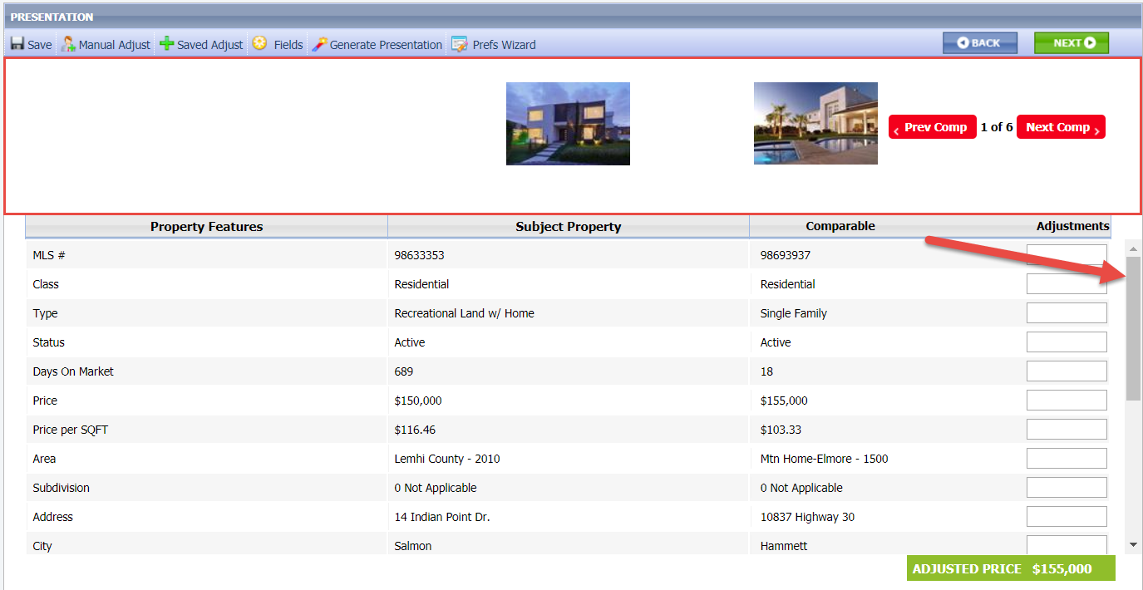

# CMA: Relabelled Adjustments Back\Next Buttons

The Back\Next buttons on the Adjustments page to scroll through comparables has been relabelled to Prev Comp\Next Comp. This was done because customers would inadvertently click the Back\Next CMA wizard buttons when they intended to click the Back\Next comparable buttons.

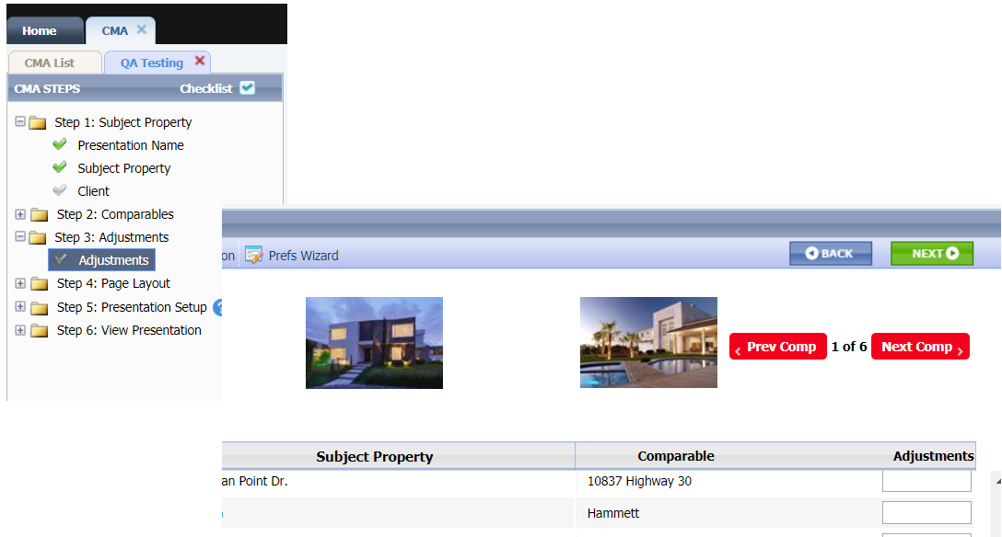

# CMA: Display Count of Available Document Uploads Remaining

When users are adding a document via Step 5: Presentation Setup\Upload Document, the dialog that appears will now indicate how many remaining documents can be uploaded. The count of documents will decrease for each upload until there is no more space available. Once all available uploads are at capacity, the Upload Document link will be disabled and will not allow additional documents to be uploaded until one or more existing documents are deleted hence freeing up space.

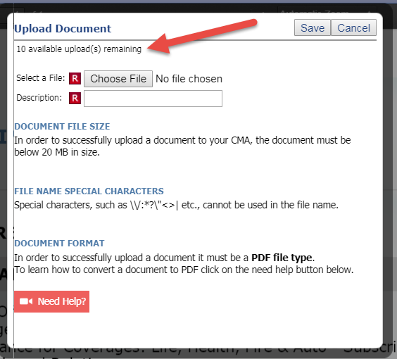

# Add Hyperlink to CMA Comparables MLS #

When users access the CMA Comparables page, they will notice that the MLS# is now a hyperlink that when clicked will open a dialog that displays the default listing detail. The detail view that displays is based on the user preferences first and if none has been provided, will use the MLS configuration.

*Figure A: MLS# Hyperlink*

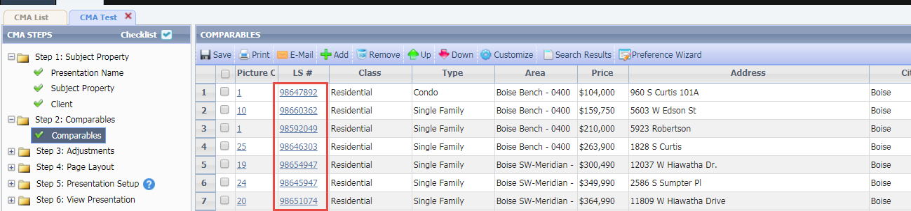

*Figure B: Detail Report View*

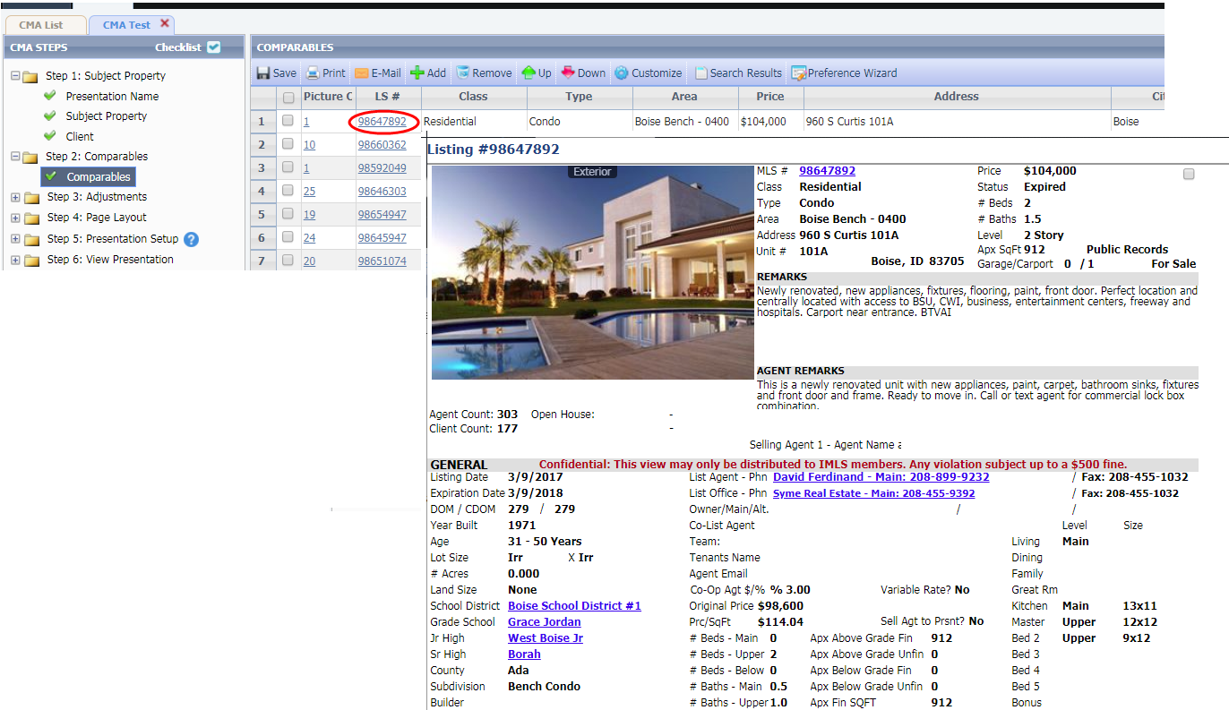

# CMA Map Legend Statuses

The status category names on the CMA map legend now matches what the MLS uses.

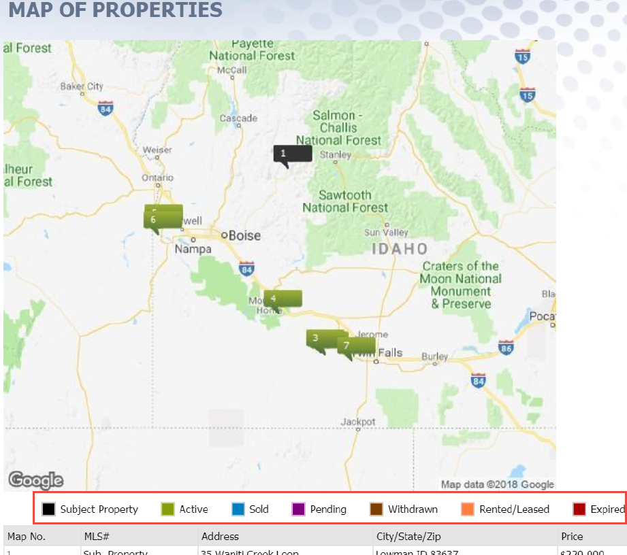

# Collab Center: Map Zoom

When viewing a detail report in Collaboration Center, the map section within the report was zoomed in too far. This has now been corrected and the Zoom level is set to match each Paragon User’s Map Zoom setting or the MLS setting if the User preference option is not set.

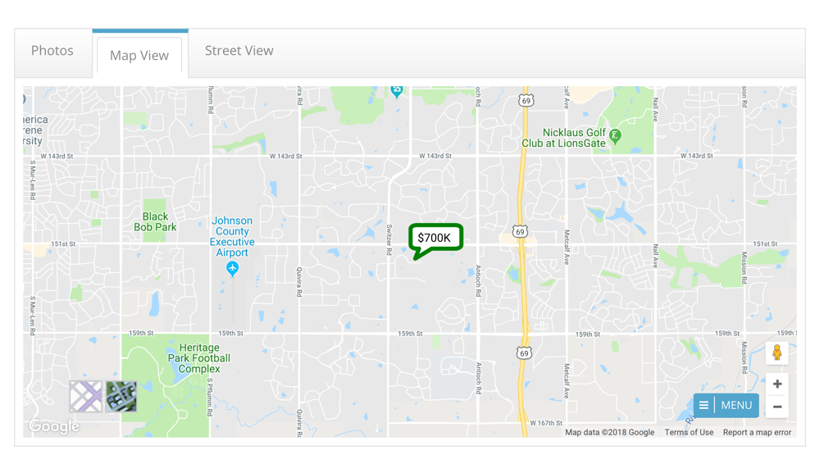

# Increased Speed Printing Multiple PDF Reports using Print+

Several customers have reported Print+ concerns when generating a PDF file that contains multiple listings that are displayed on multiple report views. The enhancements focused on two aspects of the functionality:

* The length of time required to generate the report set.
* When the user’s device defaults to a download of the PDF file, the Print+ modal does not indicate that the download is complete.

The speed of PDF generation and the download status of a PDF file cannot be significantly improved. Similar to generating a CMA presentation, Paragon has been modified to allow the user to process the Print+ request in the background so they can continue to work without waiting for the process to complete first. Therefore, a new minimize button has been added to the Print+ modal. It has also been modified with informative text describing the minimization process to the user.

*Figure A: Minimization Informative Text*

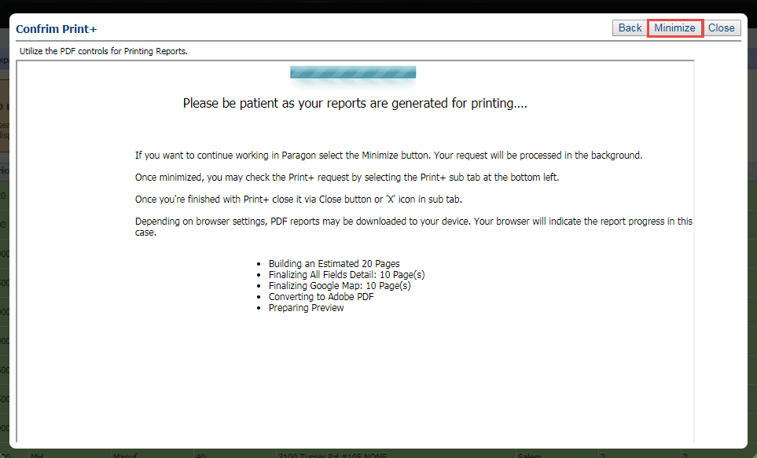

The minimized Print+ session is displayed as a red sub tab at the bottom left of the Paragon page. This display is very similar to that used when the customers minimize an email session in Paragon. The user can select the sub tab at any time after it is minimized to reopen it.

*Figure B: Red Sub Tab*

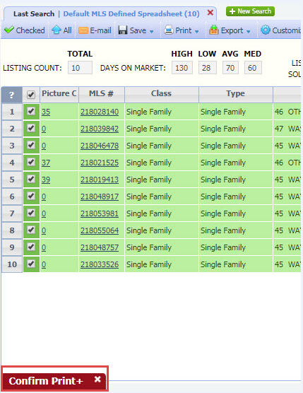

If the user attempts to initiate another Print+ session while one is minimized, a warning will display. The user may overwrite the current minimized session with a new one or can cancel to leave the current session intact. Once the Print+ session is finished, the user *must* close it via the Close button or the X icon in the sub tab. The user *cannot* dismiss the Print+ modal by simply clicking elsewhere on the background.

*Figure C: Overwrite\Cancel Current Session*

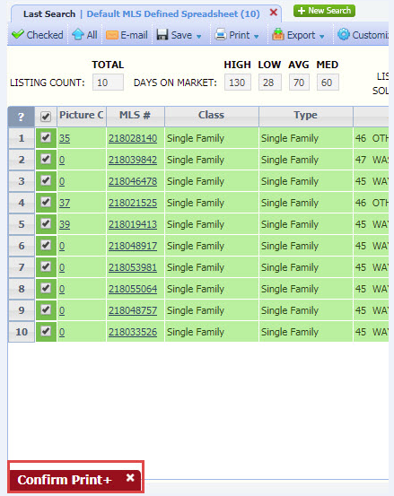

# New Theme

­­Our tour around the country continues with our latest banner theme from the southwest. This theme features some traditional elements from the southwest. Watch the clouds fly by and maybe a few more fun items.

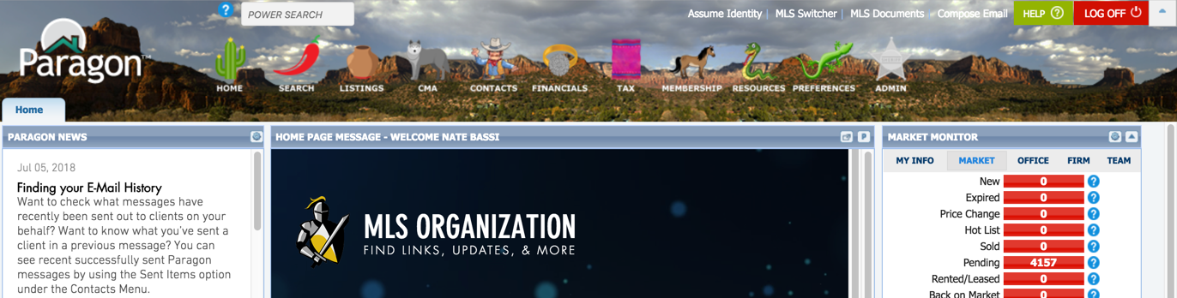

# MLS Customizations and Administration

**All options in this section are either configurable via MLS Administration controls or by your System Support Manager as noted.**

# Reduction of Stored Photo Sizes and CSS for Browser Scaling

In the latest version of Paragon we have added an enhancement that will reduce the resource load required for the storage and display of listing photos. The changes are as follows:

* The number of stored system listing photo sizes will be reduced to 3 from 13. This will reduce the amount of storage required for photos. This change also frees resources used to create duplicate listing photos for each predefined size.
* When a report view requests a photo from Paragon, it will send a photo larger than required by the report. Paragon reports include code that instruct browsers in resizing listing photos so that they display correctly in the report and in the best quality possible.
* **PLEASE NOTE:** Some slight adjustments to listing photos on reports may be necessary if any impact is seen.

When editing custom report views end users will no longer be required to add photos via predefined sizes. The end user may choose to use any photo size dynamically by changing the size of the listing photo container with mouse controls.

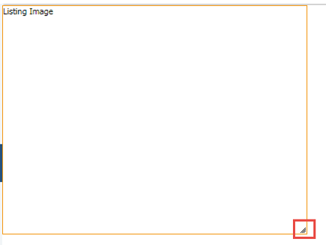

# Preferences Auto Count Setting Update

There have been so many improvements made to the map searches over the past few years that the Preferences\System Preferences\Search Options\‘Auto Count’ setting has been removed. This setting use to allow customers to turn map search result counts on or off. Although the setting has been removed from the screen, this feature remains behind the scenes and will default to *on* for all customers.

Note that this change does ***not*** affect how the Quick Search currently functions in which search criteria is required in order for the auto count to appear.

*Figure A: Auto Count has been* ***removed***

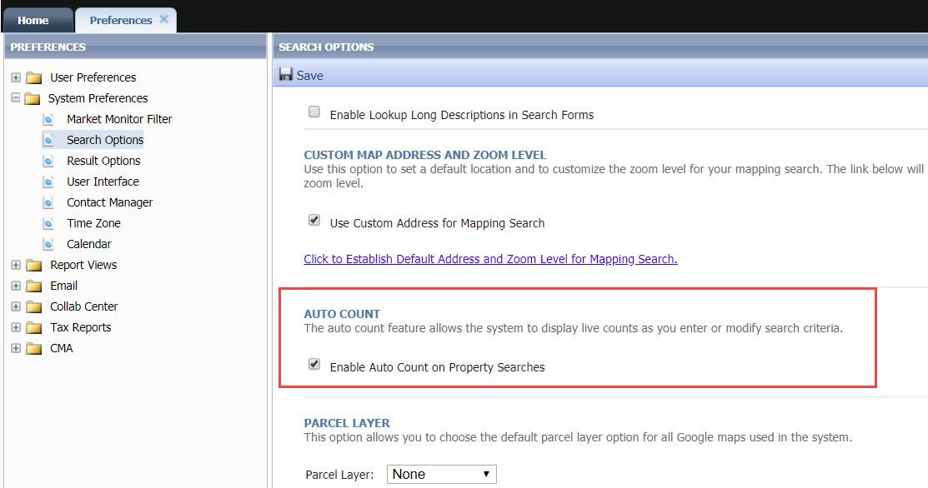

*Figure B: Auto Count is always on*

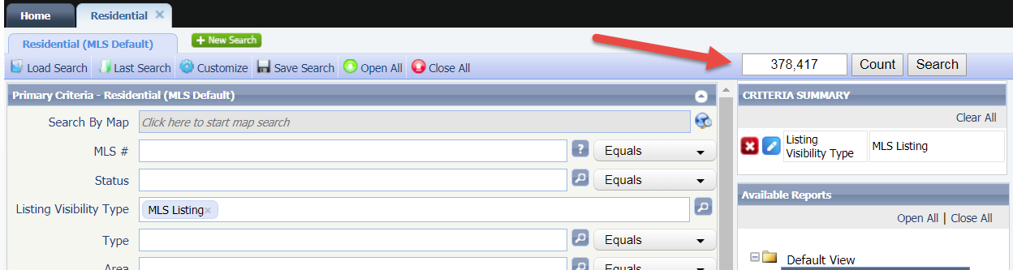

# Number of Allowed Shapes on Map Searches

Customers have asked that we increase the number of default shapes that can been drawn on the map search. Although this is controlled at the MLS level, we have taken the liberty of updating the Admin\Mapping\Max Shapes to seven for all customers that had it set to a lower value. Every Paragon User will now have the ability to draw at least seven shapes per map search.

# SSL Added to IDX Smart Framing, Affiliate Connect and Collaboration Center

IDX Smart Framing, Affiliate Connect and Collab Center pages have been modified to incorporate SSL. This will increase the security of the pages and mitigate modern browser errors indicating that the pages are insecure.

*Figure A: IDX Smart Framing*

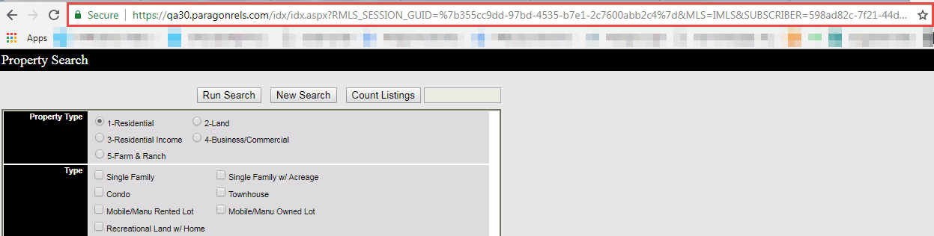

*Figure B: Collab Center*

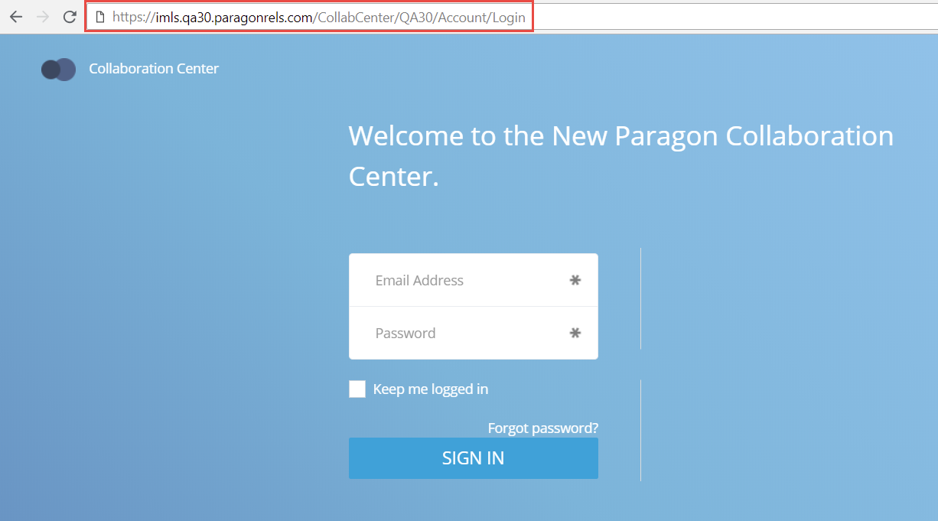

# Display Listing Office Brokerage Name in Collaboration Center Views

This enhancement fulfills a requirement for those MLS customers that have to display the Listing Office Name in the Collaboration Center views. Listing Office is already enabled on the Client Collaboration Center Detail view, however this enhancement displays the ‘Courtesy Of’ footer on the Tile, Thumbnail, and Map views. This function is configurable; please contact your SSM if this is a necessary option for your MLS.

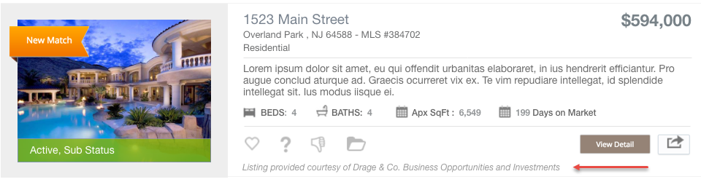

# Collab Center: License # can be Displayed

In the Collaboration Center we now have the ability to display the License number where applicable. This is disabled by default and must be enabled by your SSM. When enabled it will display the license number wherever the agent information is displayed throughout the Collaboration Center site.

*Figure A: Contact Me Modal & Desktop Dashboard*

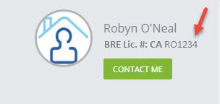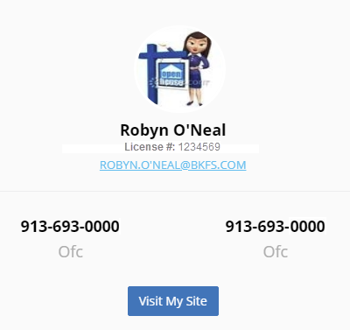

*Figure B: Mobile View*

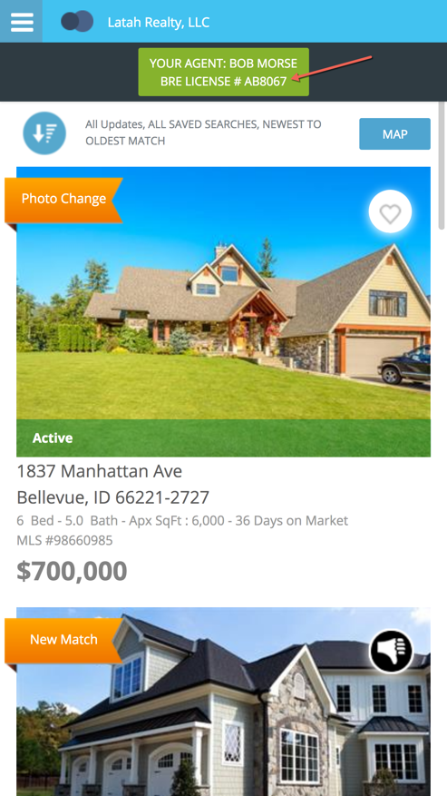

# Listing Field Additions for Native RESO DD Compliance

New fields have been added to the Paragon listing tables to accommodate future native RESO Data Dictionary compliance and growth needs. The fields added are as follows.

|  |  |  |  |
| --- | --- | --- | --- |
| Field Type | Count | Bytes | Purpose |
| VARCHAR (50) | 30 | 1500 | Meet Data Dictionary requirements and provide a buffer for future needs. |
| INT (4) | 30 | 120 | Provide buffer for future needs. |
| DECIMAL | 40 | 360 | Provide a buffer for future needs. |
| VARCHAR (1024) Hyperlinks | 3 | 3072 | Meet Data Dictionary requirements and provide a buffer for future needs. |
| Totals | 103 | 5052 |  |

The fields will be added to each listing class and may be accessed via the Fields administration function.

*Figure A: Fields Admin Function*

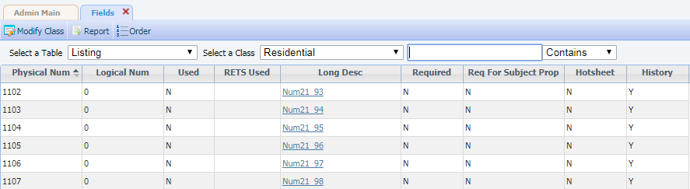

The behavior of the new fields will be customizable with the same controls available for listing table fields:

* The new VARCHAR fields may be configured to be lookup fields and added to lookup relationships.
* Field security may be applied to all of the newly added fields.
* The newly added fields may also be controlled by the use of field rules. The fields may be used as target fields or evaluated for use as conditional expressions or post value expressions.
* The newly added fields will be added to the property audit tables so they can be viewed in the Listing Audit and Property History Reports.
* Once activated, the newly added fields may be added to:
  + The Listing Input/Maintenance (LIM) module.
  + Searches. The only exception will be the new VARCHAR 1024 fields which are reserved for use as hyperlink fields.
  + Report views. The fields may be added to custom report views, legacy report views and Collab Center report views.
  + RETS profiles.

**REMINDER:** A RETS metadata refresh is required to ensure that the data in the new fields is available via RETS.

*Figure B: RETS Profile Module*

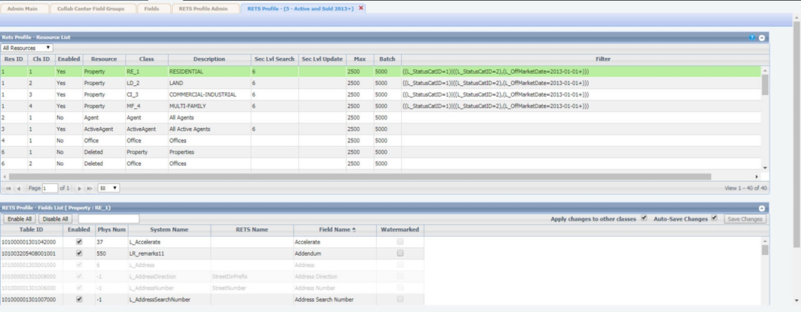

# Advanced Listing Sharing: CollabLink and Facebook

In order to accommodate the sharing of multiple Paragon listings, new functionality has been added. This functionality also allows the user to share listings using multiple platforms. Listings may be shared in the following ways:

* A short URL which can be used to share listings in SMS, MMS, or instant messenger applications.
* Multiple listings may be shared to Facebook leveraging the current functionality utilized in Paragon and Collaboration Center. If customers allow single listing sharing to Facebook currently that functionality will continue to work the same.

In order to facilitate the sharing of multiple listings the search results pages will be modified to include a new function ribbon option called **Share**. CollabLink Share may be added to Listing Input/Maintenance so that listing parties only may share individual listings via this method. These new sharing options will be disabledby default. The customer will need to contact their account manager to activate the functionality. The sharing methods may be implemented independently of one another. Several layers of security have been added to ensure that only listings eligible for sharing may be shared. All of the security is configurable and may be tailored to the specific needs of the MLS customer. The security protocol is as follows:

* The *primary* listing office of the listing to be shared must be an IDX Affiliate. The IDX Affiliate setting is found in the office record in Paragon.

*Figure A: Listing Office IDX Affiliate field*

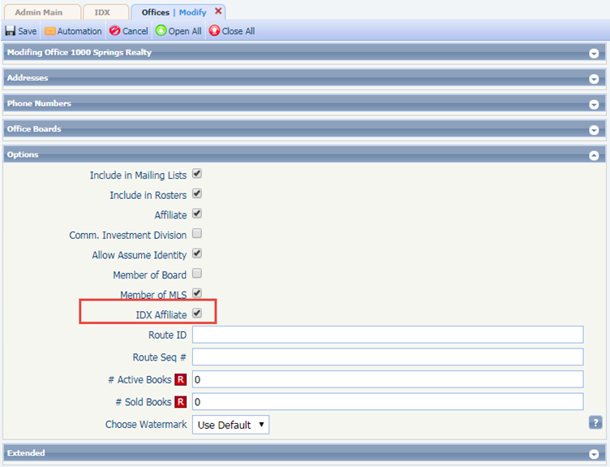

* The listing must be assigned a status and/or listing visibility type that is eligible for sharing. Customers will need to convey the eligible statuses and/or listing visibility types to their account manager so that they can be properly configured.

**NOTE:** This configuration is ***not*** needed for customers that do not use listing visibility types.

* Optional eligibility requirement: Customers may have additional optional requirements that must be met for sharing eligibility. These could include items such as user security level, user type, office assignment, board affiliation, etc.

The short URL used for advanced sharing options point to the CollabLink landing page ***only***. This *cannot* be configured to display other report types. Advanced sharing of listings is designed to be used with multiple device types, the sharing results must be presented in a format that is easily viewed on any device a recipient might have. In addition, the lifespan of the CollabLink URL will be the same as that of the current Publink (legacy) email hyperlinks.

* If the CollabLink URL expires an error message will be displayed.
* The user will select a group of listings for sharing using the selection boxes in Paragon’s spreadsheet or detail report views.
* Once the listings are selected the user will choose the Share option in the functions ribbon.

*Figure B: CollabLink Share and Share to Facebook Options*

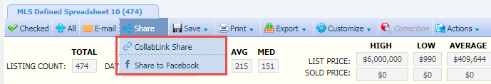

If the user does not select one or more listings before selecting a share menu option an error message will be displayed. This error is only applicable when sharing from search results.

*Figure C: Error Message to Select a Listing*



When sharing listings from search results an error message is displayed if one or more of the selected listings is assigned an ineligible status, Listing Visibility Type, or if the primary listing office is not an IDX affiliate.

**NOTE:** If one or more selected listings are eligible for sharing the user may continue to share only the eligible listings. If none of the selected listings are eligible for sharing the user must cancel the sharing session.

*Figure D: Error Message for Issues w/Selected Listing*

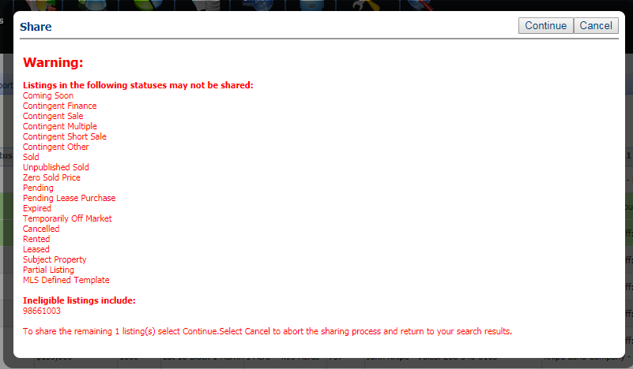

If there is an error when sharing a listing via LIM a modal will be displayed.

*Figure E: LIM Modal*

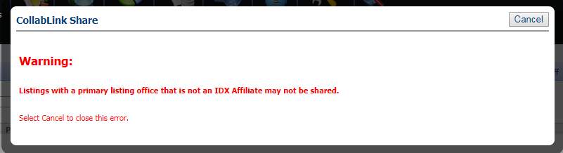

When multiple listings are shared successfully via CollabLink Share the URL is displayed in a modal. This URL can be highlighted and copied to another application on the user’s local device. Examples of the CollabLink landing page are also displayed. The examples are static images and do not represent the user or listings shared.

*Figure F: CollabLink Share URL Modal*

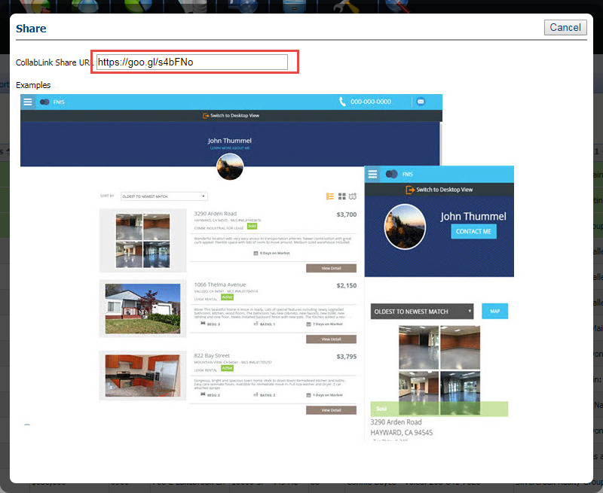

When multiple listings are shared successfully via Facebook, the Facebook sharing API will be displayed in a modal. The Facebook post or message will direct the user to a CollabLink landing page.

*Figure G: Facebook*

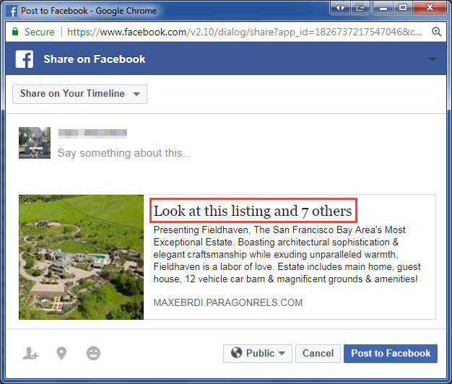

When a single listing is shared via CollabLink Share from listing maintenance the URL is displayed in a modal. This URL can be highlighted and copied to another application on the user’s local device. The modal is identical to the one displayed when multiple listings are shared via search results.

When a single listing is shared via Facebook from LIM the Facebook API is displayed in a modal. The link in the Facebook post or message will redirect the recipient to a CollabLink landing page. The modal will be similar to the one above without the reference to multiple listings.

If the CollabLink URL hyperlink expires the following error will be displayed when the CollabLink URL hyperlink is selected.

*Figure H: Expired CollabLink URL Hyperlink*

