Agent Level Enhancements
The following section contains changes that are active system wide and available to users based on their assigned security levels.

Mapping: New Distance Measurement Feature
We have added the ability to measure distance from any point on the map to another point. Multiple distance shapes can be added and saved to the search. The shapes will display the measurement based on user setting. Typically, miles for the U.S. and kilometers for Canada. If you click on the distance quantity, the distance will change to reflect feet or meters for that shape only. Users can close the shape by clicking the Exit button next to the distance quantity. This new shape does not affect RETS or searches since it does not filter results.

Driving Directions - Issue Update
There was an issue with the starting address appearing as the first destination address in the driving directions. This caused the last address in the directions to appear with a 0 subtotal drive time. This has been corrected to reflect the correct first address destination and the correct last address drive time subtotal.

CMA: Copy Adjustments to Other Comparables
The ability to copy an adjustment forward and backward to subsequent and previous comparables has been added to the CMA Adjustments page. ‘Copy’ buttons have been added to the adjustments row so the user can specify which direction the adjustment should be applied.

CMA Saved Adjustments - Issue Update
In the last release, we added a feature that allows users to add a manual adjustment to the CMA presentation and upon clicking Save, the adjustment automatically saved to a Saved Adjustments list. Although the adjusted field description carried over to the other comparables, its associated adjusted value did not. This has been updated so that the value also gets applied to the comparables.
The column header font sizes have been updated so that they are all consistent in their size.

CMA Comparables Grid Changes
Sorting and column width adjustments on the Comparables page of the CMA now saves.

Comparables Price Analysis Modification
When there wasn’t a subject property price, the Comparable Price Analysis would default to the highest comparable price. If there was a subject property price, it defaulted to that price. This has been modified so that regardless of whether there is a subject property price, the analysis will default to the Average Adjusted Price. The assumption is that after adding all the adjustments to the comparables, the adjusted price should be considered in the price analysis.

CMA Amount Values Now Display Consistently
The dollar amounts displayed differently on the Summary of Adjustments, Horizontal Report, and Vertical Report. All three have been modified so that the amounts appear the same. Positive amounts will include a plus sign and negative amounts will include a negative sign.

Total Adjustments Added to CMA Vertical Report
The Vertical Report has been updated to include a total adjustments row at the bottom of the report. This row calculates the total of all adjustment amounts being added and subtracted per comparable and displays the combined total.

Collab Center: Agent Information
The agent information section contains quite a bit of information making the header too large on a mobile device. There is also a desire to implement a new tab structure for several of the categories found in the Collab Center. To address this, the agent information is being moved to the top of the Hamburger menu. The agent’s photo has also been included.

Collab Center: Navigation Cleanup
As the Collab Center buy side and sell side was redesigned into a tab navigation, it was noticed that the menu structure was not very user friendly. If the consumer is both a buyer and a seller and wants to run a search from the sell side they were forced to navigate to the buy side and then open the menu again to run the search. This has been corrected. Consumers can now view all menu items.

Collab Center: New Mobile Tab
While using a smart phone, consumers are having a difficult time knowing where to go to see their favorites, possible, and rejected listings. This could be done by using the Filter button which wasn’t very obvious. Therefore, a new tab structure has been implemented to help make it easier for consumers to find.

Collab Center – Mobile “Competition” Option
When viewing the sell side activity on a smart phone the consumer had no option to view the “Competition” option found when using a tablet or desktop device. A new menu option has been added for Competition. This will open the map and run the same search as on a tablet/desktop view.

Collab Center – Mobile “My Listings” Option
To help the consumer even more while using a smart phone, we have added a new menu option just for mobile called, “My Listings”. This contains all of the other categories that were once hidden under the Filter button.

Collab Center: Address before Location
Several consumers expressed confusion with the Location option found in the property search feature in Collab Center. They want to enter an address which doesn’t work as expected. It is intended to be a general search of your MLS based on listings found in the MLS. The Address tab is now first, and the Location tab is second.

Collab Center: Time Zone – Open House
For users that are utilizing the open house feature within the Collaboration Center site, they will be pleased to hear that we have added the time zone to the date and time stamp.

Collab Center: Request Showing Date
The ‘request a showing’ date will no longer allow the consumer to select a date in the past. Users must select the current or a future date.

Email the Listing Activity Report
The Listing Activity Report has been modified so that it may be printed or sent as a PDF attachment via email. All other report behavior and permissions will remain as-is.

833 Area Codes Now Accepted
Since our introduction of advanced phone number entry in Paragon several new area codes have been implemented. The 833 area code is a new toll free area code in the United States. Previously, when users tried to use this area code for phone numbers in Paragon the validation of the phone number failed.
We have resolved this issue by modifying the phone number code to recognize the 833 area code along with several others toll free numbers that have been added since the phone number entry method was updated a few years earlier.

MLS Customizations and Administration
  - All options in this section are configurable via MLS Administration controls or by your System Support Manager as noted.

Share to Twitter
In order to accommodate the sharing of multiple listings in Paragon, new functionality has been added. Multiple listings may be shared to Twitter leveraging a standardized method. In order to facilitate sharing of multiple listings, the search results pages will be modified to include a new function ribbon option called ‘Share’. Share to Twitter may be added to Listing Input/Maintenance so that only listing parties may share individual listings via this method.

Homebot Enhancements
In order to help agents locate Homebot so they can take advantage of staying connected with their contacts using this awesome tool, we have enhanced the process for the Agent Registration and the Contact Subscription process.

Configuration Added to Listing City, State, and Zip Reporting
Several customers use multiple City/Community fields in conjunction to pinpoint the location of a listing. In order to accommodate these scenarios, a new configuration setting has been added to control the city value displayed in the Listing City, State, and Zip reporting field. This setting will allow a customer to specify an alternate city field to use when creating the Listing City, State, and Zip field. The alternate city field must have the same ID in all listing classes.

RETS Server Changes
This release includes a few significant changes to our RETS Servers. We made major alterations to increase performance and help reduce database server load. We also expanded the fields available to be used with InKeyIndex. Finally, we corrected a rare error that could occur during a RETS Listing Update transaction.

Corrected Issues
Work Order | Seq | Module | Reporting Customer(s) | Issue Corrected
122151 | 2 | CMA | RANW | CMA Summary (within the CMA Packet) preview does not match PDF generated
125459 | 1 | Input Maintenance | REB3 | When inputting invalid List date received critical error saving.
138311 | 1 | Search - Property | Duluth, GTAR, HKAR, Huntsville, Memphis, NEREN, Northeast Iowa, Traverse, Pensacola, REB3, Triangle, Omaha | Driving directions are showing the Starting address as the Arrival Address
138311 | 2 | Search - Property | Duluth, GTAR, HKAR, Huntsville, Memphis, NEREN, Northeast Iowa, Traverse, Pensacola, REB3, Triangle, Omaha | Driving directions showing 0 subtotal time for last listing
138733 | 1 | Mapping | REB3 | When viewing a listing Cluster in Google map view, the sharing options display an incorrect listing
140911 | 1 | CMA | NEREN | CMA Cover page photo too small and poor quality
141309 | 1 | Views/Reports | South Central Wisconsin MLS (Madison) | Collab Link Share - Switch to Desktop view shows wrong report
141605 | 1 | RETS | REB2 2 | RETS Update has Incorrect Data in Output due to Change in Behavior
141643 | 1 | CMA | South Central Wisconsin MLS (Madison) | Cannot Print the CMA Comparables Grid 5.67, cma
136224 | 1 | Seller Side Activity | North Central (Mountain Home AR) Board of Realtors 3 | CC2 Seller Side - Values show as "undefined" and "Listing Views" does not load bp67
136982 | 1 | CMA | Baldwin County AOR (BCAR) | Requesting that changes be made to the CMA display for adjustment values
122151 | 4 | CMA | Olympic 9 | Comparable Property Statistics report has incorrect page breaks reb3
125860 | 1 | CMA | REB2 2 | CMA COMPARABLE PRICE ANALYSIS - Subject property defaults to highest price if no subject price....
127268 | 2 | Market Monitor | New England Real Estate Network (NEREN) | Setting MM filters after customizing does not refresh the MM listing counts
130686 | 1 | CMA | REB2 | Spelling Error in Selling Price vs. Timing Report in Vivid theme CMA
137087 | 1 | Contact Activity | New England Real Estate Network (NEREN) | Board requesting change from naming Seller as Prospect to naming them as Seller
140106 | 1 | Buy Side | REALTORS Association of Edmonton | CC2 - Cancel-out of Share options returns user to different pages bp67, reb3
140761 | 1 | Buy Side Communication | REB2 | Assoc Docs & Affil Connect appear on Detail view of Collab Center when viewing on a mobile device bp67
140900 | 1 | General UI | REB2 5 | Save button missing from User Preferences for CMA Page Layout reb3
141129 | 1 | HomePage Message | North Central West Virginia | RTE: Full Screen Button Does Not Enlarge Like Previous Version

Agent Level Changes
The following section contains changes that are active system wide and

Mapping: New Distance Measurement Feature
We have added the ability to measure distance from any point on the map to another point. Multiple distance shapes can be added and saved to the search. The shapes will display the measurement based on user setting. Typically, miles for the U.S. and kilometers for Canada. If you click on the distance quantity, the distance will change to reflect feet or meters for that shape only. Users can close the shape by clicking the Exit button next to the distance quantity. This new shape does not affect RETS or searches since it does not filter results. Therefore, if the shape is saved it will only reference the criteria used for the search, the measurement shapes along with any other shapes you've saved will be reflected on the map when accessing the saved search.
Note that due to rounding, although the distance may show one mile, when converted to feet it may not be exactly 5,280 feet which is equivalent to a mile as it will round up to a mile in this example. The map will not reload after drawing a distance shape within the map boundary.
Figure A: Distance Measurement Shapes
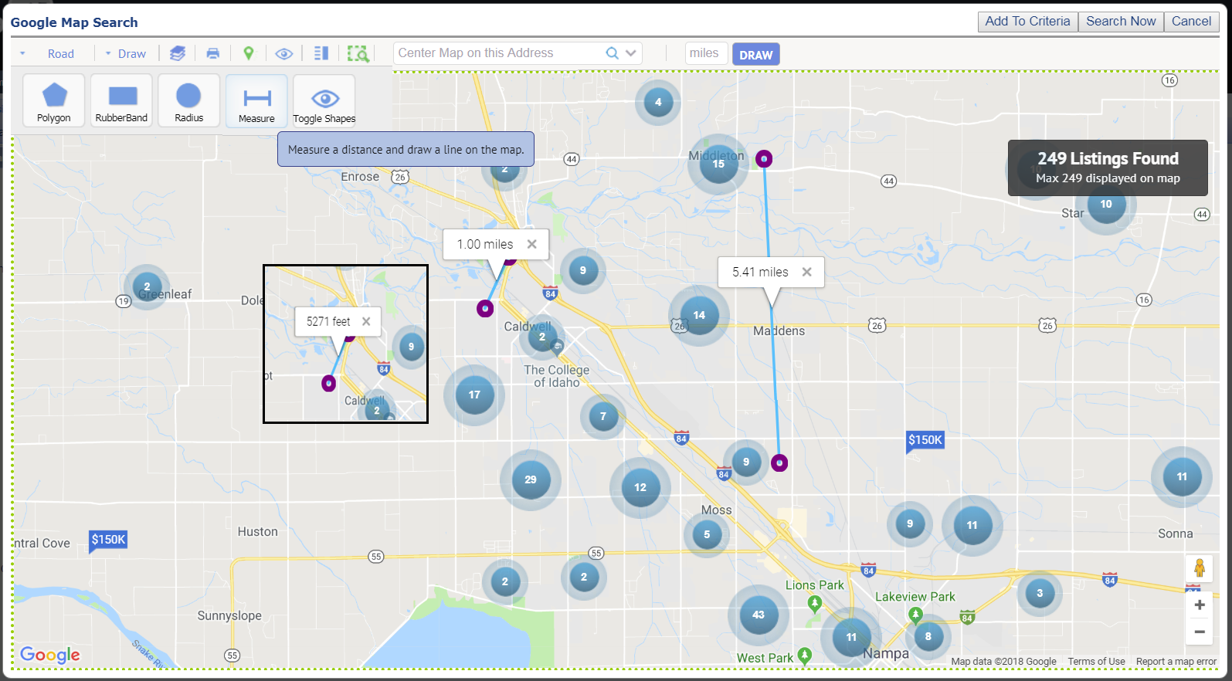

Figure B: Shape Added to Criteria
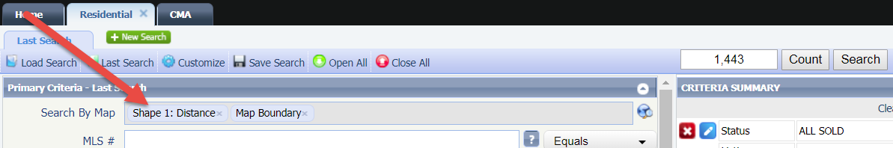

Driving Directions – Issue Update
There was an issue with the starting address appearing as the first destination address in the driving directions. This caused the last address in the directions to appear with a 0 subtotal drive time. This has been corrected to reflect the correct first address destination and the correct last address drive time subtotal.
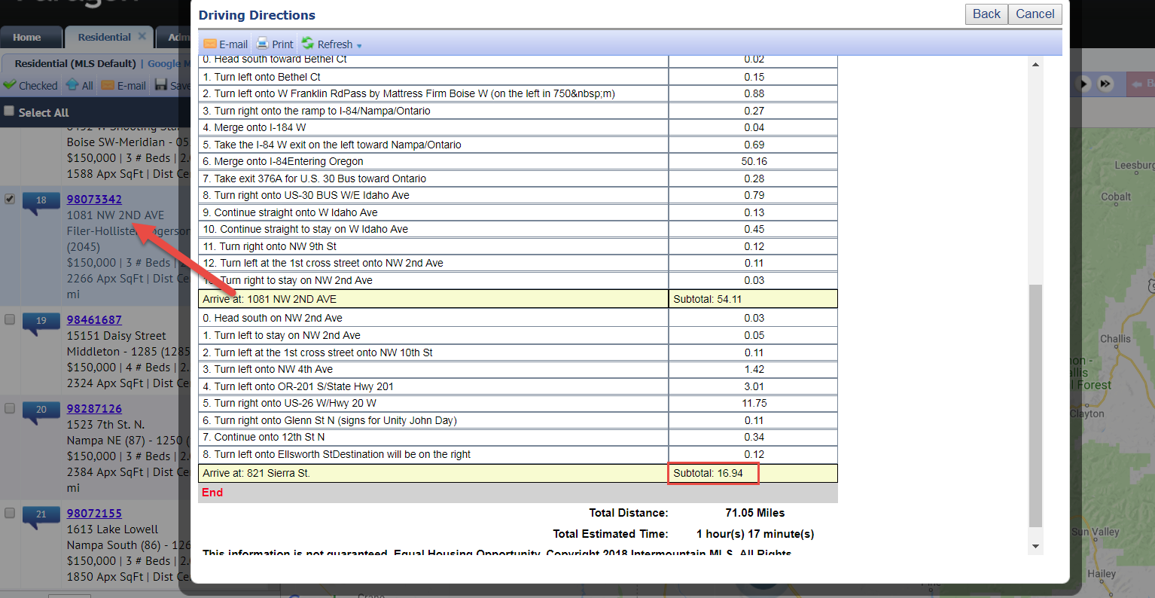

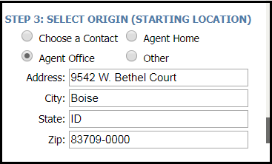

CMA: Copy Adjustments Over to Other Comparables
We have added the ability to copy an adjustment forward and backward to subsequent and previous comparables on the CMA Adjustments page. ‘Copy’ buttons have been added to the adjustments row so the user can specify which direction the adjustment should be applied.
On the first comparable, there will only be a Copy Forward button. Likewise, on the last comparable there will only be a Copy Backward button. The comparables in between will contain two buttons as seen below. A confirmation message will appear at the top of the screen indicating how many comparables the adjustment was copied to.
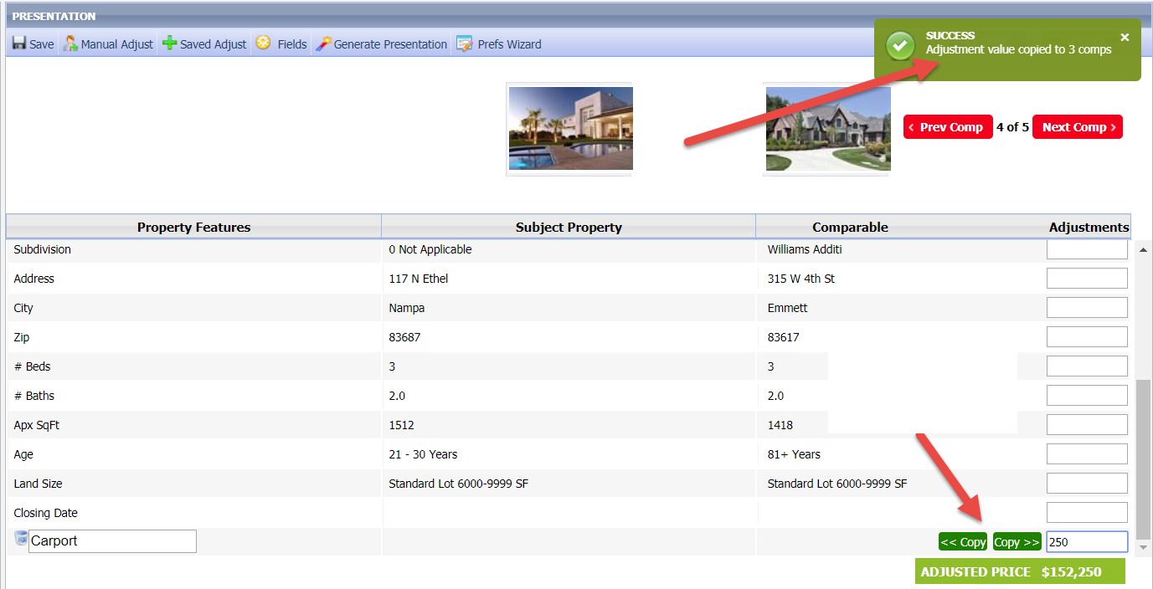

CMA Saved Adjustments – Issue Update
In the last release, we added a feature that allows users to add a manual adjustment to the CMA presentation and upon clicking Save, the adjustment automatically saves to a Saved Adjustments list. Although the adjusted field description carried over to the other comparables, its associated adjusted value did not. This has been updated so that the value also gets applied to the comparables.

Figure A: Saved Adjustment Value Carries Over
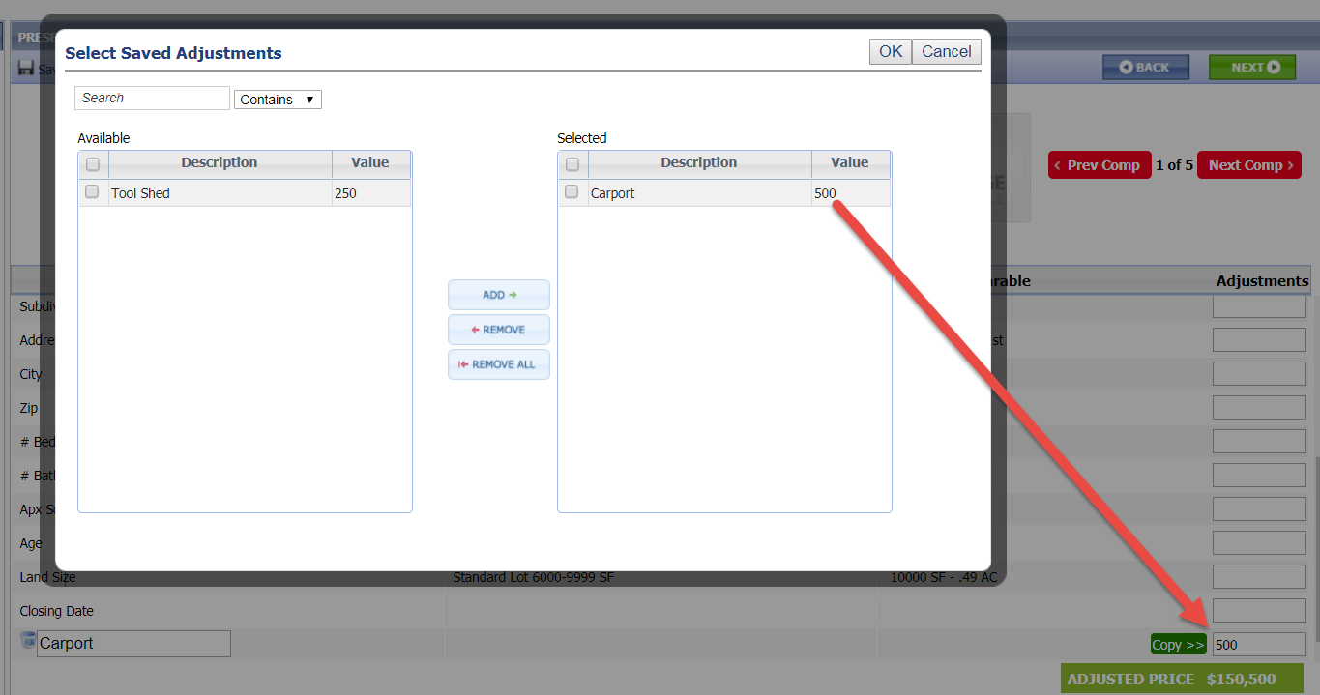
Figure B: Columns Headers
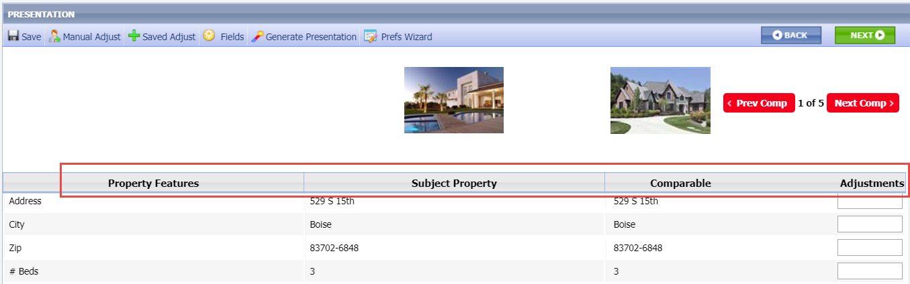

CMA Comparables Grid Changes
Sorting and column width adjustments on the Comparables page of the CMA now saves.
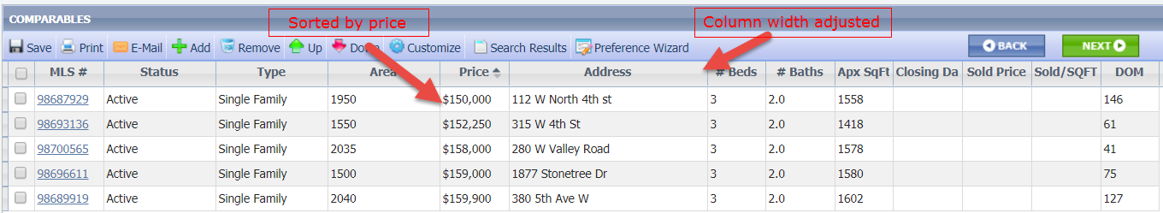

Comparables Price Analysis Modification
When there wasn’t a subject property price, the Comparable Price Analysis would default to the highest comparable price. If there was a subject property price, then it defaulted to that price. This has been modified so that regardless of whether there is a subject property price, the analysis will default to the Average Adjusted Price. The assumption is that after adding all the adjustments to the comparables, the adjusted price should be considered in the price analysis.
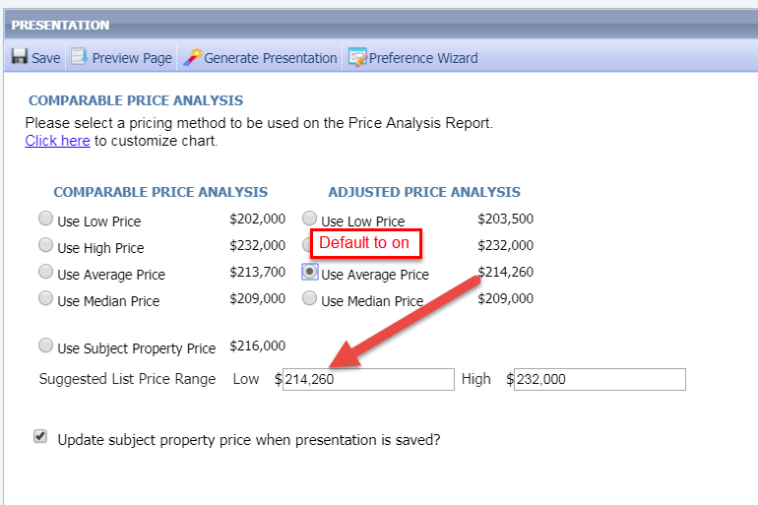

CMA Amount Values Now Display Consistently
The dollar amounts displayed differently on the Summary of Adjustments, Horizontal Report, and Vertical Report. All three have been modified so that the amounts appear the same. Positive amounts will include a plus sign and negative amounts will include a negative sign.
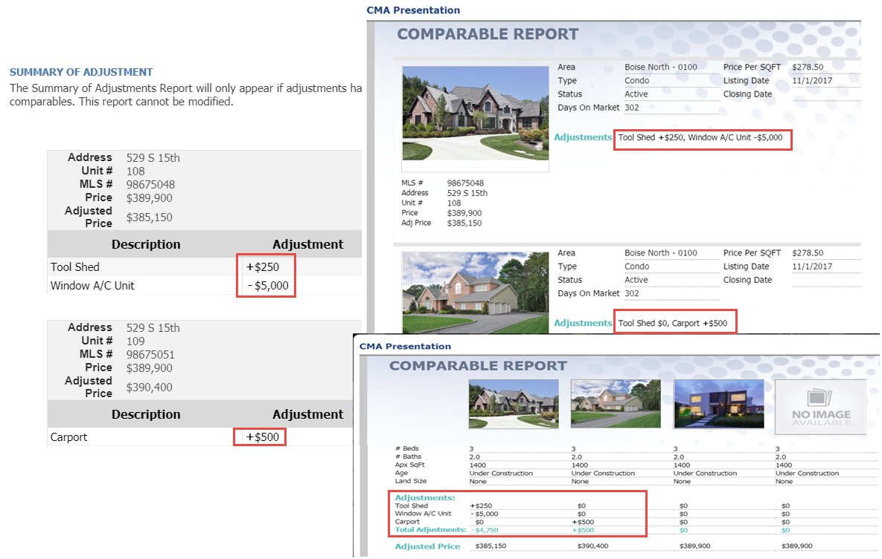

Total Adjustments Added to CMA Vertical Report
The Vertical Report has been updated to include a total adjustments row at the bottom of the report. This row calculates the total of all adjustment amounts being added and subtracted per comparable and displays the combined total.
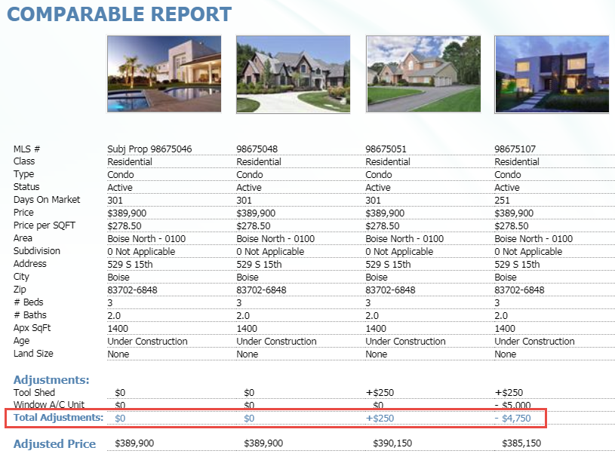

Collab Center: Agent Information
The agent information section contains quite a bit of information making the header too large on a mobile device. There is also a desire to implement a new tab structure for some of the categories found in the Collab Center. To address this, the agent information is being moved to the top of the Hamburger menu. The agent’s photo has also been included.
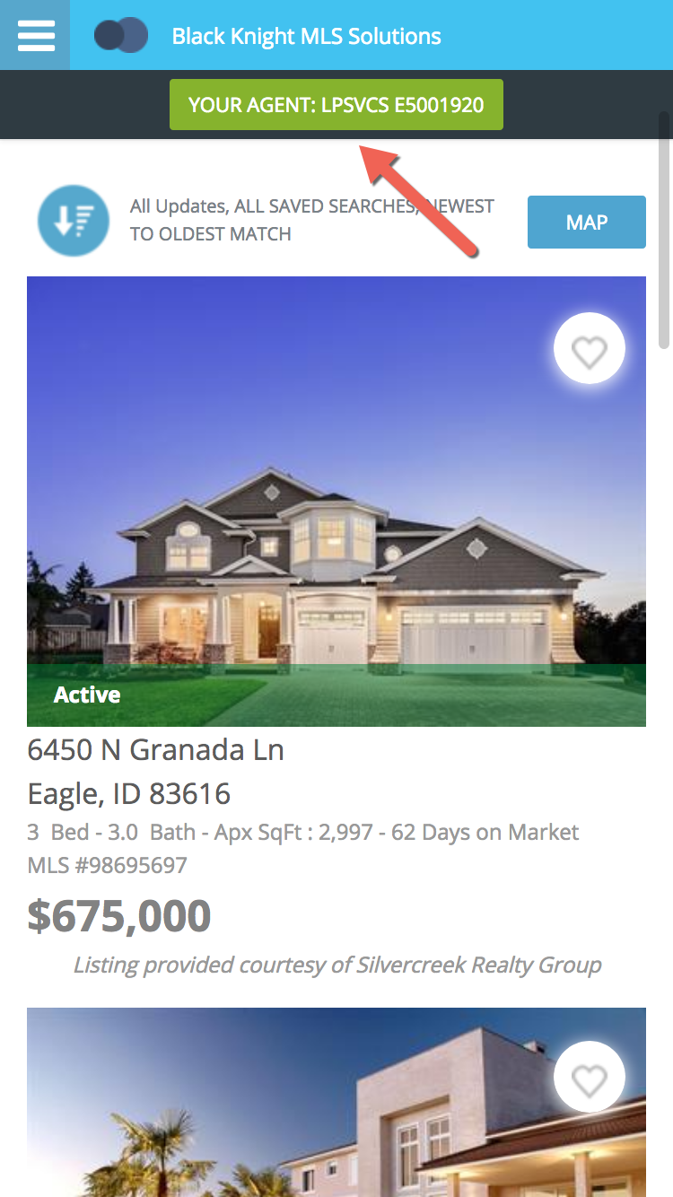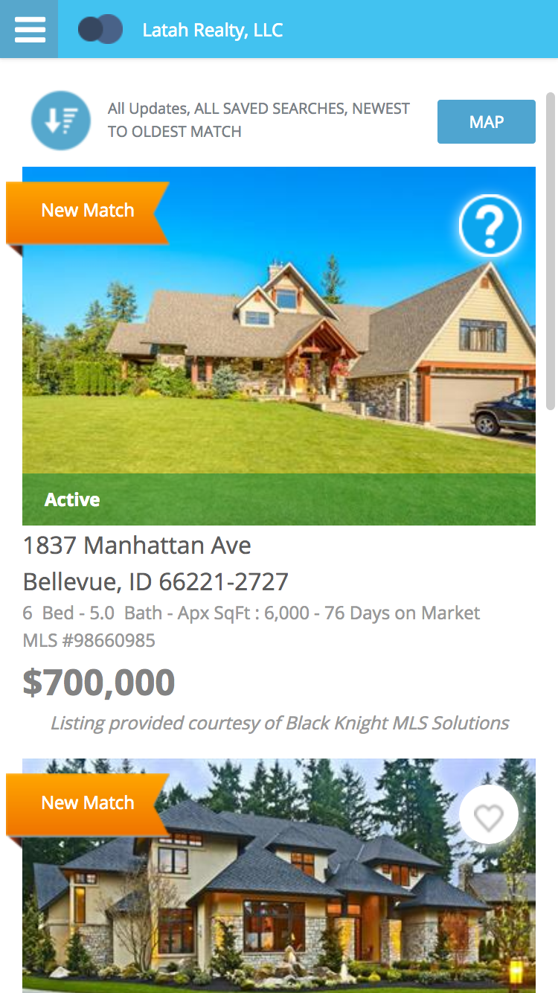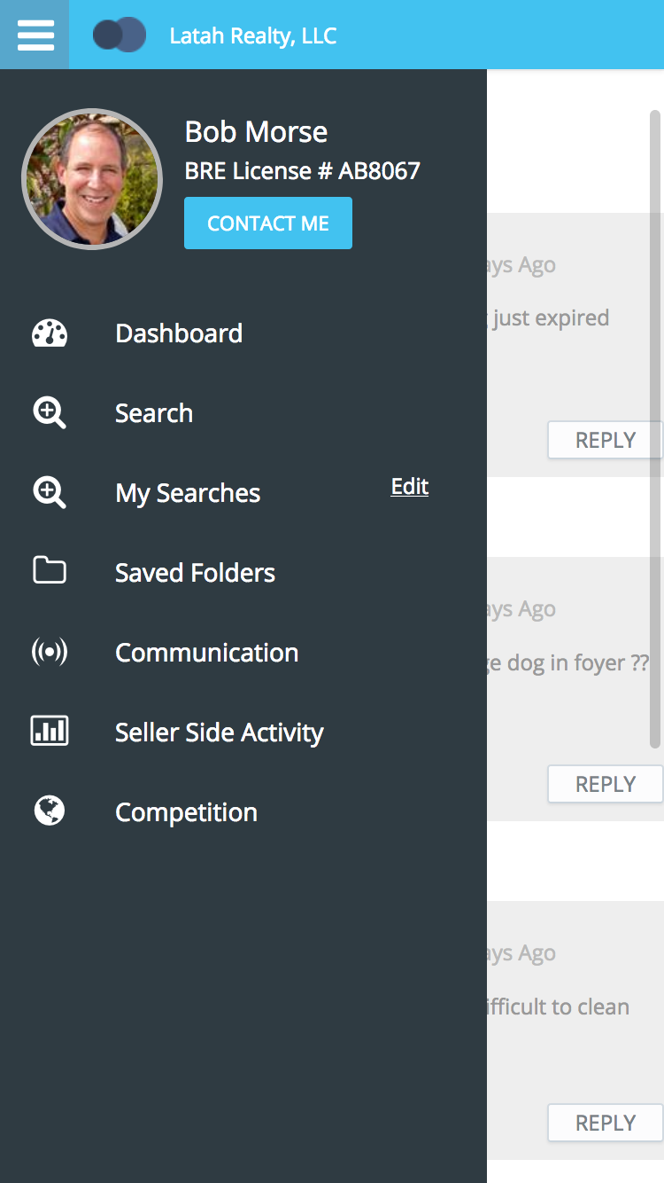

Collab Center: Navigation Updates
As BK MLS transitioned the Collab Center buy side and sell side into a tab navigation, it was noticed that the menu structure was not very user friendly. If the consumer is both a buyer and a seller and wants to run a search from the sell side they were forced to navigate to the buy side and then open the menu again to run the search. This has been corrected. Consumers can now view all menu items.
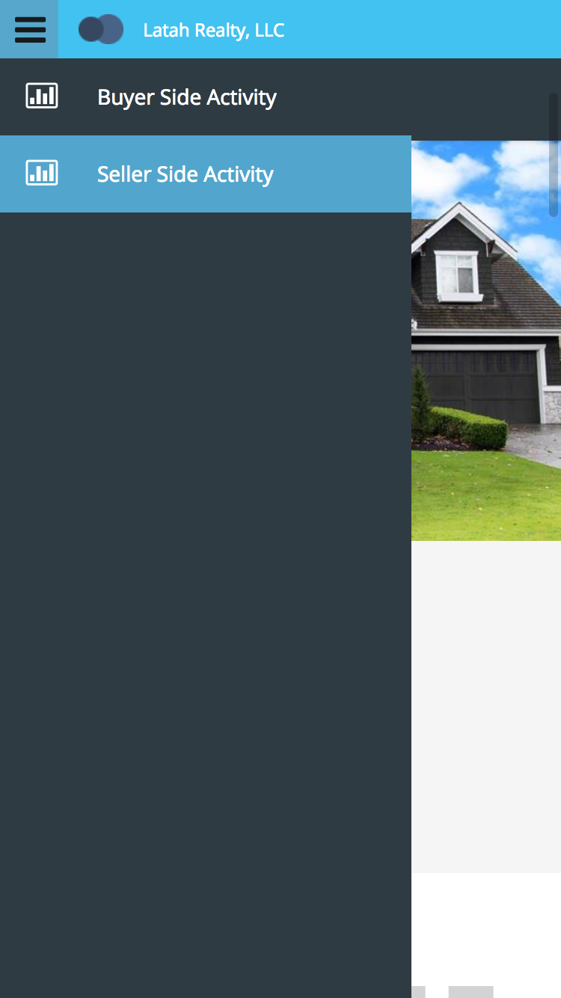

Collab Center: New Mobile Tab
While using a smart phone, consumers are having a difficult time knowing where to go to see their favorites, possible, and rejected listings. This could be done by using the Filter button which wasn’t very obvious. Therefore, a new tab structure has been implemented to help make this easier for consumers to find.
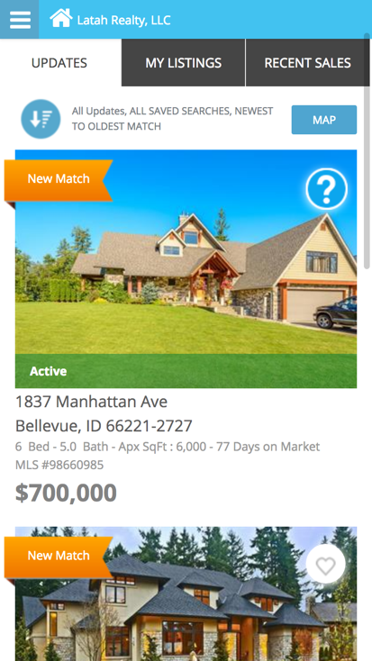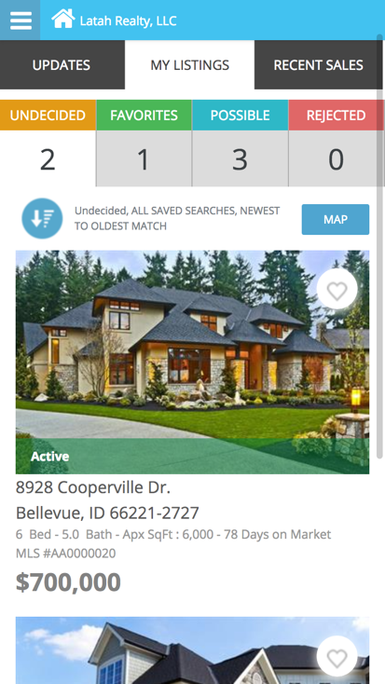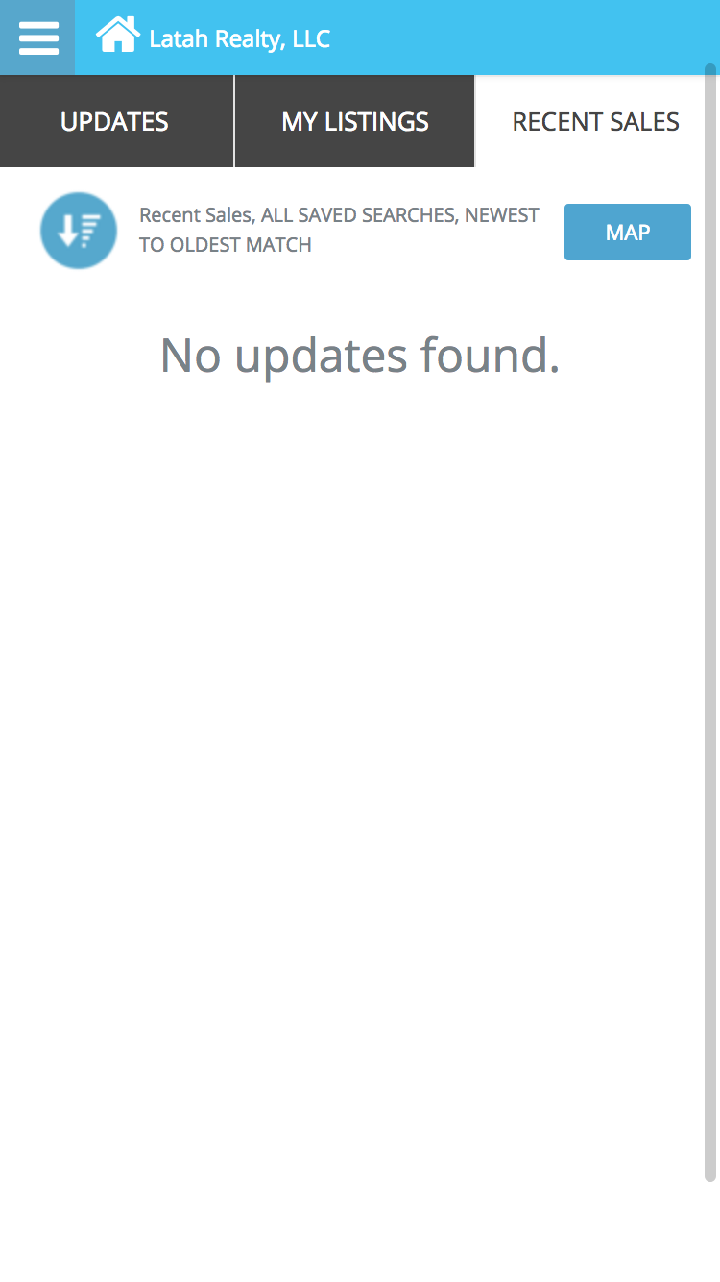

Collab Center – Mobile “Competition” Option
When viewing the sell side activity on a smart phone the consumer had no option to view the “Competition” option found when using a tablet or desktop device. A new menu option has been added for Competition. This will open the map and run the same search as on a tablet/desktop view.
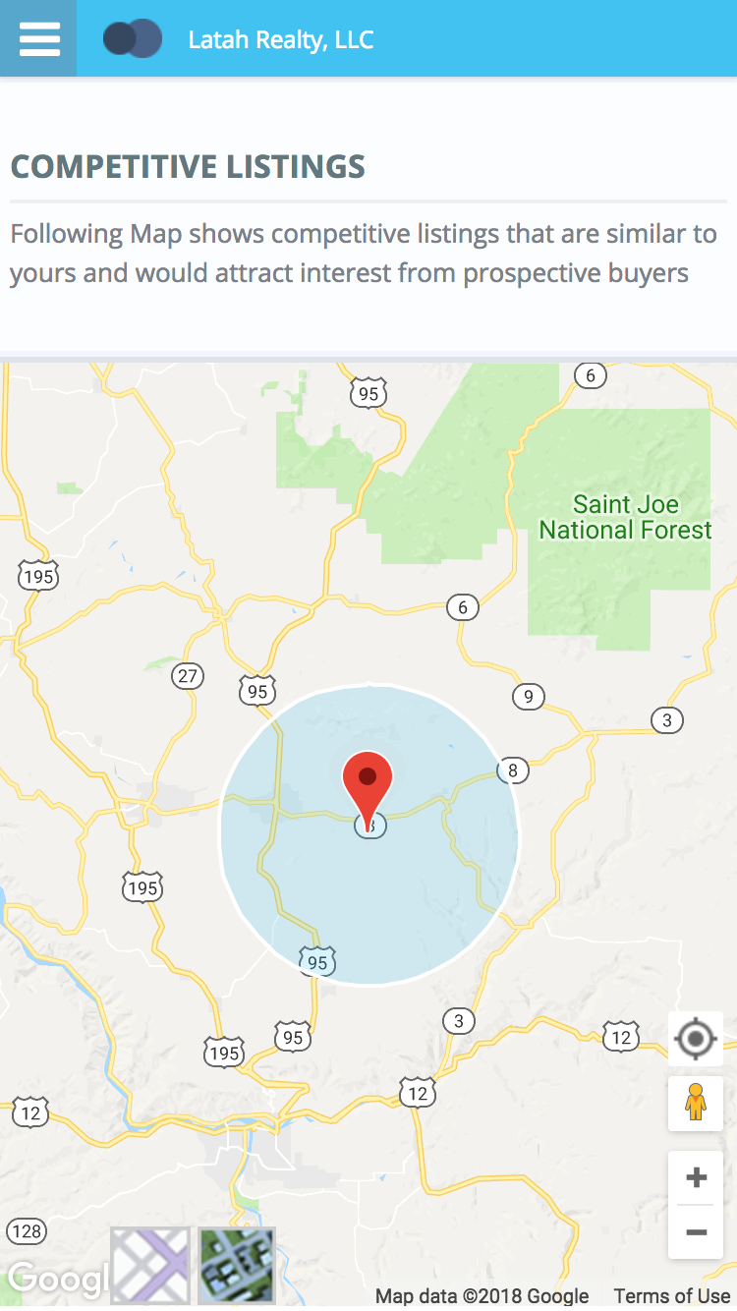

Collab Center – Mobile “My Listings” Option
To help the consumer even more while using a smart phone, we have added a new menu option just for mobile called, “My Listings”. This contains all of the other categories that were once hidden under the Filter button.
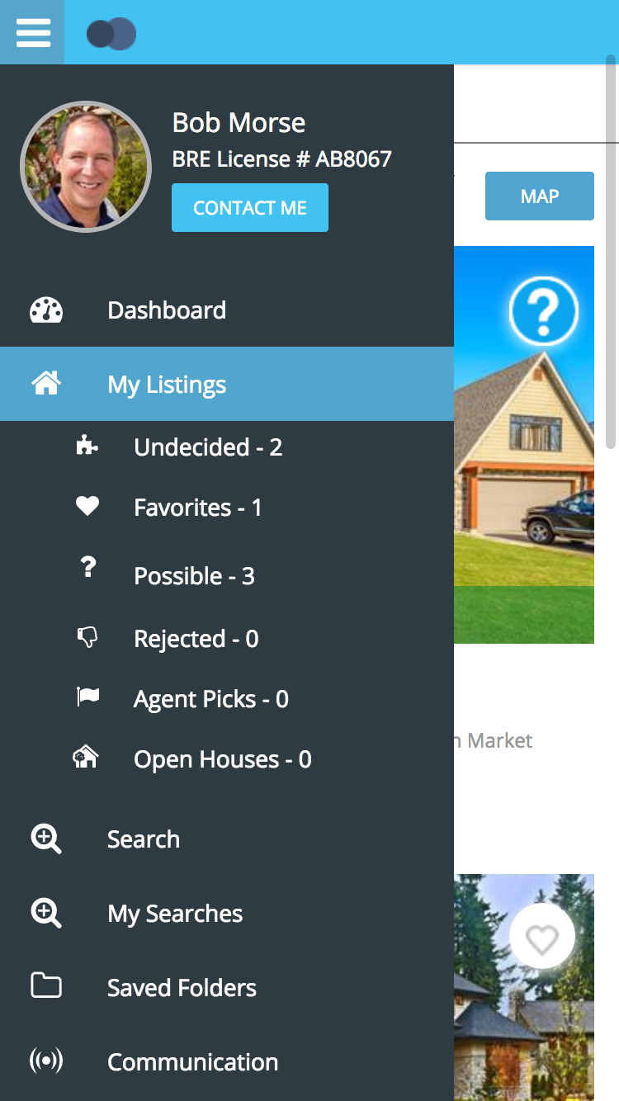

Collab Center: Address before Location
Several consumers expressed confusion with the Location option found in the property search feature in Collab Center. They want to enter an address which doesn’t work as expected. It is intended to be a general search of your MLS based on listings found in the MLS. The plan is to switch this so the Address tab is first then the Location tab.

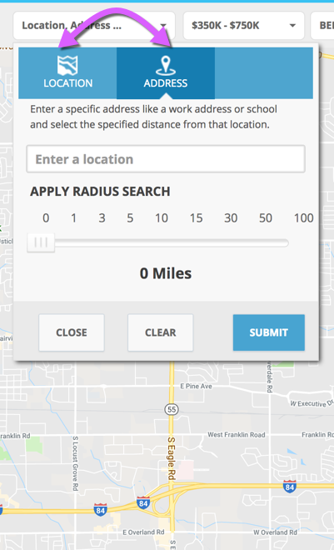

Collab Center: Time Zone – Open House
For users that are utilizing the open house feature within the Collaboration Center site, they will be pleased to hear that we have added the time zone to the date and time stamp.

Collab Center: Request Showing Date
The ‘request a showing’ date will no longer allow the consumer to select a date in the past. Users must select the current or a future date.
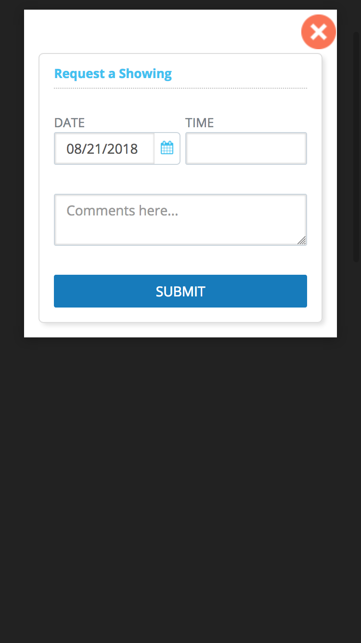

Email the Listing Activity Report
In order to accommodate multiple customers, the Listing Activity Report has been modified so that it may be printed or sent as a PDF attachment via email. All other report behavior and permissions will remain as-is.
Figure A: Printing the Listing Activity Report
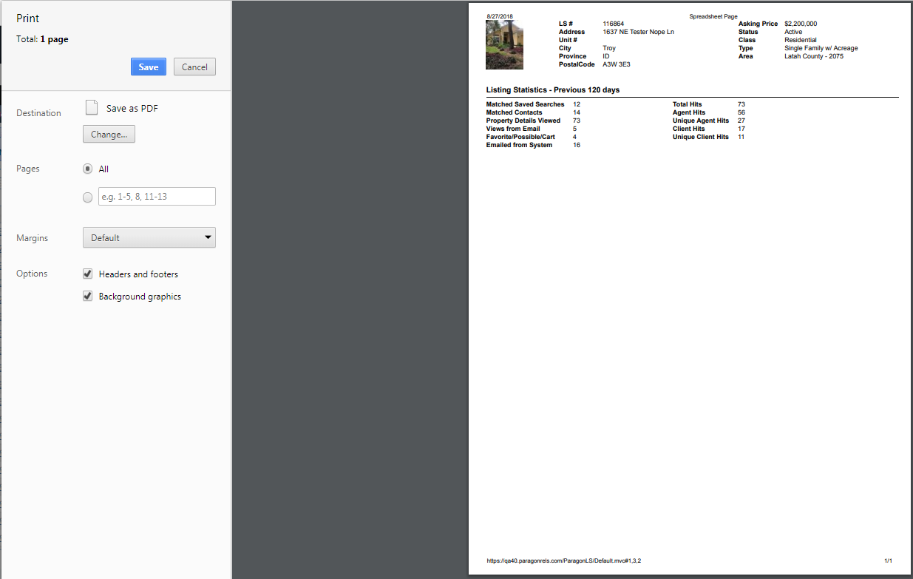
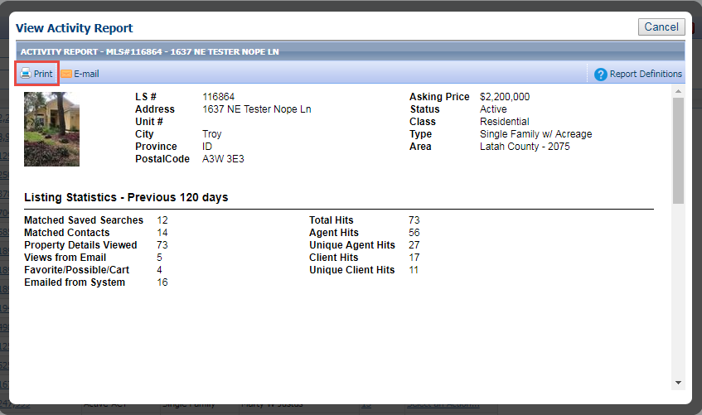

Figure B: Emailing the Listing Activity Report
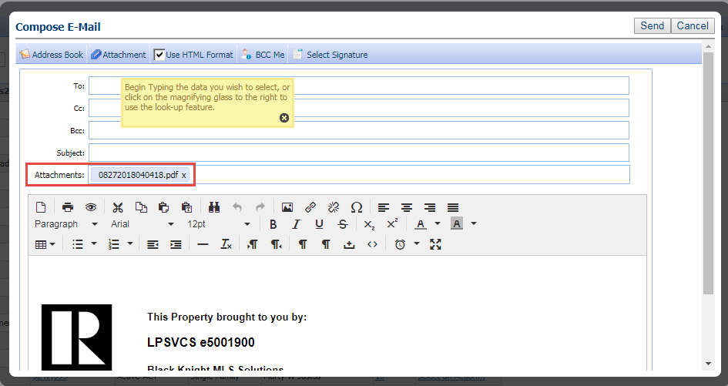
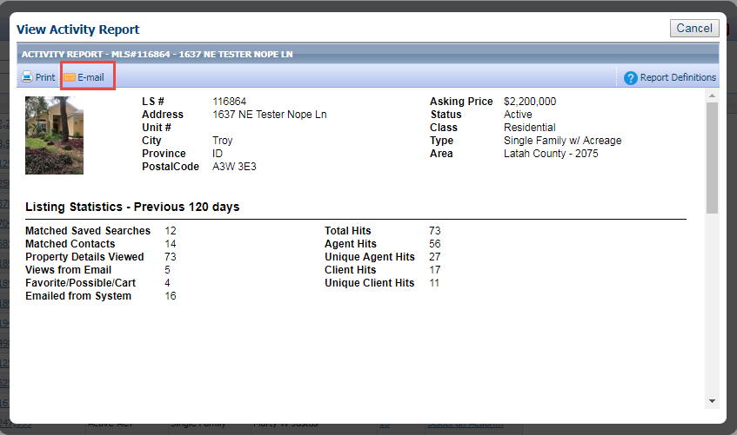

833 Area Codes Now Accepted
Since our introduction of advanced phone number entry in Paragon several new area codes have been implemented. The 833 area code is a new toll free area code in the United States. Previously, when users tried to use this area code for phone numbers in Paragon the validation of the phone number failed.
We have resolved this issue by modifying the phone number code to recognize the 833 area code along with several others toll free numbers that have been added since the phone number entry method was updated a few years earlier.
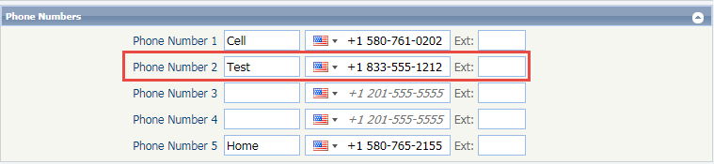

MLS Customizations and Administration
All options in this section are either configurable via MLS Administration controls or by your System Support Manager as noted.

Share to Twitter
In order to accommodate the sharing of multiple listings in Paragon, new functionality has been added. Multiple listings may be shared to Twitter leveraging a standardized method. In order to facilitate sharing of multiple listings, the search results pages will be modified to include a new function ribbon option called ‘Share’. Share to Twitter may be added to Listing Input/Maintenance so that only listing parties may share individual listings via this method.
The new sharing option will be DISABLED by default. Customers will need to contact their account manager to activate the functionality. The sharing methods may also be implemented independently of one another. Several layers of security have been added to ensure that only listings eligible for sharing may be shared. All of the security is configurable and may be tailored to the specific needs of the customer. The security protocol is as follows:
- The PRIMARY listing office of the listing to be shared MUST be an IDX Affiliate. The IDX Affiliate setting is found in the office record in Paragon.
Figure A: IDX Affiliate checkbox in Admin\Offices
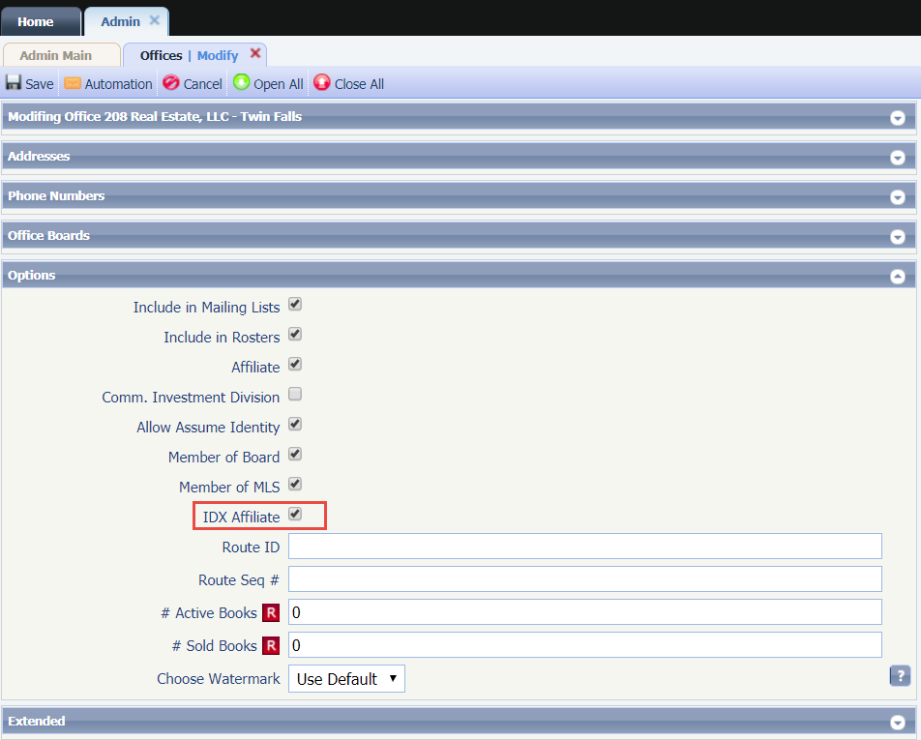
The listing must be assigned a status and listing visibility type that is eligible for sharing. The customer may have additional optional requirements that must be met for sharing eligibility. These could include items like: user security level, user type, office assignment, board affiliation, etc.
The short URL used for Share to Twitter points to a CollabLink landing page. This functionality CANNOT be configured. Since advanced sharing of listings is designed to be used with multiple device types, the sharing results must be presented in a format that is easily viewed on any device a recipient might have. The CollabLink landing page is designed specifically for responsive viewing of listing data. The lifespan of the Share to Twitter URL will be the same as that of the current Publink (legacy) email hyperlinks. Lastly, the user will select a group of listings for sharing using the selection element in Paragon report views.
Figure A: Spreadsheet View
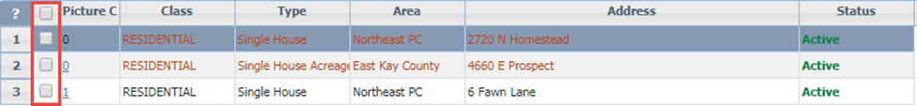
Figure B: Detail View
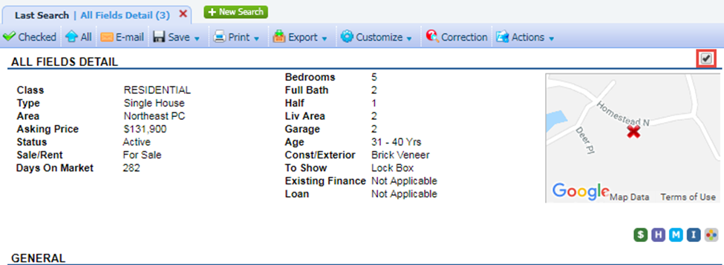
Once the listings are selected the end user will choose the Share option in the functions ribbon.
Figure C: Share Menu
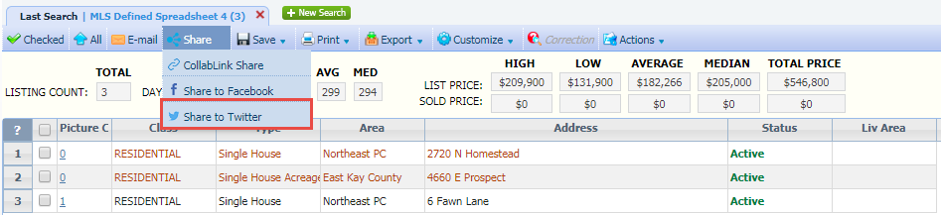
If the user does not select one or more listings before selecting a Share menu option an error message will be displayed. This error is only applicable when sharing from search results. Sharing from Listing Input\Maintenance is on an individual listing basis only.
Figure D: Error Message
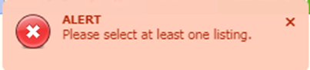
If the listing(s) are ineligible for sharing to Twitter, an error message will be displayed. The error messages are the same as those displayed when sharing listings via CollabLink Share or Share to Facebook. NOTE: If one or more selected listings are ineligible for sharing, the user may continue to share only the eligible listings. If NONE of the selected listings are eligible for sharing, the error message will indicate the ineligibility and force the user to cancel the sharing session.
Figure E: Ineligible Status Error - when some listings are eligible for sharing
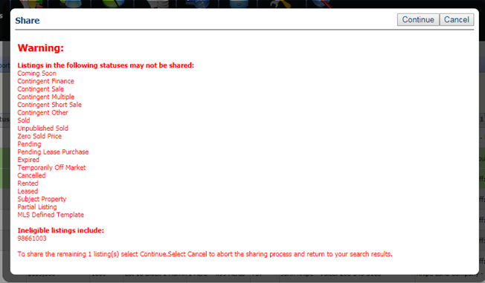
Figure F: Listing Visibility Type Error - when none of the selected listings are eligible for sharing
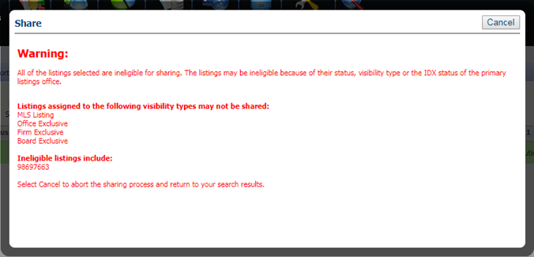
Figure G: IDX Affiliate Error – when none of the selected listings are eligible for sharing
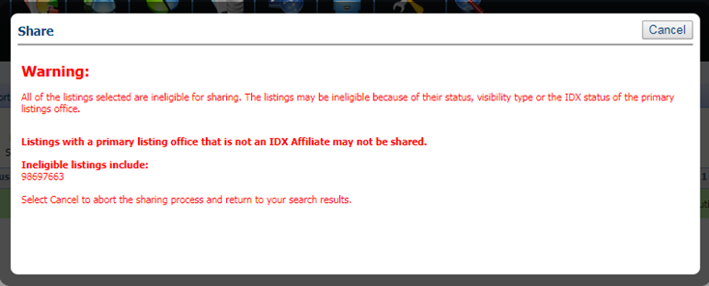
Figure H: Listing Input/Maintenance Sharing Error – when only a single listing may not be shared
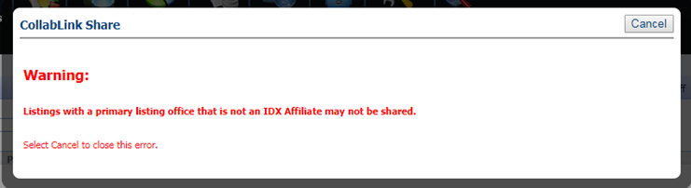
When listings are shared successfully via Twitter, the Twitter sharing API will be displayed in a modal. The URL in the tweet will direct the user to a CollabLink landing page. The user may add additional text to the tweet before publishing it. NOTE: The user may have to login to their Twitter account before sending the tweet.
Figure I: Twitter Sharing API Modal
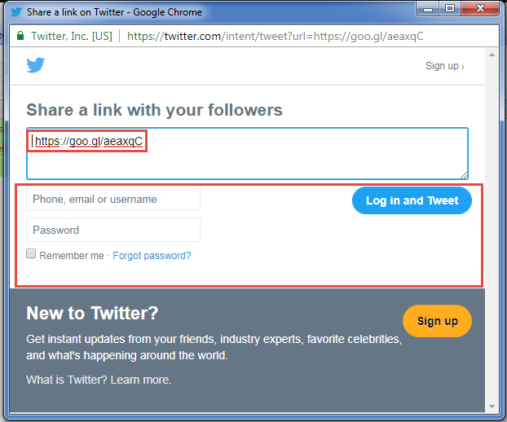
Figure J: Sample Sharing Tweet
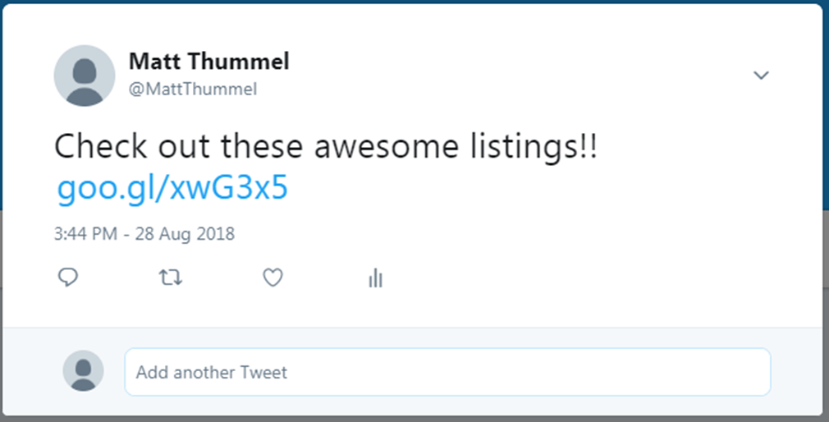
If the CollabLink URL hyperlink expires, the following error will be displayed when the CollabLink URL hyperlink is selected.
Figure K: CollabLink Expiration Error
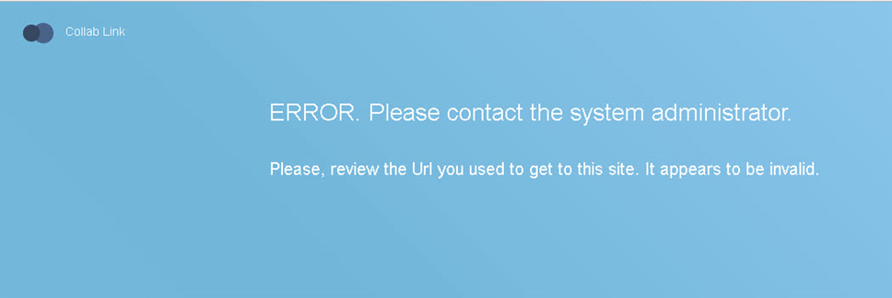

Homebot Enhancements
In order to help agents locate Homebot so they can take advantage of staying connected with their contacts using this awesome tool, we have enhanced the process for the Agent Registration and the Contact Subscription process.
For agents who have not yet subscribed, they will see this new section in the Contact Information page where they can view a video to get more information or click the ‘Get Started’ button to register for an account.
Figure A: Get Started for Agents not yet Subscribed
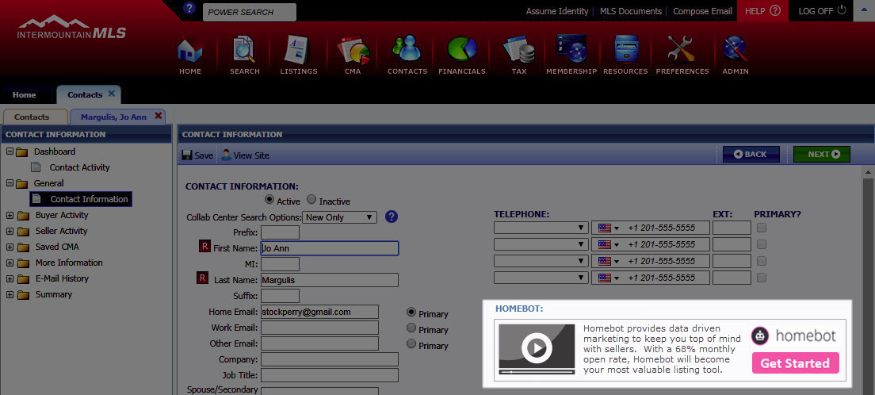
After an agent has subscribed, they will see an “Add Contact to Homebot” checkbox for any NEW contact that they add to Paragon. This control is checked by default so when the agent saves the contact, they are automatically subscribed. This saves the agent from having to reopen the contact to click on the button, which was how it previously worked.
Figure B: Add Contact to Homebot Checkbox
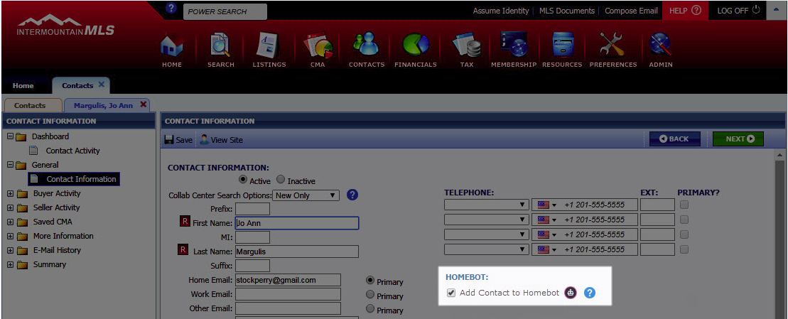
For existing Contacts, registered agents will see the “Add Contact to Homebot” button. If the fields are not complete, the button will be gray (disabled). If the primary email and address are complete, the button will be pink. This is how it worked previously, but the control was moved from below the address to above the Manage Contact section.
Figure C: Add Contact to Homebot Button
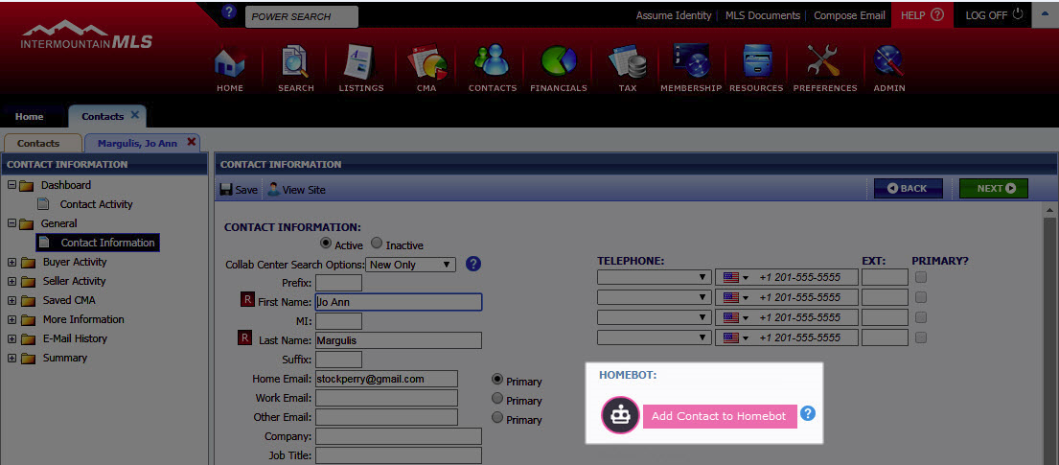
Since agents land on the Contact Activity screen first, we’ve added a Homebot section to this page as well. If an agent has an active Homebot account, they will see the following for a contact who is not yet subscribed.
Figure D: Subscribed Agent Viewing a Non-Subscribed Contact
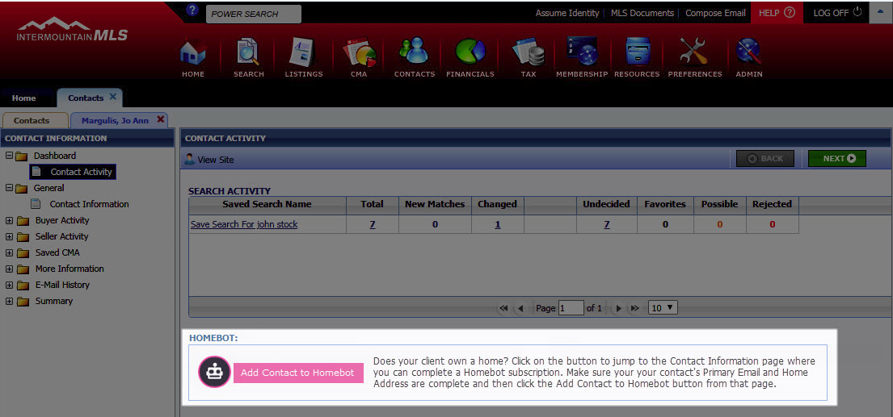
Clicking this link will jump the agent to the Contact Information page where they can complete the Contact subscription process.
If an agent has an active Homebot account, they will see the following for a contact who is subscribed.
Figure E: Subscribed Agent Viewing a Subscribed Contact
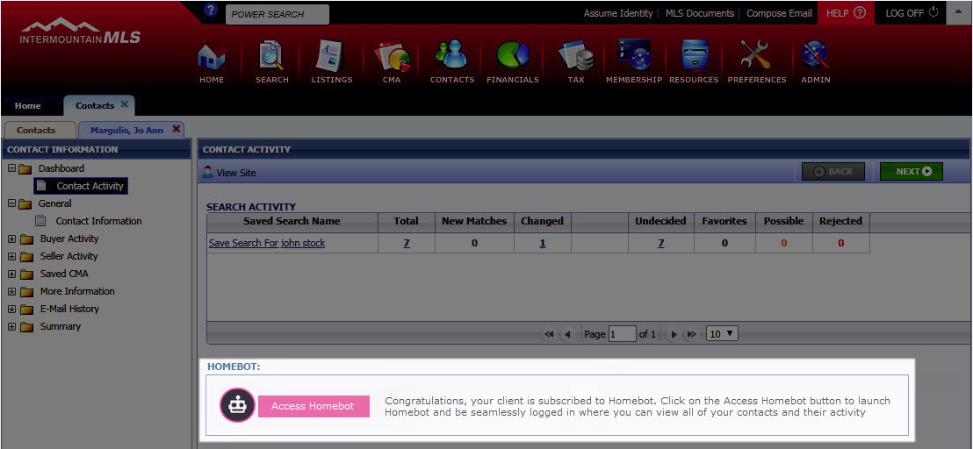
Clicking this link will launch a new browser and log the agent into Homebot where they can view all of their contacts and activity.

Configuration Added to Listing City, State, and Zip Reporting
Several customers use multiple City/Community fields in conjunction to pinpoint the location of a listing. In order to accommodate these scenarios, a new configuration setting has been added to control the city value displayed in the Listing City, State, and Zip reporting field. This setting will allow a customer to specify an alternate city field to use when creating the Listing City, State, and Zip field. The alternate city field must have the same ID in all listing classes.
Figure A: Listing Input Maintenance - example of multiple city fields
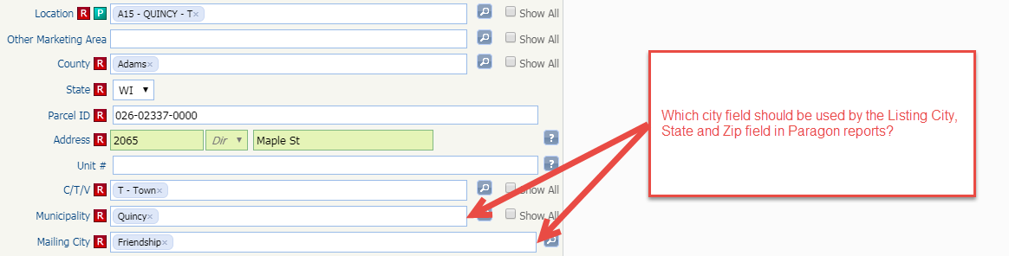

Figure B: All Fields Report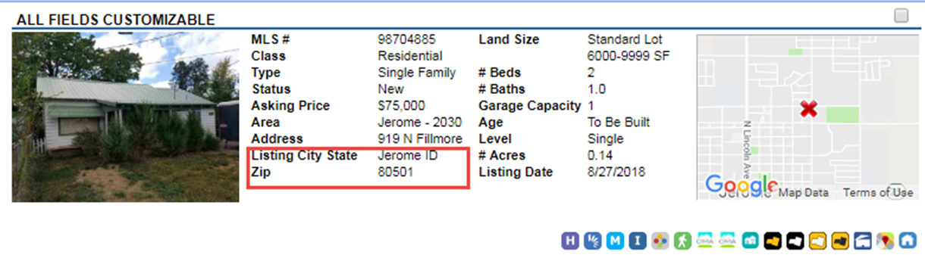

RETS Server Changes
This release includes a few significant changes to our RETS Servers. We made major alterations to increase performance and help reduce database server load. We also expanded the fields available to be used with InKeyIndex. Finally, we corrected a rare error that could occur during a RETS Listing Update transaction.
- We have been making modifications to our RETS Servers and RETS fields over the past few releases and continue to show improvements this release. The most significant change was to increase overall performance. This included some refactoring of our RETS code to reduce server loads on the databases.
No specific communication is needed for your RETS Vendors and no metadata refresh is required for these changes to take effect.
- The second RETS change includes the addition of three new fields supported with the InKeyIndex feature. This is a native RETS feature allowing clients to return values for specific fields when searching with Limit=NONE. This feature is used by some power-RETS users and now includes the addition of the Class, Status, and Status Category fields. These fields will now appear as enabled for InKeyIndex within the RETS Metadata.
PLEASE NOTE: No specific communication is needed for your RETS Vendors, however a metadata refresh is required for these changes to take effect.
- The final RETS change includes a correction when using the RETS Update option to modify a listing. In the rare event that a listing update was attempted after removing all feature values, an error would occur. This error has been corrected.
No specific communication is needed for your RETS Vendors and no metadata refresh is required for these changes to take effect.

