# Agent Level Enhancements

**The following section contains changes that are active system wide** **and available to users based on their assigned security levels.**

# Driving Directions is Now Generated in Google Maps

We are excited to announce that the Paragon driving directions has been revamped. The dialog has been redesigned and will redirect the user to Google Maps via a new browser tab. Once in Google, the map is interactive and users can enjoy all the features that Google has to offer.

# Larger Map in Print+ Driving Directions

When customers access driving directions from Print+, the map has been enlarged and the destination letters that represent listings on the map have also been added to the step by step directions next to the associated listing address. This helps customers identify which letter represents which listing on the map.

# Paragon’s New Midwest Theme!

A new theme has been added to the Paragon database. This time, we didn’t have to travel very far. Introducing the “Midwest” theme. Known for farming, BBQ, and bad weather? Check out this latest addition today.

# Center Map on Address – Update

The colors on the dropdown has been reversed so that the background is white and the address is gray. This more consistently resembles the coloring of the Map Layers panel.

# CollabLink Share: Copy Link Functionality

A button that will copy the sharing URL to a user’s local device has been added for the CollabLink Share function. Users will no longer need to highlight and copy the URL to their device manually.

The Copy Link button will copy the CollabLink URL to the clipboard of the user’s device which can then be pasted where needed.

# Collab Center: Start an Offer

Consumers can now send information to their real estate agent to make an offer on a property. The consumer will fill out a form requesting the offer price, proposed closing date, and any special terms associated with the offer. This will cause an email to be sent to the agent with the details of the property and the offer so that the agent can contact the consumer and a contract can be written. **Please Note: This feature will be activated a few weeks after the 5.68 release when a few final touches are complete. Communications will be sent in advance.**

# Collab Center: Make My New Home

Consumers now have the ability to select one or more properties as their new home. What this means is that after an offer has been accepted, the consumer can mark the property(ies) as the one that they intend to purchase. In doing so, this will cause a new tab to be added to the Collaboration Center as the first tab, ‘My New Home’. All properties marked as ‘my new home’ will appear on this tab. **Please Note: This feature will be activated a few weeks after the 5.68 release when a few final touches are complete. Communications will be sent in advance.**

# Automatic Creation of Collaboration Center URL

This enhancement is the first step in simplifying the Collaboration Center setup for users that are setting up their Collaboration Center site for the first time. Instead of requiring agents to create their Collaboration Center (CC) site, the system will automatically create the URL when Contacts or Collaboration Center Preferences are accessed. Users that have already created a CC site will not be affected by this enhancement.

# Collab Center – Black Knight Privacy Policy

In order to keep in compliance with our Black Knight legal department, a privacy policy link was added to Collaboration Center. The link can be found on the hamburger menu and detail report of Collaboration Center, Collab Link, and public detail report from Collaboration Center.

# Updated Contact Activity Widget

This enhancement brings a major upgrade to the existing Contact Activity Widget. The new, four-tab layout is designed to provide direct access to client activity from Collaboration Center. Although this new functionality heavily leans toward information from user’s Collaboration Center sites, users can still access all Contacts including those not yet setup on Collaboration Center by clicking the Contact Activity title on the Contact Activity widget. Needless to say, Collaboration Center is not only the solution of the future, but it is the Agent/Consumer communication feature of now.

# MLS Customizations and Administration

All options in this section are configurable via MLS Administration controls or by your System Support Manager as noted.

# Homebot Enhancements

Two enhancements were added to the Paragon Contact Manager to improve the user experience for agents with active Homebot accounts:

* Icons were added next to the Address fields to designate that the fields are required for subscribing contacts with Homebot.
* The last five actions by the contact will display on the Contact Activity page with a button that links directly to the Contact’s page in Homebot for quick access.

# Field Setup: Limit Data Visibility by User Type

Several customers have requested a method that allows listing field visibility to be filtered by user type. This will allow customers to create fields that can house confidential data and be displayed optionally in standard report views.

This new functionality will work ***in conjunction*** with the current field security rules. This framework will allow granular permissions for field data visibility. This functionality has been added to Admin\Fields module and uses controls similar to the current searchable field attribute.

# RESO DD Compliance: Agent\Office Table Changes

In order to meet the requirements of the current and future RESO Data Dictionary standards BK MLS has added new fields to the agent and office tables.

# RETS Update with Extra Spaces

In the RETS Update request Record parameter, if there was extra whitespace it would not properly match the fields and they would be ignored by the update. This has been modified to trim the whitespace when the field names are parsed.

# RETS Metadata: Enhanced to Include Current Length as Max Length

The RETS Metadata has been modified to report the actual character width of a field instead of the potential width. For example: A 255 character field has been enabled but the actual number of characters has been limited to 150 characters via field configuration settings. The RETS Metadata will report the field’s maximum width as 150 instead of 255.

# RETS Update: Last Value Submitted is Final

When a RETS Update transaction is performed on a character field the last value submitted for the field will be its final value. For example: A series of changes is saved to a field named Char10. The first value saved is test1, the second is test2 and the final value is test3. Once all of the transactions are processed the final value of the Char10 field would be test3.

# Corrected Issues

|  |  |  |  |  |
| --- | --- | --- | --- | --- |
| **Work Order** | **Seq** | **Module** | **Reporting Customer(s)** | **Issue Corrected** |
| 139701 | 1 | Views/Report | Columbia SC, Quad City, Wichita | Advanced Mapping Not Displaying Listing Thumbnail Images |
| 139418 | 1 | Admin Listings | NRV | Please review Room Information modals |
| 141509 | 1 | Third Party Integrations | Wisconsin Real Estate Exchange | Issue due to recent work to only display ShowingTime icon on Active/Pending records |
| 141808 | 1 | Print/Print+ | CRIB | P150 Google Map not printing or showing in preview on View Detail Report using Chrome |
| 141767 | 2 | RETS |  | Modified to return only one tax record even when more than one valid record exists as this caused problems. |

# Agent Level Changes

**The following section contains changes that are active system wide** **and available to users based on their assigned security levels.**

# Driving Directions is Now Generated in Google Maps

We are excited to announce that the Paragon driving directions has been revamped. The dialog has been redesigned and will redirect the user to Google Maps via a new browser tab. Once in Google, the map is interactive and users can enjoy all the features that Google has to offer.

The dialog will still ask for the starting location which will be set to your default address. The selected listing addresses will display but cannot be reordered until after being redirected to Google Maps. If a listing address is blank, the dialog will indicated that at least one listings address will be ignored (in red text). Map updates are instantaneous. When Google updates their map features, customers will enjoy those updates immediately. No waiting for a Paragon release cycle.

Note that there is a slight limitation on how many addresses can be used to generate driving directions, which is currently nine (10 including the starting address). However, once in Google Maps, customers can take advantage of all the features offered such as reorder addresses, add addresses (up to nine), zoom in\out, change map views, rotate the map, print the directions with\without the map, email or text the directions to their phones, share the directions via social media, and much, much more.

*Figure A: Driving Directions Dialog*

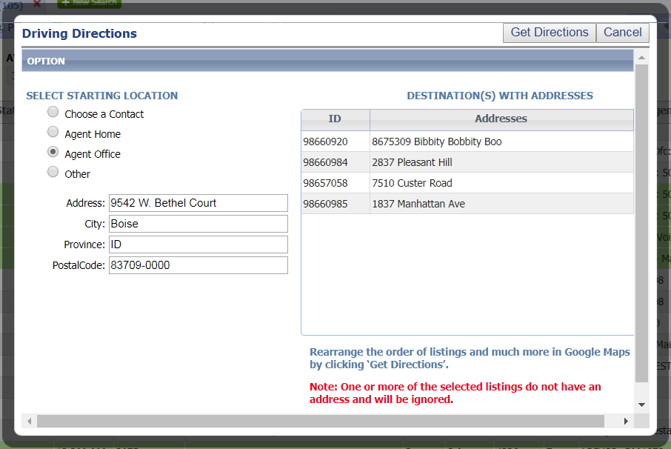

*Figure B: Google Maps Driving Directions*

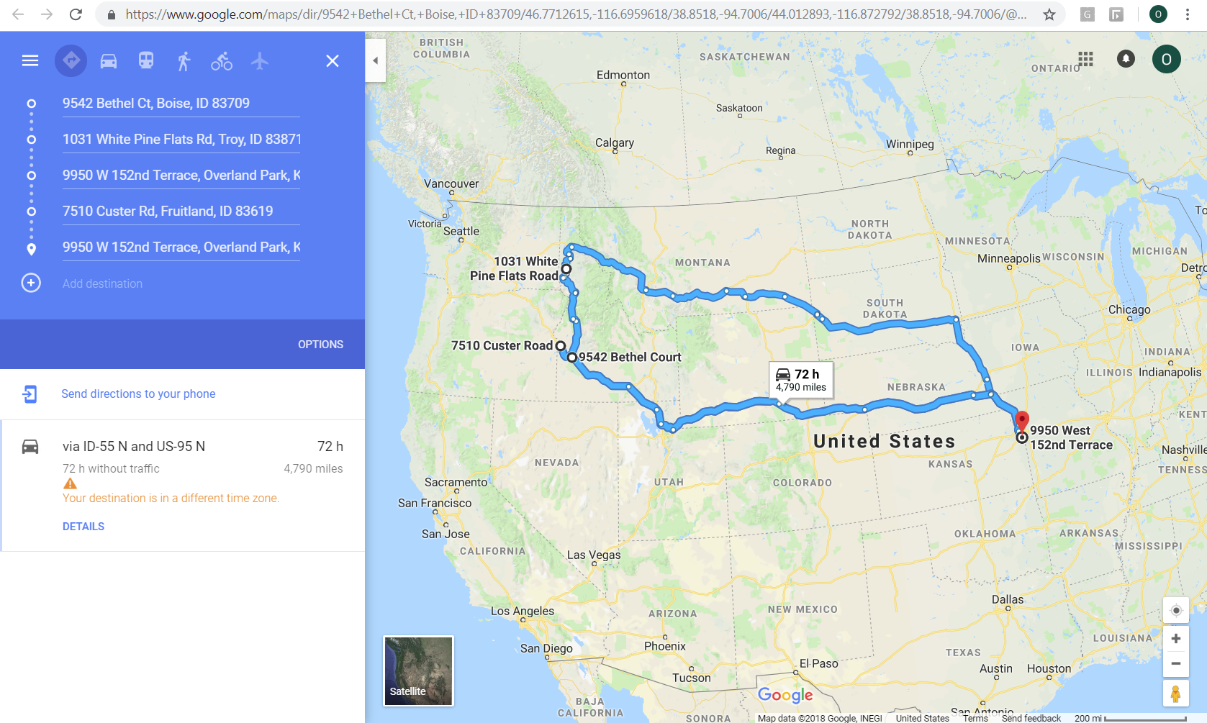

# Larger Map in Print+ Driving Directions

When customers access driving directions from Print+, the map has been enlarged and the destination letters that represent listings on the map have also been added to the step by step directions next to the associated listing address. This helps customers identify which letter represents which listing on the map.

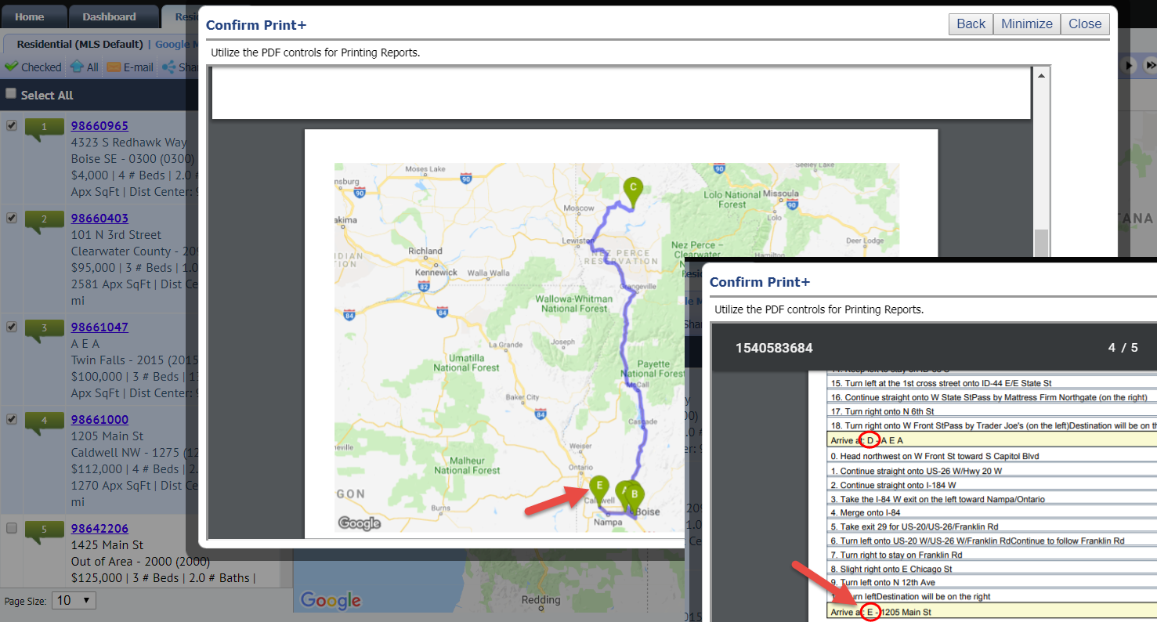

# Paragon’s New Midwest Theme!

A new theme has been added to the Paragon database. This time, we didn’t have to travel very far. Introducing the “Midwest” theme. Known for farming, BBQ, and bad weather? Check out this latest addition today.



# Center Map on Address – Update

The colors on the dropdown has been reversed so that the background is white and the address is gray. This more consistently resembles the coloring of the Map Layers panel.

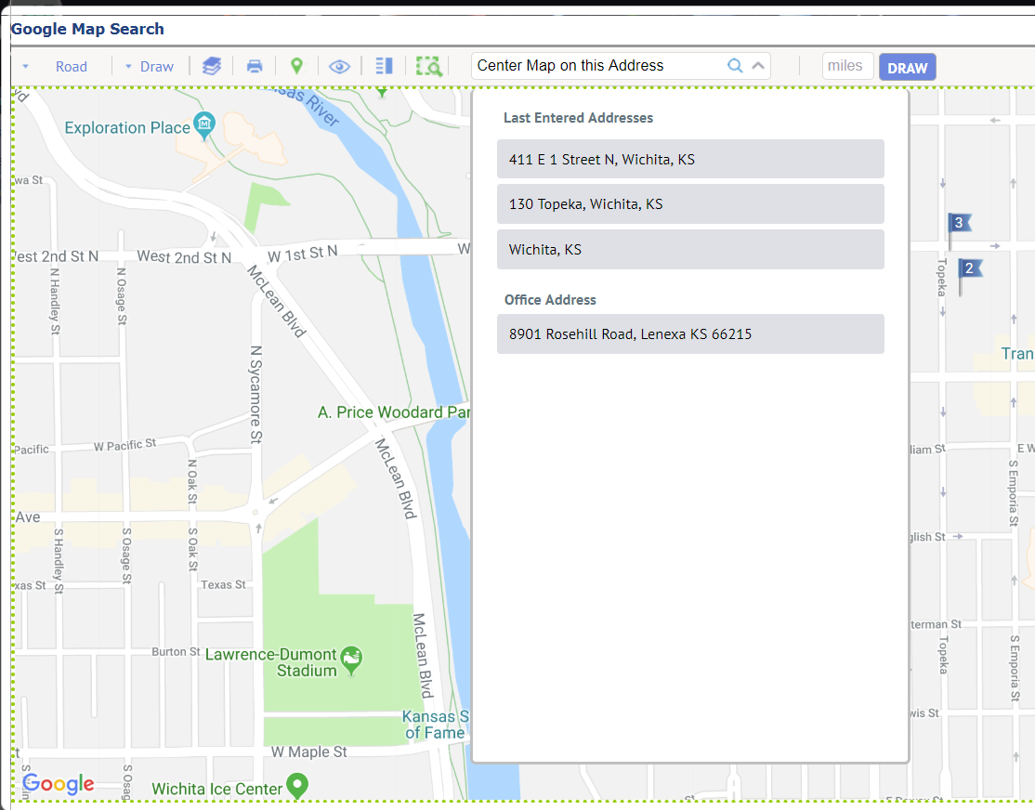

# Collaboration Center – Black Knight Privacy Policy

In order to keep in compliance with our Black Knight legal department, a privacy policy link was added to Collaboration Center. The link can be found on the hamburger menu and detail report of Collaboration Center, Collab Link, and public detail report from Collaboration Center.

<https://www.blackknightinc.com/privacy-notice/>

# CollabLink Share: Copy Link Functionality

A button that will copy the sharing URL to a user’s local device has been added for the CollabLink Share function. Users will no longer need to highlight and copy the URL to their device manually.

The Copy Link button will copy the CollabLink URL to the clipboard of the user’s device which can then be pasted where needed.

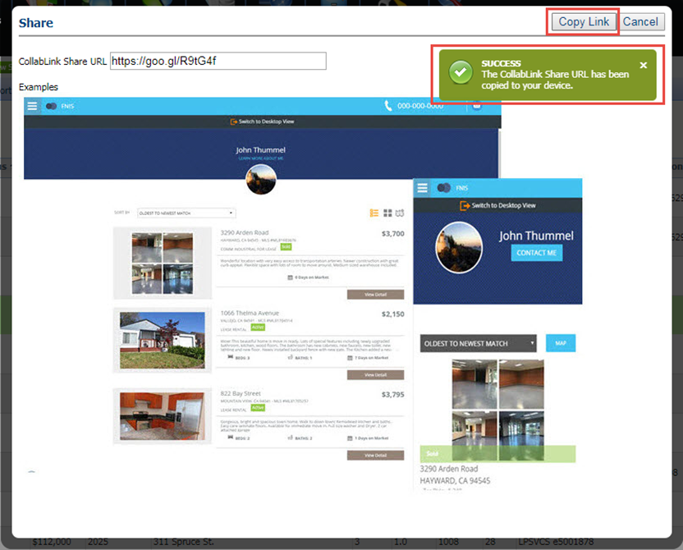

# 

# Collab Center: Start an Offer

Consumers can now send information to their real estate agent to start an offer on a property. The consumer will fill out a form requesting the offer price, proposed closing date, and any special terms associated with the offer. This will cause an email to be sent to the agent with the details of the property and the offer so that the agent can contact the consumer and a contract can be written. **Please Note: This feature will be activated a few weeks after the 5.68 release when a few final touches are complete. Communications will be sent in advance.**

An offer can be made from two areas of Collaboration Center:

* Additional Options button
* View Detail button.

*Figure A: Additional Options button*

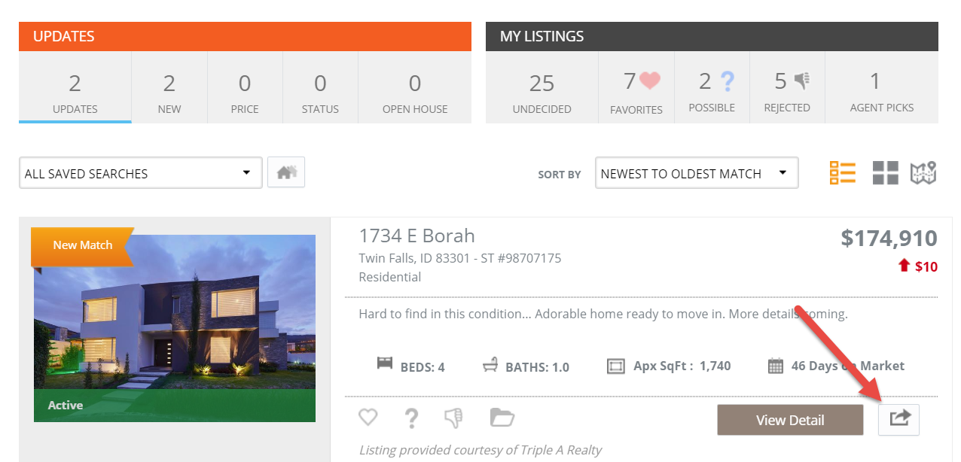

*Figure B: Start An Offer button*

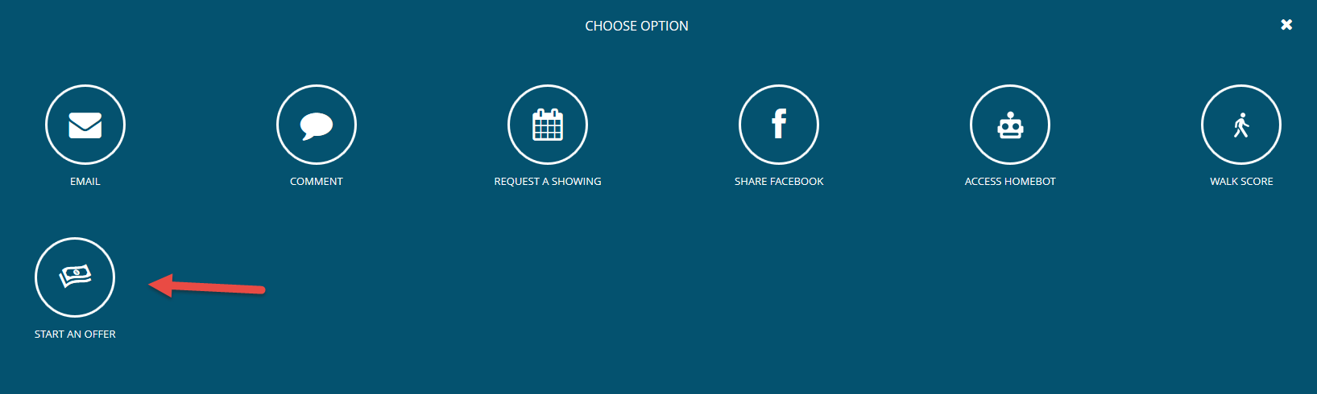

*Figure C: Start an Offer Form and Message*

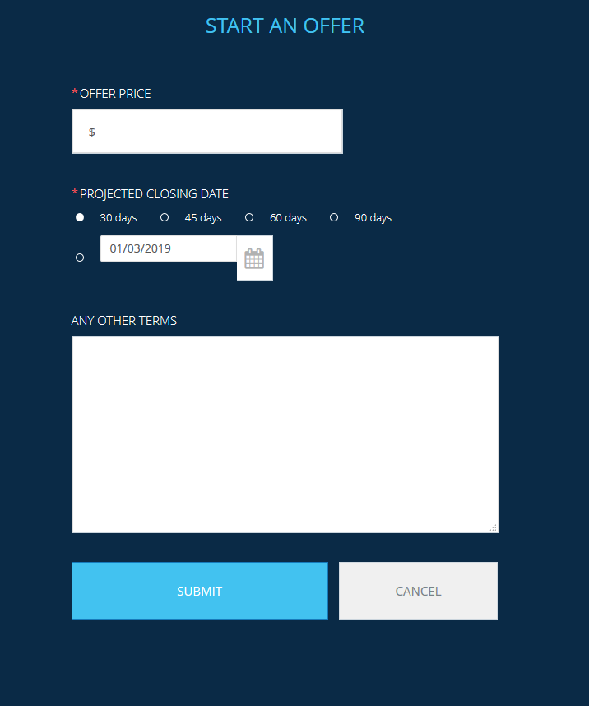

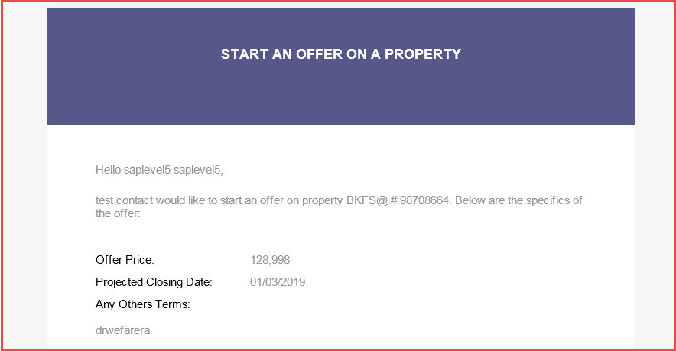

*Figure D: View Detail Button*

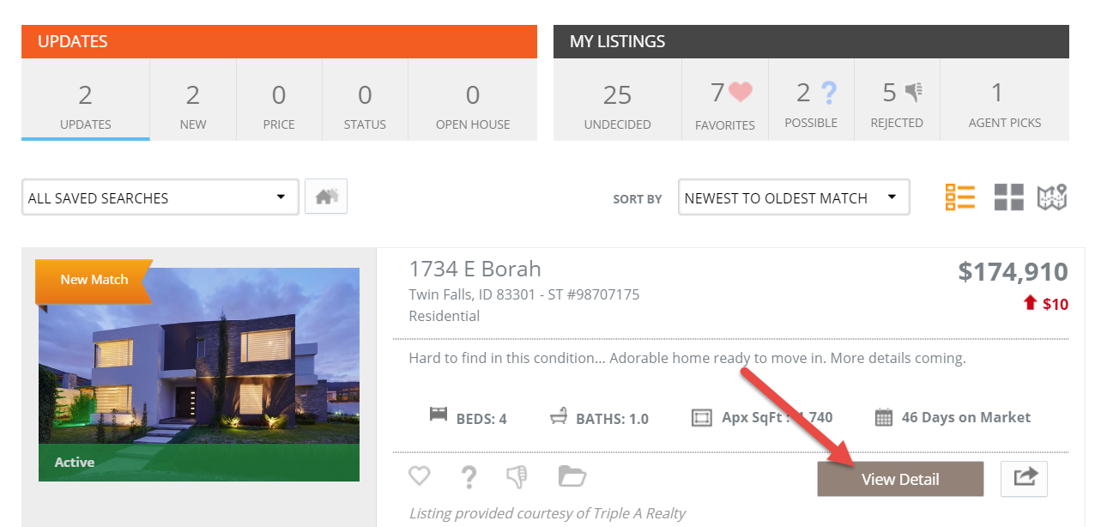

*Figure E: Listing Details Screen – Start an Offer Box*

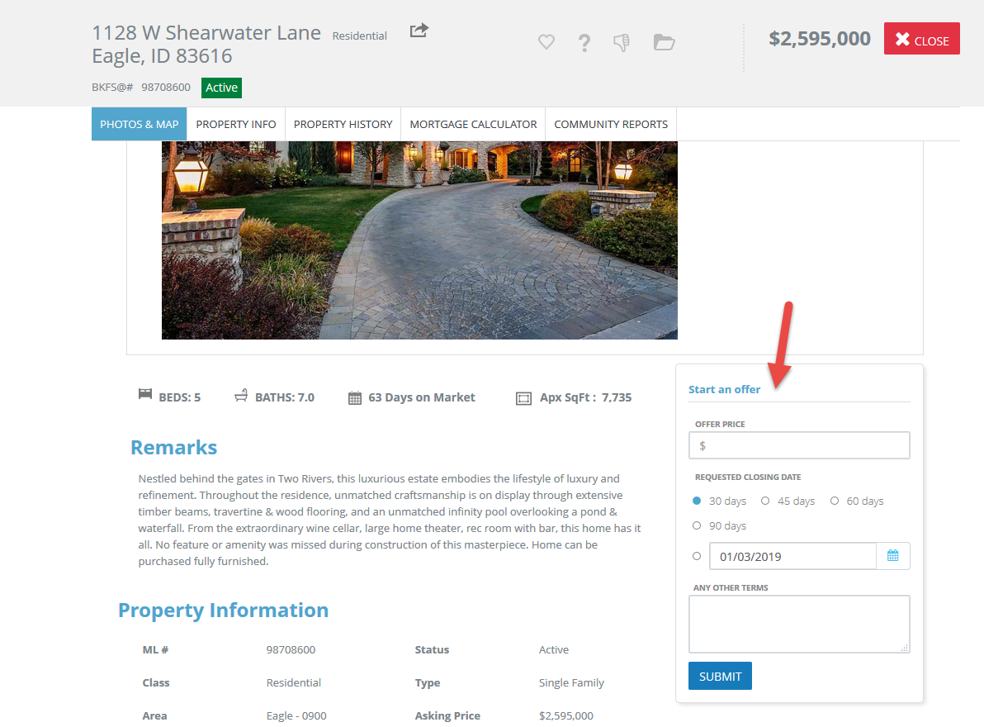

# Collab Center: Make My New Home

Consumers now have the ability to select one or more properties as their new home. What this means is that after an offer has been accepted, the consumer can mark the property(ies) as the home that they intend to purchase. In doing so, this will cause a new tab to be added to the Collaboration Center as the first tab, ‘My New Home’. All properties marked as ‘my new home’ will appear on this tab. **Please Note: This feature will be activated a few weeks after the 5.68 release when a few final touches are complete. Communications will be sent in advance.**

*Figure A: Additional Options button*



*Figure B: Make My New Home button*

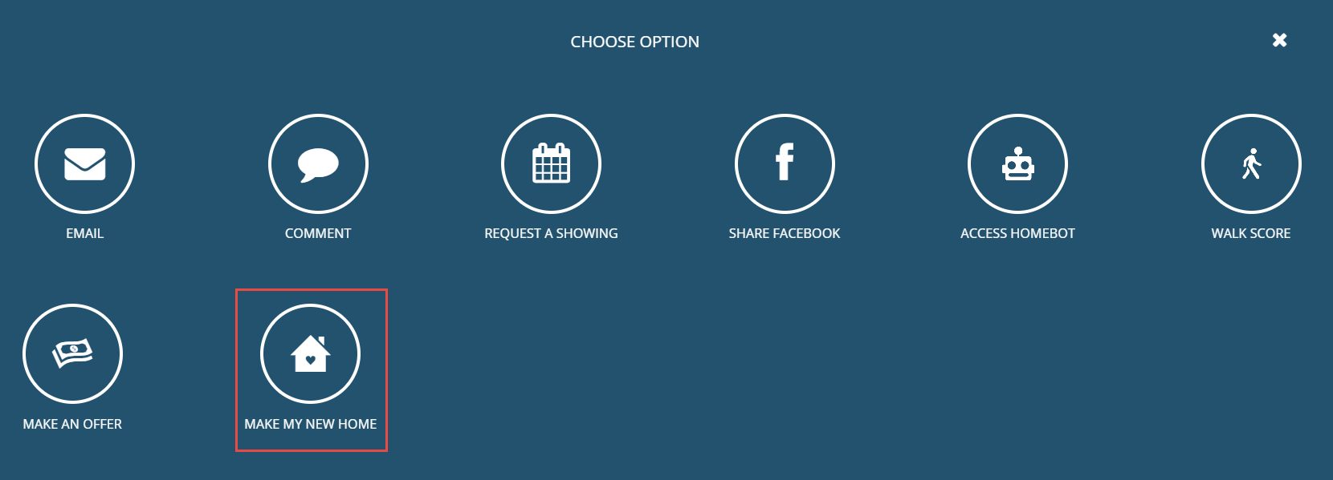

*Figure C: Make My New Home Confirmation*

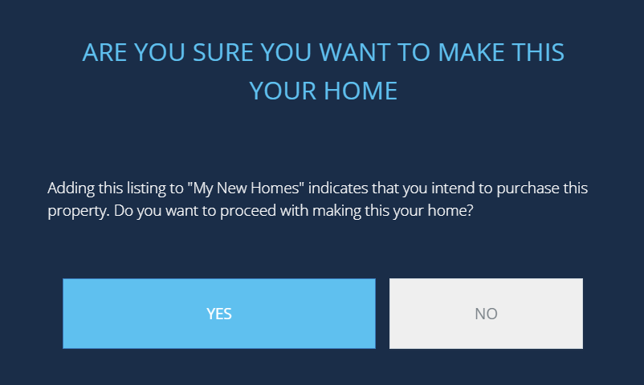

*Figure D: My New Home Tab*

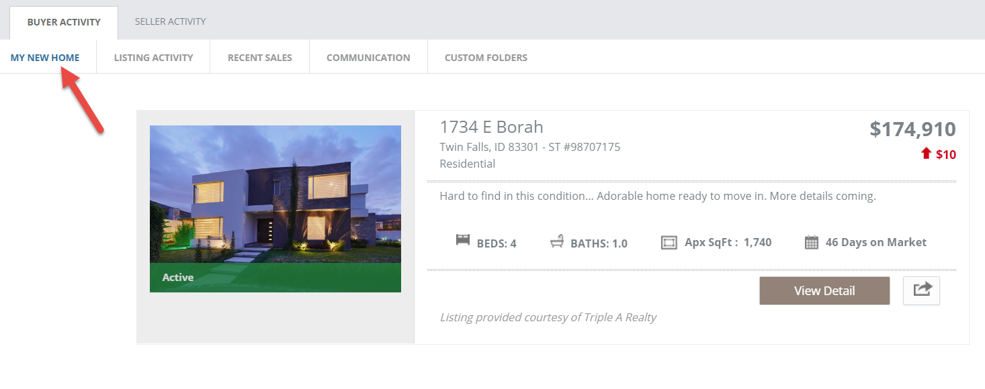

# Automatic Creation of Collaboration Center URL

This enhancement is the first step in simplifying the Collaboration Center setup for users that are setting up their Collaboration Center site for the first time. Instead of requiring agents to create their Collaboration Center (CC) site, the system will automatically create the URL when Contacts or Collaboration Center Preferences are accessed. Users that have already created a CC site will not be affected by this enhancement.

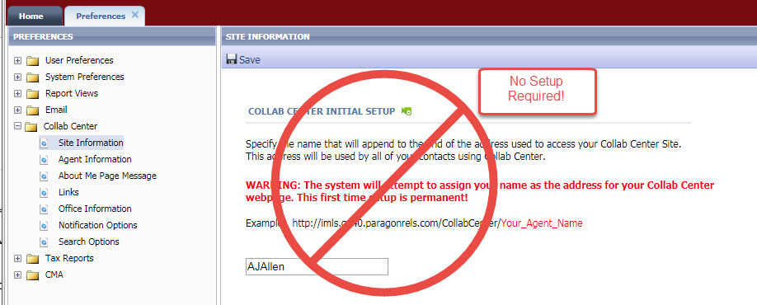

# Updated Contact Activity Widget

This enhancement brings a major upgrade to the existing Contact Activity Widget. The new, four-tab layout is designed to provide direct access to client activity from Collaboration Center.

The header links to the Contacts > View/Manage Contacts activity page – view all recent activity here.

Use the Days Back selector to view activity up to 30 days back. Use the Edit Widget tool () or the new setting in Preferences > System > Contact Manager to set the Default Days Back from 0 to 7 days.

Up to 50 records will display on each tab. All activity can at any time be viewed from Contacts > View/Manage Contacts.

**Activity Tab**

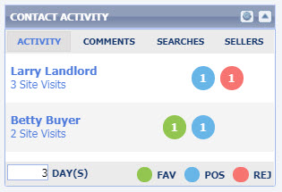

On the Activity tab, your Contacts are displayed by most visits to their Collaboration Center site.

Click the **Contact Name** to view the Paragon Contact Activity page.

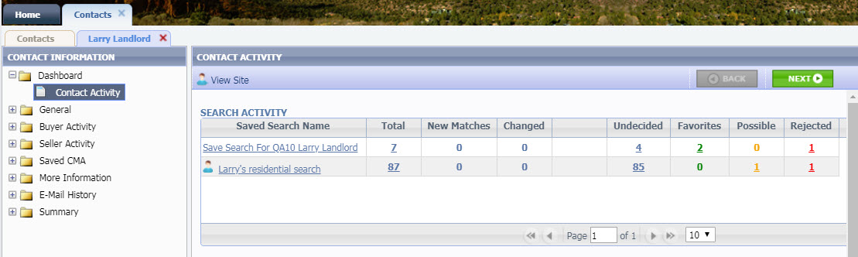



Click the **# Site Visits** to view their Collaboration Center Buyer Activity page.

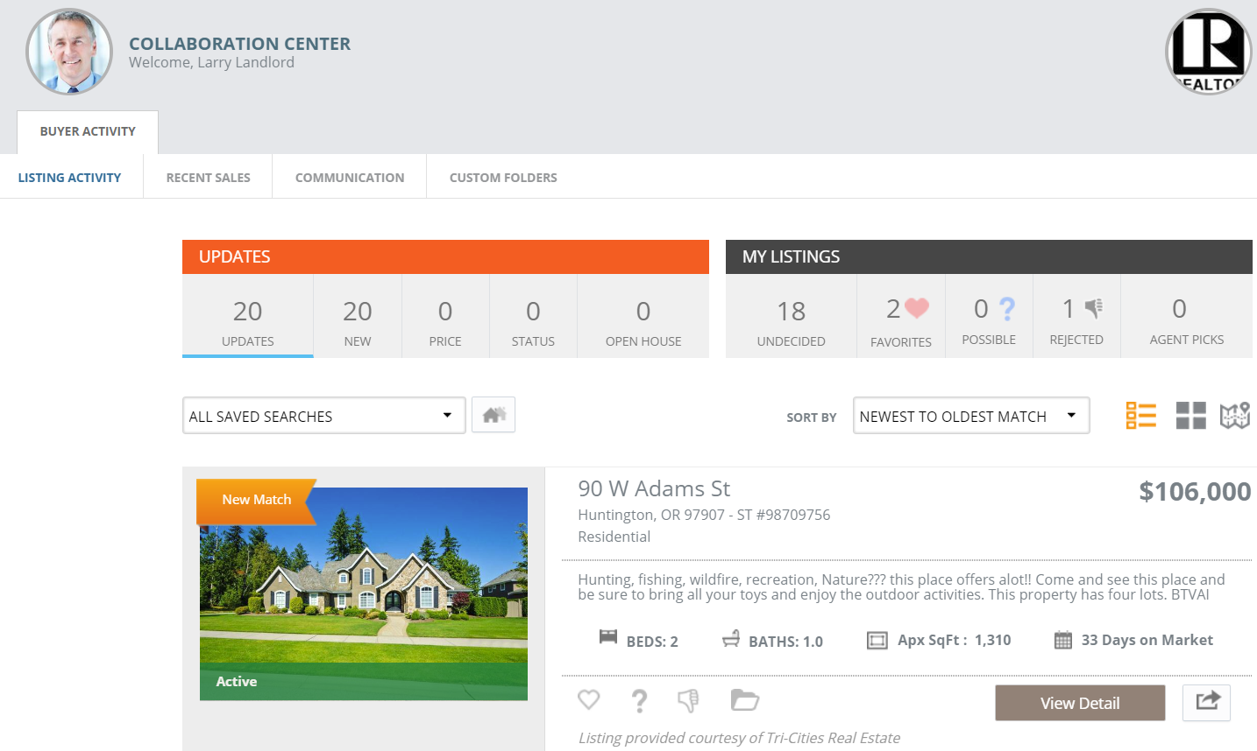

Next to each Contact is a link to the Favorite, Possible, and Rejected listings they marked in the specified Days Back. Click the numbers to view those specific listings in your Paragon spreadsheet view.

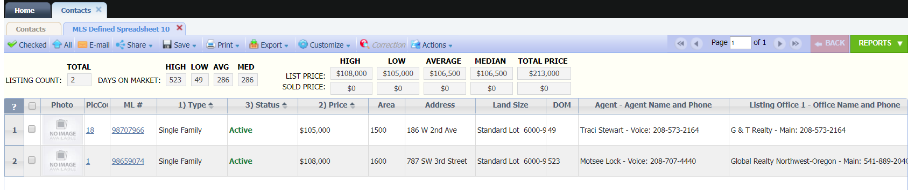

**Comments Tab**

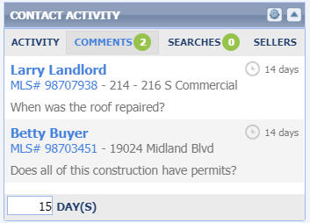

The Comments tab displays comments added by the Client in Collaboration Center. The display includes the Contact name, the Listing Number and Address for the property, and the Comment. Click the contact name to open the Manage Comments modal and reply or click the listing number to see the default Listing Detail report.

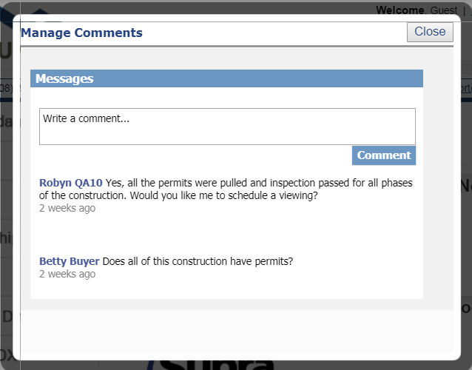

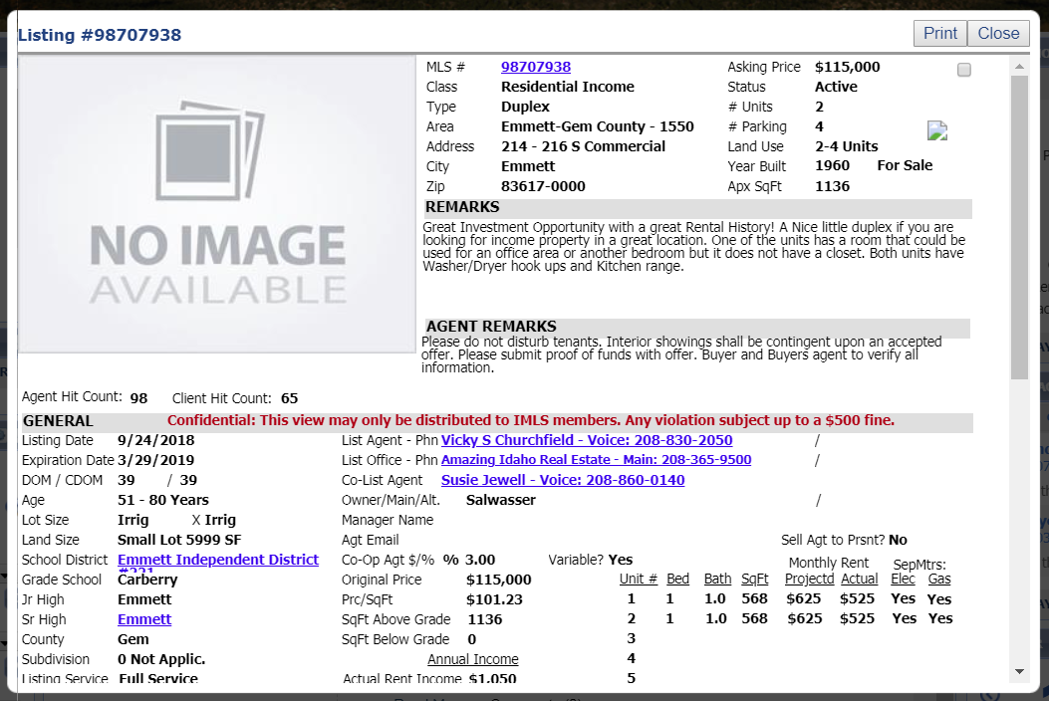

**Searches Tab**

When search capability is enabled in Collaboration Center, the Searches tab displays client-created New and Modified searches. The display includes the Search name, Contact name, and number of matches. Click the Search name to view the matches in the Contact’s Collaboration Center Map view. Click # Matches to view the listings in Paragon.

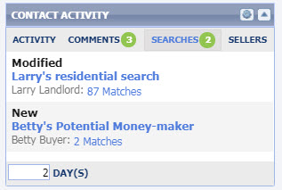

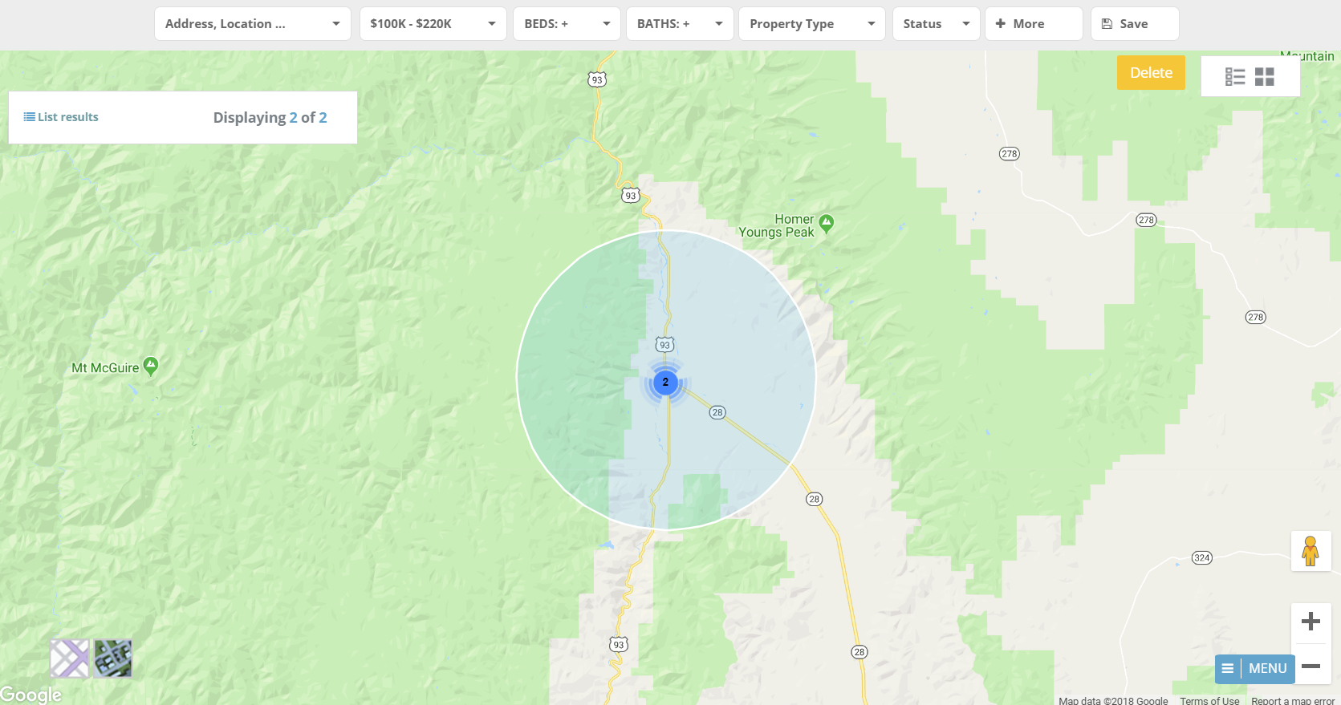

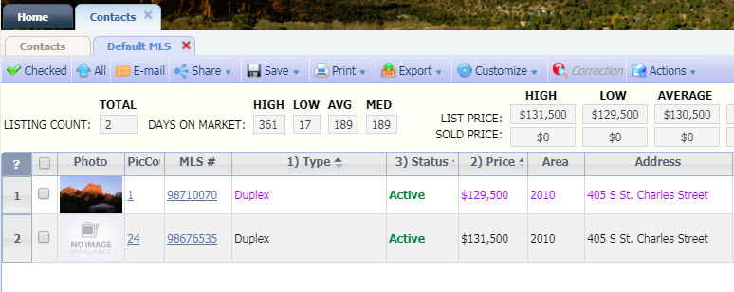

**Sellers Tab**

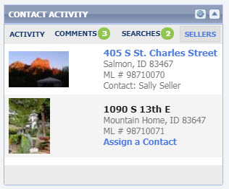

The Sellers tab displays your Active [status category 1] and Pending [status category 3] listings. The display includes the Listing address, Listing Number, and Contact, if assigned.

If a listing has been associated with one of your Contacts and Sell Side is enabled, click to go to the Contact’s Collaboration Center Seller Activity tab to view listing activity from buyers and agents: views, shares, favorites, and more.

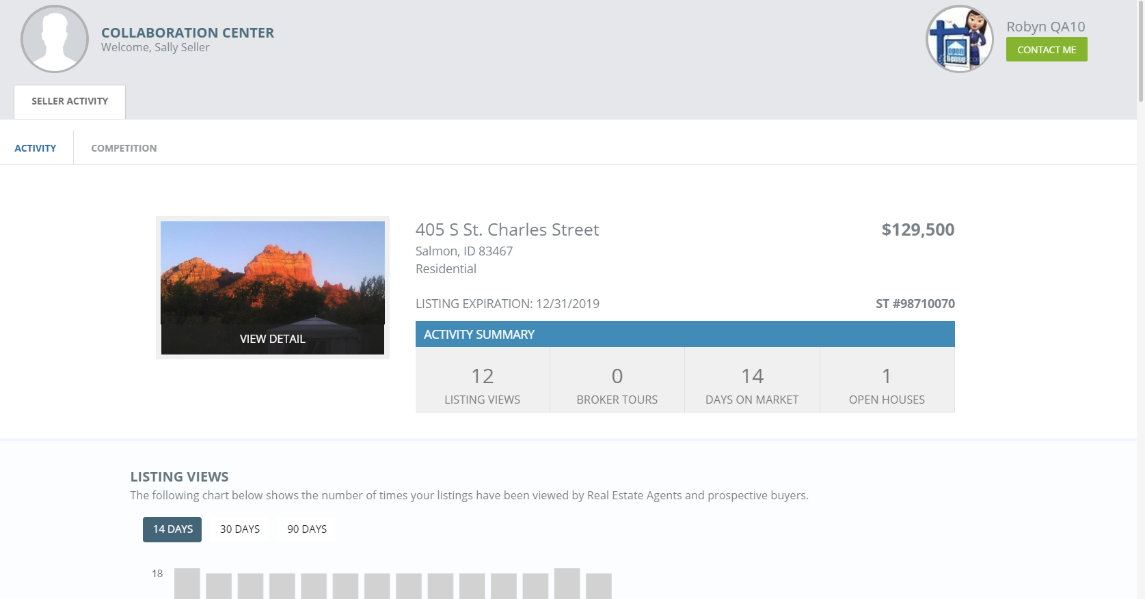

If a listing has not been associated to a Contact, click the Assign a Contact link to add a Contact and enable the Sell Side.

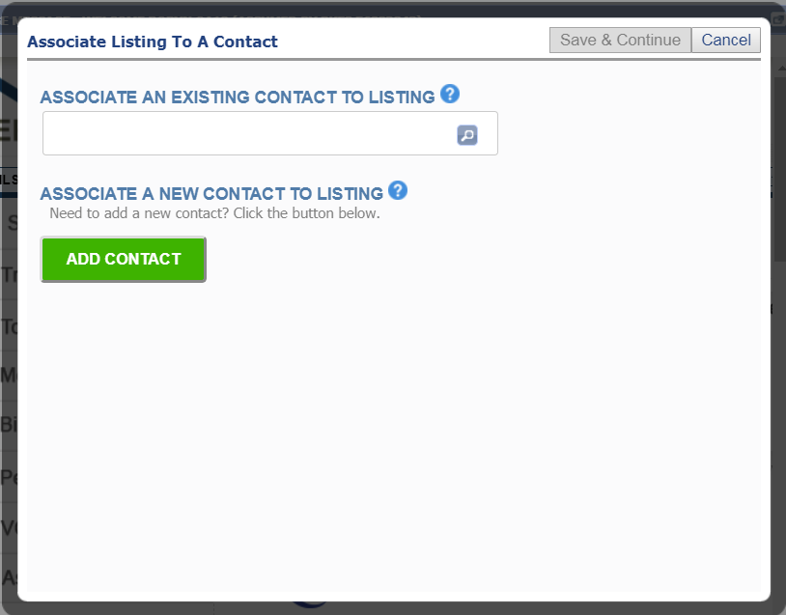

# MLS Customizations and Administration

**All options in this section are either configurable via MLS Administration controls or by your System Support Manager as noted.**

# Homebot Enhancements

Two enhancements were added to the Paragon Contact Manager to improve the user experience for agents with active Homebot accounts:

* Icons were added next to the Address fields to designate that the fields are required for subscribing contacts with Homebot.

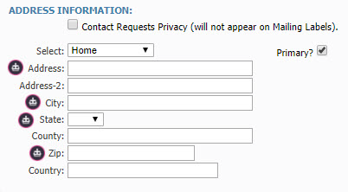

* The last five actions by the contact will display on the Contact Activity page with a button that links directly to the Contact’s page in Homebot for quick access.

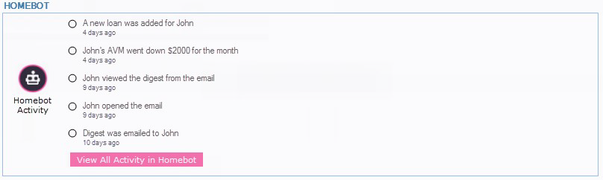

* If the contact subscription is new, no activity will appear but the button will still jump the agent to the Contact’s page in Homebot.

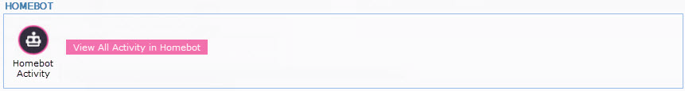

To repeat, these changes will only appear to agents with active Homebot accounts.

# Field Setup: Limit Data Visibility by User Type

Several customers have requested a method that allows listing field visibility to be filtered by user type. This will allow customers to create fields that can house confidential data and be displayed optionally in standard report views.

This new functionality will work ***in conjunction*** with the current field security rules. This framework will allow granular permissions for field data visibility. This functionality has been added to Admin\Fields module and uses controls similar to the current searchable field attribute.

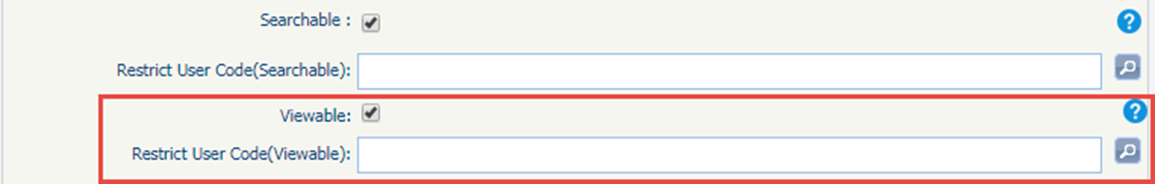

If a user is a member of an excluded user group, they cannot add the prohibited field to a report view.

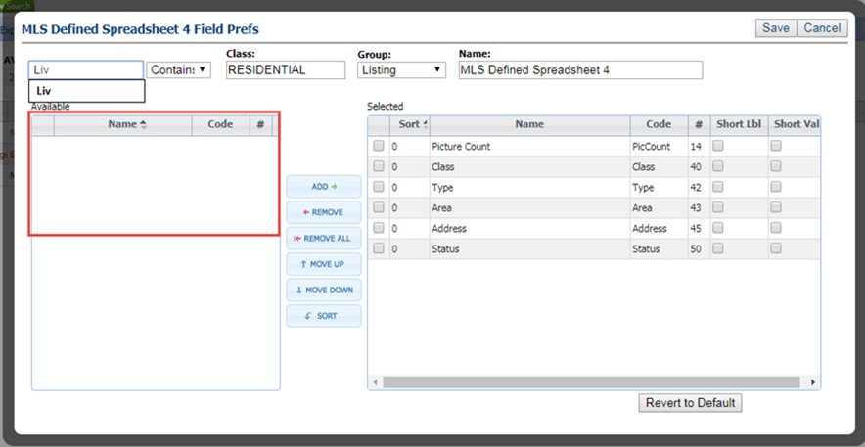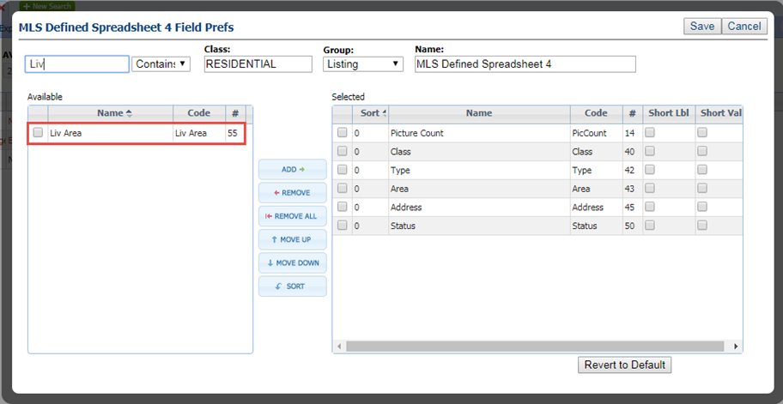

If the user is a member of an excluded group but the prohibited field is already included in a report view the data will not be displayed.

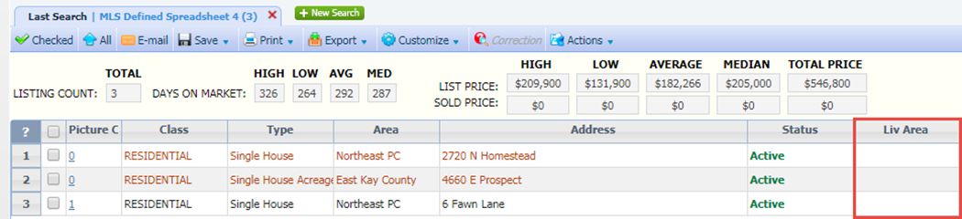

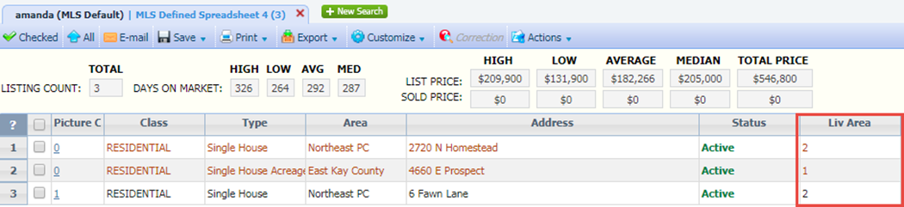

# **RESO DD Compliance: Agent\Office Table Changes**

In order to meet the requirements of the current and future RESO Data Dictionary standards BK MLS has added new fields to the agent and office tables. The additional fields are as follows:

*Figure A: Agent Table*

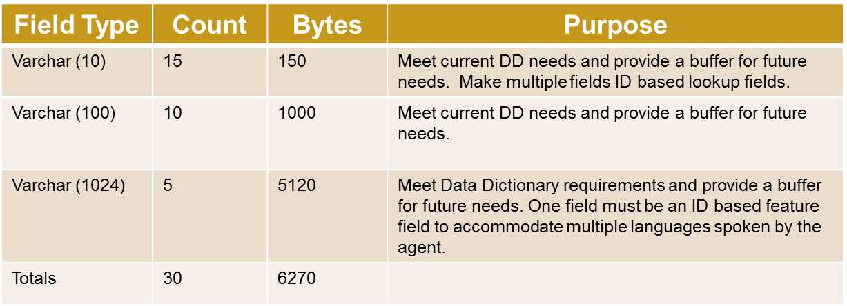

*Figure B: Office Table*

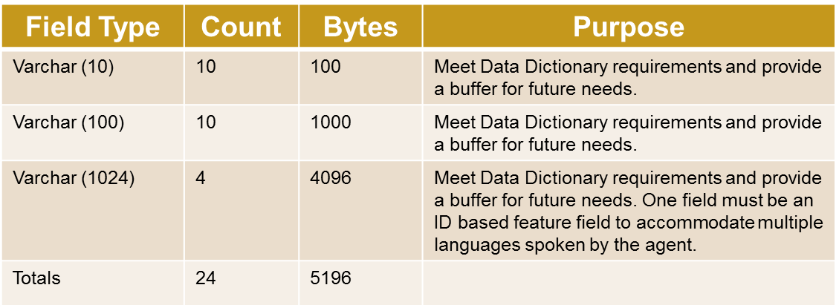

The new agent and office fields may be accessed in the same manner as current fields and will have the same controls. Several of the new fields will be Lookup or Features fields:

* The ID based Lookup and Features functions will be updated to allow options to be created and mapped to these new fields.
* The new fields will be visible on agent or office audit reports.
* The new fields may be added to custom and legacy report views.

RETS will be modified to accommodate the new fields.

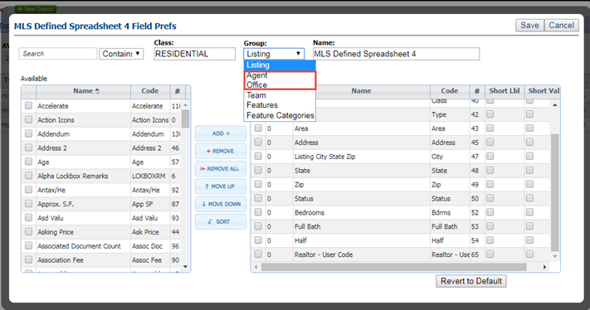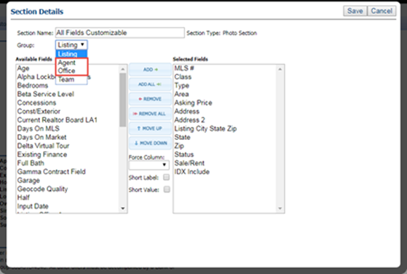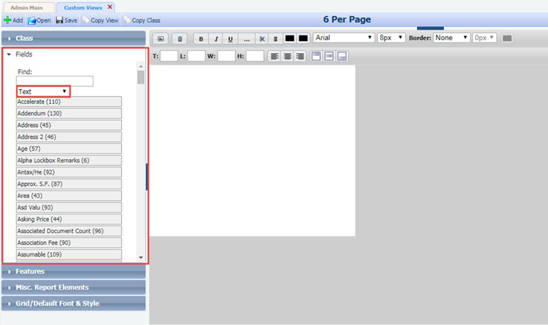

# 

# RETS Update with Extra Spaces

In the RETS Update request Record parameter, if there was extra whitespace it would not properly match the fields and they would be ignored by the update. This has been modified to trim the whitespace when the field names are parsed.

# RETS Metadata: Enhanced to Include Current Length as Max Length

The RETS Metadata has been modified to report the actual character width of a field instead of the potential width. For example: A 255 character field has been enabled but the actual number of characters has been limited to 150 characters via field configuration settings. The RETS Metadata will report the field’s maximum width as 150 instead of 255.

# RETS Update: Last Value Submitted is Final

When a RETS Update transaction is performed on a character field the last value submitted for the field will be its final value. For example: A series of changes is saved to a field named Char10. The first value saved is test1, the second is test2 and the final value is test3. Once all of the transactions are processed, the final value of the Char10 field would be test3.