# Agent Level Enhancements

**The following section contains changes that are active system wide** **and available to users based on their assigned security levels.**

LIM – Remove Paragon Spell Checker in Favor of Browser-based Spell Check

Freeform input fields in Listing Input and Maintenance have been updated to use the browser-based spell check that was previously implemented elsewhere in Paragon.

Mapping – Listings no longer Re-Geocoded if Pin is Manually Placed and Address is Updated

When the map pin is manually placed (geocode quality = 1.0), and the listing agent modifies the listing address, the system will not attempt to re-geocode the listing.

**Mapping – Option to Restrict the Search Map Boundary to User’s Selected Zoom Level**

A new option has been added to Preferences > Search Options that, when checked, will restrict the Google search map to the user/MLS default zoom level.

Search – Action Buttons Added to Top of Quick Search Widget

The Count, Clear, and Search buttons on the Quick Search Widget are now available at both the top and bottom of the widget.

Search Results – Sale/Rented Price Included in Summary Stats Sold Price

The logic for generating the Sold Price Summary statistics on Search Results has been modified to include the sale/rental price for listings in (Status Category 6) Rented/Leased.

CMA – Warning Message if Agent Résumé, Company Info, or Final Comments Exceeds Allotted Space

When combined images and text in CMA Agent Résumés, Company Info, or Final Comments exceeds the space allotted in the finalized document, a warning message will display.

CMA – Updated Instructions for Adding Subject Property

When adding a Subject Property to your CMA, we updated the instructional text to better describe the available options.

CMA – View Subject Property from Comparables Search

From the Comparables Search screen, a button to View the Subject Property will display the Detail of the Subject Property to help the User to select the appropriate comparables criteria.

CMA – Calculated Auto Adjustments for Numeric and Feature Fields

A highly anticipated feature for CMA Users, they can now pre-set adjustment values for Numeric and Feature fields that will automatically calculate values across Comps in a User’s CMA.

Collaboration Center – Set Default Client Notification Types

A new setting in Collab Center Preferences allows the user to set default Client notification types for all subsequent Collaboration Center searches.

Collaboration Center – Miscellaneous Contact Activity Widget Changes

Based on valuable feedback, updates have been implemented in the Contact Activity Widget on the Paragon Home Page to include additional functionality and clarify several actions.

# MLS Customizations and Administration

All options in this section are configurable via MLS Administration controls or by your System Support Manager as noted.

LIM – New Green Information Fields

To comply with RESO Data Dictionary formats, three existing Green Information fields have been converted from lookups to freeform fields.

LIM – Interactive Congratulations Modal in Listing Input & Maintenance

The Congratulations message that appears when a listing is saved has been enhanced with clickable integrations.

LIM – Launch Third Party Integrations in a New Browser from Listing Input & Maintenance

The left navigation menu on the Listing Edit form has been enhanced to support the ability to launch third party integrations in a new browser or tab.

LIM – Additional Fields added to Listing Input & Maintenance Summary Display

City and State/Province have been added to the LIM Summary Display, to aid in easily identifying listings. Additional fields can be added to the display by the MLS.

Search Results – Display Long Description for Custom City Lookup Fields

For MLS systems using a custom City lookup field for Listing City State Zip, the long description of the City now displays, instead of the lookup abbreviation.

RETS – Maximum Logins Per Day

A configuration setting has been added to impose a limit on the number of RETS logins per user per day, to limit excessive login activity that periodically causes performance issues. Please contact your RETS vendors to make them aware of this important performance change.

RETS – Compact Listing Field Names in RETS Metadata

Paragon Listing fields with labels longer than 25 characters are now compacted (spaces removed) to avoid being truncated in RETS metadata.

Listing Audit Reports – Photo Changes Removed from Listing Audit Report

By multiple Customer request, Picture Count records have been removed from the Listing Audit Report to keep the report manageable in size. Photo maintenance records can still be viewed from the Photo Audit Report.

Admin – Simplified Phone Number Validation Process

Rather than validating against a constantly changing Area Code table, Phone Numbers will now verify for formatting instead of specific values, preventing the need for a Paragon release for updates.

Admin – Changes to Agent/Office Tables for Native RESO Data Dictionary Compliance

RETS support has been implemented for new Agent and Office table fields added in Paragon with the previous 5.68 release.

Admin – Restrict Board Access for Level 7 Users in MLS Messaging Module

For Paragon Systems using multiple Boards, Admin users with security level 7 and access to create MLS Messages are restricted to add messages for their assigned Office/User Boards.

Admin – Collaboration Center Default Client Notification Triggers

Default Client notification triggers for new Collaboration Center searches can now be set at the MLS level.

Admin – Collaboration Center Admin Module

To help make Collaboration Center setup more convenient, all CC Admin configurations have been consolidated into a single module.

Collaboration Center – Start an Offer

An exciting new option for the Agent and their consumers who can now notify their Agent from Collaboration Center that they would like to start an offer on a specific listing.

Collaboration Center – Make My New Home

Another exciting option in Collaboration Center is for the ability of the consumer to mark a listing as a potential purchase, creating a new “My New Home” tab in Collaboration Center.

General – Collaboration Center Promotional Text and Link

To help promote Collaboration Center, a notation has been added to the legacy email notifications.

General – Replace Google URL Shortening Service

In anticipation of Google’s termination of its URL shortening service, a new solution has been implemented for advanced listing sharing and mobile password reset messages.

General – Updated Text on Email Opt-In Screens

The text on the Email Opt-in screens was updated to clarify the workflow.

# Corrected Issues

|  |  |  |  |  |
| --- | --- | --- | --- | --- |
| **Work Order** | **Seq** | **Module** | **Reporting Customer(s)** | **Issue Corrected** |
| 44344 | 7 | Input Maintenance | Duluth, CW Tennessee, Columbia SC, ECAR, Gainesville, Jonesboro, NEREN, NCWV, REB3, RANW, Juneau, Tahoe Sierra, Tallahassee, Triangle | Add City and State to the LIM Summary Display and make it customizable. |
| 121387 | 2 | Admin - Reports | Triangle MLS | Grid summary stats omits Rented listings (statuscatid 6) |
| 126774 | 1 | Admin - Agent | (RANM) Realtors Association of New Mexico | Adding new agent, Reason Comment do not save on the first initial save |
| 128483 | 1 | Tax | New England Real Estate Network (NEREN) | Tax Autofill from Spreadsheet View is not working correctly for Vermont |
| 134107 | 1 | Mapping | Santa Fe Association of Realtors, Inc. | Advanced Mapping - Parcels not showing all the parcel tax info and the MLS data not displaying |
| 136538 | 1 | Admin - Reports | Willamette, GALMLS, NEREN | Remove photo changes data from the listing audit report |
| 139024 | 1 | Collab Center - Buy Side | REB3 | Office logo is missing on Contact me page |
| 139457 | 1 | Mapping | Santa Fe Association of Realtors, Inc. | Intermittent Lasso results in Advanced Mapping |
| 141062 | 1 | Print/Print+ | Hot Springs Board of Realtors, Bloomington/Normal, Charlottesville, CARMLS, Omaha, Hot Springs, MAXMLS/EBRD | Report prints in upper left corner in Chrome only using Print + |
| 141838 | 1 | CMA | Great Plains Realtors MLS Inc (Omaha) | CMA Summary of Adjustments page has incorrect page break |
| 142001 | 1 | Views/Reports | Quad City Area Realtor Association | Advanced Mapping lists extra listings that are not part of the original search results |
| 142146 | 1 | CMA | REB2 | CMA Map of Properties page has incorrect page break |
| 142149 | 1 | CMA | REB2 | CMA Suggested Price shows as $1 |
| 142527 | 1 | Input Maintenance | Pacific Regional MLS System (PACMLS) | Assumption Payment and Equity Amount not updating values |
| 142880 | 1 | Preferences | New England Real Estate Network (NEREN) | User isn't Able to Scroll While in E-mail - Verification Preferences |
| 142889 | 1 | Tax | Wisconsin Real Estate Exchange/SCWMLS/WIREX | SCWMLS:P50 - Bug with Tax IDs that include Ampersands in CRS Tax Autofill |
| 143055 | 1 | Affiliate Connect | New England Real Estate Network (NEREN) | NEREN My Affiliates Will Not Display, Cannot be Found |
| 143248 | 1 | Quick Search | Santa Fe Association of Realtors, Inc. | Power Search - Short queries return no matches for some categories |
| 143388 | 1 | Search | MAXMLS / EBRD | Issue with Agent/ActiveAgent searches when a non-internal account is used |
| 142100 | 1 | Third Party Integration | Sioux Empire, GALMLS, NEREN, NRV, RASE, SCWMLS | Shared Photo is Blurry |
| 139663 | 1 | Email | Coastal Carolinas Association of Realtors | Email notice that there is an error with CC site gives incorrect instructions |
| 103928 | 1 | MLS Docs | Tallahassee, Huntsville, NRV | Clicking 'MLS Documents' kicks level 1 users back to login screen |
| 115030 | 3 | Mapping | South Central Wisconsin MLS (Madison), REB3 | Listing being regeocoded when address changed after having been manually geocoded. |
| 121725 | 2 | Input Maintenance | Intermountain, CMMLS, Gainesville, GAMLS, GALMLS, Huntsville, IRMLS, Memphis, NEREN, Nova Scotia, Pensacola, RAYAC, San Diego | Clicking Modify for required features takes you to all features not specific feature in question |
| 130241 | 1 | Views/Reports | Hudson County Multiple Listing Service | CMA Summary Avg/Min/Max/Med not formatting properly when Display Format = Money |
| 134136 | 1 | Mapping | Santa Fe Association of Realtors, Inc., ECAR | Advanced Mapping Parcel and Data layers enabled difficult selecting Data/Display Data for MLS # |
| 111320 | 1 | Search – Property | SCWMLS, Central Wisconsin, Eastern New York, Minot MLS | Expiration date field is no longer available unless you choose Exp Status |

# Agent Level Changes

**The following section contains changes that are active system wide** **and available to users based on their assigned security levels.**

LIM – Remove Paragon Spellchecker in Favor of Browser-based Spell Check

For a consistent experience throughout Paragon, all freeform fields now use a browser-based spell check function. The update in Paragon 5.69 affects large freeform fields in Listing Input and Maintenance.

Browser-based spell checking is supported in all browsers compatible with Paragon, and in iOS and Android devices.

* **Action Item:** No action is required by you to implement this functionality.

Figure 1, Browser-based spell checker

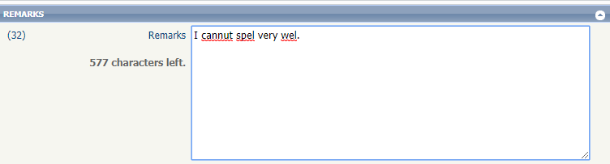

# Mapping – Listings no longer Re-Geocoded if Pin is Manually Placed and Address is Updated

With Paragon 5.69, for listings with a geocode quality = 1.0, Paragon will not attempt to re-geocode the listing if the list agent modifies the listing address.

Previously, even a minor modification, such as correcting a typo in the address, would cause the system to re-geocode the map coordinates. In most cases, if the list agent has manually placed the pin, it should be on the correct map coordinates, therefore Paragon will no longer override that decision by re-geocoding the listing if the address changes.

* **Action Item:** No action is required by you to implement this feature.

Figure 1, Geocode Quality = 1.0

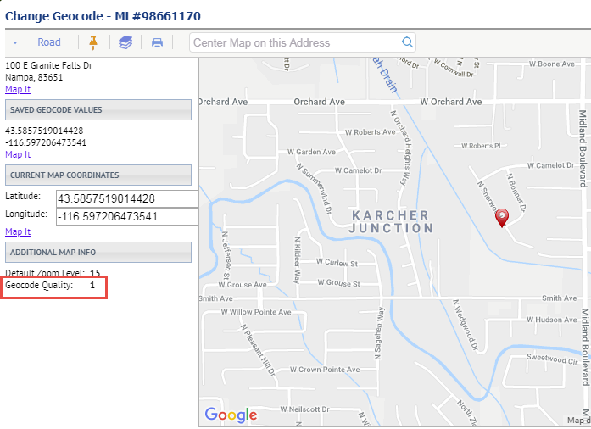

# Mapping – Option to Restrict the Search Map Boundary to User’s Selected Zoom Level

A new option has been added to Preferences > Search Options that, when checked, will restrict the Google search map to the user/MLS default zoom level.

The new option, “Enable Map Boundary to Zoom Out to Display all Listing Results,” works in conjunction with the MLS default zoom level and existing Preferences option “Custom Map Address and Zoom Level.”

When checked, the Search by Map option in Property Search will zoom out to display all listings in the current results set.

When unchecked, the Search by Map option in Property Search will retain the user’s default zoom level; some listings in the result set may not be visible on the map without zooming out.

* **Action Item:** “Enable Map Boundary to Zoom Out to Display all Listing Results” will be unchecked by default (Search map will respect the MLS default zoom level, or the user’s default zoom level when specified in Preferences).

Figure 1, New Preferences Option to Enable Map Boundary to Zoom Out

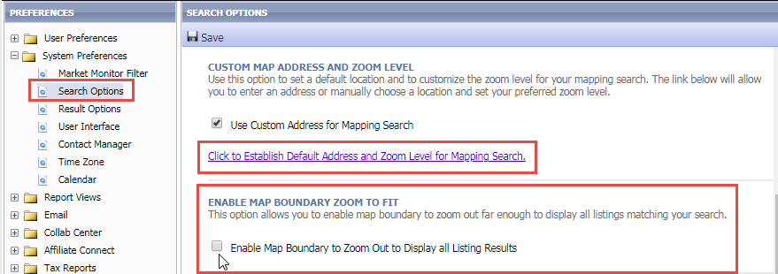

Figure 2, Enable Map Boundary to Zoom Out is **disabled**

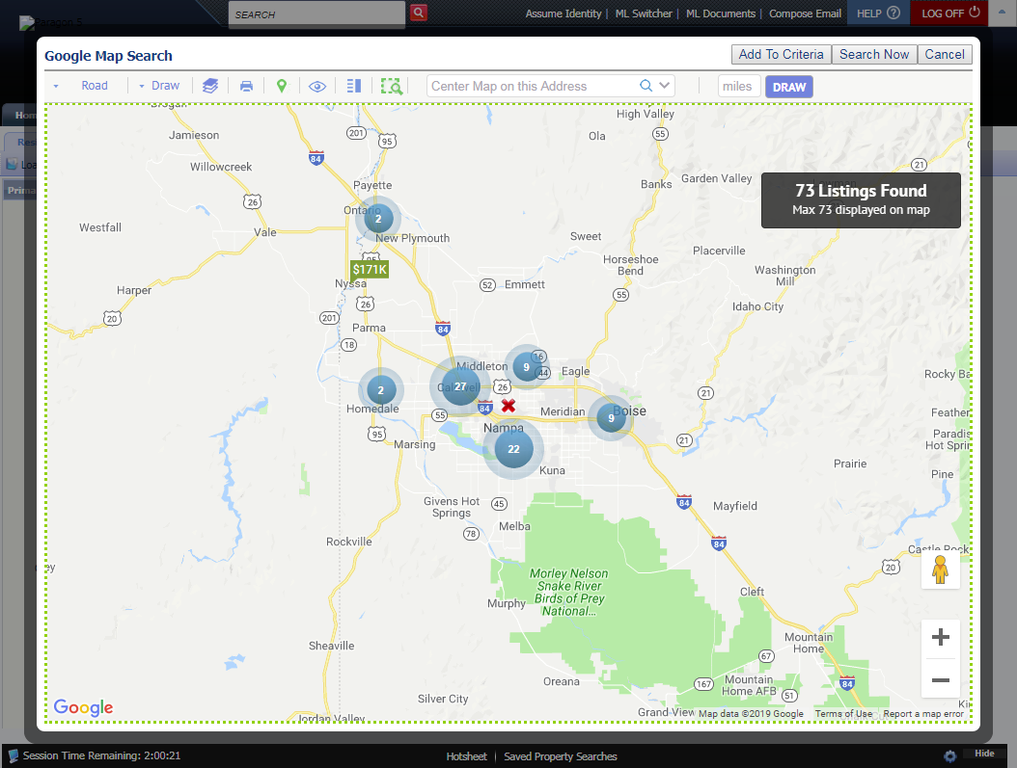

Figure 3, Enable Map Boundary to Zoom Out is **enabled**

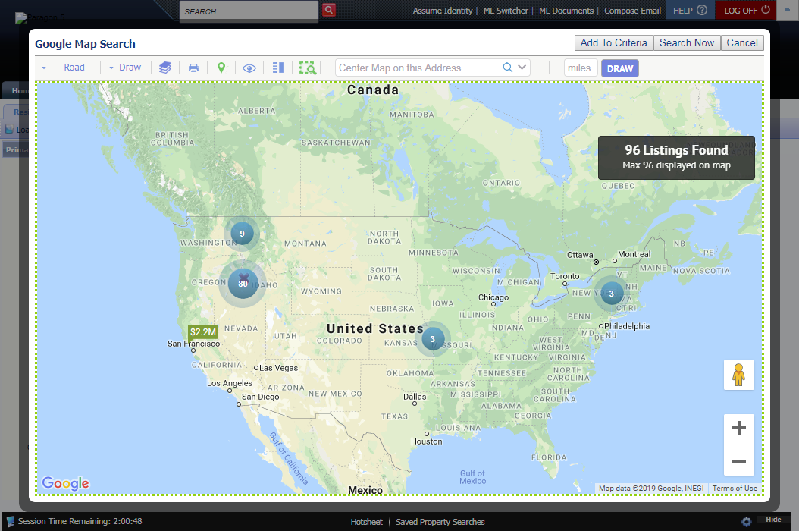

# Search – Action Buttons Added to Top of Quick Search Widget

The Count/Clear/Search buttons have been added to the top of the Quick Search widget; the buttons can now be accessed from both the top and bottom of the widget.

* **Action Item:** No action is required by you to implement this functionality.

Figure 1, Quick Search Widget

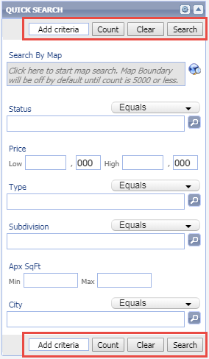

# Search Results – Sale/Rented Price Included in Summary Stats Sold Price

Previously, the Sold Price summary statistics at the top of the Search Results grid did not include listings in Status Category 6, Leased/Rented. The calculations for Sold Price statistics have been updated to include the Sold Price for Leased/Rented listings.

***Note:*** *Your MLS may have a different label for Status Category 6.*

* **Action Item:** No action is required by you to implement this functionality.

Figure 1, Summary Statistics for Status=Leased

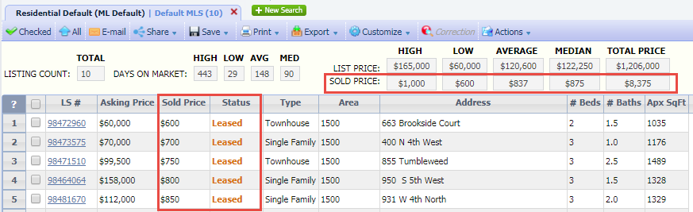

# CMA – Warning Message if Agent Résumé, Company Info, or Final Comments Exceeds Allotted Space

When creating the Agent Résumé, Company Info, and Final Comments pages in CMA Setup, there was previously no indication if the text and images entered in the rich text editor would fit the final, formatted document thus causing data to be cut off. This enhancement will automatically calculate whether the data will fit, based on images, text, and text formatting. If the data will exceed the boundaries of the finalized document page, a warning message will display when the user saves the document.

Because of many possible variables – font size, font style, images, etc. – a character count can’t be provided within the text editor for these pages.

This enhancement is available from Preferences > CMA > Presentation Setup, Preferences > CMA Preferences Wizard, and from the CMA module > Presentation Setup.

* **Action Item:** No action is required by you to implement this functionality.

Figure 1, Warning Message for text exceeding page size

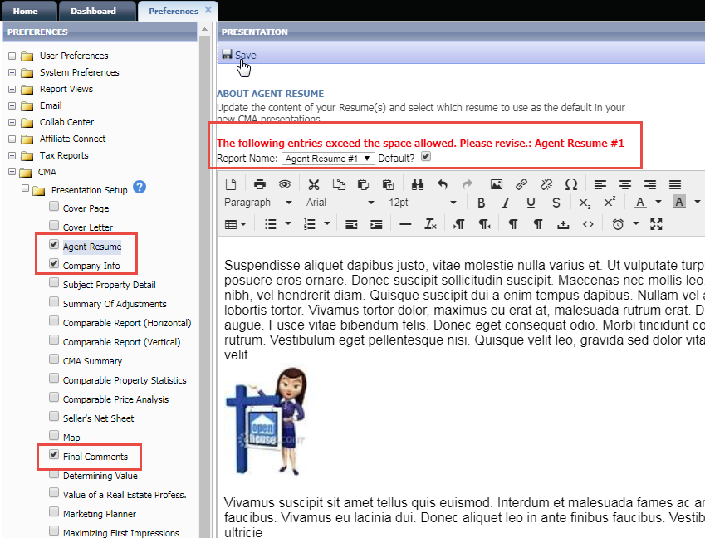

# CMA – Updated Instructions for Adding Subject Property

The CMA Presentation supports three options for adding a Subject Property. To provide better information regarding the functionality of each option, we included new instructional text on this page. The new text highlights that the first option, “Create New Subject Property”, should be used to manually create a brand new Subject Property or to copy an existing listing into an editable Subject Property. This option can take advantage of the Copy/Clone function to create a Subject Property based upon an existing Listing Number so that the data (price, etc.) can be updated to reflect the current status of the Subject Property listing. The third option “Use and Existing Listing” allows you to reference an existing listing with no ability to edit the listing details.

* **Action Item:** No action is required by you to see the new text.

Figure 1, Define Subject Property within a CMA Presentation

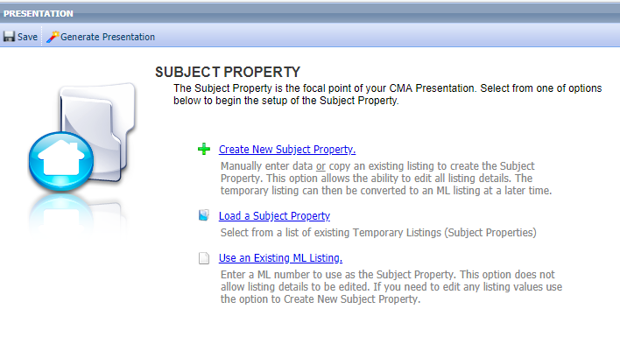

# CMA – View Subject Property from Comparables Search

To enable users to easily access their Subject Property details while searching for Comps, a button to “View Subject Property” has been added to the Search Criteria screen. Click the button to open a detail view modal with the Subject Property information. Click the Minimize button on the modal to minimize the detail view for quick access while on the Search Criteria screen.

* **Action Item:** No action is required by you to implement this functionality.

Figure 1, View Subject Property Button

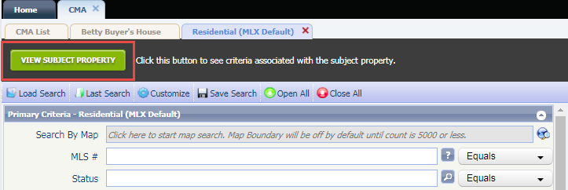

Figure 2, Detail View Modal in Minimize mode

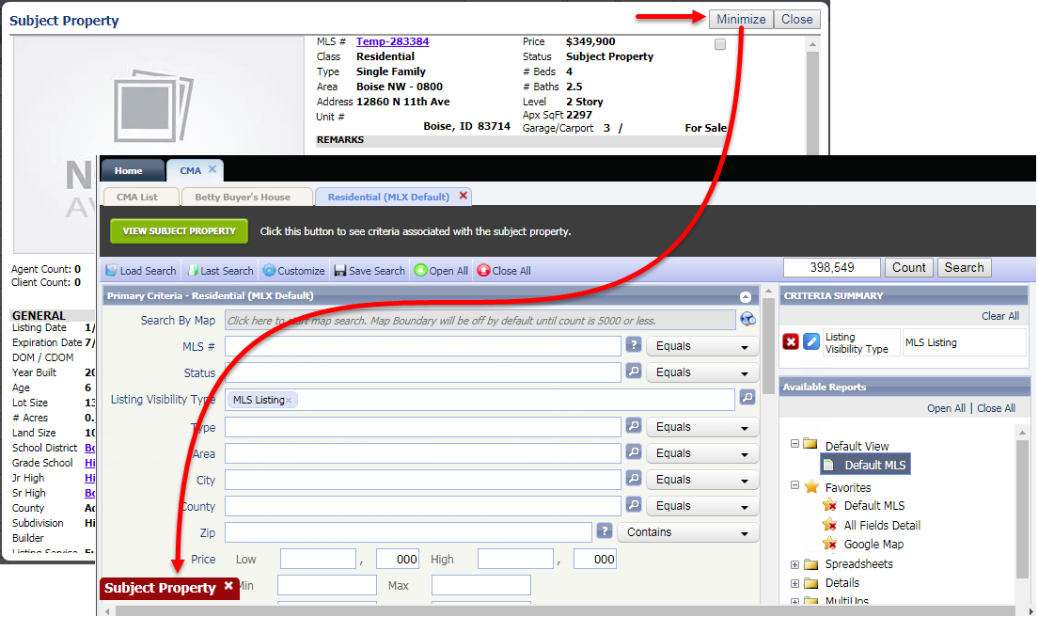

# CMA – Calculated Auto Adjustments for Numeric and Feature Fields

This enhancement allows each user to create and save adjustment values to current system fields (numeric and features only) that can be applied to CMA comparables and automatically calculated based on field values. Feature fields and Numeric fields can be added to the Calculated Adjustments table. When applied to comps in CMA with the Calc Adjust button, the adjustment value is added to each comp, and the total adjustment for that field on each comp is automatically calculated based upon the value in each comp listing compared to the Subject Property value.

* **Action Item:** Users can customize the selected fields and values in Preferences > CMA > Adjustments > Calculated Adjustments. **MLS should select which Numeric fields will be available by selecting the CMA Auto Adjustable Checkbox at the bottom of the field setup screen.**

Figure 1, Preferences > CMA > Calculated Adjustments > Numeric fields

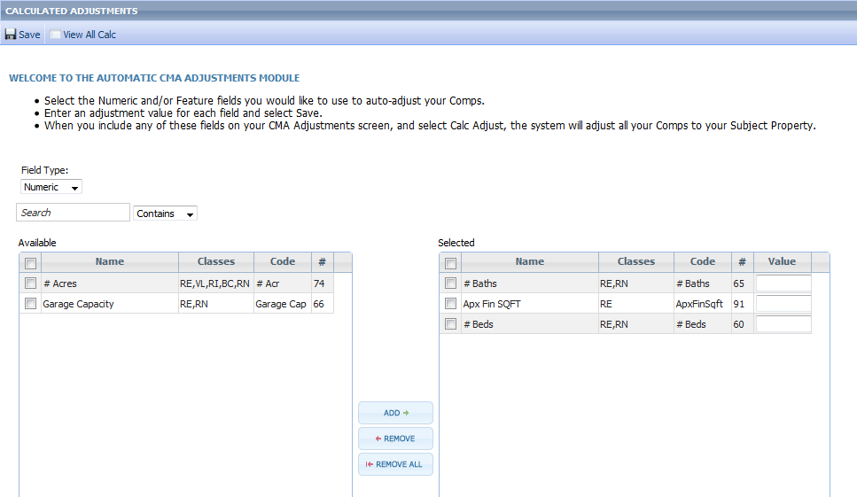

Figure 2 - Fields > Select Numeric Field> CMA Auto Adjustable Checkbox

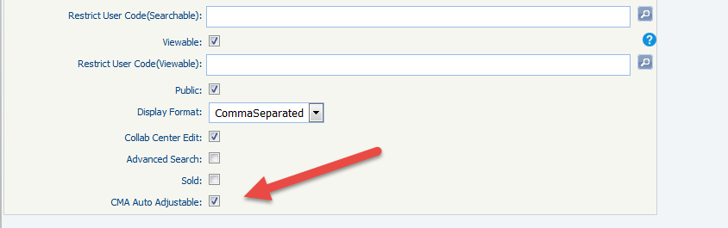

Figure 2, Preferences > CMA > Calculated Adjustments > Feature fields

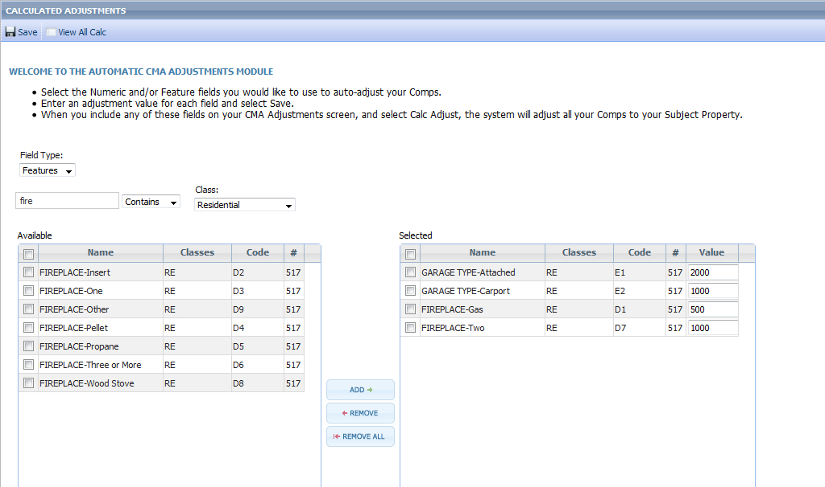

Figure 3, Calculated Adjustments applied to CMA Comps

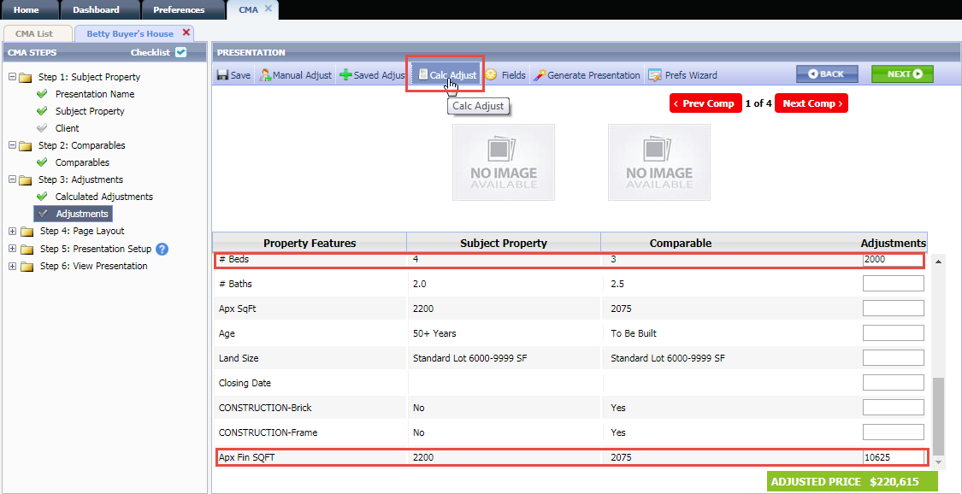

# Collaboration Center – Set Default Notification Types

This enhancement allows each user to set preferred notification types for Collaboration Center searches. This eliminates the need for the user to check the notification options each time a Collaboration Center search is created. The defaults can be set from Preferences > Collab Center > Notifications. Initial settings will inherit any system or MLS level defaults; any changes made by the user will take precedence on future Collaboration Center searches.

* **Action Item:** No action is required by you to implement this functionality.

Figure 1, Preferences > Collab Center > Notifications

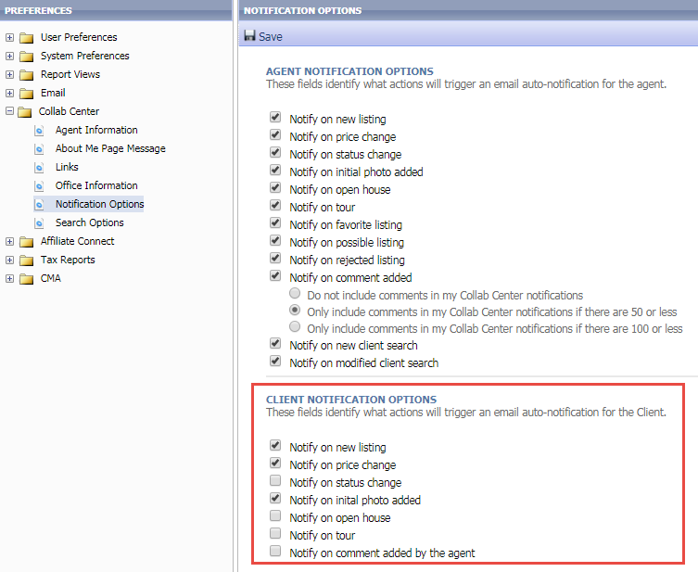

# Collaboration Center – Miscellaneous Contact Activity Widget Changes

In Paragon 5.68, a new, updated Contact Activity Widget was implemented on the Paragon Home Page to bring users’ Collaboration Center activity front and center. With the 5.69 release, some additional functionality was added, and some workflows were clarified.

* **Action Item:** No action is required by you to implement this functionality.

**New Activity:** To mimic the New Activity button on the old Contact Activity widget, a link for “# New” was added to the header. Click the # New to open Contacts > View/Manage Contacts > New Activity.

Figure 1, New Activity Link

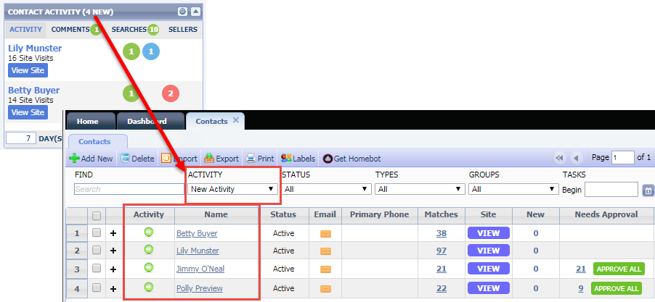

**Activity Tab:** To clarify the workflow, the link from # Site Visits was removed, and a **View Site** button was added. Clicking View Site opens that Contact’s Buyer Activity tab in Collaboration Center.

Figure 2, Activity Tab View Site Button

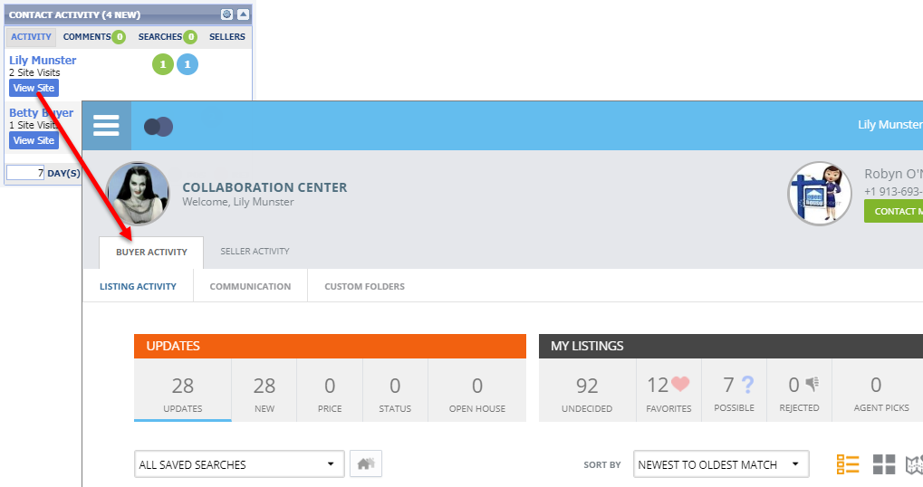

**Comments Tab:** The Contact name now opens Contacts > View/Manage Contacts > Contact Activity; this is consistent with the other tabs in the widget. A **Reply** button opens the Manage Comments modal, to allow the user to view the entire comment and reply to the Contact. The Comment will remain visible on the widget (within the selected number of days back) until the agent replies.

Figure 3, Comments Tab Reply Button

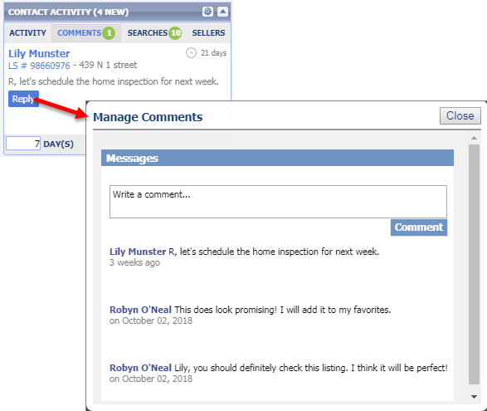

**Searches Tab:** The Contact name opens Contacts > View/Manage Contacts > Contact Activity; this is consistent with the other tabs in the widget. The Search name links to the Contact’s Collaboration Center and opens the Map view of that client-created search. The # Matches is a link to the Paragon spreadsheet view of the matches in that client-created search.

**Sellers Tab:** When a listing has been associated to a Contact, but the Collaboration Center Sell Side has not been enabled, clicking the listing address opens Contacts > View/Manage Contacts > Seller Activity, where the Sell Side and Seller Email Report can be enabled. When Sell Side has been enabled, the listing address opens the Seller Activity tab in the Contact’s Collaboration Center.

Figure 4, Sellers Tab, Sell Side Not Enabled

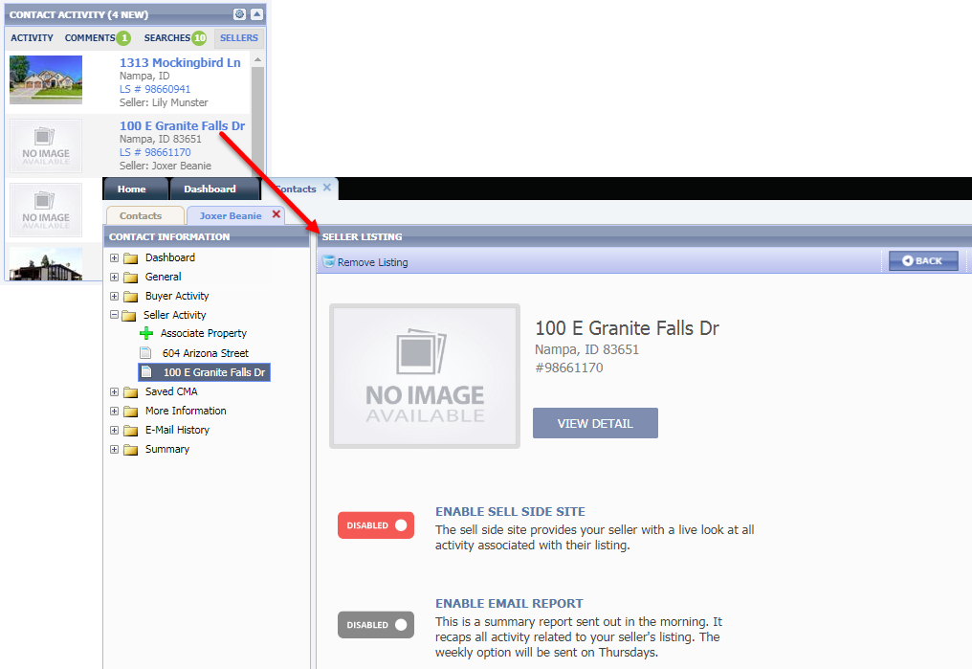

Figure 5, Sellers Tab, Sell Side Enabled

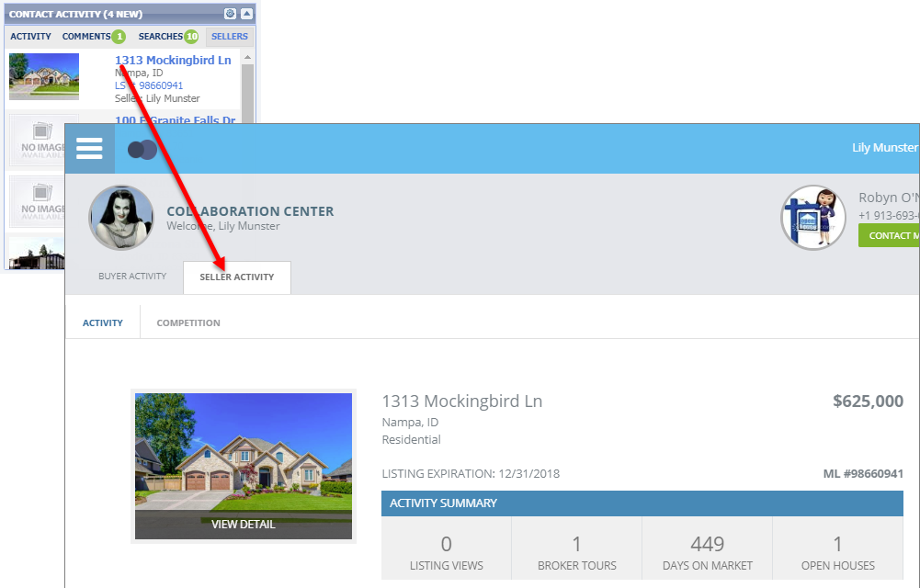

# MLS Customizations and Administration

**All options in this section are either configurable via MLS Administration controls or by your System Support Manager as noted.**

# LIM – New Green Information Fields

As part of the RESO Data Dictionary compliance mandate, three existing Green Information lookup fields were converted to freeform fields. The old lookup fields have been renamed and retained, for possible future use.

Figure 1, Green Info Table. New fields highlighted in Green, old fields highlighted in Red

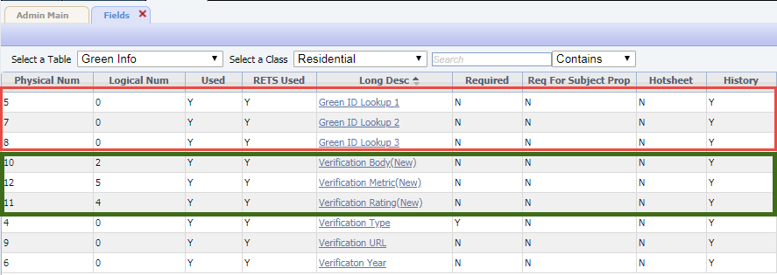

The new fields can be included in LIM, Report views, and RETS.

Figure 2, New Green Info fields in LIM

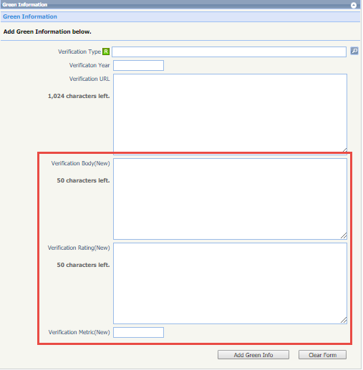

Figure 3, New Green Fields in Report View

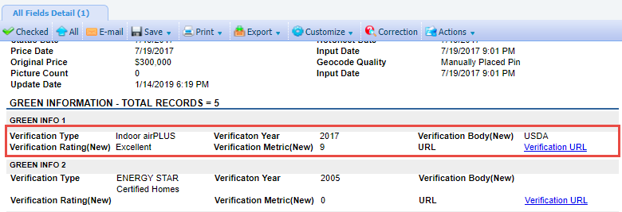

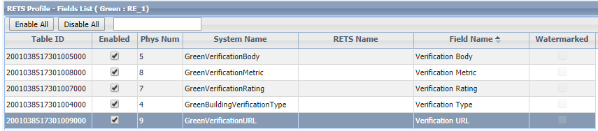Figure 3, Green Fields in RETS Profile

# LIM – Interactive Congratulations Modal in Listing Input & Maintenance

The Congratulations message that appears when saving a listing now has clickable third party integration links, to aid users in marketing and selling the listing.

The default headline, “Third Party Integrations to help market and sell your listing,” can be modified by your SSM at the MLS or Board level; the message supports up to 100 characters (about two rows of text). For example, you may want to include a reminder message, such as “Be sure you visit ShowingTime to configure your listings.”

The tool tip for each third party integration is also customizable, up to 100 characters.

To provide access to all the links, the Congratulations message remains on screen until the user clicks Finished.

* **Action Item:** Contact your SSM to customize the message and/or info tips.

***Note:*** *Your MLS may have different integrations than in the example below.*

Figure 1, Congratulations Message

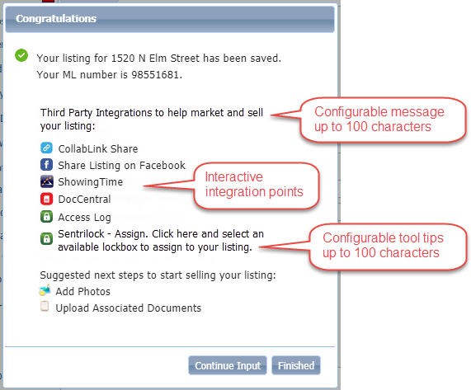

# LIM – Launch Third Party Integrations in a New Browser from Listing Input & Maintenance

Currently, third party integrations that appear in the left navigation pane of the Listing Edit form are forced to open in the right-side frame, or in a modal. These integration points have been enhanced to support the ability to launch a new browser/tab.

* **Action Item:** To change the LIM integrations to open in a new browser or tab, instead of the right-side frame, contact your SSM to have the integration(s) configured.

Figure 1, LIM Left Navigation Pane with Third Party Integrations

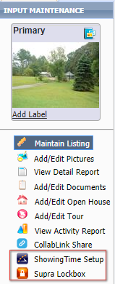

# LIM – Additional Fields added to Listing Input & Maintenance Summary Display

To aid users in identifying listings in the Listing Maintenance grid, City and State/Province have been added to the display.

Additional fields can be added to the display by the MLS or Board, for a total of 15 fields. The Listing Number and Select an Action fields cannot be removed from the summary display.

* **Action Item:** MLS/Board Administrative users can add up to a total of 15 fields from Admin > Listings > LIM Info Display. The City and State/Province fields have been added to the grid for you.

Figure 1, LIM Summary Display Setup

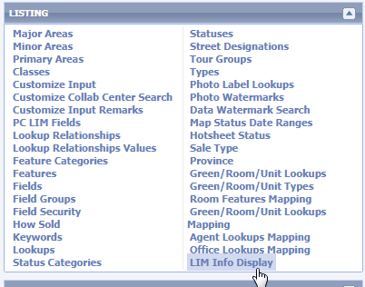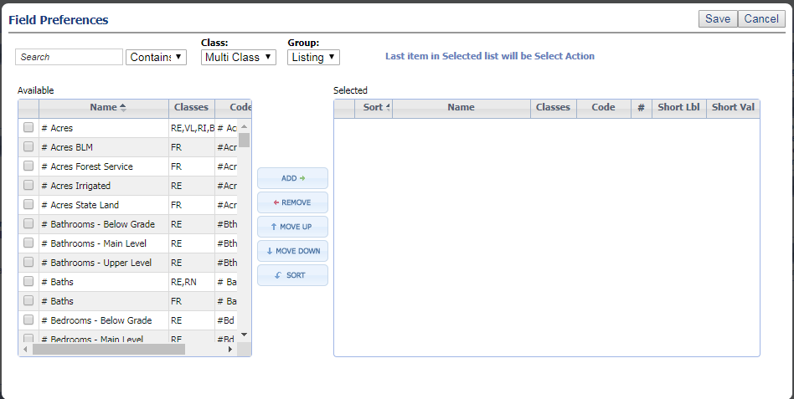

Figure 2, LIM Summary Grid with City and State/Province

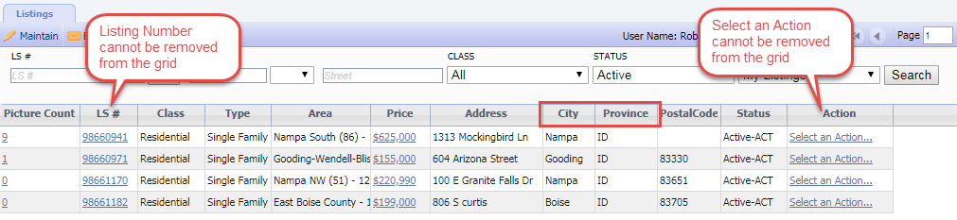

# Search Results – Display Long Description for Custom City Lookup Fields

An issue with the new Listing City State Zip field was identified and corrected in this release. For customers using a non-standard City lookup field, the Listing City State Zip field was displaying the short abbreviation for the City; this has been corrected to always display the long description for the City.

*Note: This affects a very limited number of Paragon customers.*

* **Action Item:** No action is required by you to implement this functionality.

Figure 1, Listing City State Zip field with long description

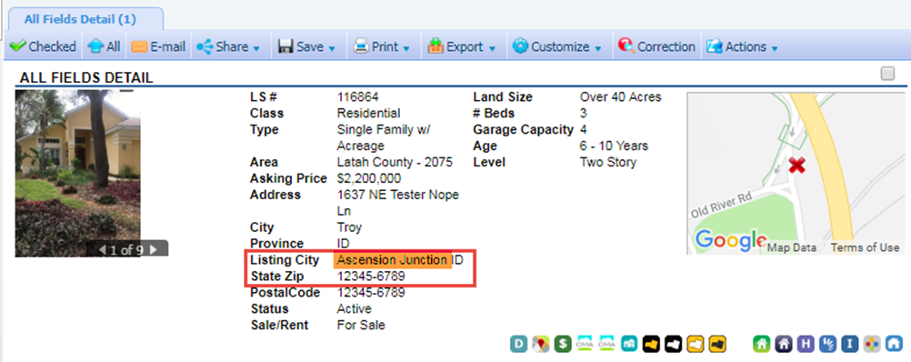

# RETS – Add Maximum Logins Per Day

Excessive activity has been noted by some RETS vendors logging into Paragon RETS servers over 2,000,000 times per day, causing performance issues on the servers. In order to limit that activity, a new configuration setting has been added that limits the number of RETS logins per day, per user. The default value for this setting is 20000 and CANNOT be changed. The goal will be to narrow it down to 5000 in the near future.

RETS users exceeding the maximum logins per calendar day will receive an error message, “Maximum number of logins per 24 hour period exceeded!”

* **Action Item:** No action is required by you to implement this functionality.

# RETS – Compact Listing Field Names in RETS Metadata

Currently, Paragon field names longer than 25 characters are truncated in the RETS metadata. This can lead to confusion where several fields have similar names. In Paragon 5.69, the RETS metadata process has been modified to compact field names longer than 25 characters. For example, the field Estimated Selling Office 1 was getting truncated to Estimated Selling Office. With this enhancement, the field name will be compacted in the metadata as EstimatedSellingOffice1.

# Listing Audit Reports – Remove Photo Change Records from Listing Audit Report

To keep the Listing Audit Report manageable, Picture Count records have been removed from the report. The Listing Picture Audit Report has not been modified, and can still be used to track changes in listing photos.

* **Action Item:** No action is required by you to implement this functionality.

Figure 1, Listing Audit Report with multiple Picture Count records

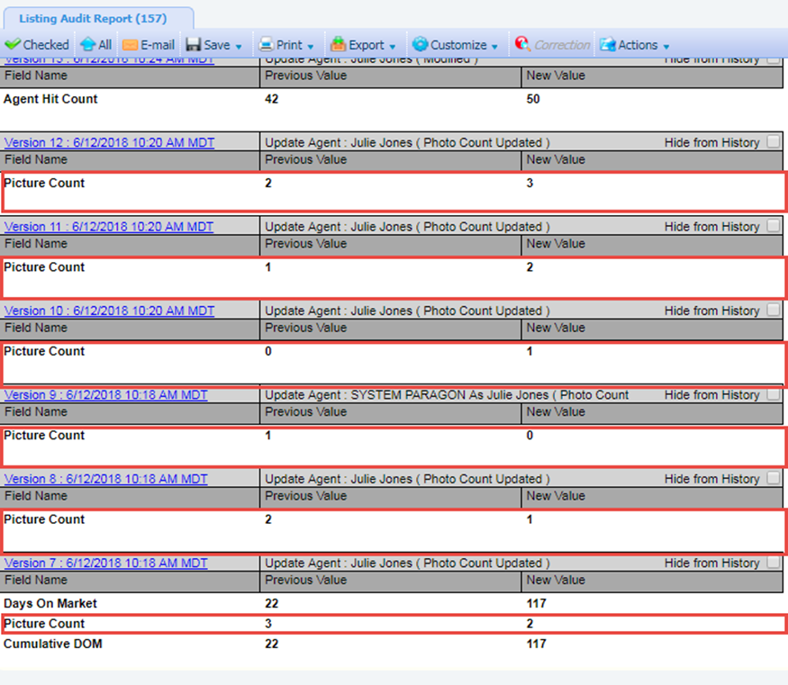

Figure 2, New Listing Audit Report

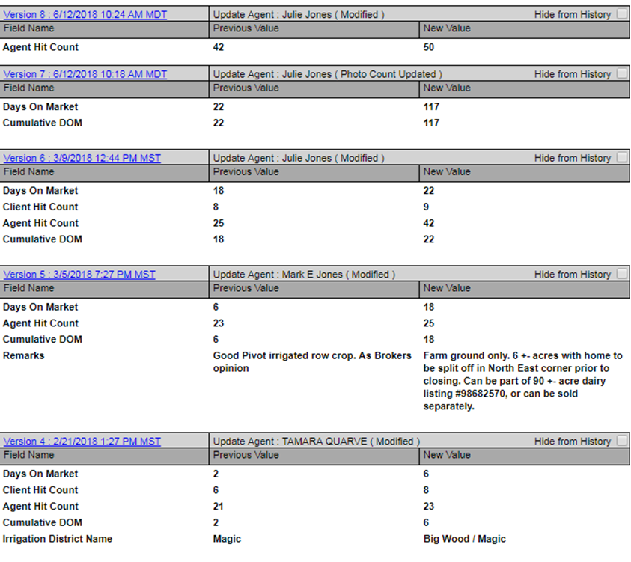

# Admin – Simplified Phone Number Validation Process

Prior to this release, Paragon would verify that the phone number’s area code as entered matched a table of confirmed area codes. Because new codes are added regularly, that table required ongoing maintenance via Paragon releases. To simplify this process, phone number fields in Paragon will now verify the format only, rather than for specific values.

* **Action Item:** No action is required by you to implement this functionality.

Figure 1, Admin Phone Fields with invalid format

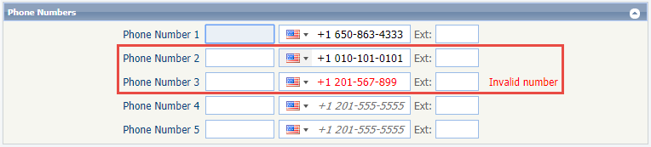

# Admin – Changes to Agent/Office Tables for Native RESO Data Dictionary Compliance

In the Paragon 5.68 release, additional fields were added to the Agent and Office tables to support native RESO data dictionary compliance. In the 5.69 release, RETS support was added for these new fields. The new fields must be activated and a RETS metadata refresh completed before the fields can be used in RETS profiles. The fields will be available in the following resources:

1. All Agents
2. Active Agents
3. Offices
4. Active Offices
5. Deleted Agents
6. Deleted Offices

* **Action Item:** Please contact your SSM to enable these fields and schedule a RETS metadata refresh.

# Admin – Restrict Board Access for Level 7 Users in MLS Messaging Module

For Paragon systems using multiple Boards, the MLS Messaging module now uses existing Board and Association Autonomy rules for level 7 Admin users with access to this module.

Level 7 Admin users will only be able to create or modify messages for their assigned Office or User Boards. The Board Name field will be required in MLS Messaging, and the Board Name lookup will only display that user’s Office or User Boards.

Level 8 Admin users with unrestricted Board access can continue to create and modify MLS messages for any board.

*Note: This only applies to Paragon systems using multiple Boards or Association Autonomy.*

* **Action Item:** No action is required by you to implement this functionality.

Figure 1, Office Boards, User Boards

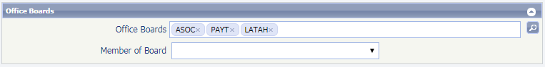

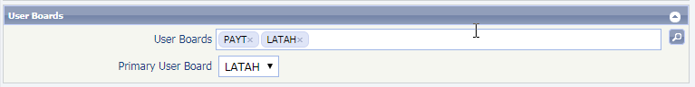

Figure 2, MLS Messaging with restricted Board lookup

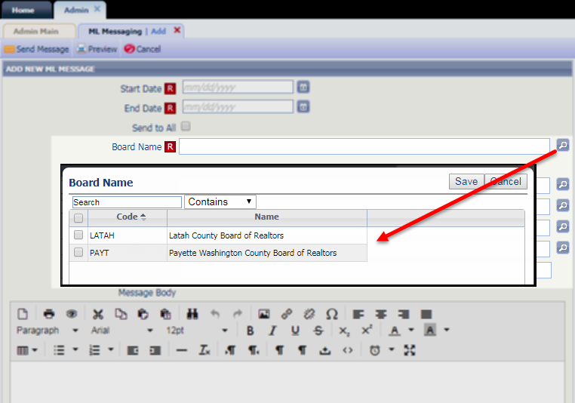

# Admin – Collaboration Center Default Client Notification Triggers

This enhancement adds missing functionality to the Collaboration Center setup at the MLS level, providing the option to set MLS-level defaults for Collaboration Center client notifications.

* **Action Item:** No action is required by you to implement this functionality.

Figure 1, Default Client Notification options in Admin > MLS Information



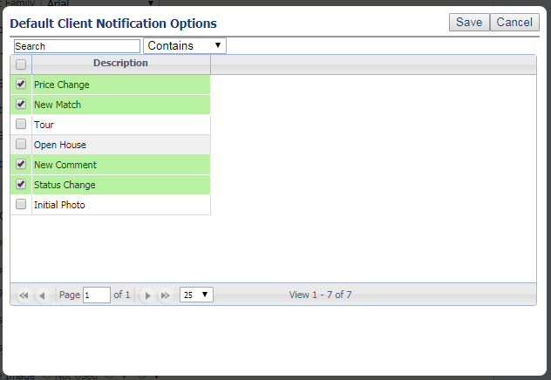

# Admin – Collaboration Center Admin Module

This new Admin module collects all of the Collaboration Center configuration settings from throughout Admin, and presents them in one convenient location. With all of the CC settings in one location, Admin users can easily see what functionality and settings have been enabled for CC.

The Collab Center module is organized by section: Buy Side Options, Property Search, Detail Report, Sell Side Options, Board Settings for MLS systems with multiple Boards enabled, and Reference.

* **Action Item:** No action is required by you to implement this functionality.

Figure 1, Collab Center Admin Module

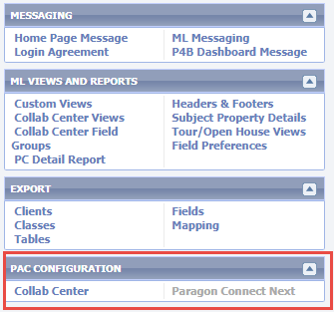

Figure 2, Collab Center Admin Module > Buy Side Options

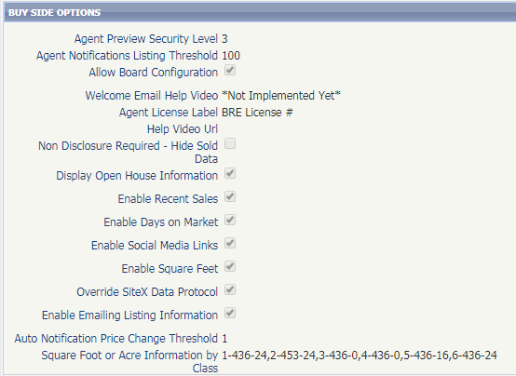

Figure 3, Collab Center Admin Module > Property Search

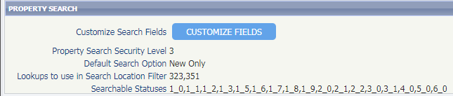

Figure 4, Collab Center Admin Module > Detail Report

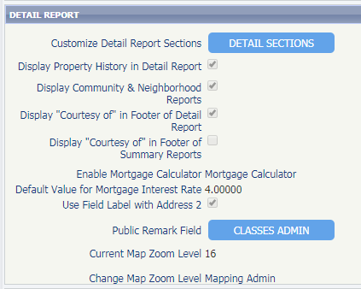

Figure 5, Collab Center Admin Module > Sell Side Options

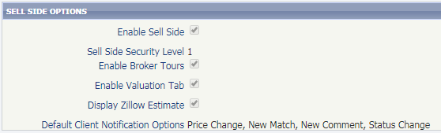

Figure 6, Collab Center Admin Module > Board Settings

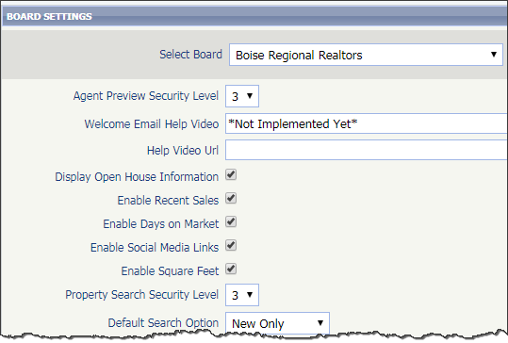

Figure 7, Collab Center Admin Module > Reference

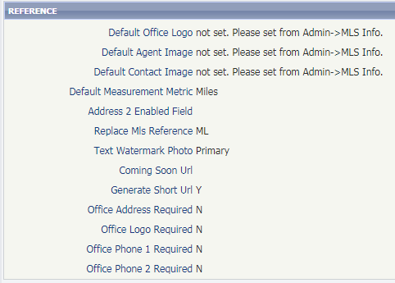

# Collaboration Center – Start an Offer

Start an Offer provides a way for Contacts to send their real estate agent information to start an offer on a property. The Contact fills out a form on Collaboration Center, requesting the offer price, proposed closing date, and any special terms associated with the offer. The property can also be marked as “Make My New Home.”

When the form is submitted, an email is sent to the agent with the details of the property and the offer; the agent can contact that client and proceed with an offer, based on the information provided in the Start an Offer form.

An offer can be made from the Additional Options button or the View Detail button in Collaboration Center.

* **Action Item:** This option is disabled by default. Please contact your SSM if you wish to enable this feature.

Figure 1, Start an Offer from the Detail View

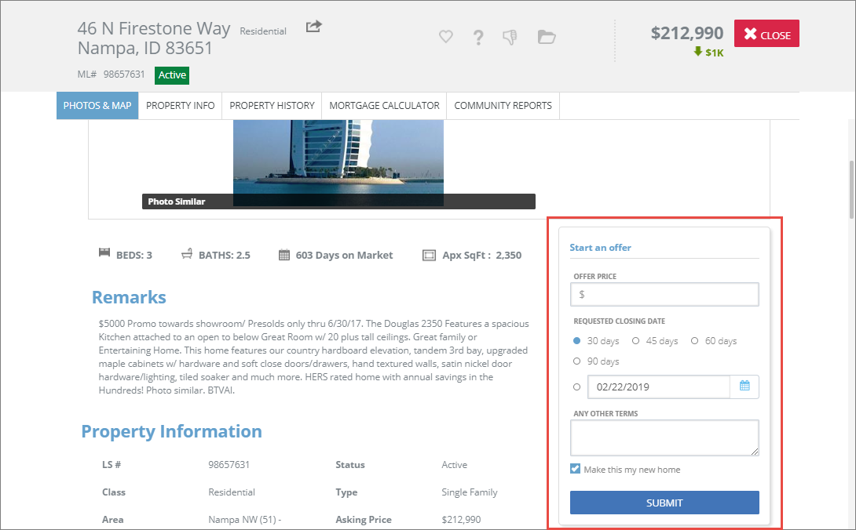

Figure 2, Start an Offer from the Additional Options Button

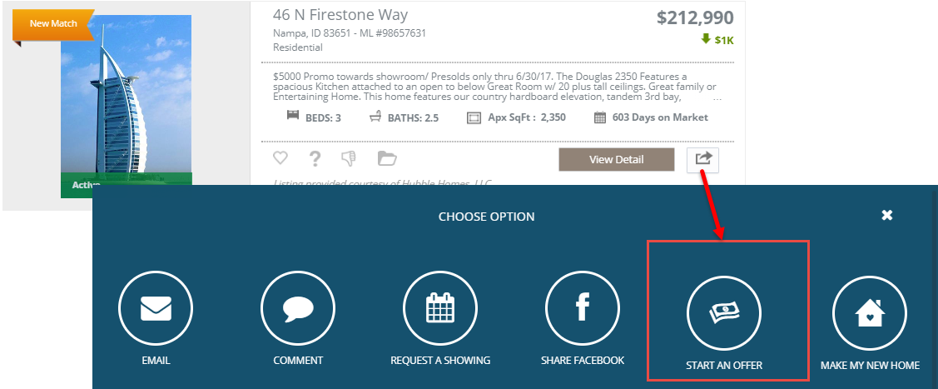

Figure 3, Start an Offer Form

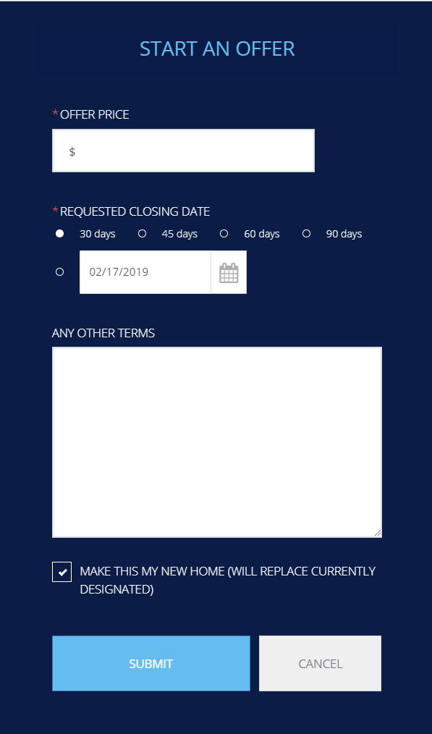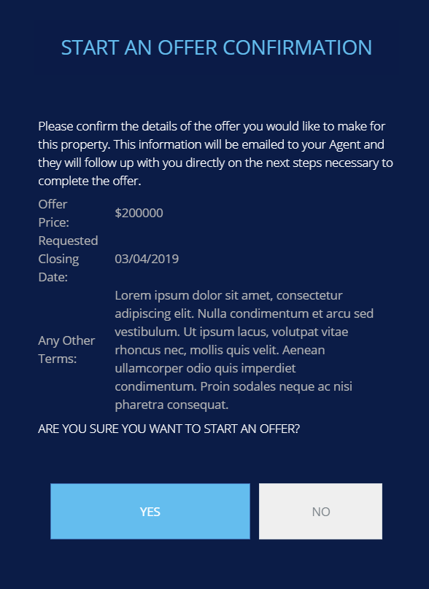

# Collaboration Center – Make My New Home

Contacts now have the ability to tag one or more properties as their new home on Collaboration Center. After an offer has been accepted, the client can mark the property or properties as the one they intend to purchase. When a listing is tagged, a new tab, “My New Home,” is added to Collaboration Center as the first tab. All properties marked as “my new home” will appear on this tab.

“Make My New Home” is available from the Additional Options button.

* **Action Item:** No action is required by you to implement this functionality. Please contact your SSM if you wish to disable this feature.

Figure 1, Additional Options button to Make My New Home

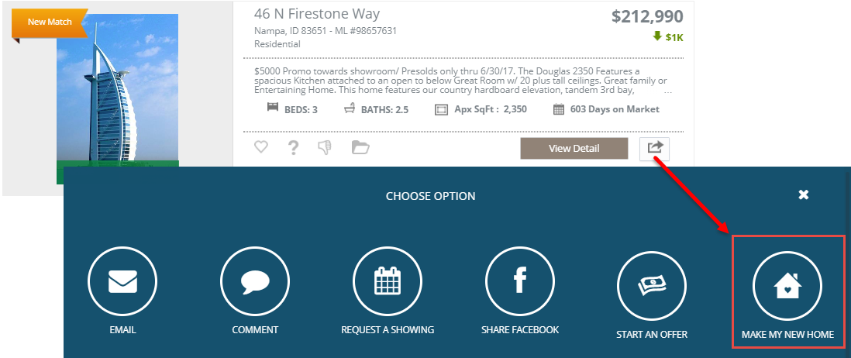

Figure 2, Make My New Home form

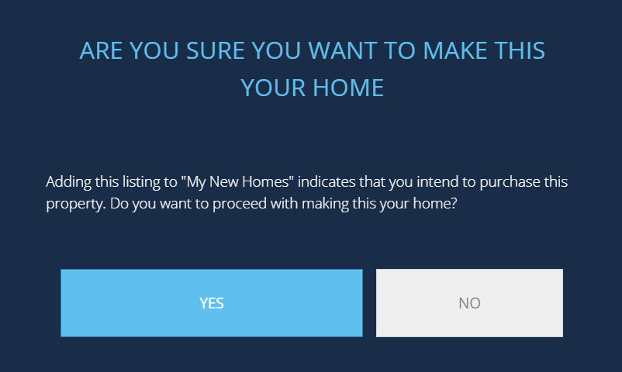

Figure 3, My New Home tab

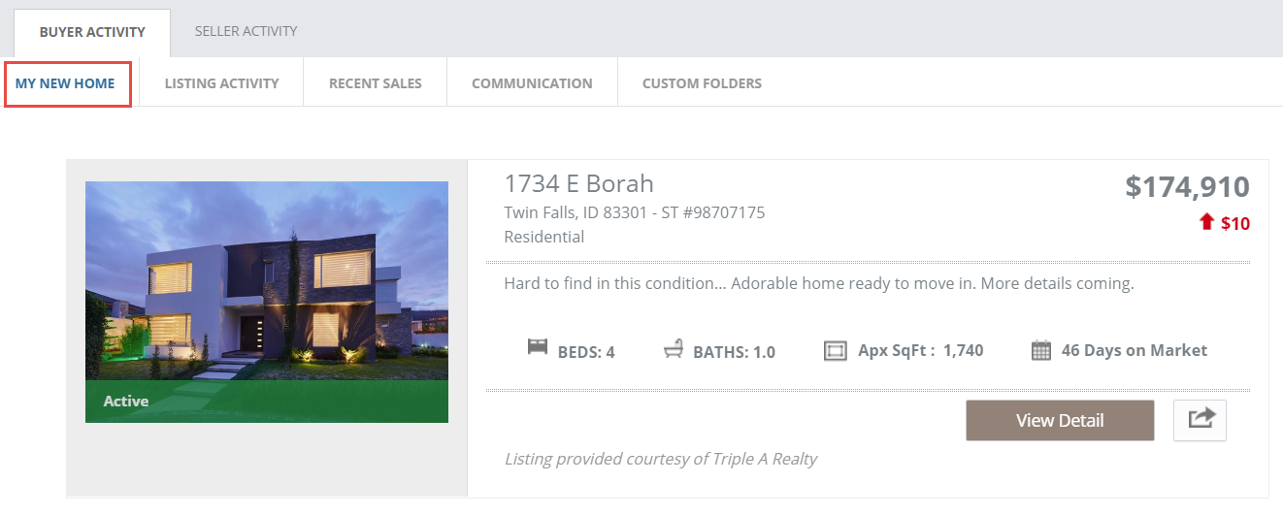

# General – Collaboration Center Promotional Text and Link

To help promote the interactive Collaboration Center and its benefit to clients, a line of promotional text and [a link to an overview page](https://paragonrels.wixsite.com/paragon-info/about-collaboration-center) has been added to the bottom of the legacy email notifications.

* **Action Item:** No action is required by you to implement this functionality.

Figure 1, Collaboration Center Promotional Text



Figure 2, Sample of Collaboration Center for Buyers Wix page

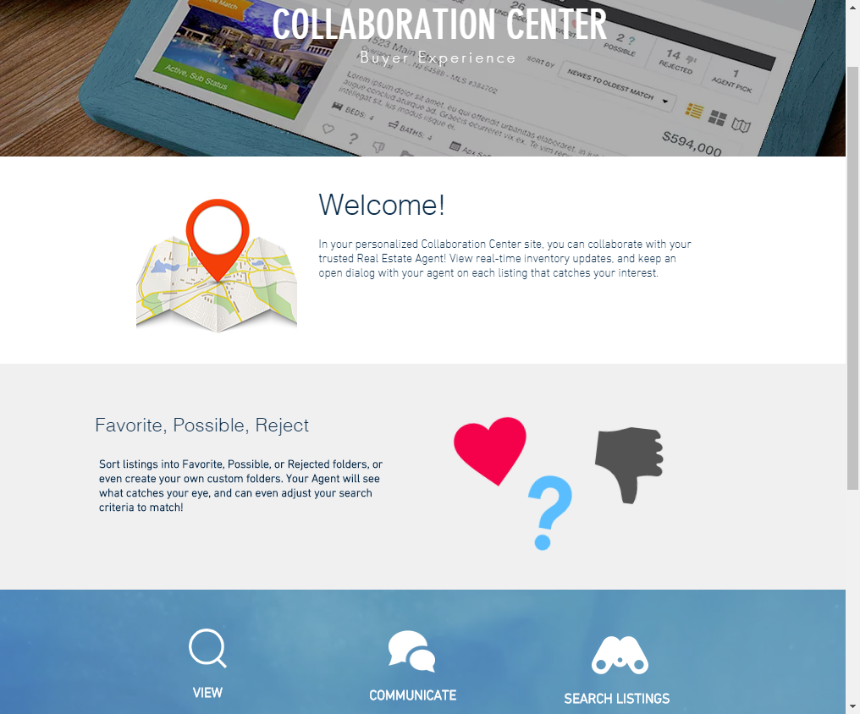

# General – Replace Google URL Shortening Service

Paragon uses a short URL that allows users to access Paragon resources in advanced listing sharing and mobile password reset messages. Previously, these short URLs were generated using a service provided by Google, which is ending as of March, 2019. To continue to provide short URLs for listing sharing and mobile messages, a new service has replaced the Google service. All changes will be processed in the background, and will not affect the functionality of emails or texts using these URLs.

* **Action Item:** No action is required by you to implement this functionality.

Figure 1, Short URL in Listing Share, Mobile Message

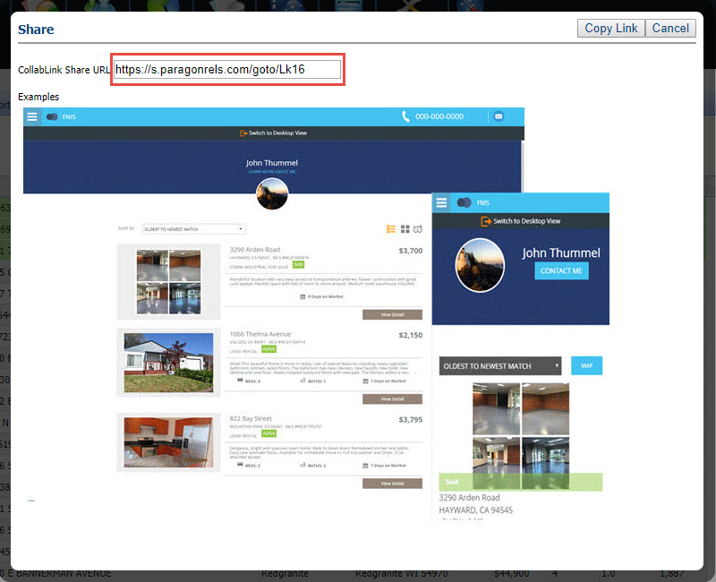

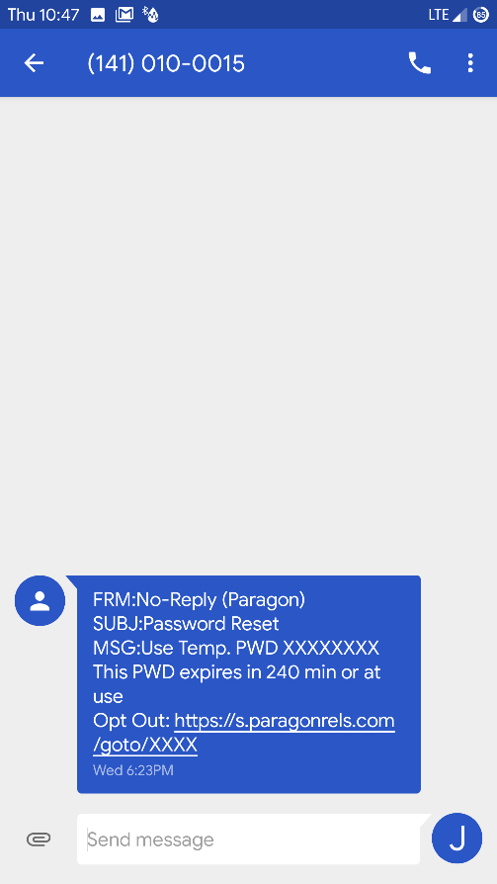

# General – Updated Text on Email Opt-In Screens

The text on the opt-in screens has been simplified to help clarify the workflow when a user is opting back into Paragon emails. No change has been made to the actual workflow.

Figure 1, Email Opt-in, Step 1

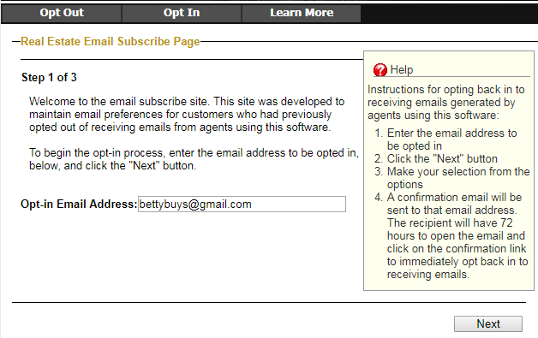

Figure 2, Email Opt-in, Step 2, Unsubscribed from Single Agent

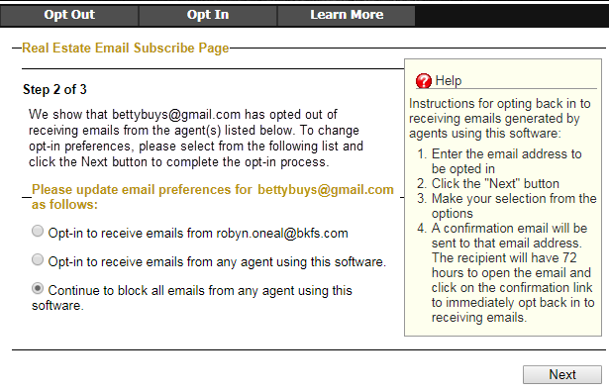

Figure 3, Email Opt-In, Step 2, Unsubscribed from All Agents

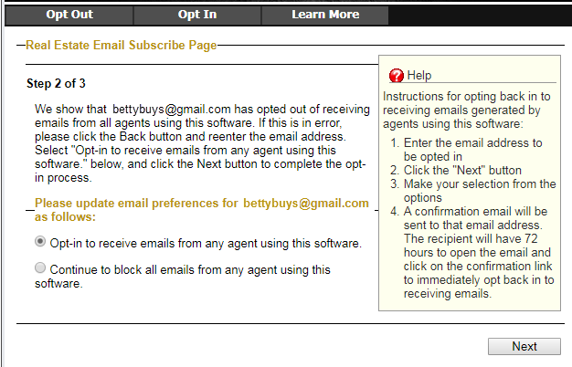

Figure 4, Email Opt-In, Step 3

