# Agent Level Enhancements

**The following section contains changes that are active system wide** **and available to users based on their assigned security levels.**

Search – Power Search Voice Recognition

Introducing an exciting new “Live Prototype” feature – Voice Recognition for Power Search

Search – Power Search Tab

Updated label for the Power Search tab.

Search – Map Tab and Results Tab

An updated Property Search user interface brings easy access to the Map Search.

Quick Search – Load Last Search

Ability to recall and run a previous Quick Search.

Quick Search – Save Quick Search

Option to Save and recall a Quick Search.

CMA – Warning Message if Cover Letter Exceeds Allotted Space

When combined images and text in CMA Cover Letter exceeds the space allotted in the finalized document, a warning message will display.

CMA – Tool Tip for Suggested List Price

A tool tip on the CMA Presentation > Comparable Price Analysis page points out where to find the Suggested List Price.

Email Notifications – Extra line breaks removed in Rich Text Editor

The rich text editor for Email Notifications has been corrected to stop adding additional line breaks when editing.

General – Updated User Interface on Tabs

Enjoy an updated look to Paragon tabs and sub-tabs!

# MLS Customizations and Administration

All options in this section are configurable via MLS Administration controls or by your System Support Manager as noted.

Collaboration Center – Implement RatePlug

Collaboration Center now supports the RatePlug integration.

CMA – Restrict Copy Listing to Subject Property

A new configuration setting can prevent copying listing data to a CMA Subject Property except by the primary listing agent.

LIM – Restrict Agent Lookup Fields by Association Autonomy Rules

A new Admin module allows the Listing Agent and Selling Agent fields in Listing Input & Maintenance to be restricted using Association Autonomy rules.

LIM – Required Field icon on Unit Field

Changes to the Unit field in LIM to use the Required flag in Admin > Fields.

LIM – Room Description Field Character Limit

Enforce custom character limit in the Room Table’s Room Description field.

CDOM – Additional Fields added to CDOM/Property History Matching

Improved Address matching for CDOM when using geocode and Unit/Suite fields.

Admin – Remove RUG Listing Table Parent Fields from Field Rules

RUG Table parent fields can’t be used in Field Rules, and have been removed from the Field Rules admin.

Views/Reports – Listing Number display on Broker Sales Detail Report

Views/Reports – Listing Number display on Broker Sales Detail ReportViews/Reports – Listing Number display on Broker Sales Detail ReportThe Broker Sales Detail Report has been updated to use the Display ID on listings.

RETS/RESO – Updated text in RETS Update Error Message

Updated error message to refer to Postal Code instead of ZIP Code for listings with an incorrect postal code added via RETS Update.

Collaboration Center – Updates to the Start an Offer form

Miscellaneous improvements to the UI and workflow for the Start an Offer form.

Collaboration Center – Updates to Start an Offer Confirmation Form

Miscellaneous improvements to clarify the intent of the Start an Offer confirmation form.

Collaboration Center – Updates to the Start an Offer Agent Email

Miscellaneous improvements to highlight and clarify the Start an Offer email received by the agent.

# Corrected Issues

|  |  |  |  |  |
| --- | --- | --- | --- | --- |
| **Work Order** | **Seq** | **Module** | **Reporting Customer(s)** | **Issue Corrected** |
| 87953 | 1 | Email | Cape May, MiRealSource, NEREN, NORMLS | Not able to scroll down in email window. |
| 111252 | 1 | Admin - Maintain | MAXEBRD, Birmingham, IRMLS, North Central WV | When going to the Admin> CAN-SPAM only will display 25. |
| 115456 | 1 | Admin - Messaging | Longview BOR, Central Mississippi, Highland Lakes, NEREN, NRV, Mountain Home AR, Range MLS, RANM, Wichita | Blank preview modal when trying to print MLS message. |
| 118721 | 1 | Email | Duluth Area AOR, Lewis-Clark BOR, Mempis, NEREN, NRV, RANW, REB3, Tahoe Sierra, Triangle | Display the Address with the MLS# when e-mailing as a Hyperlink causes multi-up report to show incorrectly in email. |
| 124322 | 1 | Mapping | Upper Peninsula AOR, Huntsville, NEREN, NORMLS, Nova Scotia, RANW, Selkirk | When trying to validate map on listing the map is blank. |
| 126986 | 1 | CMA | REB3 | When adding comparables to CMA if MLS# is added, incorrectly causes error. |
| 132852 | 1 | Admin - Listings | San Diego MLS | Agents unable to edit their photos. |
| 134501 | 1 | Email | Gainesville-Alachua County Association of REALTORS | Associated Document Icon displays as Broken Link when no document is associated. |
| 135006 | 16 | General UI | Western Kentucky, CARMLS, GAMLS, Birmingham, IRMLS, MAXEBRD, NCWV, NNRMLS, REB3, SCWMLS, Spokane | Rich Text Editor (RTE) - Editing an E-mail Notification Multiple Times Adds Extra Line Breaks. |
| 135696 | 1 | CMA | Tallahassee BOR, REB3, NEREN, Willamette | When closing CMA Wizard subtab system also closes CMA List subtab |
| 136352 | 1 | Search - Saved Searches | MAXEBRD, Grand Junction, REB3 | When Adding a Note to Listing Cart, the HTML from the User's Default E-mail Signature is Auto-filled. |
| 137231 | 2 | Input Maintenance | Northwest Iowa BOR, Bayou BOR | Correct Unit to show proper LIM (R) requirement when using Address Display Order Configuration. |
| 138230 | 1 | Input Maintenance | New River Valley AOR | Unable to set character limit for Room Description field. |
| 139674 | 1 | Third Party Integration | Eastern New York Regional MLS, Albany/Capital Region | CRS Tax Autofill to Street Name is not working as expected. |
| 139686 | 1 | CMA | Greater Greenville AOR, Columbia SC, Heart of Kentucky AOR, IRMLS, Northeast Iowa BOR, Paul Bunyan, REB3, SCWMLS | Edge version 38.14393.00 is not saving adjustments in CMA. |
| 141041 | 1 | Third Party Integration | Greater Alabama MLS/Birmingham | Do Not Show Inactive Listing Visibility Types Display in Facebook CollabLink Share Warning Modal |
| 141131 | 1 | Field Mapping | Monroe County AOR | Date fields mapped with specific script off 1hr from UTC. |
| 141158 | 2 | CMA | REB3, NEREN | CMA Adjustments - Quotes in Description cause syntax error. |
| 141446 | 1 | CMA | REB3 | MLS reporting formatting errors in CMA |
| 141934 | 1 | Input Maintenance | MAXEBRD | Edit photo option is no longer available. |
| 144277 | 2 | Collab Center | San Diego MLS | Start an Offer - Unable to add a price in Firefox. |
| 142704 | 1 | Statistical Reporting | NEREN | Page Can't Be Displayed When Some Users Try to Run Team Volume Report. |
| 144277 | 3 | Collab Center | San Diego MLS | Make an Offer email fails when sending. |
| 29735 | 1 | CMA | SCWMLS, Rockford AOR | CMA lets you copy any listing in the MLS and convert it to a listing. |
| 117064 | 1 | Tour/Open House | Iowa City Area AOR, Bayou BOR | Tour/Open house module - User Code must have tax module enabled to load T/OH input screen. |
| 121004 | 1 | Statistical Reporting | REB3 | Broker Sales Detail report shows SystemID rather than DisplayID for MLS# |
| 121499 | 3 | Configuration | Northern Kentucky MLS | Allow CDOM_GEOCODE_SECONDARY_PROP_HIST Configuration to utilize the new Address fields. |
| 132507 | 1 | Tour/Open House | Gallatin AOR, Charlottesville AOR | Tour Comments do not display on report, although they are on the listing |
| 138007 | 1 | Email | NEREN | NEREN would like to change the auto populating subject line. |
| 141149 | 1 | General UI | REB3 | Action Icon drop-down shows SystemID rather than DisplayID for MLS# |
| 144107 | 1 | CC2 | NEREN | Affiliate Connect - Branding Block - Affiliate Photo is misaligned when the Phone Number record is displayed |
| 89207 | 1 | Input Maintenance | NW Illinois | Set Focus on Hotsheet Comment Box after updating a Listing. |
| 137061 | 1 | RETS Update | REB3 | Error message when adding a new Listing via RETS Update needs to be edited. |
| 143698 | 2 | RETS MetaData | REB3 | Customer needs to expose a field in RETS. |
| 87953 | 1 | Email | Cape May County AOR, MiRealSource, NEREN, NORMLS | Not able to scroll down in email window. |

# Agent Level Changes

**The following section contains changes that are active system wide** **and available to users based on their assigned security levels.**

Search – Power Search Voice Recognition

**BK MLS is proud to introduce Voice Recognition in Power Search with the Paragon 5.70 release.** This new functionality gives users the option to use voice input for Power Search. This new feature is a live Prototype showcasing future possibilities in using Voice Technology in the Paragon Suite of Products. As a result, initially, this functionality will be limited to the Google Chrome browser in Windows, MacOS, and Android.

To explore this exciting feature and begin using Voice Recognition, simply click the microphone icon in the Power Search field. The first time you use Voice Recognition, Google Chrome will ask for permission to use your microphone.

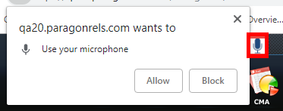

If you Allow permission, a modal displays, indicating Power Search is recording. The recording ends when the user stops speaking for a moment.

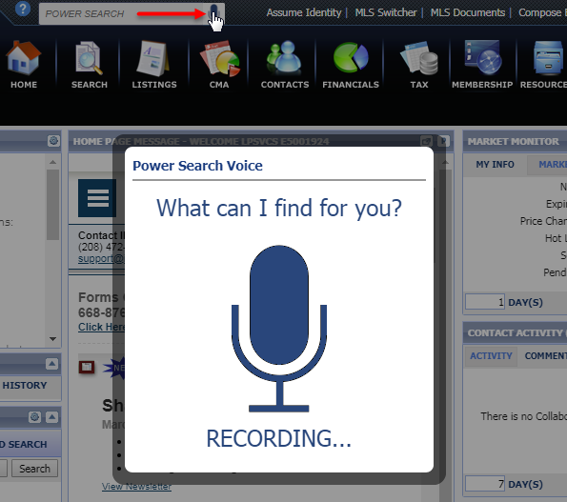

Power Search processes the spoken input and returns the search results.

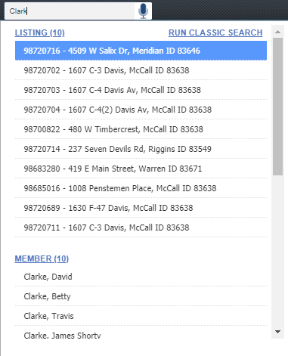

If recording permissions have been denied, or no microphone is present, a warning message is returned.

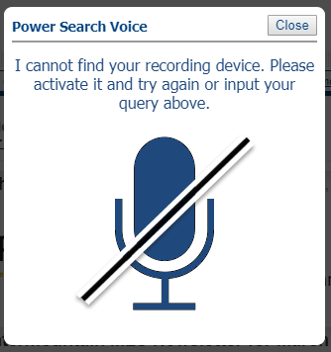

Recording permissions can also be enabled or disabled in Chrome browser settings at any time.

**Note:** The Voice Recognition function is natively supported in the Chrome browser with the following operating systems: Windows, MacOS and Android. This functionality may be used on other devices (iPhone, iPad) via the recording function of the keyboard. Older iOS devices may not support voice recognition via the keyboard.

**Action Item:** To use Voice Recognition Power Search, you will need to give Chrome permission to access your microphone. No other action is required to implement this functionality.

# Search – Power Search Tab

The label on the Power Search results tab has been updated from ‘Search’ to ‘Power Search.’ This makes it consistent with other tabs in Paragon, and helps the user to easily identify the tab when multiple tabs are open.

**Action Item:** No action is required by you to implement this functionality.

Figure A, Power Search Tab

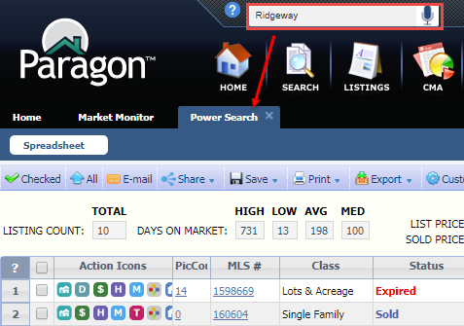

# Search – Map Tab and Results Tab

**One of our main strategic objectives for Paragon going forward is to improve Primary workflows in Paragon.** This updated user interface in Property Search, Property History Search, and Mapping Search brings the Map out of a modal and into the main search window, allowing users to easily switch between the Search criteria and the Map when creating a search. The Run Search tab allows you to access search results from either the Criteria tab or the Map tab.

Users can set their default Map View in Preferences > System > Search Options, with Enable Map Boundary by Default, and Zoom Out to Display All Listing Results. The universal system default is **Zoom Out to Display All Listing Results**.

With **Zoom Out to Display All Listing Results** enabled, the map zooms out as needed to show the entire results set within the overall MLS Map limit (usually 5000 or less). The count doesn’t change, and no Map Shapes are automatically added to your criteria. You can enable Map Boundary manually or draw a map shape to further refine your search. **See** Figure B, Map Tab view, with Zoom Out to Display All Listings enabled

With **Enable Map Boundary by Default** enabled, your center-on-address preferences and default zoom level are retained, and the map boundary is locked on that area. Listings within that area are returned, the results count is updated, and Map Boundary is automatically added to the Map field criteria as a shape. **See** Figure C, Map Tab View, with Enable Map Boundary by Default enabled

Figure A, New Criteria/Map/Run Search Tabs

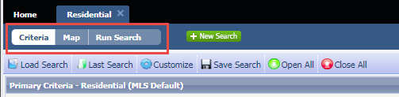

Select the Map Search tab or the Map Control field to switch to the Map view. All the familiar Map tools are available for you to help refine your search criteria.

Figure B, Map Tab view, with Zoom Out to Display All Listings enabled

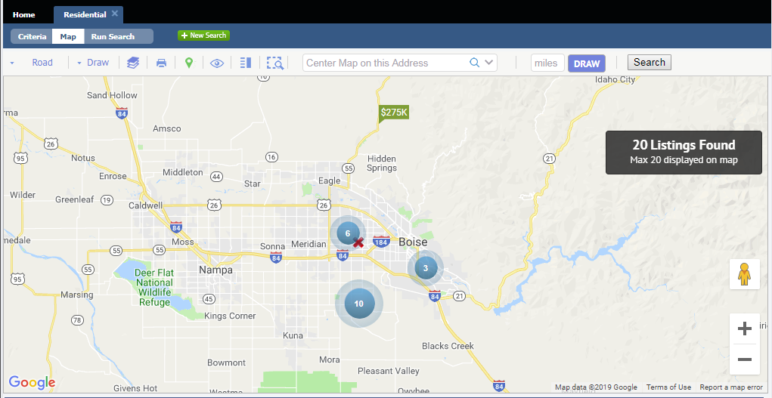

Figure C, Map Tab View, with Enable Map Boundary by Default enabled

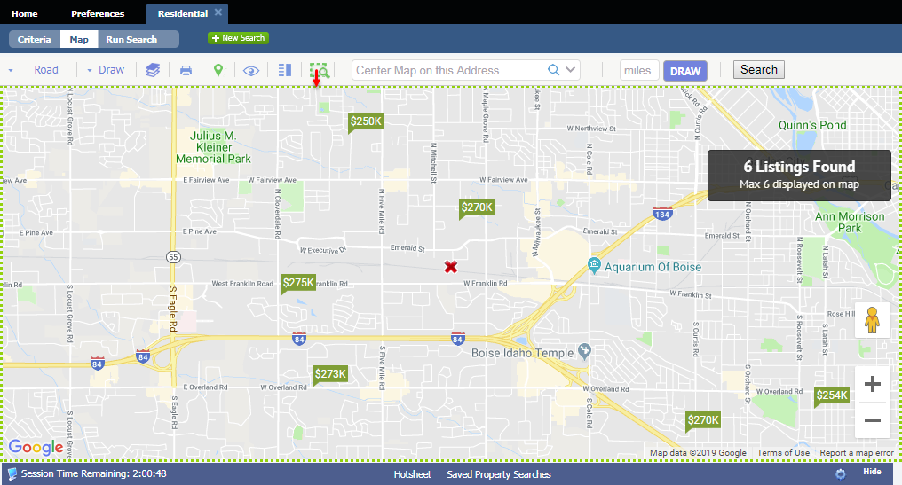

Select the Run Search tab to view the search results in your default search results view. Users can easily switch between all three tabs.

Figure D, Run Search Results tab view

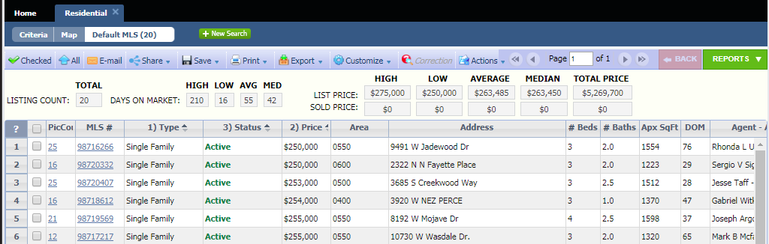

# Quick Search – Load Last Search

This enhancement provides a way to recall and rerun previous Quick Searches. Similar to the Load Last Search function in Property Search, your previous Quick Searches will display in the dropdown. Select a search, and the criteria will load into the Quick Search widget. The number of previous searches that displays is determined by the same configuration setting used in Property Search > Load Last Search.

**Action Item:** No action is required by you to implement this functionality.

Figure A, Last Quick Search

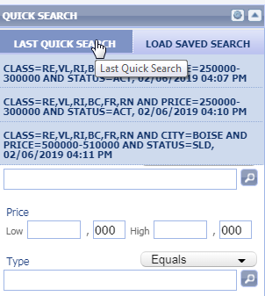

# Quick Search – Save Quick Search

This enhancement allows the user to save a Quick Search that can be recalled and run at a later date. From the Quick Search Results screen, the Save Search and Save Search As options are now enabled. Searches are saved as a Multi-Class search, and can be recalled from the new Load Saved Search button on the Quick Search widget. Additionally, the saved Quick Searches can be opened into the Multi-Class Property Search form by using the Load Saved Search option, or from Saved Property Searches.

**Action Item:** No action is required by you to implement this functionality.

Figure A, Save Quick Search

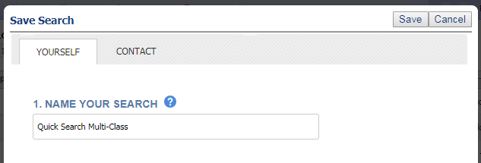

Figure B, Load Saved Quick Search

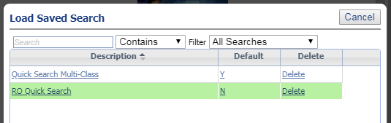

# CMA – Warning Message if Cover Letter Exceeds Allotted Space

When creating the Cover Letter pages in CMA Setup, there was previously no indication if the text and images entered in the rich text editor would fit the final, formatted document thus causing data to be cut off. This enhancement will automatically calculate whether the data will fit, based on images, text, and text formatting. If the data will exceed the boundaries of the finalized document page, a warning message will display when the user saves the document.

Because of many possible variables – font size, font style, images, etc. – a character count can’t be provided within the text editor for these pages.

This enhancement is available from Preferences > CMA > Presentation Setup, Preferences > CMA Preferences Wizard, and from the CMA module > Presentation Setup.

**Action Item:** No action is required by you to implement this functionality.

Figure A, Modify Cover Letter

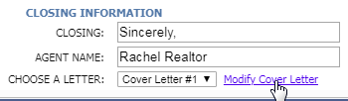

Figure B, Cover Letter Error

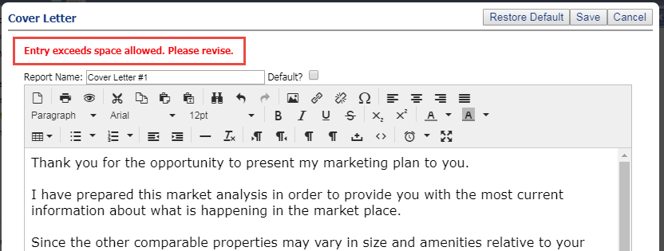

CMA – Tool Tip for Suggested List Price

An info tip has been added to the CMA Presentation > Comparable Price Analysis page that points out where the Suggested List Price Range appears in the CMA Presentation documents.

**Action Item:** No action is required by you to implement this functionality.

Figure A, Suggested List Price Info Tip

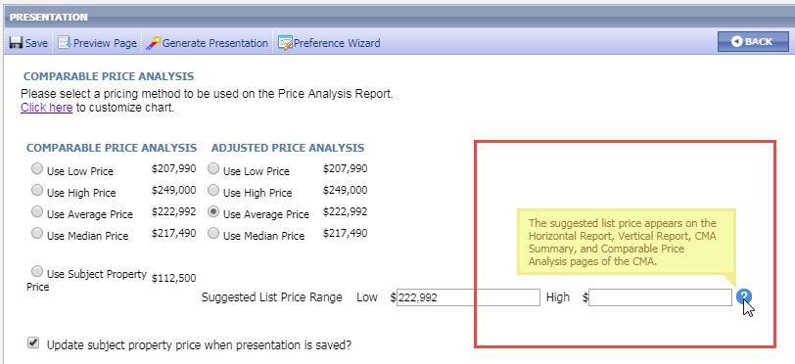

Email Notifications – Extra line breaks removed in Rich Text Editor

This corrects a reported issue where extra line breaks were added to the top of the email body text each time the email notification text was edited.

**Action Item:** No action is required by you to implement this functionality.

General – Updated User Interface on Tabs

You may notice a new look to the Paragon tabs with the 5.70 Release! The tabs and sub-tabs have been given a more modern look, and the color of the tabs is matched to your selected Theme (Preferences > System > User Interface). The tab and sub-tab in focus are highlighted.

**Action Item:** No action is required by you to implement this functionality.

Figure A

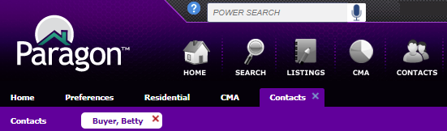

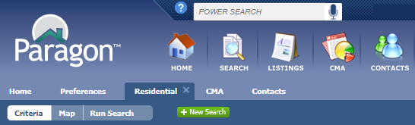

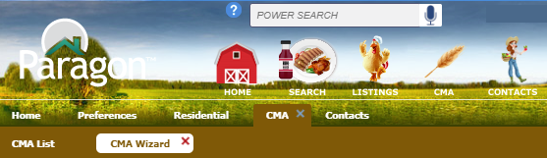

# MLS Customizations and Administration

**All options in this section are either configurable via MLS Administration controls or by your System Support Manager as noted.**

Collaboration Center – Implement RatePlug

Collaboration Center has been enhanced to support the RatePlug integration to determine if an agent has an active RatePlug account.

**Action Item:** If your MLS uses RatePlug, please contact your SSM to have the integration point enabled.

Figure A, Collaboration Center RatePlug Icon



CMA – Restrict Copy Listing to Subject Property

This configuration setting allows the MLS to control who can copy an existing listing to a new CMA Subject Property listing.

A new configuration setting will prevent users from copying listing data to a CMA Subject Property unless the agent is the primary listing agent for the source listing. With this restriction in place, if the user tries to copy another agent’s listing to a CMA Subject Property, an error message will be returned.

**Action Item:** By default, users can copy listing data from any standard listing into a CMA Subject Property listing. Please contact your SSM to change the setting if you want to restrict this function to the primary listing agent.

Figure A, Copy Listing to CMA Subject Property Error Message

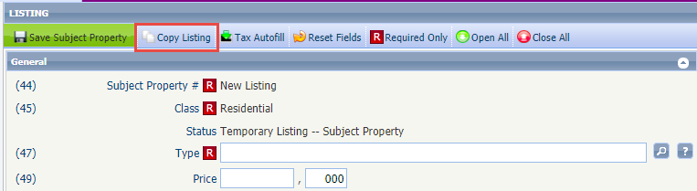

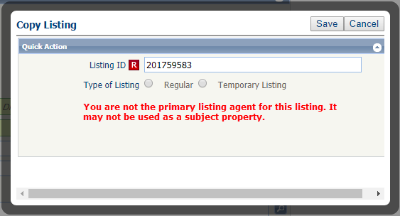

LIM – Restrict Agent Lookup Fields by Association Autonomy Rules

This enhancement allows an MLS using Association Autonomy to filter the Listing Agent and Selling Agent lookups in Listing Input & Maintenance by Board Listing Participation or Membership Participation. This will eliminate ineligible agents from displaying in those LIM fields. By default, no filters are applied.

**Action Item:** The Listing Participation filter or Membership Participation filter can be enabled in the new Admin > Listings > LIM Agent Filter module.

Figure A, LIM Agent Filter module

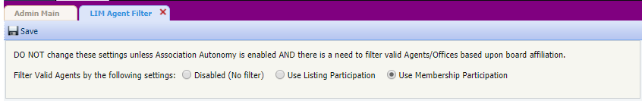

Figure B, Agent Lookup without Filter enabled

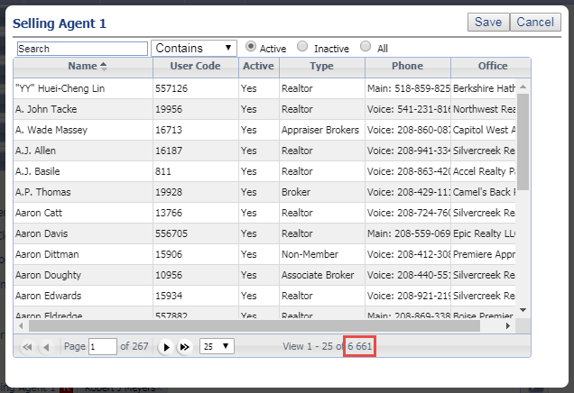

Figure C, Agent Lookup with Filter enabled

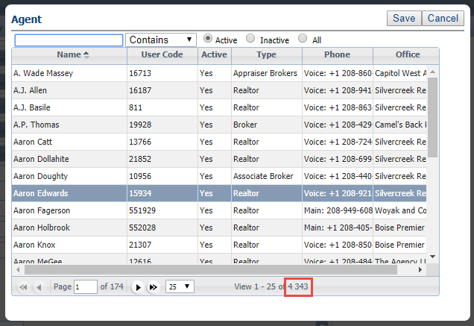

LIM – Required Field icon on Unit Field

This fixes an issue in Listing Input and Maintenance where the dedicated Unit field was inheriting the ‘required’ field icon from the Address field, when the Unit field was placed after the Address. If the Unit was not actually required, this was preventing users from saving the listing when there was no Unit data to be entered. The LIM form now references the Required flag in Admin > Fields for Unit when displaying the ‘required’ icon and enforcing required field rules.

**Action Item:** No action is required by you to implement this functionality.

Figure A, Unit after address, with inherited Required icon

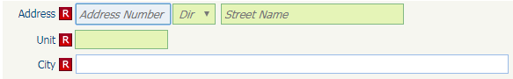

Figure B, Unit after address, no field requirement

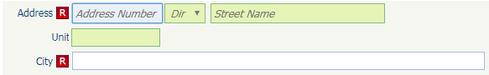

LIM – Room Description Field Character Limit

This fixes an issue with characters allowed in the Room Information Table’s **Room Description** Field in Listing Input & Maintenance. This freeform field allows a maximum number of characters, but the field character limit can be set to less than that maximum in Admin > Fields. LIM was not respecting that lower character limit.

**NOTE:** For Customers with a defined custom length for the Room Description field, data in existing listings may be truncated when the custom length is enforced with this release.

Figure A, Room Description Field

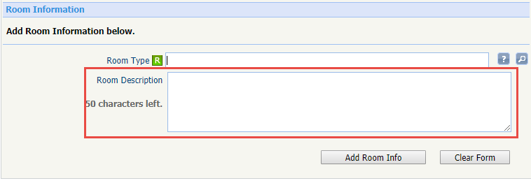

CDOM – Additional Fields added to CDOM/Property History Matching

This enhancement improves address matching for CDOM and Property History when the international address fields are used in combination with geocode values. The matching procedures have been modified so the geocode and international address fields can be used together when determining listing matches.

**Action Item:** Please notify your SSM if you would like to enable any of the international address fields for CDOM/Property History matching.

Admin – Remove RUG Listing Table Parent Fields from Field Rules

This correction to the Field Rules > Variables table removes the RUG Table parent fields (Room Information, Unit Information, and Green Information). Using these fields as variables in Listing Input & Maintenance field rules would cause the rule to fail. In order to ensure they are not inadvertently used, these fields have been removed from the Field Rules admin.

**Action Item:** No action is required by you to implement this functionality.

Views/Reports – Listing Number display on Broker Sales Detail Report

This enhancement modifies the Broker Sales Detail Report to display a listings Display ID value, rather than the System ID. This affects Paragon customers who use a Display ID, which can include alphanumeric characters. When the Sales Detail report referenced the System ID, users could not correctly identify listings in the report.

**Note:** Customers that do not use alphanumeric Display ID values should not see any changes in the report.

**Action Item:** No action is required by you to implement this functionality.

RETS/RESO – Updated text in RETS Update Error Message

This enhancement updates the error message relating to incorrect postal codes for listings processed via RETS Update Transactions. For our Canadian customers, when a RETS Update Transaction was processed and the postal code was not correctly formatted for Canada, the resulting error message referred to the system name, ZIP Code, rather than the Canadian term, Postal Code. The error message has been modified to refer to the system ZIP Code field as Postal Code, which also complies with the RESO Data Dictionary term for ZIP Code.

**Action Item:** No action is required by you to implement this functionality.

Collaboration Center – Updates to the Start an Offer form

Additional text has been added to the Start an Offer form in Collaboration Center, to help clarify for the Client the intent of the form. The UI has also been modified slightly for better workflow and consistency within Collaboration Center.

**Action Item:** Start an Offer is disabled by default; please contact your SSM if you would like to enable this feature.

Figure A, Start an Offer form

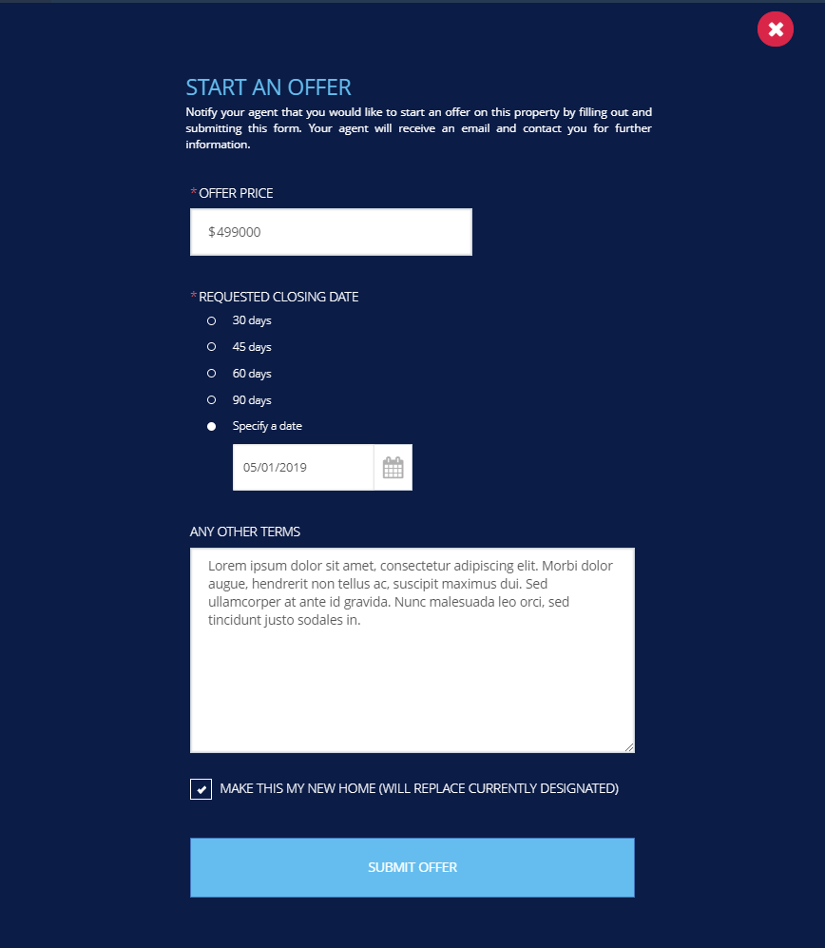

Collaboration Center – Updates to Start an Offer Confirmation Form

A disclaimer was added to the bottom of the Start an Offer confirmation modal: ***This offer is not a contract, and is not intended to create a binding agreement on the Seller or Buyer; it is simply a notification to your agent of your interest in this property.*** The UI was also updated slightly to be consistent with other modals in Collaboration Center.

**Action Item:** Start an Offer is disabled by default; please contact your SSM if you would like to enable this feature.

Figure A, Start an Offer Confirmation form

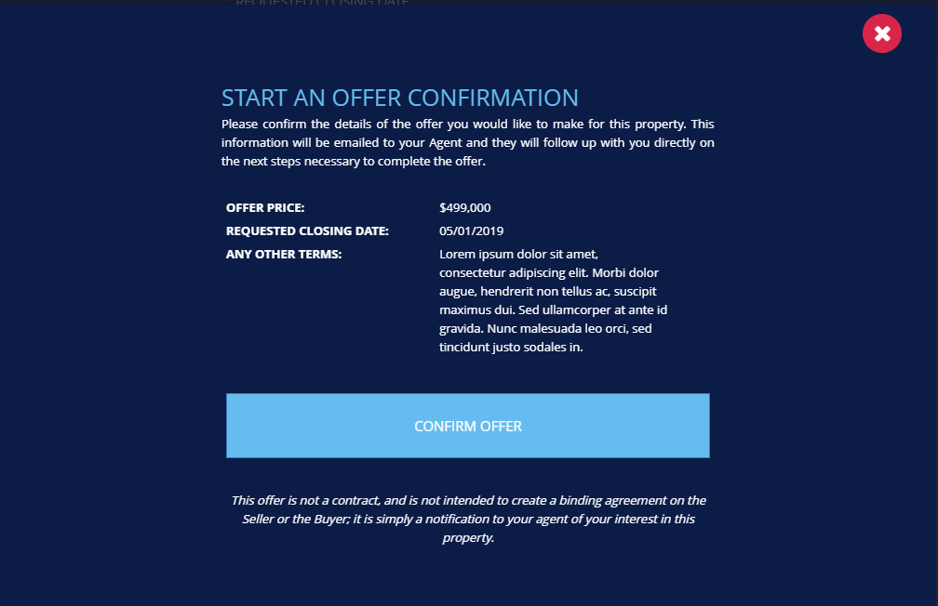

Collaboration Center – Updates to the Start an Offer Agent Email

Several updates were made to the Agent email received when a Client uses the Start an Offer form in Collaboration Center. The email Subject line was enhanced to help the email stand out, additional listing information was included in the body of the email, and the Client’s contact information from Collab Center was included.

**Action Item:** No additional action required by you to implement these changes.

Figure A, Updated Start an Offer Email

